Dell Inspirion 5570

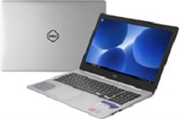

Price: $744.9

\*\*\*Specification:

-Screen:15.6", Full HD (1920x1080)

-CPU:Intel Core i5, 1.6GHz

-RAM: 4GB, Hard drive HDD:1TB

-VGA:AMD Radeon 530, 2GB

-OS: Windows 10

-Instant battery, DVD: None

\*\*\*Salient feature:

-Simple, sturdy design

-Strong configuration

-Big screen, clear picture

-Smart touchpad