Dell Inspirion 7570

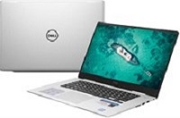

Price: $989.9

\*\*\*Specification:

-Screen:15.6", Full HD(1920x1080).

-CPU:Intel Core i5, 2.4GHz.

-RAM: 4GB, Hard drive HDD:1TB.

-VGA:NVIDIA GeForce 940MX, 4GB.

-OS: Windows 10.

-Instant battery, DVD: None.

\*\*\*Salient feature:

-Simple, sturdy design.

-Strong configuration.

-Big screen, clear picture.

-Smart touchpad.