Iphone X 256GB Silver

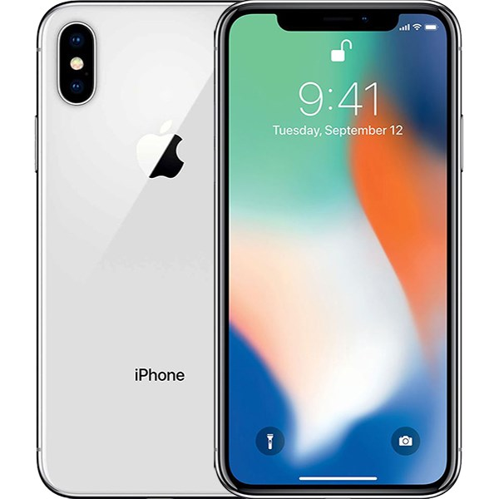

Price: $1337.8

\*\*\*Specification:

-Screen:OLED, 5.8", Super Retina.

-OS: iOS 11.

-Back camera:2 camera 12MP.

-Front camera: 7MP.

-CPU: Apple A11 Bionic 6 core.

-RAM: 3GB.

-Internal memory: 256GB.

-Battery capacity: 2716 mAh.

\*\*\*Salient features:

-High Quality OLED screen from Apple.

-Double cameras come with artificial intelligent.

-Design for stainless steel rim and high pressure surface.

product is combined with HDR10 technology and 120hz frequency that improve the quality of the picture.

-Apple 12 Bionic chip shows strong performance.