Iphone XR 256GB White

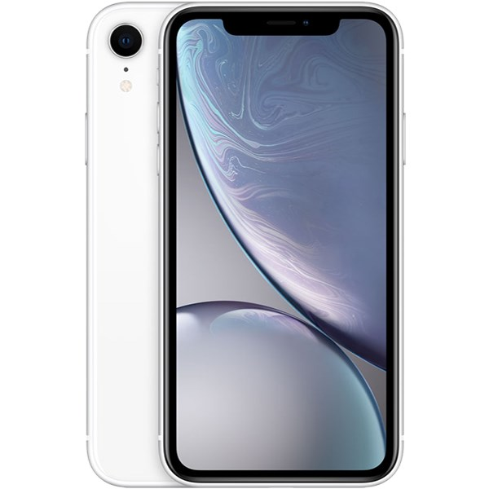

Price: $1076.4

\*\*\*Specification:

-Screen:IPS LCD, 6.1", IPS LCD, 16 triệu màu.

-OS: iOS 12.

-Back camera: 12MP.

-Front camera: 7MP.

-CPU: Apple A12 Bionic 6 core.

-RAM: 3GB.

-Internal memory: 256GB.

-Battery capacity: 2942 mAh.

\*\*\*Salient features

-High Quality OLED screen from Apple.

-Double cameras come with artificial intelligent.

-Design for stainless steel rim and high pressure surface.

product is combined with HDR10 technology and 120hz frequency that improve the quality of the picture.

-Apple 12 Bionic chip shows strong performance.