Iphone XS Max 64GB

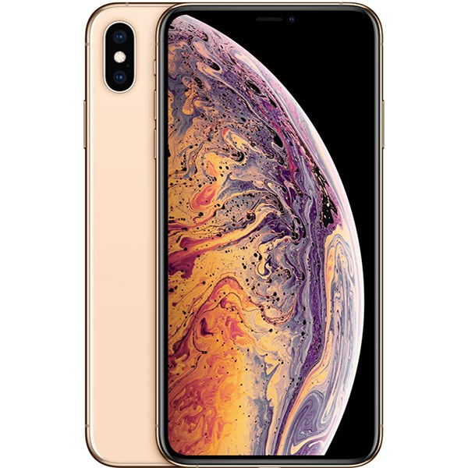

Price: $1420.9

\*\*\*Specification:

-Srceen:OLED, 6.5",Super Retina.

-OS: iOS 12.

-Back camera:2 camera 12MP.

-Front camera: 7MP.

-CPU: Apple A12 Bionic 6 core.

-RAM: 4GB.

-Internal memory: 64GB.

-Battery capacity: 3174 mAh.

\*\*\*Salient features

-High Quality OLED screen from Apple.

-Double cameras come with artificial intelligent.

-Design for stainless steel rim and high pressure surface.

product is combined with HDR10 technology and 120hz frequency that improve the quality of the picture.

-Apple 12 Bionic chip shows strong performance.