MACBOOK PRO Touch MR9q2sa

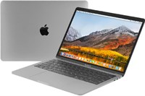

Price: $1913.3

\*\*\*Specification:

- Screen:15.4", Retina.

-CPU:Intel Core i7, 2.2GHz.

-RAM: 16GB, Hard drive SSD:256GB.

-VGA:AMD Radeon Pro 555X, 4GB.

-OS: MAC OS.

-Battery: 10h, DVD: None.

\*\*\*Salient features:

-High Quality Aluminim Design.

-A keyboard refined for an even better hands-on experience.

-The Force Touch trackpad. Press a little deeper, do a lot more.

-Multi-Touch.Precise control at your fingertips.