MACBOOK PRO Touch MVXP2sa

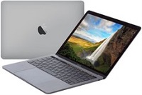

-Price: $1953.3

\*\*\*Specification:

-Screen :13.3", Retina.

-CPU:Intel Core i5, 3.1GHz.

-RAM: 8GB, Hard drive SSD:256GB.

-VGA:Intel Iris Plus Graphics 650.

-HDH: MAC OS.

-Battery: 10h, DVD: None.

\*\*\*Salient features:

-High Quality Aluminim Design.

-A keyboard refined for an even better hands-on experience.

-The Force Touch trackpad. Press a little deeper, do a lot more.

-Multi-Touch.Precise control at your fingertips.