MACBOOK PRO touch MR932sa 2018

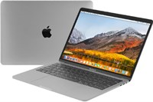

Price: $2473.9

\*\*\*Specification:

-Screen: 13.3’’, Retina.

-CPU: Intel Core I5, 2.3GHz.

-RAM: 8GB, Hard drive SSD:256GB

-VGA: Intel Iris plus Graphics 665.

-OS: MAC OS.

-Battery: 10h, DVD:None.

\*\*\*Salient features:

-High Quality Aluminim Design.

-A keyboard refined for an even better hands-on experience.

-The Force Touch trackpad. Press a little deeper, do a lot more.

-Multi-Touch.Precise control at your fingertips.