|  |  |  |  |  |  |
| --- | --- | --- | --- | --- | --- |
| **REV** | **DESCRIPTION OF CHANGE** | **ECO** | **DATE** | **BY** | **ENG** |
| X1 | FIRST RELEASE |  | 30-Mar-2022 |  | Van.vu |
| X1X2 | Update setup low security authority for user account  remove install eink  run upgrade firmware procedure |  | 2-MATCH-2023 |  | Van.vu |
| X1X3 | update install eink dll and setup admin permission  setup laptop 14/15 inches  run ule procedure  update run testcases  típ to run automation smoothly |  | 23-aug-2023 |  | van.vu |
| X1X4 | update setup application paths  update configuration file of aladdin |  | 22-Sep-2023 |  | vanvu |
| X1X5 | Update Service port mode procedure |  | 23-nov-2023 |  | vanvu |
| X1X6 | Update country mode procedure  update audio beep install and setting |  | 4-may-2024 |  | vanvu |
| X1X7 | Update Instal TBarcode to create barcode automatically |  | 21-may-2024 |  | vanvu |
| X1X8 | update install sdk to display barcode on andriod phone |  | 22-july-2024 |  | vanvu |
| X1X9 | update Setup Ms word for country mode |  | 12-sep-2024 |  | vanvu |
|  |  |  |  |  |  |
|  |  |  |  |  |  |
|  |  |  |  |  |  |
|  |  |  |  |  |  |
|  |  |  |  |  |  |
|  |  |  |  |  |  |
|  |  |  |  |  |  |
|  |  |  |  |  |  |
|  |  |  |  |  |  |
|  |  |  |  |  |  |
|  |  |  |  |  |  |
|  |  |  |  |  |  |
|  |  |  |  |  |  |
|  |  |  |  |  |  |
|  |  |  |  |  |  |
|  |  |  |  |  |  |
|  |  |  |  |  |  |
|  |  |  |  |  |  |
|  |  |  |  |  |  |
|  |  |  |  |  |  |
|  |  |  |  |  |  |
|  |  |  |  |  |  |
|  |  |  |  |  |  |
|  |  |  |  |  |  |
|  |  |  |  |  |  |

|  |  |  |  |  |  |
| --- | --- | --- | --- | --- | --- |
|  | NAME | DATE | DESCRIPTION | | |
| COMPILED BY |  | 30/03/2022 | **Software integration test procedure** | | |
| CHECKED BY |  |  | **automation** | | |
| ENGINEER | van.vu, | 30/03/2022 |  | REV: X1X4 |  |
|  |  |  | PART NUMBER: | | |

VERIFY REVISION WITH DOCUMENTATION PRIOR TO INITIATING CHANGES

**CONFIDENTIAL DATALOGIC PROPRIETARY**

1. Purpose 4

2. Scope 4

3. References 4

4. Terms and Definitions 4

5. Test Environment Setup 4

Window 10 4

.Net framwork 4

6. Install 5

7. Structure of the Tool 8

8. Run testcase 8

# Purpose

The purpose of this test procedure is to run automation for all testcase of all procedure of HHS

# Scope

This procedure is applicable to handhelds designed with all Procedures on all active interfaces.

# References

Quick Test procedure

Interface procedure

ULE procedure

Upgrade Firmware procedure

….

# Terms and Definitions

Scan: point scanner at bar code and pull trigger

HH: Handheld

BT: Blue Tooth

RF: Radio Frequency

SUT: System Under Test

# Test Environment Setup

## Window 10/Window11

## .Net framwork

# Install

1. Choose Start/Settings/Update & Security/For developers to turn on “Developer Mode” on Window 10

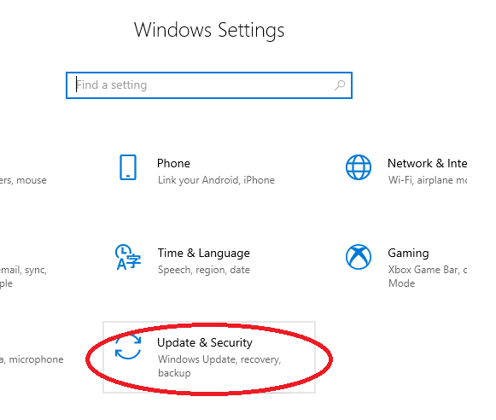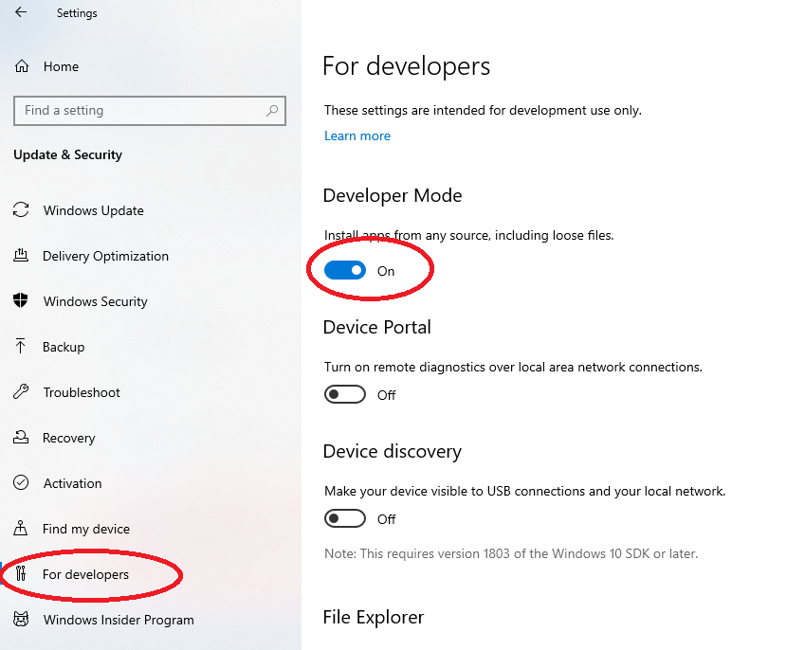

1. Turn Off User Account Control Setting by go to **Control Panel/Security and Maintenance/Change User Account Control settings** (Explain: This step helps the Diamond tool can open all applications on your PC without asking Admin Account authority)

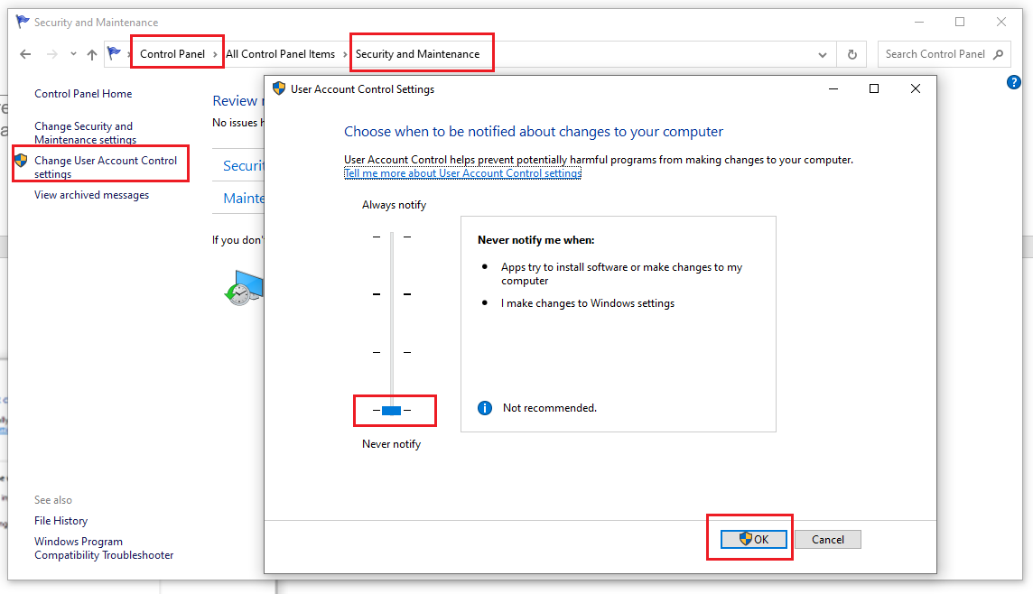

1. Install Winappdriver form: \\vnmsrv305\grpfiles\R&D\HH_VN_SWTestTeam\Diamond Tool\Documents\Supported SW\WindowsApplicationDriver_1.2.1.msi (please install at default)
2. Copy folder: \\vnmsrv305\grpfiles\R&D\HH_VN_SWTestTeam\Diamond Tool\Tool\Release….\Debug to your PC at C:\Diamond
3. Click on file Serviceport.exe in Debug folder to open the tool. The tool will display like below:

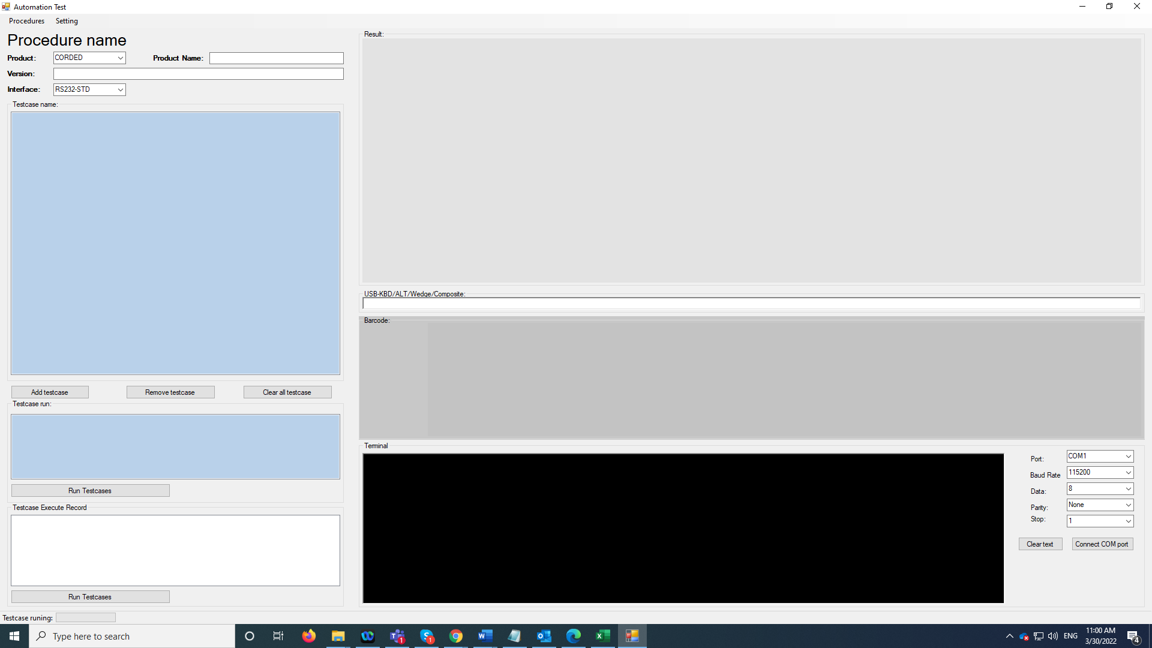

# Install Eink

1. Go to this folder \\vnmsrv305\grpfiles\R&D\HH_VN_SWTestTeam\Diamond Tool\Documents\Supported SW\Eink\Eink_dll
2. Copy 2 files: EInk.dll and EInk_Wrapper.dll to folder: C:\Diamond\Debug

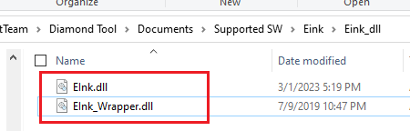

1. Plug in your Eink device to PC
2. Click on Menu Setting/Setting All
3. Choose Using Eink check box. And click on OK. If your Eink flashing, mean, the application already see your Eink. And your setting is successful.

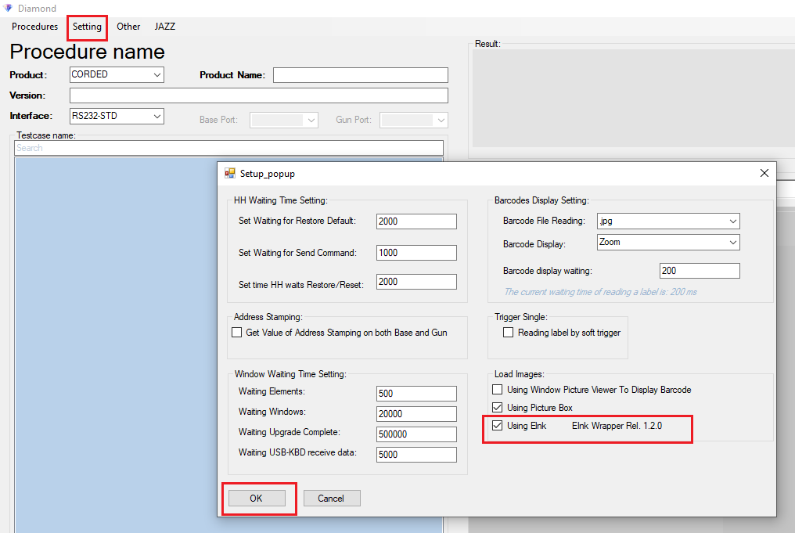

# Install TBarcode to create automatical barcode

How to install TBarcode.dll

1. Download TBarCode SDK from <https://www.tec-it.com/Download>
2. Remenber that this TBarcode will install to: 2 paths
   1. C:\Program Files\Common Files\TEC-IT\TBarCode\11.0
   2. C:\Program Files (x64)\Common Files\TEC-IT\TBarCode\11.0
3. If you use Window 64 bit, please use the second path (2b), else use the first path(2a)

Copy this file to your Debug

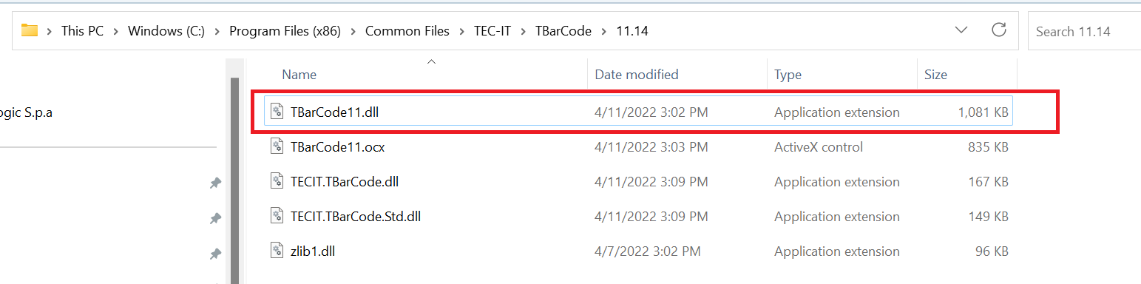

# Setup for laptop 14 inches or 15 inches

Because the screen of laptop 14/15 inches is a little bit small. So Aladdin screen can’t fix with the screen.

For testcase run on Aladdin (special Upgrade Firmware testcases), please adjust your screen like below:

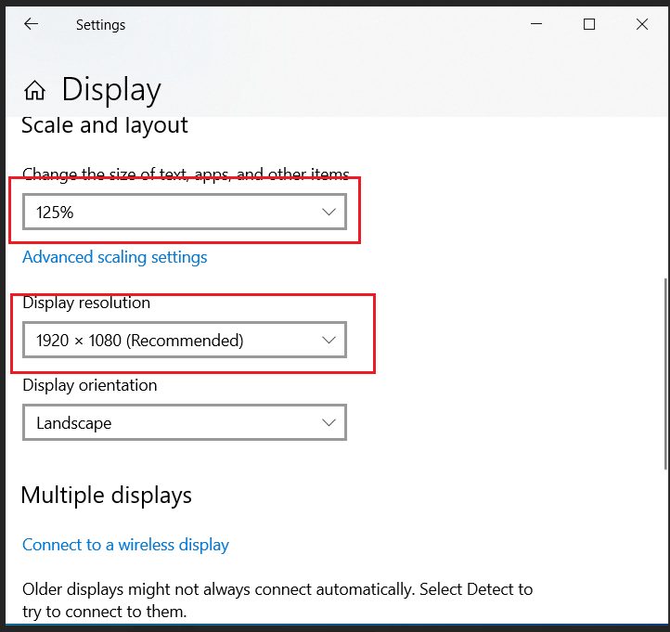

# Setup Administrator

* Because IT setup a new rule to all user account. So You must setup full control permission for your account on all application that you use.
* Please follow this file to setup administrator permission for all your application on Window. \\vnmsrv305\grpfiles\R&D\HH_VN_SWTestTeam\Diamond Tool\Documents\ Execute_Diamond_without_admin_permission_error.pptx
* Below are listed applications need to be setup

1. Aladidn
2. Winappdrvier
3. Jazz Adapter
4. …..

# Install Applications

Please install all applications that you use for testing devices

1. Dual Test tool
2. Aladdin tool
3. USB driver
4. …..

# Setup Application Paths

1. Open file C:\Diamond\Debug\Tools\Path files.csv
2. Type your application paths to the file like below:

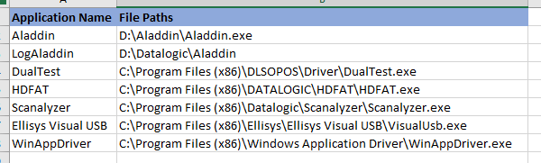

# Install Audio Beep Setup

1. Go to \Debug\Tools\python-3.10.1-amd64 and double click on python 3.10 to install Python to your PC. (Audio Beep just work on Python 3.10.1)
2. Please instal Python 2 times, with your user account and admin account (such as: vtvu and vtvuadm)
3. Run 2 command below in cmd like the below picture. Make sure that they respond to version of Python and pip

py --version

py -m pip --version

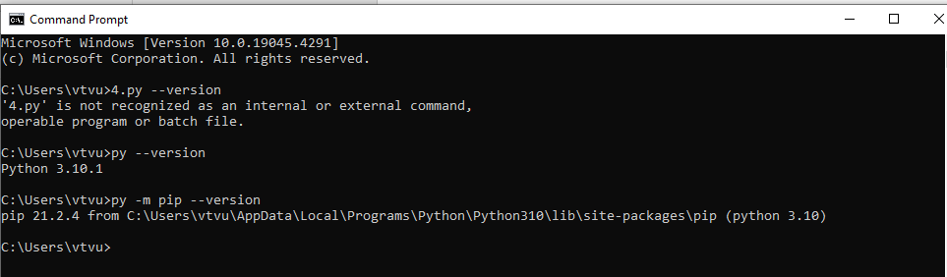

1. Change to ..\Debug\Audio\utrad-cleanup\Beeper like picture below

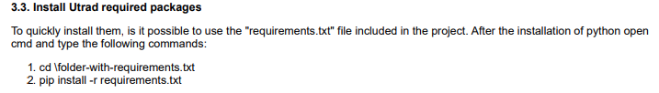



or Install step by step like below:

py -m pip install "matplotlib==3.5.1"

py -m pip install "numpy==1.22.1"

py -m pip install "PeakUtils==1.3.3"

py -m pip install "scipy==1.7.3"

py -m pip install "sounddevice==0.4.4"

1. Type py utrad_demo.py and make sure that picture below display. It means you instal Audio Beep completely.

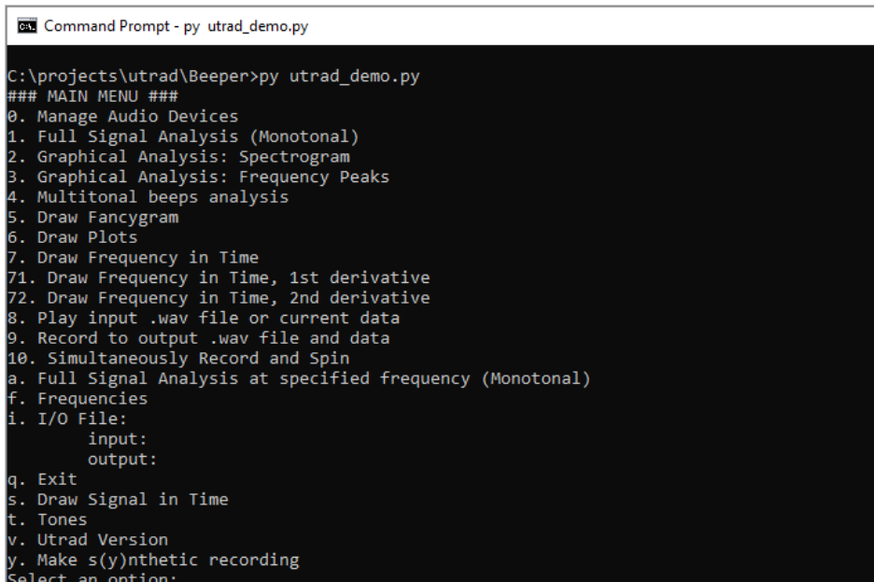

# Install SDK for Android phone Setup

1. Download the latest Android platform tool from: <https://developer.android.com/studio/releases/platform-tools>
2. Download the latest Android SDK build tool from: <https://androidsdkoffline.blogspot.com/p/android-sdk-build-tools.html>
   * 1. Unzip and rename the “android-x” folder to “tools”
     2. Go to “tools” > “lib” > copy all files from “libs” outside to “tools” folder
     3. Copy “tools” folder into the platform-tools_rxx.x.x-windows folder, below “platform-tools”

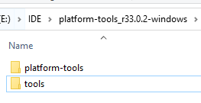

* + 1. Go to “tools” > “lib”, copy all files to “tools” folder
       1. Appium expects them outside

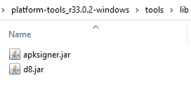

1. Add Environment for SDK
   * 1. Go to Start/System Environment

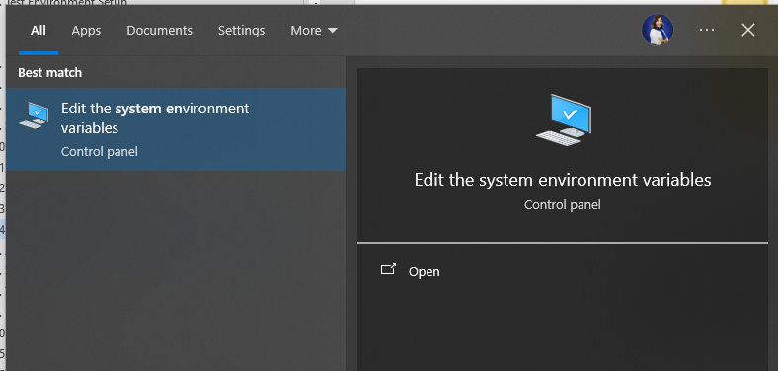

1. Add installed “platform-tools” folder into PATH variable
2. Create new ANDROID_HOME variable point to the “platform-tools_rxx.x.x-windows” folder

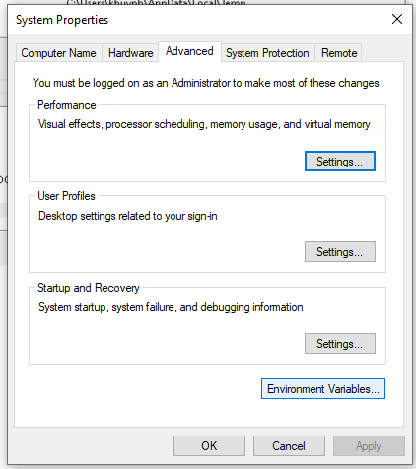

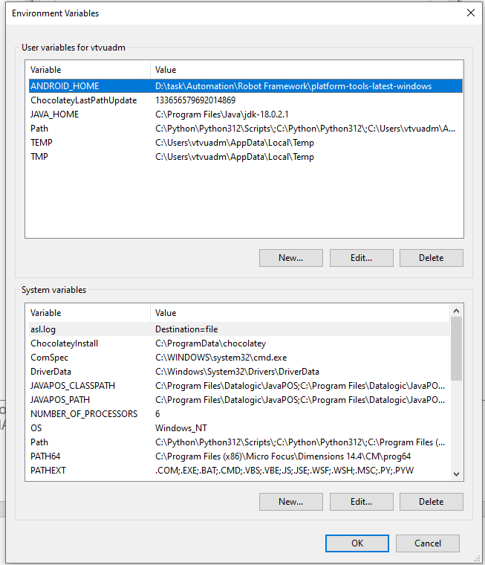

1. Download the latest JDK
   * + <https://www.oracle.com/java/technologies/javase-jdk14-downloads.html>
     + Just use default options
2. Go to System Environment
3. Add JDK bin folder to Path variable
   * + E.g. C:\Program Files\Java\jdk-18.0.1.1\bin
4. Create new JAVA_HOME variable to the JDK
   * + E.g. C:\Program Files\Java\jdk-18.0.1.1\
5. Delete Environment path’s Oracle Javapath
   * + %ProgramData%\Oracle\Java\javapath

1. To driver Chrome
   * + <https://chromedriver.chromium.org/downloads>
     + Must be compatible with current Chrome version
     + Must update manually when Chrome automatically update itself
     + Copy the downloaded ChromeDriver.exe to Python script folder
       - E.g. C:\Python310\Scripts
2. Copy all foder to Debug\Android

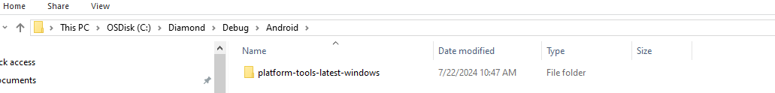

# Aladdin Setup

1. Setup Aladidn in Developer Mode and disable Automatic Update:

* Open file C:\ProgramData\Datalogic\Aladdin\config.properties in Notepad
* Type raw: DeveloperMode=true into the file
* Type raw: AutomaticUpdates=false into the file

Like below picture:

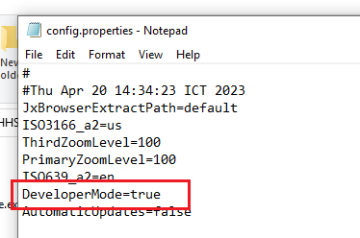

# Structure of the Tool

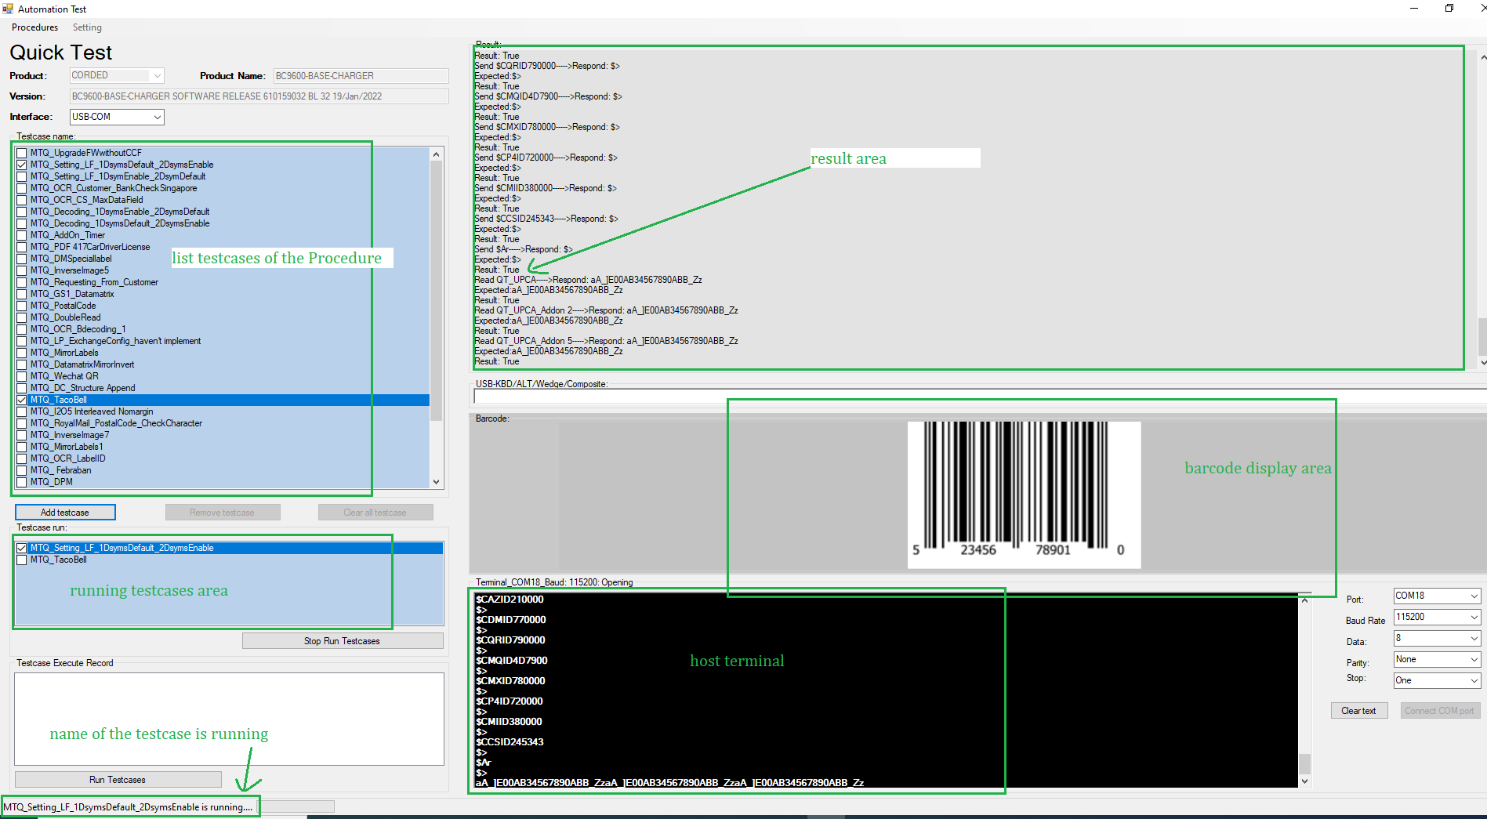

# Tips to run automation smoothly

1. If you use a Wireless device.
   1. Please check and make sure Gun and Base is link together
   2. Clear log On Gun: $S,AR,Er,EDEr,s
   3. Clear log On Base: $S,AR,Er,s
   4. Check again all Guns and the Base are link together. By puting Gun on Base, or read a label programing $P,CABEN01,P. If the Guns and Base link together then, Green LED on Base will be flashing, Green LED on Guns will be flashing.
2. Software center window

When running overnight, please pull this window to your taskbar

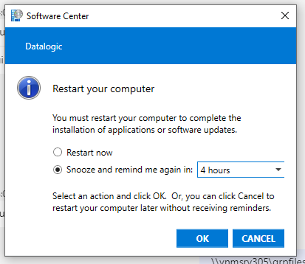

1. Run overnight:

To run overnight and keep the screen always On, you can use this file: \\vnmsrv305\grpfiles\R&D\HH_VN_SWTestTeam\Diamond Tool\Documents\Supported SW\stay_awake2.exe

# Run testcases

1. Go to C:\Diamond\Debug\Log folder and clear all logs
2. Go to C:\Diamond\Debug\Log\ScreenShots and clear all images
3. Go to C:\Diamond\Debug\Log\AladdinLogs and clear all log files.
4. Choose interface and connect device with the COM port like picture below

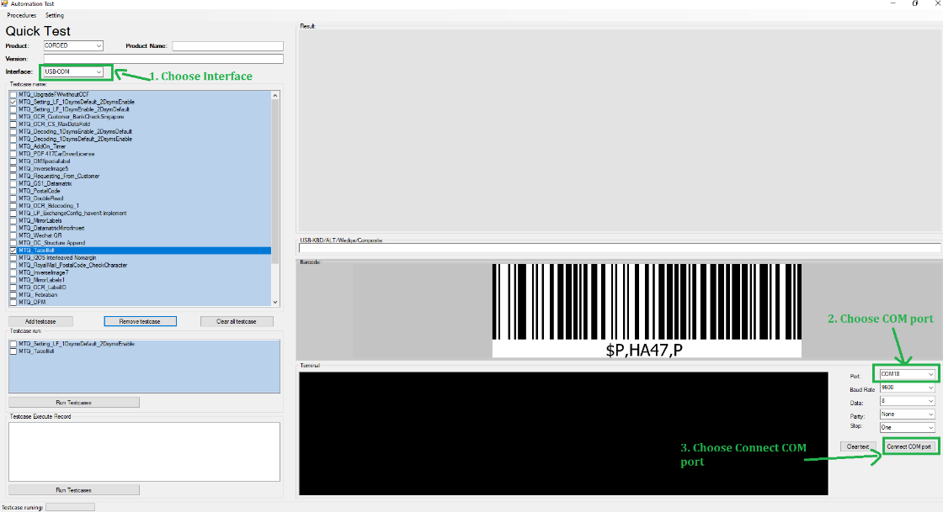

1. Setup Preconditional for the testcase (if needed). (If the testcase don’t need Preconditional, then you don’t need to do this option.)

* PreCondictional_LP: 🡪 run PreConditional by Label Programming
* PreCondictional_SP: 🡪 run PreCondictional by Service Port Mode

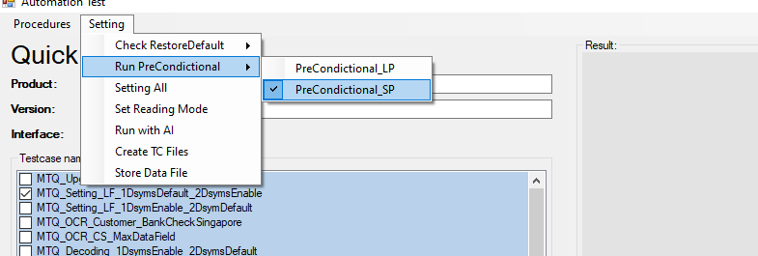

1. Setup Setting All if needed. (If don’t need, you can pass this step)

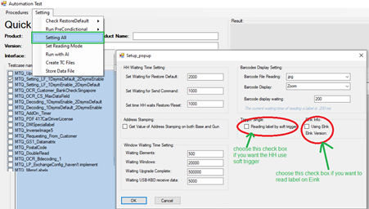

1. Put the HH in front of the barcode area of the HH. Try to AIMing of the HH cover full the barcode bar.
2. Choose Procedure, Testcases and Run

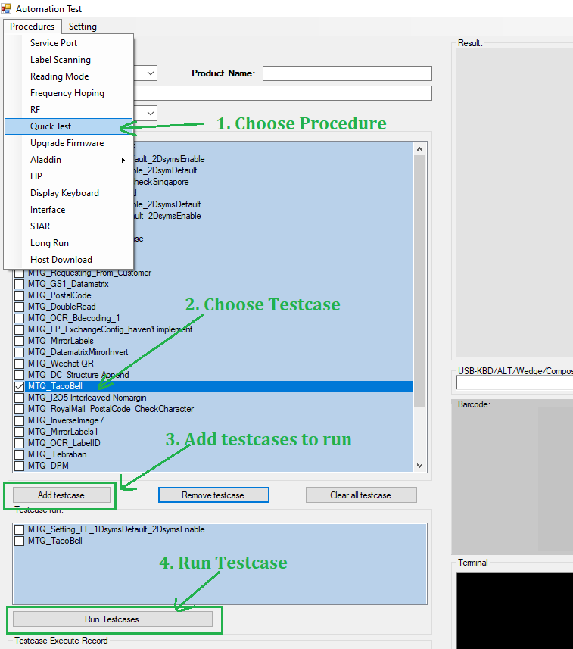

1. The result will be put in Log file.

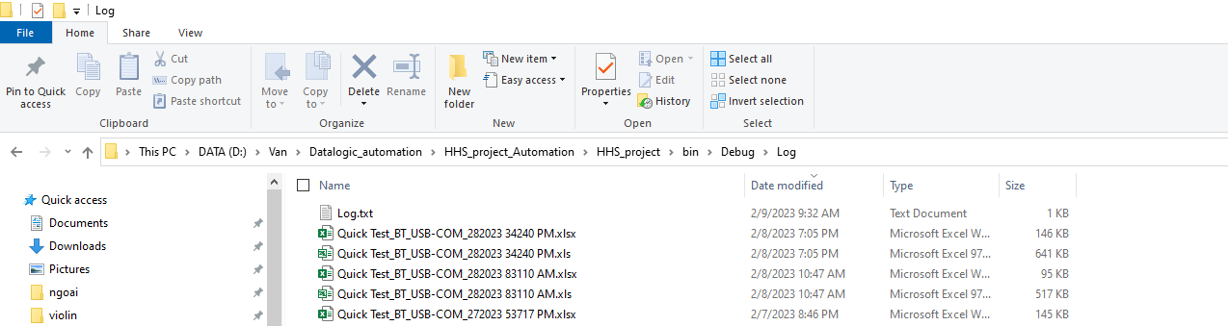

The log file will be like below:

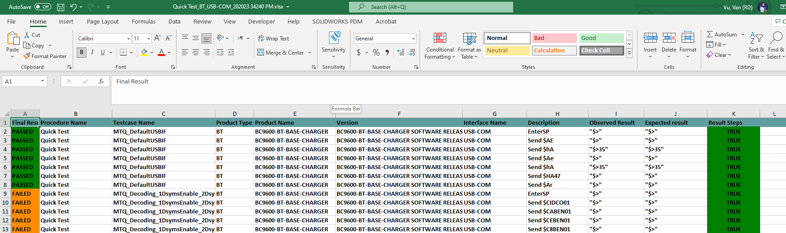

# Procedures

# QuickTest Procedure

You don’t need to do any setup. Just open the Diamond tool/ Choose QuickTest Procedure/ testcases and click Run

Example:

* For DPM device: you should put the camera near the barcode and 10 degree tilt.
* For AR device: you should put the camera opposite and far form the barcode.
* For HP device: you should put the camera opposite with the barcode.

# ULE Procedure

1. Setup Aladidn in Developer Mode and disable Automatic Update:

* Open file C:\ProgramData\Datalogic\Aladdin\config.properties in Notepad
* Type raw: DeveloperMode=true into the file
* Type raw: AutomaticUpdates=false into the file

Like below picture:



# For : AT_UL_1D_CountryMode_FunctionKey

To run CountryMode, you need to add Language to your Window

Steps to add Languages

1. Choose Start/Setting

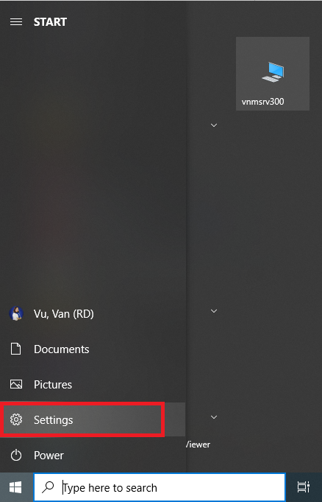

1. Choose Time & Languages

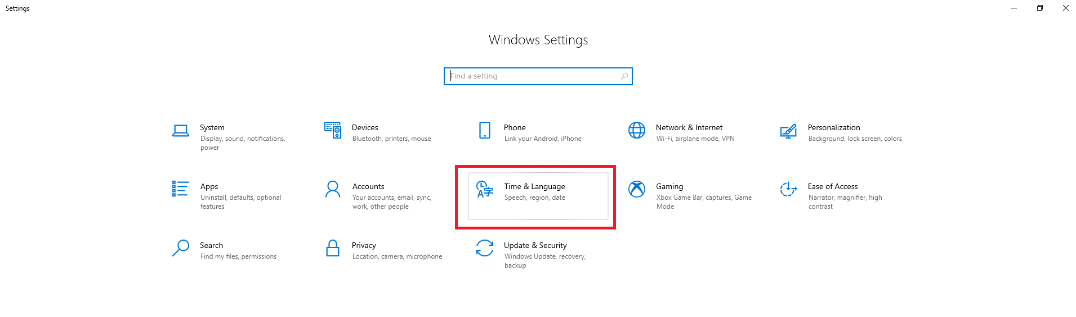

1. Choose Language/Add a language

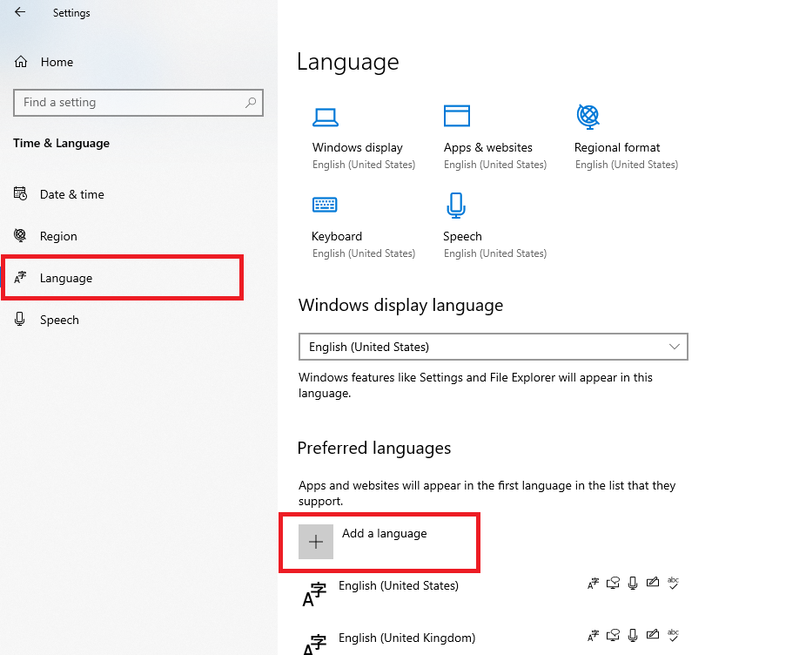

1. Type the Language that you need into Search textbox (Remenber to type exactly Name) and click on Next button.

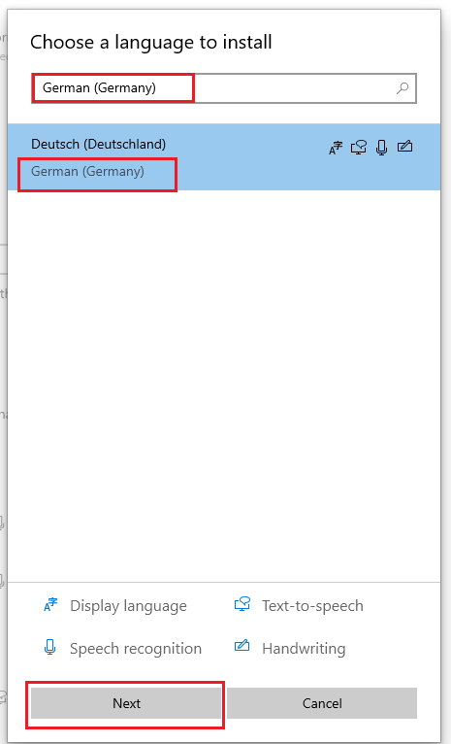

1. Choose like below picture and click Install button

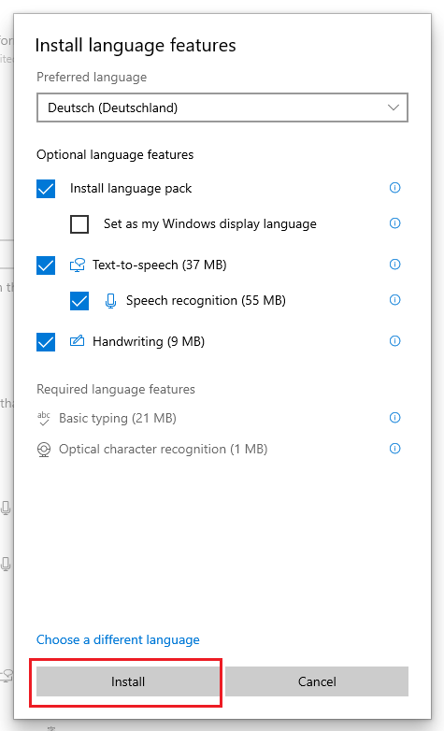

1. Wait it for install for a while.



1. Repeat these steps for all other languages. Rementer that, must exactly the Language Name in the below table

|  |
| --- |
| **Language Name** |
| German (Germany) |
| Spanish (Spain) |
| French (France) |
| Slovak |
| Czech |
| Polish |
| Italian (Italy) |
| English (United States) |

# Upgrade Firmware Procedure

**PreConditional**

1. Setup Aladidn in Developer Mode and disable Automatic Update:

* Open file C:\ProgramData\Datalogic\Aladdin\config.properties in Notepad
* Type raw: DeveloperMode=true into the file
* Type raw: AutomaticUpdates=false into the file

Like below picture:



1. Copy all upgrade firmware file to the folder: C:\Diamond\Debug\Procedures Store\Upgrade Firmware Files

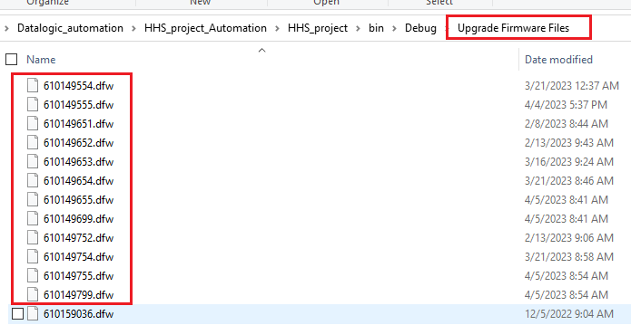

1. Open file “C:\Diamond\Debug\Procedures Store\Upgrade Firmware Files\UpgradeFirmware_file_path.csv” and fill all information of Upgrade firmware file. You can use release note file to get this information.



1. Open file “C:\Diamond\Debug\Procedures Store\Upgrade Firmware Files\CheckBoxElementID.xlsx” and type yes for CheckBoxs that you want to click on

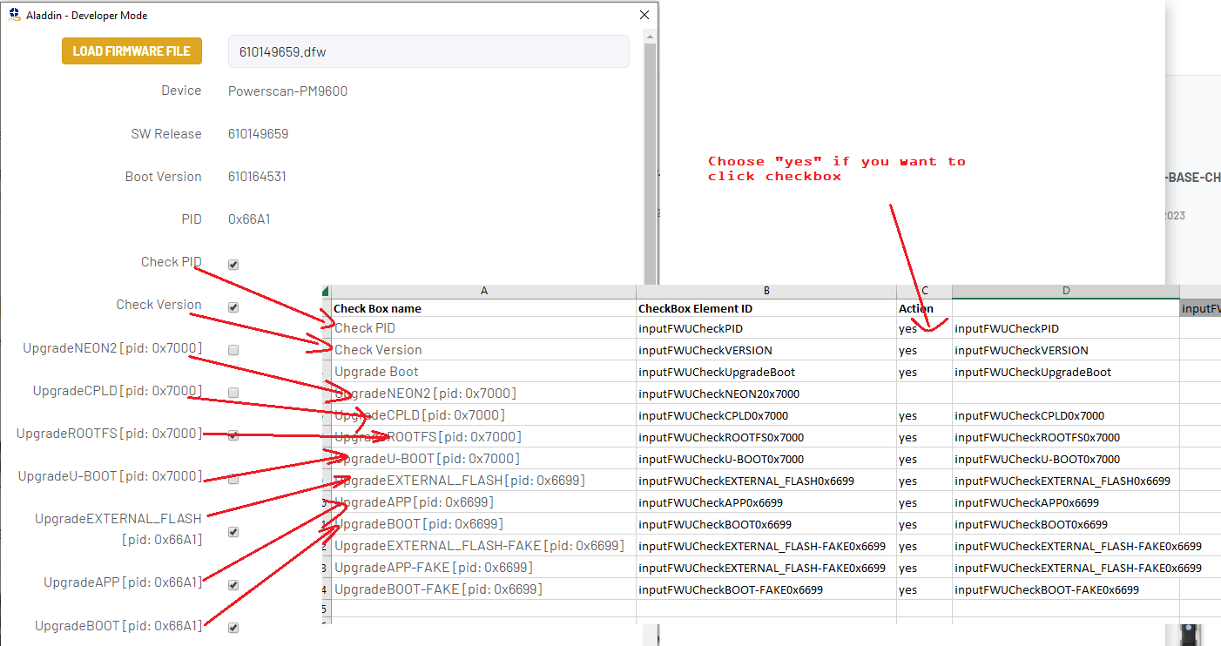

1. Copy data in Cell E1 of excel CheckBoxElementID.xlsx to Check_Box and Check_Box_FAKE columns of file UpgradeFirmware_file_path.csv”.

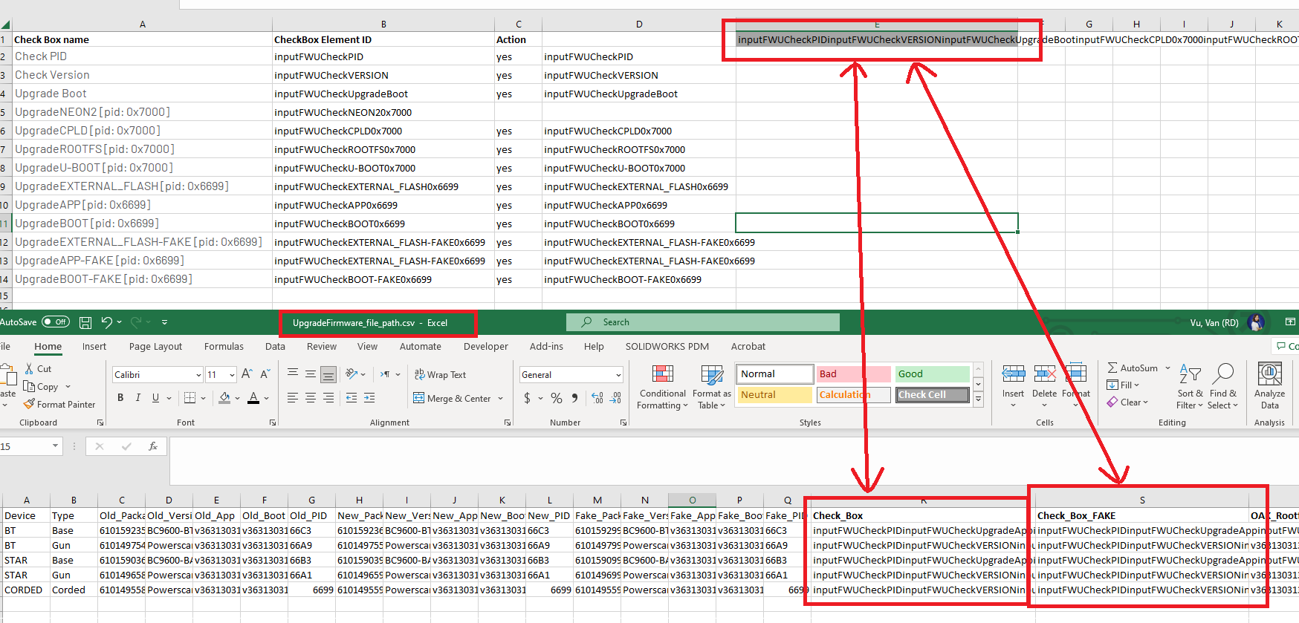

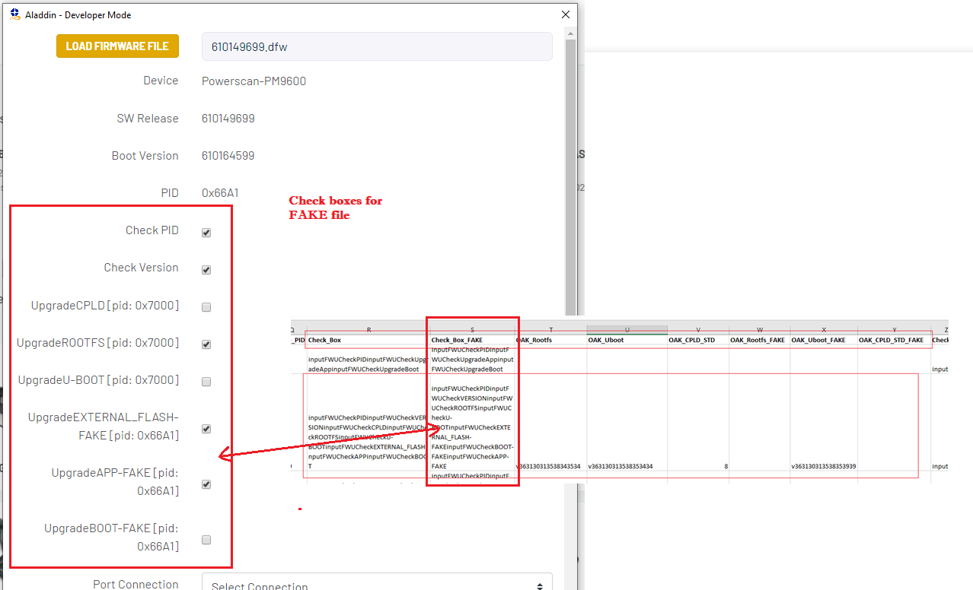

Use release Note to fill OAK_boot, OAK_Uboot, OAK_CPLD_STD

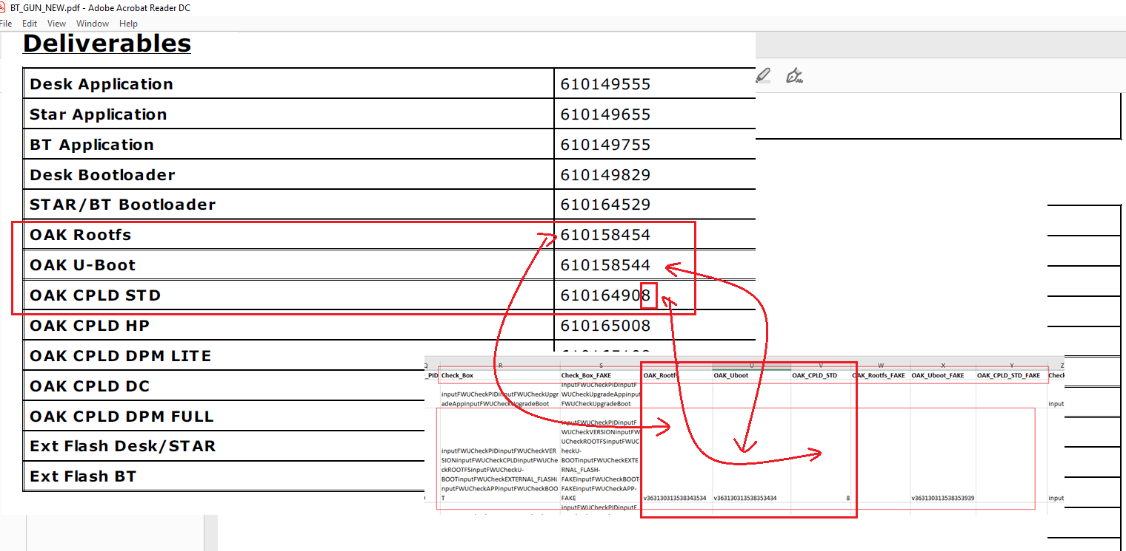

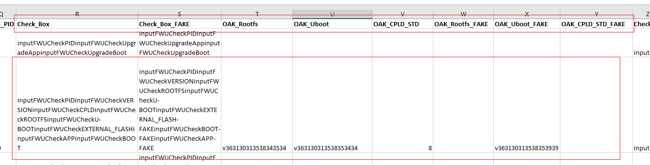

1. For MicroUSB cable upgrade firmware

* If running by application then choose Base port and Gun port like below

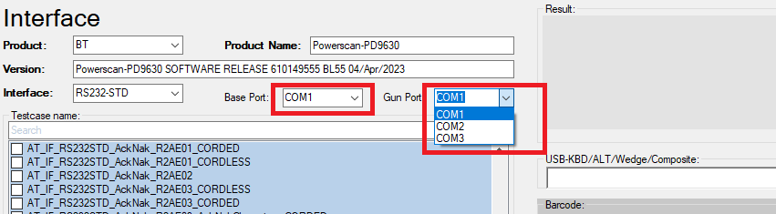

* If running by JAZZ then choose Base port and Gun port like below:
  + Open file \\Debug\Command Line Running\Pre-Configuration.txt
  + Insert com port

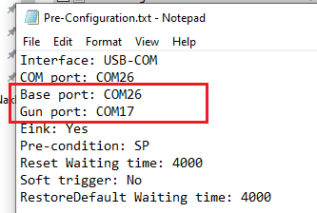

# Force Connection Procedure

1. Remenber to copy Aladdin package of your device to Aladdin

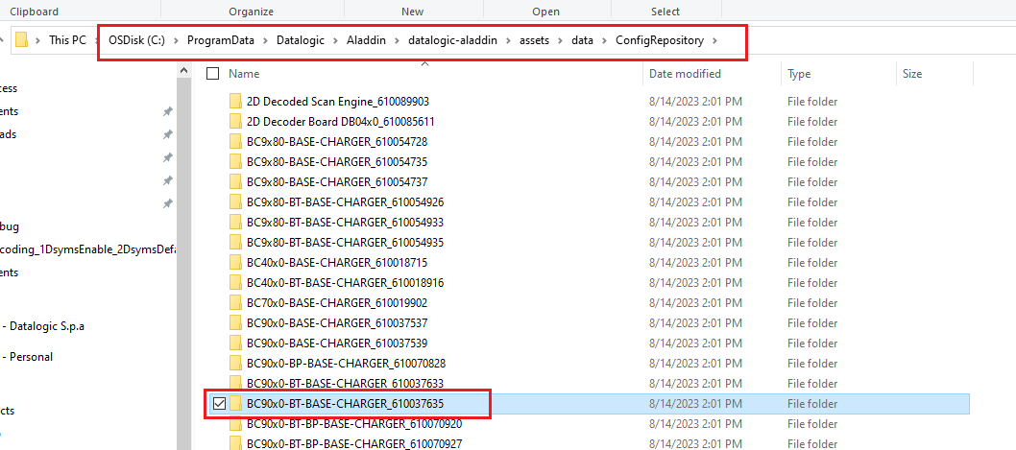

1. Connect the device with Aladdin and check if information on Aladdin and the file are match: C:\Diamond\Debug\Configuration Files\ProductName__AladdinPackage.csv

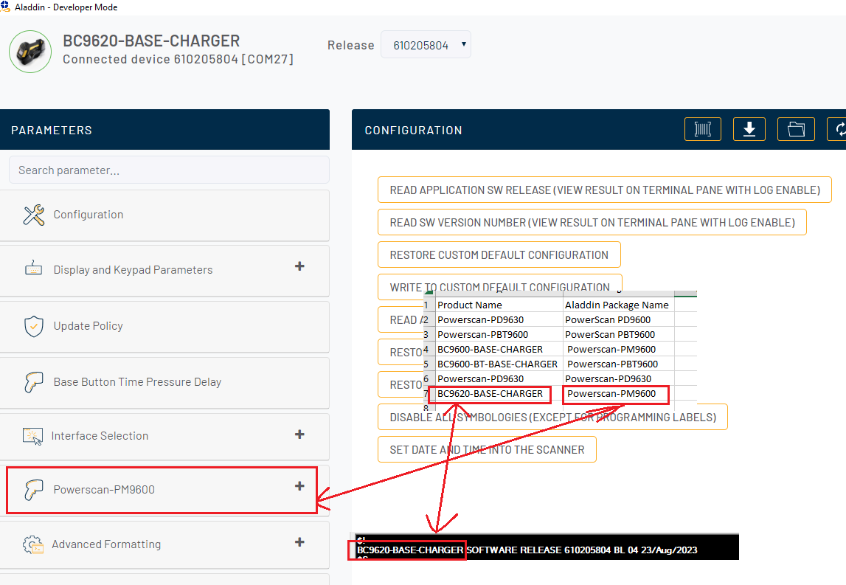

# Label Programing Procedure

* Choose Label Programing Procedure.
* Adjust Aiming of the device cover center of the barcode to read Datamatrix and Code128 easily.

# Service Port Mode Procedure

* Don’t need to do any setup. Just choice the testcase and run.

For : **AT_SP_MasterDefault.** You need to prepare Configration file for running**.**

1. Copy configuration file to folder: \\Debug\Procedures Store\Restore_Default.

🡪Often your product configuration file is put in Release at: … \test\mergedinputfiles

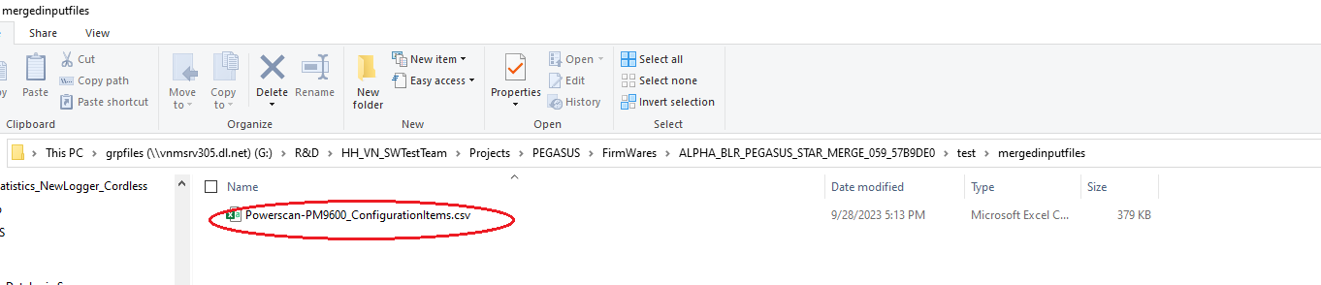

1. In folder \Debug\Procedures Store\Restore_Default, open the copyed configuration file and delete RED columns



1. The file after delete will like this. Remenber to click Save.



1. After running the testcase. Click on result to open detail log:

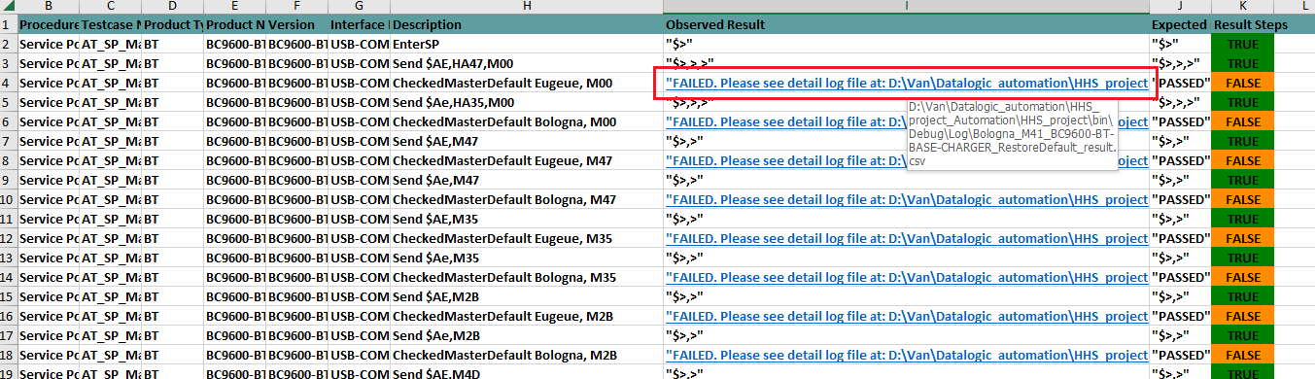

1. Debug the detail log file. Below is class of interfaces. Please refer **Info:** of manual testcase to know the rule of Master Default for debugging.

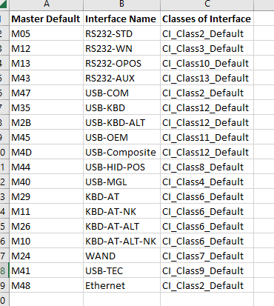

# Country Mode Procedure

# 1. Microsoft Word setup:

Please execute steps in the picture to setup for Word before running Country Mode

1. Open MS Word

2. Choose Select File > Options > Proofing > AutoCorrect Options...

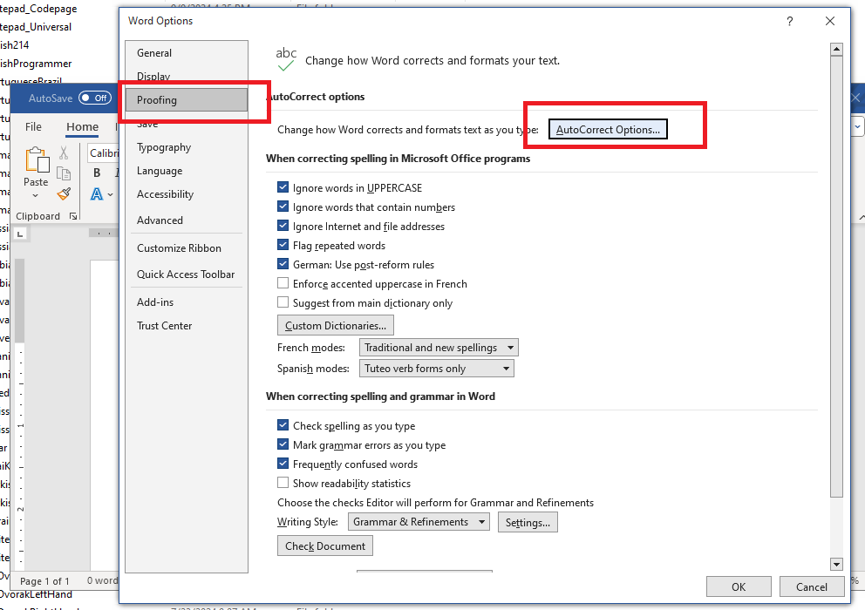

3. Uncheck all check box in the all tabs

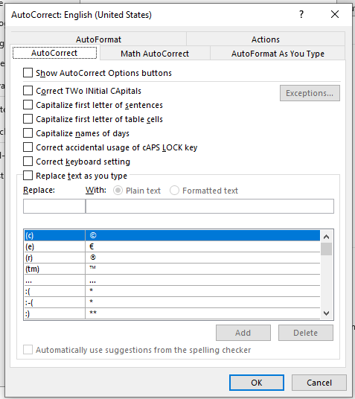

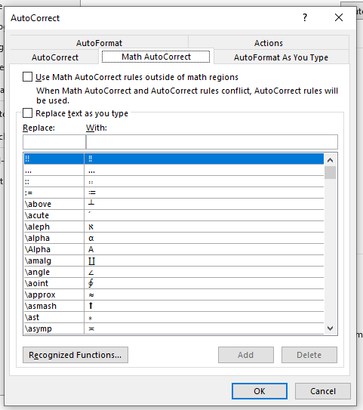

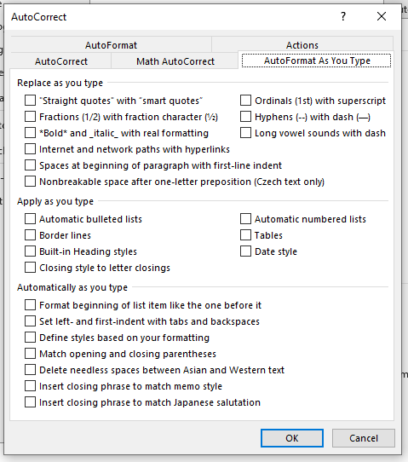

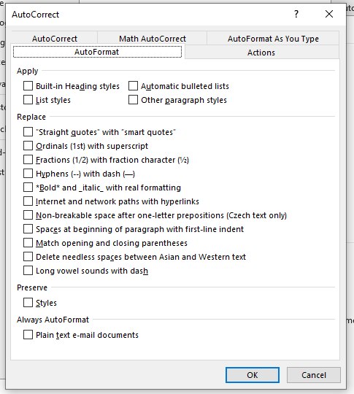

# Interface Procedure

* Don’t need to do any setup. Just choice the testcase and run.

# Robotframework

* Install Python: https://www.python.org/downloads/windows/
* Check version of python: python --version
* Check pip verstion: pip --version

### [Installing and uninstalling Robot Framework](https://github.com/robotframework/robotframework/blob/master/INSTALL.rst#id19)

# Install the latest version (does not upgrade)

pip install robotframework

# Upgrade to the latest stable version

pip install --upgrade robotframework

# Upgrade to the latest version even if it is a pre-release

pip install --upgrade --pre robotframework

# Install a specific version

pip install robotframework==7.0

# Install separately downloaded package (no network connection needed)

pip install robotframework-7.0-py3-none-any.whl

# Install latest (possibly unreleased) code directly from GitHub

pip install https://github.com/robotframework/robotframework/archive/master.zip

# Uninstall

pip uninstall robotframework

## [Verifying installation](https://github.com/robotframework/robotframework/blob/master/INSTALL.rst#id21)

robot --version

Install PILL: pip install pillow