Chapters 18–21 · Correcting for the File Drawer (Tier 2a / 3 :: Publication Bias) · Research Integrity Detection Tool Guides
CORRECTING FOR THE FILE DRAWER  Tier 2a / 3 :: Publication Bias |  | At a glance: These four tools all address the same distortion: because journals preferentially publish significant positive results, the literature that reaches readers is not a representative sample of all studies conducted. Each tool uses different mathematical logic to detect or correct for this bias in a body of published evidence.
 |  | 1. The Shared Problem: The File Drawer
 |  | Publication bias operates at two levels simultaneously. At the team level, researchers file away null results and submit only significant findings. At the journal level, editors preferentially accept papers reporting significant or novel outcomes. The combined effect is that the published record systematically overstates both the prevalence and the magnitude of true effects.
 |  | The consequences are significant. Meta-analyses — which are supposed to synthesize the best available evidence — absorb this distortion directly: if the input studies are biased toward significance, the pooled estimate will be inflated, sometimes dramatically. Clinical guidelines, policy decisions, and further research programs are then built on inflated foundations.
 |  | Detecting and correcting for publication bias requires indirect inference — we are trying to estimate the shape of a distribution from a visible, biased sample of it. The four tools here take different approaches to that inference problem, with different assumptions, different outputs, and different sensitivities to violations of those assumptions:
Dimension | Funnel Plot / Egger Test | Trim-and-Fill | PET-PEESE | Excess Significance (TES)
Core logic | Asymmetry in a plot of effect size vs. precision | Impute missing studies to restore funnel symmetry | Model the relationship between effect size and SE to separate signal from bias | Compare observed to expected number of significant results
Primary output | Visual + Egger's regression test statistic | Bias-corrected pooled effect estimate | Bias-corrected true effect (PET = 0 test, PEESE estimate) | χ² statistic; excess significant findings count
Raw data? | No — published effect sizes and SEs | No — published effect sizes and SEs | No — published effect sizes and SEs | No — published effect sizes and power estimates
Introduced | Light (1984); Egger et al. (1997) | Duval & Tweedie (2000) | PET: Stanley & Doucouliagos (2014); PEESE: Stanley (2017) | Ioannidis & Trikalinos (2007)
Best used for | Initial visual screening; Egger adds inferential rigor | Bias-corrected effect after asymmetry confirmed | Literatures with many studies and varying precision | Literatures where power can be estimated a priori

Tool A · Funnel Plot & Egger Test
Visual detection of publication bias through asymmetry in effect size distributions
 |  | Overview
 |  | The funnel plot is the foundational diagnostic for publication bias in meta-analysis. It works from a simple observation: in the absence of bias, the relationship between a study's effect size and its precision (the inverse of its standard error) should be symmetric. Large, precise studies cluster near the true effect; small, imprecise studies fan out around it on both sides equally. The resulting shape is an inverted funnel.
 |  | When publication bias is present, the bottom-left of the funnel — small studies with small or null effects — is missing. Small studies that found nothing were never published; only the small studies that happened to find large effects made it into print. The funnel becomes asymmetric, with a gap at the bottom-left and an excess of studies at the bottom-right.
The Egger test, introduced in 1997, converts the visual inspection into a formal statistical test. It regresses the standardized effect size on precision and tests whether the intercept is significantly different from zero. A non-zero intercept indicates funnel asymmetry — which may reflect publication bias, but could also arise from genuine between-study heterogeneity, poor methodological quality in small studies, or artifactual correlations between sample size and effect size.

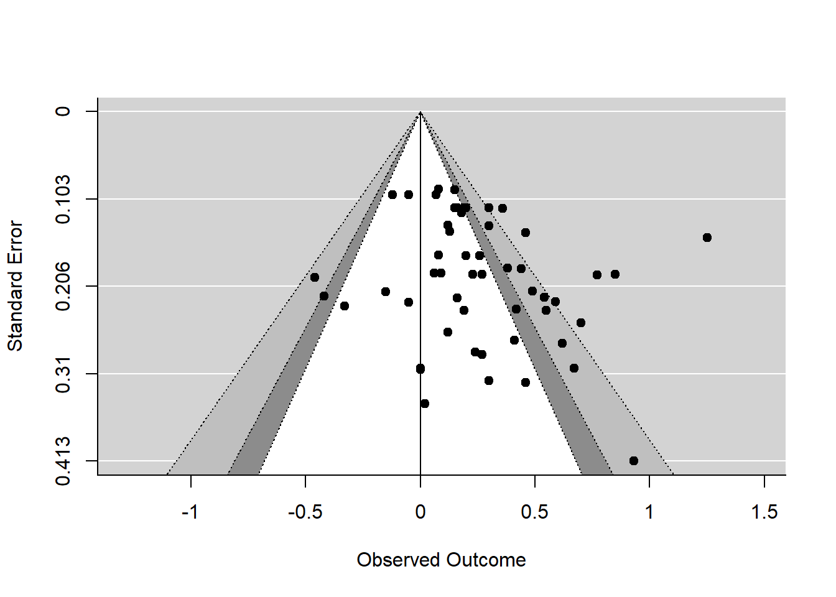
 |  | 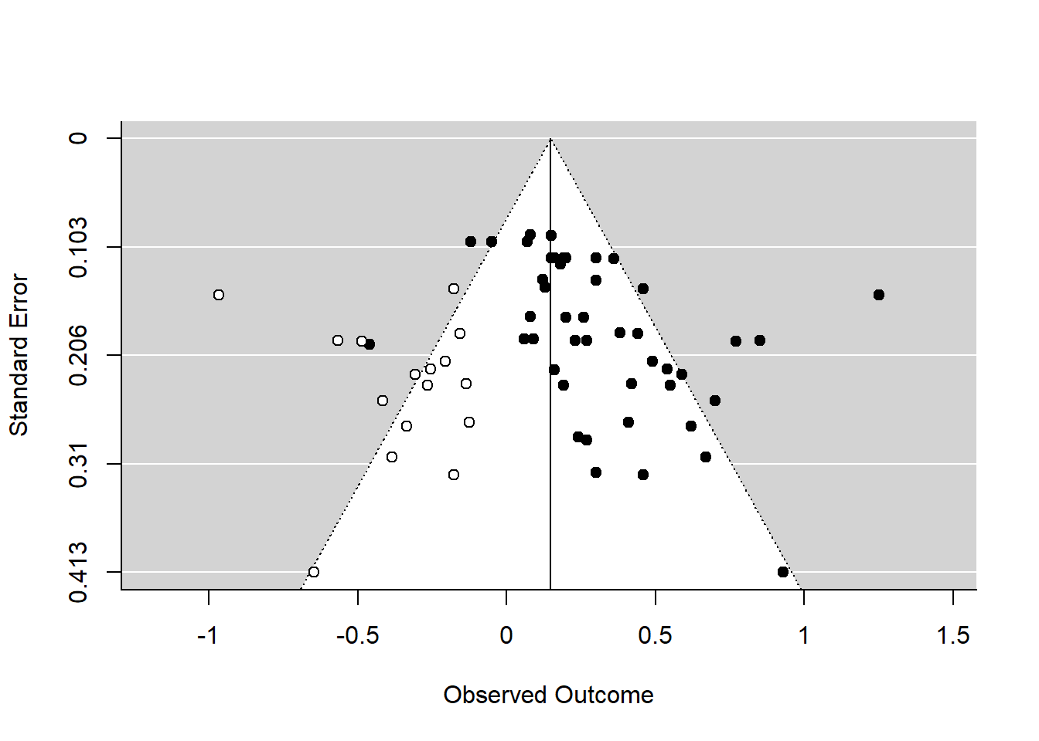
Example funnel plot and funnel plot with imputed missing studies added.
From: https://cjvanlissa.github.io/Doing-Meta-Analysis-in-R/smallstudyeffects.html

 |  | Methodological Overview
 |  | Constructing a funnel plot requires three quantities for each study in the meta-analysis: the effect size estimate (d, r, OR, etc.), its standard error (SE), and optionally the sample size (used as an alternative precision axis). The plot displays effect size on the x-axis and precision (1/SE) or sample size on the y-axis, with each study as a point and a reference line at the pooled effect estimate.
 |  | The Egger test formalizes the asymmetry check:
Standardized effect = a + b × (1/SE)
Where a is the intercept and b is the slope. Under no bias: a = 0.
H₀: a = 0 (symmetric funnel, no bias)
A significant intercept (p < .10 by convention) is taken as evidence of asymmetry.
 |  | Note that the Egger test uses p < .10 as the conventional threshold rather than .05, because it is typically underpowered in small meta-analyses. A non-significant Egger test does not rule out publication bias — it may simply reflect insufficient studies to detect the asymmetry.
 |  | Example: SSRIs and Depression
 |  | Turner et al. (2008, NEJM) used funnel plot inspection alongside registry analysis to demonstrate that the published literature on SSRIs dramatically overstated efficacy. Of 74 FDA-registered trials, 38 with positive results were published; 37 with negative or questionable results were either unpublished or published in a way that conveyed a positive outcome. The funnel plot of published studies was visibly asymmetric. When the unpublished trials were included, the effect size for SSRIs dropped substantially — from a magnitude that appeared clinically meaningful to one that was borderline. This analysis influenced regulatory guidance on pharmaceutical trial reporting.
 |  | Requirements
Effect sizes | The standardized effect size (Cohen's d, correlation r, log odds ratio) and its standard error for each study in the meta-analysis. These are typically available from published papers.
Minimum study count | Funnel plot asymmetry is only interpretable when there are at least 10 studies. Egger's test has very low power below this threshold and should not be reported as a definitive test with fewer than 10–15 studies.
Effect size homogeneity | The funnel plot assumes all studies are estimating the same underlying effect. When genuine heterogeneity exists (different populations, interventions, or outcomes), funnel asymmetry may reflect heterogeneity rather than bias.
No raw data required | The test operates on published summary statistics: effect size and SE per study. Individual-level participant data are not needed.
Contour-enhanced funnel | A useful extension adds contour lines at p = .05, .01, .001 to the funnel plot. If missing studies cluster in non-significant regions, publication bias is a plausible cause; if they cluster in significant regions, heterogeneity is more likely.

Tool B · Trim-and-Fill
Imputing missing studies to restore funnel symmetry and re-estimate the true effect
 |  | Overview
 |  | Trim-and-fill, developed by Sue Duval and Richard Tweedie in 2000, takes funnel plot logic one step further. Rather than simply detecting asymmetry, it estimates how many studies are missing from the publication record and imputes them — mirroring the observed asymmetric studies to restore symmetry — and then re-calculates a bias-corrected pooled effect estimate with these imputed studies included.
 |  | The method gives a concrete answer to the question: 'If all the missing small-N null studies had been published, what would the meta-analytic estimate be?' This makes it one of the most intuitive and widely reported correction methods, though it rests on assumptions that are often violated in practice.
 |  | Methodological Overview
 |  | The algorithm proceeds iteratively in two phases:
 |  | Phase 1 (Trim): Starting with the full set of studies, the method identifies and temporarily removes the most extreme studies on the side of the funnel showing excess (typically the right side, where significant small-N studies cluster). Studies are trimmed iteratively until the funnel is approximately symmetric around the pooled estimate. The number of trimmed studies is the estimated number of missing studies.
 |  | Phase 2 (Fill): Mirror images of the trimmed studies are created on the opposite side of the funnel. These imputed studies, combined with the original studies, produce a symmetric funnel. The pooled effect is then re-estimated using all studies — real and imputed.
k₀ = estimated number of missing studies
Estimated from the number of studies that must be trimmed to achieve funnel symmetry.
δ_adjusted = pooled effect with k₀ imputed studies added
The bias-corrected estimate. The difference between δ_adjusted and the original estimate quantifies the impact of publication bias.
 |  | The R₀ estimator (Duval & Tweedie 2000) and the L₀ estimator are the two most common variants; they differ in how they locate the center of the funnel. Results can differ meaningfully between estimators, so sensitivity analyses should report both.
 |  | Example: Antidepressants and Placebos
 |  | Kirsch et al. (2008) applied trim-and-fill alongside registry data in their influential analysis of SSRI versus placebo effect sizes. Trim-and-fill indicated that several small-N null studies were likely missing from the published record. When these studies were imputed, the bias-corrected effect size for antidepressants fell below the NICE clinical significance threshold for all but the most severely depressed patients. The analysis triggered a public debate about the clinical utility of SSRIs for mild-to-moderate depression and subsequently influenced prescribing guidelines in the US and UK.
 |  | Requirements
Published effect sizes and SEs | As with the funnel plot, trim-and-fill requires only the summary statistics (effect size, SE) from each included study — no individual-level data needed.
Sufficient number of studies | The algorithm is unreliable with fewer than 10 studies and should not be applied below this threshold. With very few studies, the trim-and-fill estimate is highly sensitive to the choice of estimator variant.
Symmetric bias assumption | The method assumes that missing studies are exact mirror images of the asymmetric observed studies — a strong assumption rarely fully satisfied. In heterogeneous literatures, trimmed studies may differ qualitatively, not just directionally.
Homogeneous true effect | Trim-and-fill was derived under a fixed-effect model assumption. Under genuine heterogeneity, the method may over-correct (imputing studies that do not exist) or under-correct, and the bias-corrected estimate should be interpreted cautiously.
Complement, not replace | Trim-and-fill results are most credible when they converge with other methods (Egger test, PET-PEESE). Divergent results across methods signal model sensitivity and should prompt explicit sensitivity analysis.

Tool C · PET-PEESE
Regression-based separation of true effect signal from precision-dependent bias
 |  | Overview
 |  | PET-PEESE (Precision Effect Test – Precision Effect Estimate with Standard Error) is a meta-regression approach developed by Tom Stanley and colleagues that takes a fundamentally different view of publication bias. Rather than trying to identify missing studies and impute them, it models the mathematical relationship between an effect size and its standard error across all published studies, and uses that model to extrapolate what the effect size would be at infinite precision — that is, what signal remains after the bias is removed.
 |  | The key insight is that publication bias creates a predictable correlation between effect size and standard error: studies with large standard errors (small samples, imprecise) tend to report larger effects, because small imprecise studies only make it into print when they happen to find something large. PET-PEESE models this correlation and uses it to estimate the bias-free effect.
 |  | Methodological Overview
 |  | The method proceeds in two sequential steps:
 |  | Step 1 — PET (Precision Effect Test): Regress the effect size on the standard error with study-level weights (1/SE²). Test whether the intercept — the predicted effect size when SE = 0, i.e., at infinite sample size — is significantly different from zero.
Effect size = β₀ + β₁ × SE + ε
Under publication bias: β₁ > 0 (larger SE → larger reported effect). Under no bias: β₁ = 0.
H₀: β₀ = 0 (the true effect is zero after correcting for bias)
If PET fails to reject H₀, the literature may be entirely explained by bias. If it rejects, proceed to PEESE.
 |  | Step 2 — PEESE (Precision Effect Estimate with Standard Error): If PET rejects the null (suggesting a non-zero true effect exists), switch to a model that regresses effect size on SE² rather than SE. This provides a less biased estimate of the true effect size, because squaring the SE reduces the leverage of the most extreme outliers.
Effect size = β₀ + β₁ × SE² + ε
The intercept β₀ is the PEESE estimate of the true effect — the predicted effect at SE = 0.
 |  | The two-step logic is important: if PET suggests zero true effect, reporting the PEESE estimate can be misleading (because PEESE extrapolates assuming a non-zero effect exists). PET acts as a gatekeeper.
 |  | Example: Ego Depletion
 |  | Carter et al. (2015) applied PET-PEESE to the ego depletion literature — the highly influential finding that acts of self-control deplete a limited mental resource, making subsequent self-control harder. The published meta-analytic effect size was d ≈ 0.62. PET found a significant relationship between effect size and SE, indicating bias. The PEESE-corrected estimate was d ≈ 0.24 — less than half the published estimate. A subsequent pre-registered multi-lab replication (Hagger et al., 2016, 23 labs) found d ≈ 0.04, essentially zero. The PET-PEESE estimate, while not perfectly accurate, correctly identified that the published literature dramatically overstated the true effect.
 |  | Requirements
Effect sizes and SEs | Published effect sizes and standard errors for each study in the meta-analysis. Unlike trim-and-fill, PET-PEESE is also valid under heterogeneous random-effects models if the between-study variance is accounted for in the weights.
Minimum study count | Reliable regression requires at least 20–30 studies. With fewer studies, the regression is unstable and the intercept estimate has very wide confidence intervals.
No floor/ceiling effects | PET-PEESE assumes an approximately linear relationship between effect size and SE (PET) or SE² (PEESE). This assumption can break down at extreme precision values or when effect sizes are bounded (e.g., proportions near 0 or 1).
Domain knowledge | The two-step PET → PEESE decision rule requires the analyst to correctly judge whether PET's rejection of H₀ reflects a real effect or is itself a product of model misspecification. Context matters.
No individual-level data | Operates entirely on published summary statistics. This makes it among the most accessible post-publication bias checks.

Tool D · Excess Significance Test (TES)
Comparing the observed rate of significant findings to what statistical power would predict
 |  | Overview
 |  | The Excess Significance Test (TES), developed by John Ioannidis and Thomas Trikalinos in 2007, approaches publication bias from an entirely different angle. Instead of examining the distribution of effect sizes, it examines the rate of statistical significance across a literature and asks: given the sample sizes and effect sizes in these studies, how many of them should have been statistically significant, if the underlying effect is real and the studies are conducted properly? If the observed number of significant results far exceeds what power calculations would predict, something is wrong — either the studies are p-hacked, or publication bias has suppressed the null results.
 |  | Methodological Overview
 |  | The test estimates the expected power of each study under a specific assumed true effect size (typically the pooled estimate from the meta-analysis, or a minimum clinically important difference). It then calculates the expected number of significant results given those power values, and compares that to the observed number using a chi-squared or binomial test.
E = Σᵢ πᵢ
Expected number of significant findings, where πᵢ is the estimated power of study i.
O = observed number of significant findings in the literature
Test: O >> E → excess significance detected
A formal χ² test compares O to E. Significant excess implies p-hacking, publication bias, or both.
 |  | The critical assumption is the choice of true effect size used to estimate power. Ioannidis and Trikalinos recommend using the effect size from the largest and most precise study in the literature (rather than the inflated pooled estimate), as this provides a less biased benchmark. Sensitivity analyses across a range of assumed true effects are strongly recommended.
 |  | Example: Genetic Associations in Epidemiology
 |  | Ioannidis and Trikalinos first applied TES to a set of genetic association studies for common diseases — a field notorious for non-replication. Across multiple meta-analyses, they found that the number of statistically significant findings was several times higher than what the observed power of the individual studies would predict. For example, in a set of 25 studies on a particular gene-disease association, the expected number of significant results (given the observed effect size and sample sizes) was approximately 7, but 19 of the 25 studies reported significance. This excess was consistent with either systematic p-hacking within studies or severe publication suppression of null results — likely both.
 |  | TES has since been applied to neuroimaging, nutrition, psychology, and economics. Šimkus et al. (2023) found substantial excess significance in prominent criminology literatures. Tenkanen et al. (2023) found it pervasive in dietary intervention trials.
 |  | Requirements
Effect sizes and SEs / sample sizes | To estimate power for each study, you need either the SE (from which approximate power can be calculated given an assumed true effect) or the raw sample size and design details.
Assumed true effect size | The test requires a benchmark true effect. Options: (1) the effect size from the single largest study; (2) the meta-analytic estimate; (3) a minimum clinically important difference. Each yields different power estimates, so sensitivity analysis across assumptions is essential.
Statistical significance decisions | You need the reported p-value or significance status (p < .05 or not) for each study. The test counts the number of studies that crossed the threshold.
Homogeneous outcome | TES works best when all studies are testing the same directional hypothesis. Mixed literatures with different outcomes or different effect directions make the expected count hard to interpret.
No individual-level data | Operates entirely on published summary statistics and significance thresholds. This makes it applicable to any meta-analytic dataset.

 |  | 4. Shared Limitations & When to Use Each
 |  | All four methods share a fundamental constraint: they infer the shape of an unobserved distribution from a biased visible sample. This means their conclusions are probabilistic and assumption-dependent, not definitive. Several specific limitations apply across the set:
 |  | • Heterogeneity confounds asymmetry. When true effects genuinely vary across studies (different populations, interventions, or contexts), small-study effects that mimic publication bias can arise even without any bias at all. A small study conducted in a high-effect subpopulation will look like a publication-biased small study with a large effect. All four methods struggle to distinguish genuine heterogeneity from bias-driven asymmetry.
 |  | • Power is low in small meta-analyses. Egger's test, trim-and-fill, and PET-PEESE are unreliable with fewer than 10–15 studies. TES requires enough studies to make a meaningful comparison between O and E. Null results from small meta-analyses should not be taken as evidence of no bias.
 |  | • The methods frequently disagree. It is common for trim-and-fill to indicate substantial bias while PET suggests a non-zero effect, or for TES to detect excess significance while Egger's test is non-significant. Analysts should report all four, acknowledge the divergence, and avoid cherry-picking the method that supports their preferred conclusion.
 |  | • None can recover the true effect with certainty. These methods estimate how much the literature is distorted; they do not directly observe the missing studies. The bias-corrected estimates from trim-and-fill and PEESE are themselves uncertain and model-dependent — they are better understood as lower bounds on the true effect than as precise corrections.
When to use which
Funnel plot + Egger: always, as a first visual and inferential screen. Trim-and-fill: when you need a bias-corrected effect estimate and the literature is reasonably homogeneous. PET-PEESE: when you have ≥ 20 studies and want a regression-based correction, especially in economics or psychology. TES: when you want to test whether the rate of significant findings itself is implausibly high given the studies' power.
 |  | 5. Related Tools
p-curve | Examines the distribution of p-values within the significant range (0–.05) rather than comparing observed to expected significance rates. Right-skew indicates true signal; flat or left-skew indicates p-hacking. Complements TES by diagnosing within-study flexibility rather than between-study publication suppression.
z-curve 2.0 | Estimates the expected replication rate and discovery rate from the distribution of all test statistics, significant and non-significant. Provides a field-level summary of evidential value that situates individual meta-analyses within the broader literature.
Multiverse / Specification Curve | If raw data are available, these tools can quantify how the meta-analytic pooled effect itself varies across defensible inclusion and coding decisions — a higher-level form of publication bias correction.
Registered Reports | The prospective remedy: publishing a commitment to report results regardless of outcome removes publication bias at the source, eliminating the need for post-hoc correction.

 |  | Key Citations
 |  | Egger, M., Smith, G. D., Schneider, M., & Minder, C. (1997). Bias in meta-analysis detected by a simple, graphical test. BMJ, 315(7109), 629–634. https://doi.org/10.1136/bmj.315.7109.629
 |  | Duval, S. & Tweedie, R. (2000). Trim and fill: A simple funnel-plot–based method of testing and adjusting for publication bias in meta-analysis. Biometrics, 56(2), 455–463. https://doi.org/10.1111/j.0006-341X.2000.00455.x
 |  | Stanley, T. D. & Doucouliagos, H. (2014). Meta-regression approximations to reduce publication selection bias. Research Synthesis Methods, 5(1), 60–78. https://doi.org/10.1002/jrsm.1095
 |  | Ioannidis, J. P. A. & Trikalinos, T. A. (2007). An exploratory test for an excess of significant findings. Clinical Trials, 4(3), 245–253. https://doi.org/10.1177/1740774507079441
 |  | Turner, E. H., Matthews, A. M., Linardatos, E., Tell, R. A., & Rosenthal, R. (2008). Selective publication of antidepressant trials and its influence on apparent efficacy. New England Journal of Medicine, 358(3), 252–260. https://doi.org/10.1056/NEJMsa065779
 |  | Carter, E. C., Kofler, L. M., Forster, D. E., & McCullough, M. E. (2015). A series of meta-analytic tests of the depletion effect: Self-control does not seem to rely on a limited resource. Journal of Experimental Psychology: General, 144(4), 796–815. https://doi.org/10.1037/xge0000083
 |  | Kirsch, I., Deacon, B. J., Huedo-Medina, T. B., Scoboria, A., Moore, T. J., & Johnson, B. T. (2008). Initial severity and antidepressant benefits: A meta-analysis of data submitted to the Food and Drug Administration. PLOS Medicine, 5(2), e45. https://doi.org/10.1371/journal.pmed.0050045
 |  | Stanley, T. D. (2017). Limitations of PET-PEESE and other meta-regression methods. Social Psychological and Personality Science, 8(5), 581–591. https://doi.org/10.1177/1948550617693062
 |  | Light, R. J. & Pillemer, D. B. (1984). Summing up: The science of reviewing research. Harvard University Press.
Research Integrity Framework · Detection Tool Guide Series · Graduate Seminar

