CPP 524: Prog Eval II
Prof. Jesse Lecy

Lab 01 – Counterfactual Reasoning with RCTs

Submit answers via Canvas

Provide answers to the questions below after reading Chapter 5 from:
Bingham, R., & Felbinger, C. (2002). Evaluation in practice: A methodological approach. CQ Press.
CH-05: Improving Cognitive Ability in Chronically Deprived Children [pdf]

Question 1:
How would you describe the treatment in this study? Be specific about the activities and “dosage”.

Question 2:
What primary outcome was measured in this impact study (p67)? Is this a latent construct, and why?
Many variables studied by psychologists are straightforward and simple to measure. These include sex, age, height, weight, and birth order. Age is measured as days since birth. Weight can be measured with a scale. Other variables studied by psychologists—perhaps the majority—are not so straightforward or simple to measure. We cannot accurately assess people’s level of intelligence by looking at them, and we certainly cannot put their self-esteem on a bathroom scale. These kinds of variables are called LATENT CONSTRUCTS and include personality traits (e.g., extraversion), emotional states (e.g., fear), attitudes (e.g., toward taxes), and abilities (e.g., athleticism). We will cover this topic more in week 2.

Question 3:
Explain the theory of change of this study.

Question 4:
What is the population of the study? Is this a unique group, or is it a specific instance of a more general population that the program hopes to reach? Asked differently, are the results generalizable?

Question 5:
The research design in the study includes six groups: T0 T1 T2 T3 T4 HS
Which group is the treatment group? Which group is the control group?
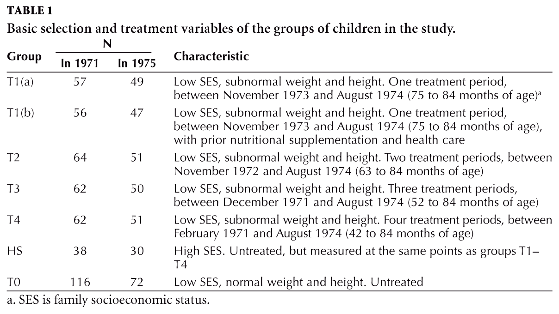

Question 6:
Is this a pure RCT? Did the study randomly assign all study participants to groups T0 through T4? How were students assigned?

Question 7:
Based upon Table 2, would you argue that randomization was “happy” or successful in this study? How can you tell?
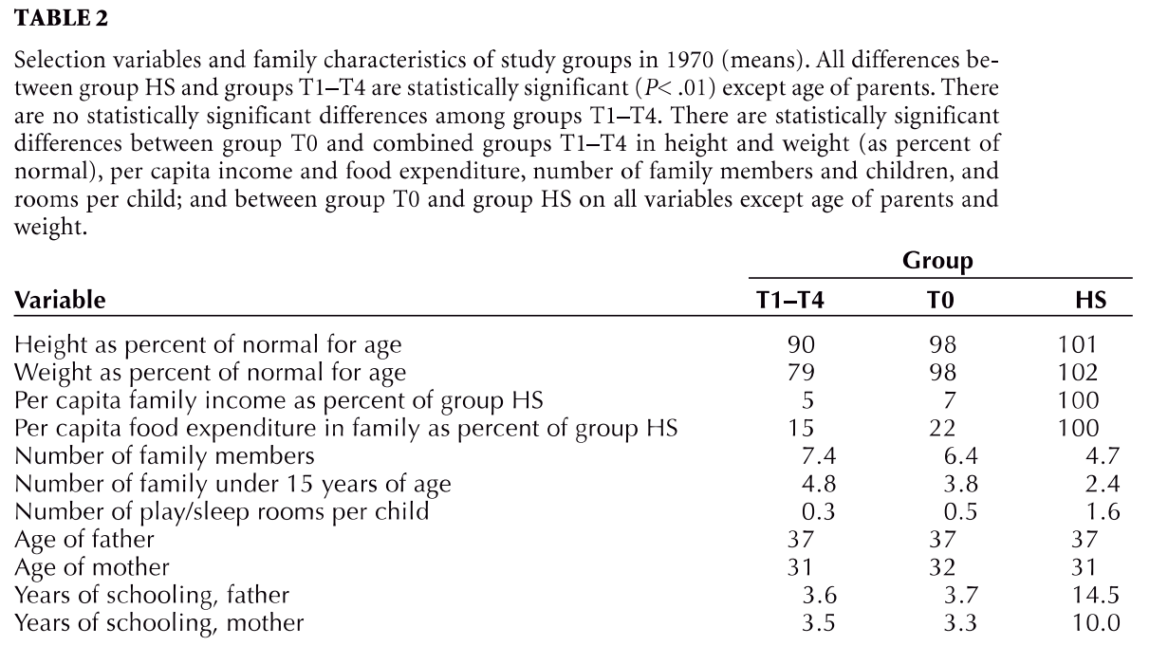

Question 8:
What is the time period (length) of the treatment? This may vary by group.
How is the length of treatment different from the dosage? Could you double the dosage and cut the treatment period in half?

Question 9:
What is the time-frame for the study? Treatment length measures duration of active participation in the program. Study length can include pre-treatment and post-treatment periods of observation.

Question 10:
If we are looking at the end of the second time period in the study (Nov 1972) how would we interpret the impact of the program? What is our treatment group, and what is our control group?
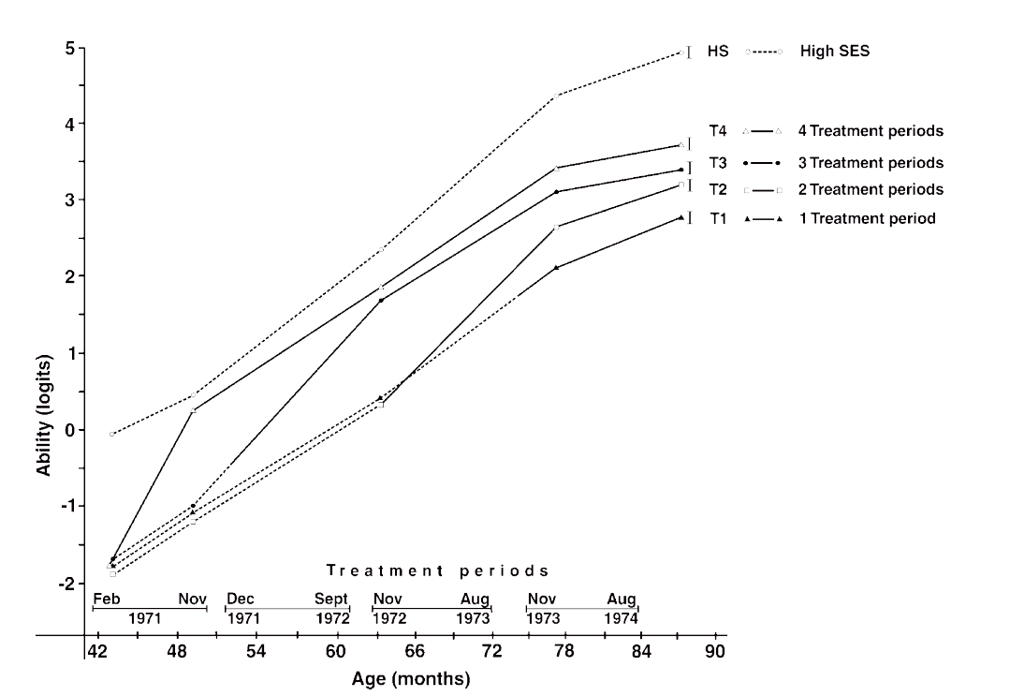

Question 11:
Was there attrition within the study? Did it differ between study groups?

Question 12:
You have 60 seconds (one paragraph) to give an elevator pitch to a donor that is interested in funding a pilot study of this program in the United States. As clearly and succinctly as possible, describe the proposed program model and include details about what you think make this program unique to distinguish it from other early childhood education program models they could fund. Include details on the population it will serve (assume it will be analogous to the population in the study but the equivalent in the US context), and the impact you believe the program will achieve. This question is to see if you can synthesize dense program information and explain it in simple terms to another.

