Regression Review Self-Test

- What do variance and standard deviation represent?
- What is a sampling distribution?
- What is the difference between the standard deviation and standard error?
- What role does the standard error play in the confidence interval?
CI = b +/- (SE_{b})(t-value)
- What are the definitions of covariance and correlation?
- What does it mean to say that a regression line is a conditional average?
- Explain the “intuitive” regression slope as an input, output function.
Slope = cov(x,y) / var(x)

- How does the regression line split the variance of Y into the explained and unexplained portion?
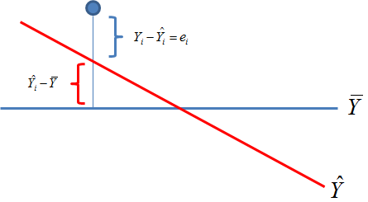
- What are the three parts of the standard error of the slope?
$${SE}_{b}=\sqrt{\frac{residual}{sampSize∙var\left(x\right)}}$$

Looking Ahead:

- In program evaluation, what does it mean to say that a regression slope is an input-output function? What is the input, and what is the output in this metaphor?

- We have two types of treatments – binary (you either do or do not receive the treatment) and levels (subjects receive different dosages).
  - What does the regression coefficient represent if subjects receive different dosages?
  - What does the regression coefficient represent if subjects are in treatment or control groups?

- What is the null hypothesis in every regression model?

- The “p” in p-value stands for “probability”. The probability of what?

- What does it mean for program impact (the slope) to be statistically significant? How do we interpret the case when it is NOT statistically significant?

- What are two ways that omitted variable bias can make a slope appear statistically significant when it is not?

