CPP 523: Foundations of Program Evaluation I

Lab #1

Type out your responses (show your work) and submit via Canvas.
Name your file Lab-##-LastName.doc.

In this assignment you will be working with a very small data set. You need to build a regression from the ground up. Read pages 9-25 in the Lewis-Beck text, Applied Regression, posted on the course website to review basic regression formulas.

I want you to focus on your understanding of the regression error term (often called the “residual”). Can you have an error term without first having a regression line?
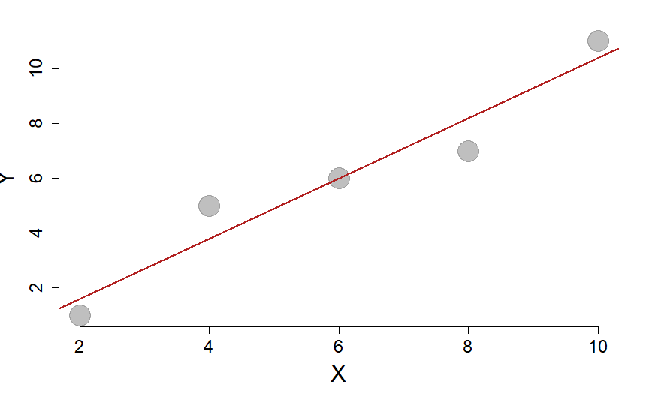

X | Y |  | e | e²
2 | 1
4 | 5
6 | 6
8 | 7
10 | 11
Mean=6 | Mean=6 | Mean=6 | Sum=0 | Sum=

Regression model:

var(x): 10
var(y): 13
cov(x,y): 11

(1) Calculate b₁ using the knowledge the slope can be calculated as cov(x,y) / var(x).

(2) Interpret the coefficient b₁ in plain English.

(3) Calculate b₀ (recall that )

(4) What is the predicted value of Y when X has a value of 14?

(5) Calculate the sum of the squared errors (see page Lewis-Beck, p14) by completing the table above.

(6) Calculate the regression sum of squares (Lewis-Beck p21). You can check your work for questions 5-6 against the ANOVA table below.

(7) Calculate the R² using the sum of squares in the table.

Analysis of Variance Table
 | Df | Sum Sq | Mean Sq | F value | Pr(>F)
x | 1 | 48.4 | 48.4 | 40.33 | 0.007898
Residuals | 3 | 3.6 | 1.2 | NA | NA

