**House Decor System**

Instructor: Than Thi Ngoc Van

Cao Duc Son Ngoc – Le Dai An

FPT University. Software Engineering

Ho Chi Minh city, Viet Nam

Email: ngoccdsse61116@fpt.edu.vn; ledaian41@gmail.com

**Abstract**

We build the system to support customer to find home building services and home products with high quality and reasonable price. Our system also support supplier to sell more products and have more customer use services. For that reason, we create a website that achieve their requirements.

In order to satisfy customer’s demand, we help them create idea books, buy products.

Customer can also make a review about the suppliers.

For supplier, the system helps suppliers manage their online shop, their projects had built and notify suppliers about orders.

# **INTRODUCTION**

House is very important to everyone. In order to have a house as your wish, you will search for home services. So far, people select home service providers often through referrals of friends or relatives. This leaves the user with limited choice and more difficult in finding reliable service providers. On the service provider side, they are also limited in introducing their package services or products.

As a result, we built a system that helps people find the home service provider easier and the service provider will have more customers.

- The supplier of interior and exterior products has many, but the introduction of online products is limited because it costs to build and maintain a website.

- The problems of housing and the way of thinking in Vietnam are always carefully selected and specific authentication (for example: ask people who have just built houses, neighbors or find relatives). Private Websites are rarely found unless they are big, reputable companies.

- Customer services usually work in groups including contractors, builders, painters, electrician water. The customer only needs minor repairs, it is difficult to find the painters, electricians, service clean the house…

# **PROBLEM AND SOLUTION PLAN**

- In Vietnam, there aren’t any home building services website.

- Cost to build and maintain a website is an issue that many suppliers can’t introduce their products and services online.

Our proposed solution is to build a website online furniture retailer:

- Provide information and sell seller’s products.

- Support to search for service providers: interior design, exterior, construction contractor, home repair services.

- It also supports users to upload designs, share ideas, stories related to the exterior and interior.

# **PLAN IMPLEMENTATION**

System architectural design:

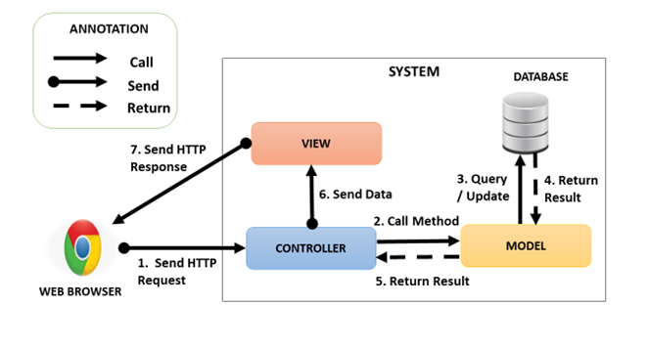

Component diagram:

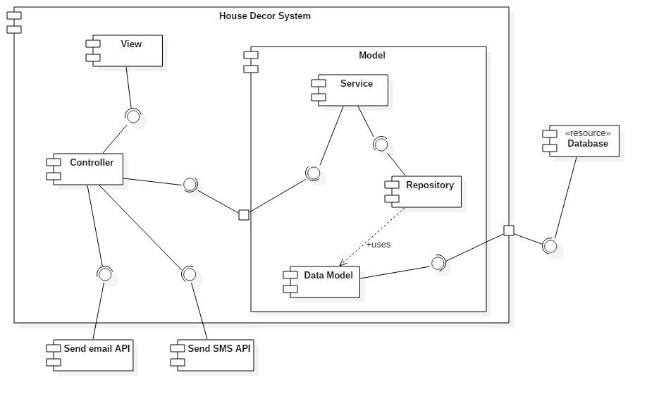

The algorithms are applied to solve the problems:

**-** Approve an idea book: (parameter: Idea book Id)

Load all photos of the idea book by idea book id in “Idea Book Photo” table

For all photos in photo list

If photo’s status is waiting for approval then

Output: Error message

End for

End if

End for

Load the idea book by idea book id

Update idea book’s status to approve.

**-** Tracking: (parameters: user Id, category Id)

Load tracking by user Id and category Id

If tracking is existed then

Update this tracking

Else

Create new tracking

Save new tracking to Database

End if

Load tracking is out of date by user Id

If exist tracking is out of date then

Remove tracking out of date

End if.

**-** Send promotion emails: (parameter: product Id)

Load product by product Id

Load category Id of product

Use category Id to find users matched with in “Tracking” table

If users are not empty then

Load emails of founded users.

Send promotion email to users

End if.

# **ANALYSIS**

In the previous sections, we described system architectural design and algorithm. In this section, we are going to introduce advantages and disadvantages of these ones. Firstly, we’ll analyze benefits and limitation of using MVC architectural. Here are benefits of using MVC:

- Many MVC vendor framework toolkits are available.

- Multiple views synchronized with same data model. - Easy to change or plug in new interface views, allowing updating of interface views with new technologies without overhauling the rest of the system.

- Very effective for developments if graphics, programming, and database development professionals are working in a team in a designed project.

Limitations of using MVC:

- Not suitable for agent-oriented applications such as interactive mobile and robotics applications.

- Multiple pairs of controllers and views based on the same data model make any data model change expensive.

- The division between the View and the Controller is not clear in some cases.

Secondly, we’ll analyze advantage and disadvantage of using “Full-text search” algorithm.

Here are advantages:

- Indexing: full-text indexes can offer a lot more flexibility in terms of matching words, how close those words works together.

- Weighted result: A full-text index can encompass multiple columns. For example, you can search for “table ZA16”, and the index can include a title, keywords, and a body. Results that match the title can be weighted higher, as more relevant, and can be sorted to show near the top.

Disadvantages of using this algorithm:

- Index can potentially be huge. For this reason, many hosted providers who offer database instances disable this feature, or at least charge extra for it.

- Full-text indexes can also be slower to update. If the data changes a lot, there might be some lag updating indexes compared to standard indexes.

# **EXPERIMENTAL RESULTS AND CONCLUSIOn**

There are features be tested:

Guest: login, add product to shopping cart. (PASS: 8/9 test cases)

Member: check out order, create an idea book, add photo to idea book. (PASS: 10/13 test cases)

Professional: create a project, add photo to project. (PASS: 12/16 test cases)

Seller: create a product. (PASS: 11/12 test cases)

Admin: activate/deactivate an account, approve a photo in idea book, approve an idea book, and approve a product. (PASS: 11/12 test cases)

System: send notification to seller, send promotion to customer. (PASS: 3/3 test cases)

## **ACKNOWLEDGMENT**

We thank Than Thi Ngoc Van for help with the software. We thank the referees of this and the earlier conference version for several suggestions that helped improve the presentation signiﬁcantly.

## **REFERENCES**

*[1] FPT University, E-Commerce Subject, “Introduction to E-Commerce and E-Marketplace”.*

*[2] https://javaee.github.io/javamail/*