# Report 3 - Software Requirement Specification

## User Requirement Specification

### Guest Requirement

Guest are those do not login to this system. They have some functions:

* View photo
* View product
* Search product
* Search professional
* View other Profile
* View Project
* View Idea Book
* Sign up
* Sign in
* Manage shopping cart

### Member Requirement

They can use some following functions:

* Sign out
* Edit Profile
* View photo
* View product
* Search product
* Search professional
* View other profile
* View project
* View idea book
* Send an order
* Create idea book
* Edit idea book
* Delete idea book
* Add photo to idea book
* Delete photo in idea book
* Order

### Professional Requirement

Professional, who is professional in house-building service. They provide house services or sell house products (like desk, chain, table, bed…). They can use some following functions:

* Manage projects:
  + - * Create new project.
      * View project detail.
      * Edit project.
      * Delete project.
      * Add photo to project.
      * Delete photo from project.
* Seller register.
* Manage store:

### Admin Requirement

Admin, who is responsible for managing accounts, products, projects, idea books, photos, sellers for the whole system, has the following function:

* Manage accounts:
  + - * View account list.
      * Search accounts.
      * View account’s detail.
      * Deactivate account.
      * Activate account.
* Manage products:
* View products.
* Search products.
* View product’s detail.
* Accept product.
* Block product.
* Manage idea books:
* View idea books.
* Search idea books.
* View idea book’s detail.
* Approve idea books.
* Accept photo in idea book.
* Block photo in idea book.
* Manage projects:
* View projects.
* Search projects.
* View project’s detail.
* Approve projects.
* Accept photo in project.
* Block photo in project.
* Manage sellers:
* View seller’s detail
* Update sale time

### System Requirement

System, which automatically runs some following functions:

* Send order to seller by email
* Add tracking
* Remove tracking
* Update quantity of product
* Send promotion to Customers
* Send notification to User:

• Admin: have new product, image need accept

* User and Professional: their product or image has been proceed.

## System Requirement Specification



### External Interface Requirement

#### User Interface

* The user interface uses Vietnamese language for web application.
* General requirement for graphics user interface is the GUI should be simple, clear, intuitive, and reminiscent.

#### Hardware Interface

#### Software Interface

* Web application work with Firefox (v30 or above), Chrome (v14 or above), Internet Explorer (v10 or above).

#### Communication Protocol

* Use HTTP to communicate between the web browser and the web server.

### System Overview Use Case

(Figure 1 : <Use case> System overview)

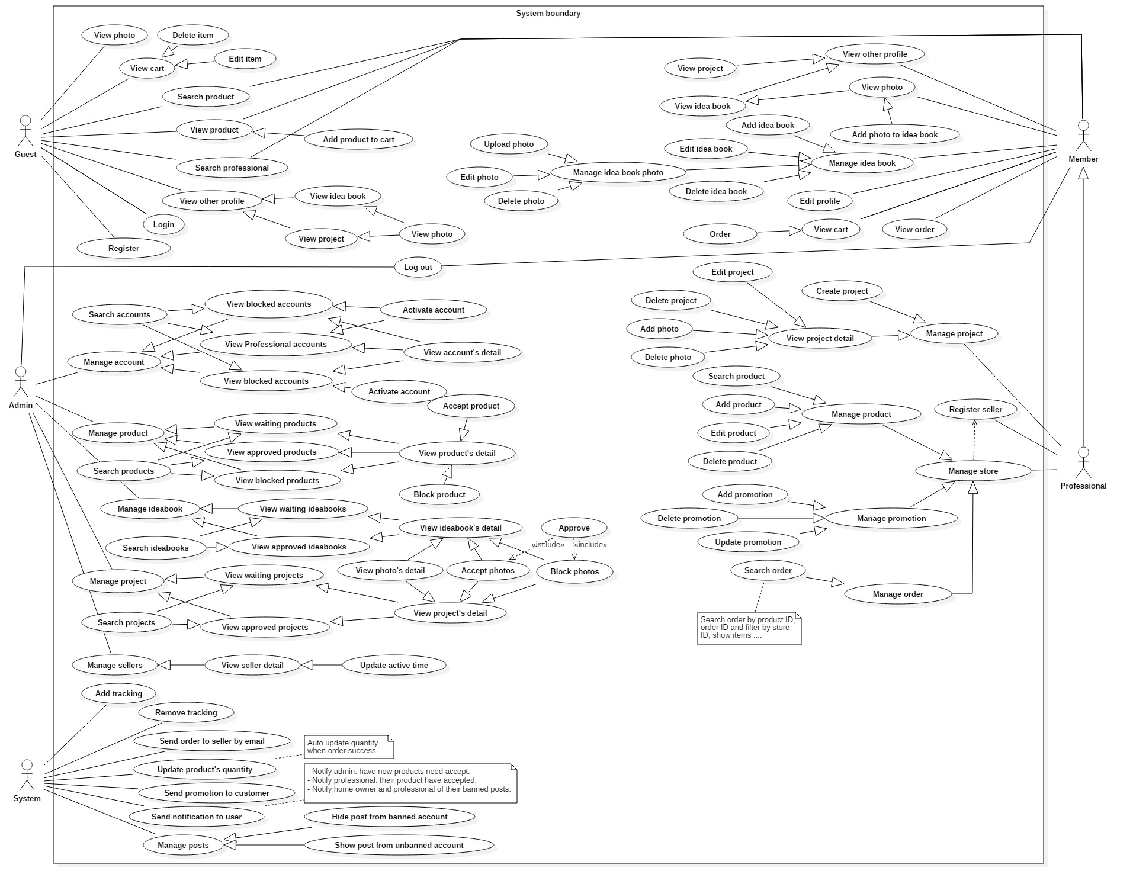



### List of Use Case

#### 2.3.1 Guest

##### < Guest > Overview use case

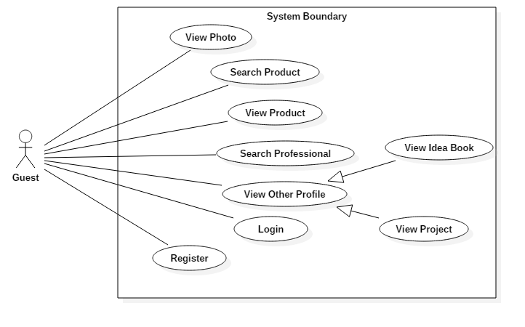

Figure 2: <Guest> Overview Use Case

##### < Guest > View Photo

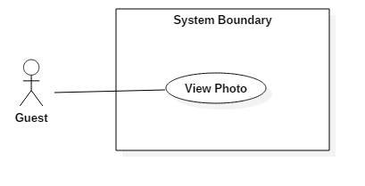

Figure 3: <Guest> View Photo

|  |  |  |  |
| --- | --- | --- | --- |
| **USE CASE – 1.1** | | | |
| **Use Case No.** | 1.1 | **Use Case Version** | 1.0 |
| **Use Case Name** | View Photo | | |
| **Author** | Cao Đức Sơn Ngọc | | |
| **Date** | May 20, 2017 | **Priority** | Normal |
| **Actor:**   * Guest   **Summary:**   * This use case allows a guest to view some photos in the project.   **Goal:**   * The lists of photos in the system are displayed -> **The lists of photos (images) is displayed in the system**   **Triggers:**  Guest clicks on “ảnh” tab.  **Preconditions:** N/A  **Post Conditions:**   * **Success:** Guest views photos in system -> Guest views images in system * **Fail:** N/A   **Main Success Scenario:**   |  |  |  | | --- | --- | --- | | Step | Actor Action | System Response | | 1 | Guest clicks on “ảnh” tab. | System loads the result. Information for each photo:   * Photo * Name Project has this photo * Professional post this photo -> **Professional posts this photo**   [Exception 1]: Internet connection is lost |   **Alternative Scenario:**   |  |  |  | | --- | --- | --- | | No. | Actor Action **(action actor)** | System Response (respond system) | | 1 | |  |  |   **Exception:** N/A  **Relationships:** N/A  **Business Rules: N/A** | | | |

##### < Guest > Search Product

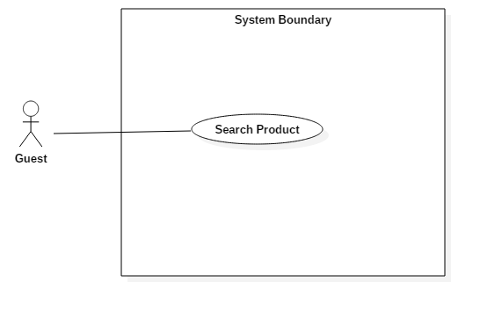

Figure 4: <Guest> Search Product

|  |  |  |  |
| --- | --- | --- | --- |
| **USE CASE – 1.2** | | | |
| **Use Case No.** | 1.2 | **Use Case Version** | 1.0 |
| **Use Case Name** | Search Product | | |
| **Author** | Cao Đức Sơn Ngọc | | |
| **Date** | May 20, 2017 | **Priority** | Normal |
| **Actor:**   * Guest   **Summary:**   * This use case allows a guest to search **for** products. **Bỏ For**   **Goal:**   * The list of products is displayed , with the search keyword. -> **displayed searches keyword**   **Triggers:**  **Guest inputs data into the search box to find the product and press “Enter”.**  **Preconditions:** N/A  **Post Conditions:**   * **Success:** Guest view**s** list product the same keyword. * **Fail:** N/A   **Main Success Scenario:**   |  |  |  | | --- | --- | --- | | Step | Actor Action **(action actor)** | System Response **(response system)** | | 1 | ~~Guest input information to search in search product input and “Enter”.~~ -> **Guest inputs data into the search box to find the product and press “Enter”.** | System loads the result. Information for each product:   * Product * Price * Seller post**s** product   [Exception 1]: Internet connection is lost |   **Alternative Scenario:**   |  |  |  | | --- | --- | --- | | No. | Actor Action | System Response | | 1 | |  |  |   **Exception:** N/A  **Relationships:** N/A  **Business Rules: N/A** | | | |

##### < Guest > View Product

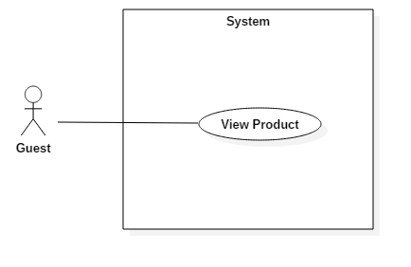

Figure 5: <Guest> View Product

|  |  |  |  |
| --- | --- | --- | --- |
| **USE CASE – 1.3** | | | |
| **Use Case No.** | 1.3 | **Use Case Version** | 1.0 |
| **Use Case Name** | View Product | | |
| **Author** | Cao Đức Sơn Ngọc | | |
| **Date** | May 20, 2017 | **Priority** | Normal |
| **Actor:**   * Guest   **Summary:**   * This use case allows guest to view product in project.   **Goal:**   * The list of product in the system is displayed -> The list of producing is displayed in the system   **Triggers:**  Guest clicks on “Sản phẩm” tab.  **Preconditions:** N/A  **Post Conditions:**   * **Success:** Guest view**s** product in system * **Fail:** N/A   **Main Success Scenario:**   |  |  |  | | --- | --- | --- | | Step | Actor Action | System Response | | 1 | Guest clicks on “Sản phẩm” tab. | System loads the result. Information for each product:   * Product * Price * Seller post**s** product   [Exception 1]: Internet connection is lost |   **Alternative Scenario:**   |  |  |  | | --- | --- | --- | | No. | Actor Action | System Response | | 1 | |  |  |   **Exception:** N/A  **Relationships:** N/A  **Business Rules: N/A** | | | |

##### < Guest > Search Professional

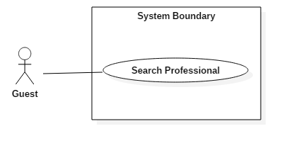

Figure 6: <Guest> Search Professional

|  |  |  |  |
| --- | --- | --- | --- |
| **USE CASE – 1.4** | | | |
| **Use Case No.** | 1.4 | **Use Case Version** | 1.0 |
| **Use Case Name** | Search Professional | | |
| **Author** | Cao Đức Sơn Ngọc | | |
| **Date** | May 20, 2017 | **Priority** | Normal |
| **Actor:**   * Guest   **Summary:**   * This use case allows guest to search for professional.   .  **Goal:**   * Guest search**es** Professional in the system.   **Triggers**  Guest clicks on “Sign in” tab.  **Preconditions:** N/A  **Post Conditions:**   * **Success:** Guest found professional. * **Fail:** N/A   **Main Success Scenario:**   |  |  |  | | --- | --- | --- | | Step | Actor Action | System Response | | 1 | Guest clicks on “Tìm Nhà Thiết Kế” tab. | System loads the page search professional.  . | | 2 | Guest input information to search and click button “ Tìm Kiếm” | System loads the result. Information for each professional:   * Name professional * About professional * ~~Number phone of~~ Phone number of professional * Address of professional -> **Professional Address** |   **Alternative Scenario:**   |  |  |  | | --- | --- | --- | | No. | Actor Action | System Response | | 1 | |  |  |   **Exception:** N/A  **Relationships:** N/A  **Business Rules: N/A** | | | |

##### < Guest > View Other Profile

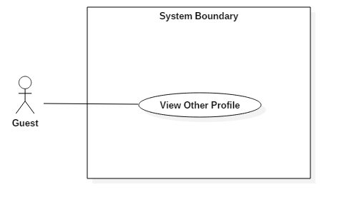

Figure 7: <Guest> View Other Profile

|  |  |  |  |
| --- | --- | --- | --- |
| **USE CASE – 1.5** | | | |
| **Use Case No.** | 1.5 | **Use Case Version** | 1.0 |
| **Use Case Name** | View Other Profile | | |
| **Author** | Cao Đức Sơn Ngọc | | |
| **Date** | May 20, 2017 | **Priority** | Normal |
| **Actor:**   * Guest   **Summary:**   * This use case allows guest to view other profile.   .  **Goal:**   * Guest views profile of member.   **Triggers**  Guest clicks on the member's name.  **Preconditions:** N/A  **Post Conditions:**   * **Success:** Guest views profile of member. * **Fail:** N/A   **Main Success Scenario:**   |  |  |  | | --- | --- | --- | | Step | Actor Action | System Response | | 1 | Guest clicks on the member's name. | System loads the page member’s profile.  . |   **Alternative Scenario:**   |  |  |  | | --- | --- | --- | | No. | Actor Action | System Response | | 1 | |  |  |   **Exception:** N/A  **Relationships:** N/A  **Business Rules: N/A** | | | |

##### < Guest > View Idea Book

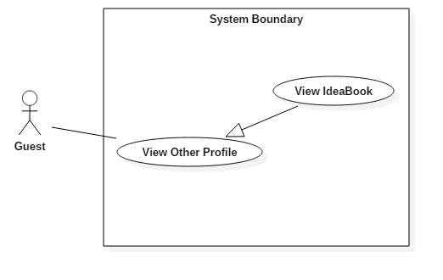 Figure 8: <Guest> View Idea Book

|  |  |  |  |
| --- | --- | --- | --- |
| **USE CASE – 1.6** | | | |
| **Use Case No.** | 1.6 | **Use Case Version** | 1.0 |
| **Use Case Name** | View Idea Book | | |
| **Author** | Cao Đức Sơn Ngọc | | |
| **Date** | May 20, 2017 | **Priority** | Normal |
| **Actor:**   * Guest   **Summary:**   * This use case allows guest to view member’s idea book.   .  **Goal:**   * Guest view idea book of member.   **Triggers**  Guest clicks on the member's name. Then click “Ý Tưởng” tab.  **Preconditions:** N/A  **Post Conditions:**   * **Success:** Guest views list of the idea book. * **Fail:** N/A   **Main Success Scenario:**   |  |  |  | | --- | --- | --- | | Step | Actor Action | System Response | | 1 | Guest clicks on the member's name. | System loads the page member’s profile.  . | | 2 | Guest clicks on “Ý Tưởng” tab. | System loads the result of the list idea book of member. |   **Alternative Scenario:**   |  |  |  | | --- | --- | --- | | No. | Actor Action | System Response | |  | |  |  |   **Exception:** N/A  **Relationships:** N/A  **Business Rules: N/A** | | | |

##### < Guest > View Project

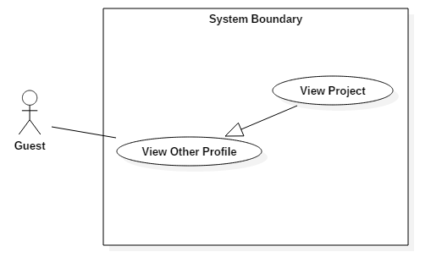 Figure 9: <Guest> View Project

|  |  |  |  |
| --- | --- | --- | --- |
| **USE CASE – 1.7** | | | |
| **Use Case No.** | 1.7 | **Use Case Version** | 1.0 |
| **Use Case Name** | View Project | | |
| **Author** | Cao Đức Sơn Ngọc | | |
| **Date** | May 20, 2017 | **Priority** | Normal |
| **Actor:**   * Guest   **Summary:**   * This use case allows guest to view member’s project.   .  **Goal:**   * Guest views project of member.   **Triggers**  Guest clicks on the member's name. Then click “Dự Án” tab.  **Preconditions:** That member must be a professional  **Post Conditions:**   * **Success:** Guest view list idea book. * **Fail:** N/A   **Main Success Scenario:**   |  |  |  | | --- | --- | --- | | Step | Actor Action | System Response | | 1 | Guest clicks on the member's name. | System loads the page member’s profile.  . | | 2 | Guest clicks on “Dự Án” tab. | System loads the result list project of member. |   **Alternative Scenario:**   |  |  |  | | --- | --- | --- | | No. | Actor Action | System Response | |  | |  |  |   **Exception:** N/A  **Relationships:** N/A  **Business Rules: N/A** | | | |

##### < Guest > Login

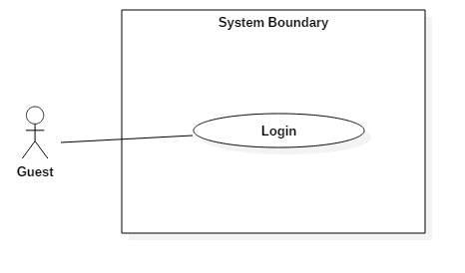

Figure 10: <Guest> Login

|  |  |  |  |
| --- | --- | --- | --- |
| **USE CASE – 1.8** | | | |
| **Use Case No.** | 1.8 | **Use Case Version** | 1.0 |
| **Use Case Name** | Login | | |
| **Author** | Cao Đức Sơn Ngọc | | |
| **Date** | May 20, 2017 | **Priority** | Normal |
| **Actor:**   * Guest   **Summary:**   * This use case allows guest login.   **Goal:**   * Guest logins account in the system.   **Triggers:**  Guest clicks on “Login” tab.  **Preconditions:** N/A  **Post Conditions:**   * **Success:** Guest logins success. * **Fail:** N/A   **Main Success Scenario:**   |  |  |  | | --- | --- | --- | | Step | Actor Action | System Response | | 1 | Guest inputs username and password then click button “Đăng nhập”. | Success login and system loads home page. |   **Alternative Scenario:**   |  |  |  | | --- | --- | --- | | No. | Actor Action | System Response | | 1 | |  |  |   **Exception:** N/A  **Relationships:** N/A  **Business Rules: N/A** | | | |

##### < Guest > Register

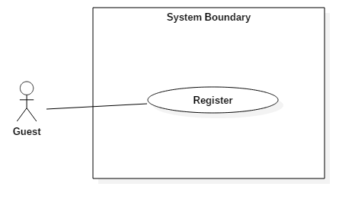

Figure 11: <Guest> Register

|  |  |  |  |
| --- | --- | --- | --- |
| **USE CASE – 1.9** | | | |
| **Use Case No.** | 1.9 | **Use Case Version** | 1.0 |
| **Use Case Name** | Register | | |
| **Author** | Cao Đức Sơn Ngọc | | |
| **Date** | May 20, 2017 | **Priority** | Normal |
| **Actor:**   * Guest   **Summary:**   * This use case allows guest register to member.   **Goal:**   * Guest registers account in the system.   **Triggers:**  Guest clicks on “Login” tab. Click on link “Don’t have account? Register.”  **Preconditions:** N/A  **Post Conditions:**   * **Success:** Guest registers successfully. * **Fail:** N/A   **Main Success Scenario:**   |  |  |  | | --- | --- | --- | | Step | Actor Action | System Response | | 1 | Guest clicks on “Don’t have account? Register.” link | System loads the page Register.  . | | 2 | Guest inputs information to register and click button Register | Success register and system loads home page. |   **Alternative Scenario:**   |  |  |  | | --- | --- | --- | | No. | Actor Action | System Response | | 1 | |  |  |   **Exception:** N/A  **Relationships:** N/A  **Business Rules: N/A** | | | |

#### Member

##### < Member > Overview Use Case

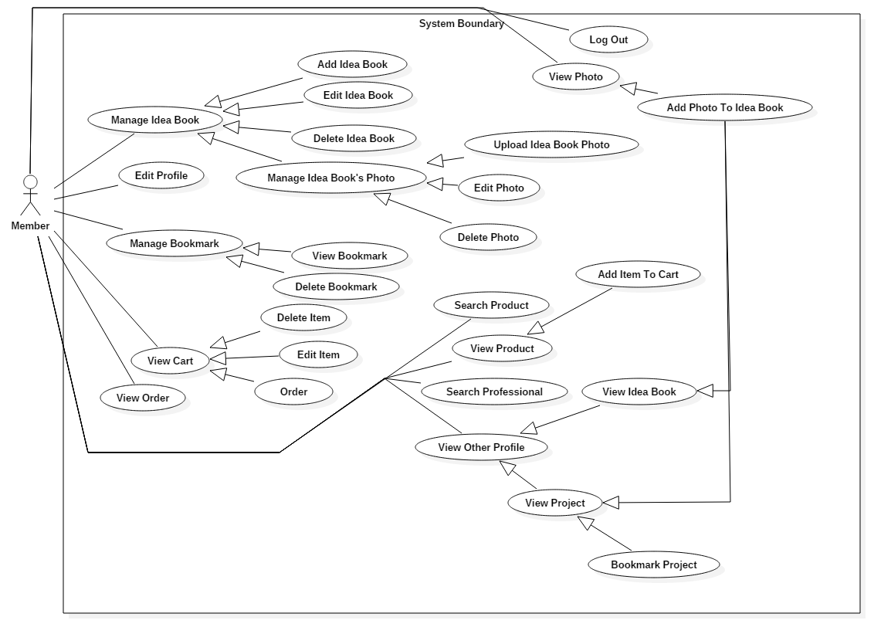

Figure 12: <Member> Overview Use Case

##### < Member > View Photo¸ Search Product, View Product, Search Professional, View Other Profile, View Idea Book, View Project the same use case of Guest.

##### < Member > Add Idea Book

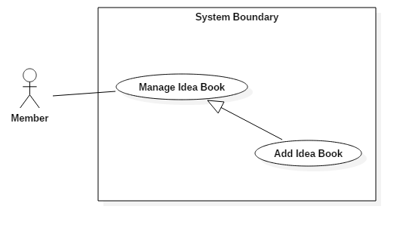

Figure 13: <Member> Add Idea Book

|  |  |  |  |
| --- | --- | --- | --- |
| **USE CASE – 2.1** | | | |
| **Use Case No.** | 2.2 | **Use Case Version** | 1.1 |
| **Use Case Name** | Add Idea Book | | |
| **Author** | Cao Đức Sơn Ngọc | | |
| **Date** | March 16, 2017 | **Priority** | Normal |
| **Actor:**   * Member   **Summary:**   * This use case allows Member to add an idea book.   **Goal:**   * Add new idea book in list idea book of member.   **Triggers:** Member clicks on “Icon Account”/”Ý Tưởng”/”Thêm Mới Ý Tưởng” .  **Preconditions:**   * Actor logged in system with role Member, Professional, Seller.   **Post Conditions:**   * **Success:** Add new idea book success. * **Fail:**   **Main Success Scenario:**   |  |  |  | | --- | --- | --- | | Step | Actor Action | System Response | | 1 | Member clicks on “Icon Account”.  Then clicks on “Ý Tưởng”/”Thêm Mới Ý Tưởng” button | System loads the modal to add new idea book. | | 2 | Member input idea book’s information. The click “Thêm Mới” button. | Add idea book success and result a list idea book. |   **Alternative Scenario:**   |  |  |  | | --- | --- | --- | | Step | Cause | System Response | | 1 |  |  |   **Exceptions: N/A**  **Relationships:** N/A  **Business Rules: N/A** | | | |

##### < Member > Edit Idea Book

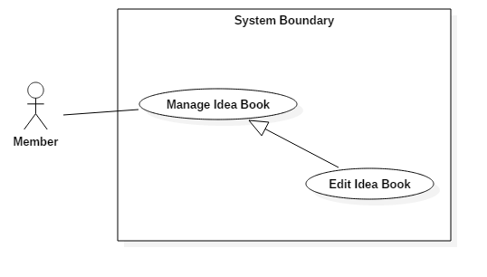

Figure 14: <Member> Edit Idea Book

|  |  |  |  |
| --- | --- | --- | --- |
| **USE CASE – 2.3** | | | |
| **Use Case No.** | 2.3 | **Use Case Version** | 1.1 |
| **Use Case Name** | Edit Idea Book | | |
| **Author** | Cao Đức Sơn Ngọc | | |
| **Date** | March 16, 2017 | **Priority** | Normal |
| **Actor:**   * Member   **Summary:**   * This use case allows Member to edit an idea book.   **Goal:**   * Edit description idea book.   **Triggers:** Member clicks on “Icon Account”/”Ý Tưởng” and click to idea book need edit.  **Preconditions:**   * Actor logged in system with role Member, Professional, Seller.   **Post Conditions:**   * **Success:** Edit description idea book success. * **Fail: N/A**   **Main Success Scenario:**   |  |  |  | | --- | --- | --- | | Step | Actor Action | System Response | | 1 | Member clicks on “Icon Account”.  Then clicks on “Ý Tưởng” click to idea book need edit. | System loads the page detail about idea book. | | 2 | Member input idea book’s description. The click “Lưu” button. | Update description success and result page detail idea book. |   **Alternative Scenario:**   |  |  |  | | --- | --- | --- | | Step | Cause | System Response | | 1 |  |  |   **Exceptions: N/A**  **Relationships:** N/A  **Business Rules: N/A** | | | |

##### < Member > Delete Idea Book

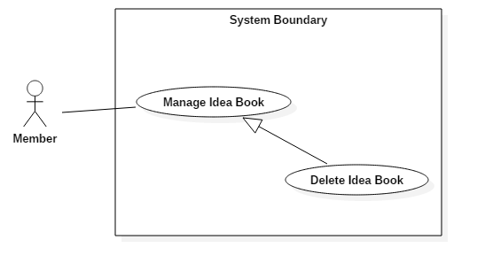

Figure 15: <Member> Delete Idea Book

|  |  |  |  |
| --- | --- | --- | --- |
| **USE CASE – 2.4** | | | |
| **Use Case No.** | 2.4 | **Use Case Version** | 1.1 |
| **Use Case Name** | Delete Idea Book | | |
| **Author** | Cao Đức Sơn Ngọc | | |
| **Date** | March 16, 2017 | **Priority** | Normal |
| **Actor:**   * Member   **Summary:**   * This use case allows Member to delete an idea book.   **Goal:**   * Delete an idea book.   **Triggers:** Member clicks on “Icon Account”/”Ý Tưởng” and click to idea book need delete.  **Preconditions:**   * Actor logged in system with role Member, Professional, Seller.   **Post Conditions:**   * **Success:** Delete description idea book success. * **Fail: N/A**   **Main Success Scenario:**   |  |  |  | | --- | --- | --- | | Step | Actor Action | System Response | | 1 | Member clicks on “Icon Account”.  Then clicks on “Ý Tưởng” click to idea book need delete. | System loads the page detail about idea book. | | 2 | Member input idea book’s description. The click “Xóa Ý Tưởng” button. | Delete idea book success and returns the idea list page. |   **Alternative Scenario:**   |  |  |  | | --- | --- | --- | | Step | Cause | System Response | | 1 |  |  |   **Exceptions: N/A**  **Relationships:** N/A  **Business Rules: N/A** | | | |

##### < Member > Upload Idea Book Photo

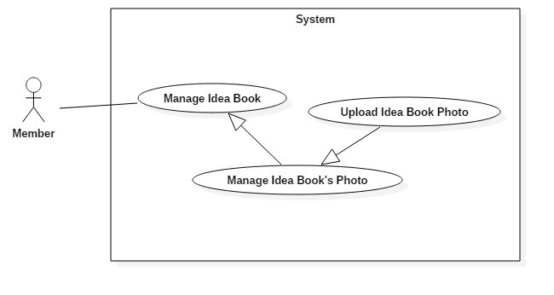

Figure 16: <Member> Upload Idea Book Photo

|  |  |  |  |
| --- | --- | --- | --- |
| **USE CASE – 2.5** | | | |
| **Use Case No.** | 2.5 | **Use Case Version** | 1.1 |
| **Use Case Name** | Upload Idea Book Photo | | |
| **Author** | Cao Đức Sơn Ngọc | | |
| **Date** | March 16, 2017 | **Priority** | Normal |
| **Actor:**   * Member   **Summary:**   * This use case allows Member to add a photo in idea book.   **Goal:**   * Add an idea book photo.   **Triggers:** Member clicks on “Icon Account”/”Ý Tưởng” and click to idea book for adding photos.  **Preconditions:**   * Actor logged in system with role Member, Professional, Seller.   **Post Conditions:**   * **Success:** Add photo to idea book success. * **Fail: N/A**   **Main Success Scenario:**   |  |  |  | | --- | --- | --- | | Step | Actor Action | System Response | | 1 | Member clicks on “Icon Account”.  Then clicks on “Ý Tưởng” click to idea book. | System loads the page detail about idea book. | | 2 | Member click “Thêm ảnh” button. | Add photo success and returns the idea book page. |   **Alternative Scenario:**   |  |  |  | | --- | --- | --- | | Step | Cause | System Response | | 1 |  |  |   **Exceptions: N/A**  **Relationships:** N/A  **Business Rules: N/A** | | | |

##### < Member > Edit Idea Book Photo

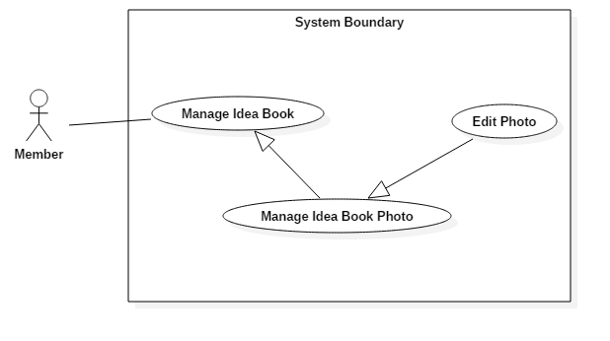

Figure 17: <Member> Edit Idea Book Photo

|  |  |  |  |
| --- | --- | --- | --- |
| **USE CASE – 2.6** | | | |
| **Use Case No.** | 2.6 | **Use Case Version** | 1.1 |
| **Use Case Name** | Edit Idea Book Photo | | |
| **Author** | Cao Đức Sơn Ngọc | | |
| **Date** | March 16, 2017 | **Priority** | Normal |
| **Actor:**   * Member   **Summary:**   * This use case allows Member to edit a photo in ideabook.   **Goal:**   * Edit a description idea book photo.   **Triggers:** Member clicks on “Icon Account”/”Ý Tưởng” and click to idea book for adding photos.  **Preconditions:**   * Actor logged in system with role Member, Professional, Seller.   **Post Conditions:**   * **Success:** Edit description photo to idea book success. * **Fail: N/A**   **Main Success Scenario:**   |  |  |  | | --- | --- | --- | | Step | Actor Action | System Response | | 1 | Member clicks on “Icon Account”.  Then clicks on “Ý Tưởng” click to idea book. | System loads the page detail about idea book. | | 2 | Member input description for photo. | Update photo success and returns the idea book page. |   **Alternative Scenario:**   |  |  |  | | --- | --- | --- | | Step | Cause | System Response | | 1 |  |  |   **Exceptions: N/A**  **Relationships:** N/A  **Business Rules: N/A** | | | |

##### < Member > Delete Idea Book Photo

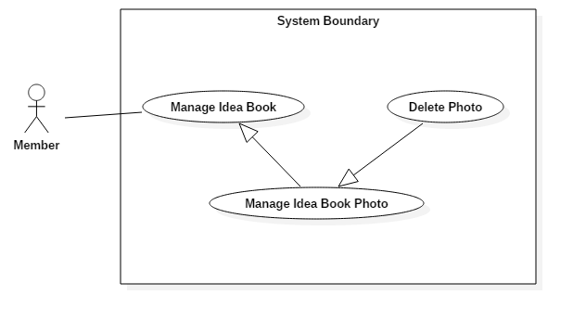

Figure 18: <Member> Delete Idea Book Photo

|  |  |  |  |
| --- | --- | --- | --- |
| **USE CASE – 2.7** | | | |
| **Use Case No.** | 2.7 | **Use Case Version** | 1.1 |
| **Use Case Name** | Delete Idea Book Photo | | |
| **Author** | Cao Đức Sơn Ngọc | | |
| **Date** | March 16, 2017 | **Priority** | Normal |
| **Actor:**   * Member   **Summary:**   * This use case allows Member to delete a photo in ideabook.   **Goal:**   * Delete a description idea book photo.   **Triggers:** Member clicks on “Icon Account”/”Ý Tưởng” and click to idea book for adding photos.  **Preconditions:**   * Actor logged in system with role Member, Professional, Seller.   **Post Conditions:**   * **Success:** Delete photo in idea book success. * **Fail: N/A**   **Main Success Scenario:**   |  |  |  | | --- | --- | --- | | Step | Actor Action | System Response | | 1 | Member clicks on “Icon Account”.  Then clicks on “Ý Tưởng” click to idea book. | System loads the page detail about idea book. | | 2 | Member click button “X” on the corner of the image. | Delete photo success and returns the idea book page. |   **Alternative Scenario:**   |  |  |  | | --- | --- | --- | | Step | Cause | System Response | | 1 |  |  |   **Exceptions: N/A**  **Relationships:** N/A  **Business Rules: N/A** | | | |

##### < Member > Add Photo into Idea Book

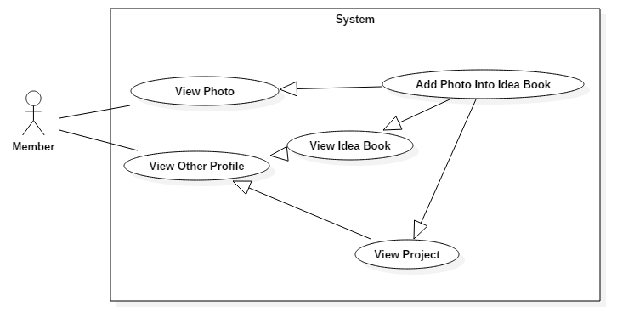

Figure 19: <Member> Add Photo into Idea Book

|  |  |  |  |
| --- | --- | --- | --- |
| **USE CASE – 2.8** | | | |
| **Use Case No.** | 2.8 | **Use Case Version** | 1.1 |
| **Use Case Name** | Add Photo Into Idea Book | | |
| **Author** | Cao Đức Sơn Ngọc | | |
| **Date** | March 16, 2017 | **Priority** | Normal |
| **Actor:**   * Member   **Summary:**   * This use case allows Member to add a photo into idea book.   **Goal:**   * Add a photo into idea book photo.   **Triggers:** Member views a photo and click “Lưu vào ý tưởng” button.  **Preconditions:**   * Actor logged in system with role Member, Professional, Seller.   **Post Conditions:**   * **Success:** Add the photo ino idea book successfull. * **Fail: N/A**   **Main Success Scenario:**   |  |  |  | | --- | --- | --- | | Step | Actor Action | System Response | | 1 | Member clicks on “Ảnh” tab.  Then clicks on a photo and click “Lưu vào ý tưởng” button. | Add the photo successfull.  System loads the page detail about idea book was just added photo. |   **Alternative Scenario 1:**   |  |  |  | | --- | --- | --- | | Step | Cause | System Response | | 1 | Member view any idea book.  Then clicks on a photo and click “Lưu vào ý tưởng” button. | Add the photo successfull.  System loads the page detail about idea book was just added photo. |   **Alternative Scenario 2:**   |  |  |  | | --- | --- | --- | | Step | Cause | System Response | | 1 | Member view any project.  Then clicks on a photo and click “Lưu vào ý tưởng” button. | Add the photo successfull.  System loads the page detail about idea book was just added photo. |   **Exceptions: N/A**  **Relationships:** N/A  **Business Rules: N/A** | | | |

##### < Member > Edit Idea Profile

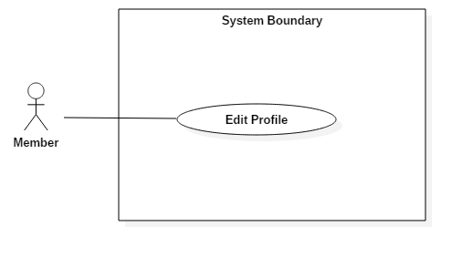

Figure 20: <Member> Edit Idea Profile

|  |  |  |  |
| --- | --- | --- | --- |
| **USE CASE – 2.9** | | | |
| **Use Case No.** | 2.9 | **Use Case Version** | 1.1 |
| **Use Case Name** | Edit Profile | | |
| **Author** | Cao Đức Sơn Ngọc | | |
| **Date** | March 16, 2017 | **Priority** | Normal |
| **Actor:**   * Member   **Summary:**   * This use case allows Member to edit profile.   **Goal:**   * Edit profile successfully.   **Triggers:** Member clicks on “Icon Account”/”Cập Nhật Hồ Sơ” .  **Preconditions:**   * Actor logged in system with role Member, Professional, Seller.   **Post Conditions:**   * **Success:** Update profile successfully. * **Fail: N/A**   **Main Success Scenario:**   |  |  |  | | --- | --- | --- | | Step | Actor Action | System Response | | 1 | Member clicks on “Icon Account”.  Then clicks on “Cập Nhật Hồ Sơ”. | System loads the page detail about member’s profile. | | 2 | Member input information to edit. Then click button “Cập Nhật” | update profile successfully and returns the profile page. |   **Alternative Scenario:**   |  |  |  | | --- | --- | --- | | Step | Cause | System Response | | 1 |  |  |   **Exceptions: N/A**  **Relationships:** N/A  **Business Rules: N/A** | | | |

##### < Member > Bookmark Project

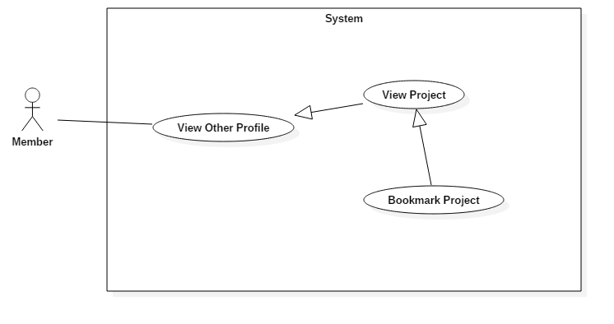

Figure 21: <Member> Bookmark Project

|  |  |  |  |
| --- | --- | --- | --- |
| **USE CASE – 2.10** | | | |
| **Use Case No.** | 2.10 | **Use Case Version** | 1.1 |
| **Use Case Name** | Bookmark Project | | |
| **Author** | Cao Đức Sơn Ngọc | | |
| **Date** | March 16, 2017 | **Priority** | Normal |
| **Actor:**   * Member   **Summary:**   * This use case allows Member to add a project of other people to bookmark.   **Goal:**   * Bookmark project in list bookmark of member.   **Triggers:** Member clicks on a project then click “Đánh Dấu” button.  **Preconditions:**   * Actor logged in system with role Member, Professional, Seller.   **Post Conditions:**   * **Success:** Bookmark project successfully. * **Fail:**   **Main Success Scenario:**   |  |  |  | | --- | --- | --- | | Step | Actor Action | System Response | | 1 | Member clicks on a project | System loads the page project details. | | 2 | Member click “Đánh Dấu” button. | Bookmark project success and loads page project. |   **Alternative Scenario:**   |  |  |  | | --- | --- | --- | | Step | Cause | System Response | | 1 |  |  |   **Exceptions: N/A**  **Relationships:** N/A  **Business Rules: N/A** | | | |

##### < Member > View Bookmark

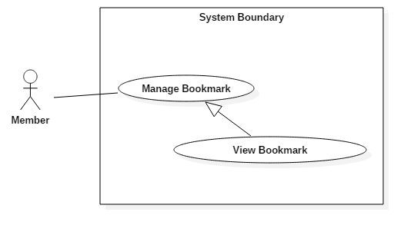

Figure 22: <Member> View Bookmark

|  |  |  |  |
| --- | --- | --- | --- |
| **USE CASE – 2.11** | | | |
| **Use Case No.** | 2.11 | **Use Case Version** | 1.1 |
| **Use Case Name** | View Bookmark | | |
| **Author** | Cao Đức Sơn Ngọc | | |
| **Date** | March 16, 2017 | **Priority** | Normal |
| **Actor:**   * Member   **Summary:**   * This use case allows Member to view bookmark.   **Goal:**   * Display list project in bookmark of member.   **Triggers:** Member clicks “Icon Account” / “Cập Nhật Hồ Sơ” or “Ý Tưởng”. Then click “Đánh Dấu” tab.  **Preconditions:**   * Actor logged in system with role Member, Professional, Seller.   **Post Conditions:**   * **Success:** Bookmark project successfully. * **Fail:**   **Main Success Scenario:**   |  |  |  | | --- | --- | --- | | Step | Actor Action | System Response | | 1 | Member clicks “Icon Account” / “Cập Nhật Hồ Sơ” or “Ý Tưởng”. | System loads the page edit profile or page idea book. | | 2 | Member click “Đánh Dấu” tab. | System loads the page bookmark return information list bookmark:  -Name project.  -Name professional.  -Bookmark date. |   **Alternative Scenario:**   |  |  |  | | --- | --- | --- | | Step | Cause | System Response | | 1 |  |  |   **Exceptions: N/A**  **Relationships:** N/A  **Business Rules: N/A** | | | |

##### < Member > Add Item to Cart

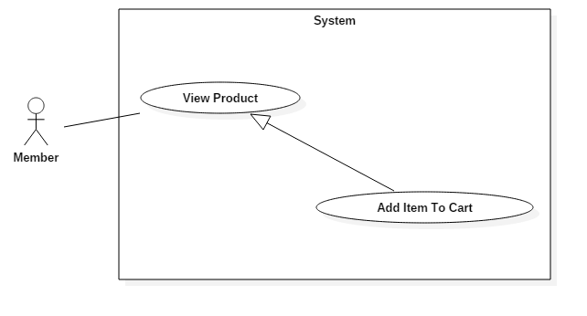

Figure 23: <Member> Add Item to Cart

|  |  |  |  |
| --- | --- | --- | --- |
| **USE CASE – 2.12** | | | |
| **Use Case No.** | 2.12 | **Use Case Version** | 1.1 |
| **Use Case Name** | Add Item To Cart | | |
| **Author** | Cao Đức Sơn Ngọc | | |
| **Date** | March 16, 2017 | **Priority** | Normal |
| **Actor:**   * Member   **Summary:**   * This use case allows Member to add a product to cart.   **Goal:**   * Add new product to cart of member.   **Triggers:** Member clicks on “Sản Phẩm” tab / Detail product.  **Preconditions:**   * Actor logged in system with role Member, Professional, Seller.   **Post Conditions:**   * **Success:** Add new product to cart successfull. * **Fail:**   **Main Success Scenario:**   |  |  |  | | --- | --- | --- | | Step | Actor Action | System Response | | 1 | Member clicks on “Sản Phẩm” tab. | System loads the list product. | | 2 | Member clicks on detail any product. Member chooses quantity of product then click “Thêm vào giỏ hang” button. | Add product to cart success and result modal to question to add cart or order. | | 3 | Member clicks on “Tiếp tục mua hang” button.  [Alternative 1] | System load page product. |   **Alternative Scenario:**   |  |  |  | | --- | --- | --- | | Step | Cause | System Response | | 1 | Member clicks on “Đặt hang” button. | System load page shopping cart for member order. |   **Exceptions: N/A**  **Relationships:** N/A  **Business Rules: N/A** | | | |

##### < Member > View Cart

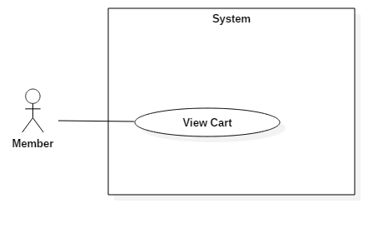

Figure 24: <Member> View Cart

|  |  |  |  |
| --- | --- | --- | --- |
| **USE CASE – 2.13** | | | |
| **Use Case No.** | 2.13 | **Use Case Version** | 1.1 |
| **Use Case Name** | View Cart | | |
| **Author** | Cao Đức Sơn Ngọc | | |
| **Date** | March 16, 2017 | **Priority** | Normal |
| **Actor:**   * Member   **Summary:**   * This use case allows Member to view member’s cart.   **Goal:**   * View cart of member.   **Triggers:** Member clicks on “Icon Cart”.  **Preconditions:**   * Actor logged in system with role Member, Professional, Seller.   **Post Conditions:**   * **Success:** View cart success. * **Fail:**   **Main Success Scenario:**   |  |  |  | | --- | --- | --- | | Step | Actor Action | System Response | | 1 | Member clicks on “Icon Cart”. | System loads the page member’s cart. |   **Alternative Scenario:**   |  |  |  | | --- | --- | --- | | Step | Cause | System Response | | 1 |  |  |   **Exceptions: N/A**  **Relationships:** N/A  **Business Rules: N/A** | | | |

##### < Member > Delete Item

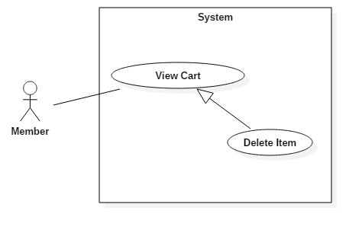

Figure 25: <Member> Delete Item

|  |  |  |  |
| --- | --- | --- | --- |
| **USE CASE – 2.14** | | | |
| **Use Case No.** | 2.14 | **Use Case Version** | 1.1 |
| **Use Case Name** | Delete Item | | |
| **Author** | Cao Đức Sơn Ngọc | | |
| **Date** | March 16, 2017 | **Priority** | Normal |
| **Actor:**   * Member   **Summary:**   * This use case allows Member to delete a product in cart.   **Goal:**   * Delete a product in cart of member.   **Triggers:** Member clicks on “Icon Cart”. Then click “Xóa sản phẩm” button.  **Preconditions:**   * Actor logged in system with role Member, Professional, Seller.   **Post Conditions:**   * **Success:** Delete product in cart successfully. * **Fail:**   **Main Success Scenario:**   |  |  |  | | --- | --- | --- | | Step | Actor Action | System Response | | 1 | Member clicks on “Icon Cart”. | System loads the page member’s cart. | | 2 | Member clicks “Xóa sản phẩm” button. | System deletes the product in member’s cart successfully. |   **Alternative Scenario:**   |  |  |  | | --- | --- | --- | | Step | Cause | System Response | | 1 |  |  |   **Exceptions: N/A**  **Relationships:** N/A  **Business Rules: N/A** | | | |

##### < Member > Edit Item

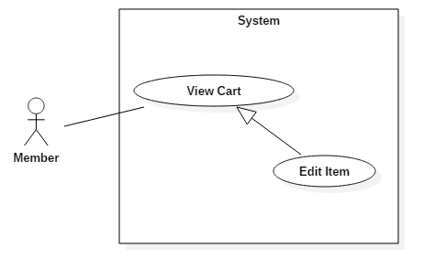

Figure 26: <Member> Edit Item

|  |  |  |  |
| --- | --- | --- | --- |
| **USE CASE – 2.15** | | | |
| **Use Case No.** | 2.15 | **Use Case Version** | 1.1 |
| **Use Case Name** | Edit Item | | |
| **Author** | Cao Đức Sơn Ngọc | | |
| **Date** | March 16, 2017 | **Priority** | Normal |
| **Actor:**   * Member   **Summary:**   * This use case allows Member to edit quantity of product in cart.   **Goal:**   * Edit quantity of product in cart of member.   **Triggers:** Member clicks on “Icon Cart”. Then click “Số lượng” dropdow.  **Preconditions:**   * Actor logged in system with role Member, Professional, Seller.   **Post Conditions:**   * **Success:** Update quantity of product in cart successfully. * **Fail:**   **Main Success Scenario:**   |  |  |  | | --- | --- | --- | | Step | Actor Action | System Response | | 1 | Member clicks on “Icon Cart”. | System loads the page member’s cart. | | 2 | Member clicks “Số lượng” dropdow. Then click “Ok” button. | System updates the quantity of product in member’s cart successfully. |   **Alternative Scenario:**   |  |  |  | | --- | --- | --- | | Step | Cause | System Response | | 1 |  |  |   **Exceptions: N/A**  **Relationships:** N/A  **Business Rules: N/A** | | | |

##### < Member > Order

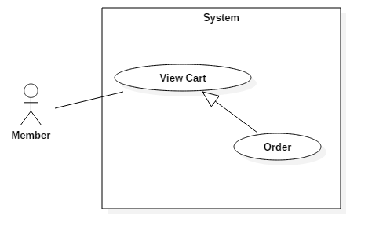

Figure 27: <Member> Order

|  |  |  |  |
| --- | --- | --- | --- |
| **USE CASE – 2.16** | | | |
| **Use Case No.** | 2.16 | **Use Case Version** | 1.1 |
| **Use Case Name** | Order | | |
| **Author** | Cao Đức Sơn Ngọc | | |
| **Date** | March 16, 2017 | **Priority** | Normal |
| **Actor:**   * Member   **Summary:**   * This use case allows Member to order all products in cart.   **Goal:**   * Order all products in cart of member.   **Triggers:** Member clicks on “Icon Cart”. Then click “Đặt hàng” button.  **Preconditions:**   * Actor logged in system with role Member, Professional, Seller.   **Post Conditions:**   * **Success:** Order all products in cart successfully. * **Fail:**   **Main Success Scenario:**   |  |  |  | | --- | --- | --- | | Step | Actor Action | System Response | | 1 | Member clicks on “Icon Cart”. | System loads the page member’s cart. | | 2 | Member clicks “Đặt hàng” button. | System sends order to seller successfully. Result view order page. |   **Alternative Scenario:**   |  |  |  | | --- | --- | --- | | Step | Cause | System Response | | 1 |  |  |   **Exceptions: N/A**  **Relationships:** N/A  **Business Rules: N/A** | | | |

##### < Member > View Order

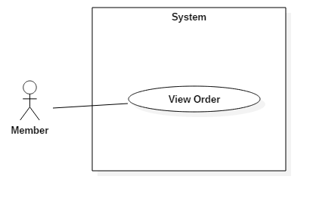

Figure 28: <Member> View Order

|  |  |  |  |
| --- | --- | --- | --- |
| **USE CASE – 2.17** | | | |
| **Use Case No.** | 2.17 | **Use Case Version** | 1.1 |
| **Use Case Name** | Order | | |
| **Author** | Cao Đức Sơn Ngọc | | |
| **Date** | March 16, 2017 | **Priority** | Normal |
| **Actor:**   * Member   **Summary:**   * This use case allows Member to view order.   **Goal:**   * View all order of member.   **Triggers:** Member clicks “Icon Account” / “Cập Nhật Hồ Sơ” or “Ý Tưởng”. Then click “Đơn hàng” tab.  **Preconditions:**   * Actor logged in system with role Member, Professional, Seller.   **Post Conditions:**   * **Success:** View all order successfully. * **Fail:**   **Main Success Scenario:**   |  |  |  | | --- | --- | --- | | Step | Actor Action | System Response | | 1 | Member clicks “Icon Account” / “Cập Nhật Hồ Sơ”.  [Alternative Scenario 1] | System loads the page member’s edit profile. | | 2 | Member clicks “Đơn hàng” tab. | System shows all order of member. |   **Alternative Scenario:**   |  |  |  | | --- | --- | --- | | Step | Cause | System Response | | 1 | Member clicks “Icon Account” / “Ý Tưởng”. | System loads the page member’s edit profile. | | 2 | Member clicks “Đơn hàng” tab. | System shows all order of member. |   **Exceptions: N/A**  **Relationships:** N/A  **Business Rules: N/A** | | | |

#### Professional

##### < Professional > Overview Use Case

Figure 29: <Professional> Overview Use Case

##### < Professional > Create project

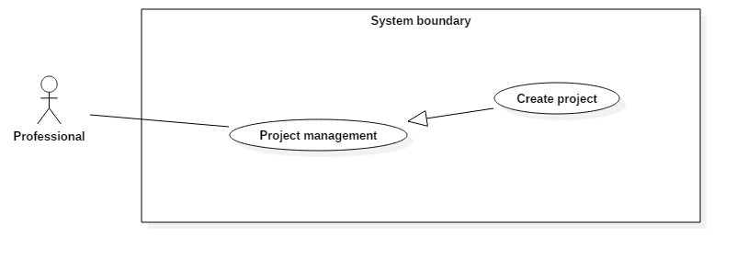

Figure 30: <Professional> Create project

|  |  |  |  |
| --- | --- | --- | --- |
| **USE CASE – 3.1** | | | |
| **Use Case No.** | 3.1 | **Use Case Version** | 1.1 |
| **Use Case Name** | Create project | | |
| **Author** | Le Dai An | | |
| **Date** | July 15, 2017 | **Priority** | Normal |
| **Actor:**   * Professional   **Summary:**   * This use case allows Professional create new project.   **Goal:**   * Create a new project.   **Triggers:** Professional clicks on “Tạo dự án” button.  **Preconditions:**   * Actor logged in system with role Professional.   **Post Conditions:**   * **Success:** New project occurs in their project list. * **Fail:**   **Main Success Scenario:**   |  |  |  | | --- | --- | --- | | Step | Actor Action | System Response | | 1 | - Clicks on create icon.  - Inputs information.  - Clicks on “Tạo dự án” button | System lists out the information of new project:   * Project’s name. * Address. * Cost. * Website. * Year.   When text change, system verifies input information.  System verifies input information. New Project with all copies of it are saved to database  [Alternative 1]: Project’s name is existed in system.  [Exception 1]: Internet connection is lost.  [Exception 2,3,4,5] |   **Alternative Scenario:**   |  |  |  | | --- | --- | --- | | Step | Cause | System Response | | 1 | The project’s name is existed in system. | Show error message “Tên dự án đã tồn tại”. |   **Exceptions:**   |  |  |  | | --- | --- | --- | | No | Cause | System Response | | 1 | Internet is disconnect. | Page with error code 404. | | 2 | Professional inputs Project’s name field with wrong format. | System displays error message: “Vui lòng điền vào trường này.” | | 3 | Professional inputs Cost field with wrong format. | System displays error message: “Giá trị phải lớn hơn hoặc bằng 0” | | 4 | Professional inputs Website field with wrong format. | System displays error message: “Vui lòng nhập URL” | | 5 | Professional inputs Year field with wrong format. | System displays error message: “Giá trị phải nhỏ hơn hoặc bằng 2017” |   **Relationships:** N/A  **Business Rules:**   * “Tên dự án”: free text input, length 1-71. * “Địa chỉ”: free text input, length 1-71. * “Giá”: float input, min 0. * “Website”: free text input, length 1-71. * “Năm”: integer input, max 2017, min 2000. | | | |

##### < Professional > View project detail

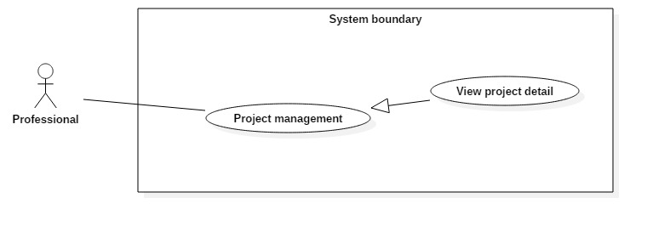

Figure 31: <Professional> View project detail

|  |  |  |  |
| --- | --- | --- | --- |
| **USE CASE – 3.2** | | | |
| **Use Case No.** | 3.2 | **Use Case Version** | 1.1 |
| **Use Case Name** | View project detail | | |
| **Author** | Le Dai An | | |
| **Date** | July 15, 2017 | **Priority** | Normal |
| **Actor:**   * Professional   **Summary:**   * This use case allows Professional to view detail of a project.   **Goal:**   * View project detail.   **Triggers:** Professional clicks on project’s name or project’s photo.  **Preconditions:**   * Actor logged in system with role Professional.   **Post Conditions:**   * **Success:** Project detail is showed. * **Fail:**   **Main Success Scenario:**   |  |  |  | | --- | --- | --- | | Step | Actor Action | System Response | | 1 | - Professional clicks on photo or name of project in list. | - System loads result and displays all information of account.  [Exception 1] Lost Internet Connection. |   **Alternative Scenario:** N/A  **Exceptions:**   |  |  |  | | --- | --- | --- | | No | Cause | System Response | | 1 | Internet is disconnect. | Page with error code 404. |   **Relationships:** N/A  **Business Rules:** N/A | | | |

##### < Professional > Edit project

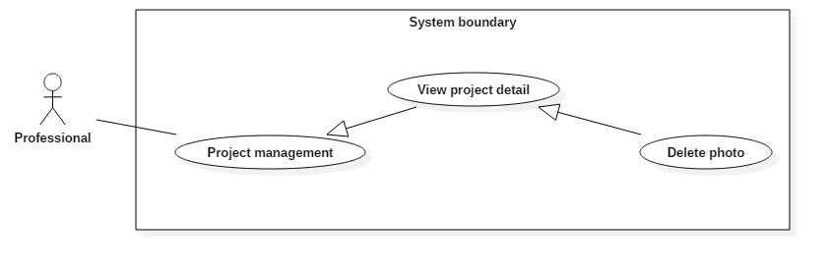

Figure 32: <Professional> Edit project

|  |  |  |  |
| --- | --- | --- | --- |
| **USE CASE – 3.3** | | | |
| **Use Case No.** | 3.3 | **Use Case Version** | 1.1 |
| **Use Case Name** | Edit project | | |
| **Author** | Le Dai An | | |
| **Date** | July 15, 2017 | **Priority** | Normal |
| **Actor:**   * Professional   **Summary:**   * This use case allows Professional to edit information of project.   **Goal:**   * Edit project’s information.   **Triggers:** Professional clicks on “Lưu” button.  **Preconditions:**   * Actor logged in system with role Professional.   **Post Conditions:**   * **Success:** Project’s information is changed. * **Fail:**   **Main Success Scenario:**   |  |  |  | | --- | --- | --- | | Step | Actor Action | System Response | | 1 | - Clicks on edit icon.  - Inputs information.  - Clicks on “Lưu” button | System lists out the information of new project:   * Project’s name. * Address. * Cost. * Website. * Year.   When text change, system verifies input information.  System verifies input information. New Project with all copies of it are saved to database  [Alternative 1]: Project’s name is existed in system.  [Exception 1]: Internet connection is lost.  [Exception 2,3,4,5] |   **Alternative Scenario:**   |  |  |  | | --- | --- | --- | | Step | Cause | System Response | | 1 | The project’s name is existed in system. | Show error message “Tên dự án đã tồn tại”. |   **Exceptions:**   |  |  |  | | --- | --- | --- | | No | Cause | System Response | | 1 | Internet is disconnect. | Page with error code 404. | | 2 | Professional inputs Project’s name field with wrong format. | System displays error message: “Vui lòng điền vào trường này.” | | 3 | Professional inputs Cost field with wrong format. | System displays error message: “Giá trị phải lớn hơn hoặc bằng 0” | | 4 | Professional inputs Website field with wrong format. | System displays error message: “Vui lòng nhập URL” | | 5 | Professional inputs Year field with wrong format. | System displays error message: “Giá trị phải nhỏ hơn hoặc bằng 2017” |   **Relationships:** N/A  **Business Rules:**   * “Tên dự án”: free text input, length 1-71. * “Địa chỉ”: free text input, length 1-71. * “Giá”: float input, min 0. * “Website”: free text input, length 1-71.   - “Năm”: integer input, max 2017, min 2000. | | | |

##### < Professional > Delete project

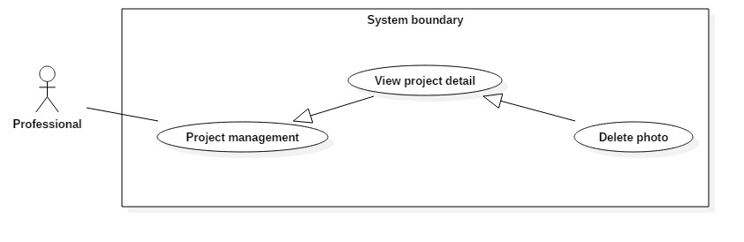

Figure 33: <Professional> Delete project

|  |  |  |  |
| --- | --- | --- | --- |
| **USE CASE – 3.4** | | | |
| **Use Case No.** | 3.4 | **Use Case Version** | 1.1 |
| **Use Case Name** | Delete project | | |
| **Author** | Le Dai An | | |
| **Date** | July 15, 2017 | **Priority** | Normal |
| **Actor:**   * Professional   **Summary:**   * This use case allows Professional to delete their project.   **Goal:**   * Delete project from system.   **Triggers:** Professional clicks on “Xóa” button.  **Preconditions:**   * Actor logged in system with role Professional.   **Post Conditions:**   * **Success:** The project is removed. * **Fail:**   **Main Success Scenario:**   |  |  |  | | --- | --- | --- | | Step | Actor Action | System Response | | 1 | - Professional clicks on “Xóa dự án” button. | System removes project. Update project’s status to “deleted” in database. And deletes all photo in project.  [Exception 1]: Internet connection is lost. |   **Alternative Scenario:** N/A  **Exceptions:**   |  |  |  | | --- | --- | --- | | No | Cause | System Response | | 1 | Internet is disconnect. | Page with error code 404. |   **Relationships:** N/A  **Business Rules:** N/A | | | |

##### < Professional > Add photo



Figure 34: <Professional> Add photo

|  |  |  |  |
| --- | --- | --- | --- |
| **USE CASE – 3.5** | | | |
| **Use Case No.** | 3.5 | **Use Case Version** | 1.1 |
| **Use Case Name** | Add photo | | |
| **Author** | Le Dai An | | |
| **Date** | July 15, 2017 | **Priority** | Normal |
| **Actor:**   * Professional   **Summary:**   * This use case allows Professional to add photo to a project.   **Goal:**   * Add photo to project.   **Triggers:** Professional clicks on “Thêm” button.  **Preconditions:**   * Actor logged in system with role Professional.   **Post Conditions:**   * **Success:** Photo is added to project. * **Fail:**   **Main Success Scenario:**   |  |  |  | | --- | --- | --- | | Step | Actor Action | System Response | | 1 | - Clicks on create icon.  - Inputs information.  - Clicks on “Thêm” button. | System lists out the information of new photo:   * Title. * Description * Category * Style * Upload file.   When text change, system verifies input information.  System verifies input information. New Photo with all copies of it are saved to database.  [Exception 1]: Internet connection is lost.  [Exception 2,3,4,5] |   **Alternative Scenario:** N/A  **Exceptions:**   |  |  |  | | --- | --- | --- | | No | Cause | System Response | | 1 | Internet is disconnect. | Page with error code 404. |   **Relationships:** N/A  **Business Rules:**   * “Tiêu đề”: free text input, length 1-71. * “Mô tả”: free text input, length 1-71. * “Phong cách”: choose 1 in 5 categories. * “Thể loại:: choose 1 in 5 styles. | | | |

##### < Professional > Delete photo



Figure 35: <Professional> Delete photo

|  |  |  |  |
| --- | --- | --- | --- |
| **USE CASE – 3.6** | | | |
| **Use Case No.** | 3.6 | **Use Case Version** | 1.1 |
| **Use Case Name** | Delete photo | | |
| **Author** | Le Dai An | | |
| **Date** | July 15, 2017 | **Priority** | Normal |
| **Actor:**   * Professional   **Summary:**   * This use case allows Professional to delete photo from a project.   **Goal:**   * Delete photo from project.   **Triggers:** Professional clicks on “Xóa” button.  **Preconditions:**   * Actor logged in system with role Professional.   **Post Conditions:**   * **Success:** Photo is removed from project. * **Fail:**   **Main Success Scenario:**   |  |  |  | | --- | --- | --- | | Step | Actor Action | System Response | | 1 | - Professional clicks on X button at top-right of photo. | System removes photo. Update photo’s status to “deleted” in database.  [Exception 1]: Internet connection is lost. |   **Alternative Scenario:** N/A  **Exceptions:**   |  |  |  | | --- | --- | --- | | No | Cause | System Response | | 1 | Internet is disconnect. | Page with error code 404. |   **Relationships:** N/A  **Business Rules:** N/A | | | |

#### Admin

##### < Admin > Overview Use Case

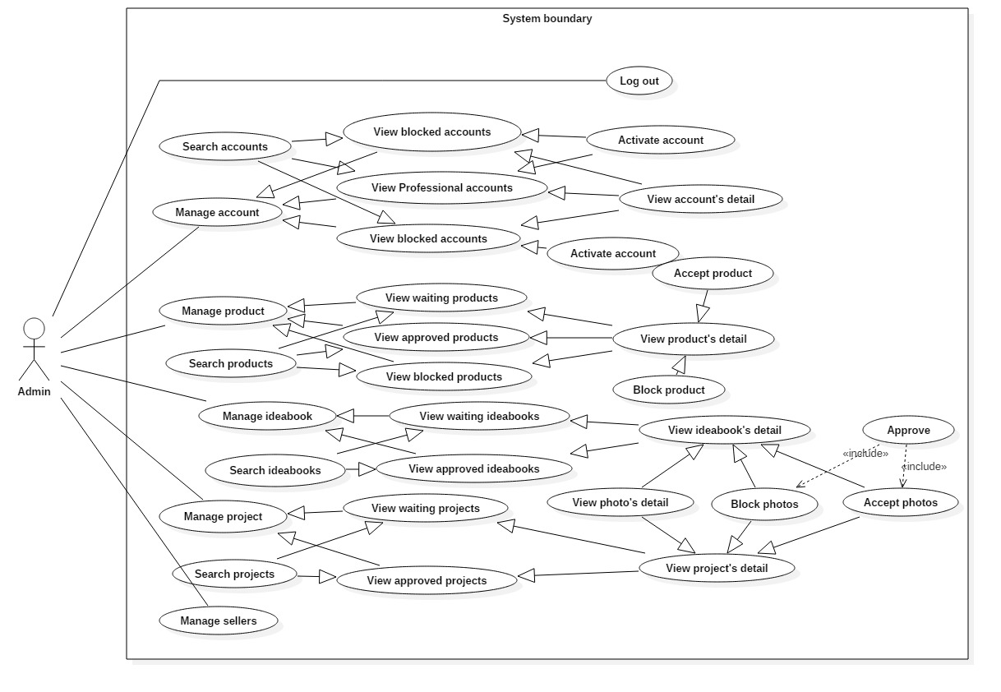

Figure 36: <Admin> Overview Use Case

##### < Admin > View accounts

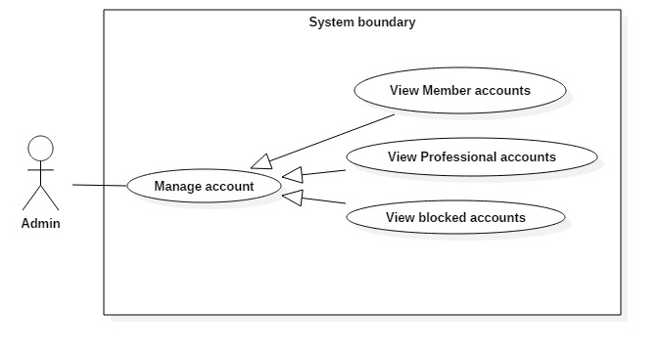

Figure 37: <Admin> View accounts

|  |  |  |  |
| --- | --- | --- | --- |
| **USE CASE – 4.1** | | | |
| **Use Case No.** | 4.1 | **Use Case Version** | 1.1 |
| **Use Case Name** | View accounts | | |
| **Author** | Le Dai An | | |
| **Date** | June 18, 2017 | **Priority** | Normal |
| **Actor:**   * Admin   **Summary:**   * This use case allows Admin to view accounts list include member, professional and blocked accounts.   **Goal:**   * A list member/professional/blocked accounts in system are displayed.   **Triggers:** Admin clicks on “Member” or ”Professional” or ”Danh sách bị chặn” button in “Quản lý tài khoản” tab.  **Preconditions:**   * Actor logged in system with role Admin.   **Post Conditions:**   * **Success:** List of accounts based on member/professional/blocked account is showed. * **Fail:**   **Main Success Scenario:**   |  |  |  | | --- | --- | --- | | Step | Actor Action | System Response | | 1 | - Admin clicks on “Tài khoản” tab.  - Then clicks on “Member” or” Professional” or ”Danh sách bị chặn” button. | System loads the result. Information for each account:   * Full name * Phone number * Email * Register date   [Alternative 1]: There is no account in system.  [Exception 1]: Internet connection is lost. |   **Alternative Scenario:**   |  |  |  | | --- | --- | --- | | Step | Cause | System Response | | 1 | System doesn’t have any account or no account in chosen status. | Web page has a table without content. |   **Exceptions:**   |  |  |  | | --- | --- | --- | | No | Cause | System Response | | 1 | Internet is disconnect. | Page with error code 404. |   **Relationships:** View accounts successfully so Admin can click to view account’s detail, deactivate account.  **Business Rules:** N/A | | | |

##### < Admin > Search accounts

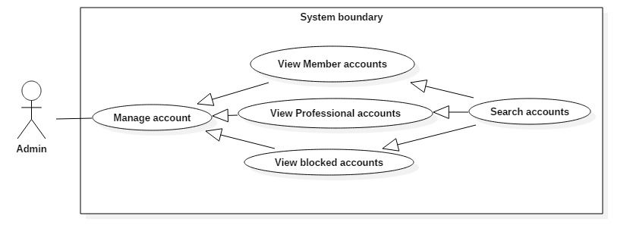

Figure 38: <Admin> Search accounts

|  |  |  |  |
| --- | --- | --- | --- |
| **USE CASE – 4.2** | | | |
| **Use Case No.** | 4.2 | **Use Case Version** | 1.1 |
| **Use Case Name** | Search accounts | | |
| **Author** | Le Dai An | | |
| **Date** | June 18, 2017 | **Priority** | Normal |
| **Actor:**   * Admin   **Summary:**   * This use case allows Admin to search account in list.   **Goal:**   * A list accounts that match input account’s name, phone, email or register date is displayed.   **Triggers:** Admin type in Search Command.  **Preconditions:**   * Actor logged in system with role Admin.   **Post Conditions:**   * **Success:** List of matching accounts based on search term is showed. * **Fail:**   **Main Success Scenario:**   |  |  |  | | --- | --- | --- | | Step | Actor Action | System Response | | 1 | - Types in Search command. | - System compare data in table with the input in Search command.  - Show results.  [Alternative 1]: There is no accounts matched with input text. |   **Alternative Scenario:**   |  |  |  | | --- | --- | --- | | Step | Cause | System Response | | 1 | - No accounts matched. | - Table without result. |   **Exceptions:** N/A  **Relationships:** N/A  **Business Rules:** N/A | | | |

##### < Admin > View account’s detail

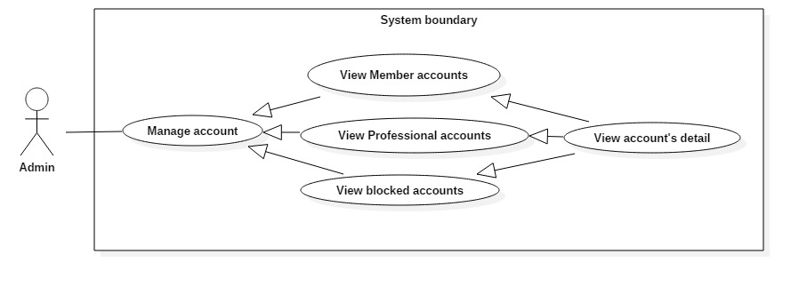

Figure 39: <Admin> View account’s detail

|  |  |  |  |
| --- | --- | --- | --- |
| **USE CASE – 4.3** | | | |
| **Use Case No.** | 4.3 | **Use Case Version** | 1.1 |
| **Use Case Name** | View account’s detail | | |
| **Author** | Le Dai An | | |
| **Date** | June 18, 2017 | **Priority** | Normal |
| **Actor:**   * Admin   **Summary:**   * This use case allows Admin view an account’s detail.   **Goal:**   * Display all information of an account.   **Triggers:** Clicks on “Chi tiết” button.  **Preconditions:**   * Actor logged in system with role Admin. * Actor can do this after use case View accounts   **Post Conditions:**   * **Success:** A page with all information of account is displayed * **Fail:** N/A   **Main Success Scenario:**   |  |  |  | | --- | --- | --- | | Step | Actor Action | System Response | | 1 | - At account list page, Admin clicks on “Chi tiết” button. | - System loads result and displays all information of account.  [Exception 1] Lost Internet Connection. |   **Alternative Scenario:** N/A  **Exceptions:**   |  |  |  | | --- | --- | --- | | No | Cause | System Response | | 1 | Internet is disconnect. | Page with error code 404. |   **Relationships:** N/A  **Business Rules:** N/A | | | |

##### < Admin > Deactivate accounts

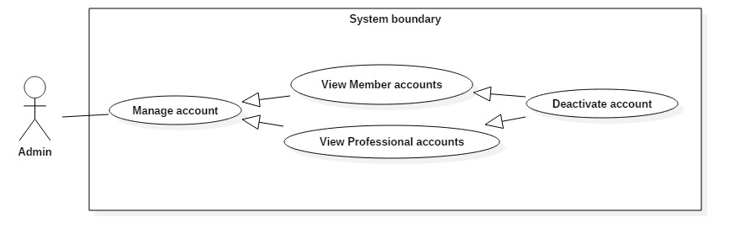

Figure 40: <Admin> Deactivate accounts

|  |  |  |  |
| --- | --- | --- | --- |
| **USE CASE – 4.4** | | | |
| **Use Case No.** | 4.4 | **Use Case Version** | 1.1 |
| **Use Case Name** | Deactivate accounts | | |
| **Author** | Le Dai An | | |
| **Date** | June 18, 2017 | **Priority** | Normal |
| **Actor:**   * Admin.   **Summary:**   * Admin can deactivate an account.   **Goal:**   * Deactivated account can’t login to system.   **Triggers:** Clicks on “Khoá tài khoản” button.  **Preconditions:**   * Actor logged in system with role Admin. * Actor can do this use case after View accounts (tabs “Member” or “Professional”) or View account’s detail (account is active).   **Post Conditions:**   * **Success:** The account is deactivated can’t login to system. * **Fail:** N/A   **Main Success Scenario:**   |  |  |  | | --- | --- | --- | | Step | Actor Action | System Response | | 1 | - Admin clicks on “Khóa tài khoản” button or go to views detail, then clicks on “Khóa tài khoản” button. | - System updates status of the account.  - Returns to account list page.  [Exception 1] Lost Internet Connection. |   **Alternative Scenario:** N/A  **Exceptions:**   |  |  |  | | --- | --- | --- | | No | Cause | System Response | | 1 | Internet is disconnect. | Page with error code 404. |   **Relationships:** N/A  **Business Rules:** N/A | | | |

##### < Admin > Activate account

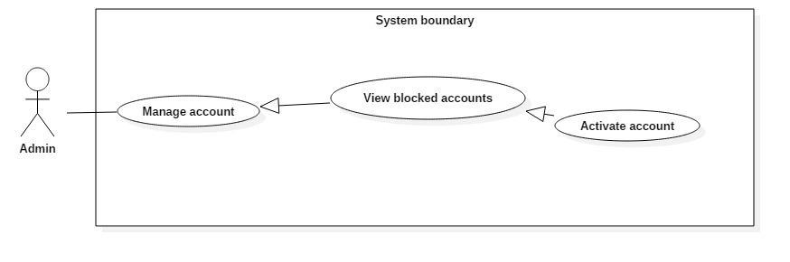

Figure 41: <Admin> Activate account

|  |  |  |  |
| --- | --- | --- | --- |
| **USE CASE – 4.5** | | | |
| **Use Case No.** | 4.5 | **Use Case Version** | 1.1 |
| **Use Case Name** | Activate account | | |
| **Author** | Le Dai An | | |
| **Date** | June 18, 2017 | **Priority** | Normal |
| **Actor:**   * Admin   **Summary:**   * Admin can activate a deactivated account.   **Goal:**   * Activate an account and the account can login to system.   **Triggers:** Clicks on “Mở tài khoản” button.  **Preconditions:**   * Actor logged in system with role Admin. * Actor can do this use case after View accounts (tab “Danh sách bị chặn) or View account’s detail (account is deactive).   **Post Conditions:**   * **Success:** Activated account can log in system * **Fail:** N/A   **Main Success Scenario:**   |  |  |  | | --- | --- | --- | | Step | Actor Action | System Response | | 1 | - Admin clicks on “Mở tài khoản” button or go to views detail, then clicks on “Mở tài khoản” button. | - System updates status of the account.  - Returns to account list page.  [Exception 1] Lost Internet Connection. |   **Alternative Scenario:** N/A  **Exceptions:**   |  |  |  | | --- | --- | --- | | No | Cause | System Response | | 1 | Internet is disconnect. | Page with error code 404. |   **Relationships:** N/A  **Business Rules:** N/A | | | |

##### < Admin > View products

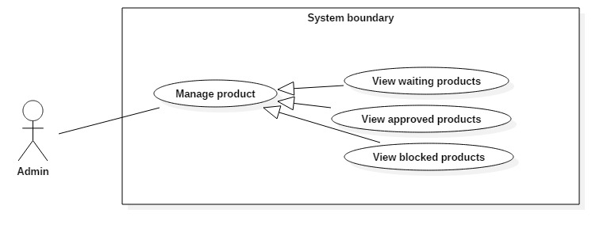

Figure 42: <Admin> View products

|  |  |  |  |
| --- | --- | --- | --- |
| **USE CASE – 4.6** | | | |
| **Use Case No.** | 4.6 | **Use Case Version** | 1.1 |
| **Use Case Name** | View products | | |
| **Author** | Le Dai An | | |
| **Date** | June 18, 2017 | **Priority** | Normal |
| **Actor:**   * Admin   **Summary:**   * This use case allows Admin to view products list include waiting, approved, blocked products.   **Goal:**   * A list waiting or approved or blocked products are displayed.   **Triggers:** Admin clicks on “Danh sách chờ duyệt” or ”Danh sách đã duyệt” or ”Danh sách bị chặn” button in “Sản phẩm” tab.  **Preconditions:**   * Actor logged in system with role Admin.   **Post Conditions:**   * **Success:** List of products based on waiting, accepted, blocked product is showed. * **Fail:**   **Main Success Scenario:**   |  |  |  | | --- | --- | --- | | Step | Actor Action | System Response | | 1 | Admin clicks on “Sản phẩm” tab.  Then clicks on “Danh sách chờ duyệt”/”Danh sách đã duyệt”/”Danh sách bị chặn” button | System loads the result. Information for each product:   * Tax number of Seller * Product’s name * Category * Style   [Alternative 1]: There is no product in system.  [Exception 1]: Internet connection is lost. |   **Alternative Scenario:**   |  |  |  | | --- | --- | --- | | Step | Cause | System Response | | 1 | System doesn’t have any product or no product in chosen status. | Web page has a table without content. |   **Exceptions:**   |  |  |  | | --- | --- | --- | | No | Cause | System Response | | 1 | Internet is disconnect. | Page with error code 404. |   **Relationships:** View products successfully so Admin can click to view product’s detail, accept or block product.  **Business Rules:** N/A | | | |

##### < Admin > Search products

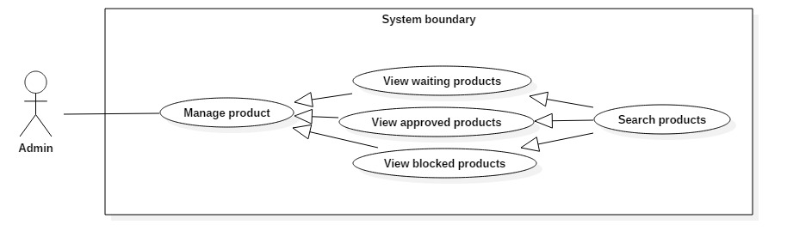

Figure 43: <Admin> Search products

|  |  |  |  |
| --- | --- | --- | --- |
| **USE CASE – 4.7** | | | |
| **Use Case No.** | 4.7 | **Use Case Version** | 1.1 |
| **Use Case Name** | Search products | | |
| **Author** | Le Dai An | | |
| **Date** | June 18, 2017 | **Priority** | Normal |
| **Actor:**   * Admin.   **Summary:**   * This use case allows Admin to search product.   **Goal:**   * A list accounts that match input tax number, product’s name, category or style is displayed.   **Triggers:**  **Preconditions:**   * Actor logged in system with role Admin.   **Post Conditions:**   * **Success:** List of matching products based on search term is showed. * **Fail:** N/A.   **Main Success Scenario:**   |  |  |  | | --- | --- | --- | | Step | Actor Action | System Response | | 1 | - Types in Search command. | - System compare data in table with the input in Search command.  - Show results.  [Alternative 1]: There is no products matched with input text. |   **Alternative Scenario:**   |  |  |  | | --- | --- | --- | | Step | Cause | System Response | | 1 | - No products matched. | - Table without result. |   **Exceptions:** N/A  **Relationships:** N/A  **Business Rules:** N/A | | | |

##### < Admin > View product’s detail

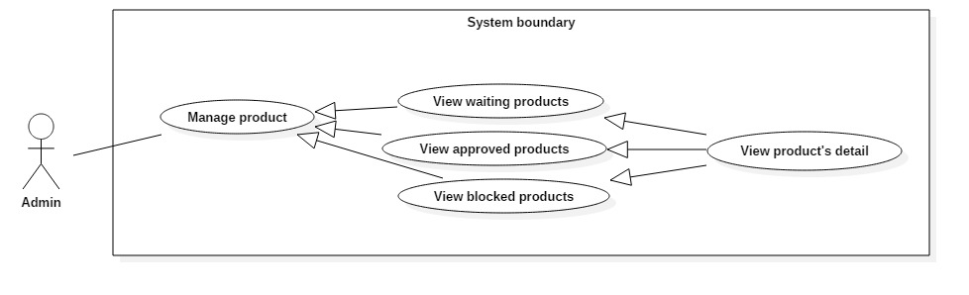

Figure 44: <Admin> View product’s detail

|  |  |  |  |
| --- | --- | --- | --- |
| **USE CASE – 4.8** | | | |
| **Use Case No.** | 4.8 | **Use Case Version** | 1.1 |
| **Use Case Name** | View product’s detail | | |
| **Author** | Le Dai An | | |
| **Date** | June 18, 2017 | **Priority** | High |
| **Actor:**   * Admin   **Summary:**   * This use case allows Admin view a product’s detail and view product’s photos list.   **Goal:**   * Display product’s detail and product’s photos list.   **Triggers:**  **Preconditions:**   * Actor logged in system with role Admin.   **Post Conditions:**   * **Success:** Product’s detail and photos list are displayed. * **Fail:**   **Main Success Scenario:**   |  |  |  | | --- | --- | --- | | Step | Actor Action | System Response | | 1 | Admin click on “Chi tiết” button. | System displays product’s detail and product’s photos.  [Exception 1] Lost Internet Connection. |   **Alternative Scenario:** N/A  **Exceptions:**   |  |  |  | | --- | --- | --- | | No | Cause | System Response | | 1 | Internet is disconnect. | Page with error code 404. |   **Relationships:** N/A  **Business Rules:** N/A | | | |

##### < Admin > Accept product

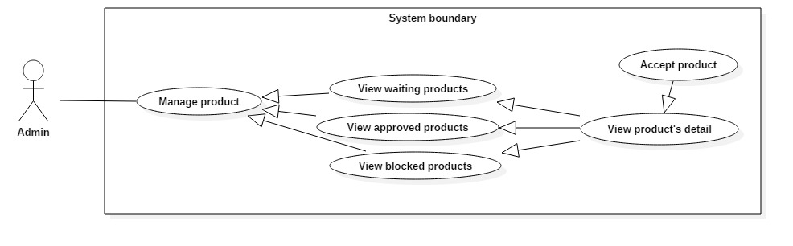

Figure 45: <Admin> Accept product

|  |  |  |  |
| --- | --- | --- | --- |
| **USE CASE – 4.9** | | | |
| **Use Case No.** | 4.9 | **Use Case Version** | 1.1 |
| **Use Case Name** | Accept product | | |
| **Author** | Le Dai An | | |
| **Date** | June 18, 2017 | **Priority** | High |
| **Actor:**   * Admin.   **Summary:**   * This use case allows Admin accept a product.   **Goal:**   * The product’s status is changed to “accepted” and system shows the product.   **Triggers:**  **Preconditions:**   * Actor logged in system with role Admin.   **Post Conditions:**   * **Success:** Product’s status is changed to “accepted”. * **Fail:**   **Main Success Scenario:**   |  |  |  | | --- | --- | --- | | Step | Actor Action | System Response | | 1 | Admin click on “Chấp nhận” button. | System redirects to before page.  [Exception 1] Lost Internet Connection. |   **Alternative Scenario:** N/A  **Exceptions:**   |  |  |  | | --- | --- | --- | | No | Cause | System Response | | 1 | Internet is disconnect. | Page with error code 404. |   **Relationships:** N/A  **Business Rules:** N/A | | | |

##### < Admin > Block product

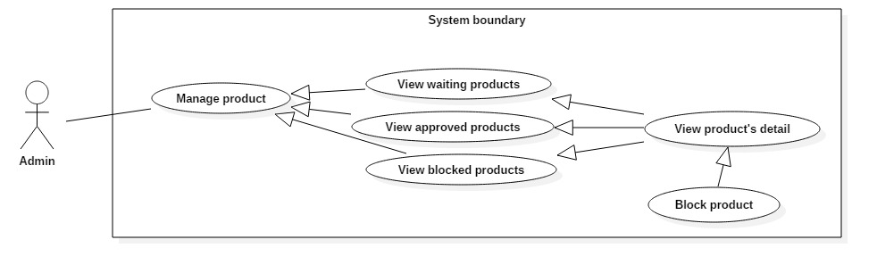

Figure 46: <Admin> Block product

|  |  |  |  |
| --- | --- | --- | --- |
| **USE CASE – 4.10** | | | |
| **Use Case No.** | 4.10 | **Use Case Version** | 1.1 |
| **Use Case Name** | Block product | | |
| **Author** | Le Dai An | | |
| **Date** | June 18, 2017 | **Priority** | High |
| **Actor:**   * Admin.   **Summary:**   * This use case allows Admin block a product.   **Goal:**   * The product’s status is changed to “blocked” and system hires the product.   **Triggers:**  **Preconditions:**   * Actor logged in system with role Admin.   **Post Conditions:**   * **Success:** Product’s status is changed to “blocked”. * **Fail:**   **Main Success Scenario:**   |  |  |  | | --- | --- | --- | | Step | Actor Action | System Response | | 1 | Admin click on “Chặn” button. | System redirects to before page.  [Exception 1] Lost Internet Connection. |   **Alternative Scenario:** N/A  **Exceptions:**   |  |  |  | | --- | --- | --- | | No | Cause | System Response | | 1 | Internet is disconnect. | Page with error code 404. |   **Relationships:** N/A  **Business Rules:** N/A | | | |

##### < Admin > View idea books

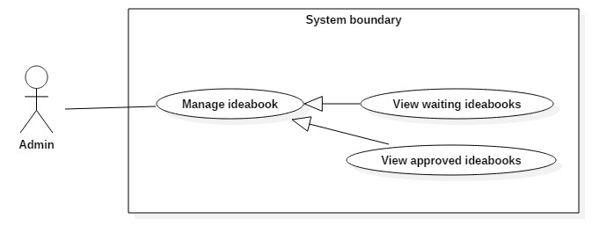

Figure 47: <Admin> View idea books

|  |  |  |  |
| --- | --- | --- | --- |
| **USE CASE – 4.11** | | | |
| **Use Case No.** | 4.11 | **Use Case Version** | 1.1 |
| **Use Case Name** | View products | | |
| **Author** | Le Dai An | | |
| **Date** | June 18, 2017 | **Priority** | Normal |
| **Actor:**   * Admin   **Summary:**   * This use case allows Admin to view idea books list include waiting and approved idea books.   **Goal:**   * A list waiting or approved idea books are displayed.   **Triggers:** Admin clicks on “Danh sách chờ duyệt”/”Danh sách đã duyệt” button in “Quản lý ideabooks” tab.  **Preconditions:**   * Actor logged in system with role Admin.   **Post Conditions:**   * **Success:** List of idea books based on waiting or approved idea book is showed. * **Fail:**   **Main Success Scenario:**   |  |  |  | | --- | --- | --- | | Step | Actor Action | System Response | | 1 | Admin clicks on “Ideabooks” tab.  Then clicks on “Danh sách chờ duyệt”/”Danh sách đã duyệt” button | System loads the result. Information for each idea book:   * A Photo * Email * Title * Category * Style   [Alternative 1]: There is no ideabook in system.  [Exception 1]: Internet connection is lost. |   **Alternative Scenario:**   |  |  |  | | --- | --- | --- | | Step | Cause | System Response | | 1 | System doesn’t have any idea book or no idea book in chosen status. | Web page has a table without content. |   **Exceptions:**   |  |  |  | | --- | --- | --- | | No | Cause | System Response | | 1 | Internet is disconnect. | Page with error code 404. |   **Relationships:** View idea books successfully so Admin can view idea book’s detail, approve idea book.  **Business Rules:** N/A | | | |

##### < Admin > Search idea books

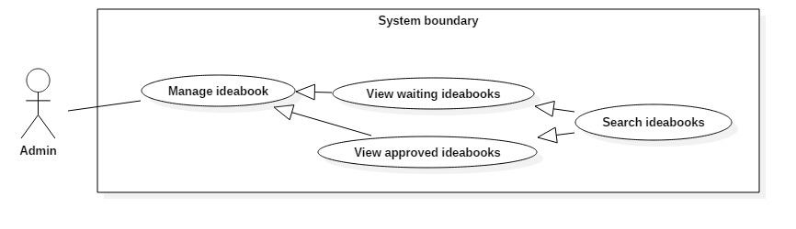

Figure 48: <Admin> Search idea books

|  |  |  |  |
| --- | --- | --- | --- |
| **USE CASE – 4.12** | | | |
| **Use Case No.** | 4.12 | **Use Case Version** | 1.1 |
| **Use Case Name** | Search idea books | | |
| **Author** | Le Dai An | | |
| **Date** | June 18, 2017 | **Priority** | Normal |
| **Actor:**   * Admin   **Summary:**   * This use case allows Admin to search idea book. So that admin can view idea book’s detail.   **Goal:**   * A list idea books that match input idea book’s name or email is displayed.   **Triggers:** Admin type in Search Command.  **Preconditions:**   * Actor logged in system with role Admin.   **Post Conditions:**   * **Success:** List of matching idea books based on search term is showed. * **Fail:**   **Main Success Scenario:**   |  |  |  | | --- | --- | --- | | Step | Actor Action | System Response | | 1 | - Types in Search command. | - System compare data in table with the input in Search command.  - Show results.  [Alternative 1]: There is no idea books matched with input text. |   **Alternative Scenario:**   |  |  |  | | --- | --- | --- | | Step | Cause | System Response | | 1 | - No idea books matched. | - Table without result. |   **Exceptions:** N/A  **Relationships:** N/A  **Business Rules:** N/A | | | |

##### < Admin > View idea book’s detail

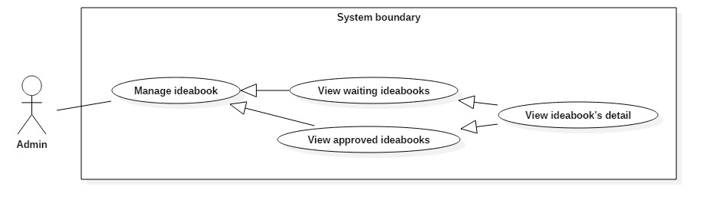

Figure 49: <Admin> View idea book’s detail

|  |  |  |  |
| --- | --- | --- | --- |
| **USE CASE – 4.13** | | | |
| **Use Case No.** | 4.13 | **Use Case Version** | 1.1 |
| **Use Case Name** | View idea book’s detail | | |
| **Author** | Le Dai An | | |
| **Date** | June 18, 2017 | **Priority** | Normal |
| **Actor:**   * Admin   **Summary:**   * This use case allows Admin view an idea book’s detail and view idea book’s photos list.   **Goal:**   * Display idea book’s detail and idea book’s photos list.   **Triggers:**  **Preconditions:**   * Actor logged in system with role Admin.   **Post Conditions:**   * **Success:** Project’s detail and photos list are displayed. * **Fail:**   **Main Success Scenario:**   |  |  |  | | --- | --- | --- | | Step | Actor Action | System Response | | 1 | Admin click on “Chi tiết” button. | System displays idea book’s detail and idea book’s photos list.  [Exception 1] Lost Internet Connection. |   **Alternative Scenario:** N/A  **Exceptions:**   |  |  |  | | --- | --- | --- | | No | Cause | System Response | | 1 | Internet is disconnect. | Page with error code 404. |   **Relationships:**  **Business Rules:** | | | |

##### < Admin > View projects

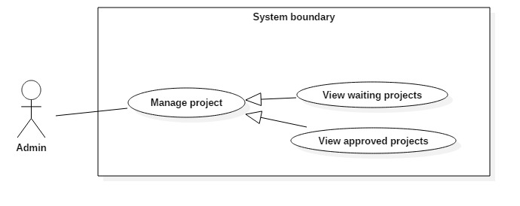

Figure 50: <Admin> View project

|  |  |  |  |
| --- | --- | --- | --- |
| **USE CASE – 4.14** | | | |
| **Use Case No.** | 4.14 | **Use Case Version** | 1.1 |
| **Use Case Name** | View projects | | |
| **Author** | Le Dai An | | |
| **Date** | June 18, 2017 | **Priority** | Normal |
| **Actor:**   * Borrower   **Summary:**   * This use case allows Borrowers to search book. So that borrowers can view status of book, add book to wish list.   **Goal:**   * A list books that match input book’s name is displayed.   **Triggers:** Borrower send Search Command.  **Preconditions:**   * Actor logged in system with role Borrower.   **Post Conditions:**   * **Success:** List of matching books based on search term is showed. * **Fail:** A Dialog will be showed and display message: “Search fail. Please check your internet connection”.   **Main Success Scenario:**   |  |  |  | | --- | --- | --- | | Step | Actor Action | System Response | | 1 | Admin clicks on “Projects” tab.  Then clicks on “Danh sách chờ duyệt”/”Danh sách đã duyệt” button | System loads the result. Information for each idea book:   * Email * Project’s name * Address * Cost * Year * Category * Style   [Alternative 1]: There is no project in system.  [Exception 1]: Internet connection is lost. |   **Alternative Scenario:**   |  |  |  | | --- | --- | --- | | Step | Cause | System Response | | 1 | System doesn’t have any project or no project in chosen status. | Web page has a table without content. |   **Exceptions:**   |  |  |  | | --- | --- | --- | | No | Cause | System Response | | 1 | Internet is disconnect. | Page with error code 404. |   **Relationships:** Search successfully so Borrower can add book to wish list if Book is not available at that time.  **Business Rules:**   * Search return the most matched book with the search term. * Book Title: free text * Position: free text, get floor, shelf from position table. * Author: free text, get author name from author table. * Is available: Available if total book copies is more than number of borrowing books. If not, it’s not available. | | | |

##### < Admin > Search projects

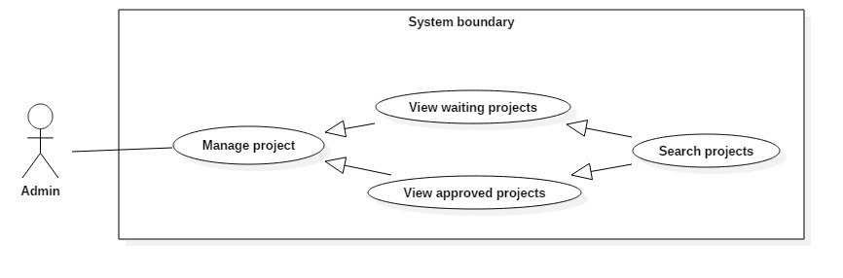

Figure 51: <Admin> Search project

|  |  |  |  |
| --- | --- | --- | --- |
| **USE CASE – 4.15** | | | |
| **Use Case No.** | 4.15 | **Use Case Version** | 1.1 |
| **Use Case Name** | Search projects | | |
| **Author** | Le Dai An | | |
| **Date** | June 18, 2017 | **Priority** | Normal |
| **Actor:**   * Admin   **Summary:**   * This use case allows Admin to search project. So that admin can view project’s detail.   **Goal:**   * A list projects that match input project’s name or email is displayed.   **Triggers:** Admin type in Search Command.  **Preconditions:**   * Actor logged in system with role Admin.   **Post Conditions:**   * **Success:** List of matching projects based on search term is showed. * **Fail:**   **Main Success Scenario:**   |  |  |  | | --- | --- | --- | | Step | Actor Action | System Response | | 1 | - Types in Search command. | - System compare data in table with the input in Search command.  - Show results.  [Alternative 1]: There is no projects matched with input text. |   **Alternative Scenario:**   |  |  |  | | --- | --- | --- | | Step | Cause | System Response | | 1 | - No projects matched. | - Table without result. |   **Exceptions:** N/A  **Relationships:** N/A  **Business Rules:** N/A | | | |

##### < Admin > View project’s detail

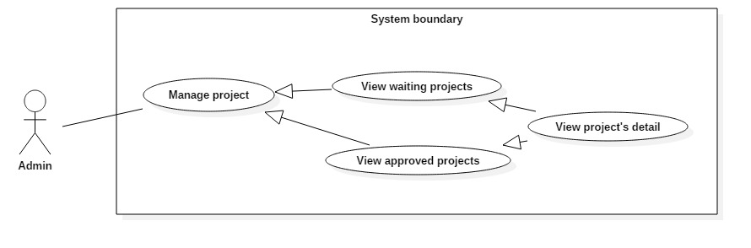

Figure 52: <Admin> View project

|  |  |  |  |
| --- | --- | --- | --- |
| **USE CASE – 4.16** | | | |
| **Use Case No.** | 4.16 | **Use Case Version** | 1.1 |
| **Use Case Name** | View project’s detail | | |
| **Author** | Le Dai An | | |
| **Date** | June 18, 2017 | **Priority** | Normal |
| **Actor:**   * Admin   **Summary:**   * This use case allows Admin view a project’s detail and view project’s photos list.   **Goal:**   * Display project’s detail and project’s photos list.   **Triggers:** Clicks on “Chi tiết” button.  **Preconditions:**   * Actor logged in system with role Admin.   **Post Conditions:**   * **Success:** Project’s detail and photos list are displayed. * **Fail:**   **Main Success Scenario:**   |  |  |  | | --- | --- | --- | | Step | Actor Action | System Response | | 1 | Admin clicks on “Chi tiết” button. | System displays project’s detail and project’s photos list.  [Exception 1] Lost Internet Connection. |   **Alternative Scenario:** N/A  **Exceptions:**   |  |  |  | | --- | --- | --- | | No | Cause | System Response | | 1 | Internet is disconnect. | Page with error code 404. |   **Relationships:**  **Business Rules:** | | | |

##### < Admin > View photo’s detail

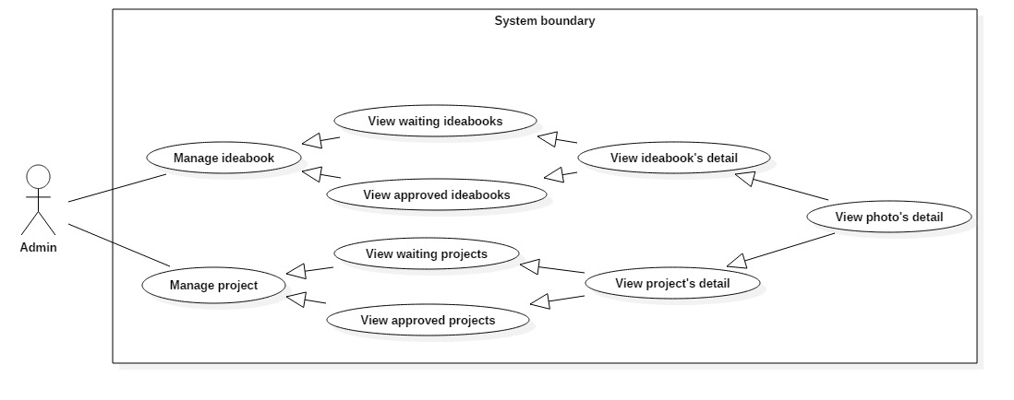

Figure 53: <Admin> View photo’s detail

|  |  |  |  |
| --- | --- | --- | --- |
| **USE CASE – 4.17** | | | |
| **Use Case No.** | 4.17 | **Use Case Version** | 1.1 |
| **Use Case Name** | View photo’s detail | | |
| **Author** | Le Dai An | | |
| **Date** | June 18, 2017 | **Priority** | Normal |
| **Actor:**   * Admin   **Summary:**   * This use case allows Admin view photo’s detail.   **Goal:**   * Display photo’s detail.   **Triggers:** Select a photo from in list.  **Preconditions:**   * Actor logged in system with role Admin.   **Post Conditions:**   * **Success:** Photo’s detail is displayed. * **Fail:**   **Main Success Scenario:**   |  |  |  | | --- | --- | --- | | Step | Actor Action | System Response | | 1 | Admin clicks to select a photo from photo list in an idea book or project. | System displays photo’s detail.  [Exception 1] Lost Internet Connection. |   **Alternative Scenario:** N/A  **Exceptions:**   |  |  |  | | --- | --- | --- | | No | Cause | System Response | | 1 | Internet is disconnect. | Page with error code 404. |   **Relationships:** N/A  **Business Rules:** N/A | | | |

##### < Admin > Accept photo

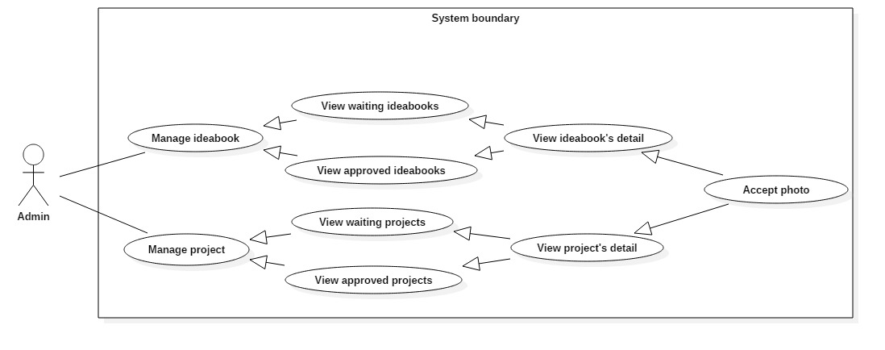

Figure 54: <Admin> Accept photo

|  |  |  |  |
| --- | --- | --- | --- |
| **USE CASE – 4.18** | | | |
| **Use Case No.** | 4.18 | **Use Case Version** | 1.1 |
| **Use Case Name** | Accept photo | | |
| **Author** | Le Dai An | | |
| **Date** | June 18, 2017 | **Priority** | High |
| **Actor:**   * Borrower.   **Summary:**   * This use case allows Admin accept a photo in ideabook or project.   **Goal:**   * The photo’s status is changed to “accepted” and publish photo in system.   **Triggers:** Clicks on “Chấp nhận” button.  **Preconditions:**   * Actor logged in system with role Admin.   **Post Conditions:**   * **Success:** Photo’s status is changed to blocked and display a correct image on the photo. * **Fail:**   **Main Success Scenario:**   |  |  |  | | --- | --- | --- | | Step | Actor Action | System Response | | 1 | Admin clicks on “Chấp nhận” button. | System refresh page and set correct icon on the photo.  [Exception 1] Lost Internet Connection. |   **Alternative Scenario:** N/A  **Exceptions:**   |  |  |  | | --- | --- | --- | | No | Cause | System Response | | 1 | Internet is disconnect. | Page with error code 404. |   **Relationships:** N/A  **Business Rules:** N/A | | | |

##### < Admin > Block photo

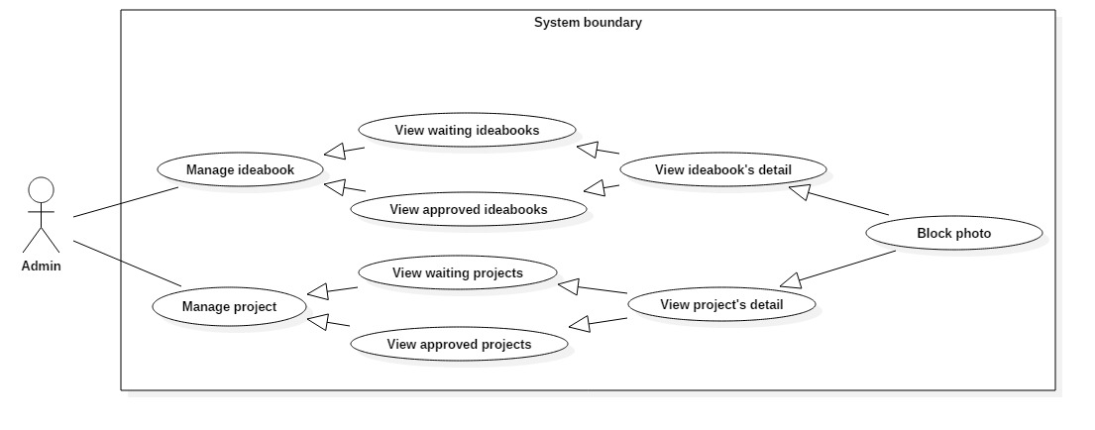

Figure 55: <Admin> Block photo

|  |  |  |  |
| --- | --- | --- | --- |
| **USE CASE – 4.19** | | | |
| **Use Case No.** | 4.19 | **Use Case Version** | 1.1 |
| **Use Case Name** | Block photo | | |
| **Author** | Le Dai An | | |
| **Date** | June 18, 2017 | **Priority** | High |
| **Actor:**   * Admin   **Summary:**   * This use case allows Admin block a photo in ideabook or project.   **Goal:**   * The photo’s status is changed to “blocked” and remove the photo from system.   **Triggers:** Clicks on “Chặn” button.  **Preconditions:**   * Actor logged in system with role Admin.   **Post Conditions:**   * **Success:** Photo’s status is changed to blocked and display a wrong image on the photo. * **Fail:**   **Main Success Scenario:**   |  |  |  | | --- | --- | --- | | Step | Actor Action | System Response | | 1 | Admin clicks on “Chặn” button. | System refresh page and set wrong icon on the photo.  [Exception 1] Lost Internet Connection. |   **Alternative Scenario:** N/A  **Exceptions:**   |  |  |  | | --- | --- | --- | | No | Cause | System Response | | 1 | Internet is disconnect. | Page with error code 404. |   **Relationships:** N/A  **Business Rules:** N/A | | | |

##### < Admin > Approve

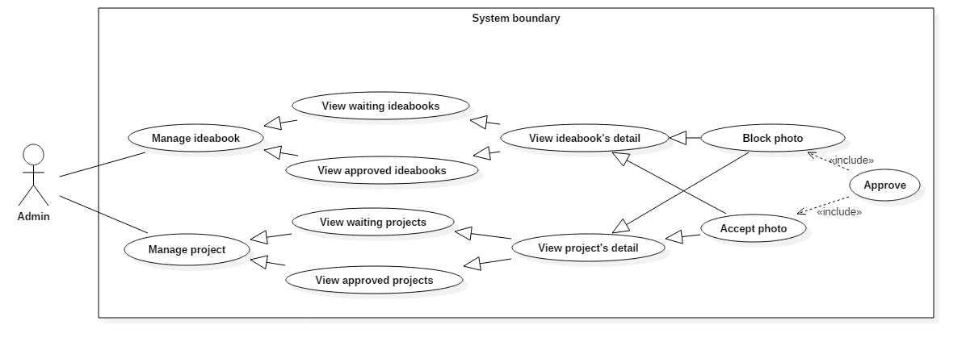

Figure 56: <Admin> Approve

|  |  |  |  |
| --- | --- | --- | --- |
| **USE CASE – 4.20** | | | |
| **Use Case No.** | 4.20 | **Use Case Version** | 1.1 |
| **Use Case Name** | Approve | | |
| **Author** | Le Dai An | | |
| **Date** | June 18, 2017 | **Priority** | Normal |
| **Actor:**   * Admin   **Summary:**   * This use case allows Admin approve an ideabook or project.   **Goal:**   * Set ideabook’s status or project’s status to accepted or blocked.   **Triggers:** Clicks on “Hoàn thành” button.  **Preconditions:**   * Actor logged in system with role Admin.   **Post Conditions:**   * **Success:** Ideabook’s status or project’s status is change and system redirects back to list page. * **Fail:** show message “Vui lòng duyệt hết tất cả hình ảnh!!”   **Main Success Scenario:**   |  |  |  | | --- | --- | --- | | Step | Actor Action | System Response | | 1 | Admin clicks on “Hoàn thành” button. | System redirects to before page.  [Alternative 1]: Idea book or project has photo is not approved yet.  [Exception 1] Lost Internet Connection. |   **Alternative Scenario:**   |  |  |  | | --- | --- | --- | | Step | Cause | System Response | | 1 | Photos in idea book or project are not approved completely. | Shows message “Vui lòng duyệt hết tất cả hình ảnh!!” |   **Exceptions:**   |  |  |  | | --- | --- | --- | | No | Cause | System Response | | 1 | Internet is disconnect. | Page with error code 404. |   **Relationships:** N/A  **Business Rules:** N/A | | | |

##### < Admin > Logout

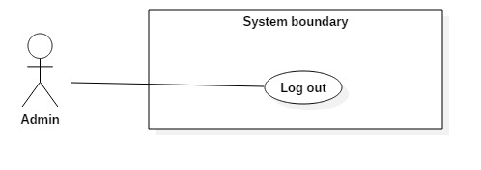

Figure 57: <Admin> Logout

|  |  |  |  |
| --- | --- | --- | --- |
| **USE CASE – 4.21** | | | |
| **Use Case No.** | 4.21 | **Use Case Version** | 1.0 |
| **Use Case Name** | Logout | | |
| **Author** | Le Dai An | | |
| **Date** | June 18, 2017 | **Priority** | Normal |
| **Actor:**   * Admin.   **Summary:**   * This use case allows Admin to logout of the system.   **Goal:**   * Invalidate the Admin, redirect to login view   **Triggers:** Clicks on log out icon or “Đăng xuất” button.  **Preconditions:** Actor logged in the system as an Admin.  **Post Conditions:**   * **Success:** Admin is logged out of the system. * **Fail:** N/A   **Main Success Scenario:**   |  |  |  | | --- | --- | --- | | Step | Actor Action | System Response | | 1 | - Admin clicks on Setting then clicks on “Đăng xuất” button. | - Clear session.  - System redirects the Admin to login view.  [Exception 1] Lost Internet Connection. |   **Alternative Scenario:** N/A  **Exceptions:**   |  |  |  | | --- | --- | --- | | No | Cause | System Response | | 1 | Internet is disconnect. | Page with error code 404. |   **Relationships:** N/A  **Business Rules:** N/A | | | |

#### System

##### < System > Add tracking

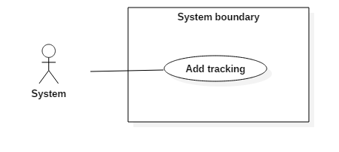

Figure 58: <System > Add tracking

|  |  |  |  |
| --- | --- | --- | --- |
| **USE CASE – 5.1** | | | |
| **Use Case No.** | 5.1 | **Use Case Version** | 1.0 |
| **Use Case Name** | Add tracking | | |
| **Author** | Vo Tran Hoang Long | | |
| **Date** | June 18, 2017 | **Priority** | Normal |
| **Actor:**   * System   **Summary:**   * This use case allows System keep tracking on user behavior   **Goal:**   * Keep tracking when user view photo and product on website   **Triggers:**  **Preconditions:** User view photo or product  **Post Conditions:**   * **Success:** User behavior is tracked * **Fail:** N/A   **Main Success Scenario:**   |  |  |  | | --- | --- | --- | | Step | Actor Action | System Response | | 1 | User view photo or product. | System catch the category of photo which was viewed by user and store in database |   **Alternative Scenario:**   |  |  |  | | --- | --- | --- | | No. | Actor Action | System Response | | 1 | |  |  |   **Exception:** N/A  **Relationships:** N/A  **Business Rules:** N/A | | | |

##### < System > Remove tracking

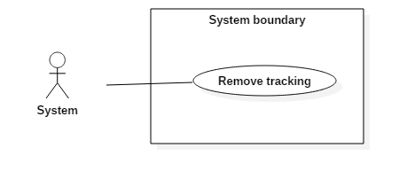

Figure 59: <System > Remove tracking

|  |  |  |  |
| --- | --- | --- | --- |
| **USE CASE – 5.2** | | | |
| **Use Case No.** | 5.2 | **Use Case Version** | 1.0 |
| **Use Case Name** | Remove tracking | | |
| **Author** | Vo Tran Hoang Long | | |
| **Date** | June 18, 2017 | **Priority** | Normal |
| **Actor:**   * System   **Summary:**   * This use case allows System automatically remove outdate tracking   **Goal:**   * This function will be run automatically at a specific time, it remove tracking which out of date base on a predefined period time variable.   **Triggers:**  **Preconditions:**  **Post Conditions:**   * **Success:** Outdate tracking is deleted * **Fail:** N/A   **Main Success Scenario:**   |  |  |  | | --- | --- | --- | | Step | Actor Action | System Response | | 1 | At the specific time, a crontab will run function to remove outdate tracking | System find and remove outdate tracking from database |   **Alternative Scenario:**   |  |  |  | | --- | --- | --- | | No. | Actor Action | System Response | | 1 | |  |  |   **Exception:** N/A  **Relationships:** N/A  **Business Rules:** N/A | | | |

##### < System > Send promotion to Customer

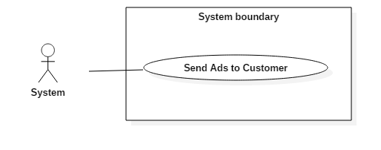

Figure 60: <System> Send Ads to Customer

|  |  |  |  |
| --- | --- | --- | --- |
| **USE CASE – 5.3** | | | |
| **Use Case No.** | 5.3 | **Use Case Version** | 1.0 |
| **Use Case Name** | Send promotion to Customer | | |
| **Author** | Vo Tran Hoang Long | | |
| **Date** | June 18, 2017 | **Priority** | Normal |
| **Actor:**   * System   **Summary:**   * This use case allows System automatically send Ads of promotion to Customer   **Goal:**   * This function will be run automatically at a specific time, it collect promotion and send them to customers who are interested in (base on “Tracking”).   **Triggers:**  **Preconditions:**  **Post Conditions:**   * **Success:** Promotions will be sent to customer * **Fail:** N/A   **Main Success Scenario:**   |  |  |  | | --- | --- | --- | | Step | Actor Action | System Response | | 1 | At the specific time, a crontab will run function to collect promotion and send them to customer via email | System collects promotion and email them to customer |   **Alternative Scenario:**   |  |  |  | | --- | --- | --- | | No. | Actor Action | System Response | | 1 | |  |  |   **Exception:** N/A  **Relationships:** N/A  **Business Rules:** N/A | | | |

##### < System > Send notification to Admin

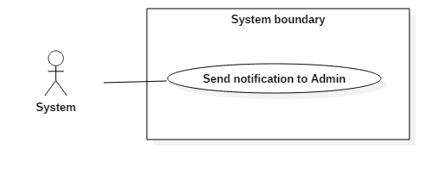

Figure 61: <System > Send notification to Admin

|  |  |  |  |
| --- | --- | --- | --- |
| **USE CASE – 5.4** | | | |
| **Use Case No.** | 5.4 | **Use Case Version** | 1.0 |
| **Use Case Name** | Send notification to Admin | | |
| **Author** | Vo Tran Hoang Long | | |
| **Date** | June 18, 2017 | **Priority** | Normal |
| **Actor:**   * System   **Summary:**   * This use case allows System automatically send notification to admin on admin page   **Goal:**   * This function will be run automatically, it check and notify to admin when:   + Product need approval   + New photo of project and idea book need approval   **Triggers:**  **Preconditions:**   * Product need approval * New photo of project and idea book need approval   **Post Conditions:**   * **Success:** Notification will be shown on admin page * **Fail:** N/A   **Main Success Scenario:**   |  |  |  | | --- | --- | --- | | Step | Actor Action | System Response | | 1 | At the specific time, a crontab will run function to check unapproved product and photo | System check and send notification to admin if it has any unapproved product or photo |   **Alternative Scenario:**   |  |  |  | | --- | --- | --- | | No. | Actor Action | System Response | | 1 | |  |  |   **Exception:** N/A  **Relationships:** N/A  **Business Rules:** N/A | | | |

##### < System > Send notification of product approval

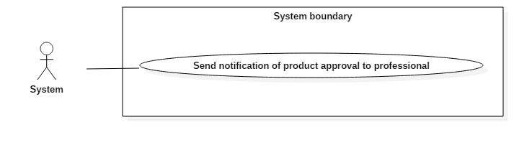

Figure 62: <System > Send notification of product approval

|  |  |  |  |
| --- | --- | --- | --- |
| **USE CASE – 5.5** | | | |
| **Use Case No.** | 5.5 | **Use Case Version** | 1.0 |
| **Use Case Name** | Send notification of product approval | | |
| **Author** | Vo Tran Hoang Long | | |
| **Date** | June 18, 2017 | **Priority** | Normal |
| **Actor:**   * System   **Summary:**   * This use case allows System automatically send notification to Professional when their product is approved (via email)   **Goal:**   * An email will be sent to Professional when Admin approve a Product.   **Triggers:**   * N/A   **Preconditions:**   * N/A   **Post Conditions:**   * **Success:** An email will be sent to Professional when Admin approve a Product. * **Fail:** N/A   **Main Success Scenario:**   |  |  |  | | --- | --- | --- | | Step | Actor Action | System Response | | 1 | Admin approve a Product | System will sent an email to Professional when their Product is approved |   **Alternative Scenario:**   |  |  |  | | --- | --- | --- | | No. | Actor Action | System Response | | 1 | |  |  |   **Exception:** N/A  **Relationships:** N/A  **Business Rules:** N/A | | | |

##### < System > Send notification of banned post



Figure 63: <System > Send notification of banned post

|  |  |  |  |
| --- | --- | --- | --- |
| **USE CASE – 5.6** | | | |
| **Use Case No.** | 5.6 | **Use Case Version** | 1.0 |
| **Use Case Name** | Send notification of banned post | | |
| **Author** | Vo Tran Hoang Long | | |
| **Date** | June 18, 2017 | **Priority** | Normal |
| **Actor:**   * System   **Summary:**   * This use case allows System automatically send notification to Professional or Customer when their post is banned (post is Product or photo in Idea Book, Project) via email   **Goal:**   * An email will be sent to Professional or Customer when Admin banned a post   **Triggers:**   * N/A   **Preconditions:**   * N/A   **Post Conditions:**   * **Success:** An email will be sent to Professional or Customer when Admin banned a post * **Fail:** N/A   **Main Success Scenario:**   |  |  |  | | --- | --- | --- | | Step | Actor Action | System Response | | 1 | Admin ban a post | System will sent an email to Customer or Professional when their post is banned |   **Alternative Scenario:**   |  |  |  | | --- | --- | --- | | No. | Actor Action | System Response | | 1 | |  |  |   **Exception:** N/A  **Relationships:** N/A  **Business Rules:** N/A | | | |

##### < System > Manage order

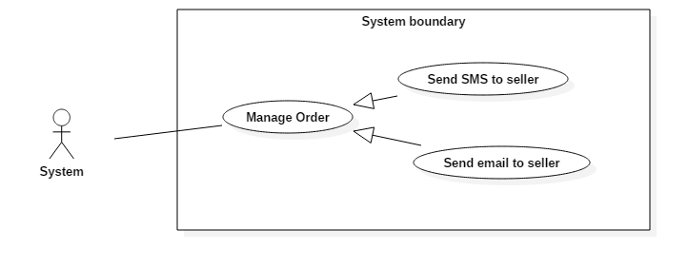

Figure 64: <System > Manage order

|  |  |  |  |
| --- | --- | --- | --- |
| **USE CASE – 5.7** | | | |
| **Use Case No.** | 5.7 | **Use Case Version** | 1.0 |
| **Use Case Name** | Manage order | | |
| **Author** | Vo Tran Hoang Long | | |
| **Date** | June 18, 2017 | **Priority** | Normal |
| **Actor:**   * System.   **Summary:**   * This use case allows System send email to seller when order is created   **Goal:**   * Send email to seller which appears in orders.   **Triggers:**  **Preconditions:** User checkout shopping cart.  **Post Conditions:**   * **Success:** Email will be sent to seller * **Fail:** N/A   **Main Success Scenario:**   |  |  |  | | --- | --- | --- | | Step | Actor Action | System Response | | 1 | User checkout shopping cart. | System send email to seller. |   **Alternative Scenario:**   |  |  |  | | --- | --- | --- | | No. | Actor Action | System Response | | 1 | |  |  |   **Exception:** N/A  **Relationships:** N/A  **Business Rules:** N/A | | | |

## Software System Attribute



### Usability

* The Web application for guest/ member/ professional/ seller will take less than 5 minutes to get used.
* The Web application for admin will take 10-30 minutes to get used to the system completely

### Reliability

* The number of sending notification failure is 1 time per 1000 notifications.
* Timer tasks run at configured time with 100% execution rate.

### Availability

* System is available 24 hours per day and 7 days per week.
* System should take at most 5 hours per month for backup or repairing.

### Security

* Privacy: Each role of user has a specific permission to interact with system.
* System always checks authorization and authenticated before doing anything.
* Only admin can grant permission to other roles.

### Maintenance

* The system is divided into separated modules.
* The code is easy to maintain and upgrade.

### Portability

* The web application is running on Windows Server 2008 or above.

### Performance

* Web appication handles the task within 30 seconds.