# Report 4 - Software Design Description

## Design Overview

* The architectural design describes the overall architecture of the system and the architecture of each main component and subsystem.
* The detailed design describes static and dynamic structure for each component and functions. It includes class diagrams, class explanations and sequence diagrams for each use cases.
* The database design describes the relationships between entities and details of each entity.
* Document overview:
* Section 1: gives an overall description of the system architecture design.
* Section 2: gives component diagrams that describe the connection and integration of the system.
* Section 3: gives the detail design description, which includes class diagram, class explanation, and sequence diagram to details the application functions.
* Section 4: gives the interface design description, which includes component interface, web application interface and mobile application design.
* Section 5: describe a fully attributed Entity Relationship Diagram.
* Section 6: describe the algorithms that apply to the system.

## System Architectural Design

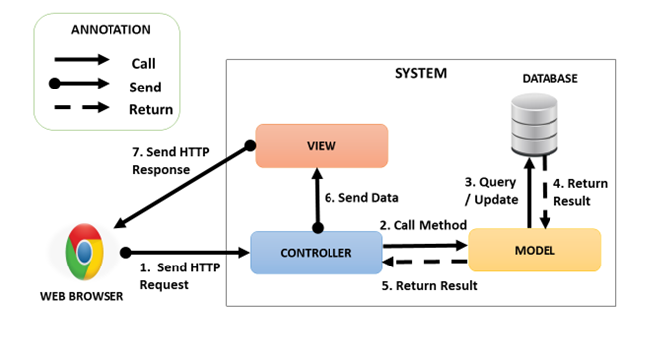

*Figure 1: System Architectural Design*

### Web Application Architecture Description

In Web Application, we develop the system under MVC architecture style. We choose this architecture for Web application because of following advantages:

* Web application contains Web services with MVC architecture; we can separate business code with Controller and View. In addition, we can use the business code in web service without repeat the code.
* We can organize the code better for maintainability, extensibility, reusability.
* In scope of 4-members team, MVC architecture makes it easier to split the big project into small modules and make it easier to assign each module for members in our team

## Component Diagram

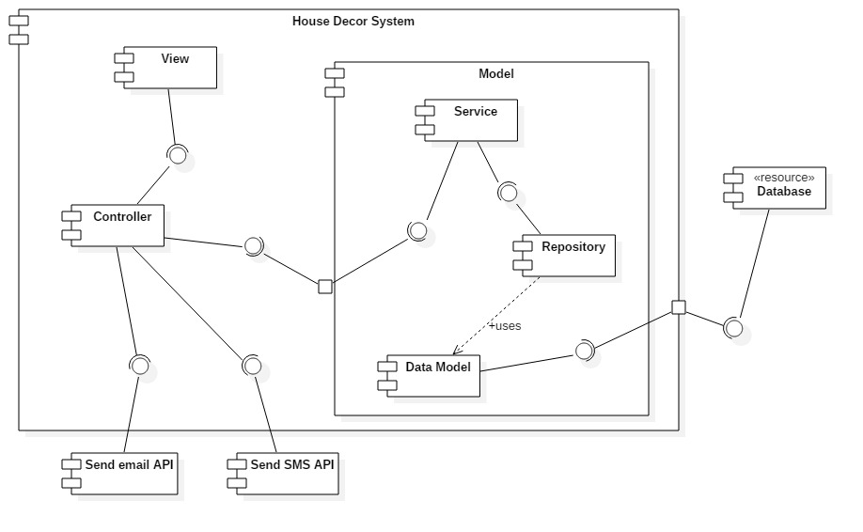

*Figure 2: Web Service Architecture*

|  |  |
| --- | --- |
| **Name** | **Description** |
| Controller | Common component used to handle request. |
| Service | Common component used to handle system’s business operations. |
| Repository | Component used to handle interaction between the system and database. |
| Data Model | Class entity |
| Database | Support storage and manipulate data. |
| Send email API | Provide API for send email. |
| Send SMS API | Provide API for send SMS. |

*Table 1: Component Dictionary*

## Detailed Description

### Class Diagram

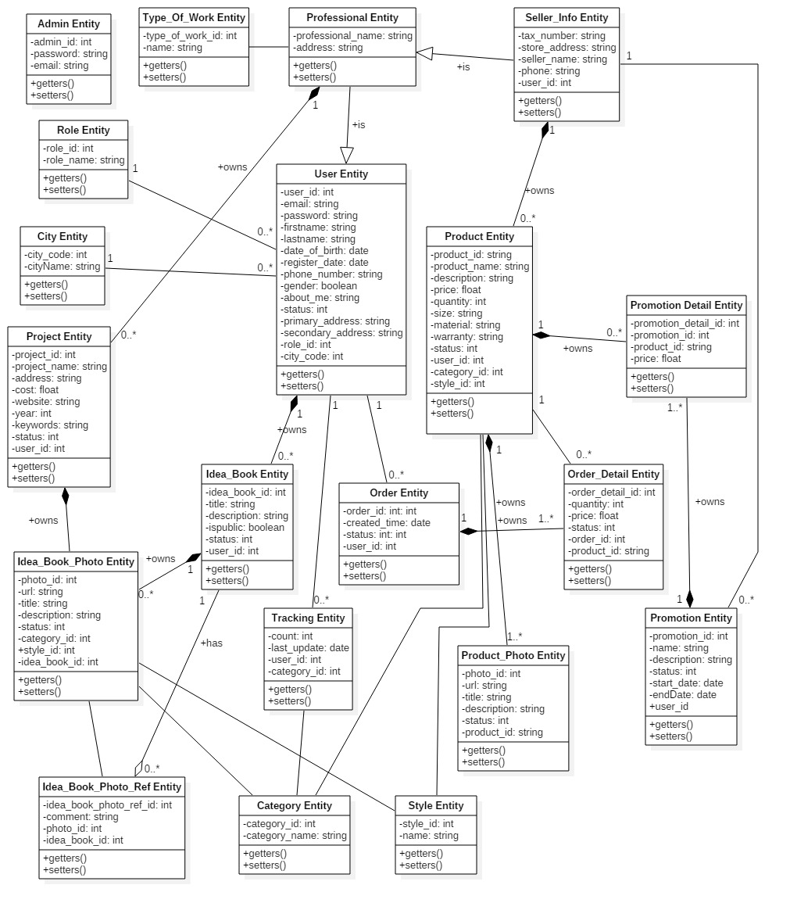

*Figure 3: Web Service Architecture*

|  |  |  |
| --- | --- | --- |
| **Class name** | **Mapping column with conceptual diagram** | **Description** |
| Admin Entity | Admin | Admin’s accounts in the system. |
| Professional Entity | Account | Professional’s information in the system. |
| User Entity | User | User’s accounts in the system. |
| Role Entity | Role | Roles in the system. |
| Order Entity | Order | Orders in the system. |
| Order Detail Entity | Order Detail | Order’s details in the system. |
| City Entity | City | Cities in the system. |
| Tracking Entity | Tracking | Tracking user’s activities in the system. |
| Category Entity | Category | Categories in the system. Example of category are . |
| Idea_Book_Photo Entity | Idea Book Photo | Idea book and project photos in the system. |
| Idea_Book_Photo_Ref Entity | Idea Book Photo Ref | Photos are saved from other idea books, projects in the system. |
| Project Entity | Project | Projects in the system. |
| Idea_Book Entity | Idea Book | Idea books in the system. |
| Product_Photo Entity | Product Photo | Product’s photos in the system. |
| Type_Of_Work Entity | Type of Work | Types of work in the system. |
| Seller_Info_Entity | Seller Info | Seller’s informations in the system. |
| Promotion Entity | Promotion | Promotions in the system. |
| Promotion_Detail Entity | Promotion Detail | Promotion details in the system. |
| Product Entity | Product | Products in the system. |
| Style Entity | Style | Styles in the system. |

*Table 2: Class Diagram Dictionary*

### Class Diagram Explanation

#### Admin

**Attributes**

|  |  |  |  |
| --- | --- | --- | --- |
| **Attribute** | **Type** | **Visibility** | **Description** |
| id | Integer | Private | Unique id of an account. |
| password | String | Private | Password of an account. |
| email | String | Private | Email of an account. |
| *Table 3: Admin class attributes explanation* | | | |

**Methods**

|  |  |  |  |
| --- | --- | --- | --- |
| **Method** | **Return type** | **Visibility** | **Description** |
| Getter | Attribute type | Public | Get attribute value |
| Setter | Void | Public | Set value of attribute |
| *Table 4: Admin class methods explanation* | | | |

#### Professional

**Attributes**

|  |  |  |  |
| --- | --- | --- | --- |
| **Attribute** | **Type** | **Visibility** | **Description** |
| nameProfessional | String | Private | Unique id of an professional. |
| address | String | Private | Address of an professional. |
| userId | Integer | Private | Id of user. |
| TypeOfWorkId | Integer | Private | Id of TypeOfWork |
| *Table 5: Professional class attributes explanation* | | | |

**Methods**

|  |  |  |  |
| --- | --- | --- | --- |
| **Method** | **Return type** | **Visibility** | **Description** |
| Getter | Attribute type | Public | Get attribute value |
| Setter | Void | Public | Set value of attribute |
| *Table 6: Professional method methods explanation* | | | |

#### User

**Attributes**

|  |  |  |  |
| --- | --- | --- | --- |
| **Attribute** | **Type** | **Visibility** | **Description** |
| userId | Integer | Private | Unique id of user role. |
| email | String | Private | Email of an user. |
| Password | String | Private | Password of an user. |
| Firstname | String | Private | Firstname of an user. |
| Lastname | String | Private | Lastname of an user. |
| DateOfBirth | Date | Private | Birthdate of an user. |
| RegisterDate | Date | Private | Register date of an user. |
| PhoneNumber | String | Private | Phone number of an user. |
| RoleId | Integer | Private | Id of role. |
| Gender | Integer | Private | Gender of an user. |
| AboutMe | String | Private | Description about user. |
| Status | Integer | Private | Status of an user. |
| PrimaryAddress | String | Private | Primary address of an user. |
| SecondAddress | String | Private | Second address of an user. |
| cityCode | Integer | Private | Code of city |
| *Table 7: User class attributes explanation* | | | |

**Methods**

|  |  |  |  |
| --- | --- | --- | --- |
| **Method** | **Return type** | **Visibility** | **Description** |
| Getter | Attribute type | Public | Get attribute value |
| Setter | Void | Public | Set value of attribute |
| *Table 8: User class methods explanation* | | | |

#### Role

**Attributes**

|  |  |  |  |
| --- | --- | --- | --- |
| **Attribute** | **Type** | **Visibility** | **Description** |
| RoleId | Integer | Private | Unique id of a role. |
| RoleName | String | Private | Name of a role. |
| *Table 9: Role class attributes explanation* | | | |

**Methods**

|  |  |  |  |
| --- | --- | --- | --- |
| **Method** | **Return type** | **Visibility** | **Description** |
| Getter | Attribute type | Public | Get attribute value |
| Setter | Void | Public | Set value of attribute |
| *Table 10: Role class methods explanation* | | | |

#### Order

**Attributes**

|  |  |  |  |  |  |  |
| --- | --- | --- | --- | --- | --- | --- |
| **Attribute** | | **Type** | | **Visibility** | | **Description** |
| OrderId | | Integer | | Private | | Unique id of a order. |
| CreatedTime | | Date | | Private | | Created time of an order. |
| Status | Integer | | Private | | Status of an order. | |
| UserId | Integer | | Private | | Id of user. | |
| *Table 11: Order class attributes explanation* | | | | | | |

**Methods**

|  |  |  |  |
| --- | --- | --- | --- |
| **Method** | **Return type** | **Visibility** | **Description** |
| Getter | Attribute type | Public | Get attribute value |
| Setter | Void | Public | Set value of attribute |
| *Table 12: Order class methods description* | | | |

#### Order Detail

**Attributes**

|  |  |  |  |
| --- | --- | --- | --- |
| **Attribute** | **Type** | **Visibility** | **Description** |
| OrderDetailId | Integer | Private | Unique id of an OrderDetail. |
| ProductId | Integer | Private | Id of product. |
| Quantity | Integer | Private | Quantity of an product. |
| Price | Float | Private | Price of an product. |
| StoreId | Integer | Private | Id of store. |
| Status | Integer | Private | Status of an OrderDetail. |
| OrderId | Integer | Private | Id of an order. |
| *Table 13: Order Detail class attributes explanation* | | | |

**Methods**

|  |  |  |  |
| --- | --- | --- | --- |
| **Method** | **Return type** | **Visibility** | **Description** |
| Getter | Attribute type | Public | Get attribute value |
| Setter | Void | Public | Set value of attribute |
| *Table 14: Order Detail class methods explanation* | | | |

#### City

**Attributes**

|  |  |  |  |
| --- | --- | --- | --- |
| **Attribute** | **Type** | **Visibility** | **Description** |
| CityCode | Integer | Private | Unique id of a City. |
| CityName | String | Private | Name of a city. |
| *Table 15: City class attributes explanation* | | | |

**Methods**

|  |  |  |  |
| --- | --- | --- | --- |
| **Method** | **Return type** | **Visibility** | **Description** |
| Getter | Attribute type | Public | Get attribute value |
| Setter | Void | Public | Set value of attribute |
| *Table 16: City class methods explanation* | | | |

#### Tracking

**Attributes**

|  |  |  |  |
| --- | --- | --- | --- |
| **Attribute** | **Type** | **Visibility** | **Description** |
| Count | Integer | Private | Unique id of an author. |
| LastUpdate | Date | Private | Last update date. |
| UserId | Integer | Private | Id of an user. |
| CategoryId | Integer |  | Id of a category |
| *Table 17: Tracking class attributes explanation* | | | |

**Methods**

|  |  |  |  |
| --- | --- | --- | --- |
| **Method** | **Return type** | **Visibility** | **Description** |
| Getter | Attribute type | Public | Get attribute value |
| Setter | Void | Public | Set value of attribute |
| *Table 18: Tracking class methods explanation* | | | |

#### Category

**Attributes**

|  |  |  |  |
| --- | --- | --- | --- |
| **Attribute** | **Type** | **Visibility** | **Description** |
| CategoryId | Integer | Private | Unique id of a category. |
| CategoryName | String | Private | Name of a category. |
| *Table 19: Category class attributes explanation* | | | |

**Methods**

|  |  |  |  |
| --- | --- | --- | --- |
| **Method** | **Return type** | **Visibility** | **Description** |
| Getter | Attribute type | Public | Get attribute value |
| Setter | Void | Public | Set value of attribute |
| *Table 20: Category class methods explanation* | | | |

#### Idea Book Photo

**Attributes**

|  |  |  |  |
| --- | --- | --- | --- |
| **Attribute** | **Type** | **Visibility** | **Description** |
| PhotoId | Integer | Private | Unique id of a Photo. |
| Url | String | Private | Url of a photo. |
| Title | String | Private | Title of a photo. |
| Description | String | Private | Description of a photo |
| Status | Integer | Private | Status of a photo. |
| ProjectId | Integer | Private | Id of a project. |
| CategoryId | Integer | Private | Id of a categegory. |
| StyleId | Integer | Private | Id of a style. |
| *Table 21: Photo class attributes explanation* | | | |

**Methods**

|  |  |  |  |
| --- | --- | --- | --- |
| **Method** | **Return type** | **Visibility** | **Description** |
| Getter | Attribute type | Public | Get attribute value |
| Setter | Void | Public | Set value of attribute |
| *Table 22: Photo class methods explanation* | | | |

#### Project

**Attributes**

|  |  |  |  |
| --- | --- | --- | --- |
| **Attribute** | **Type** | **Visibility** | **Description** |
| ProjectId | Integer | Private | Unique id of a Project. |
| ProjectName | String | Private | Name of a project. |
| Address | String | Private | Address of a project. |
| Cost | Float | Private | Cost of a project. |
| Website | String | Private | Website of a project. |
| Year | Integer | Private | Year of a project |
| Keywords | String | Private | Keywords of a project. |
| Status | Integer | Private | Status of a project. |
| UserId | Integer | Private | Id of an user. |
| *Table 23: Project class attributes explanation* | | | |

**Methods**

|  |  |  |  |
| --- | --- | --- | --- |
| **Method** | **Return type** | **Visibility** | **Description** |
| Getter | Attribute type | Public | Get attribute value |
| Setter | Void | Public | Set value of attribute |
| *Table 24: Project class methods explanation* | | | |

#### Idea Book

**Attributes**

|  |  |  |  |
| --- | --- | --- | --- |
| **Attribute** | **Type** | **Visibility** | **Description** |
| IdeabookId | Integer | Private | Unique id of a idea book. |
| Title | String | Private | Title of an idea book. |
| Description | String | Private | Description of an idea book. |
| IsPublic | Integer | Private | Idea book is public or not. |
| Status | Integer | Private | Status of an idea book. |
| UserId | Integer | Private | Id of an user. |

*Table 25: Idea book class attributes explanation*

**Methods**

|  |  |  |  |
| --- | --- | --- | --- |
| **Method** | **Return type** | **Visibility** | **Description** |
| Getter | Attribute type | Public | Get attribute value |
| Setter | Void | Public | Set value of attribute |

*Table 26: Idea book class methods explanation*

#### Product Photo

**Attributes**

|  |  |  |  |
| --- | --- | --- | --- |
| **Attribute** | **Type** | **Visibility** | **Description** |
| ProductPhotoId | Integer | Private | Unique id of a product’s photo. |
| Url | String | Private | Url of a product’s photo. |
| Title | String | Private | Title of a product’s photo. |
| Description | String | Private | Description of a product’s photo. |
| Status | Integer | Private | Status of a product’s photo. |
| Product_ProductId | Integer | Private | Id of a product |
| *Table 29: Product Photo class attributes explanation* | | | |

**Methods**

|  |  |  |  |
| --- | --- | --- | --- |
| **Method** | **Return type** | **Visibility** | **Description** |
| Getter | Attribute type | Public | Get attribute value |
| Setter | Void | Public | Set value of attribute |
| *Table 30: Product Photo method methods explanation* | | | |

#### Type of Work

**Attributes**

|  |  |  |  |
| --- | --- | --- | --- |
| **Attribute** | **Type** | **Visibility** | **Description** |
| Id | Integer | Private | Unique id of a type of work. |
| Name | String | Private | Name of a type of work. |
| *Table 31: Type Of Work class attributes explanation* | | | |

**Methods**

|  |  |  |  |
| --- | --- | --- | --- |
| **Method** | **Return type** | **Visibility** | **Description** |
| Getter | Attribute type | Public | Get attribute value |
| Setter | Void | Public | Set value of attribute |
| *Table 32: Type Of Work method methods explanation* | | | |

#### Seller

**Attributes**

|  |  |  |  |
| --- | --- | --- | --- |
| **Attribute** | **Type** | **Visibility** | **Description** |
| TaxNumber | String | Private | Unique id of a seller. |
| StoreAddress | String | Private | Store address. |
| SellerName | String | Private | Name of a seller. |
| StartDate | Date | Private | Date seller open store on system. |
| DueDate | Date | Private | Date seller close store on system. |
| Phone | String | Private | Phone of a seller. |
| UserId | Integer | Private | Id of an user. |
| *Table 33: Seller class attributes explanation* | | | |

**Methods**

|  |  |  |  |
| --- | --- | --- | --- |
| **Method** | **Return type** | **Visibility** | **Description** |
| Getter | Attribute type | Public | Get attribute value |
| Setter | Void | Public | Set value of attribute |
| *Table 34: Seller method methods explanation* | | | |

#### Promotion

**Attributes**

|  |  |  |  |
| --- | --- | --- | --- |
| **Attribute** | **Type** | **Visibility** | **Description** |
| Id | Integer | Private | Unique id of a promotion. |
| Name | String | Private | Name of a promotion. |
| Description | String | Private | Description of a promotion. |
| Status | Integer | Private | Status of a promotion. |
| StartDate | Date | Private | Date promotion start on system. |
| EndDate | Date | Private | Date promotion end on system. |
| userId | Integer | Private | Id of a user. |
| *Table 35: Promotion class attributes explanation* | | | |

**Methods**

|  |  |  |  |
| --- | --- | --- | --- |
| **Method** | **Return type** | **Visibility** | **Description** |
| Getter | Attribute type | Public | Get attribute value |
| Setter | Void | Public | Set value of attribute |
| *Table 36: Promotion method methods explanation* | | | |

#### Product

**Attributes**

|  |  |  |  |
| --- | --- | --- | --- |
| **Attribute** | **Type** | **Visibility** | **Description** |
| ProductId | Integer | Private | Unique id of a Product. |
| ProductName | String | Private | Name of a product. |
| Desciption | String | Private | Desciption of a product. |
| Price | Float | Private | Price of a product. |
| Quantity | Integer | Private | Quantity of a product. |
| Size | String | Private | Size of a product. |
| Material | String | Private | Material of a product. |
| Warranty | String | Private | Warranty of a product. |
| Status | Integer | Private | Status of a product. |
| Style_StyleId | Integer | Private | Id of a style. |
| Category_CategoryId | Integer | Private | Id of a category. |
| Seller_UserId | Integer | Private | Id of user is seller. |
| *Table 37: Product class attributes explanation* | | | |

**Methods**

|  |  |  |  |
| --- | --- | --- | --- |
| **Method** | **Return type** | **Visibility** | **Description** |
| Getter | Attribute type | Public | Get attribute value |
| Setter | Void | Public | Set value of attribute |
| *Table 38: Product method methods explanation* | | | |

#### Style

**Attributes**

|  |  |  |  |
| --- | --- | --- | --- |
| **Attribute** | **Type** | **Visibility** | **Description** |
| StyleId | Integer | Private | Unique id of a Style. |
| Name | String | Private | Name of a style. |
| *Table 39: Style class attributes explanation* | | | |

**Methods**

|  |  |  |  |
| --- | --- | --- | --- |
| **Method** | **Return type** | **Visibility** | **Description** |
| Getter | Attribute type | Public | Get attribute value |
| Setter | Void | Public | Set value of attribute |
| *Table 40: Style method methods explanation* | | | |

#### Promotion Detail

**Attributes**

|  |  |  |  |
| --- | --- | --- | --- |
| **Attribute** | **Type** | **Visibility** | **Description** |
| PromotionDetailId | Integer | Private | Unique id of a Promotion detail. |
| PromotionId | Integr | Private | Id of a promotion. |
| ProductId | String | Private | Id of a product. |
| Price | Float | Private | Discounted price. |
| *Table 39: Promotion Detail class attributes explanation* | | | |

**Methods**

|  |  |  |  |
| --- | --- | --- | --- |
| **Method** | **Return type** | **Visibility** | **Description** |
| Getter | Attribute type | Public | Get attribute value |
| Setter | Void | Public | Set value of attribute |
| *Table 40: Promotion Detail method methods explanation* | | | |

#### Idea Book Photo Ref

**Attributes**

|  |  |  |  |
| --- | --- | --- | --- |
| **Attribute** | **Type** | **Visibility** | **Description** |
| IdeabookPhotoRefId | Integer | Private | Unique id of an Idea book photo ref. |
| Comment | String | Private | Comment of a photo. |
| PhotoId | Integer | Private | Id of a photo. |
| IdeabookId | Integer | Private | Id of an idea book. |
| *Table 39: Idea Book Photo Ref class attributes explanation* | | | |

**Methods**

|  |  |  |  |
| --- | --- | --- | --- |
| **Method** | **Return type** | **Visibility** | **Description** |
| Getter | Attribute type | Public | Get attribute value |
| Setter | Void | Public | Set value of attribute |
| *Table 40: Idea Book Photo Ref method methods explanation* | | | |

### Interaction Diagram

Web Application

#### Guest

##### < Guest > View Idea Book Detail

Sumary: This diagram shows the process of load idea book return idea book detail.

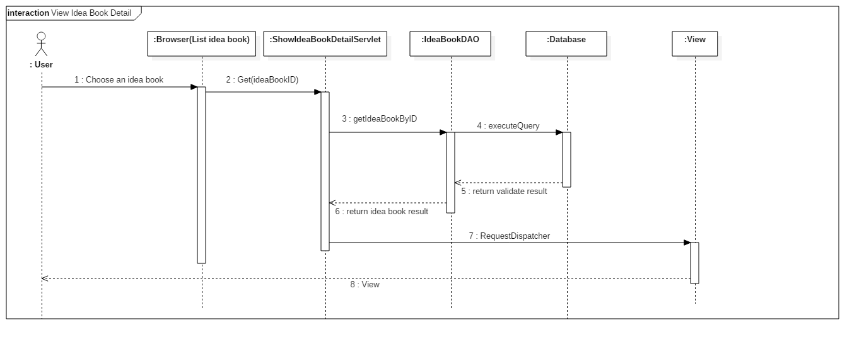

##### < Guest > View Product Detail

Sumary: This diagram shows the process of load product return product detail.

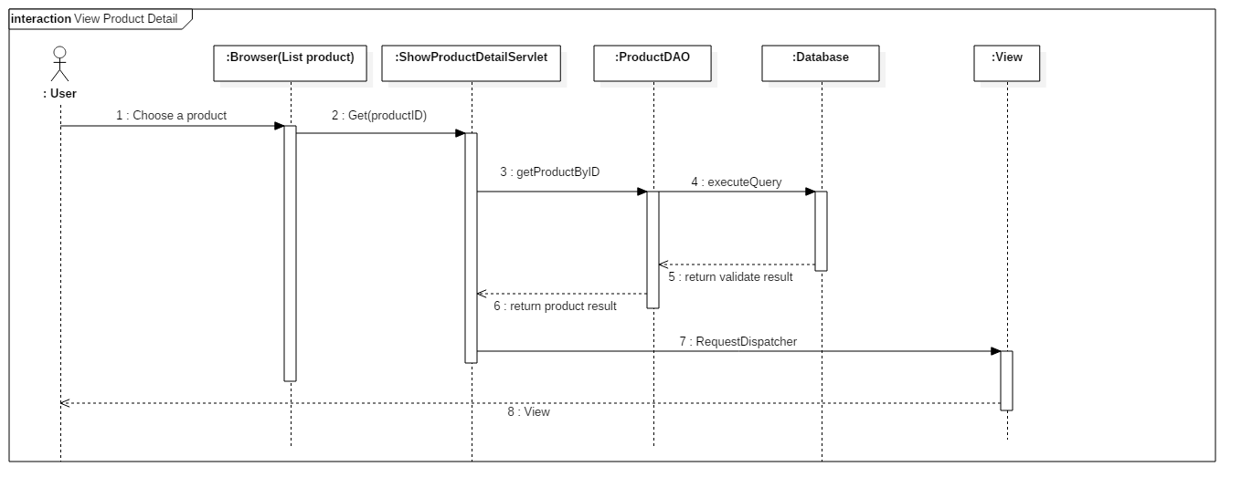

#### Member

##### < Member > Create Idea Book

Sumary: This diagram shows the process of create idea book by user.

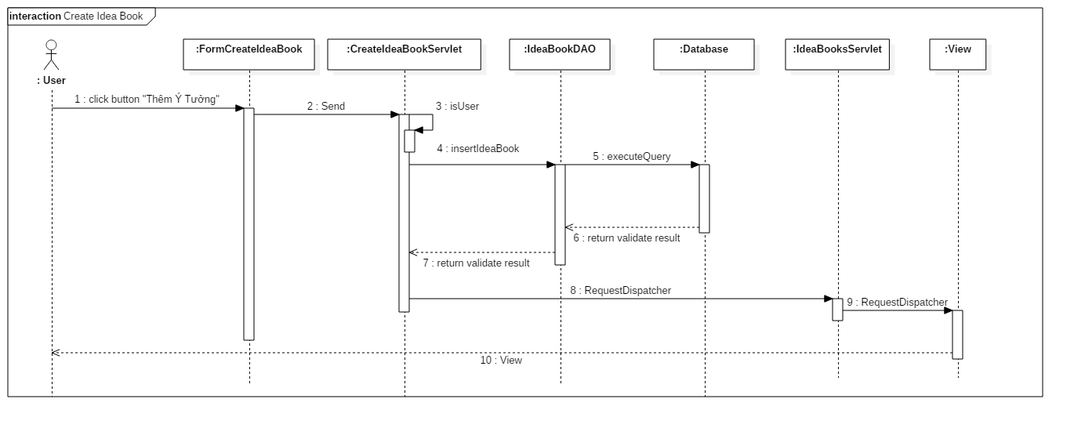

##### < Member > Order Product

Sumary: This diagram shows the process of order product by user.

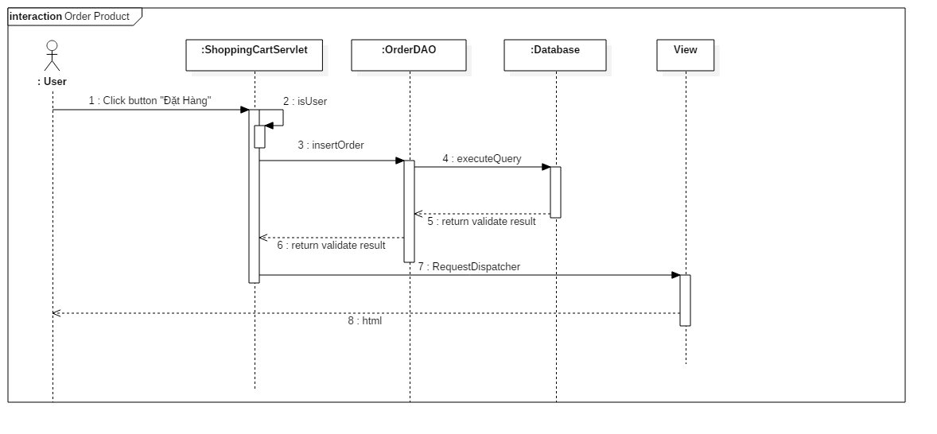

#### Professional

##### < Professional > Create project

Sumary: This diagram shows the process of create project by professional.

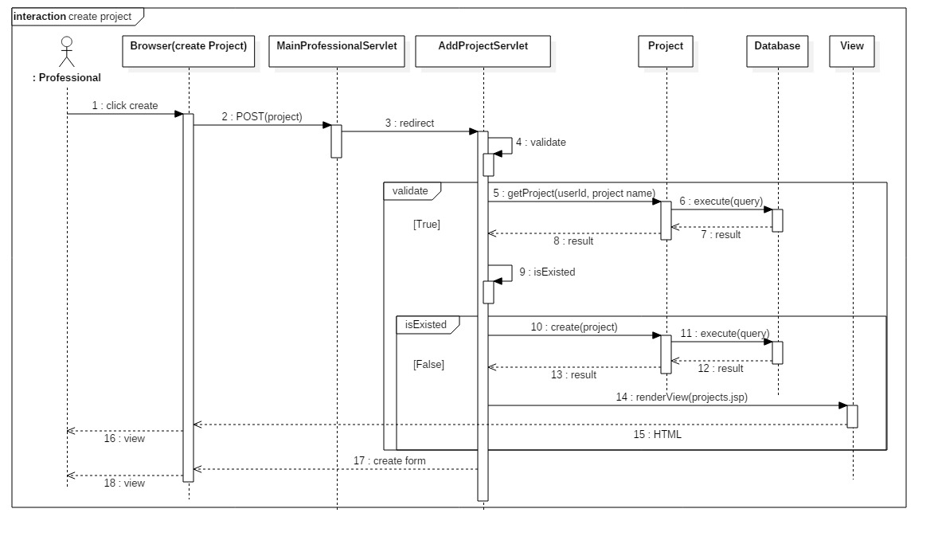

##### < Seller > Add Product

Sumary: This diagram shows the process of add product by seller.

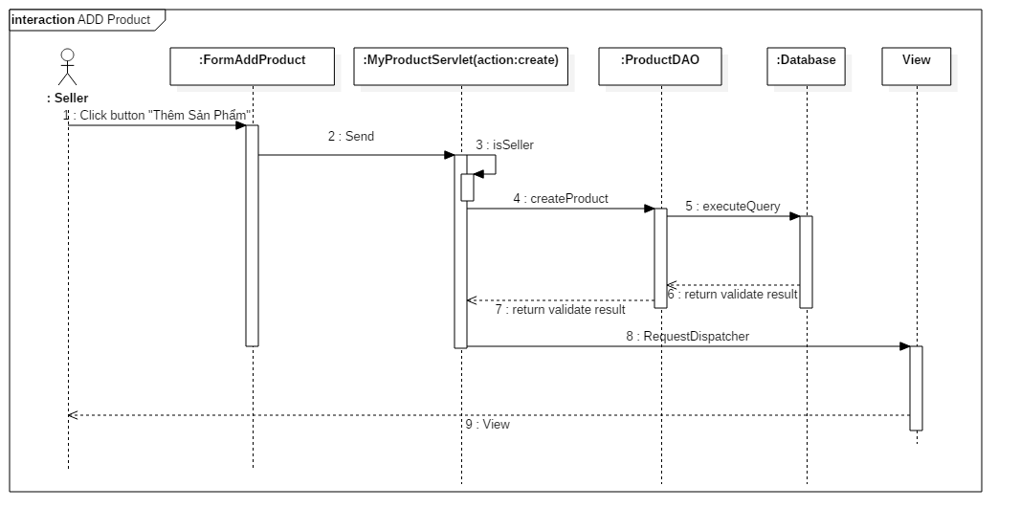

#### Admin

Sumary: The diagrams shows the process of load product list, view details about a product with product’s photos and update product’s status.

##### < Admin > Load Products

Sumary: This diagram shows the process of load product list return product list by product’s status.

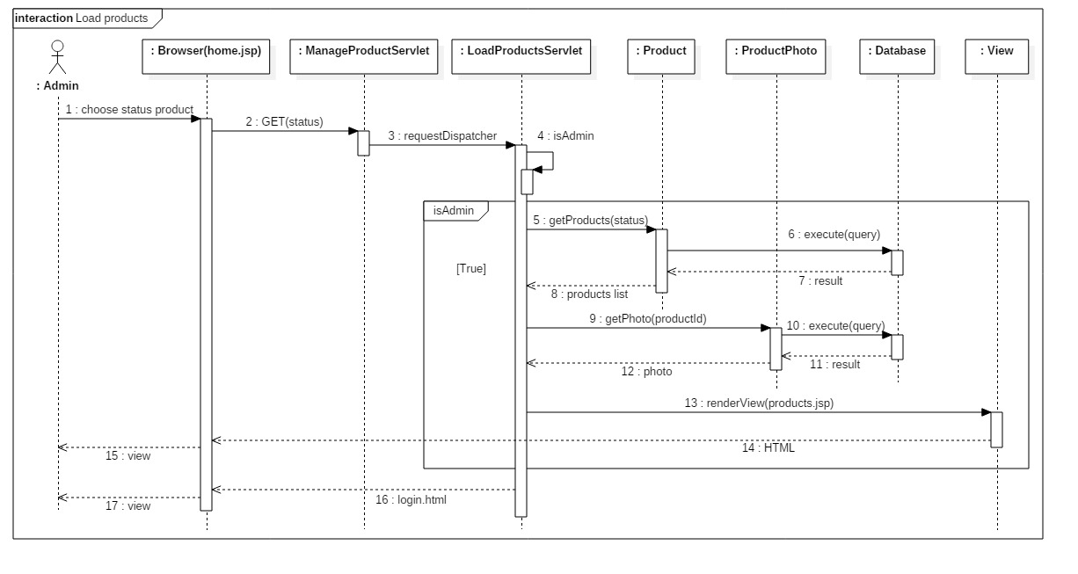

##### < Admin > View Product’s Detail

Sumary: This diagram shows the process of view product’s detail return product’s detail and product’s photos.

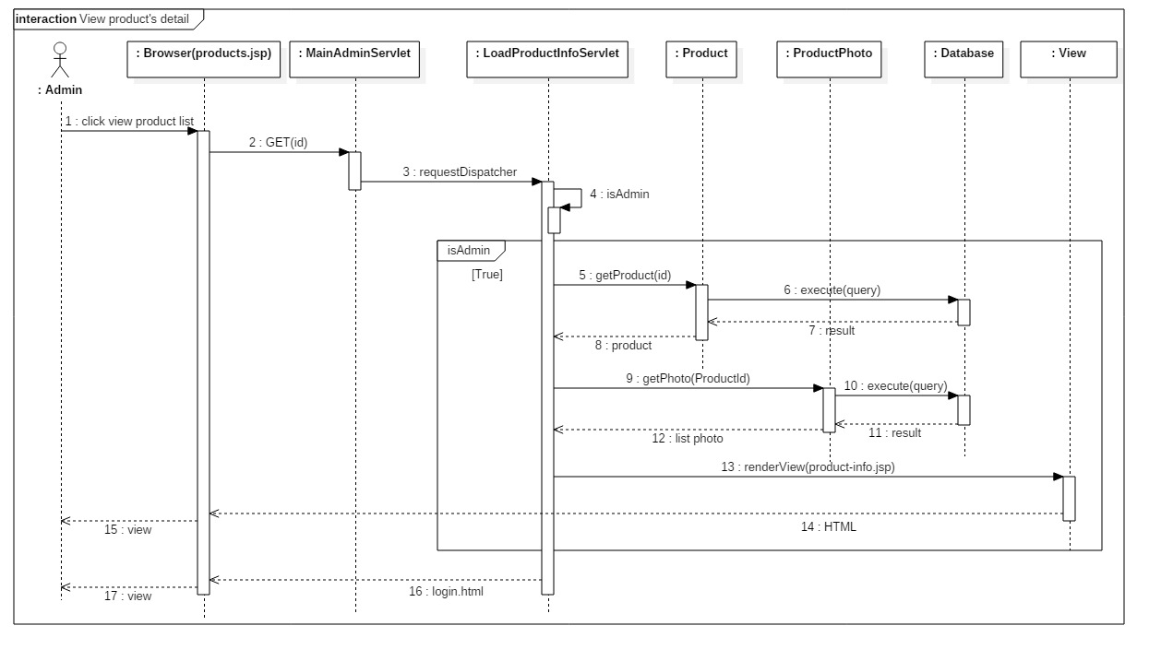

##### < Admin > Update Product’s Status

Sumary: This diagram shows the process of update product’s status.

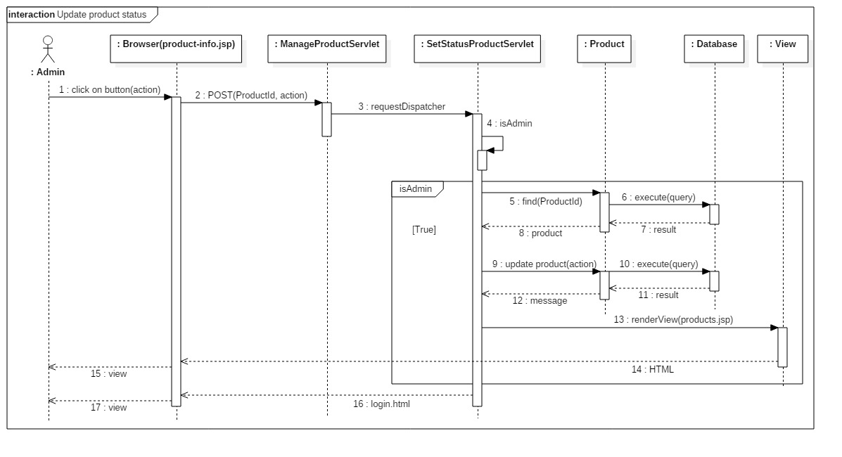

#### System

##### < System > Tracking

Sumary: This diagram shows the process of tracking in system.

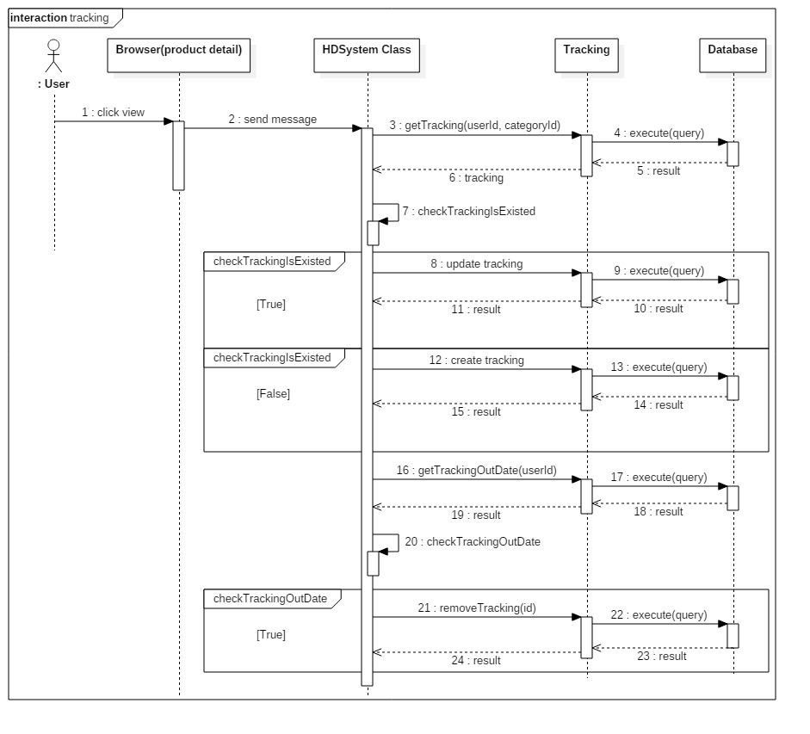

## Interface

### Component interface

|  |  |  |  |  |  |
| --- | --- | --- | --- | --- | --- |
| **Signature** | **Description** | **Input** | **Output** | **Output**  **Format** | **Exception** |
| Tên hàm | Mô tả mục  đích | Tham số  truyền | Kết xuất khi  hàm xử lý xong | Kiểu dữ  liệu | Xử lý lỗi |

### User Interface Design

#### Guest

##### < Guest > View photo

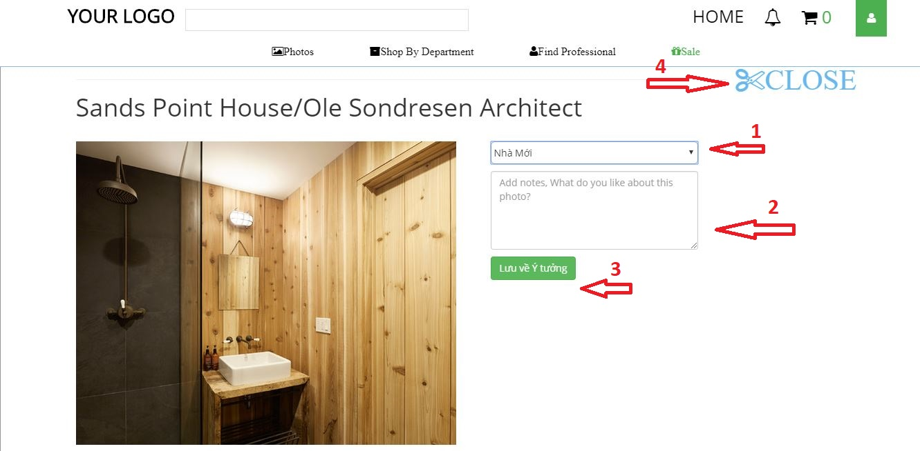

**Fields**

|  |  |  |  |  |  |  |  |
| --- | --- | --- | --- | --- | --- | --- | --- |
| **No** | **Field Name** | **Description** | **Read Only** | **Mandatory** | **Control Type** | **Data Type** | **Length** |
| **1** | Name idea book | Your list idea book | No | Yes | Drop down | String | N/A |
| **2** | Description photo | Description photo to save your idea book | No | No | Text box | String | N/A |

**Buttons/Hyperlinks**

|  |  |  |  |  |
| --- | --- | --- | --- | --- |
| **No** | **Function** | **Description** | **Validation** | **Outcome** |
| **3** | Lưu về Ý tưởng | Save image into your idea book. | N/A | Your idea book you just added photo |
| **4** | Close | Close page photo detail. | N/A | List of photos before |

##### < Guest > Search Professional

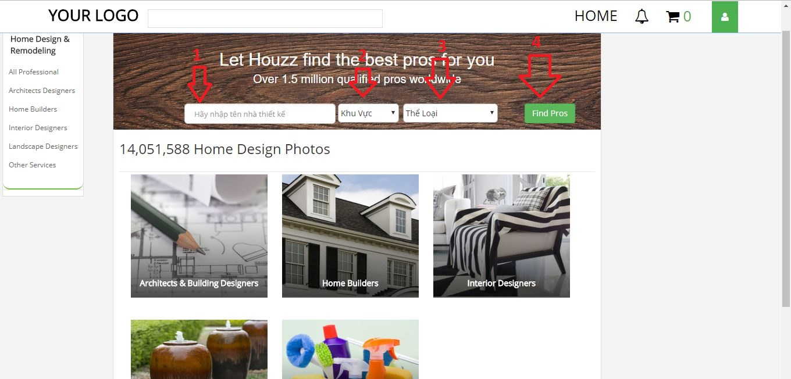

**Fields**

|  |  |  |  |  |  |  |  |
| --- | --- | --- | --- | --- | --- | --- | --- |
| **No** | **Field Name** | **Description** | **Read Only** | **Mandatory** | **Control Type** | **Data Type** | **Length** |
| **1** | Name Professional | Search professional’s name | No | No | Text box | String | N/A |
| **2** | Location | Search location of professional | No | No | Drop down | String | N/A |
| **3** | Type of work | Search professional by type of work | No | No | Drop down | String | N/A |

**Buttons/Hyperlinks**

|  |  |  |  |  |
| --- | --- | --- | --- | --- |
| **No** | **Function** | **Description** | **Validation** | **Outcome** |
| **4** | Find Pros | Search professional | N/A | List of professional. |

#### Member

##### < Member > Member’s idea book

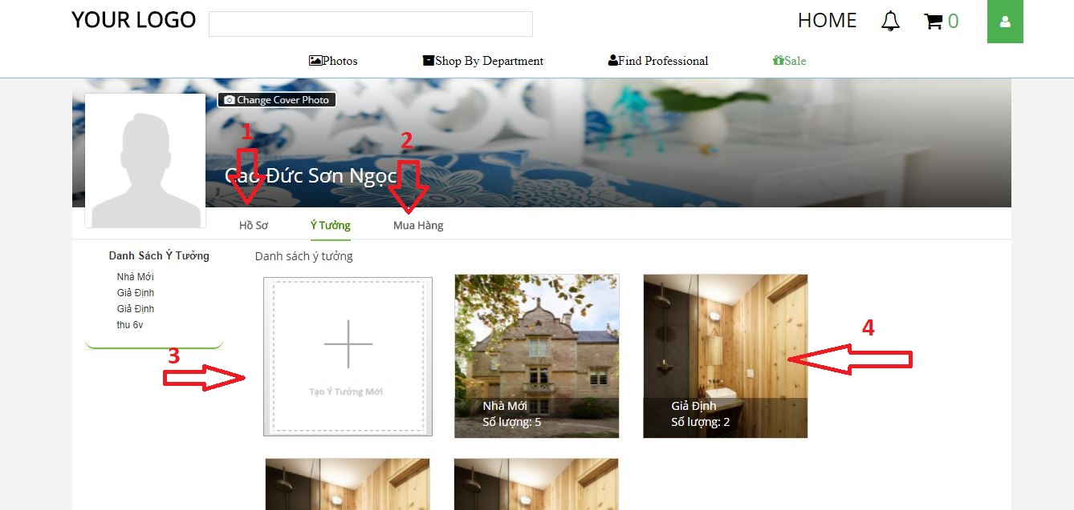

**Buttons/Hyperlinks**

|  |  |  |  |  |
| --- | --- | --- | --- | --- |
| **No** | **Function** | **Description** | **Validation** | **Outcome** |
| **1** | Profile | Edit member’s profile | N/A | Form to edit profile |
| **2** | Purchase | List order of member | N/A | List order page |
| **3** | Add new idea book | Add new idea book | N/A | Form to add idea book |
| **4** | Idea book | View idea book detail | N/A | Show idea book detail |

#### Professional

##### < Seller > Add Product

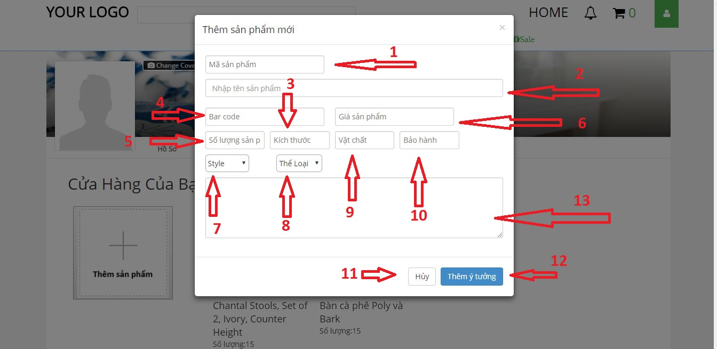

**Fields**

|  |  |  |  |  |  |  |  |
| --- | --- | --- | --- | --- | --- | --- | --- |
| **No** | **Field Name** | **Description** | **Read Only** | **Mandatory** | **Control Type** | **Data Type** | **Length** |
| **1** | Product code | Input product code | No | Yes | Text box | String | N/A |
| **2** | Product’s name | Input product name | No | Yes | Text box | String | N/A |
| **3** | Product’s size | Input product’s size | No | No | Text box | String | N/A |
| **4** | Bar Code | Input bar code | No | No | Text box | String | N/A |
| **5** | Quantity | Quantity of product | No | No | Text box | String | N/A |
| **6** | Product’s price | Input price | No | Yes | Text box | String | N/A |
| **7** | Style | Choose style for product | No | Yes | Text box | String | N/A |
| **8** | Category | Choose category | No | Yes | Text box | String | N/A |
| **9** | Material | Input material | No | No | Text box | String | N/A |
| **10** | Warranty | Input warranty | No | No | Text box | String | N/A |
| **13** | Description | Input description | No | No | Text Box | String | N/A |

**Buttons/Hyperlinks**

|  |  |  |  |  |
| --- | --- | --- | --- | --- |
| **No** | **Function** | **Description** | **Validation** | **Outcome** |
| **11** | Cancel | Cancel add product | N/A | N/A |
| **12** | Add Product | Add product | N/A | Seller’s list product |

#### Admin

##### <Admin> Manage Accounts

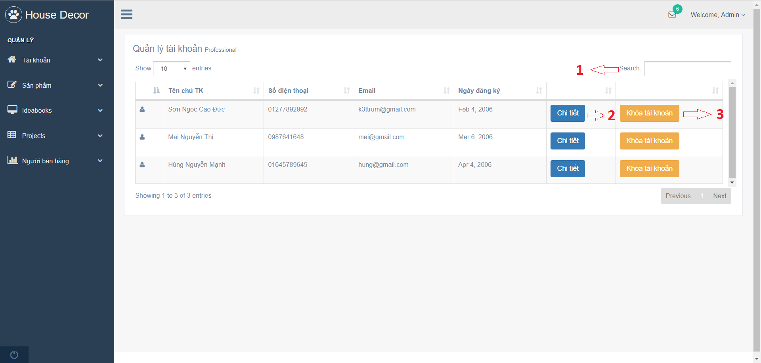

**Fields**

|  |  |  |  |  |  |  |  |
| --- | --- | --- | --- | --- | --- | --- | --- |
| **No** | **Field Name** | **Description** | **Read Only** | **Mandatory** | **Control Type** | **Data Type** | **Length** |
| **1** | Search Input | Search account | No | Yes | Textbox | String | N/A |

**Buttons/Hyperlinks**

|  |  |  |  |  |
| --- | --- | --- | --- | --- |
| **No** | **Function** | **Description** | **Validation** | **Outcome** |
| **2** | loadAccountInfo | Go to account detail view | N/A | Redirect to account detail view. |
| **3** | setStatusAccount | Ban or unban chosen account | N/A | Call SetStatusAccountServlet. |

##### <Admin> Manage Products

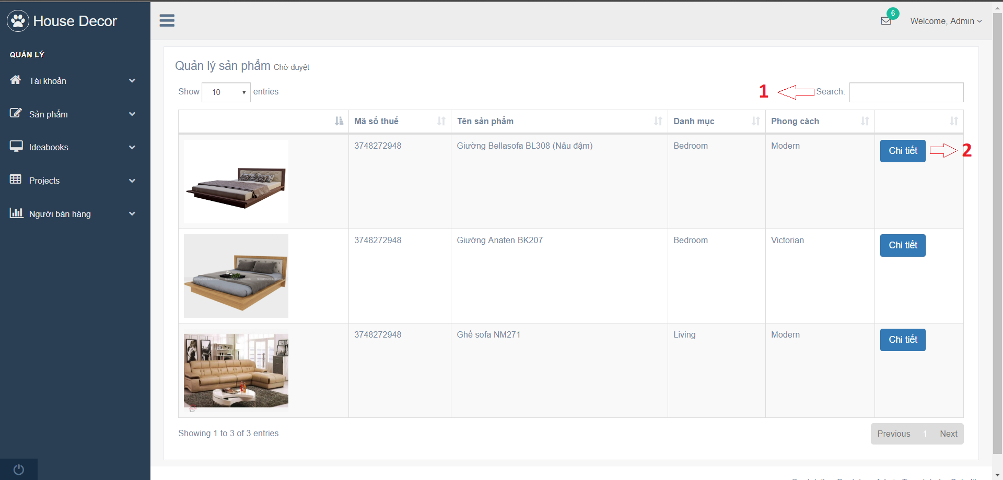

**Fields**

|  |  |  |  |  |  |  |  |
| --- | --- | --- | --- | --- | --- | --- | --- |
| **No** | **Field Name** | **Description** | **Read Only** | **Mandatory** | **Control Type** | **Data Type** | **Length** |
| **1** | Search Input | Search product | No | Yes | Textbox | String | N/A |

**Buttons/Hyperlinks**

|  |  |  |  |  |
| --- | --- | --- | --- | --- |
| **No** | **Function** | **Description** | **Validation** | **Outcome** |
| **2** | loadProductInfo | Go to product detail view | N/A | Redirect to account detail view. |

## Database Design

### Entity Relationship Diagram (ERD)

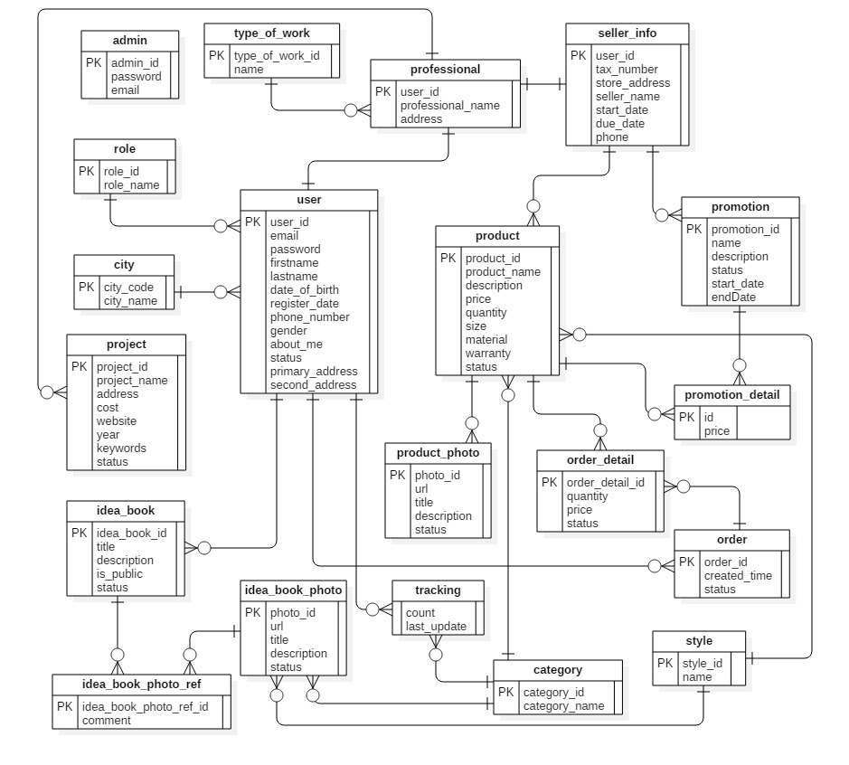

*Figure 4: Entity Relationship Diagram (ERD)*

### Data Dictionary

|  |  |
| --- | --- |
| **Entity Data Dictionary: describe contents of all entities** | |
| **Entity Name** | **Description** |
| User | All user accounts in the system. |
| Professional | All professional accounts in the system. |
| Admin | All admin accounts in the system. |
| Tracking | All activities of users in the system. |
| Idea_book_photo_ref | All accepted idea book/project’s photos in the system. |
| Idea_book | All idea books in the system. |
| Order_detail | Detail information of all orders in the system. |
| Idea_book_photo | All idea book/project’s photo in the system. |
| Type_of_work | All type of work in the system. |
| Role | All role in the system. |
| Promotion | All promotion of products in the system. |
| City | All city in the system. |
| Seller info | All sellers in the system. |
| Product_photo | All product’s photos in the system. |
| Product | All products in the system. |
| Project | All projects in the system. |
| Order | All orders in the system. |
| Style | All styles in the system. |
| Category | All categories in the system. |
| Promotion_detail | All promotion details in the system. |

## Algorithms

**Approve an idea book: (parameter: Idea book Id)**

Load all photos of the idea book by idea book id in “Idea Book Photo” table

For all photos in photo list

If photo’s status is waiting for approval then

Output: Error message

End for

End if

End for

Load the idea book by idea book id

Update idea book’s status to approved

**Tracking: (parameters: user Id, category Id)**

Load tracking by user Id and category Id

If tracking is existed then

Update this tracking

Else

Create new tracking

Save new tracking to Database

End if

Load tracking is out of date by user Id

If exist tracking is out of date then

Remove tracking out of date

End if

**Send promotion emails: (parameter: product Id)**

Load product by product Id

Load category Id of product

Use category Id to find users matched with in “Tracking” table

If users are not empty then

Load emails of founded users.

Send promotion email to users email

End if