* **Mô hình thực thể**
* **Role**(RoleID, RoleName)
* **Account** (Username, Password, Status)
* **Staff** (StaffID, StaffName, Age, StaffPhone, StaffAddress)
* **Customer** (CustomerID, CustomerName, CusAddress, CusPhone)
* **Vehicle** (VehicleID, NumberPlate, Type, Color, EngineNumber, ChassisNumber, Brand)
* **Manufacturer** (ManuID, ManuName, ManuPhone, ManuAddress)
* **Product** (ProductID, ProductName, ProductDescription, Brand, Unit)
* **Service** (ServiceID, ServiceName, Description, Price)
* **Receipt** (ReceiptID, Time, Condition, Note)
* **PriceQuote** (QuoteID, Status, Time)
* **PurchaseOrder** (OrderID, OrderDate)
* **Supplier** (SupplierID, SupplierName, SupPhone)
* **RepairOrder** (RepairOrderID, IsDone)
* **Invoice** (InvoiceID, TotalMoney, Time)
* **Mô hình thực thể kết hợp**

* **Mô hình dữ liệu quan hệ**
* **Role**(RoleID, RoleName)
* **Account** (Username, Password, Status, RoleID)
* **Staff** (StaffID, StaffName, Age, StaffPhone, StaffAddress, Username)
* **Customer** (CustomerID, CustomerName, CusAddress, CusPhone)
* **Vehicle** (VehicleID, , Type, Color, EngineNumber, ChassisNumber, Brand)
* **Manufacturer** (ManuID, ManuName, ManuPhone, ManuAddress)
* **Supplier** (SupplierID, SupplierName, SupPhone)
* **Product** (ProductID, ProductName, ProductDescription, Brand, Unit)
* **Product_Detail (**PDID, ProductID, SupplierID, SellingPrice, PurchasePrice, Quantity)
* **Service** (ServiceID, ServiceName, Description, Price)
* **Receipt** (ReceiptID, Time, VehicleStatus, Note, StaffID, CustomerID, VehicleID)
* **PriceQuote** (QuoteID, Status, Time, StaffID, ReceiptID)
* **PQ_Service_Detail (**PQSDID, Price, QuoteID**,** ServiceID**)**
* **PQ_Product_Detail (**QuoteID**,** PDID**,** SellingPrice**,** PurchasePrice, Quantity**)**
* **RepairOrder** (RepairOrderID, IsDone, Time, QuoteID)
* **RepairOrder_Detail (**RODID, IsDone, TimeWhenDone, RepairOrderID, PQSDID, StaffID**)**
* **PurchaseOrder** (OrderID, OrderDate, StaffID, )
* **PurchaseOrderDetails (**OrderID, PDID, PurchasePrice, Quantity**)**
* **Invoice** (InvoiceID, Time, StaffID, QuoteID)
* **Sơ đồ lớp (Class Diagram)**

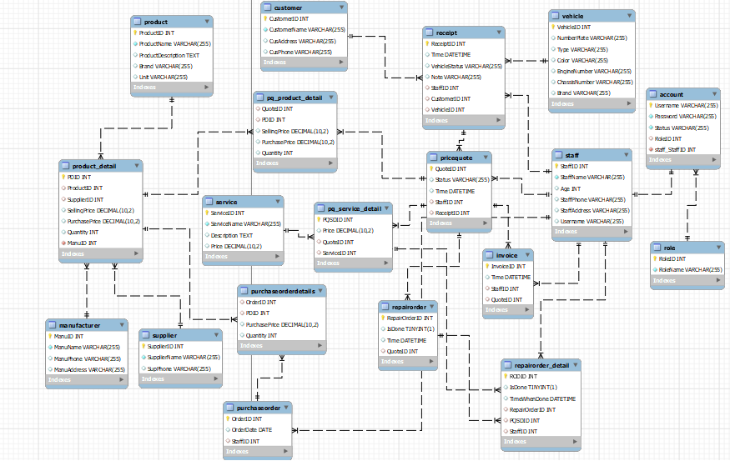

**Từ điển dữ liệu**