TECHNICAL PROJECT REPORT

# SWITCH CONTROLLED LED BAND

# Team Members / Inventors:

|  |  |  |  |  |  |
| --- | --- | --- | --- | --- | --- |
| **S. No.** | **Name** | **Department** | **Designation** | **Mobile** | **E-Mail** |
| 1. | Mohit Papneja | IS-2 | Team Member | 9671796287 | mohitpapneja424@gmail.com |
| 2. | Abdul Qahar | IS-2 | Team  Member | 8288984513 | imran.tokhi444@gmail.com |
| 3. | Prashant | IS-2 | Team  Member | 8130830192 | sharmaprashant14200@gmail.com |
| 4. | Divneet Singh Kapoor | ECE | Mentor | 9878422653 | divneet.ece@cumail.in |
| 5. | Khushal Thakur | ECE | Mentor | 9646030764 | khushal.thakur@cumail.in |
| 6. | Anshul Sharma | ECE | Mentor | 9478697475 | anshulsharma.ece@cumail.in |
| 7. | Kiran Jot Singh | ECE | Mentor | 9463909689 | kiranjotsingh.ece@cumal.in |
|  |  |  |  |  |  |

Section – 1 (IPR Related)

# Brief Abstract (500 words):

The band which we have created is more of a fashion thing than a necessity in one’s life. The band saves power. We can turn on and off the band according to our need.

The band is cheap. Green color glows very well at night. Light weight and comfortable to wear.  LEDs are subject to very limited wear and tear if operated at low currents and at low temperatures that’s why our band is long lasting.

Furthermore we are going to customize our band with different led pattern which will make it more unique and attractive. The customer can switch between the band patterns using a simple gesture . We will are also planning to add a chargeable battery to this which will make it more interesting. We will also add a Bluetooth module with which we can control our smart led light band with an android application through our smart phone.

# Existing state-of-the-art and Drawbacks in existing state-of-the-art

There are some Led bands in the market but our will be one of its kind.

|  |  |  |
| --- | --- | --- |
| **S. No.** | **Existing state of art** | **Drawbacks in existing state of art** |
| 1 | Led bands | No or only single led pattern was available. |
| 2 |  |  |

# Novel/Additional modifications that you can propose to improve upon

# drawbacks

We can later add neon fluid in our band which will enhance the intensity and colour of the light. Also we are planning to add a motion sensor which will eliminate the switch in our circuit. The band then can be controlled by a simple air swipe. We will also add various pattern of lights from which a user can choose the choice of his or her favourite light pattern. We are also planning to build an application which can be used to control all the operations on the band.

# Advantages

If the above features are added our product will become more interesting and will be more flexible to use. The light patterns and combination of Led and neon colours will attract a variety of customers. The techsavy generation will be attracted towards our product.

# Block Diagram

Below shown is a simple block diagram of our led band. The switch controls the on and off mechanism of the led.

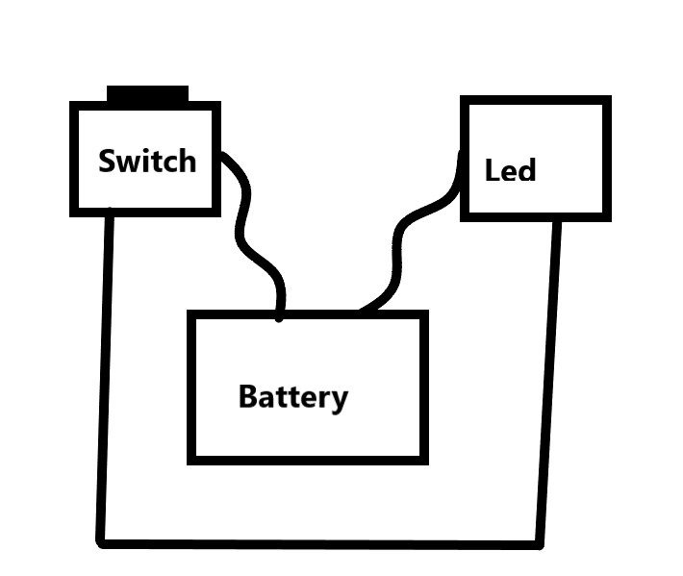

Section – 2 (Real Project)

# Materials

1. Green Leds
2. A circular 9v battery
3. A wrist band(rubber)
4. Connecting wires
5. Electrical tape
6. ON/OFF switch
7. Motion Sensor (will be used in later modification)
8. Bluetooth Module (will be used in later modification)

# Circuit Diagram

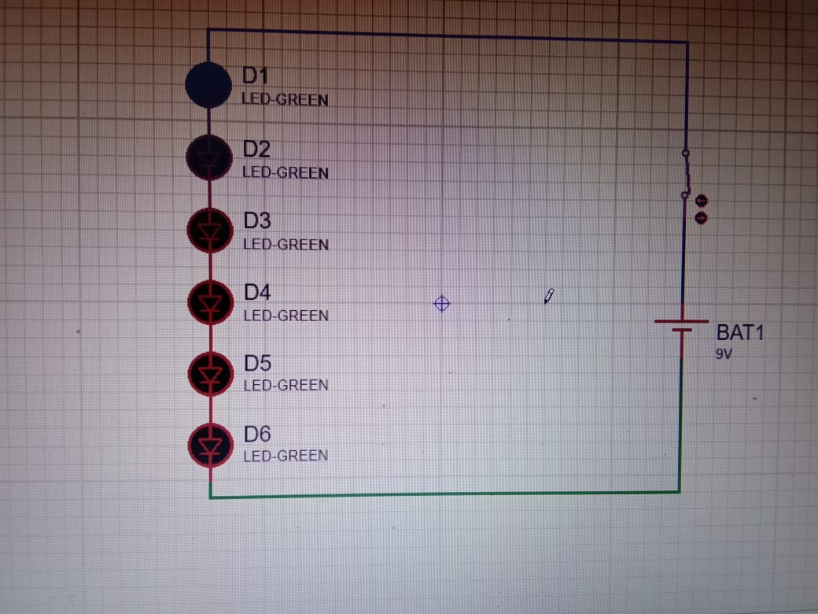

# Steps of Circuit Completion

The various photos from making of our project till the end product is shown below.

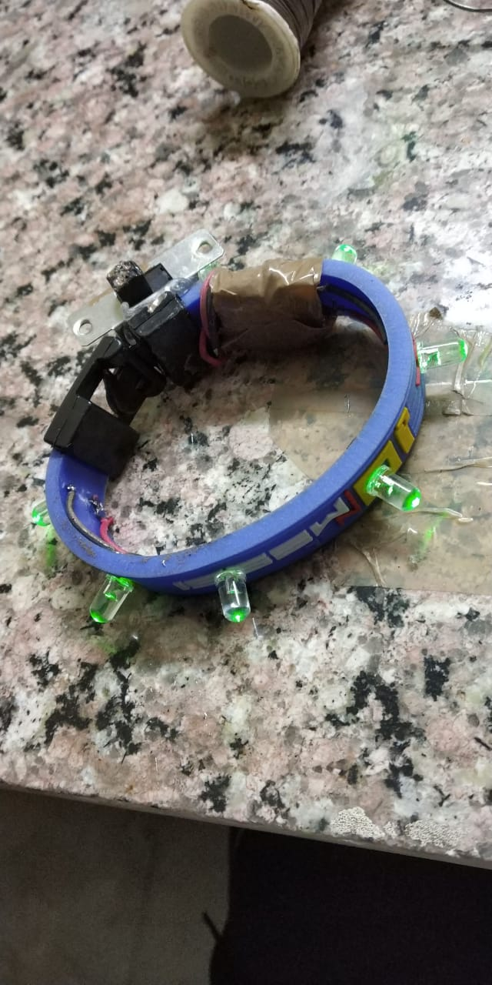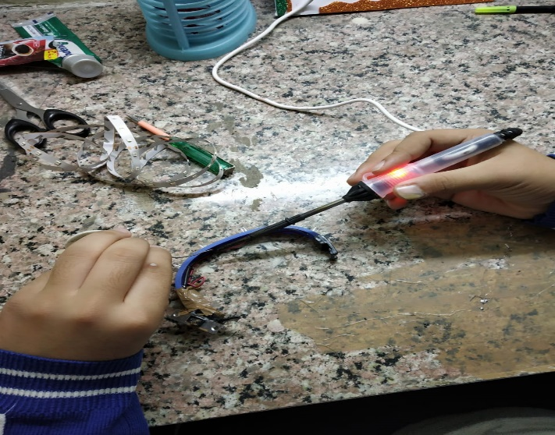

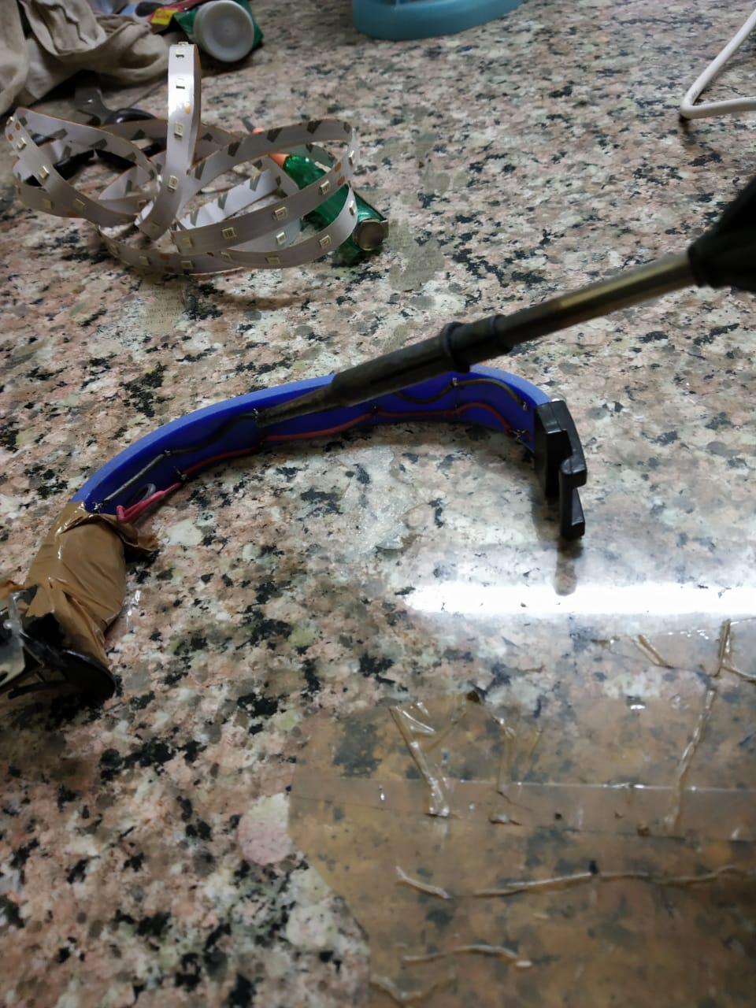

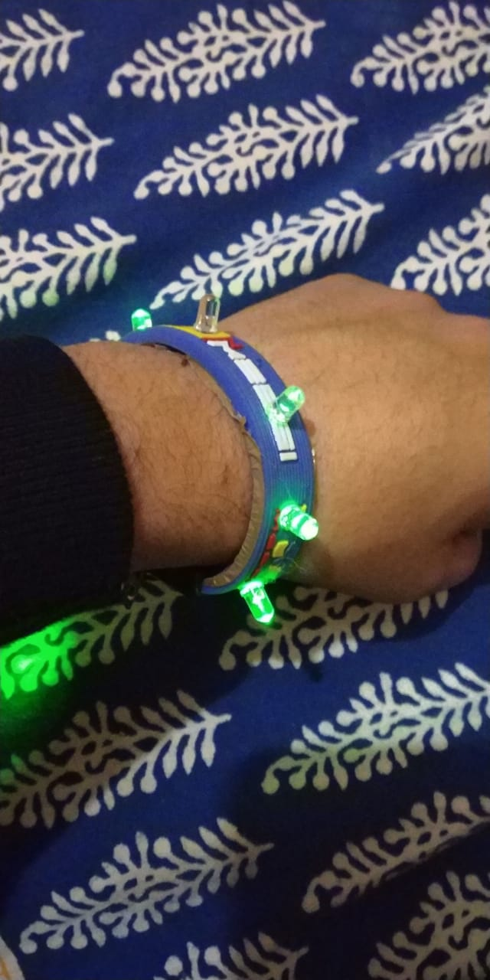

# Program Code

[Github Link](https://github.com/ledband-project/ledband)