 | EDAX TEAM |  |  |  |  |  |  |  |  |  |  |  |  |  |  |  |  |  |  |  |  |  |  |  |  |  |  |  |  |  |  |  |  |  |  |  |  |  |  |  |  |  |  |  |  |  | Page | 1
 |  |  |  |  |  |  |  |  |  |  |  |  |  | Afra
Author:
Creation: |  |  |  |  |  |  |  |  |  |  |  |  |  | 04/12/2017 2:09:00 PM
Sample Name: |  |  |  |  |  |  |  |  |  |  |  |  |  | Lapiz1
Area 1
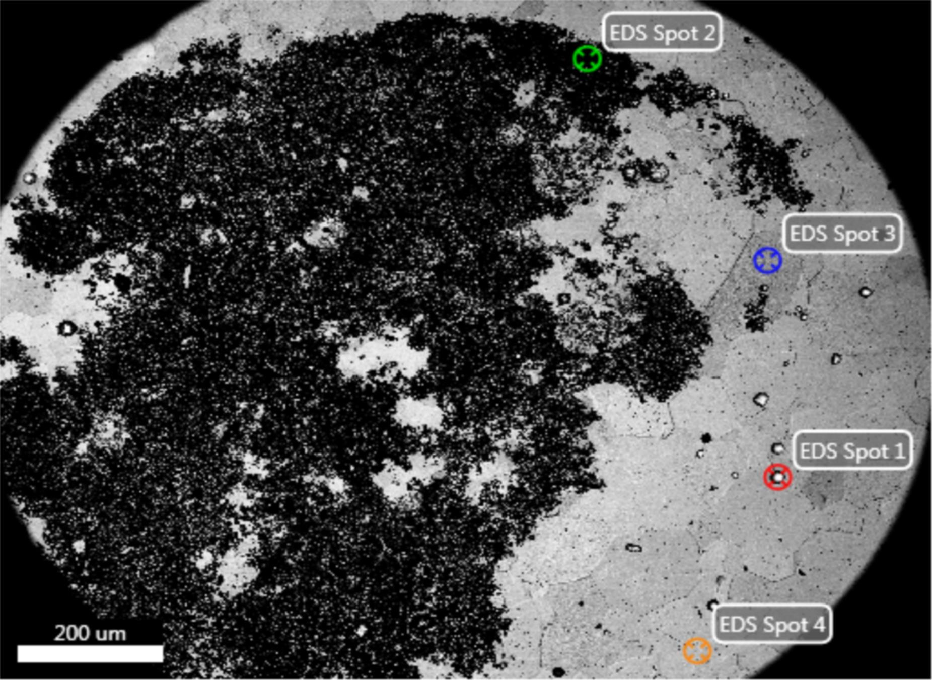 |  |  |  |  |  |  |  |  |  |  |  |  |  |  |  |  |  |  |  |  |  |  |  |  |  | 
Notes:
 | EDAX TEAM |  |  |  |  |  |  |  |  |  |  |  |  |  |  |  |  |  |  |  |  |  |  |  |  |  |  |  |  |  |  |  |  |  |  |  |  |  |  |  |  |  |  |  |  |  | Page | 2
 |  |  | kV: |  |  | 20 |  |  |  |  |  |  | Mag: |  |  | 100 |  |  | Takeoff: |  |  | 35.2 |  |  |  |  | Live Time(s): |  |  |  | 1.1 |  |  |  |  |  | Amp Time(µs): |  |  |  |  |  | 1.92 |  |  |  | Resolution:(eV) |  |  | 123.8
 |  |  |  |  |  |  |  |  |  | EDS Spot 1
 |  |  |  |  |  |  |  |  |  | 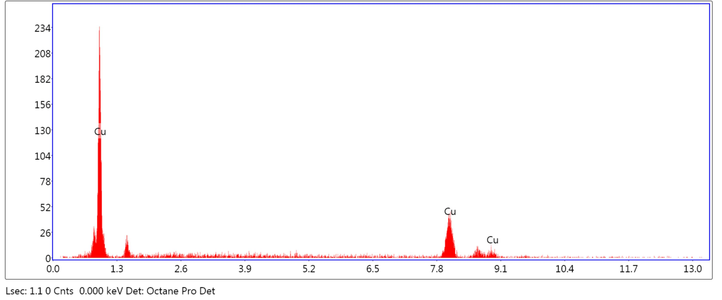
 |  |  |  | eZAF Smart Quant Results
 |  |  |  |  |  |  |  |  |  |  |  |  |  |  |  |  |  | Element |  | Weight % |  |  |  |  | Atomic % |  |  |  | Error %
 |  |  |  |  |  |  |  |  |  |  |  |  |  |  |  |  |  | CuK |  | 100.00 |  |  |  |  | 100.00 |  |  |  | 10.48
 | EDAX TEAM |  |  |  |  |  |  |  |  |  |  |  |  |  |  |  |  |  |  |  |  |  |  |  |  |  |  |  |  |  |  |  |  |  |  |  |  |  |  |  |  |  |  |  |  |  | Page | 3
 |  |  | kV: |  |  | 20 |  |  |  |  |  |  | Mag: |  |  | 100 |  |  | Takeoff: |  |  | 35.2 |  |  |  |  | Live Time(s): |  |  |  | 100 |  |  |  |  |  | Amp Time(µs): |  |  |  |  |  | 1.92 |  |  |  | Resolution:(eV) |  |  | 123.8
 |  |  |  |  |  |  |  |  |  | EDS Spot 2
 |  |  |  |  |  |  |  |  |  | 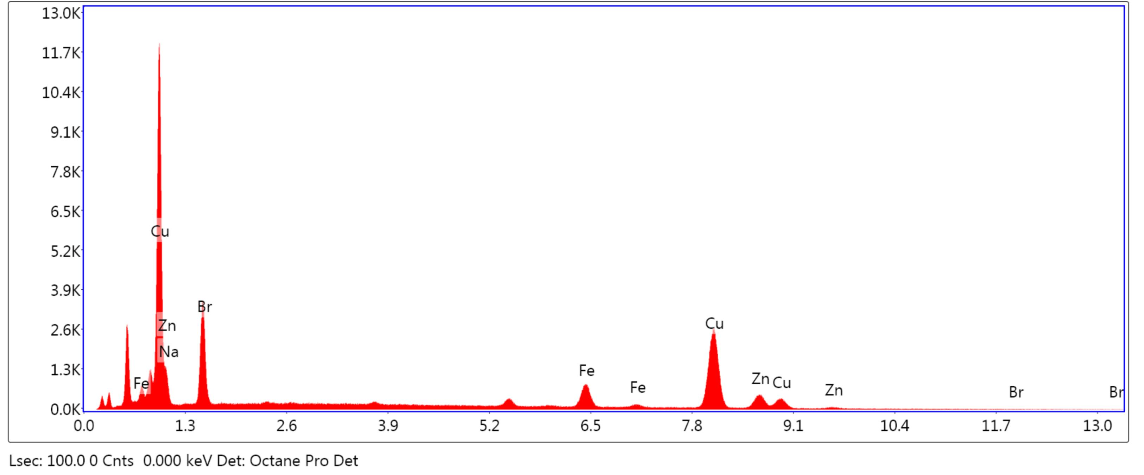
 |  |  |  | eZAF Smart Quant Results
 |  |  |  |  |  |  |  |  |  |  |  |  |  |  |  |  |  | Element |  | Weight % |  |  |  |  | Atomic % |  |  |  | Error %
 |  |  |  |  |  |  |  |  |  |  |  |  |  |  |  |  |  | NaK |  | 0.00 |  |  |  |  | 0.00 |  |  |  | 99.99
 |  |  |  |  |  |  |  |  |  |  |  |  |  |  |  |  |  | BrL |  | 14.84 |  |  |  |  | 12.07 |  |  |  | 7.89
 |  |  |  |  |  |  |  |  |  |  |  |  |  |  |  |  |  | FeK |  | 8.28 |  |  |  |  | 9.64 |  |  |  | 4.80
 |  |  |  |  |  |  |  |  |  |  |  |  |  |  |  |  |  | CuK |  | 63.64 |  |  |  |  | 65.12 |  |  |  | 2.48
 |  |  |  |  |  |  |  |  |  |  |  |  |  |  |  |  |  | ZnK |  | 13.23 |  |  |  |  | 13.16 |  |  |  | 4.58
 | EDAX TEAM |  |  |  |  |  |  |  |  |  |  |  |  |  |  |  |  |  |  |  |  |  |  |  |  |  |  |  |  |  |  |  |  |  |  |  |  |  |  |  |  |  |  |  |  |  | Page | 4
 |  |  | kV: |  |  | 20 |  |  |  |  |  |  | Mag: |  |  | 100 |  |  | Takeoff: |  |  | 35.2 |  |  |  |  | Live Time(s): |  |  |  | 100 |  |  |  |  |  | Amp Time(µs): |  |  |  |  |  | 1.92 |  |  |  | Resolution:(eV) |  |  | 123.8
 |  |  |  |  |  |  |  |  |  | EDS Spot 3
 |  |  |  |  |  |  |  |  |  | 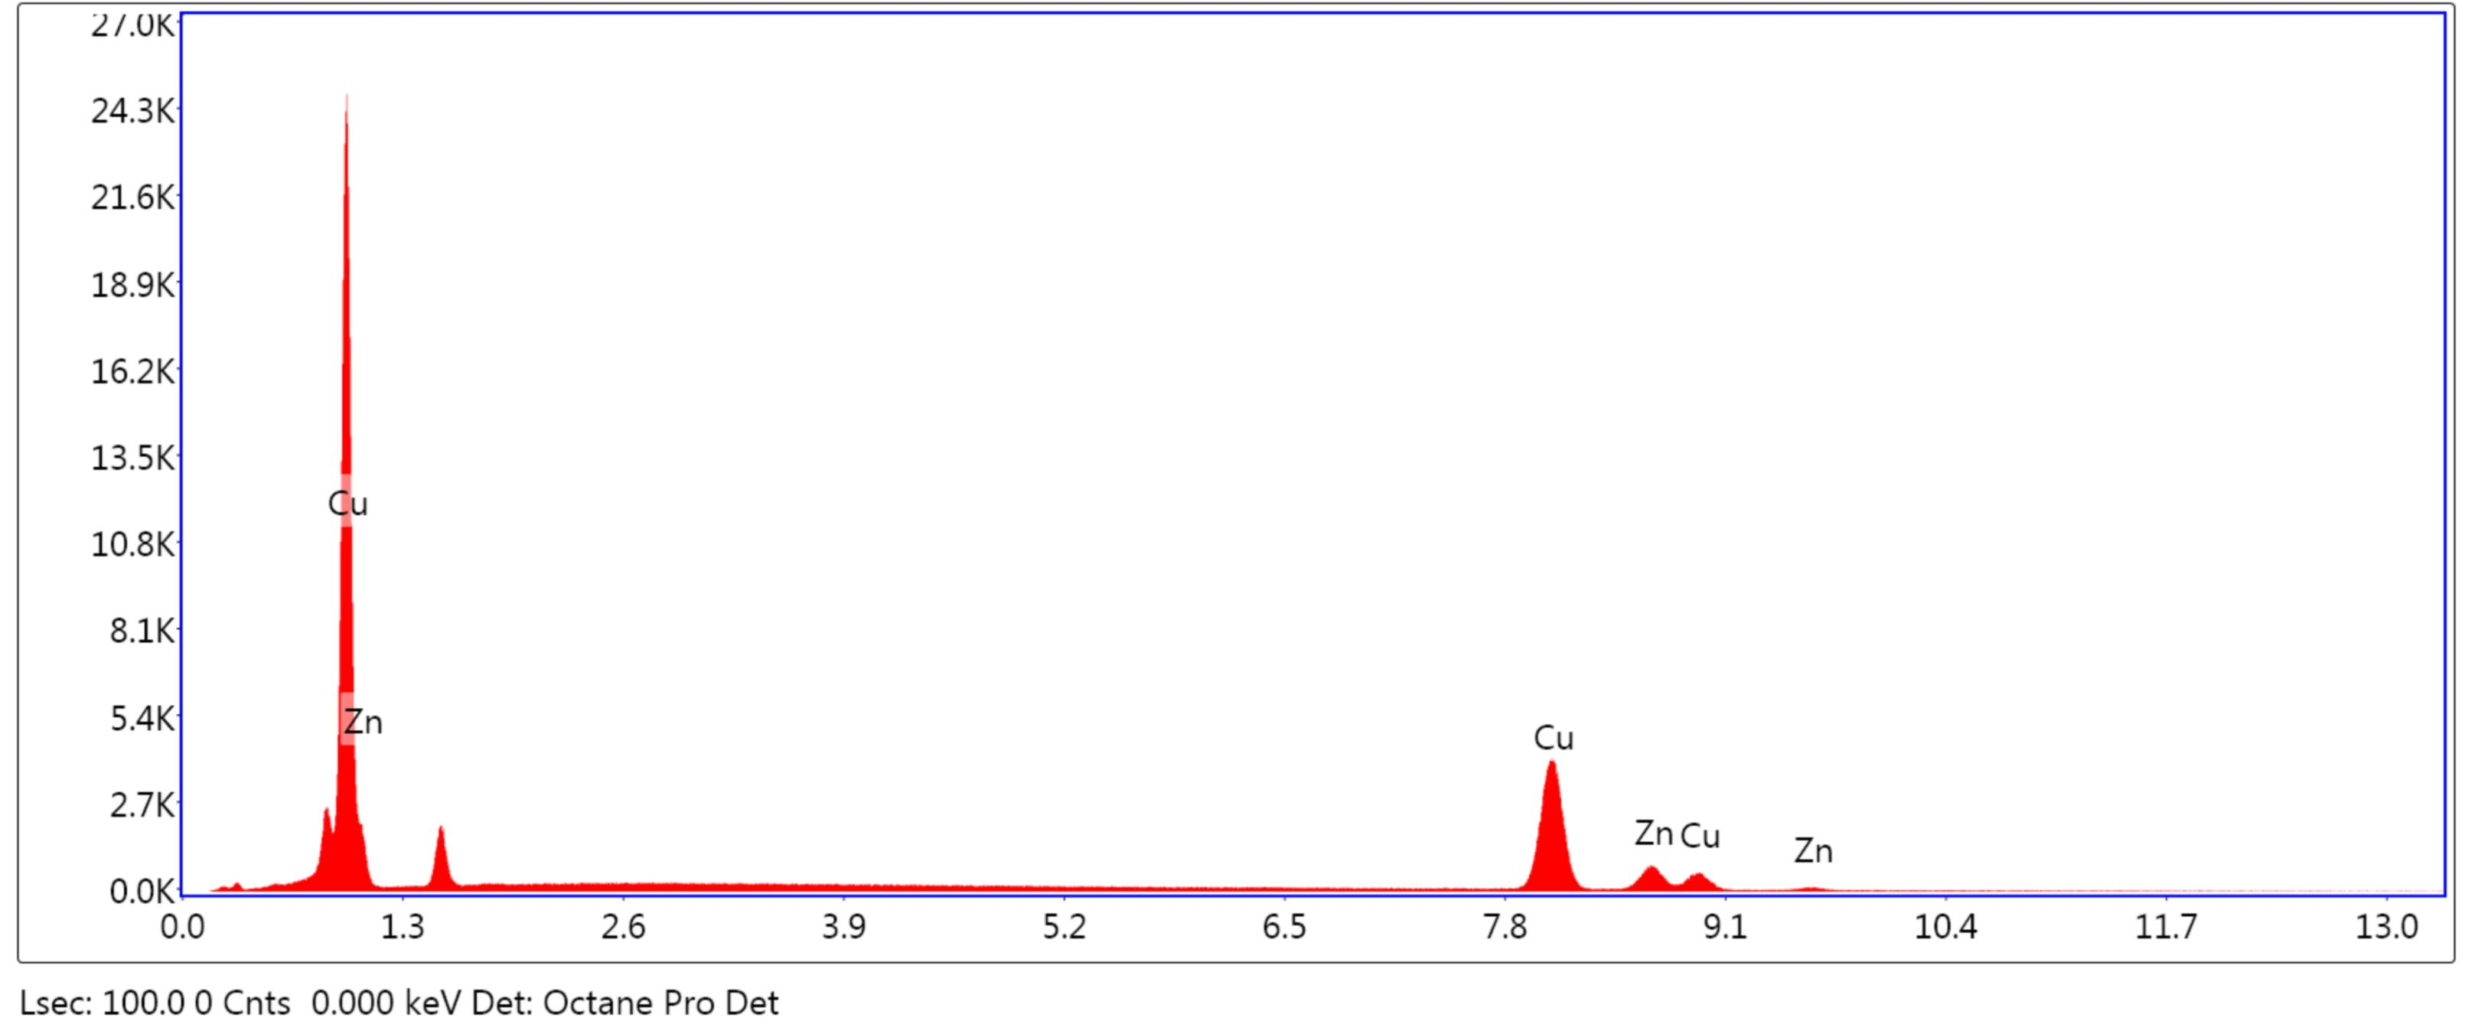
 |  |  |  | eZAF Smart Quant Results
 |  |  |  |  |  |  |  |  |  |  |  |  |  |  |  |  |  | Element |  | Weight % |  |  |  |  | Atomic % |  |  |  | Error %
 |  |  |  |  |  |  |  |  |  |  |  |  |  |  |  |  |  | CuK |  | 82.18 |  |  |  |  | 82.59 |  |  |  | 2.20
 |  |  |  |  |  |  |  |  |  |  |  |  |  |  |  |  |  | ZnK |  | 17.82 |  |  |  |  | 17.41 |  |  |  | 3.65
 | EDAX TEAM |  |  |  |  |  |  |  |  |  |  |  |  |  |  |  |  |  |  |  |  |  |  |  |  |  |  |  |  |  |  |  |  |  |  |  |  |  |  |  |  |  |  |  |  |  | Page | 5
 |  |  | kV: |  |  | 20 |  |  |  |  |  |  | Mag: |  |  | 100 |  |  | Takeoff: |  |  | 35.2 |  |  |  |  | Live Time(s): |  |  |  | 100 |  |  |  |  |  | Amp Time(µs): |  |  |  |  |  | 1.92 |  |  |  | Resolution:(eV) |  |  | 123.8
 |  |  |  |  |  |  |  |  |  | EDS Spot 4
 |  |  |  |  |  |  |  |  |  | 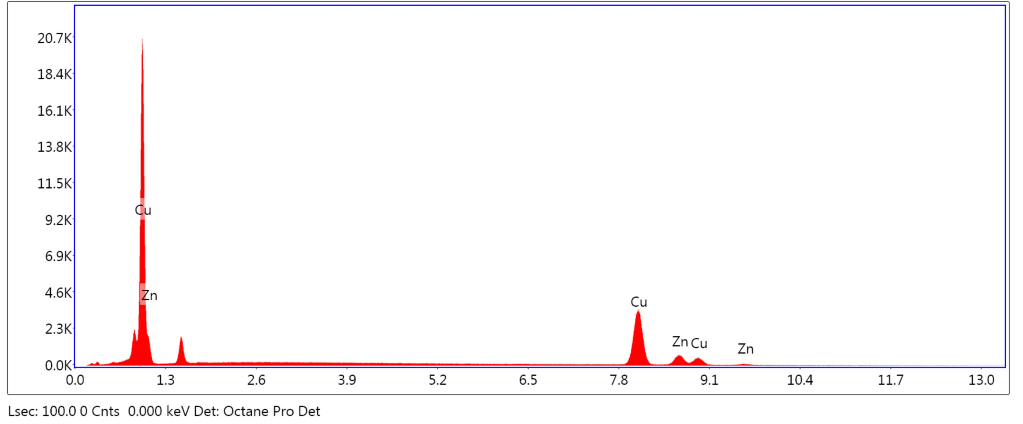
 |  |  |  | eZAF Smart Quant Results
 |  |  |  |  |  |  |  |  |  |  |  |  |  |  |  |  |  | Element |  | Weight % |  |  |  |  | Atomic % |  |  |  | Error %
 |  |  |  |  |  |  |  |  |  |  |  |  |  |  |  |  |  | CuK |  | 82.39 |  |  |  |  | 82.80 |  |  |  | 2.23
 |  |  |  |  |  |  |  |  |  |  |  |  |  |  |  |  |  | ZnK |  | 17.61 |  |  |  |  | 17.20 |  |  |  | 3.88

