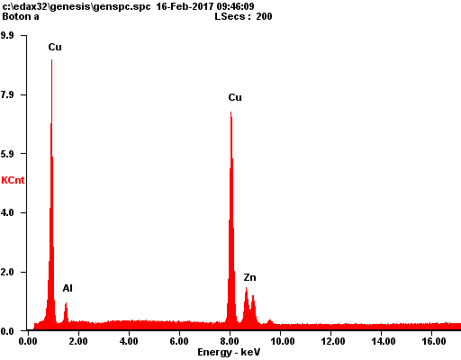
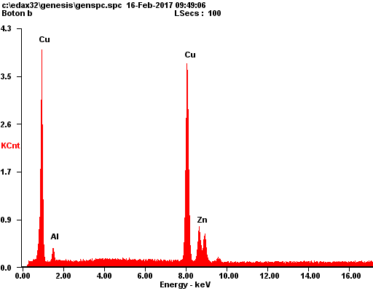
Element | Wt % | At %
AlK | 8.08 | 17.22
CuK | 76.55 | 69.27
ZnK | 15.37 | 13.51
EDAX ZAF Quantification Standardless SEC Table : Default
kV:30.00 Tilt: 0.00 Take-off:39.15 AmpT:6.4 Detector Type :SUTW-Sapphire Resolution :151.84

Element | Wt % | At %
AlK | 6.41 | 13.95
CuK | 77.73 | 71.81
ZnK | 15.86 | 14.24
EDAX ZAF Quantification Standardless SEC Table : Default
kV:30.00 Tilt: 0.00 Take-off:39.15 AmpT:6.4 Detector Type :SUTW-Sapphire Resolution :151.84
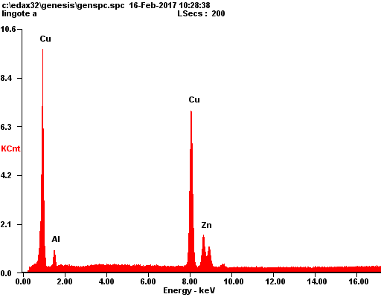
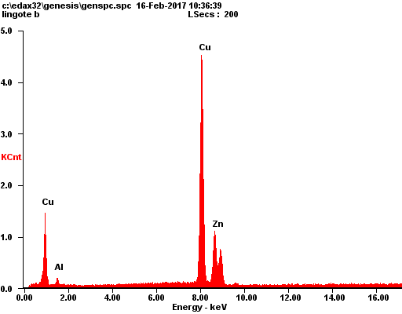
Element | Wt % | At %
AlK | 8.58 | 18.18
CuK | 73.71 | 66.33
ZnK | 17.71 | 15.49
EDAX ZAF Quantification Standardless SEC Table : Default
kV:30.00 Tilt: 0.00 Take-off:39.39 AmpT:6.4 Detector Type :SUTW-Sapphire Resolution :151.84

Element | Wt % | At %
AlK | 2.81 | 6.41
CuK | 76.12 | 73.75
ZnK | 21.07 | 19.84
EDAX ZAF Quantification Standardless SEC Table : Default
kV:30.00 Tilt: 0.00 Take-off:39.39 AmpT:6.4 Detector Type :SUTW-Sapphire Resolution :151.84
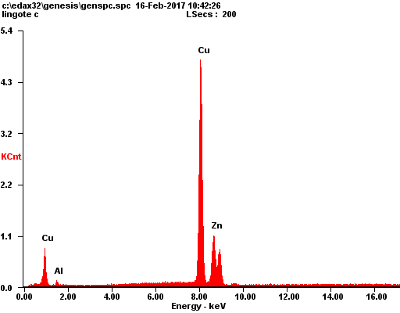
Element | Wt % | At %
AlK | 1.78 | 4.12
CuK | 77.76 | 76.35
ZnK | 20.46 | 19.53
EDAX ZAF Quantification Standardless SEC Table : Default
kV:30.00 Tilt: 0.00 Take-off:39.19 AmpT:6.4 Detector Type :SUTW-Sapphire Resolution :151.84

