Problem Definition : Table design, registration of banks and users in order for users to carry out borrowing transactions from the bank

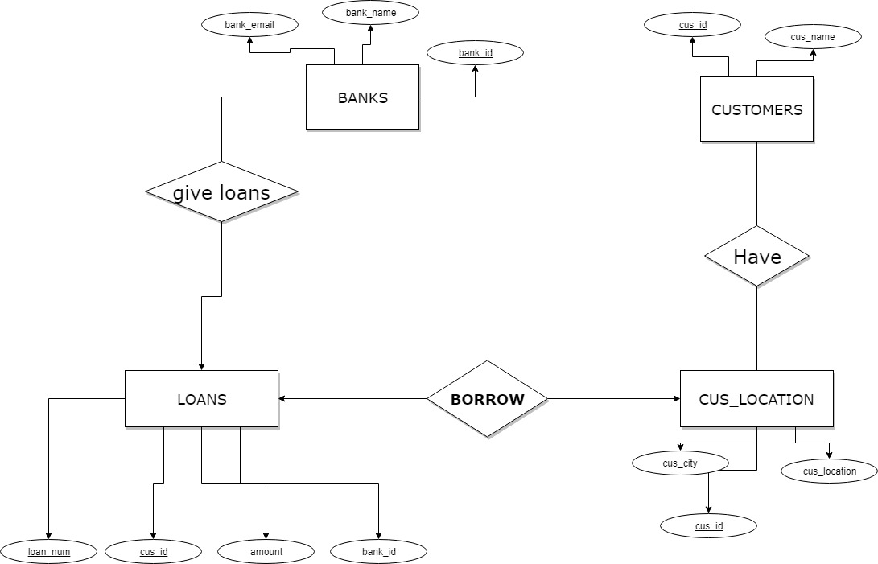

GUI

