

**software project management**

Fitness and Yoga Online System



December 3, 2016

duy tan university

Da Nang City

Lecturer: Jan Samuelsson

Sub.Lecturer: Vo Van Luong

Team 3

1. Le Dinh Nhat Khanh
2. Le Thi Thuy Dung
3. Thai Thi Hong Minh
4. Nguyen Tung Duong

**FITNESS AND YOGA ONLINE SYSTEM**

**1.** **Overall description:** 1

✓ Product perspective: 1

✓ User classes and characteristics: 1

✓ Expected: 2

**2.** **Requirement phases:** 2

✓ Vision and Scope: 2

✓ Actors list: 2

✓ List of user case: 2

✓ Use case diagram: 3

✓ Context Diagram: 4

**3.** **Work breakdown structure (WBS):** 5

✓ WBS about System: 5

✓ WBS about Product: 5

**4.** **Plan:** 6

✓ Delphi: 6

✓ Plan: 6

**5.** **Earned Value Management (EVM):** 7

✓ Plan: 7

✓ EVM 4: 7

✓ Forecast: 8

✓ Plotting CPI and SPI: 8

**FITNESS AND YOGA ONLINE SYSTEM**

1. **Overall description:**

* Product perspective:

The California Fitness and Yoga system is a new system that replaces the current manual and register course at the center. The context diagram in Figure 1 illustrates the external entities and system interfaces for release 1.0. The system is expected to evolve two releases, ultimately connecting to credit and debit card authorization services.

* User classes and characteristics:
* Trainee:

A Trainee is a Process Impact at the corporate campus at Da Nang, who wishes to register the course from the center. There are about 500 trainees, of which an estimated 400 are expected to use the FaYOS an average of 4 times per week. An estimated 90 percent of register will be register using the internet, with 10 percent of registers being register at the center. All trainee have internet access from wherever. Some trainees will wish to manage their calendar to manage their time.

* Staff:

The center currently employs about 20 Staff, who will receive registers from the FaYOS, take care of the trainee, and do the center's small jobs. Most of the center Staff will need to be trained in the use of the computer, the Web browser, and the FaYOS.

* The Administrator:

The Administrator is a center employee, perhaps the center manager, who is responsible for maintaining the center work and make it more widen. The Administrator can also manage the trainer and staff. The Administrator will need to edit the trainer and the staff of the center if there are any changes.

* The trainer:

The trainer of the system who will teach the trainee of the center can manage their calendar in the system. Most of the center trainers will need to be trained in the use of the computer, the Web browser, and the FaYOS

* Expected:

|  |  |
| --- | --- |
| Start day | 2/11/2016 |
| End day | 10/4/2017 |
| Budget | $62.000 |

1. **Requirement phases:**

* Vision and Scope:
* Vision Statement:

For customers who want a training management system which is efficient, convenient and for employees who want to work easily and conveniently then Fitness and Yoga System (FaYOS) is a great system. Unlike other offline systems, FaYOS is an online system that helps create favorable conditions for the management of time and personnel. Customers can manage the schedule, get the latest news from the Centre and pay with just a few steps in everywhere that have Internet. Staff and coaches will also do things more conveniently because everything now is stored automatically.

* Actors list:

|  |  |  |
| --- | --- | --- |
| **Actor** | **Major Value** | **Priority** |
| Manager | Manage the system | 1 |
| Staff | Manage trainers, trainees, courses, schedule, provide supports,… | 2 |
| Trainer | Register courses, receive notifications, calendar,… | 3 |
| Trainee | Register for courses, pay the fees, maintaince the schedule | 3 |

* List of use case:

|  |  |  |  |
| --- | --- | --- | --- |
| **User case (US)** | **Name** | **Description** | **Priority** |
| 1 | Account Management | Users can manage account information themselves by update function | 1 |
| 2 | Feedback | Trainers and trainees can send an opinion about something what they want to know or complaint to staff | 2 |
| 3 | Contact to supporter | Trainers and trainees can contact to the supporter of the center to be supported about the registered courses, … | 2 |
| 4 | Get Notification | Trainers, trainees and staff can get the notification from system about the calendar or fees, … | 2 |
| 5 | Register courses | Trainees can choose one or more courses and then doing registered | 1 |
| 6 | Abort courses | Trainees can abort courses which were registered | 1 |
| 7 | Trainer Management | Staff can manage trainers of the center about their information and teaching calendar, … | 1 |
| 8 | Trainee Management | Staff can manage trainees of the center about their information and schedule, … | 1 |
| 9 | Calendar Management | Staff can manage the calendar of courses. They can arrange, update or cancel schedule | 1 |
| 10 | Fees Management | Staff can manage the fees of courses. They can notice the fee to trainers and collect fee from them | 1 |
| 11 | Staff management | Manager can manage staff of the center about their information | 1 |
| 12 | Staff Salary Management | Manager can manage the salary of staff by tracking and evaluating their attitude | 1 |

* Use case diagram:

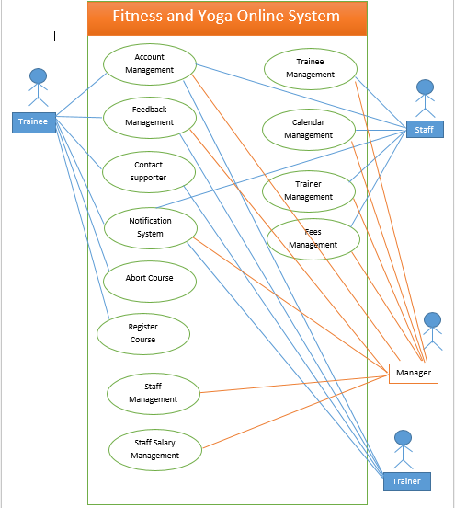

* Context Diagram:

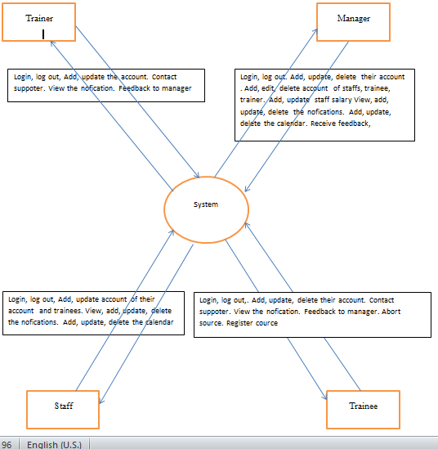

1. **Work breakdown structure (WBS):**

* WBS about System:

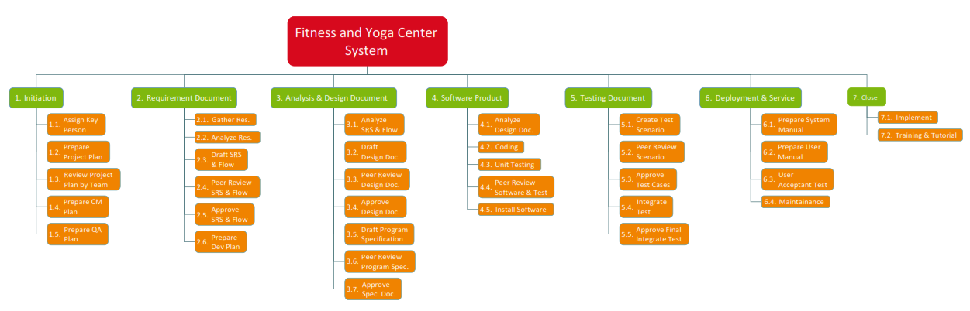

* WBS about Product:

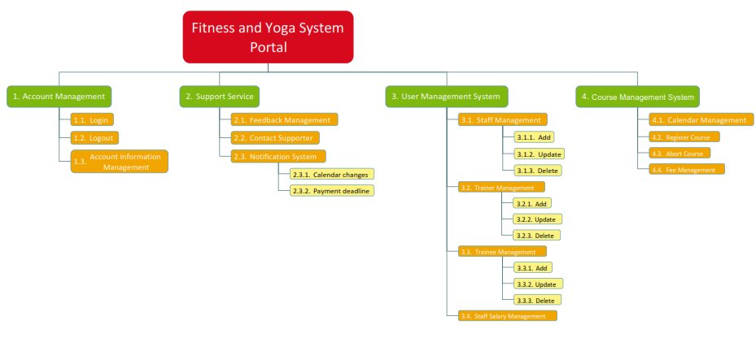

1. **Plan:**

* Delphi:

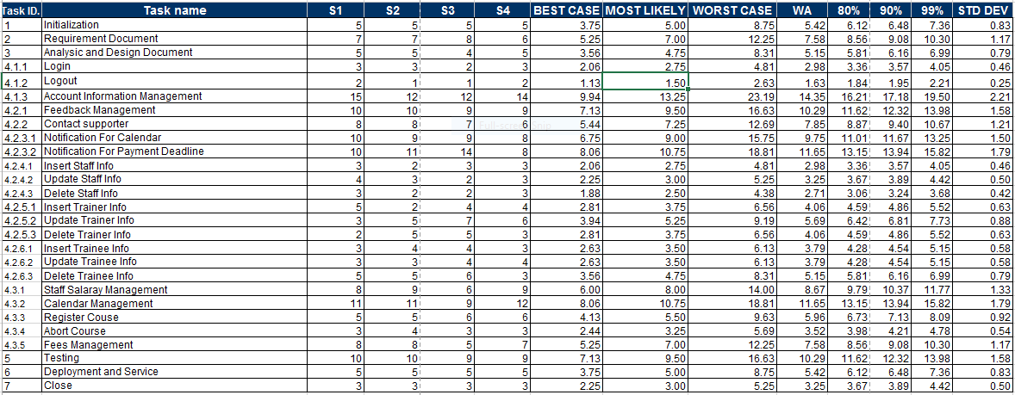

* Plan:

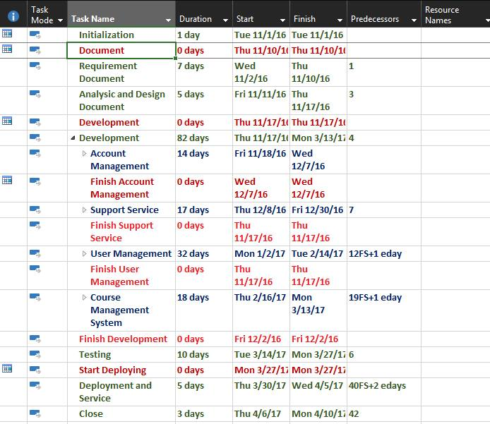

1. **Earned Value Management (EVM):**

* Plan:
* From Week 1 to Week 7:

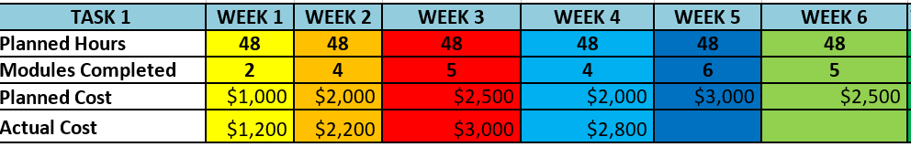

* From Week 8 to Week 16:

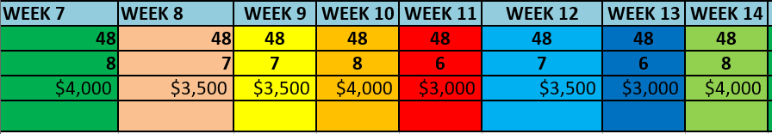

* From Week 17 to Week 21:

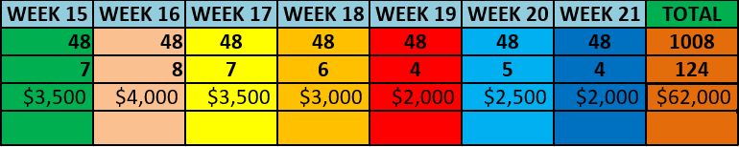

* EVM 4:

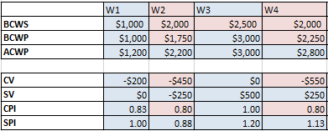

* Forecast:

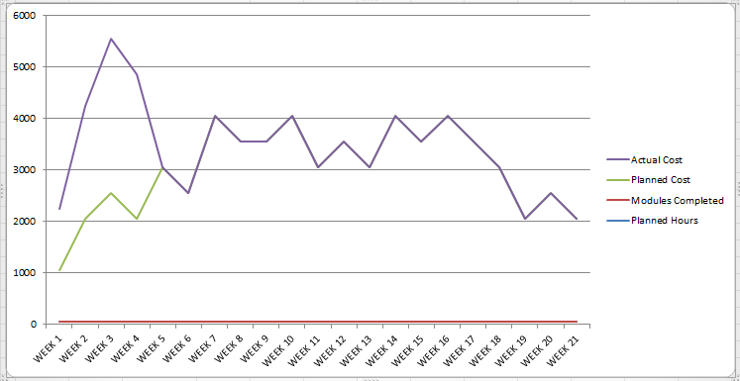

* Plotting CPI and SPI:

