IP pinout
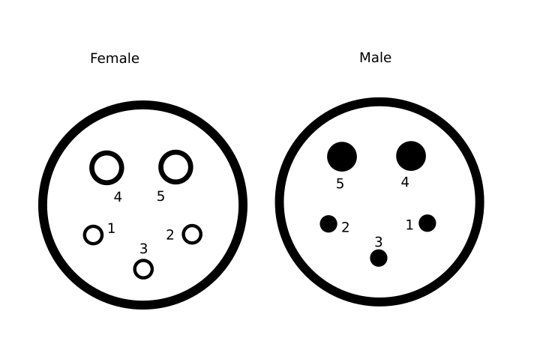
XLR-pinout

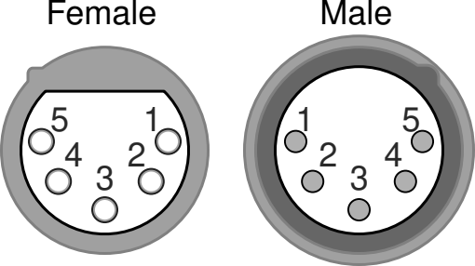

PIN | DMX 1990 | DMX-UCS+PSU | Pix-RS485 | Pixeldata
1 | DATA-GND | Pi-Po | Nc/ gnd couple | Nc/ gnd couple
2 | DMX- data – (inverted uart) | DMX- | Data - | Data backup  (only if supported)
3 | DMX+ data + | DMX+ | Data + | Data
4 | NC/ (avolites uni2-) | PSU-GND | PSU-GND | PSU & Signal- GND
5 | NC/ (avolites uni2+) | PSU-VCC (+24V) | PSU-VCC (7-32V) | PSU-VCC



Cat5e/6 twisted pair (tia568B)
            Pin | col | LS/(thomann) | Advatek mk3
1 |  | 1 Pin 3 (red+) | Uni 2 +
2 |  | 1 Pin 2 (red-) | Uni 2 -
3 |  | 2 Pin 3 (green+) | Uni 1 +
4 |  | 3 Pin 2 (blue-) | Uni 4 + !!
5 |  | 3 Pin 3 (blue+) | Uni 4 - !!
6 |  | 2 Pin 2 (green-) | Uni 1 -
7 |  | 4 Pin 3 (yellow+) | Uni 3+
8 |  | 4 Pin 2 (yellow-) | Uni 3-

SN75176 /SN65HVD/ MAX485 etc. pinout:

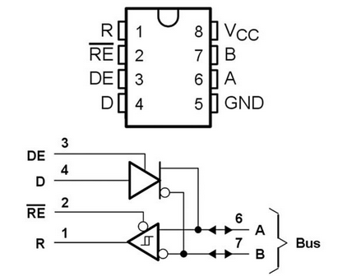

pin | fn | desc
1 | Incomming data | Dmx-frame if trensciever in receive mode (check pin 2/3), of pixel ‘frame’ if used in 485 pixel mode setting.
2/3 | Data direction e.g. send receive | Useally combined, low in send high in receive
4 | Outgoing data | Transmitting data, for (fixtures) devices (should) only in transmit in rdm.
6 | Bus data + | Dmx pin 3/ or pixeldata +
7 | Bus data - | Dmx pin 2/ or pixeldata -

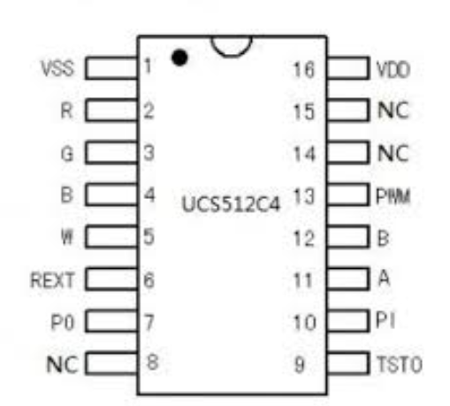

pin | fn | desc
2/3/4/5 | Pwm led sink | In khz range pwm
7 | Position out | Low impedance high/low signal only used in program mode?  Used for determening the next-in-line ic. Last connected to dmx f
10 | Position in | Same as position out, but input.
11 | Dmx a | Dmx pin 3
12 | Dmx b | Dmx pin 2

