Seba’s notes
According to these figures:
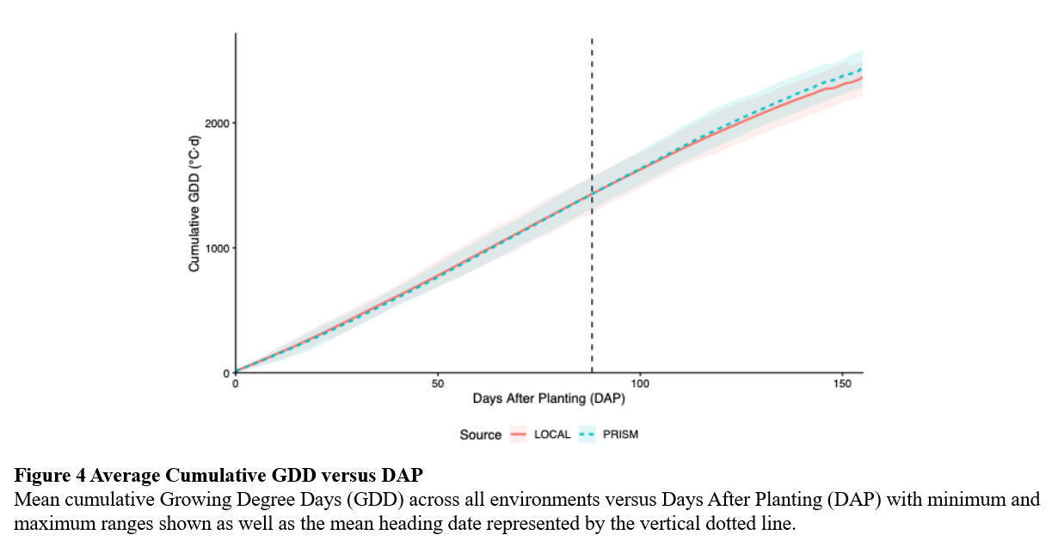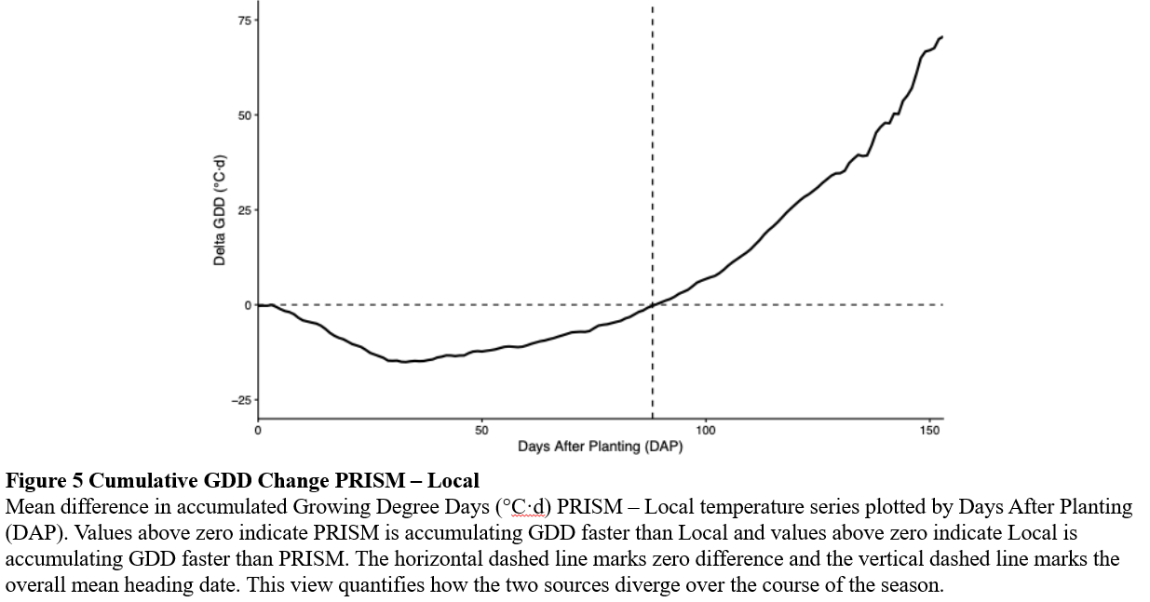
- Why is there no evident difference in Cumulative GDD calculated from PRISM and Local (Fig. 4)? Particularly knowing that there is a difference observed in Fig. 5.
- Why are both temperature sources the same at mean heading (Fig. 5)? Is that just a coincidence?

