(4 marks, file to be edited: Q1.cpp)
Notes: (1) You can create new function(s) if you see it is necessary. (2) In the main function: (a) Do not edit given statements. (b) Write statements in the indicated area only. (3) Suppose that a user enter data correctly, thus you do not need to write code to check input.

TC1 (1 mark):
Enter data for 3 given variables a, b, c. Suppose a contains the number of minutes. Calculate b and c so that b is the number of hours and c is the number of minutes calculated from a. E.g. if a = 150 then b = 2 and c = 30.

Sample output:
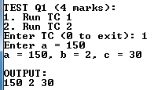

TC2 (3 marks):
Enter data for 2 given integer variables m and n. Calculate the sum s as below:
if n < m then s = 1+++...+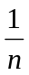, . E.g. if m = 20 and n = 5 then s = 1++++ = 2.833
otherwise (i.e. n ≥ m)
s = the least common multiple of m and n. E.g. if m = 12, n = 18 then s = 36.

Sample output:
