(2 marks, file to be edited: Q3.cpp)
Complete the function fun(int tc, char s[]). The task of the function fun:
if tc = 1 then
convert all words at even positions to uppercase.
otherwise
convert all words at odd positions to uppercase.

Notes: (1) word is a string without space(s) (2) You can create new function(s) if you see it is necessary. (3) Do not edit the main function.

Sample input and output:
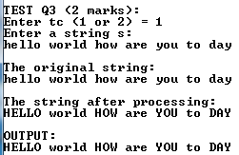 | 