**Bài tập cơ bản 1 1A.**

**Question 1: (2 marks)**

The given file Q1.cpp already contains statements to input data for 3 variables a, b and c. You should write statements to sort these numbers in ascending order (see sample output).

**Notes**:

* You can create new function(s) if you see it is necessary.
* Do not edit given statements in the **main** function.

**Sample output**:

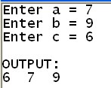

**1B.**

# Question 1: (2 marks)

The given file Q1.cpp already contains statements to input data for 3 variables a, b and c. You should write statements to sort these numbers in descending order (see sample output).

**Notes**:

* You can create new function(s) if you see it is necessary.
* Do not edit given statements in the **main** function.

**Sample output**:

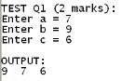

# 2A

## Question 2: (2 marks)

The given file Q2.cpp already contains statement to input data for variable n. Suppose a user always enter n > 1. You should write statement to calculate the sum:

1 1 1

s = 1+ + +...+ , where m = n if n is

2 4 *m*

even, m = n-1 if n is odd **Notes**:

* You can create new function(s) if you see it is necessary.

* Do not edit given statements in the **main** function.

**Sample output**:

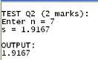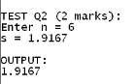

# 2B

## Question 2: (2 marks)

The given file Q2.cpp already contains statement to input data for variable n. Suppose a user always enter n > 2. You should write statement to calculate the sum:

1 1 1

s = 1+ + +...+ , where m = n if n is odd,

3 5 *m*

m = n-1 if n is even **Notes**:

* You can create new function(s) if you see it is necessary.
* Do not edit given statements in the **main** function.

**Sample output**:

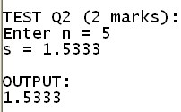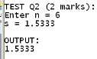

# 3A

## Question 3: (2 marks)

The given file Q3.cpp already contains statement to input data for the variable m. Suppose a user always enter m > 1. You should write statements to find the first n, for which the sum s > m, where:

s = 1+2+3+… + n

**Notes**:

* You can create new function(s) if you see it is necessary.
* Do not edit given statements in the **main** function.

**Sample output**:

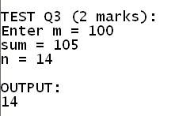

# 3B

## Question 3: (2 marks)

The given file Q3.cpp already contains statement to input data for the variable m. Suppose a user always enter m > 1. You should write statements to find the last n, for which the sum s < m, where:

s = 1+2+3+… + n

**Notes**:

* You can create new function(s) if you see it is necessary.

* Do not edit given statements in the **main** function.

**Sample output**:

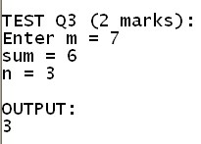

|  |
| --- |
| **4A**  **Question 4: (2 marks)**  The given file Q4.cpp already contains the function named **triangleArea** with 3 parameters a, b, c but its body is empty. You should complete this function to perform the following task:  Check *if a, b and c are sides of a triangle* then calculate and return the area of the triangle by the Heron formula below:  S = *p*(*p**a*)(*p**b*)(*p**c*) , where *p* (*a**b**c*)  2  Otherwise return 0.    **Notes**:  - You can create new function(s) if you see it is necessary. |

* Do not edit the **main** function.

**Sample output**:

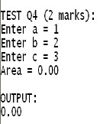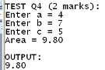

# 4B

## Question 4: (2 marks)

The given file Q4.cpp already contains the function named **triangleAltitude** with 3 parameters a, b, c but its body is empty. You should complete this function to perform the following task:

Check *if a, b and c are sides of a triangle* then calculate and return the altitude from the side a, by the formula below:

where s =



)

(

*c*

*b*

*a*





2

Otherwise return 0.

**Notes**:

* You can create new function(s) if you see it is necessary.
* Do not edit the **main** function.

**Sample output**:

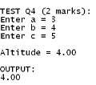 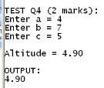

# 5A

## Question 5: (2 marks)

The given file Q5.cpp already contains the function named **calSin** with 2 parameters a and c but its body is empty. You should complete this function to perform the following task:

Return value of sin(x) using the approximate formula below:

*x x*3 *x*5 n *x*(2*n*1)

sin x = - + -... +(-1)

1! 3! 5! (2*n* 1)!

*x*(2*n*1)

here n is the first integer for which | |  c is

(2*n* 1)!

satisfied.

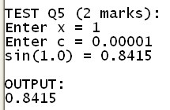**Notes**:

* You can create new function(s) if you see it is necessary.
* Do not edit the **main** function.

**Sample output**:

# 5B

## Question 5: (2 marks)

The given file Q5.cpp already contains the function named **calSin** with 2 parameters a and n but its body is empty. You should complete this function to perform the following task:

Return value of sin(x) using the approximate formula below:

sin x = *x* - *x*3 + *x*5 -... +(-1)n *x*(2*n*1)

1! 3! 5! (2*n* 1)!

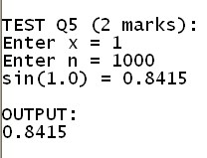**Notes**:

* You can create new function(s) if you see it is necessary.
* Do not edit the **main** function.

**Sample output**:

## Bài tập cơ bản 2

**1A.**

### Question 1: (2 marks)

The given file Q1.cpp already contains statement to input data for a variable x, which contains the number of seconds. Write statements to convert x to number of hours, minutes and seconds (see sample output).

**Notes**:

* You can create new function(s) if you see it is necessary.
* Do not edit given statements in the **main** function.

**Sample output**:

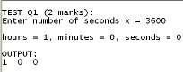 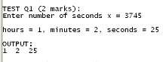

**1B.**

### Question 1: (2 marks)

The given file Q1.cpp already contains statement to input data for a variable x, which contains the number of minutes. Write statements to convert x to number of days, hours and minutes (see sample output).

**Notes**:

* You can create new function(s) if you see it is necessary.
* Do not edit given statements in the **main** function.

**Sample output**:

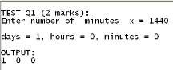 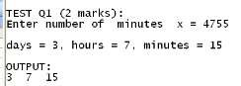

# 2A

**Question 2**

The given file Q2.cpp already contains statement to input data for a variable n. Suppose a user always enter n > 2. Write statement to find the first prime number m, where m > n.

**Notes**:

- You can create new function(s) if you see it is necessary.

# 2B

## Question 2: (2 marks)

* Do not edit given statements in the **main** function.

**Sample output**:

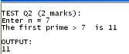

The given file Q2.cpp already contains statement to input data for a variable n. Suppose a user always enter n > 2. Write statement to find the first square number m, where m > n (a **square number** is an integer that is the square of an integer).

**Notes**: **Sample output**:

* 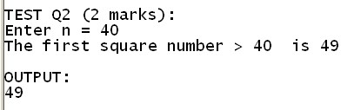You can create new function(s) if you see it is necessary.
* Do not edit given statements in the **main** function.

# 3A

## Question 3: (2 marks)

The given file Q3.cpp already contains statements to input data for the variables m and n. Suppose a user always enter positive numbers. Write statements to find the gratest common divisor of m and n.

**Notes**: **Sample output**:

* 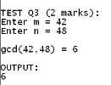You can create new function(s) if you see it is necessary.
* Do not edit given statements in the **main** function.

# 3B

## Question 3: (2 marks)

The given file Q3.cpp already contains statement to input data for a variable n. Suppose a user always enter n > 0. Write statements to calculate the sum of all digits of n.

**Notes**: **Sample output**:

* 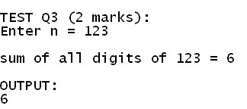You can create new function(s) if you see it is necessary.
* Do not edit given statements in the **main** function.

# 4A

**Question 4**

The given file Q4.cpp already contains the function named **callCharge** with 4 parameters sh, sm, fh and fm, where sh and sm are start hour and minute, fh and fm are ending hour and minute of a phone call. The body of the function is empty. This function calculates and returns the call charge based on 50

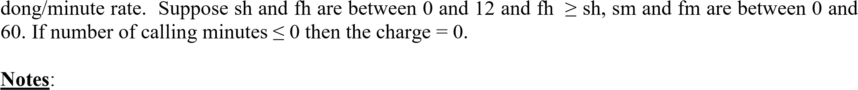

* You can create new function(s) if you see it is necessary.
* Do not edit the **main** function.

**Sample output**:

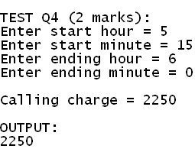 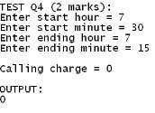

# 4B

## Question 4: (2 marks)

The given file Q4.cpp already contains the function named **callCharge** with 4 parameters sh, sm, fh and fm, where sh and sm are start hour and minute, fh and fm are ending hour and minute of a phone call. The body of the function is empty. This function calculates and returns the call charge based on 70 dong/minute rate. Suppose sh and fh are between 0 and 12 and fh ≥ sh, sm and fm are between 0 and 60. If number of calling minutes ≤ 0 then the charge = 0.

**Notes**:

* You can create new function(s) if you see it is necessary.
* Do not edit the **main** function.

**Sample output**:

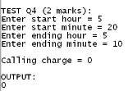 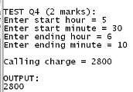

# 5A

**Question 5**

The given file Q5.cpp already contains the function named **calCos** with 2 parameters x and c but its body is empty. You should complete this function to perform the following task:

Return value of cos(x) using the approximate formula below: cos x = 1 - *x*2 + *x*4 -... +(-1)n *x*2*n*

2! 4! (2*n*)!

*x*2*n*

here n is the first integer for which | |  c is satisfied.

(2*n*)!

**Notes**:

* You can create new function(s) if you see it is necessary.
* Do not edit the **main** function.

**Sample output**:

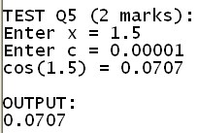

# 5B

## Question 5: (2 marks)

The given file Q5.cpp already contains the function named **calCos** with 2 parameters x and n but its body is empty. You should complete this function to perform the following task:

Return value of cos(x) using the approximate formula below: cos x = 1 - *x*2 + *x*4 -... +(-1)n *x*2*n*

2! 4! (2*n*)!

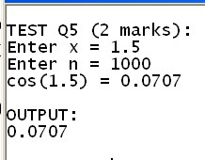**Notes**:

* You can create new function(s) if you see it is necessary.
* Do not edit the **main** function.

**Sample output**:

## Bài tập về mảng (arrays)

### Question 1A: (2 marks)

The given file Q1.cpp already contains functions to input and display an array a. There is also a function with header **search(int a[], int n, int x)**, but its body is empty. You should complete this function so that it returns the index of the first value x in the array a if it is found in the array, otherwise it returns -1.

**Notes**:

* You can create new function(s) if you see it is necessary.
* Do not edit the **main** function.

**Sample output**:

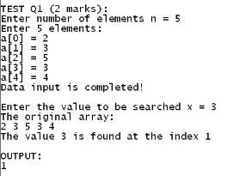 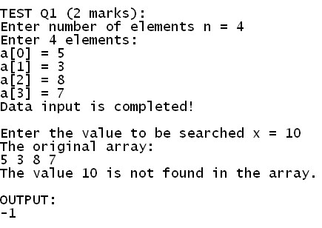

### Question 1B: (2 marks)

The given file Q1.cpp already contains functions to input and display an array a. There is also a function with header **search(int a[], int n, int x)**, but its body is empty. You should complete this function so that it returns the index of the last value x in the array a if it is found in the array, otherwise it returns -1.

**Notes**:

* You can create new function(s) if you see it is necessary.
* Do not edit the **main** function.

**Sample output**:

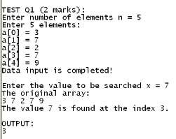 

|  |  |  |
| --- | --- | --- |
| **Question 2A: (2 marks)** |  |  |
| The given file Q2.cpp already | contains | **Sample output**: |

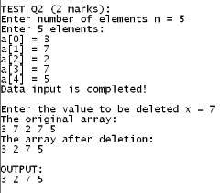functions to input and display an array a. There is also a function with header **dele(int a[], int &n, int x)**, but its body is empty and you should complete it. The task of the function is to delete the first value x in the array a if it is found in the array, otherwise it does nothing.

**Notes**:

* You can create new function(s) if you see it is necessary.
* Do not edit the **main** function.

|  |  |  |
| --- | --- | --- |
| **Question 2B: (2 marks)** |  |  |
| The given file Q2.cpp already | contains | **Sample output**: |

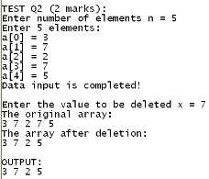functions to input and display an array a. There is also a function with header **dele(int a[], int &n, int x)**, but its body is empty and you should complete it. The task of the function is to delete the last value x in the array a if it is found in the array, otherwise it does nothing.

**Notes**:

* You can create new function(s) if you see it is necessary.
* Do not edit the **main** function.

### Question 3A: (2 marks)

The given file Q3.cpp already contains **Sample output**:

|  |  |  |
| --- | --- | --- |
| - Do not edit the **main** function.        **Question 3B: (2 marks)** |  |  |
| The given file Q3.cpp already | contains | **Sample output**: |

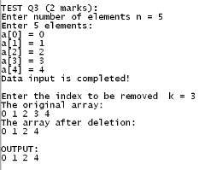functions to input and display an array a. There is also a function with header **dele(int a[], int &n, int k)**, but its body is empty and you should complete it. The task of the function is to remove the element at index k in the array, if k is in the interval [0,n-1], otherwise it does nothing.

**Notes**:

* You can create new function(s) if you see it is necessary.

|  |  |
| --- | --- |
| - Do not edit the **main** function. |  |
| **Question 4A: (2 marks)** | **Sample output**: |

functions to input and display an array a. There is also a function with header **dele(int a[], int &n, int k)**, but its body is empty and you should complete it. The task of the function is to remove the element at index k in the array, if k is in the interval [0,n-1], otherwise it does nothing.

**Notes**:

* You can create new function(s) if you see it is necessary.

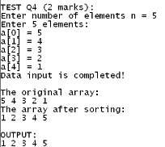The given file Q4.cpp already contains functions to input and display an array a. There is also a function with header **sort(int a[], int n)**, but its body is empty and you should complete it. The task of the function is to sort the the array ascendingly.

**Notes**:

* You can create new function(s) if you see it is necessary.

* Do not edit the **main** function.

### Question 4B: (2 marks)

The given file Q4.cpp already contains **Sample output**:

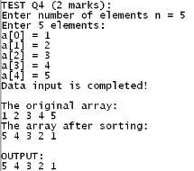functions to input and display an array a. There is also a function with header **sort(int a[], int n)**, but its body is empty and you should complete it. The task of the function is to sort the the array descendingly.

**Notes**:

* You can create new function(s) if you see it is necessary.
* Do not edit the **main** function.

|  |  |  |
| --- | --- | --- |
| **Question 5A: (2 marks)** |  |  |
| The given file Q5.cpp already | contains | **Sample output**: |

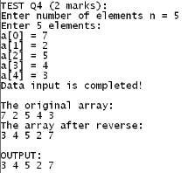functions to input and display an array a. There is also a function with header **reverse(int a[], int n)**, but its body is empty and you should complete it. The task of the function is to reverse the the array.

**Notes**:

* You can create new function(s) if you see it is necessary.
* Do not edit the **main** function.

|  |  |  |
| --- | --- | --- |
| **Question 5B: (2 marks)** |  |  |
| The given file Q5.cpp already | contains | **Sample output**: |

functions to input and display an array a. There is also a function with header **reverse(int a[], int n)**, but its body is empty and you should complete it. The task of the function is to reverse the the array.

**Notes**:

* You can create new function(s) if you see it is necessary.
* Do not edit the **main** function.

## Bài tập về chuỗi (strings)

### Question 1A: (2 marks)

In this test, we consider a string s as an array a of words (word is a string containing no spaces). For example, if s = “la ha ba na” then we consider s as an array a of size 4, where a[0]=”la”, a[1]=”ha”, a[2]=”ba” anf a[3]=”na”;

The given file Q1.cpp already contains functions to input and display a string s. There is also a function with header **toUpper(char s[])**, but its body is empty and you should complete it. The task of the function is to convert all characters of s to uppercase.

**Notes**:

* You can create new function(s) if you see it is necessary.
* Do not edit the **main** function.

**Sample output**:

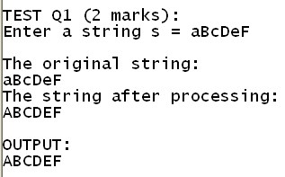

### Question 1B: (2 marks)

In this test, we consider a string s as an array a of words (word is a string containing no spaces). For example, if s = “la ha ba na” then we consider s as an array a of size 4, where a[0]=”la”, a[1]=”ha”, a[2]=”ba” anf a[3]=”na”;

The given file Q1.cpp already contains functions to input and display a string s. There is also a function with header **toLower(char s[])**, but its body is empty and you should complete it. The task of the function is to convert all characters of s to lower case.

**Notes**:

### Question 2A: (2 marks)

* You can create new function(s) if you see it is necessary.
* Do not edit the **main** function.

**Sample output**:

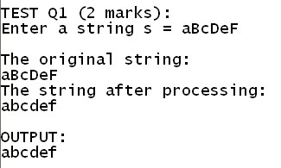

The given file Q2.cpp already contains functions to input and display a string s. There is also a function with header **countWordsUpper(char s[])**, but its body is empty and you should complete it.

This function returns the number of words starting with uppercase letter in s.

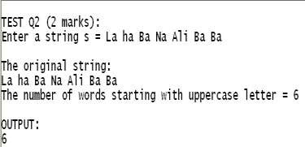**Notes**:

* You can create new function(s) if you see it is necessary.
* Do not edit the **main** function.

**Sample output**:

### Question 2B: (2 marks)

The given file Q2.cpp already contains functions to input and display a string s. There is also a function with header **countWordsLower(char s[])**, but its body is empty and you should complete it.

This function returns the number of words starting with lowercase letter in s.

|  |  |
| --- | --- |
| **Sample output**:      **Question 3A: (2 marks)** |  |
| The given file Q3.cpp already contains functions to input and display a string s. There is also a function with header **toProper(char s[])**, but its body is empty and you should | - Do not edit the **main** function.    **Sample output**: |

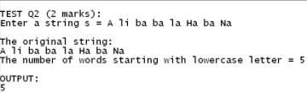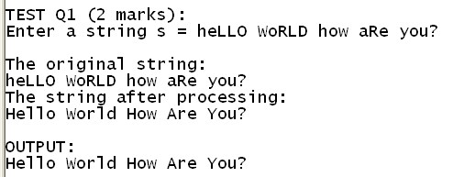**Notes**:

* You can create new function(s) if you see it is necessary.
* Do not edit the **main** function.

complete it. The task of the function is to translate all words in s to proper form, which means that the first character of all words is uppercase, the remaings are lowercase.

**Notes**:

* You can create new function(s) if you see it is

necessary.

### Question 3B: (2 marks)

The given file Q3.cpp already contains functions to input and display a string s. There is also a function with header **toProper(char s[])**, but its body is empty and you should complete it. The task of the function is to translate all words in s to proper form, which means that the first character of all words is uppercase, the remaings are lowercase.

**Notes**:

* You can create new function(s) if you see it is necessary.

* Do not edit the **main** function.

**Sample output**:



### Question 4A: (2 marks)

|  |  |
| --- | --- |
| The given file Q4.cpp already contains functions to input and display a string s. There | **Sample output**: |

|  |  |
| --- | --- |
| - Do not edit the **main** function.    **Question 4B: (2 marks)** |  |
| The given file Q4.cpp already contains functions to input and display a string s. There | **Sample output**: |

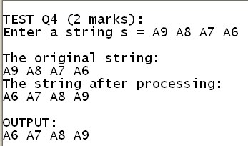is also a function with header **sortWords(char s[])**, but its body is empty and you should complete it. The task of the function is to sort all words in s ascendingly.

**Notes**:

* You can create new function(s) if you see it is necessary.

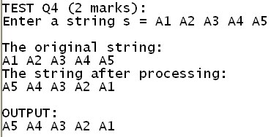is also a function with header **sortWords(char s[])**, but its body is empty and you should complete it. The task of the function is to sort all words in s descendingly.

**Notes**:

* You can create new function(s) if you see it is necessary.

|  |  |
| --- | --- |
| - Do not edit the **main** function.      **Question 5A: (2 marks)** |  |
| The given file Q5.cpp already contains functions to input and display a string s. There | **Sample output**: |

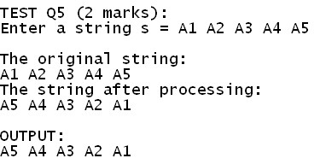is also a function with header

**reverseAllWords(char s[])**, but its body is empty and you should complete it. The task of the function is to reverse all words in s.

**Notes**:

* You can create new function(s) if you see it is necessary.
* Do not edit the **main** function.

**Question 5B: (2 marks)**

The given file Q5.cpp already contains

functions to input and display a string s. There **Sample output**:

is also a function with header

**reverseAllWords(char s[])**, but its body is empty and you should complete it. The task of the function is to reverse all words in s.

**Notes**:

* You can create new function(s) if you see it is necessary.
* Do not edit the **main** function.