UNIVERSITY OF INFORMATION TECHNOLOGY – VNUHCM
FACULTY OF COMPUTER SCIENCE
CS313 – Data Mining

------------


Project Report

Forecasting Water Levels in Hydropower Reservoirs

Instructor: | Vo Le Nguyen Duy, PhD
Student 1: | Le Duc Thanh – 23521441
Student 2: | Huynh Nhat Thanh – 23521440
Student 3: | Le Ngoc Thanh – 23521443
Student 4: | Nguyen Tien Thanh - 23521454
Class: | CS313.Q12
Group ID: | 10

December 2025

Introduction

Problem Defination
Forecasting hydropower reservoir water levels is vital for efficient power generation, dam safety, and sustainable water management. It helps operators plan electricity production, prevent flooding, and ensure reliable energy supply.

Research Motivation
Recent studies mainly focus on forecasting river water levels or predicting inflow to hydropower reservoirs (paper_1, paper_2). In addition, several other studies have predicted reservoir water levels but have not incorporated meteorological data, relying solely on historical reservoir data(paper_3, paper_4, paper_5). However, reservoir water levels are also strongly influenced by operational strategies such as water release and power generation. Therefore, during heavy rainfall or sudden flood events, models based solely on river levels or inflow may fail to reflect the actual state of the reservoir in a timely manner.
As a result, directly forecasting hydropower reservoir water levels is necessary to support operational decision-making, enable early detection of safety risks, and improve flood control efficiency. Early prediction of reservoir water levels hours or days in advance helps ensure dam safety and downstream protection while enhancing water resource management.

Research Target
The Hoa Binh Hydropower Plant, located on the Da River in northern Vietnam, is one of the country’s largest and most important hydroelectric facilities
The Song Ba Ha Hydropower Plant, located on the Ba River in Phu Yen Province in south-central Vietnam, is an important run-of-river hydroelectric facility with an installed capacity of about 220 MW.
The Tri An Hydropower Plant, situated on the Đong Nai River, Đong Nai Province, is one of southern Vietnam’s largest hydroelectric projects, with a total installed capacity of approximately 400 MW.

Dataset
The water level data of the Hoa Binh Hydropower Dam: were collected from the official website of Vietnam Electricity (EVN)
The weather data: were obtained from the Open-Meteo include variables such as temperature, precipitation, humidity, and wind speed, which are used to support hydropower reservoir forecasting

Input – Output
- Input: Target time to be predicted and Upstream water level, inflow to the reservoir, and weather data from the previous 28 days
- Output: Predicted water level at the target time

Exploratory Data Analysis

Weather

Precipitation
Overall, all three reservoirs—Hoa Binh, Song Ba Ha, and Tri An—exhibit a clear wet–dry seasonal pattern. The rainy season typically begins around May and lasts until October or November, with peak precipitation occurring mainly during July and August. This pattern reflects the characteristics of the tropical monsoon climate in Vietnam.
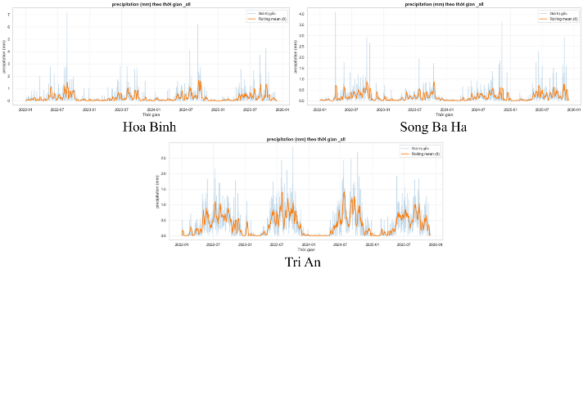


Temperature
At Hoa Binh, temperature shows strong seasonal variation, ranging approximately from 15°C to 30°C throughout the year. In contrast, Song Ba Ha exhibits a narrower temperature range, typically fluctuating between 18°C and 26°C. Meanwhile, Tri An maintains relatively stable temperatures around 24–27°C; however, during the early rainy season (around May), temperatures may exceed 27°C and occasionally approach 30°C.

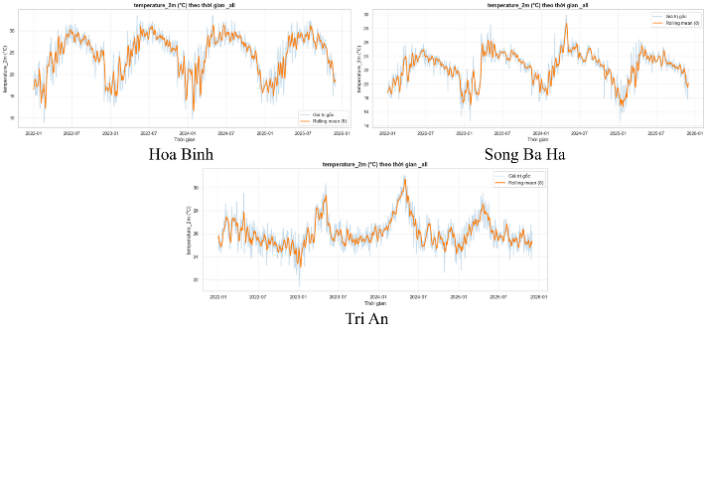


Realative Humidity
In terms of relative humidity, Hoa Binh and Song Ba Ha display similar patterns, with humidity levels generally ranging from 70% to 90% throughout the year. In contrast, Tri An shows clearer seasonal variation, with humidity decreasing to around 60% during the early months of the year (especially February, at the end of the dry season), then gradually increasing to approximately 90% during the middle of the year, coinciding with the rainy season.

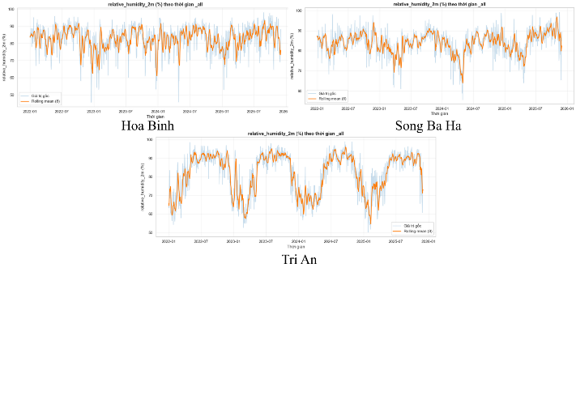


Cloud cover
Regarding cloud cover, Hoa Binh and Song Ba Ha experience relatively high and variable cloud coverage, typically ranging from 40–50% to nearly 100% throughout the year. Meanwhile, Tri An shows a sharp decrease in cloud cover during the late dry season, sometimes dropping below 40%, followed by a rapid increase as the rainy season begins.
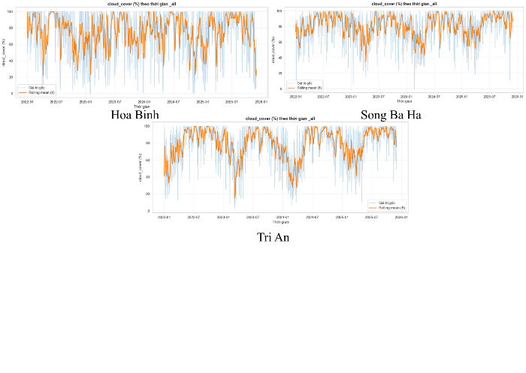


Hydropower Plant

Muc_nuoc_thuy_dien
The upstream water level represents the water level of the reservoir upstream of the hydropower dam and is the primary variable to be predicted in this study. Observations indicate that reservoir water levels tend to decrease during the rainy season, particularly around July and August, which corresponds to the period when major flood events are most likely to occur.
This phenomenon results from flood control operation strategies, in which reservoirs are intentionally drawn down to create storage capacity for flood mitigation, ensuring the safety of both the dam structure and downstream areas.
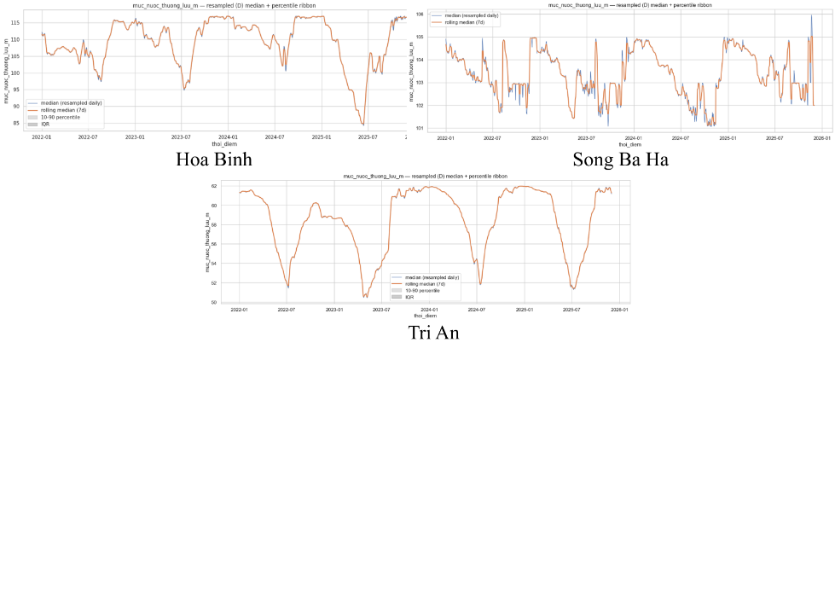


Luu_luong_den_ho
Reservoir inflow represents the volume of natural water flowing into the reservoir over time. At Hoa Binh and Tri An, inflow increases significantly during the rainy season, with multiple high peaks reflecting the direct impact of seasonal rainfall and large watershed areas.
For Song Ba Ha, inflow remains relatively stable for most of the year; however, a sharp spike is observed during November–December, likely due to the impact of major storm events affecting the central region of Vietnam
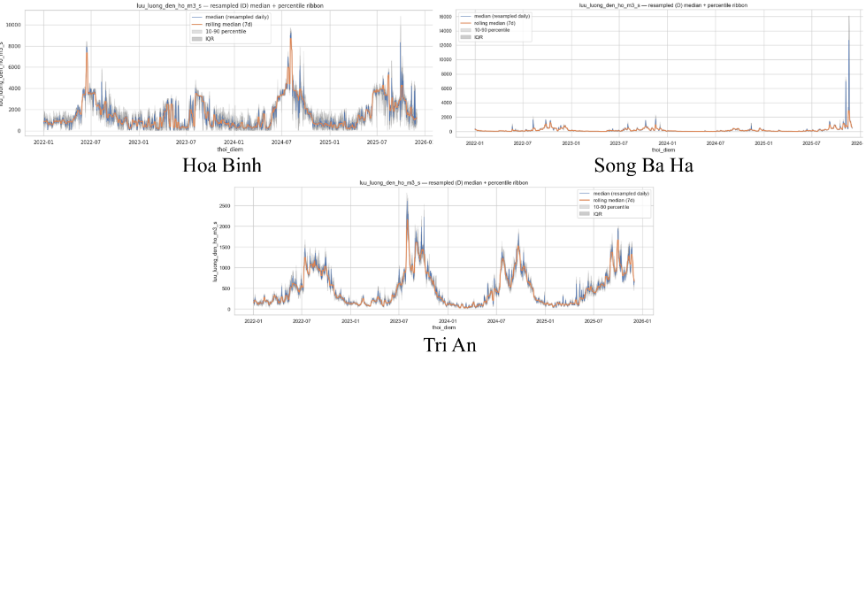


Tong_luong_xa_qua_dap_tran
Total spillway discharge occurs only when the inflow to the reservoir exceeds its normal regulation capacity. The figures indicate that spillway discharge mainly takes place during the rainy season, particularly in years with heavy rainfall. When inflow can be effectively managed through turbine discharge or reservoir regulation, spillway discharge is not required, thereby avoiding unnecessary water loss. This explains why in several years no spillway discharge was recorded.
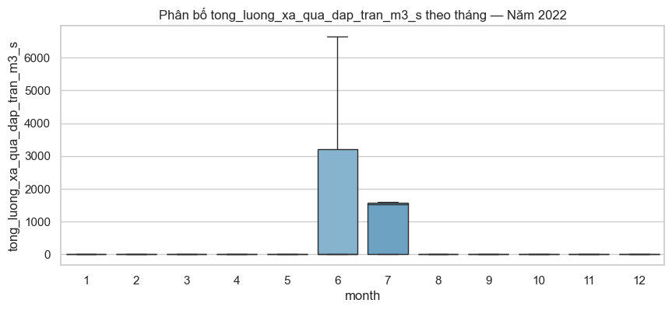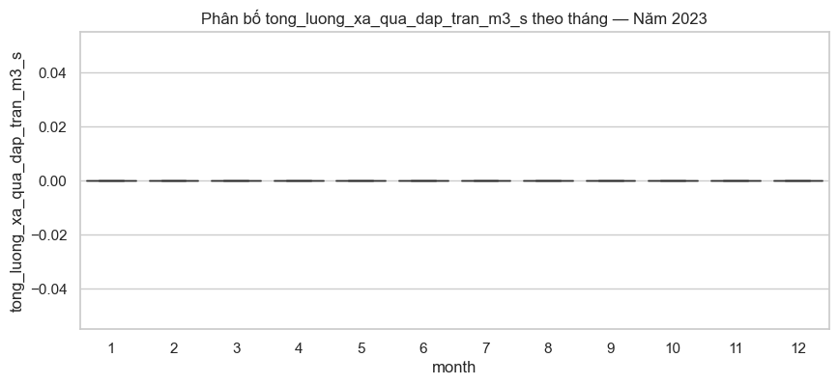
Hoa Binh
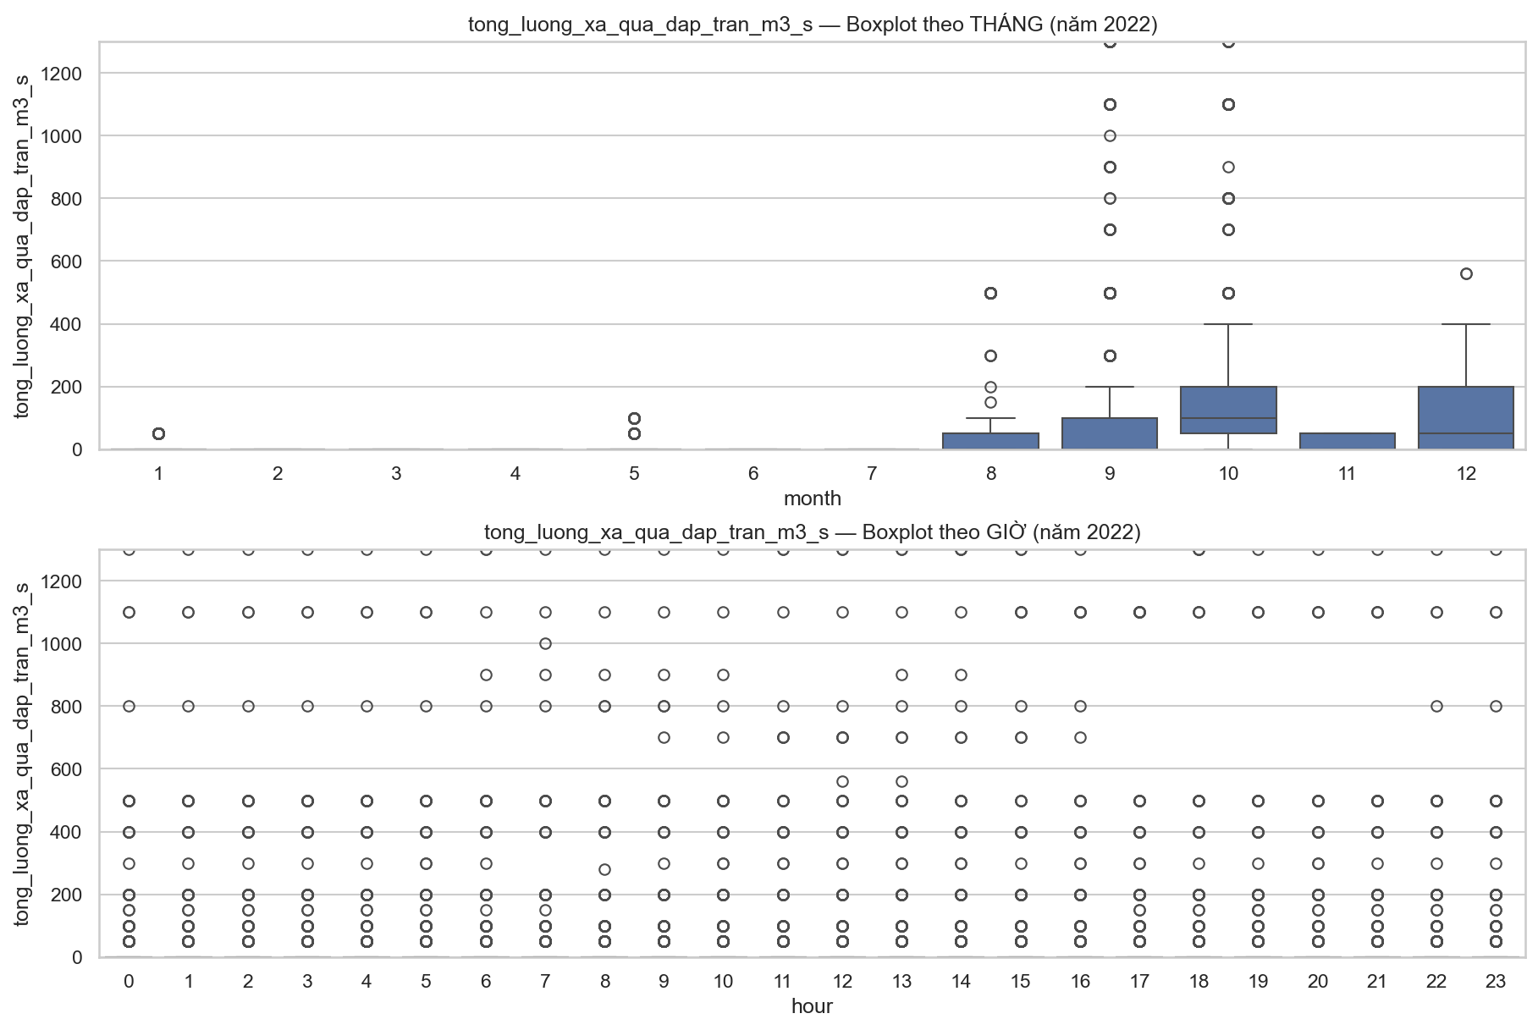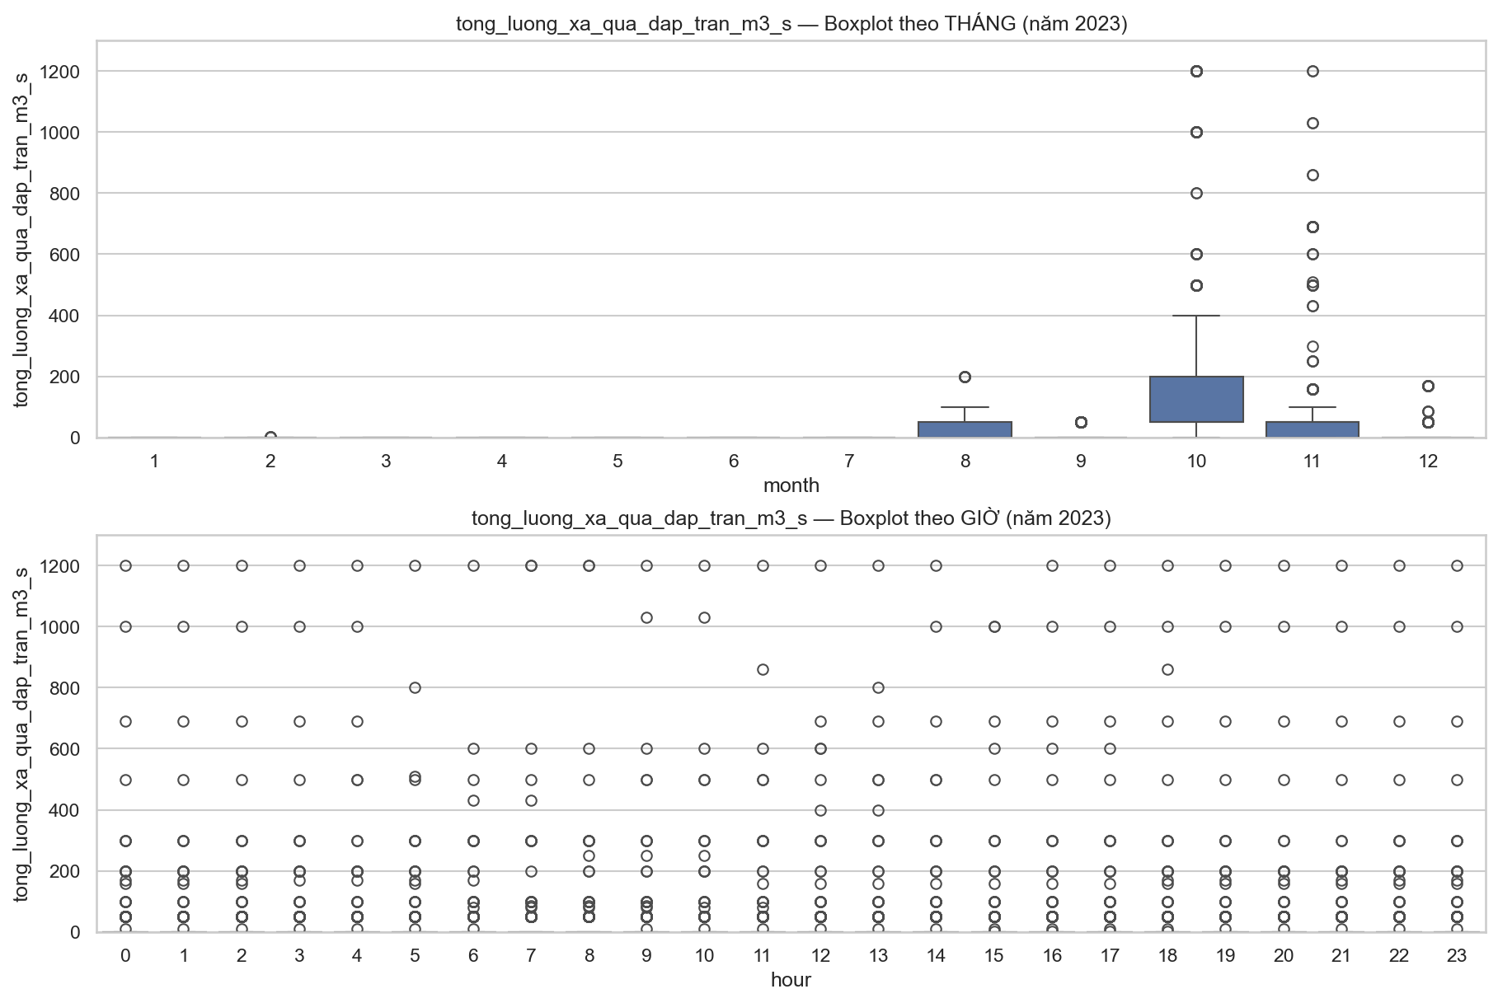
Song Ba ha
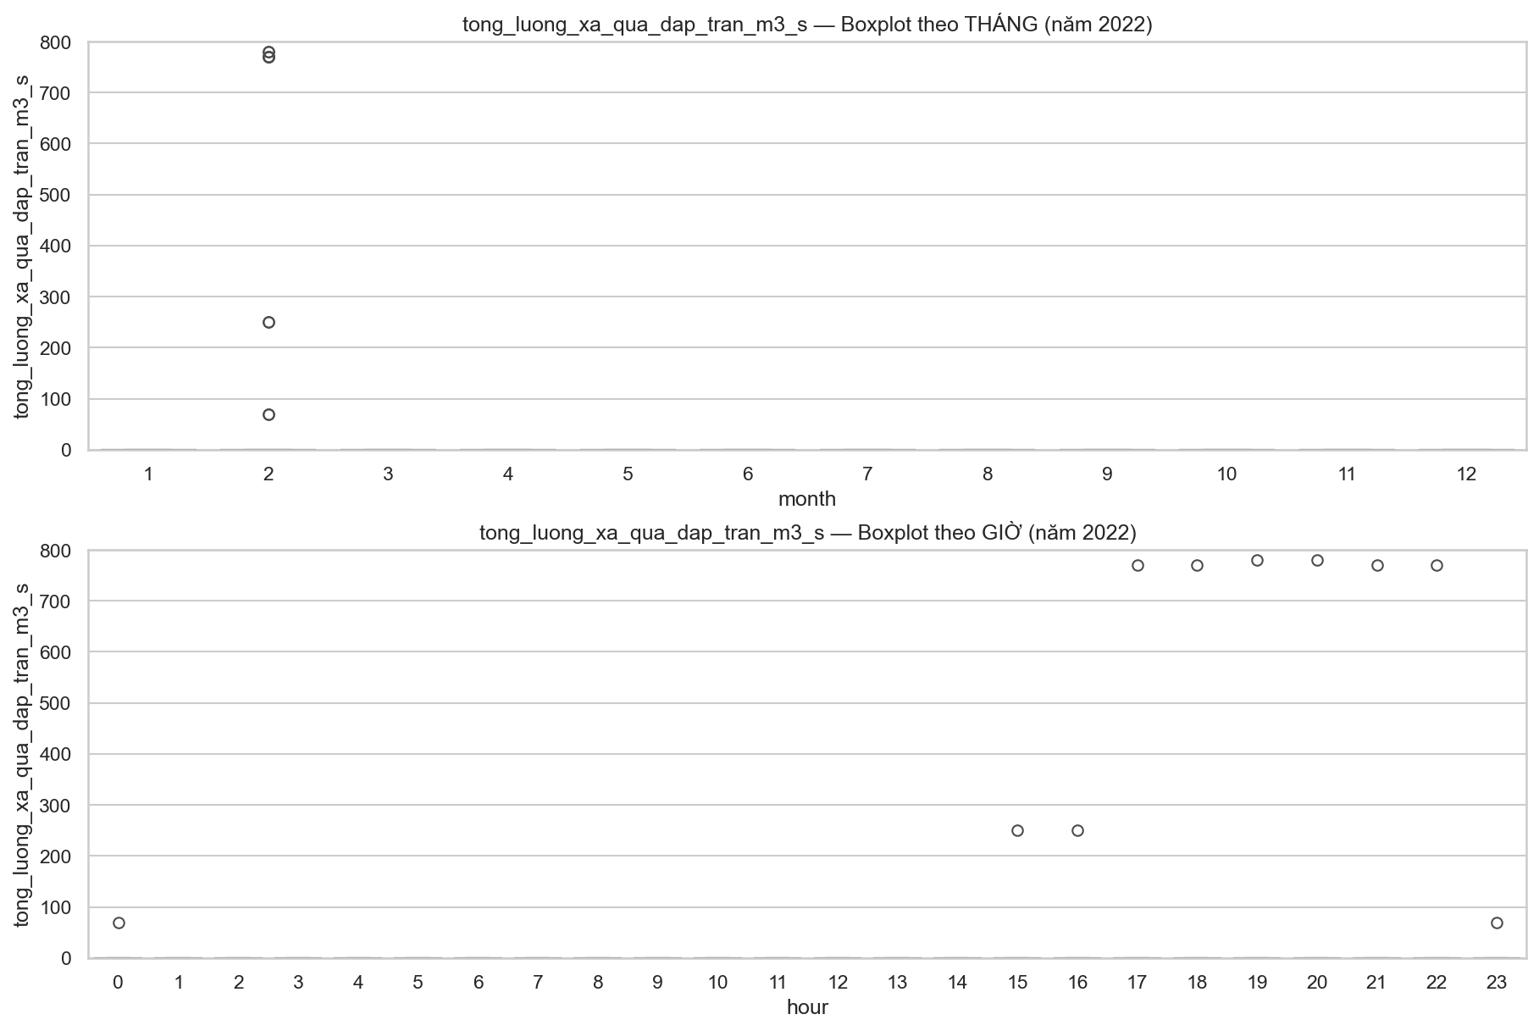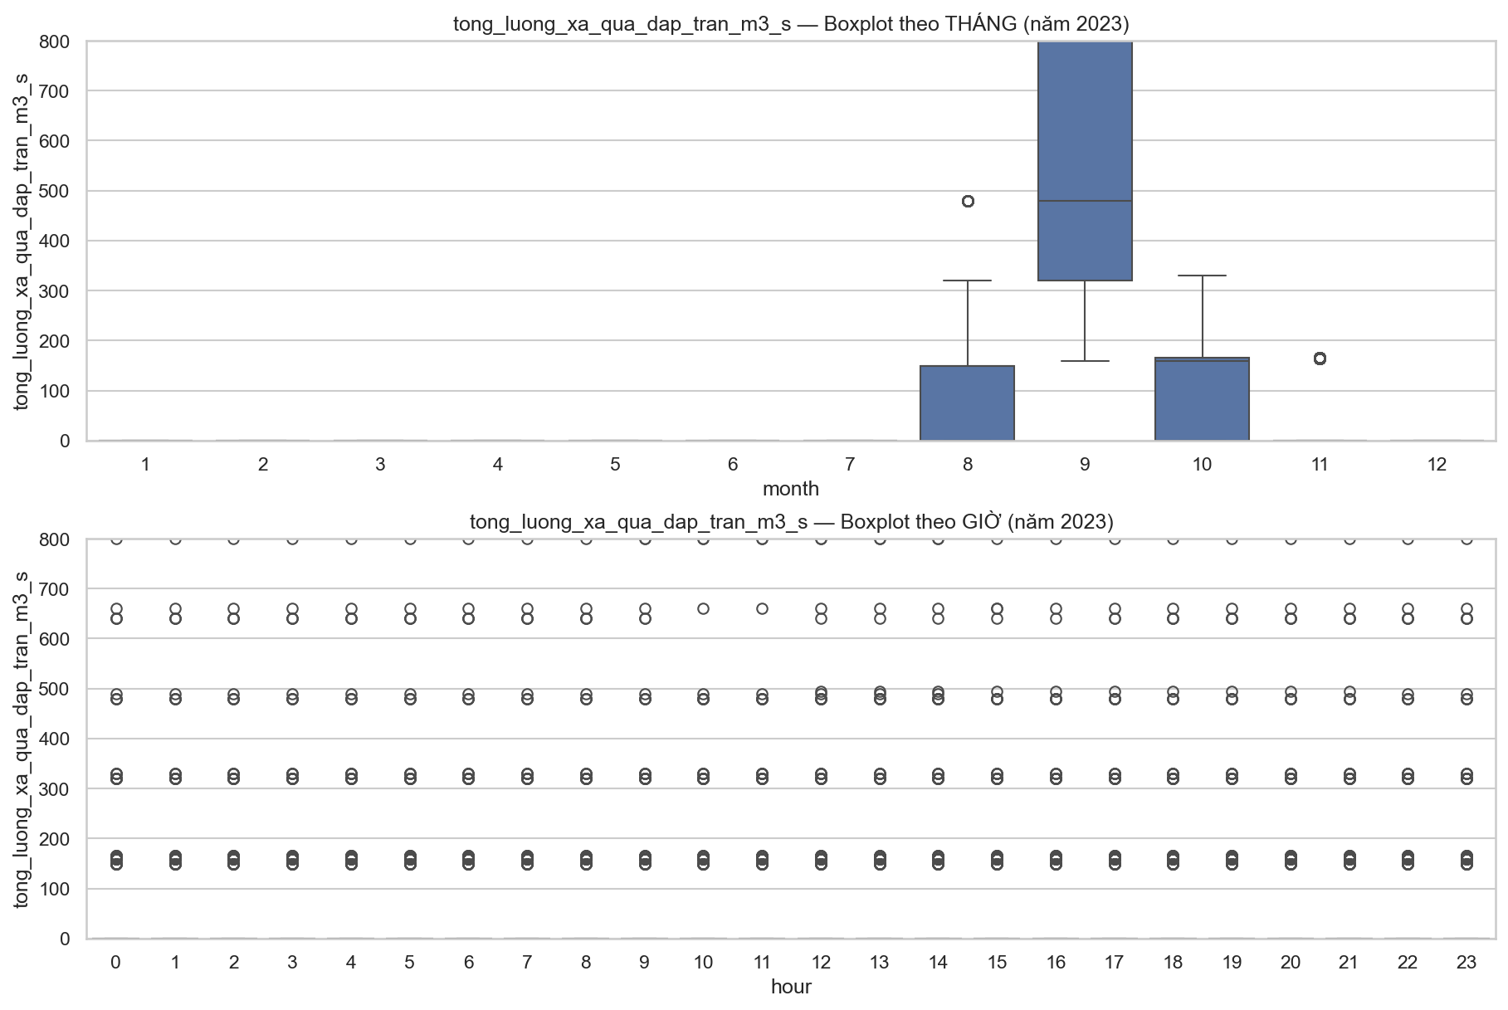
Tri An

Tong_luong_xa_qua_nha_may
Total turbine discharge refers to the volume of water released through the hydropower turbines for electricity generation and directly reflects power plant operations. Unlike spillway discharge, turbine discharge occurs regularly and remains relatively stable throughout the year. However, during the rainy season, turbine discharge tends to increase due to higher inflow, facilitating both electricity generation and water regulation.
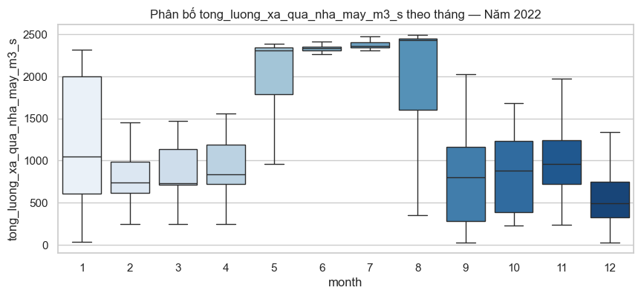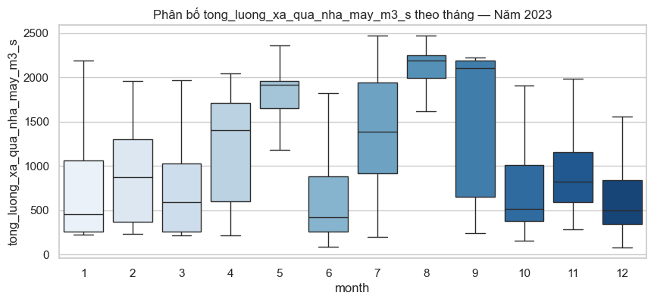
Hoa Binh
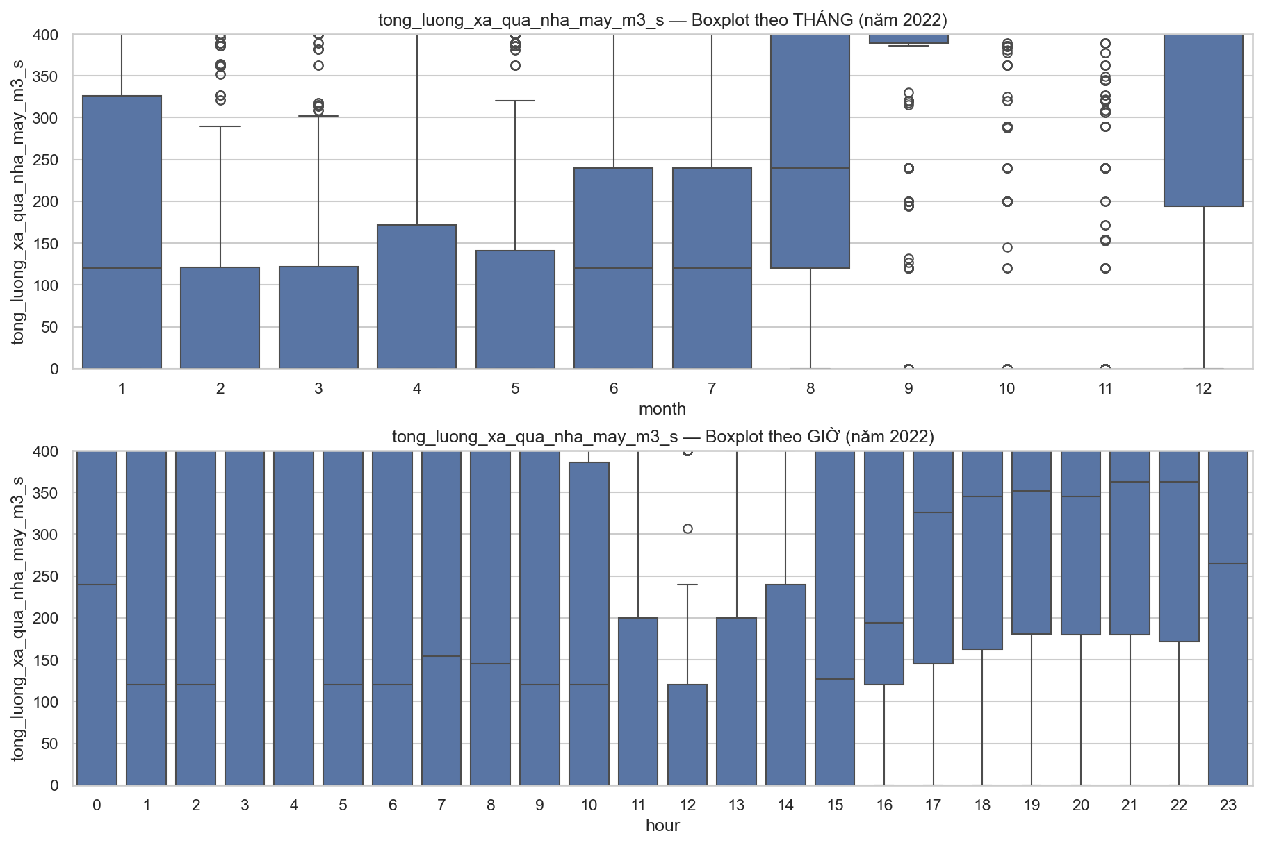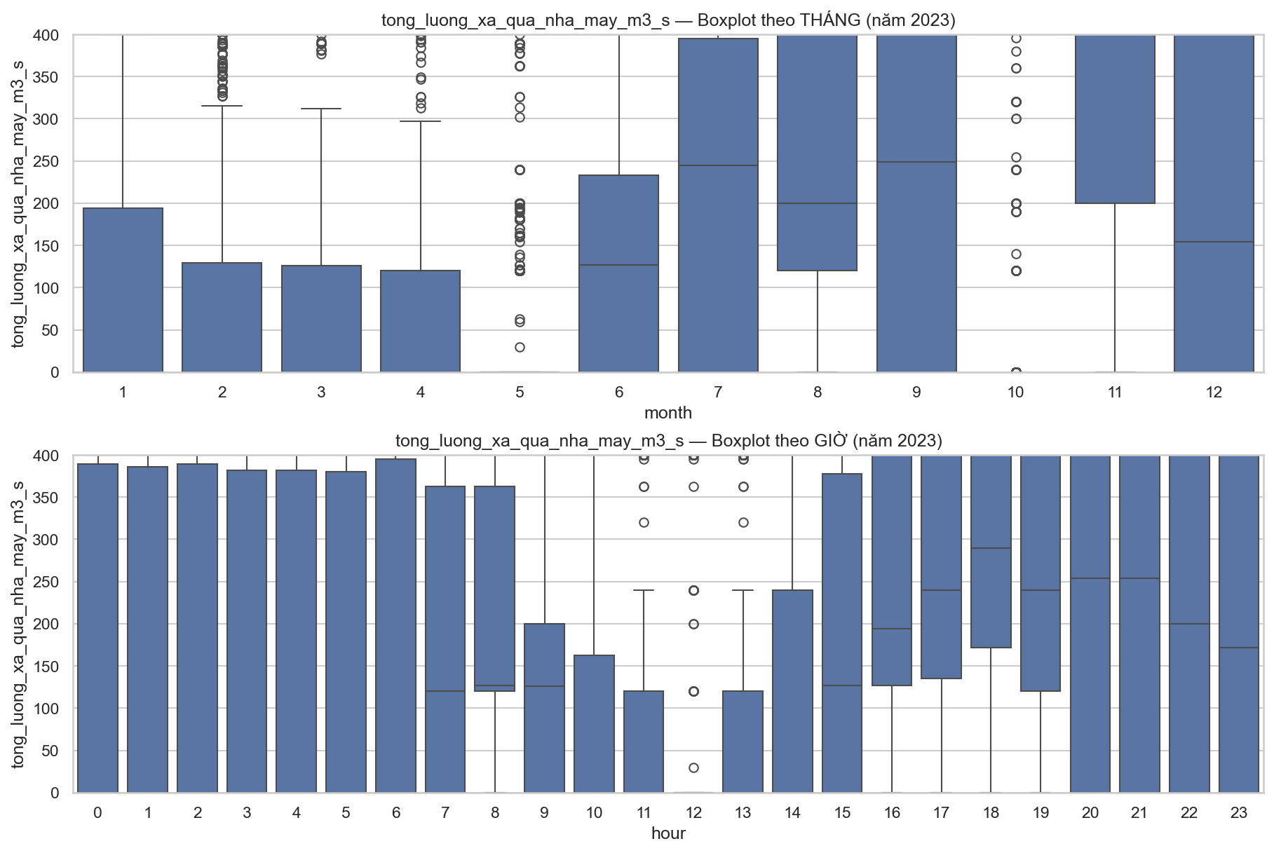
Song Ba Ha
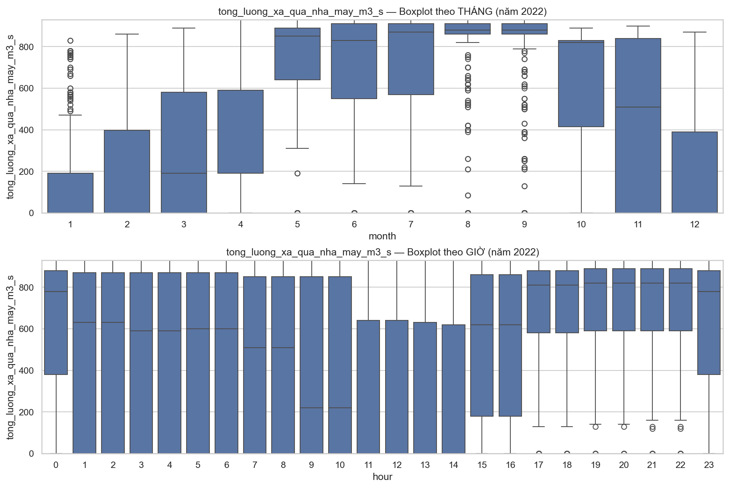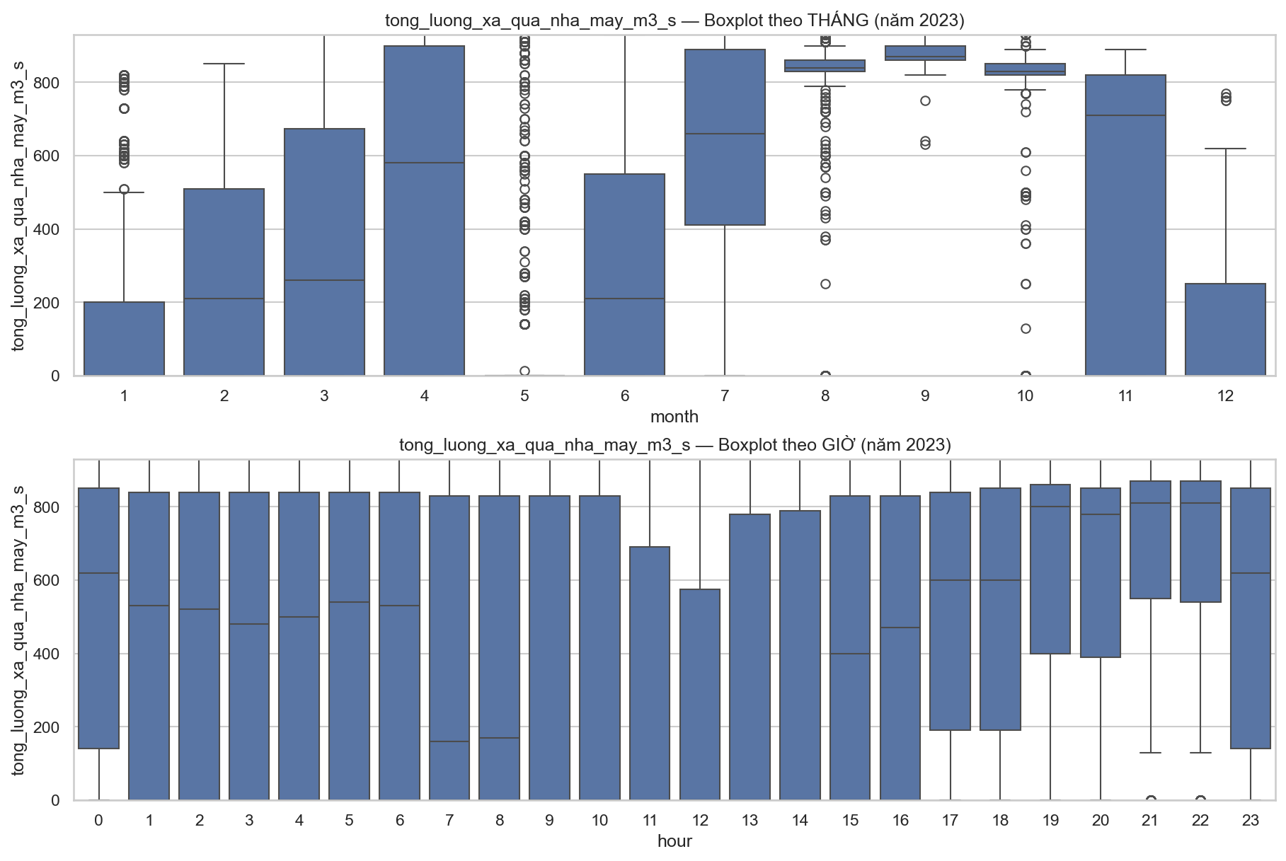
Tri An

Preprocessing
- Excluded Features: muc_nuoc_dang_binh_thuong_m (Normal Water Level), muc_nuoc_chet_m (Dead Water Level), so_cua_xa_sau (Deep Outlets), so_cua_xa_mat (Surface Outlets).
- Rationale: These are static design parameters or low-variance features that contribute negligible predictive value to the dynamic time-series model.
- Upstream Water Level (muc_nuoc_thuong_luu_m):
- Method: Month-wise Imputation. Outliers are identified and filled based on statistical distributions specific to each month (e.g., monthly median/mean) to respect seasonality.
- Scope: Applied consistently across Hoa Binh, Tri An, and Song Ba Ha dams.
- Inflow to Reservoir (luu_luong_den_ho_m3_s):
- Method: Event-Conditional Imputation. Outlier treatment is dynamic and dependent on the is_event_month flag.
- Mechanism: "Event months" (periods of extreme weather/floods) utilize a distinct imputation logic compared to "Non-event months" to preserve critical peak signals.
- Process Note: Preprocessing and Feature Engineering are executed concurrently for this variable, as the is_event_month feature is a prerequisite for the cleaning process.

Feature Engineering

Weather
Additional seasonal information is incorporated by defining the rainy season as the period from May to November, while the dry season spans from December to April.
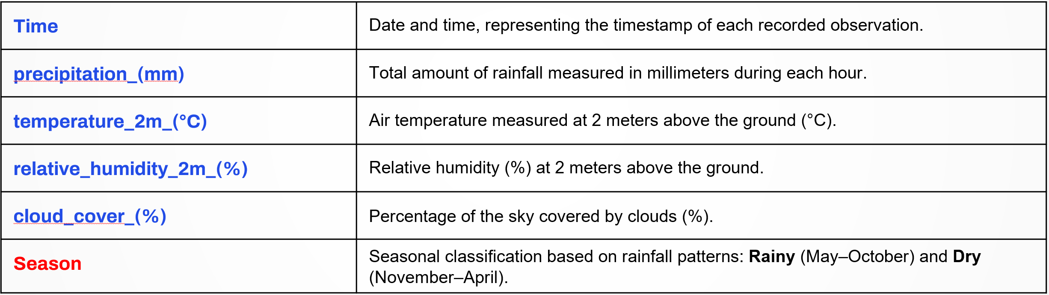

Dams
- Universal Inflow Feature (All Dams) For the Inflow to Reservoir (luu_luong_den_ho_m3_s) variable across all three dams, a binary feature named is_event_month is constructed. This flag is activated if at least one of the following criteria is met:
- Inter-monthly Volatility: Sudden fluctuation between consecutive months $≥150\backslash \%$.
- Climatological Deviation: Significant deviation from the historical multi-year average (Ratio$≥1.5).$
- Extreme Frequency: The proportion of extreme peak values within the month $≥ 8\%.$
- Dam-Specific Water Level Features (Song Ba Ha) For the Upstream Water Level (muc_nuoc_thuong_luu_m) at Song Ba Ha dam, specific Contextual Flags are generated to capture operational regimes and anomalies:
- is_low_level_month: Flags months where the median level is near the dead water level (e.g., 101–102.x meters).
- is_flood_drawdown_like: Flags months with a median level around ~102m, indicating a "pre-flood drawdown" operation (active release to prepare for incoming floods).
- is_2024_anomaly_window: A temporal flag specifically for the July–October 2024 period to explicitly signal the "regime shift" (drought/anomaly) to the model.

Modeling

Hoa Binh
Hoa Binh
Time lead | 3h |  |  | 12h |  |  | 24h
Độ đo | MAE | RMSE | R2 | MAE | RMSE | R2 | MAE | RMSE | R2
CNN + GRU | 1.037448 | 2.164762 | 0.949459 | 1.188531 | 2.318173 | 0.942052 | 1.695534 | 3.093956 | 0.896796
Random Forest | 1.392365 | 3.286040 | 0.883543 | 1.636016 | 3.567868 | 0.862734 | 2.033071 | 3.998094 | 0.827664
Decision Tree | 1.412152 | 3.277819 | 0.884125 | 1.691307 | 3.562106 | 0.863177 | 2.179939 | 4.197817 | 0.810016
XGBoost | 1.472096 | 3.396431 | 0.875587 | 1.720801 | 3.691754 | 0.853036 | 2.036572 | 4.087377 | 0.819881
CNN + LSTM | 1.227889 | 2.484112 | 0.933448 | 1.102916 | 2.257318 | 0.945055 | 1.561830 | 2.845399 | 0.912712
BayesianRidge | 0.045501 | 0.065097 | 0.999954 | 0.137619 | 0.197646 | 0.999579 | 0.269808 | 0.383057 | 0.998418

Song Ba Ha

Song Ba Ha
Time lead | 3h |  |  | 12h |  |  | 24h
Độ đo | MAE | RMSE | R2 | MAE | RMSE | R2 | MAE | RMSE | R2
CNN + GRU | 0.068213 | 0.160922 | 0.960264 | 0.115818 | 0.258367 | 0.897560 | 0.228146 | 0.434468 | 0.710297
Random Forest | 0.030994 | 0.102821 | 0.983778 | 0.086293 | 0.193429 | 0.942583 | 0.160262 | 0.317245 | 0.845536
Decision Tree | 0.043376 | 0.111192 | 0.981029 | 0.120615 | 0.240600 | 0.911164 | 0.197062 | 0.356834 | 0.804580
XGBoost | 0.031730 | 0.106204 | 0.982692 | 0.082641 | 0.186355 | 0.946706 | 0.148666 | 0.302171 | 0.859866
CNN + LSTM | 0.070030 | 0.189523 | 0.944884 | 0.130239 | 0.260834 | 0.895594 | 0.224858 | 0.425441 | 0.722210
BayesianRidge | 0.034211 | 0.088921 | 0.987867 | 0.104565 | 0.282391 | 0.877624 | 0.183098 | 0.478613 | 0.648434

Tri An
Tri An
Time lead | 3h |  |  | 12h |  |  | 24h
Độ đo | MAE | RMSE | R2 | MAE | RMSE | R2 | MAE | RMSE | R2
CNN + GRU | 0.098994 | 0.118400 | 0.998923 | 0.130447 | 0.176847 | 0.997597 | 0.129579 | 0.168773 | 0.997811
Random Forest | 0.017270 | 0.031076 | 0.999926 | 0.054456 | 0.076461 | 0.999551 | 0.103671 | 0.146910 | 0.998342
Decision Tree | 0.030928 | 0.073273 | 0.999587 | 0.086290 | 0.133176 | 0.998637 | 0.126191 | 0.189762 | 0.997233
XGBoost | 0.038360 | 0.093914 | 0.999322 | 0.053459 | 0.102035 | 0.999200 | 0.081740 | 0.129522 | 0.998711
CNN + LSTM | 0.076569 | 0.101775 | 0.999204 | 0.190521 | 0.224946 | 0.996112 | 0.162047 | 0.214493 | 0.996465
BayesianRidge | 0.024900 | 0.038837 | 0.999884 | 0.052436 | 0.071589 | 0.999606 | 0.082612 | 0.110081 | 0.999069

GROUP'S WORK
- The team's work is published at Github.
- Contribution:
Student ID – Name | Task | Contribution
23521440 – Huynh Nhat Thanh | Collected hydropower data sources. Performed EDA, preprocessing, and feature engineering on both datasets (hydropower and weather). Prepared presentation slides and final report. Run all models (Machine Learning + Deep Learning). | 27%
23521441 – Le Duc Thanh | Crawled hydropower data. Conducted EDA, preprocessing, and feature engineering for hydropower data. Evaluated three models: CNN+LSTM, XGBoost, and Decision Tree. Developed the web demo with calculating the predicted results on those three models and EDA. Prepared presentation slides and final report. | 27%
23521443 – Le Ngoc Thanh | Collected and crawled weather data. Performed preprocessing for weather data. Evaluated all the deep learning models. Prepared presentation slides. | 23%
23521454 – Nguyen Tien Thanh | Collected and crawled weather data. Evaluated the all the machine learning models. Developed the web demo with calculating the predicted results on XGBoost model. Prepared presentation slides. | 23%

