**Goals:**

* Created Mongoose Schema for: user, product, rank, producer, category
* Created APIs: get all, insert, update, delete, detail for user, product, rank, producer, category
* Created APIs to get product by category, producer and pagination
* Created simple authentication by jwt
* Have solution handle multilingual (but it's not working yet)

**Cons:**

* No middleware, no error handle
* No admin’s page

**Deployment:**

1. Environment:
   1. Node version: 14.15.0
   2. Mongo: 4 without user and password
   3. Port: 5000
2. Deploy:
   1. cd .\nodejs\
   2. npm install
   3. npm run installDatabase
   4. Ctrl + C 🡺 y
   5. npm run start

**Working on app:**

1. User
   1. Get all user: <http://localhost:5000/v1/users>



* 1. Insert user: <http://localhost:5000/v1/users>

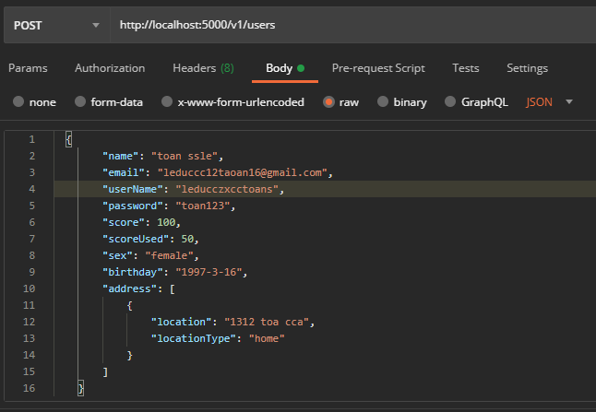

* 1. Detail user by userId: <http://localhost:5000/v1/users/:userId>



* 1. Update user: <http://localhost:5000/v1/users/:userId>

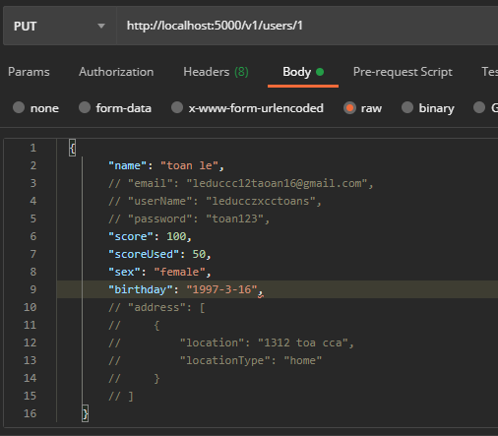

* + - **comment out**: yes or no
  1. Delete user: <http://localhost:5000/v1/users/:userId>

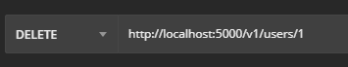

1. Category, Rank, Language, Producer, Product similar to User

APIs:

* + - <http://localhost:5000/v1/ranks>
    - http://localhost:5000/v1/ranks/:rankId
    - http://localhost:5000/v1/categories
    - http://localhost:5000/v1/categories/:categoryId
    - http://localhost:5000/v1/producers
    - http://localhost:5000/v1/producers/:producerId
    - http://localhost:5000/v1/products
    - <http://localhost:5000/v1products/:productId>
    - http://localhost:5000/languages
    - http://localhost:5000/languages/:languageId

1. Solution handle multilingual:

- Since this is my first time doing this I have a reference from the channels on the internet and I decided to use i18n, <https://www.npmjs.com/package/i18n>

- All of the blog posts I've seen, they all use the static approach (install and then deploy the app). But in my code this still doesn't work. I’ll try again later

* Solution handle multilingual:
  + - Insert 2 language to database

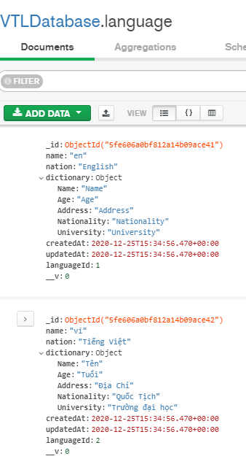

* + - When the app run, check language on database, Insert file en.json, vi.json. Same with package documentation

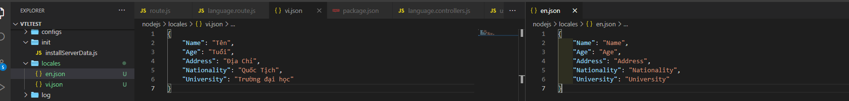

* + - And add configure:

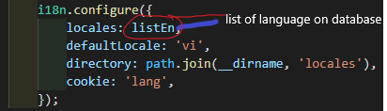

* + - When add new language:

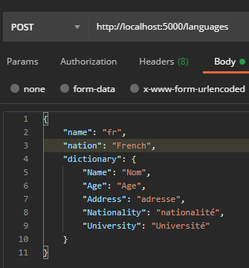

* + - Insert new dictionary file and re-configure i18n.

