*airSense*

Airsense outdoor version 1.0

Version *1.0*

*30/01/2019*

Contents

Table of figures 4

Chapter 1. Upload code 6

1.1 Upload-code program 6

1.2 Code uploading 7

1.3 Note down the MAC address 10

Chapter 2. Checking the device 12

2.1 Checking presses 12

2.2 Checking the fan of PM2.5 sensor 12

2.3 Checking the Internet connection 13

2.4 Checking for SD card 14

2.5 Checking the data on the Internet 15

2.5.1 Structure of topic and message 15

2.5.2 Download mqtt.fx on the following web 16

2.5.3 Checking data 17

2.6 Get data on the internet 20

2.6.1 URL 20

2.6.2 Epochtime 20

Chapter 3. Some problems the device may get 24

3.1 The fan does not work 24

3.2 Press and hold on the config button but the LED is still off 24

3.3 Data of PM is equal 0 24

Chapter 4. Calibration 26

4.1 Purpose 26

4.2 Method 26

4.3 Preparation 26

4.3.1 Device 26

Chapter 5. Installing instruction 27

5.1 Prepare and check before installing 27

5.1.1 Tools 27

5.1.2 Checking at Lab before install 27

5.2 Installing steps 27

5.2.1 Setup the device 27

5.2.2 Checking for operating 27

5.2.3 Immobilizing the device 27

5.2.4 Minute 27

Table of figures

Figure 1 Folder AirSENSE outdoor v1 6

Figure 2 Folder libraries 6

Figure 3 libraries.rar 6

Figure 4 C:\Users\dell\Documents\Arduino\libraries 7

Figure 5 folder final_task 7

Figure 6 Open file final_task.ino 7

Figure 7 interface of Arduino program 8

Figure 8 D1 mini kit 8

Figure 9 Choosing COM port and setting up technical specification 9

Figure 10 Uploading code successfully 9

Figure 11 state bar 10

Figure 12 Reading MAC address on state bar 10

Figure 13 Price tag 11

Figure 14 Tow presses on circuit board 12

Figure 15 SDS011 fan 12

Figure 16 Smartconfig for Android device 13

Figure 17 Smartconfig for iOS device 13

Figure 18 Configure for Android successfully 14

Figure 19 Configure for iOS successfully 14

Figure 20 Data file in SD card 14

Figure 21 Data stored in SD card 15

Figure 22 Example topic of devices 15

Figure 23 Structure of message 16

Figure 24 mqtt.fx downloading 16

Figure 25 Choose suitable version with your OS 17

Figure 26 Display of mqtt.fx 17

Figure 27 Modify the parameter 18

Figure 28 Connect to server mqtt 18

Figure 29 Click to choose scan 19

Figure 30 Topics in mqtt server 19

Figure 31 URL 20

Figure 32 open browser 20

Figure 33 Enter that link to search bar 20

Figure 34 EpochtimeConverter interface 21

Figure 35 Convert Human date to Epoch time 22

Figure 36 Open csv file 22

Figure 37 data from server 23

Figure 38 Connect device with 2.1 A USB port 25

# Chapter 1. Upload code

In this chapter, we need to know about steps to upload code for AirSENSE outdoor V1 devices

## Upload-code program

We use Arduino IDE based on Windows operational system. Here is the link

<http://arduino.vn/bai-viet/68-cai-dat-driver-va-arduino-ide>

After installing the Arduino IDE, we practice on board ESP8266

<http://arduino.vn/bai-viet/1172-lap-trinh-esp8266-bang-arduino-ide>

Next, we add code for our library.

Choose folder AirSENSE outdoor V1 code

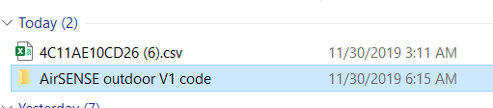

Figure 1 Folder AirSENSE outdoor v1

Choose folder **libraries**

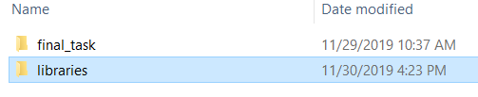

Figure 2 Folder libraries

Extract the folder **libraries.rar**

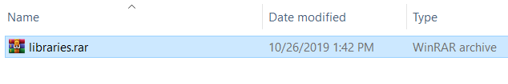

Figure 3 libraries.rar

Then, copy all the extracted folder to folder that store libraries of Arduino IDE, the address is often used as follow:

C:\Users\dell\Documents\Arduino\libraries

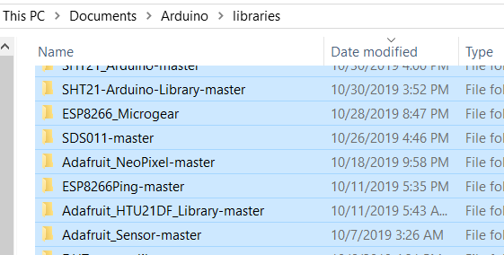

Figure 4 C:\Users\dell\Documents\Arduino\libraries

## Code uploading

Come back to folder AirSENSE outdoor V1 code, open folder final_task

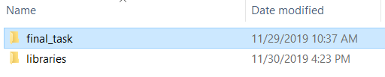

Figure 5 folder final_task

Doubleclick file final_task.ino to open Arduino IDE program

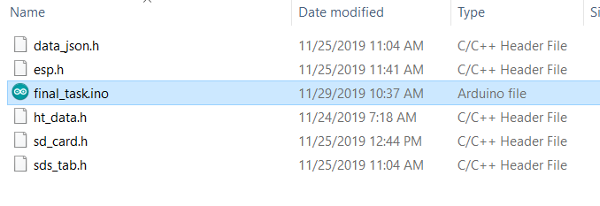

Figure 6 Open file final_task.ino

On the interface of the program, we install some parameters as follw: click Tools on bar tool, then modify as the picture.

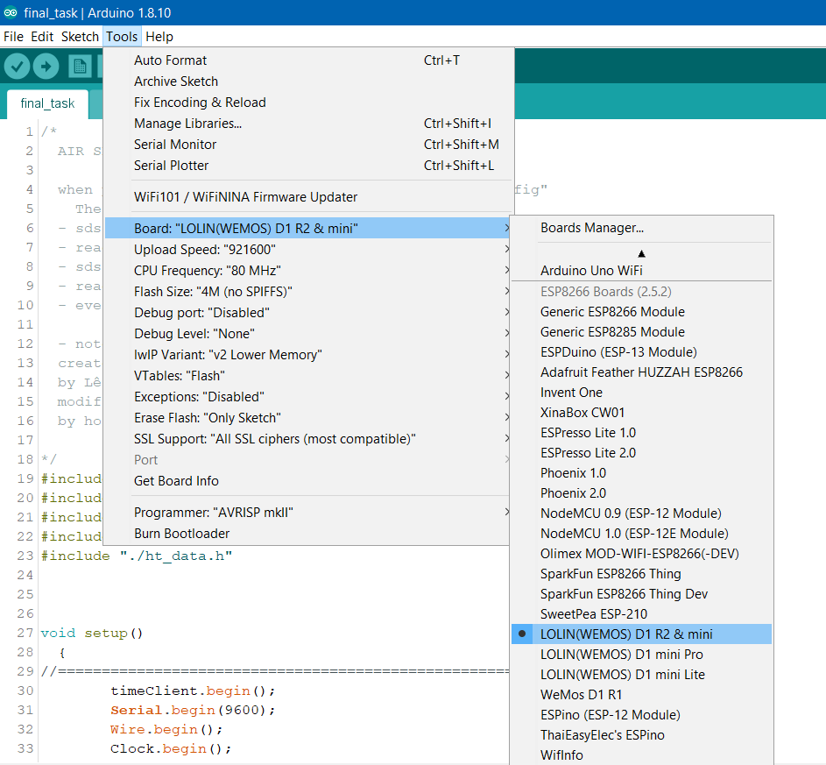

Figure 7 interface of Arduino program

Next, connect the cable of USB type A connected with computer to USB micro type A on the D1 mini kit

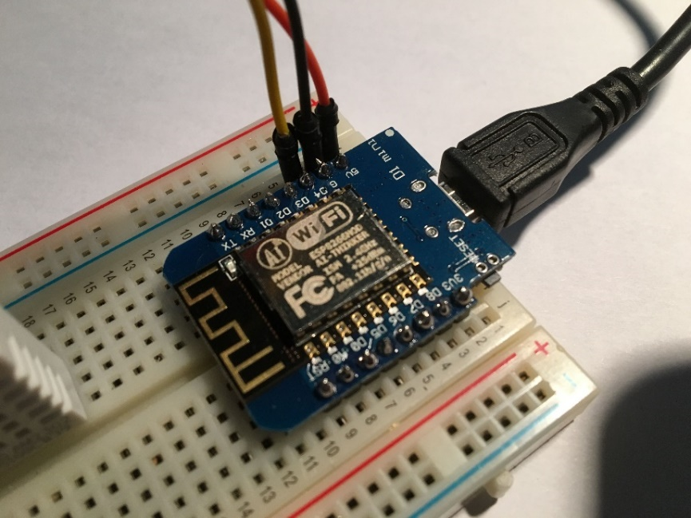

Figure 8 D1 mini kit

Choose COM port that exactly coincides with the COM port that you have connected to the kit

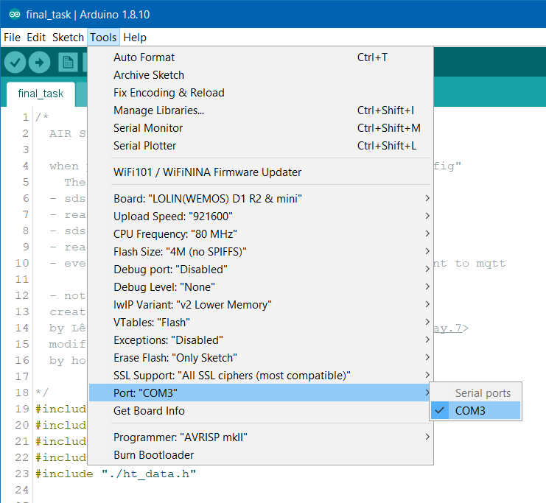

Figure 9 Choosing COM port and setting up technical specification

Upload code by clicking the symbol  or pressing Crtl + U. Wait for a while until the screen shows the notification as the following picture, that means you have been done uploading.

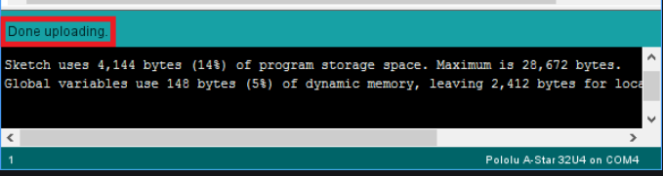

Figure 10 Uploading code successfully

## Note down the MAC address

Each device has its unique MAC address to distinguish with others. Hence, we name each device depending on its MAC address to avoid some unwanted mistakes. After completing code upload, looking for MAC address by widening the notification-state bar.

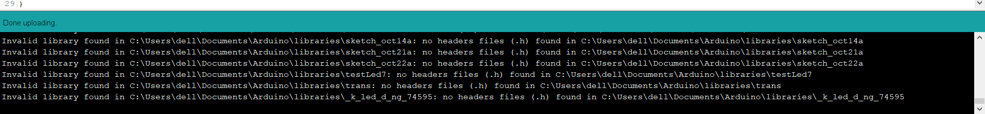

Figure 11 state bar

You can see as follow:

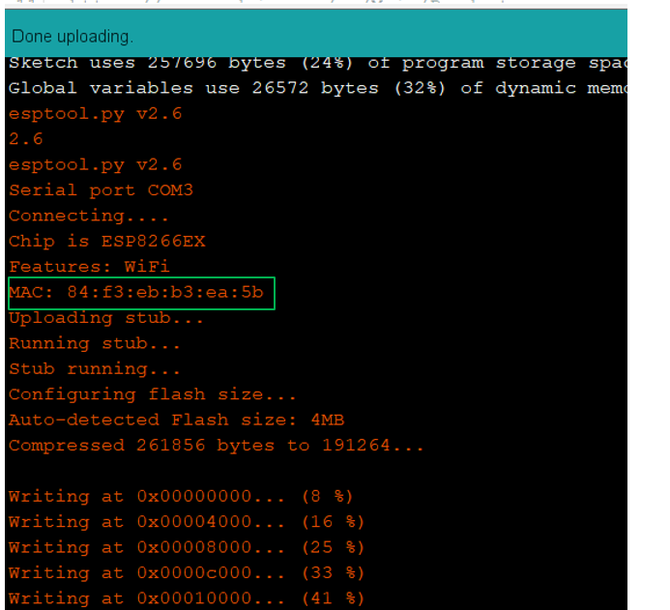

Figure 12 Reading MAC address on state bar

Take **3 pieces of price tag** and copy 12 digits of Hexadecimal on them (for example digits on Fig 12: 84 F3 EB B3 EA 5B). Stick one pieces on the chip, one on circuit board and one on the box (the circuit board container).

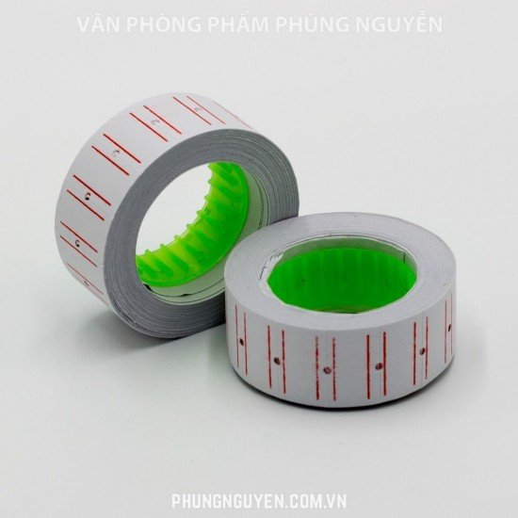

Figure 13 Price tag

# Chapter 2. Checking the device

To make sure the device can work properly on practical environment after it is produced, we need to check the device by following some steps

## Checking presses

On each device, there are 2 orange presses, one for resetting and the other for configuring.

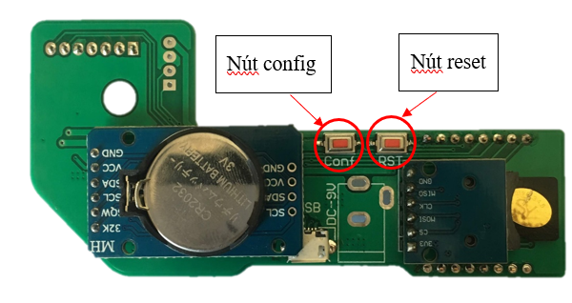

Figure 14 Tow presses on circuit board

* When pressing the Reset button, the LED will blink for a while. Repeat to press the Reset button three times.
* Hold on the config button for about 5 seconds, after that release it, the LED will light on constantly.

## Checking the fan of PM2.5 sensor

There is a fan inside the PM2.5 sensor. When you supply the power for the devide, the fan will work

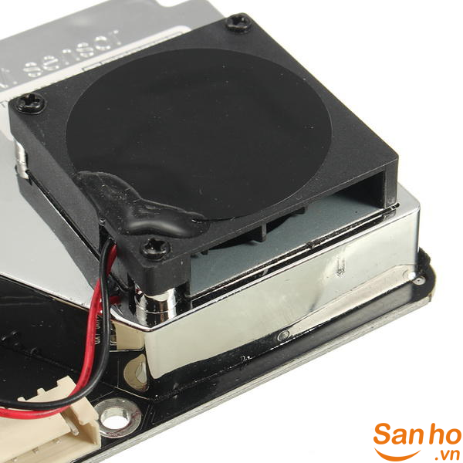

Figure 15 SDS011 fan

The device is designed to have a 30-sencond break every 30 seconds ( At the break state, the fan is off). But if the fan does not work for a long time, you should check for the connection, or cut off the power and supply it again

## Checking the Internet connection

To connect the device with the Internet, you need a Smartphone with Android or iOS operating system. Then you should download and install IoT Smartconfig on your Smartphone. Here are the download link

• iOS: <https://itunes.apple.com/app/id1222388182>

• Android: <https://play.google.com/store/apps/details?id=com.iotmaker>

After installing the app, connect your Smartphone to the Internet, open the app, your WI-FI address will be automatically filled in SSID. Then what you should do next is enter your Wi-Fi password in Password box as the following pictures (for Android is on the left) or (for iOS is on the right).

|  |  |
| --- | --- |
| Figure 16 Smartconfig for Android device | Figure 17 Smartconfig for iOS device |

After holding on the config button and the LED is on as step 2.1, you should continue by click Submit (Confirm) on the display of IoT smartconfig app on your Smartphone’s screen.

|  |  |
| --- | --- |
| Figure 18 Configure for Android successfully | Figure 19 Configure for iOS successfully |

***Notice:***

* You need to make sure that your WI-FI is stable enough for the device
* The device will store SSID and password a WI-FI that you have configured. Hence, if you bring the device to other place with other WI-FI so just configure as these above steps.

## Checking for SD card

After connecting your device to the Internet, wait for 4 to 5 minutes, then take the SD card out of device and read it using your computer.

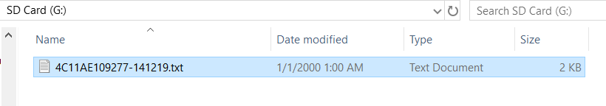

Figure 20 Data file in SD card

Name of data file has the structure like the above picture

4C11AE109277-141219

Where:

* 4C11AE109277 is the name of device
* 141219 means December 14th, 2019

Open that file, you will see the data has structure as follow:

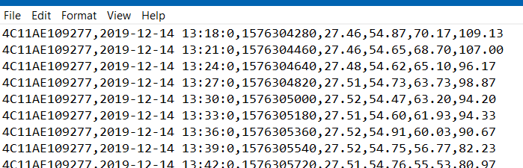

Figure 21 Data stored in SD card

NodeId, Time, Unix time, temperature, humidity, PM2.5, PM10 all are separated by commas.

***If there is one or some of 4 indexes of temperature, humidity, PM2.5, PM10 that equal 0, you need to check all the connection of sensors or check whether the sensors work or not and then follow all the instruction of chapter 3.***

## Checking the data on the Internet

Here is the simplest and fastest way to check whether data is sent to the Server mqtt or not

AirSENSE server subscribe mqtt server and get messages when they are published. Each message will be sent with an unique topic to each device (like a private folder of device).

### Structure of topic and message

* Structure of topic as follow: /SPARC/LOLIN-<DEVICE’S NAME>

Where <DEVICE’S NAME> is **12 digits in hexadecimal- MAC address which is marked on each device as you have known at part 1.3.**

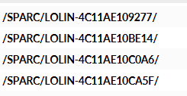

Figure 22 Example topic of devices

* Data structure of each message is published as follow:

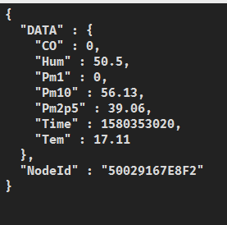

Figure 23 Structure of message

As can be seen on the structure of each message, data is devided into 2 main part: DATE and NodeId. While DATA contains all measured data and measuring time, NodeId is MAC address of each device (device name)

### Download mqtt.fx on the following web

<https://mqttfx.jensd.de/index.php/download>

Choose newest version on Latest Release

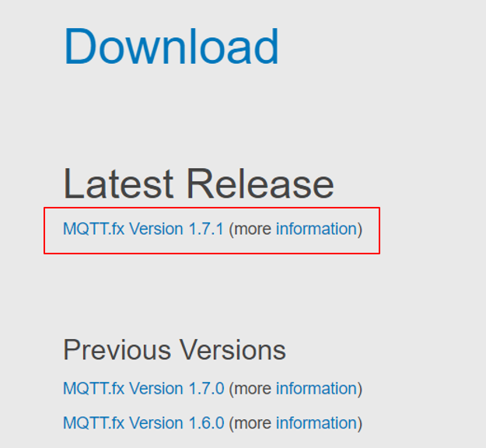

Figure 24 mqtt.fx downloading

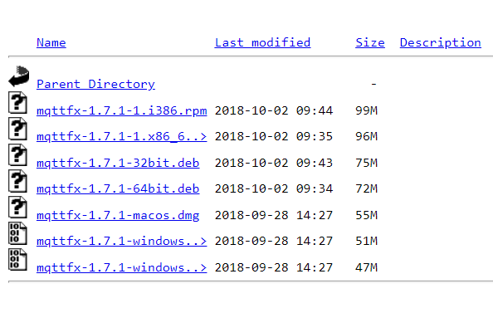

Figure 25 Choose suitable version with your OS

Choose suitable version with your operational system.

### Checking data

After installing the app mqtt.fx then open it.

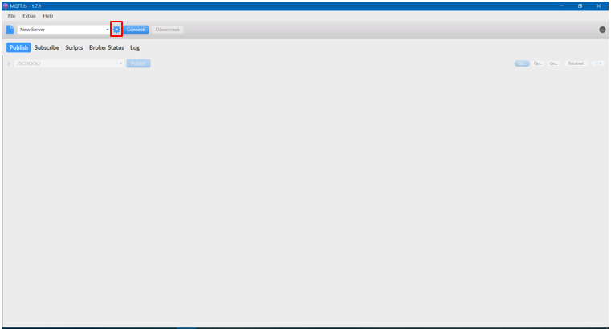

Figure 26 Display of mqtt.fx

Choose the symbol  as the above picture and follow the following steps:

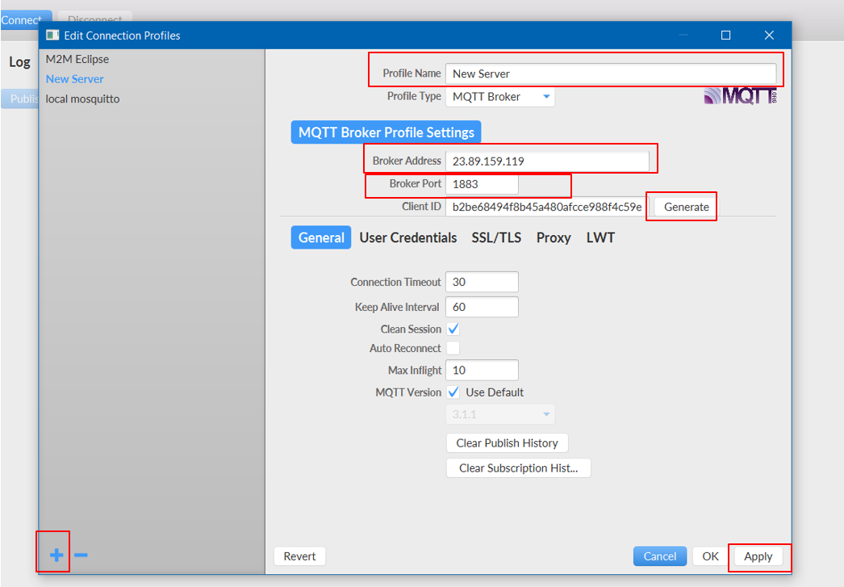

Figure 27 Modify the parameter

Click the symbol  then fill in **Profile Name** the name that you want, after that fill in **Broker Address** with the parameter: 23.89.159.119, **Broker Port** with 1883, click to choose  to create an ID. Just ignore the other parameters.

Finally, choose Apply  then exit by click button Cancel.

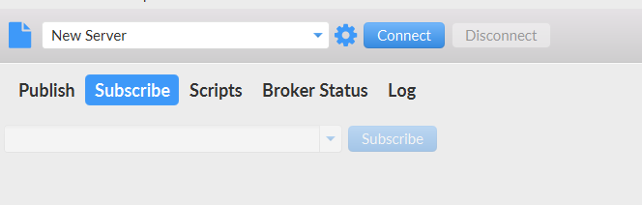

Figure 28 Connect to server mqtt

Click to connect  then 

On the display, continue to click scan to find all the messages is being published.

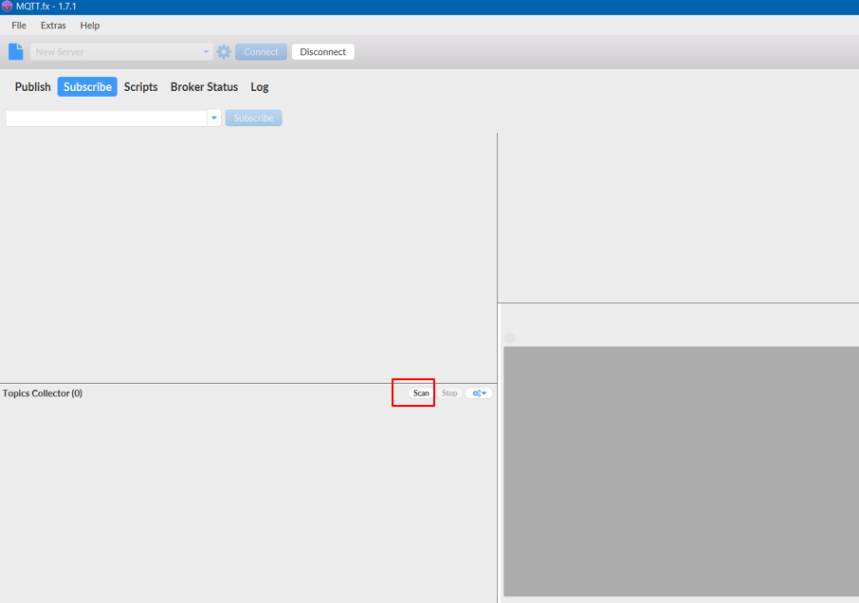

Figure 29 Click to choose scan

After that find the topic of the device that you are looking for and double click that topic.

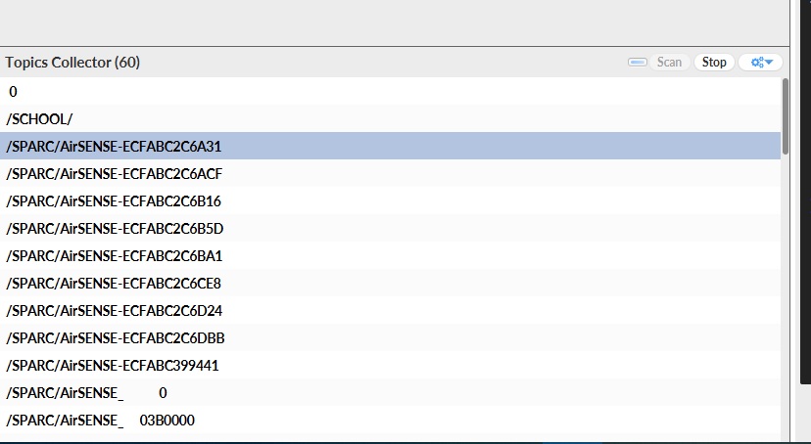

Figure 30 Topics in mqtt server

Data is published every 3 minutes, that why you should about 4 to 5 minutes to make sure the device sends data to the server or not. If there is new data on the display, the device has successfully published the data.

## Get data on the internet

### URL

Data that collected from sensors is stored on AirSENSE server, in order to get the data, we use the URL form follows:

<http://23.89.159.119:4000/airsense/getcsv?fromtime=1573094580&endtime=1573145880&NodeId=4C11AE10CD26> 

Figure 31 URL

Which:

* The values hehind “fromtime” and “endtime” are epoch timestamps that indicate a period of time which you want to get data.
* NodeId is the MAC address of sensor (device name) that you want to get data.

Follows these steps:

* Step 1: open browser



Figure 32 open browser

* Step 2: Enter the URL into the search bar

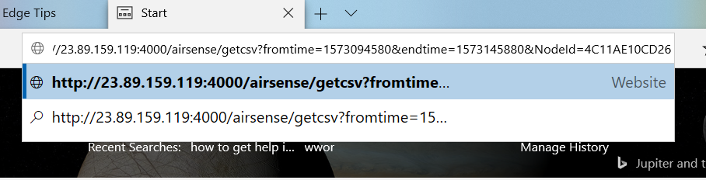

Figure 33 Enter that link to search bar

* Step 3: Replace the value <fromtime>, <endtime> and <NodeId> according as you expect then access to it.

### Epochtime

Check out this webste: <https://www.epochconverter.com/>

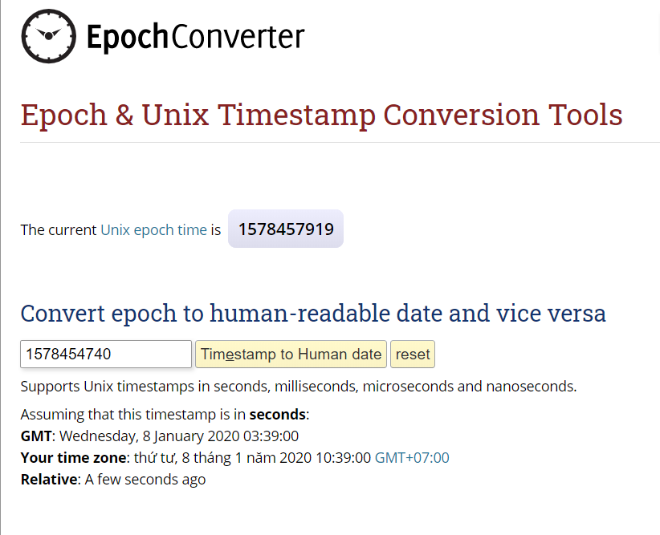

Figure 34 EpochtimeConverter interface

There are two performances we concern: transforming the UTC into epoch time and transforming from epoch time into UTC. Let get into an example to get through it.

For example, you want to get data from **12:30 January 1st 2020** to **13:30 January 1st 2020** of sensor named **DC4F227DCCD1**. (time is UTC in this example)

First, Adjust time in these boxes like I just did

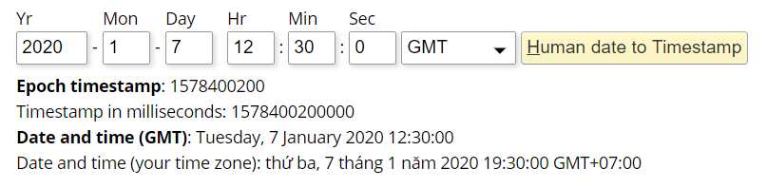

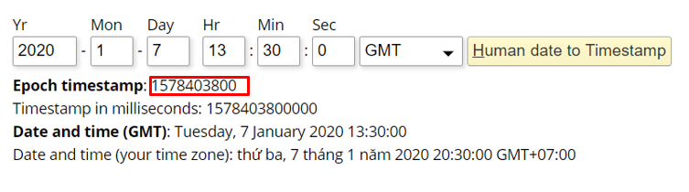

Figure 35 Convert Human date to Epoch time

After that, we got the link below:

<http://23.89.159.119:4000/airsense/getcsv?fromtime=1578400200&endtime=1578403800&NodeId=DC4F227DCCD1>

Access to that link and the browser will automatically download a csv file containing the data that we desired to get.



Figure 36 Open csv file

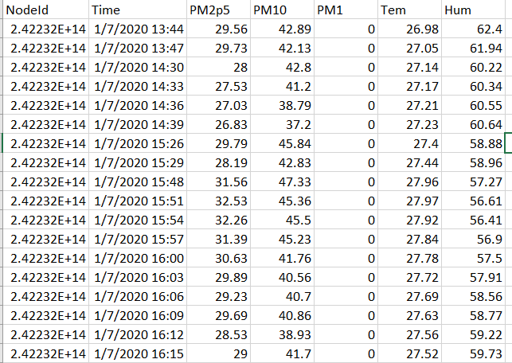

Figure 37 data from server

***Note:***

* Time is real time in Vietnam (UTC+7)

# Chapter 3. Some problems the device may get

This chapter is about some problems you may get when designing and operating the device.

## The fan does not work

What the fan does not work has 2 main causes: Firstly, connection of the cable with circuit board is not stable, so check the connection again; Secondly, since the device is works in 30 seconds then takes break in30 seconds, the problems may come from the working mode that PM2.5 sensor is programed.

## Press and hold on the config button but the LED is still off

This problem is really serious, because that means your circuit board is out of order. If meet this problem, you should try this way:

Cut off the power then supply the power again for the device. After that hold on the config button for 5-7 seconds

Disconnect the cables with sensor SDS011(PM) and HTU21d (humidity) repeat the first way. If this way makes LED light, reconnect all the sensors and press the config button once again.

If the device still does not work, you have to check the power source. This time you let try out using another adapter (using the smartphone power supply: 5V-2A)

## Data of PM is equal 0

What Data of PM is equal 0 is a really big problem. One of the causes is loose connection between the cable and board.

But the main problem (95%) comes from power supply. There are 2 USB ports: 2.1A and 1A, you have to plug in 2.1A USB port. Because 1A source cannot supply enough power for operating of the laser used inside PM sensor.

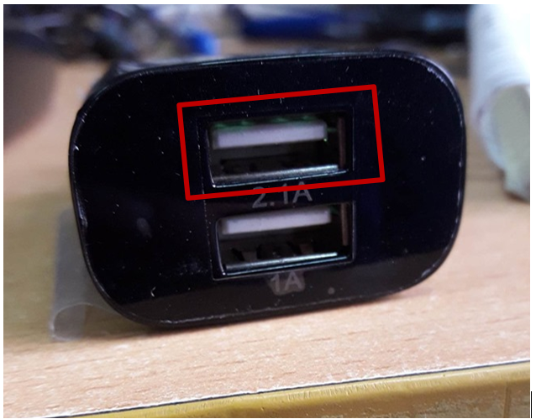

Figure 38 Connect device with 2.1 A USB port

# Chapter 4. Calibration

This chapter is about how to calibrate PM sensor.

## Purpose

What collecting raw data of different devices at the same time and condition have different results is unavoidable. We have to calibrate data of all devices follow the data of a standard device, which is extremely important.

## Method

There are many types of calibration between same-type devices but we use two-point calibration since it may be the most effective one.

Pros

X

Cons

x

## Preparation

Tro

### Device

Những thiết bị quan trọng trong việc caliab bao gồm

# Chapter 5. Installing instruction

Installing device should follow correctly the below steps.

## Prepare and check before installing

### Tools

AirSENSE outdoor V1 device

A smartphone with Iot smartconfig app as part 2.3

Dealing minute

We need one person with a computer and mqtt.fx software available as part 2.5.

### Checking at Lab before install

Besides prepare the device available, we need to check the device at the Lab one more time to make sure it can work properly before bringing to the customer’s home.

First, open the box and follow all steps as chapter 2. Note that you just care about 4 indexes of data are temperature, humidity, PM2.5 and PM10.

Some problems and fix these in chapter 3.

## Installing steps

### Setup the device

Supply power for the device. Remember to choose 2.1A usb port.

Open box, configure the device using Iot smartconfig app as instruction part 2.3.

### Checking for operating

Let the device run for 3-5 minutes and the data is sent to server.

Contact with the person who with computer to check for the data which is sent to the server or not. If it is, move to the next step. If not, follow steps in chspter 3.

### Immobilizing the device

After config and checking are done, we hang and immobilize the device.

### Minute

After installing the device completely, we need to collect the customer’s information and information of the installed device and write down on the installing minute. The needed information includes: customer’s full name, address, mobile/telephone number, email, device’s name (MAC address), device’s number, installing time.