# 2.3 Final Design

## 2.3.1 Overall Design

The final design (Figure 1), falls mostly within the desired constraints except for weight, where the length of the prototype is 160mm ***(Appendix 2.3.1 i)***, the width is 140mm, the total cost is $112 ***(Appendix 2.3.1 ii)***, and the weight is approximately 550g ***(Appendix 2.3.1 iii)***. All the components are mounted to the chassis with the exception of the ultrasonic sensors, motor shield, and arduino where the components are spread out where possible in order not to hinder functionality. This results in a centre of mass located 87mm from the front, 70mm from each side, and 34mm high which results in a deviation of 9%, 0%, and 9% respectively from the centre of each plane.

*Figure 1 - Render of Minesweeper Prototype*

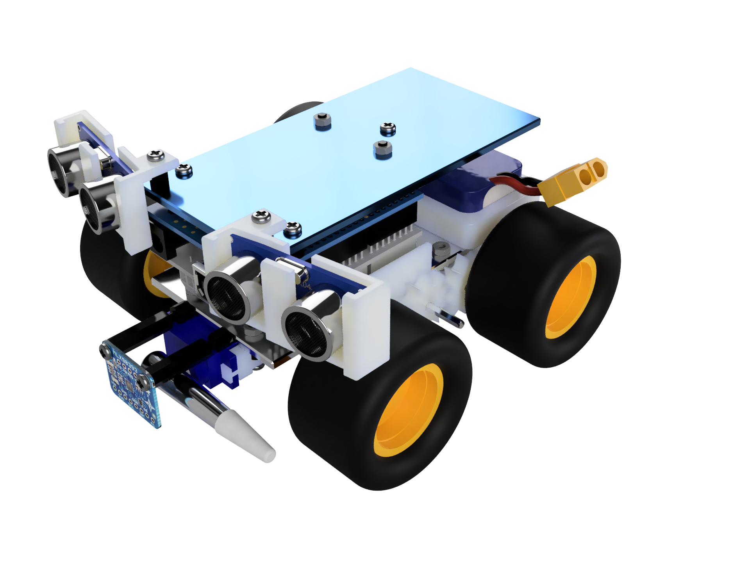

## 2.3.2 Search Algorithm

A mostly random search algorithm was developed for the robot. Random search was chosen over other common algorithms like snaking or spiralling to reduce reliance on tracking the robot’s movement. Without purchasing additional rotational encoders to record wheel rotations, an implementation of snaking or spiralling search may not search large portions of the game board, whilst unnecessarily overlapping others, as turn radius cannot be controlled accurately (Edwards & Sörme, 2018).

Typical random search, where the robot turns randomly at walls, and moves in straight lines, is supplemented by additional logic applied where the robot is nearby a landmine, which is within 30 degrees of the front of the robot. Here, proportional and integral (PI) control is applied to smoothly steer the robot toward the landmine, until the magnetometer records that the landmine is directly underneath. The PI controller implementation is shown in Figure 2.

*Figure 2 -PI controller implementation*

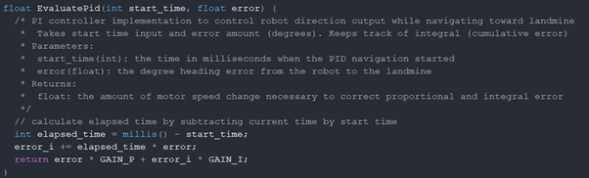

P and I GAIN parameters must be found through simulation or real world testing, so that the robot moves smoothly toward the mine without overshooting.

## 2.3.3 Drive System

The drive system consists of four wheels driven by a DC twin motor gearbox through two separate gear trains. The twin motors are independently controlled by a motor shield micro controller allowing the vehicle to have the smallest possible turning radius, by driving a set of wheels on either side of the vehicle in opposite directions. 50mm wheels with air filled tires were selected to assist the vehicle in traversing over rough terrain. The gearbox was configured to run at a 58:1 gear ratio, which was calculated to provide the necessary speed for the vehicle to cover the estimated 16.4m distance with a relatively large amount of time to spare to account for stops and turns ***(Appendix 2.3.3i)***. Values for the two configurable gearbox ratios are shown in *Table 1.* The gear box motors were positioned at the rear of the vehicle, as to not interfere with the magnetic mine detection system. 34mN∙m of torque is transmitted to the wheels via a series of tight and loose-fit 3d printed gears, which sit on snipped axles mounted to the underside of the vehicle with 3d printed mounts.

Table 1

Gear Ratio Speed, Torque and Estimated Completion Time

|  |  |  |
| --- | --- | --- |
| Criteria | 58:1 Gear Ratio | 203:1 Gear Ratio |
| Speed (ms-1) | 0.32 | 0.089 |
| Torque (mN**·**m) | 34 | 120 |
| Completion Time (mins) | 0:52 | 3:04 |

## 2.3.4 Power Supply System

The power supply system consists of a 800mAh Lipo pack that powers the prototype with a nominal voltage of 7.4v. The battery was chosen due to its large capacity where it was estimated that 370 mAh would be needed for 10 minutes of runtime ***(Appendix 2.3.4)***, and its supplied voltage where the Arduino Uno r3 recommended input voltage range is from 7 to 12 volts (Arduino, n.d.). As for configuration, the battery will be directly connected to the Arduino and motor shield where all components will be connected to get their power. Each component is able to get the necessary current from the boards as shown in Table 2.

Table 2

Current Draw of Components and Current Output of their Respective Sockets

|  |  |  |
| --- | --- | --- |
| Component/s | Current Draw | Pin Current Output |
| Magnetometer | 0.1 mA (MLX90393 Datasheet, 2020, p. 11) | 3.3 v**:** 50 mA (Arduino Uno Datasheet, n.d.) |
| Ultrasonic Sensors | 30 mA (Core Electronics, n.d.) | 5 v: 500 mA (Arduino Uno R3, n.d.) |
| Servo Motor | 100 mA (Addicore, n.d.) | 5 v: 500 mA (Arduino Uno R3, n.d.) |
| Motor (x2) | 560 mA per motor (Pololu Corporation, n.d.) | 2 A per channel (Alice1101983, n.d.) |

## 2.3.5 Sensor System

The sensor system consists of two ultrasonic sensors and one magnetometer. Placed at 10° angles relative to the front of the robot on each side, HC-SR04 Ultrasonic Sensors detect any obstacle directly ahead and 25° each side of the robot preventing any obstacle from interfering without detection occuring ***(Appendix 2.3.5)***. The sensor communicates via a timed digital output where the time taken for an emitted pulse to return outputs a high reading which can be calculated into distance. The ultrasonic sensor provides both a simple and cheap solution to obstacle detection.

A MLX90393 magnetometer is placed 30mm from the front of the chassis and can detect magnetic fields on 3 axes at a range of 5 to 50 Millitesla (Kevin Townsend, 2019) and communicates over I2C or SPI where I2C will be used in this case where the wiring method for this communication mode is seen in Figure 3. This magnetometer should theoretically be able to detect a magnetic field 220mm from the edge of a mine given that the mine has an assumed magnetic field strength of 1.1 Tesla with a radius of 32.5mm and thickness of 2mm. Magnetometers have a clear advantage over hall-effect sensors due to the hall-effect sensor’s output is in the form of a boolean output, true or false (Sanjeev, 2018), whereas the magnetometer outputs the magnetic field strength on 3 axes allowing for better accuracy and redundancy if one axis receives a false positive (Melexis, 2019).

## 2.3.6 Chassis Design

The chassis was designed to be light, strong, and big enough to accommodate for all the vehicle components, whilst staying within the optimal size, weight, and budget constraints. Weight was a key constraint for the chassis as a chassis which is too heavy may cause the vehicle to get stuck in sandy terrain, and will require more power supplied to the motors to start moving, which would be less sustainable and economical in the long run. To meet these objectives, aluminium was chosen as the chassis material due to its low weight, affordability, strength, availability and lack of magnetism. The other proposed options were acrylic and ABS plastic. Both ABS plastic and acrylic were considered too weak to support the vehicle components, and more specifically, ABS plastic would take an excessive amount of time to manufacture and could not be 3d printed as this would breach one of the constraints listed in ENGG1100 Document 3a.

## 2.3.7 Landmine Marking System

The landmine marking system consists of a servo and paint brush. The paint brush is attached directly to a TowerPro SG909 servo such that when in a mine detection, the servo rotates the brush to make contact with the mine, marking it with red paint and applying a minimal amount of force so as to not activate the mine. A team member conducted an experiment to determine the quantity of mines able to be marked with our system where we found up to 70 marks could be made on a single fill of paint.

## 2.3.8 Overall Design

One of the objectives for the prototype design was to protect the Arduino for damage which was the leading factor for the final design. To achieve this, the manufactured component was mounted 30mm above the chassis such that the Arduino Uno and motor shield could be placed in between, preventing those components from colliding with the ground in the event of a mine explosion. Acrylonitrile Butadiene Styrene (ABS) was the chosen material to use for the 3D printed components due to both its durability and sustainability. ABS is a thermoplastic meaning that the material can be heated to its melting point, cooled, and have the process repeat with insignificant degradation, allowing it to be easily recycled (Rogers, 2015). When compared to PLA and Nylon, ABS is beat in durability by Nylon however, the process of printing with nylon along with its price increase over ABS makes ABS a more suitable plastic for the prototype (Martin, 2018).

# 

# Figure 3

Circuit Diagram of all Electrical Components

# 

# 

# 3.0 Conclusion

The final prototype design fulfills all the constraints and has a system that has been structured to effectively mark mines and avoid collisions. The sensor array utilises components that are effective in mine and obstruction detection without excessively spending money. The aluminium chassis provides structural integrity for the prototype to not collapse in on itself. The drive system provides great manoeuvrability due to its integration of a dual motor design that drives each horizontal set of wheels independently. The marking system has the ability to mark up to approximately 70 mines without the need for a refill. The power system is able to supply the required energy with overhead for a 10 minutes runtime period.

# 

# 4.0 References

Arduino. n.d. ARDUINO UNO REV3. [online] Available at: <https://store.arduino.cc/usa/arduino-uno-rev3> [Accessed 21 May 2020].

Cactus.io. n.d. Arduino Uno R3. [online] Available at: <http://cactus.io/platform/arduino/arduino-uno> [Accessed 17 May 2020].

eBay.com. n.d. L298P Shield R3 DC Motor Driver Module 2A H-Bridge 2 Way For Arduino UNO 2560. [online] Available at: <https://www.ebay.com.au/itm/L298P-Shield-R3-DC-Motor-Driver-Module-2A-H-Bridge-2-way-For-Arduino-UNO-2560/310787745501?hash=item485c64a6dd:g:eZgAAOSw7BNbfglK> [Accessed 22 April 2020].

Edwards, T., & Sörme, J. (2018, June 6). A Comparison of Path Planning Algorithms for Robotic Vacuum Cleaners. Stockholm, Sweden.

gadgetmakersblog.com. 2013. Arduino Power Consumption Normal & Sleep. [online] Available at: <http://www.gadgetmakersblog.com/arduino-power-consumption/> [Accessed 19 May 2020].

Martin, N., 2018. PLA Vs ABS Vs Nylon. [online] Markforged.com. Available at: <https://markforged.com/blog/pla-abs-nylon/> [Accessed 22 May 2020].

Pololu.com. n.d. FA-130RA Datasheet. [online] Available at: <https://www.pololu.com/file/download/fa_130ra.pdf?file_id=0J11> [Accessed 22 May 2020].

Rogers, T., 2015. Everything You Need To Know About ABS Plastic. [online] Creativemechanisms.com. Available at: <https://www.creativemechanisms.com/blog/everything-you-need-to-know-about-abs-plastic> [Accessed 17 May 2020].

Sanjeev, A., 2018. How To Use A Hall Effect Sensor With Arduino. [online] Maker Pro. Available at: <https://maker.pro/arduino/tutorial/how-to-use-a-hall-effect-sensor-with-arduino> [Accessed 23 April 2020].

Townsend, K., 2019. MLX90393 Wide-Range 3-Axis Magnetometer. Adafruit.

www.addicore.com. n.d. FS90 9G Mini Servo. [online] Available at: <https://www.addicore.com/FS90-Mini-Servo-p/ad113.htm> [Accessed 16 May 2020].

# 

# 5.0 Appendices

**Appendix 2.3.1 i**

(@Top view drawing)

**Appendix 2.3.1 ii**

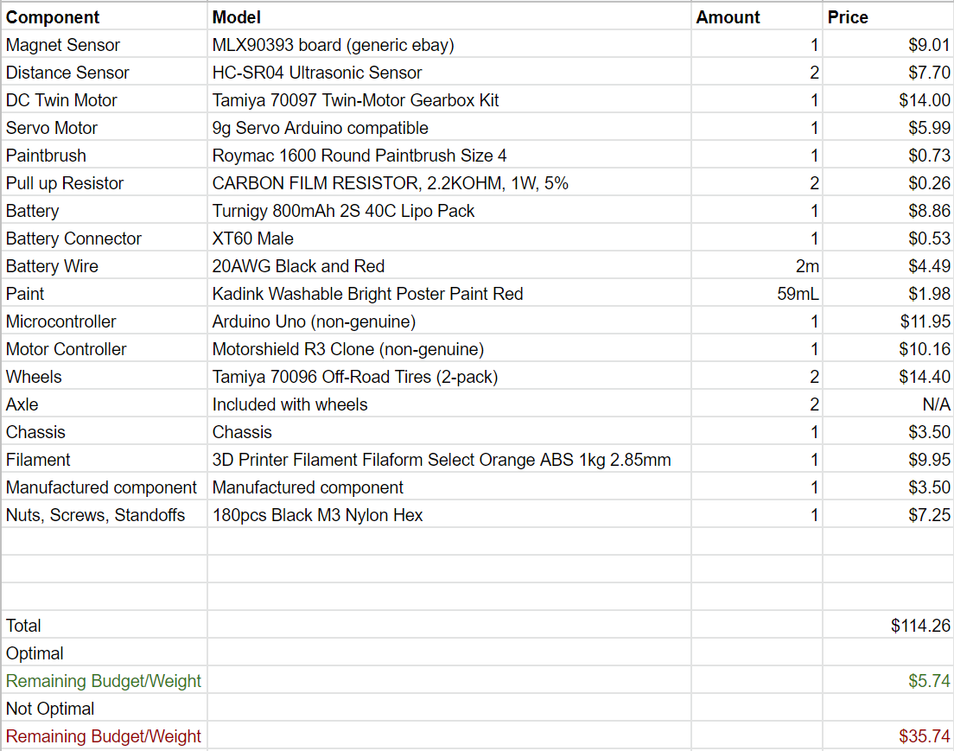

**Appendix 2.3.1 iii**

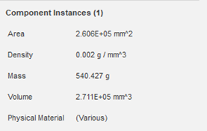

**Appendix 2.3.4**

|  |  |  |  |
| --- | --- | --- | --- |
| **Component** | **Quantity** | **Current Consumption per Item** | **Current Consumption** |
| Magnetometer | 1 | 0.1 mA (MLX90393 Datasheet, 2020, p. 11) | 0.1 mA |
| Ultrasonic Sensor | 2 | 15 mA (Core Electronics, n.d.) | 30 mA |
| Servo | 1 | 100 mA (Addicore, n.d.) | 100 mA |
| Arduino | 1 | 50 mA (Igor, 2013) | 50 mA |
| Motor Shield | 1 | 880 mA (Assumed) | 880 mA |
| Motor | 2 | 560 mA (Pololu Corporation, n.d.) | 1120 mA |
| **Total Consumption** |  |  | 2.1801 A |

10 minutes of run time (⅙ hours)

**Appendix 2.3.5**

