**PHP NOTES**

Performing SQL requests in PHP

Mysqli_connect() function performs a connection to mysql server (supply correct deets)

Mysqli_select_db() function selects database

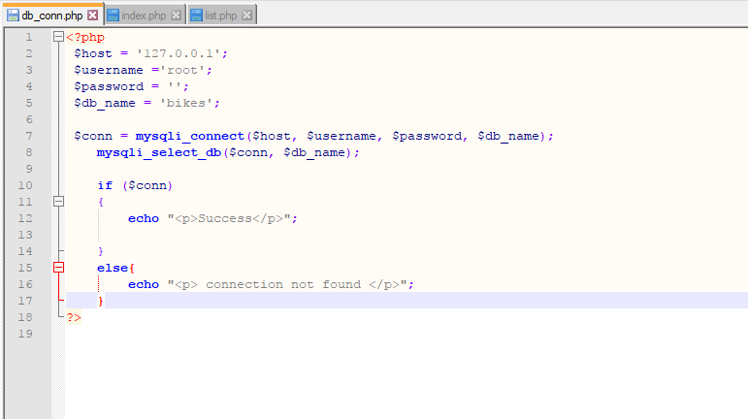

Mysqli_query() function performs a query against connected database.

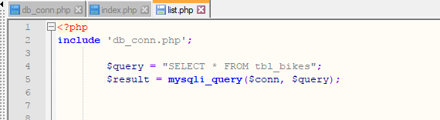

Mysqli_fetch_array() fetch index and values of array

Mysqli_fetch_assoc() fetch just the value of the array

While($row=mysqli_fetch_assoc($result))