**TESTING**

Cppunit TESTING:

* We used CPPUNIT testing with Visual C++ Studio 2010
* Reference: <http://www.comp.nus.edu.sg/~cs3215/tools/cppunitAll.html>
* The testing file will be provided (testAdmin.zip and testMemberBook.zip inside folder CPPUNIT of Source Code folder)
* If you want to rerun the test check out the notes in the website. Or simply just follow the first part (to build CPPUNIT inside Visual C++) of the website and double click the Visual C++ studio project file that we provided and simply press run.

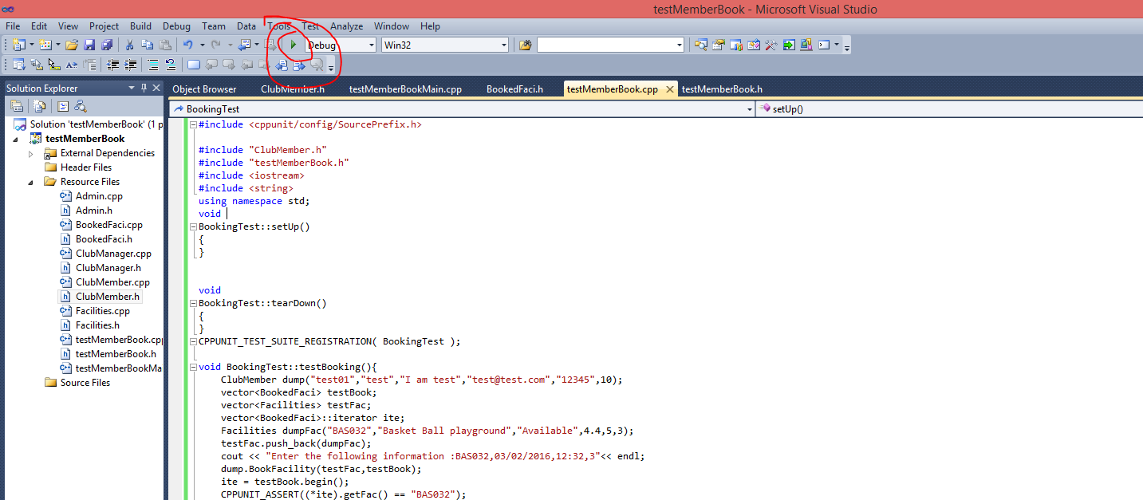

* There are some warning about fail building but just ignore it, the file is fine and it can run and can output the result

|  |  |  |  |  |
| --- | --- | --- | --- | --- |
| Test Plan for : Club Admin | | | | |
| Description | Expected Outcome | Participating Program's Class & Method to be tested | Participating CPPUnit Test Program's Class & Method doing the testing |
| Test adding a new member with ID: test01 | Message: Member successfully added and last slot of the vector is that member | Class Name : Admin  Method Name :  void addMember(vector<ClubMember>& b) | CPPUnit Class Name : AdminTest  Method Name :  void testAddMember(); |
| Delete member with ID | Message: Member deleted successfully and the last slot of vector is deleted since it’s a test so it only has 1 member in it. As a result, the vector should be empty | E.g.  Class Name : Admin  Method Name :  void deleteMember(vector<ClubMember>& b) | E.g.  CPPUnit Class Name : AdminTest  Method Name :  Void testDeleteMember |

Result :

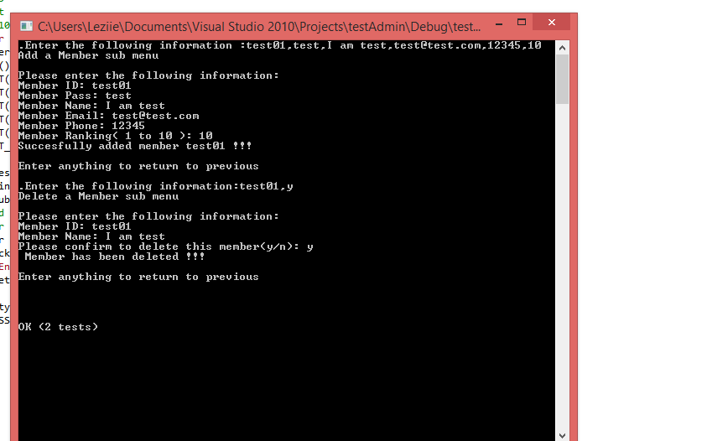

|  |  |  |  |  |
| --- | --- | --- | --- | --- |
| Test Plan for : Club Member | | | | |
| Description | Expected Outcome | Participating Program's Class & Method to be tested | Participating CPPUnit Test Program's Class & Method doing the testing |
| Booking a Facility with ID: BAS032 | Message: Booked successfully and a bookRef is generated.  A BookedFaci instance should be added to BookedFaci vector | Class Name : ClubMember  Method Name :  void  BookFacility(vector<Facilities>& a, vector<BookedFaci>& b) | CPPUnit Class Name : BookingTest  Method Name :  void testBooking() |

Result:

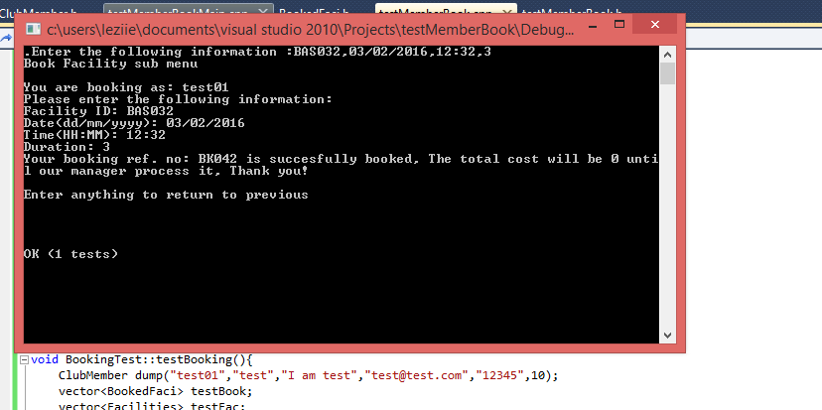

Casual TESTING:

* Please refer to product help and demonstration document, we have done testing for all the function of the program.