
csci222 ASSIGNMENT 1 REPORT

Team Number : < 4 >

 | Student Number | Name | Email Address
1 | 4944938 | (Team Leader)  Nguyen Duc Anh | Tel :92454265  Email : ft_nguyen_duc_anh@yahoo.com.sg
2 | 4948397 | William Wunady | ft_william_wunady@yahoo.com
3 | 4948178 | Ardyanto | ft_ardyanto@yahoo.com
4 | 4948403 | Wu Chin Hwa | ft_wu_chin_hwa@yahoo.com
5

February 13, 2016
University of Wollongong

Table of Contents
Project Overview 3
1. Vision 3
2. Initial Use-case Model 4
3. Requirement List 4
User Requirements: 5
System Requirements: 6
4. Project Plan 7
Roles and Responsibility 9
Risk Analysis and Counter Measures 10
Design Artefacts - Use Cases (Iteration 1) 12
Design Artefacts - Use Cases (Iteration 2) 13
Design Artefacts - Activity Workflows (Iteration 1) #1 15
Design Artefacts - Activity Workflows (Iteration 1) #2 16
Design Artefacts - Activity Workflows (Iteration 1) #3 17
Design Artefacts – Activity Workflows (Iteration 1) #4 18
Design Artefacts - Activity Workflows (Iteration 1) #5 19
Design Artefacts – Activity Workflows (Iteration 1) #6 20
Design Artefacts - Activity Workflows (Iteration 1) #7 21
Design Artefacts - Activity Workflows (Iteration 1) #8 22
Design Artefacts - Activity Workflows (Iteration 1) #9 23
Design Artefacts - Activity Workflows (Iteration 1) #10 24
Design Artefacts - Activity Workflows (Iteration 1) #11 25
Design Artefacts - Activity Workflows (Iteration 2) #1 26
Design Artefacts - Activity Workflows (Iteration 2) #2 27
Design Artefacts - Activity Workflows (Iteration 2) #3 28
Design Artefacts - Activity Workflows (Iteration 2) #4 29
Design Artefacts - Activity Workflows (Iteration 2) #5 30
Design Artefacts - Activity Workflows (Iteration 2) #6 31
Design Artefacts - Activity Workflows (Iteration 2) #7 32
Design Artefacts - Activity Workflows (Iteration 2) #8 33
Design Artefacts - Activity Workflows (Iteration 2) #9 34
Design Artefacts - Activity Workflows (Iteration 2) #10 35
Design Artefacts - Activity Workflows (Iteration 2) #11 36
Design Artefacts - Component Diagrams (Iteration 1) 37
Design Artefacts - Component Diagrams (Iteration 2) 38
Design Artefacts - Class Diagrams (Iteration 1) 39
Design Artefacts - Class Diagrams (Iteration 2) 40
Design Artefacts – Sequence Diagrams (Iteration 1) #1 41
Design Artefacts – Sequence Diagrams (Iteration 1) #2 42
Design Artefacts – Sequence Diagrams (Iteration 1) #3 43
Design Artefacts – Sequence Diagrams (Iteration 1) #4 44
Design Artefacts – Sequence Diagrams (Iteration 1) #5 45
Design Artefacts – Sequence Diagrams (Iteration 1) #6 46
Design Artefacts – Sequence Diagrams (Iteration 1) #7 47
Design Artefacts – Sequence Diagrams (Iteration 1) #8 48
Design Artefacts – Sequence Diagrams (Iteration 1) #9 49
Design Artefacts – Sequence Diagrams (Iteration 1) #10 50
Design Artefacts – Sequence Diagrams (Iteration 1) #11 51
Design Artefacts – Sequence Diagrams (Iteration 2) #1 52
Design Artefacts – Sequence Diagrams (Iteration 2) #2 53
Design Artefacts – Sequence Diagrams (Iteration 2) #3 54
Design Artefacts – Sequence Diagrams (Iteration 2) #4 55
Design Artefacts – Sequence Diagrams (Iteration 2) #5 56
Design Artefacts – Sequence Diagrams (Iteration 2) #6 57
Design Artefacts – Sequence Diagrams (Iteration 2) #7 58
Design Artefacts – Sequence Diagrams (Iteration 2) #8 59
Design Artefacts – Sequence Diagrams (Iteration 2) #9 60
Design Artefacts – Sequence Diagrams (Iteration 2) #10 61
Design Artefacts – Sequence Diagrams (Iteration 2) #11 62
Design Artefacts – Deployment Diagrams (Iteration 1) 63
Design Artefacts – Deployment Diagrams (Iteration 2) 64
Test Plan Design 65
Club Admin 65
Club Member 67
Appendix A - Formal Meeting Records 68
Construction Phase - Iteration 1 68
Construction Phase - Iteration 2 68
Transition Phase - Iteration 1 69
Transition Phase - Iteration 2 69
Appendix B - Individual Work Diaries 70
Team Member 1: Nguyen Duc Anh 70
Construction Phase - Iteration 1 70
Construction Phase - Iteration 2 70
Transition Phase - Iteration 1 70
Transition Phase - Iteration 2 71
Team Member 2: William Wunady 72
Construction Phase - Iteration 1 72
Construction Phase - Iteration 2 72
Transition Phase - Iteration 1 72
Transition Phase - Iteration 2 72
Team Member 3: Ardyanto 74
Construction Phase - Iteration 1 74
Construction Phase - Iteration 2 74
Transition Phase - Iteration 1 74
Transition Phase - Iteration 2 74
Team Member 3: Wu Chin Hwa 76
Construction Phase - Iteration 1 76
Construction Phase - Iteration 2 76
Transition Phase - Iteration 1 76
Transition Phase - Iteration 2 76
Appendix C - Evidence of using VCS (Version Control Software) 78

Project Overview

Name of product : Country Club Facilities Booking System (CCFBS)
Date established : February 24th 2016
No. of participant : 4

Production

The project used to develop a Country Club Facilities Booking System with the help of Rational Unified Process (RUP) and in this report we will be more focus on Inception and Elaboration phase.

This project is done by communication between the team member, management by the team leader and work by each member as their assigned roles. Both from Online Chatting (preferably by Facebook) and formal real life meeting were used as the project communication. Each team member worked on specific section based on their specialty.

Vision
- Main task: Our main objective of this project is to create a Country Club Facilities Book System (CCFBS) that helps club member to access the booking facilities via electronic devices. The system must allow the club member to book or search available facilities. Club manager (stake holders) also can access the system to constantly update the facilities and process any booking issued by club members.
- Scope and features: Club member can search through any available facilities by their preferred criteria and book the facilities via the system. Club member can also view and edit their personal information. Club manager as the stake holders can manage the facilities by creating new facilities, updating or deleting an existing facility while also processing any booking from the club members. The admin of the system has the highest authority which can add or delete any club member or club manager.
- Constraint: The system is a virtual database for storing any information of the club members, managers, facilities and booking information. It needs a basic GUI for any user to easily understand and a good protection from any data loss.

Initial Use-case Model
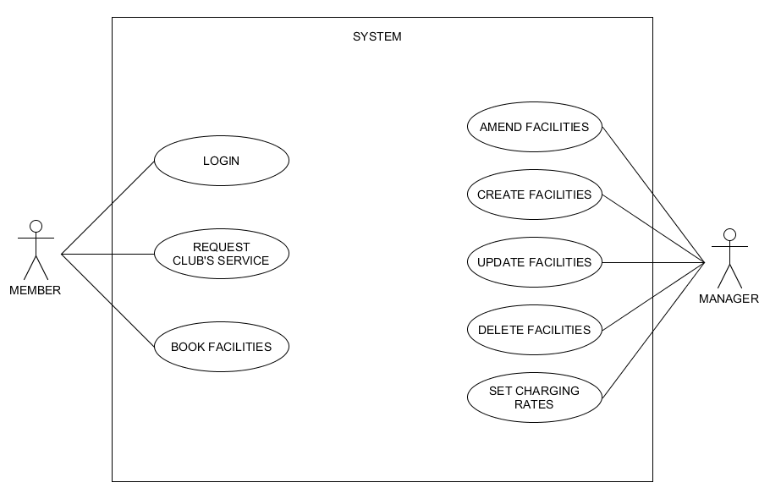

This is our initial use-case model based on our initial understanding on the project requirement of the system and it shows basic relationship between manager and the member to the system. This is only a brief understanding of the entire system and after analysing the requirement, we came up with the requirement list for this project.

Requirement List

We split the requirement list into two major component which are the user requirement and the system requirement. In the user requirement, we will cover the requirement needed by the club member, club manager and the system admin. System requirement covers the basic functionality of the system while some of them are not mandatory. As this project is still ongoing project, we may have not implemented all the function required and in the future we may drop some of them depending on the priority.

User Requirements:

- Club member:

Requested Functionality | Implemented
A Club member must be able to log into the system. | 100%
A Club member must be able to book or search a club facility. | 100%
A Club member must be able to choose a club facility from a list. | 100%
A Club member must be able to choose the time of booking. | 100%
A Club member must be able to choose the duration of booking. | 100%
A Club member must be able to view the booking they have made with the system (status, which facility booked, duration of booking, etc.) | 100%
A Club member must be able to log out of the system. | 100%
A Club member must be able to view their own personal details. | 100%
A Club member must be able to set and modify their own personal details | 100%
A Club member must be able to cancel their booking. | 0%
A Club member must be able to book club facilities for people besides themselves. | 0%

- Club manager:

Requested Functionality | Implemented
A Club member must be able to log into the system. | 100%
A Club member must be able to book or search a club facility. | 100%
A Club member must be able to choose a club facility from a list. | 100%
A Club member must be able to choose the time of booking. | 100%
A Club member must be able to choose the duration of booking. | 100%
A Club member must be able to view the booking they have made with the system (status, which facility booked, duration of booking, etc.) | 100%
A Club member must be able to log out of the system. | 100%
A Club member must be able to view their own personal details. | 100%
A Club member must be able to set and modify their own personal details | 100%
A Club member must be able to cancel their booking. | 0%
A Club member must be able to book club facilities for people besides themselves. | 0%

Requested Functionality | Implemented
A Club manager should be able to view rental behaviour, facilities, and management-related reports. | 100%
A Club manager must be able to view a Club member’s personal details. | 100%
A Club manager must be able to search for a Club member. | 100%
A Club manager must be able to view information related to club facilities.
A Club manager must be able to create, delete, amend and update a club’s facilities for booking. | 100%
A Club manager must be able to set various charging rates based on peak and off-peak periods.
A Club manager should be able to process booking made by member | 100%

- Admin:

Requested Functionality | Implemented
An Admin must be able to add, update, delete club member or club manager | 100%
An Admin must be able to access all other functionality of the system. | 100%
An Admin should be able to view rental behaviour, facilities, and management-related reports. | 100%

System Requirements:

Requested Functionality | Implemented
The system requires a persistent data model (#58 in SRS).
The system must alert Club facilities managers if a ‘watch’ status Club member has booked a flight.
The system must prevent a ‘no-booking’ status Club member from booking a facility.
The system must charge Club members a cancelation fee if they cancel a facility booking.
The system must keep records of a Club member’s cancelled bookings as well as currently booked facilities.
The system should provide a GUI to all users. [LOW PRIORITY] | NOT DOING
Multiple users should be able to access the system concurrently. [LOW PRIORITY] | NOT DOING
The System should run on Windows and/or VMWare Ubuntu. | 100%
Alerts should be issued to Club members that are booked on a flight that has been cancelled by the club facilities manager.
Reports should be interesting computations and compilations of data used by the system. Provide informative information to the company managers.
Club members who book through a friend (another club member) must provide the system all the same details that are required in a normal Club member registration.
During a booking, the Club member should receive a list of facilities yet unbooked that includes facilities up to a week away from the search date.
A Club member should have the option to revise booking details before confirming.
Passwords must be hidden by asterisks. | NOT DOING
The user interface should be in English language.

Project Plan

- Phase 1:
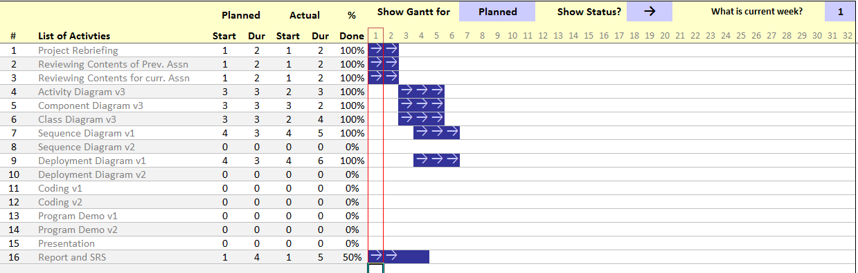

- Phase 2:
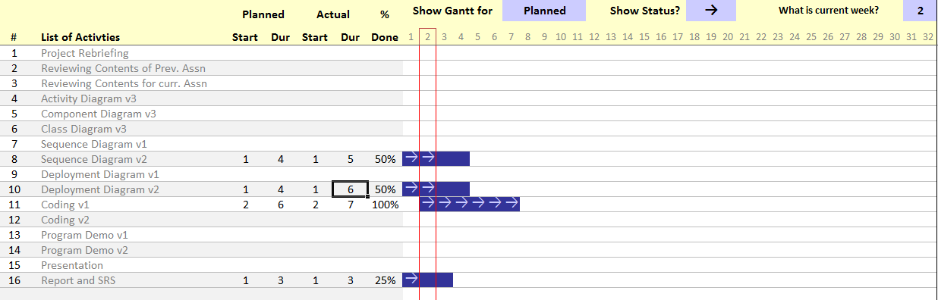

- Phase 3:
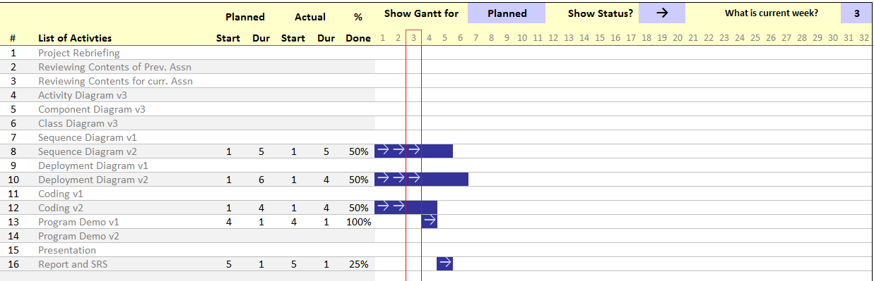

- Phase 4:
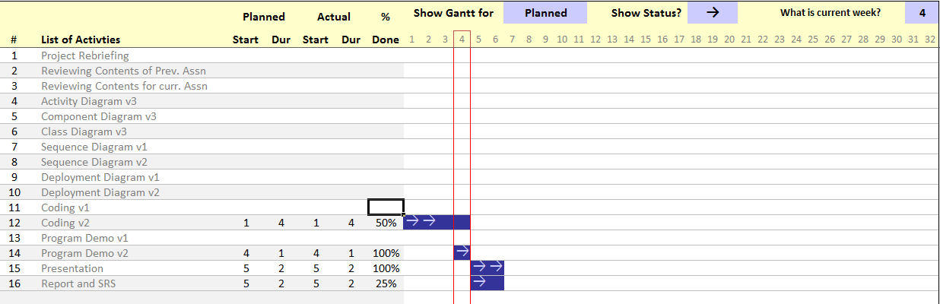

Roles and Responsibility

Team Number: < 4 >

 | Student Name | Role | Artefacts
1 | Nguyen Duc Anh | Project manager, Sub-designer | Use case diagram, Class diagram, Component diagram, SRS document, Project planning, Coding and Code testing
2 | William Wunady | Sub-manager, Project analyst | SRS document, Project planning and scheduling, All diagrams (part of), Presentation preparation
3 | Ardyanto | Project designer, Sub-analyst | Use case diagram, Activity diagram, Case analyzing, Sequence diagram, Code testing, Deployment diagram
4 | Wu Chin Hwa | Project analyst, Sub-designer, Documenter and Reviser | Use case diagram, Activity diagram, Risk analyzing, Sequence diagram, Deployment diagram, Project report
5

Risk Analysis and Counter Measures

RISKS
 | Impact Type | Risk of Seriousness (%) | Likelihood of Occurrence (%) | WBS (affected work/task) | Risk Description
1 | Budget | 70% | 10% | All | Some or all project’s team members may demand a higher pay which can result on the project being halt.
2 | Deadline | 80% | 10% | All | Some of the team’s member may resign in the middle of the process or will lower the quality of the project if rushed.
3 | Technology Problem | 90% | 5% | All | System error may slow down the project process and consume more time to fix it.
 |  |  |  |  | System crash may result in the loss of data which may move the project several step back.
4 | Document Problem | 30% | 5% | All | Wrong documentation can create some major confusion in the team’s members and it will increase the workloads. If it’s a document lost, it can potentially cause the project to move several step back.
5 | Personal Problem | 10% - 80%  (Depending on the person’s position and problem) | 5% | All | If a team’s member suddenly face a personal problem such as family matter or relationship problem, it can reduce the performance or in the worst case, the member will resign from the project.
6 | Requirement Changes | 10% - 70% (Depending on the changes) | 10% | All | If somehow the project manager or the director ask for some changes in the project, it will cause some problem depending on the changes. If the changes is big, probably the effort and the time consumed will be null. It also can increase the time consumption to finish the project thus missing the deadline. The changes can come from the company itself or by customer’s demand.

COUNTER MEASURES
 | Risk Description | Proposed Management Plan | (Possible) Reduction in Risk Seriousness (%)
1 | Some or all project’s team members may demand a higher pay which can result on the project being halt. | Plan 1: Offers the pay demanded by the team’s members. | -75%
1 |  | Plan 2: Fire some members that demand higher pay then find fill the missing position. | -25%
1 |  | Plan 3: Reduce the workload per individual and hire more members that are willing to work on the project. | -35%
2 | Some of the team’s member may resign in the middle of the process or will lower the quality of the project if rushed. | Plan 1: Reduce the workload per individual and hire more members that are willing to work on the project. | -50%
2 |  | Plan 2: Extend the deadline | -50%
3 | System error may slow down the project process and consume more time to fix it. | Plan 1: Do some regular (daily or weekly) maintenance on any electronic during the time outside the work period. | -80%
3 | System crash may result in the loss of data which may move the project several step back. | Plan 1: Back up the data after the work daily on one or more computers. | -80%
4 | Wrong documentation can create some major confusion in the team’s members and it will increase the workloads. If it’s a document lost, it can potentially cause the project to move several step back. | Plan 1: Keep track of all documents created and store them according to the type and purpose. | -20%
4 |  | Plan 2: Hire an experienced and professional documentarist. | -25%
5 | If a team’s member suddenly face a personal problem such as family matter or relationship problem, it can reduce the performance or in the worst case, the member will resign from the project. | Plan 1: Regular check-up or meeting with the team’s member. | -50%
5 |  | Plan 2: Find a replacement or hire a new employee. | -50%
6 | If somehow the project manager or the director ask for some changes in the project, it will cause some problem depending on the changes. If the changes is big, probably the effort and the time consumed will be null. It also can increase the time consumption to finish the project thus missing the deadline. The changes can come from the company itself or by customer’s demand. | Plan 1: Regular briefing and meeting between the members. | -60%
6 |  | Plan 2: Work out all of the possibilities change | -25%

Design Artefacts - Use Cases (Iteration 1)

This is the initial use-case diagram or the first iteration. In this diagram we only have two actors which are Member and Manager.

Member:
- Log In to the system by entering their ID and password
- Member can request services from the system
- Member can book facility

Manager:
- Can amend any facilities
- Create new facilities
- Update an existing facility
- Delete an existing facility
- Set charging rates base on the peak hour

Design Artefacts - Use Cases (Iteration 2)
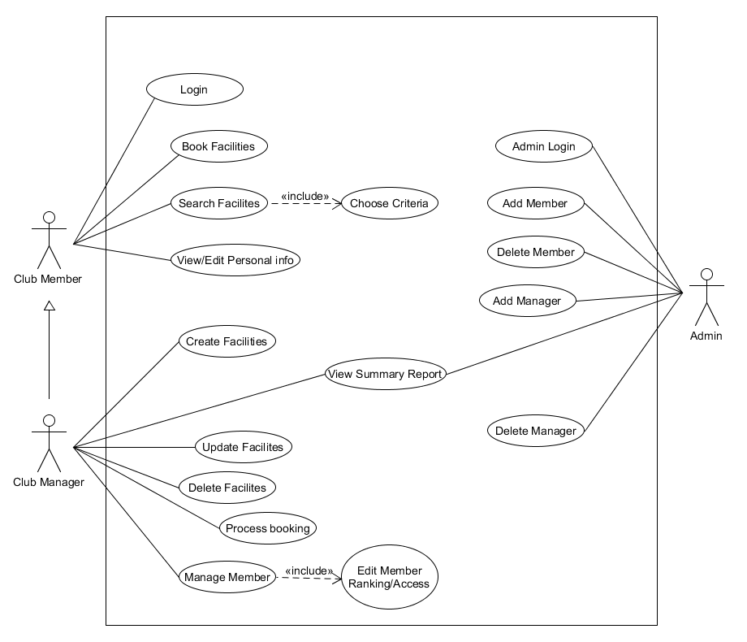
Iteration 2 Use-case diagram: (we have 3 actors now, Club Member, Club Manager, and Admin)

Club Member is the lowest user on this diagram, they can request but not changing anything from the system. Club member is a superclass of Club manager as some of the attribute inherited to manager.
- Club member can log in by entering ID and password after the admin added them
- Club member can book facilities base on the availability (date and time) and which will be processed by manager later on
- Club member can search facilities base on a criteria (ID, Name, Status (Available or not), Charging rates, Peak rate and Requirement rank)
- Club member can view and edit their personal information and the system will then update it into the database

Club Manager is a club member but they can’t book nor view and edit their personal information.
- Club manager can create another facilities which then added to the database
- Club manager can update an existing facilities by entering their ID
- Club manager can delete a facility by entering the ID
- Club manager can process booking after a club member requested
- Club manager can update the ranking of the member (1 to 10)
- Club manager can view the summary report of the system
- [EXTRA] Club manager can log in by using their ID and password then the system check if the ID is a manager or not
- [EXTRA] Club manager can also search facilities base on the criteria same as club member

Admin is the highest user of the system, they can update, delete and add manager and member but they can’t get ay service from the system except viewing report.
- Admin will log in by special case, log as admin and the system will veriy it
- Admin can add new members to the database
- Admin can delete a member from database
- Admin can add new manager to the system
- Admin can delete a manager from the database
- Admin share the ability to view summary report same as the manager

Design Artefacts - Activity Workflows (Iteration 1) #1

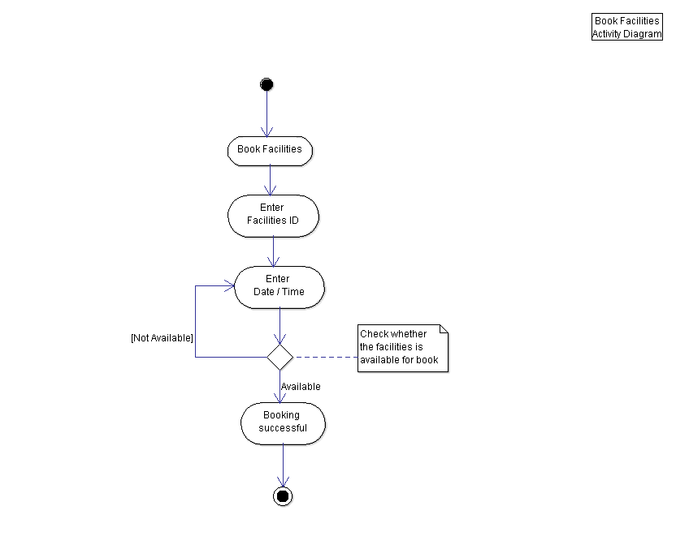

Work flow:
- Member will choose option to book a facility
- Enter the facilities ID (after searched it if the member does not know the ID)
- Then the user enter the time and date they wish to book
- The system will check if the facility is available during the date and time entered
- When the system detected unavailability, it will prompt the user to enter the date and time again
- If successful, the booking will processed

Design Artefacts - Activity Workflows (Iteration 1) #2

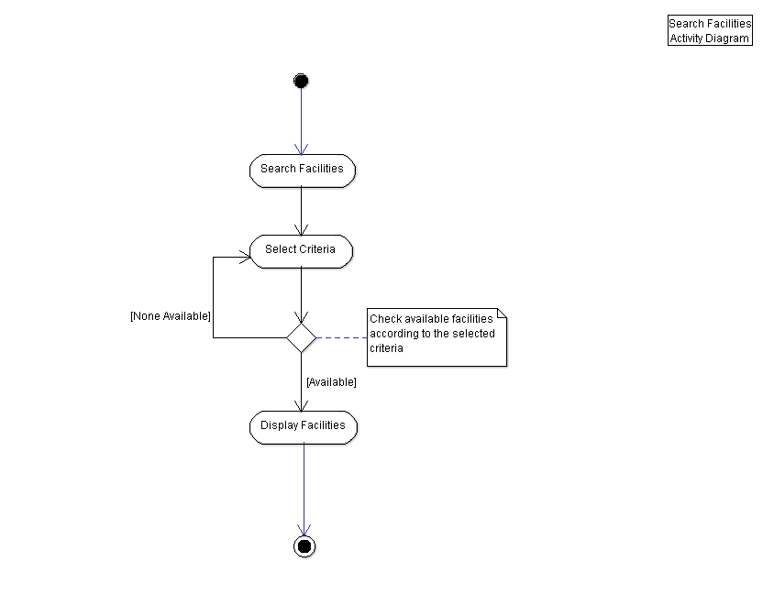
Work flow:
- Member (user) choose to search facilities
- Then the user select the criteria they wish for such as ID, name, availability, charging rate, peak rate and requirement rank to book the facility
- After selected the criteria, the system will display all facility matches the criteria
- If none available, then the system will ask the user again to select another criteria

Design Artefacts - Activity Workflows (Iteration 1) #3

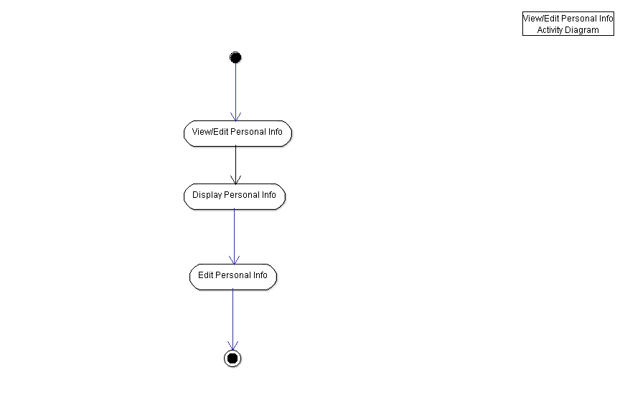
Work flow:
- Club member can view their personal info by selecting the View/Edit Personal Info option
- It will display the information of the member base on the ID they logged in
- The club member then edit their personal info in which will be saved to the database after confirming

Design Artefacts – Activity Workflows (Iteration 1) #4

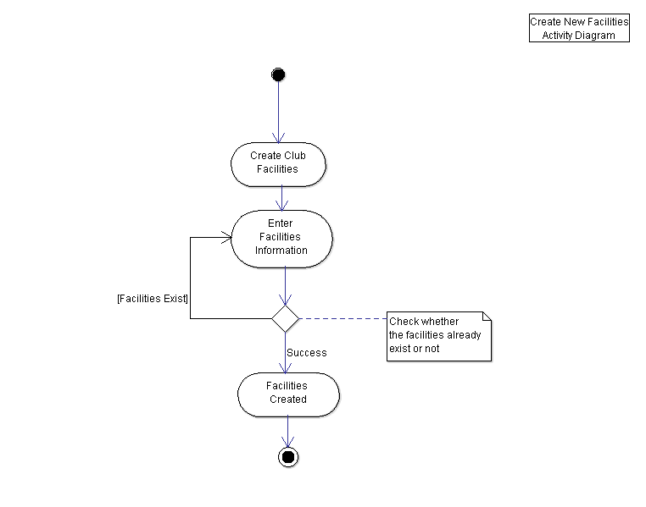
Work flow:
- As a manager they can add new facility by selecting the option to ad after log in as a manager
- Then the system will ask for the information such as ID, name, charging rate, etc.
- The system then check if there exist a duplicate facility and prompt the manager if there is one
- If no duplicate then the facility will be created

Design Artefacts - Activity Workflows (Iteration 1) #5

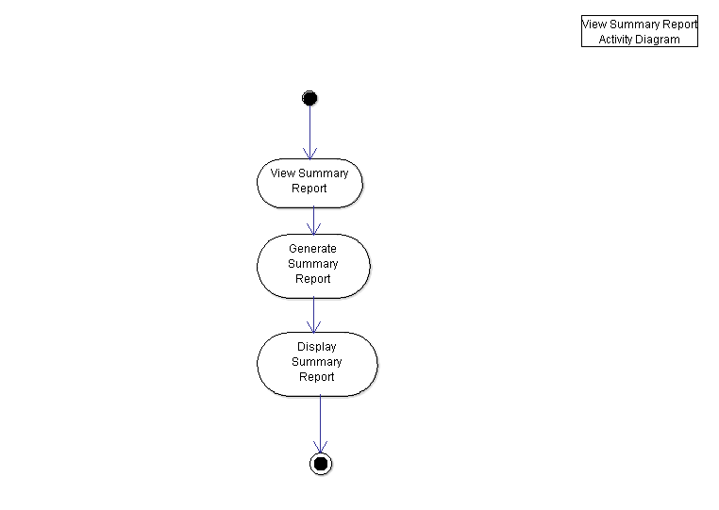
Work flow:
- To view the summary report, club manager or admin will choose the option to view
- The system then generate the summary report from the database
- Display the summary report after finished generating

Design Artefacts – Activity Workflows (Iteration 1) #6

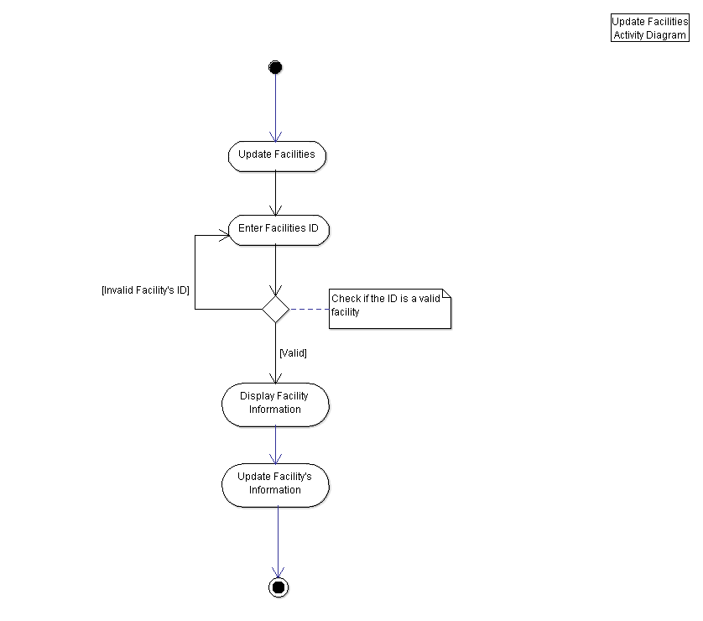
Work flow:
- Club manager choose the option to update a facility
- System will ask the ID of the facility then the user enter the ID
- System then check if the facility’s ID entered is a valid one
- Display the information when found the facility or return asking the ID if fail to find
- The manager then enter the information they wish to change and then the system will update it into the database

Design Artefacts - Activity Workflows (Iteration 1) #7

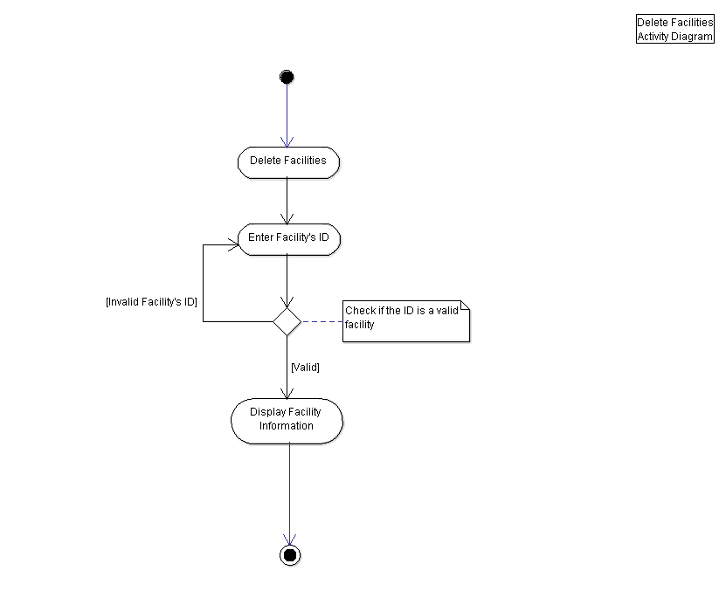
Work flow:
- Club manager wish to delete a facility by choosing the option
- The system ask the manager for the ID of the facility then the manager enter the number
- If the system found a matching ID in the database, it will proceed to the next step
- If the system failed to find a matching ID, it will return back to ask the ID again from the manager
- When successful, it will display the facility’s information then the user delete the facility

Design Artefacts - Activity Workflows (Iteration 1) #8

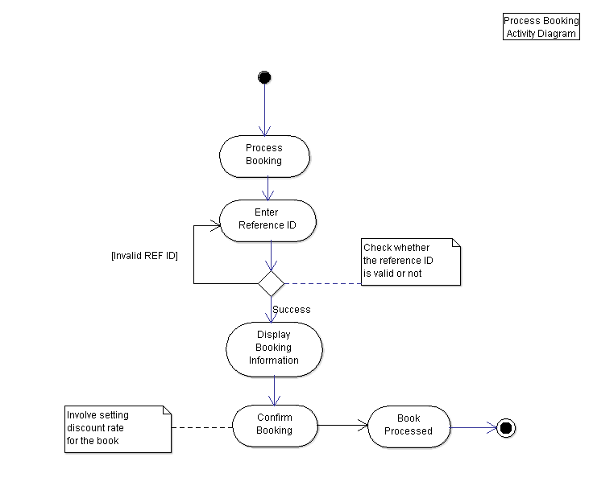
Work flow:
- A club manager will process any booking by selecting the option to Process Booking
- It will then ask the manager to enter the reference ID of the booking
- System will then find the matching ID from the database
- It then display the information of the booking
- Manager will confirm the booking and this involving the discount rate base on the member
- Book processed when successful

Design Artefacts - Activity Workflows (Iteration 1) #9

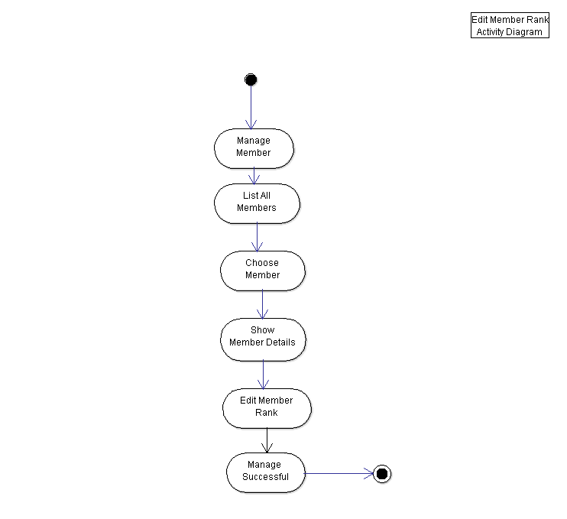
Work flow:
- To manage the member, manager will choose the manage option
- It will list all the members from the database
- The manager will enter the member’s ID
- The system will display more detailed information regarding the member
- Manager choose to update the member’s rank
- System will display success message

Design Artefacts - Activity Workflows (Iteration 1) #10
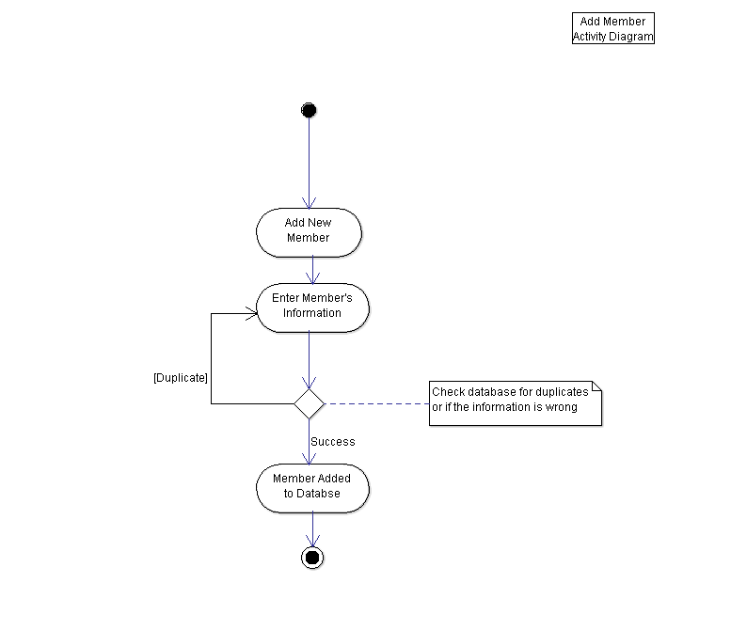
Work flow:
- For admin to add a new member, they will choose first option to add a member
- It will then ask the information needed by the system
- The system then will check for duplicates (for example if the ID is used already)
- If success, it will add to the database
- If fail, it will return to ask for the information particularly the ID

Design Artefacts - Activity Workflows (Iteration 1) #11
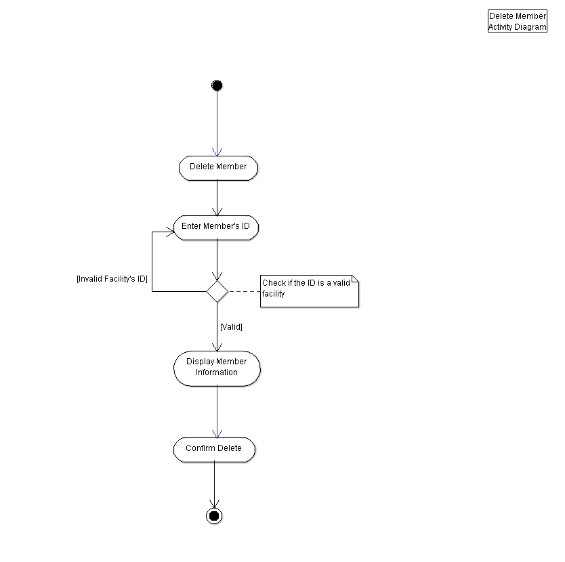
Work flow:
- To delete a member from the database, the admin will choose the second option to delete
- Enter the member’s ID
- System check if the ID is an existing member
- If found then display the information before confirming to delete
- If fail then prompt the admin again to enter correct ID

Design Artefacts - Activity Workflows (Iteration 2) #1

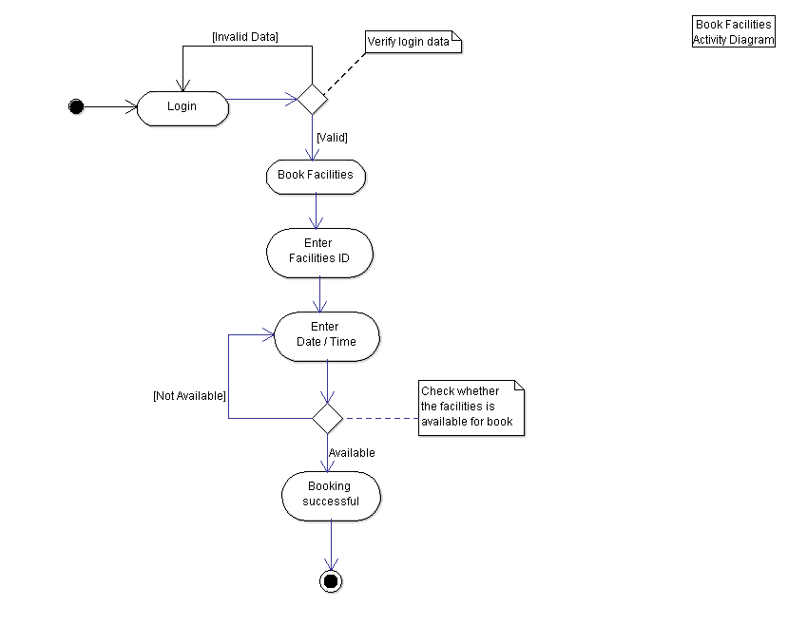

Changes:
- Add a work flow for login
- The user (member) will enter the ID and password
- System verify the login
- If success, proceed to the next step (iteration 1)
- Fail then return to ask the ID and password from user

Design Artefacts - Activity Workflows (Iteration 2) #2

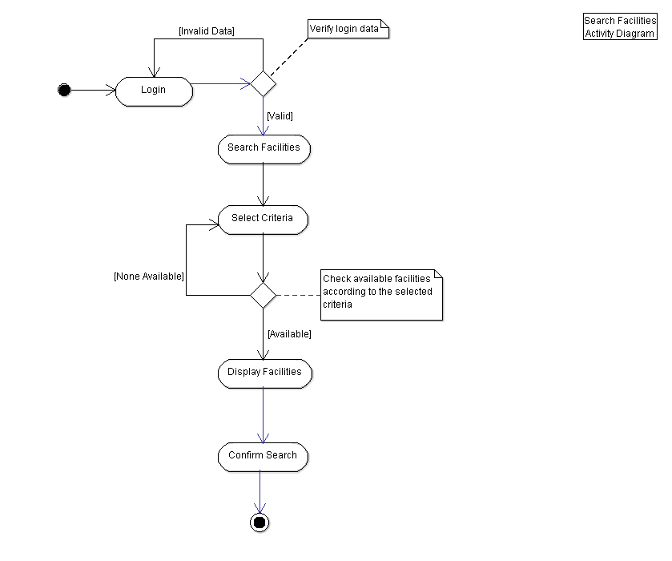
Changes:
- Add a work flow for login
- The user (member) will enter the ID and password
- System verify the login
- If success, proceed to the next step (iteration 1)
- Fail then return to ask the ID and password from user
- Add confirmation from the user at the end of search

Design Artefacts - Activity Workflows (Iteration 2) #3

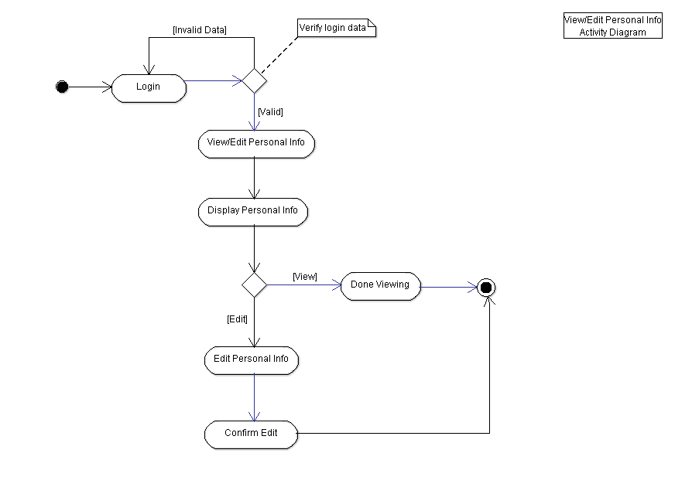
Changes:
- Add a work flow for login
- The user (member) will enter the ID and password
- System verify the login
- If success, proceed to the next step (iteration 1)
- Fail then return to ask the ID and password from user
- Add branching after displaying the personal info
- If the user only want to view, then the user can quit after it
- If the user still want to edit then the user update any information they wish (Name, Email or Phone)
- Add confirmation from the user at the end of search

Design Artefacts - Activity Workflows (Iteration 2) #4

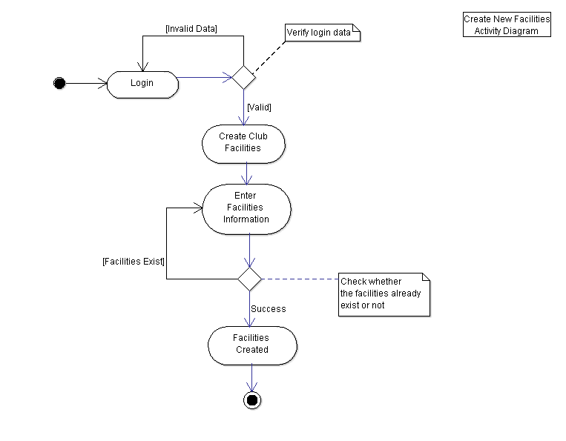
Changes:
- Add a work flow for login
- The user (member) will enter the ID and password
- System verify the login
- If success, proceed to the next step (iteration 1)
- Fail then return to ask the ID and password from user

Design Artefacts - Activity Workflows (Iteration 2) #5

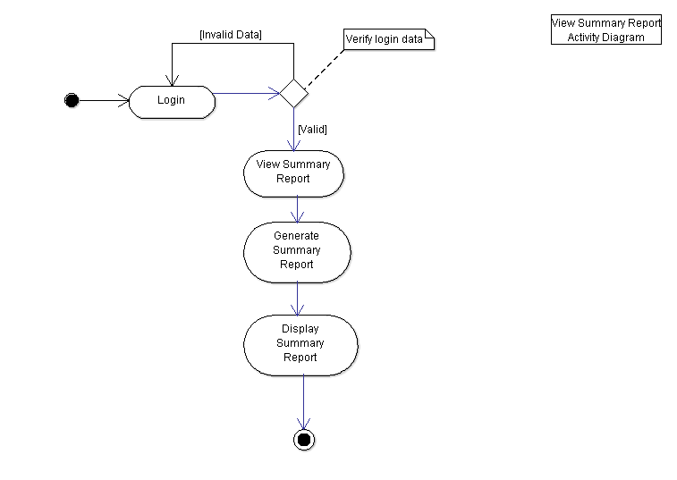
Changes:
- Add a work flow for login
- The user (member) will enter the ID and password
- System verify the login
- If success, proceed to the next step (iteration 1)
- Fail then return to ask the ID and password from user

Design Artefacts - Activity Workflows (Iteration 2) #6

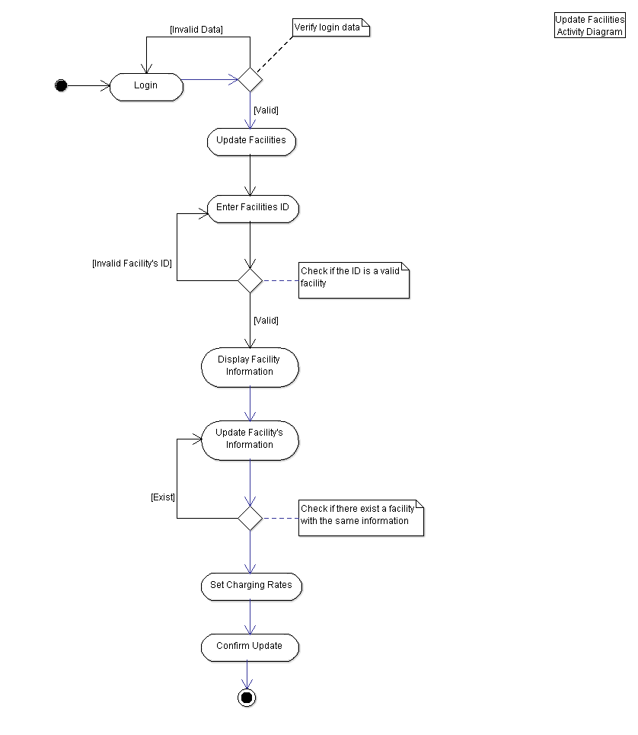
Changes:
- Add a work flow for login
- After the manager enter the information for update, add another checking
- System will check if the updated information is a duplicate
- Add set charging rate after base on the peak hour
- Add user confirmation to the update

Design Artefacts - Activity Workflows (Iteration 2) #7

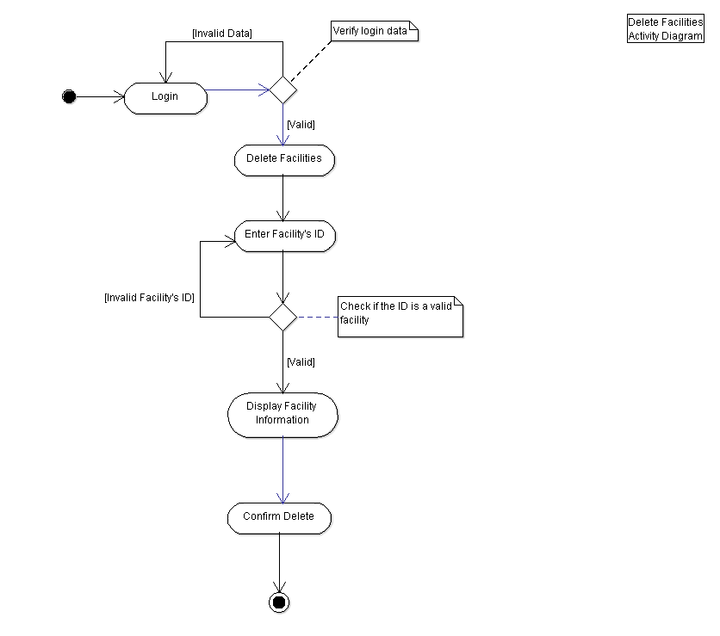
Changes:
- Add a work flow for login
- The user (member) will enter the ID and password
- System verify the login
- If success, proceed to the next step (iteration 1)
- Fail then return to ask the ID and password from user
- Add confirmation from the user at the end of search

Design Artefacts - Activity Workflows (Iteration 2) #8

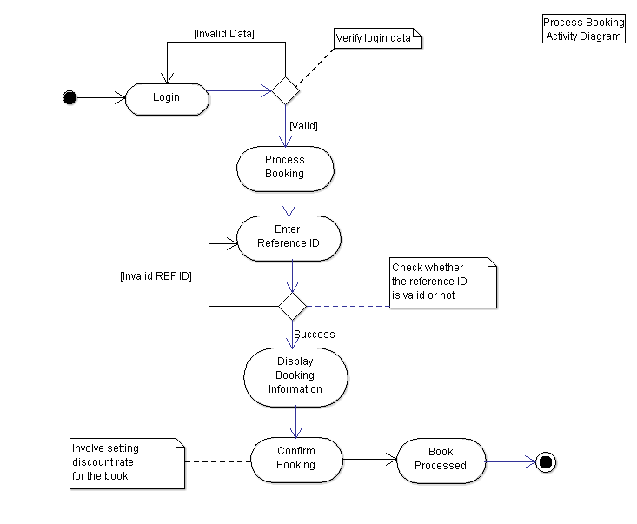
Changes:
- Add a work flow for login
- The user (member) will enter the ID and password
- System verify the login
- If success, proceed to the next step (iteration 1)
- Fail then return to ask the ID and password from user

Design Artefacts - Activity Workflows (Iteration 2) #9

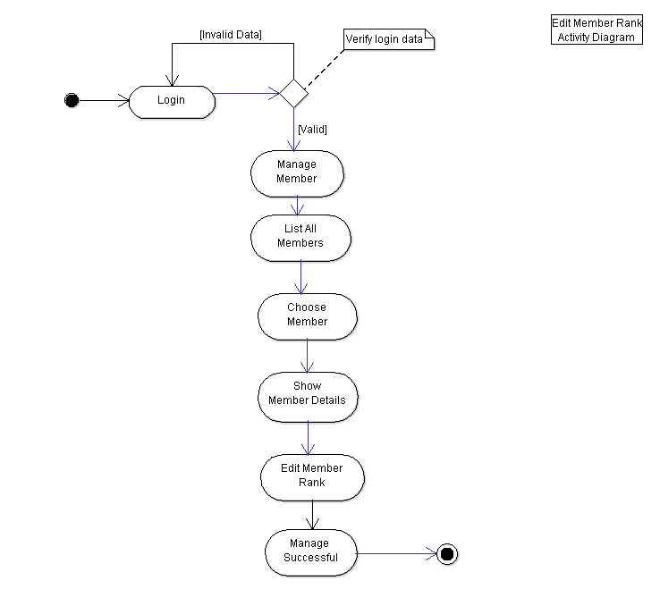
Changes:
- Add a work flow for login
- The user (member) will enter the ID and password
- System verify the login
- If success, proceed to the next step (iteration 1)
- Fail then return to ask the ID and password from user

Design Artefacts - Activity Workflows (Iteration 2) #10

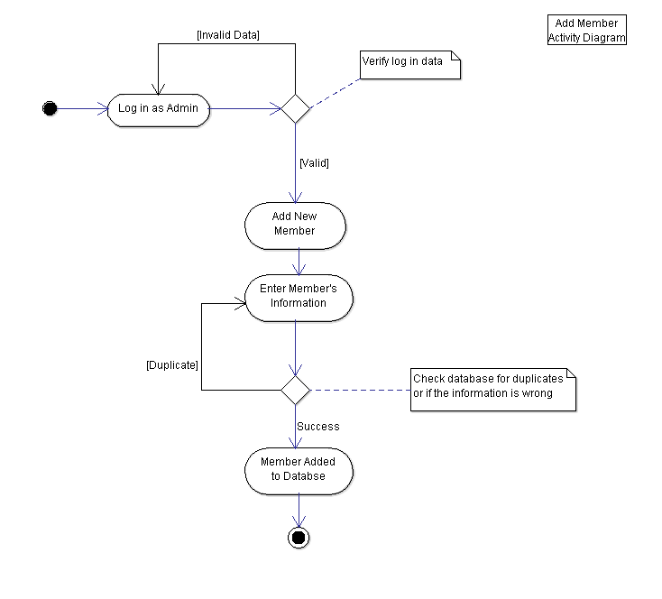
Changes:
- Add a work flow for login
- The user (member) will enter the ID and password
- System verify the login
- If success, proceed to the next step (iteration 1)
- Fail then return to ask the ID and password from user

Design Artefacts - Activity Workflows (Iteration 2) #11

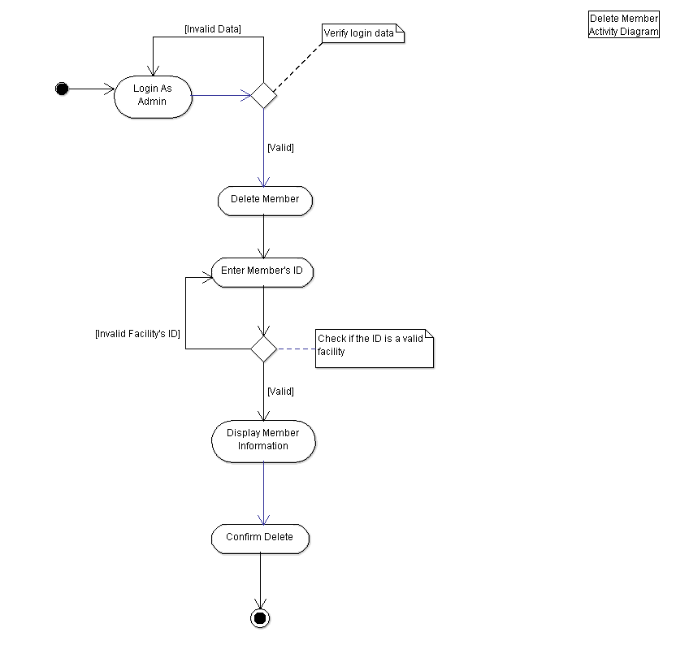
Changes:
- Add a work flow for login
- The user (member) will enter the ID and password
- System verify the login
- If success, proceed to the next step (iteration 1)
- Fail then return to ask the ID and password from user

Design Artefacts - Component Diagrams (Iteration 1)

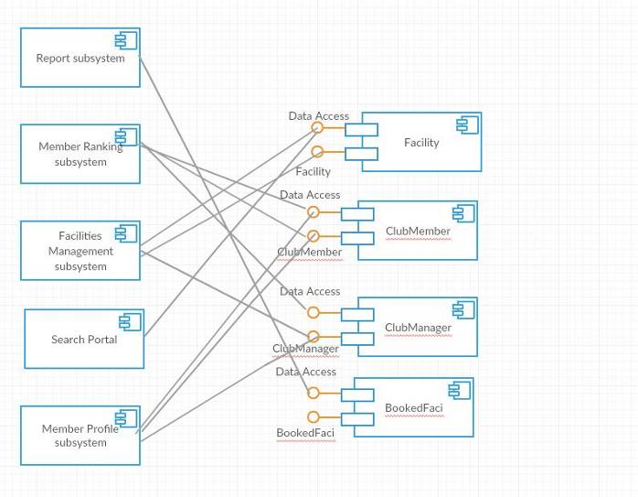

PLEASE EXPLAIN WHAT YOU WILL EXPLAIN OR EXPLAINED DURING THE PRESENTATION!!

Design Artefacts - Component Diagrams (Iteration 2)

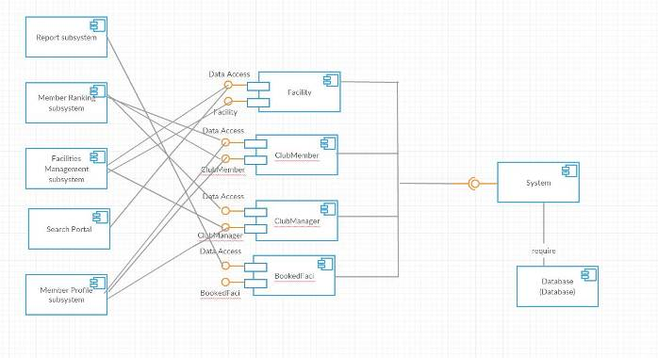

PLEASE EXPLAIN WHAT YOU WILL EXPLAIN OR EXPLAINED DURING THE PRESENTATION!!

Design Artefacts - Class Diagrams (Iteration 1)

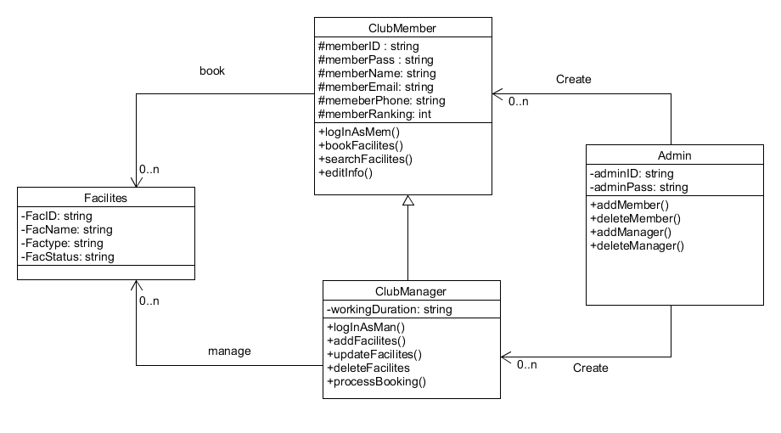

PLEASE EXPLAIN WHAT YOU WILL EXPLAIN OR EXPLAINED DURING THE PRESENTATION!!

Design Artefacts - Class Diagrams (Iteration 2)

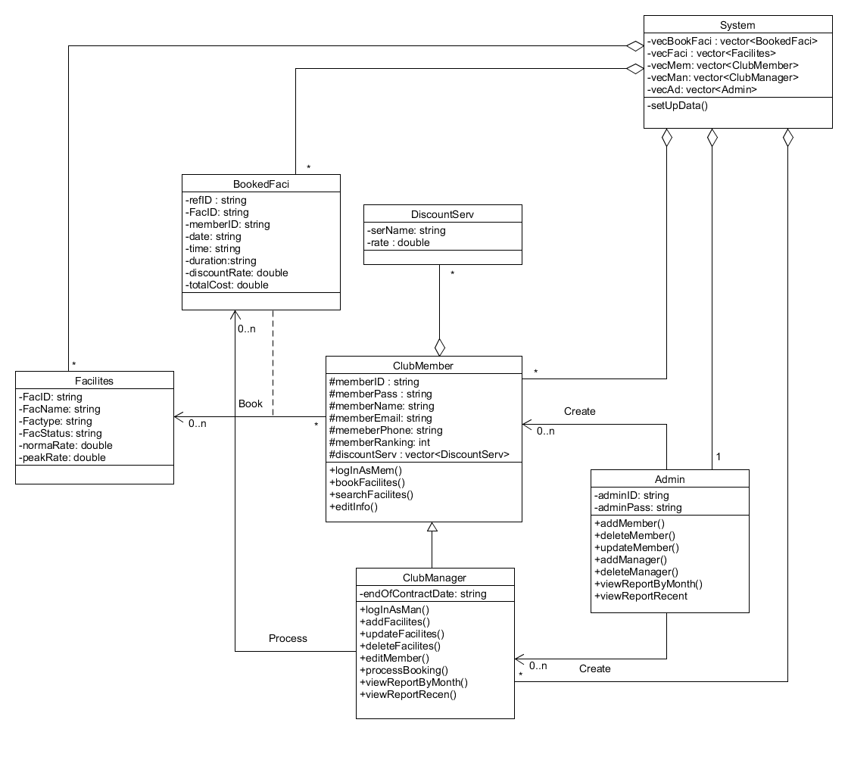
PLEASE EXPLAIN WHAT YOU WILL EXPLAIN OR EXPLAINED DURING THE PRESENTATION!!

Design Artefacts – Sequence Diagrams (Iteration 1) #1

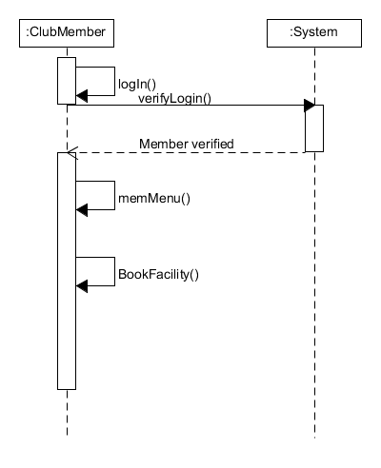

Design Artefacts – Sequence Diagrams (Iteration 1) #2

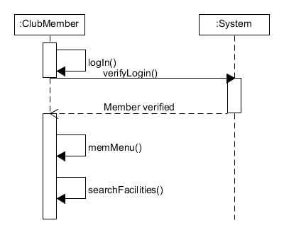

Design Artefacts – Sequence Diagrams (Iteration 1) #3

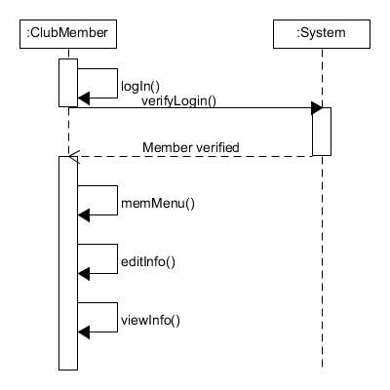

Design Artefacts – Sequence Diagrams (Iteration 1) #4
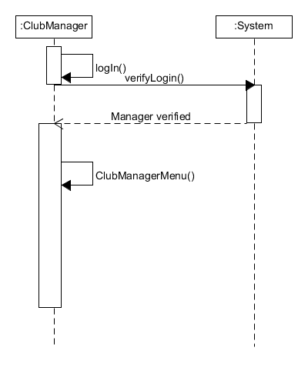
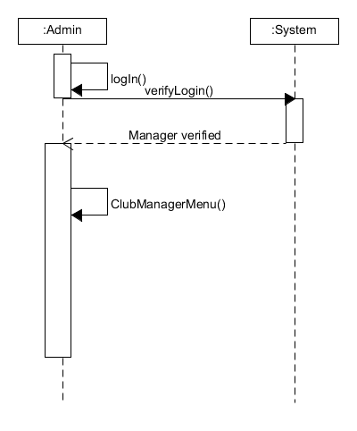

Design Artefacts – Sequence Diagrams (Iteration 1) #5

Design Artefacts – Sequence Diagrams (Iteration 1) #6

Design Artefacts – Sequence Diagrams (Iteration 1) #7

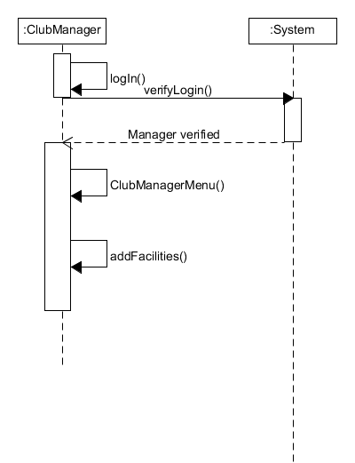

Design Artefacts – Sequence Diagrams (Iteration 1) #8

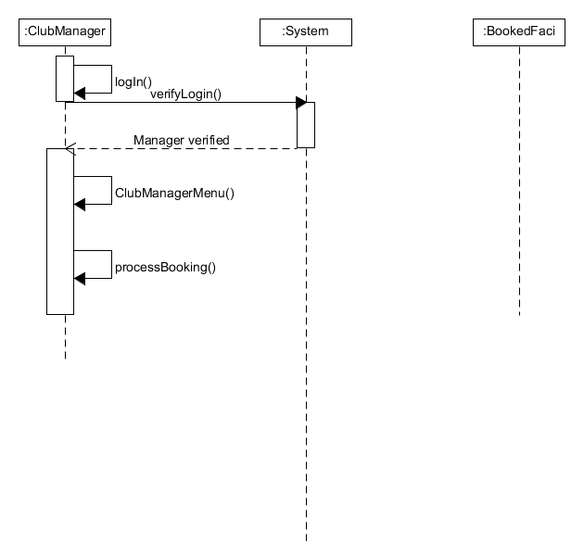

Design Artefacts – Sequence Diagrams (Iteration 1) #9

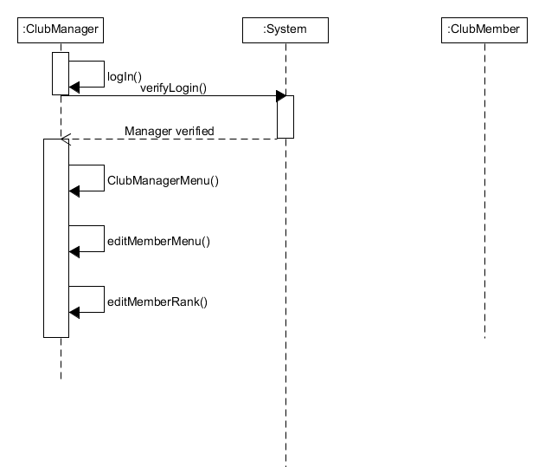

Design Artefacts – Sequence Diagrams (Iteration 1) #10

Design Artefacts – Sequence Diagrams (Iteration 1) #11

Design Artefacts – Sequence Diagrams (Iteration 2) #1

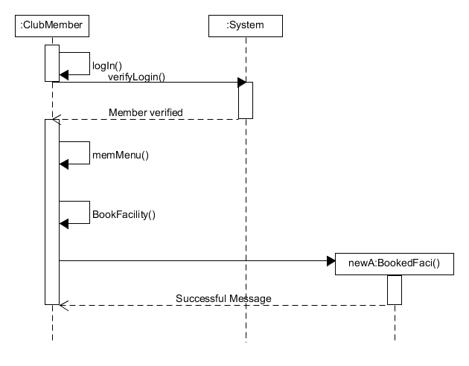

Design Artefacts – Sequence Diagrams (Iteration 2) #2

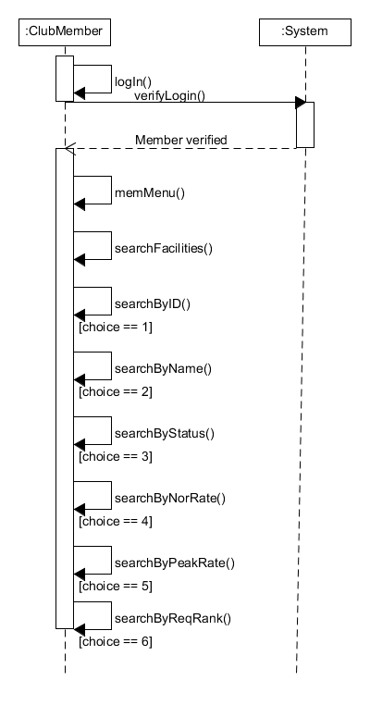

Design Artefacts – Sequence Diagrams (Iteration 2) #3

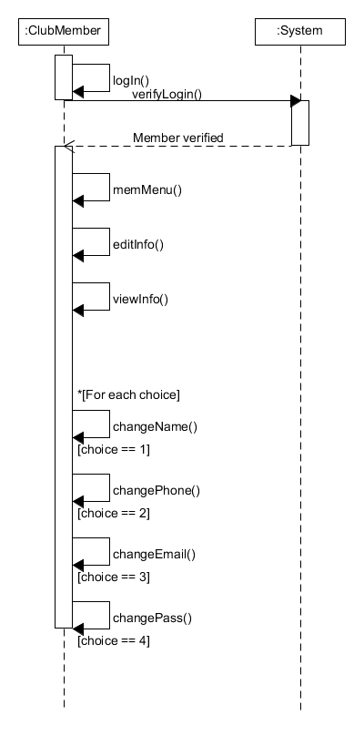

Design Artefacts – Sequence Diagrams (Iteration 2) #4

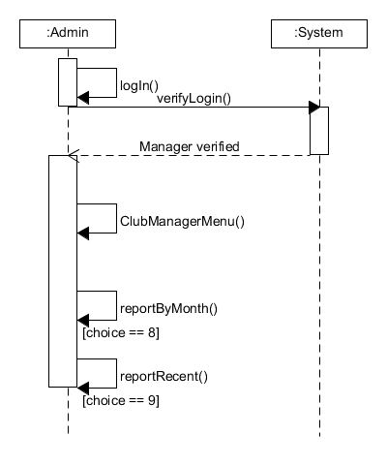
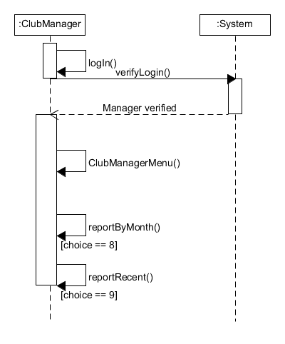

Design Artefacts – Sequence Diagrams (Iteration 2) #5

Design Artefacts – Sequence Diagrams (Iteration 2) #6

Design Artefacts – Sequence Diagrams (Iteration 2) #7

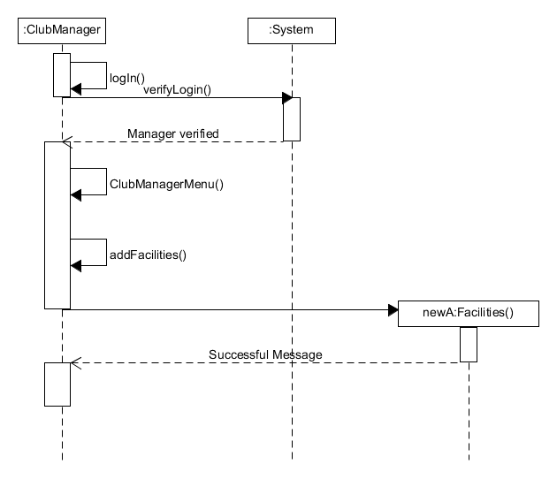

Design Artefacts – Sequence Diagrams (Iteration 2) #8

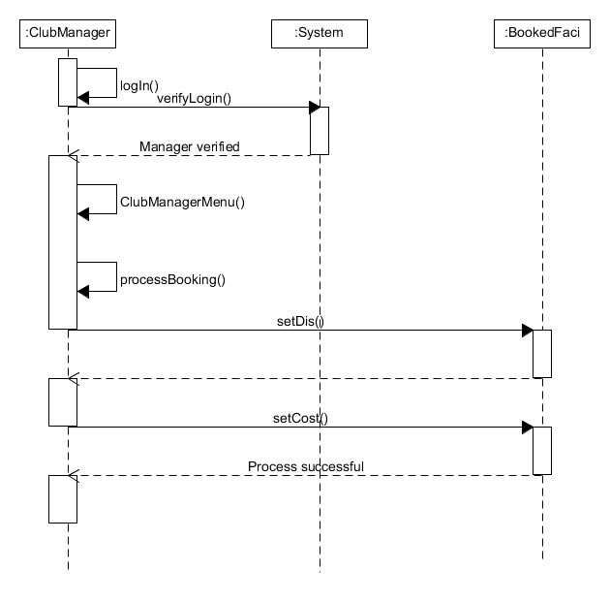

Design Artefacts – Sequence Diagrams (Iteration 2) #9

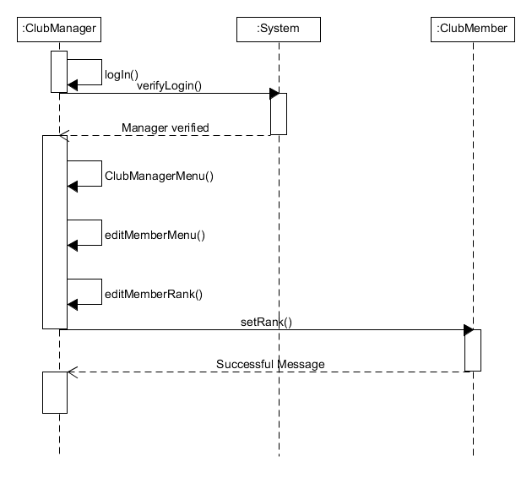

Design Artefacts – Sequence Diagrams (Iteration 2) #10

Design Artefacts – Sequence Diagrams (Iteration 2) #11

Design Artefacts – Deployment Diagrams (Iteration 1)

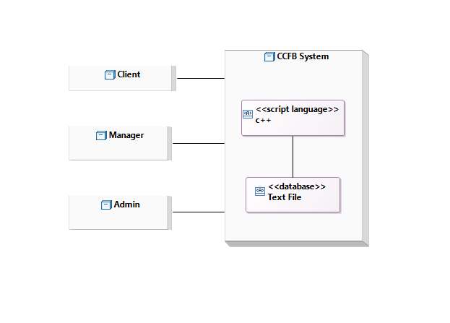
In our deployment diagram, we have 4 nodes which are Client, Manager, Admin and CCFB System or System.

Client, Manager and Admin will connect and interact with the System. All of them use the artefact inside the System, C++ for the program and a text file (database).

Design Artefacts – Deployment Diagrams (Iteration 2)

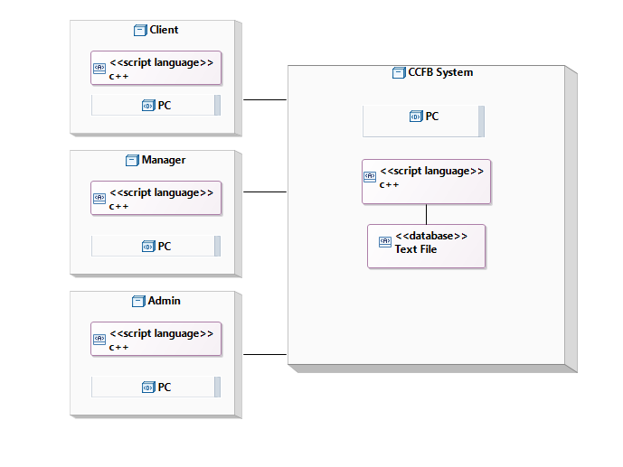
For iteration 2, we added the device used on each node and all of them use PC to connect to the server but the same C++ program will also added on each node as they will run the program from their own PC.

Test Plan Design
Cppunit TESTING:
- We used CPPUNIT testing with Visual C++ Studio 2010
- Reference: http://www.comp.nus.edu.sg/~cs3215/tools/cppunitAll.html
- The testing file will be provided (testAdmin.zip and testMemberBook.zip inside folder CPPUNIT of Source Code folder)
- If you want to rerun the test check out the notes in the website. Or simply just follow the first part (to build CPPUNIT inside Visual C++) of the website and double click the Visual C++ studio project file that we provided and simply press run.
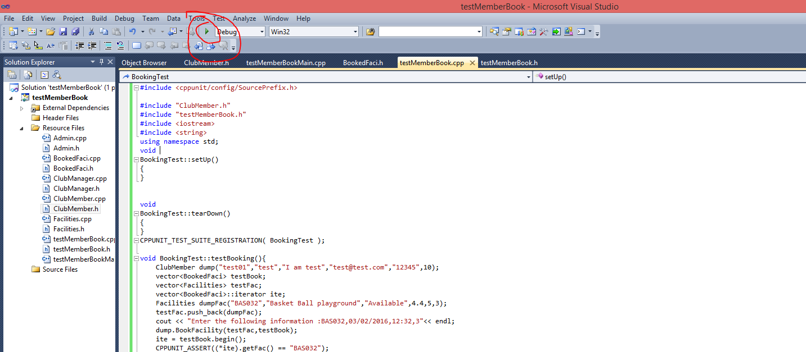
- There are some warning about fail building but just ignore it, the file is fine and it can run and can output the result
Test Plan for :

Club Admin
Description | Expected Outcome | Participating Program's Class & Method to be tested | Participating CPPUnit Test Program's Class & Method doing the testing
Test adding a new member with ID: test01 | Message: Member successfully added and last slot of the vector is that member | Class Name : Admin  Method Name :  void addMember(vector<ClubMember>& b) | CPPUnit Class Name : AdminTest  Method Name :  void testAddMember();
Delete member with ID | Message: Member deleted successfully and the last slot of vector is deleted since it’s a test so it only has 1 member in it. As a result, the vector should be empty | E.g.  Class Name : Admin  Method Name :  void deleteMember(vector<ClubMember>& b) | E.g.  CPPUnit Class Name : AdminTest  Method Name :  Void testDeleteMember

Result:
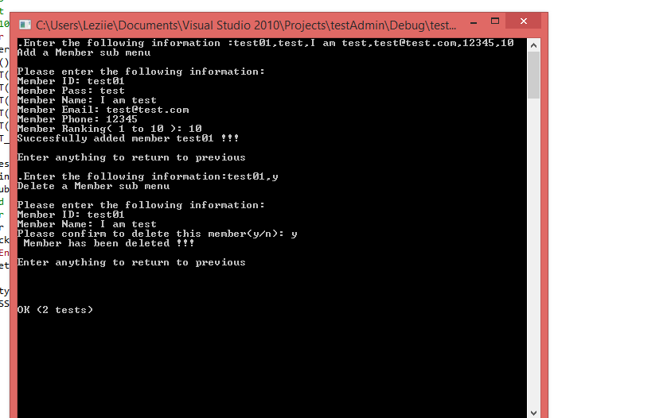

Test Plan for :

Club Member
Description | Expected Outcome | Participating Program's Class & Method to be tested | Participating CPPUnit Test Program's Class & Method doing the testing
Booking a Facility with ID: BAS032 | Message: Booked successfully and a bookRef is generated.  A BookedFaci instance should be added to BookedFaci vector | Class Name : ClubMember  Method Name :  void  BookFacility(vector<Facilities>& a, vector<BookedFaci>& b) | CPPUnit Class Name : BookingTest  Method Name :  void testBooking()

Result:
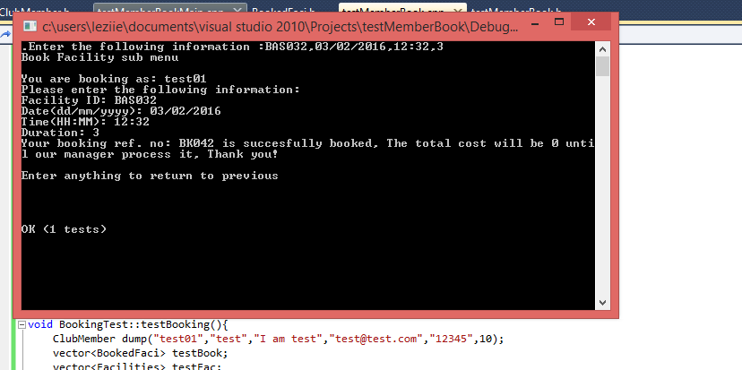

Casual TESTING:
- Please refer to product help and demonstration document, we have done testing for all the function of the program.

Appendix A - Formal Meeting Records

Construction Phase - Iteration 1
- Meeting minutes : 1 hour and 25 minutes
- Meeting date : 14 February 2016
- Purpose of meeting : Preparation for the Assignment 2
- Meeting summary :
- Discussing the assignment’s requirement
- Splitting works and roles to each member
- Establishing the coding language for the program
- Reviewing previous content of the assignment

Construction Phase - Iteration 2
- Meeting minutes : 2 hours and 30 minutes
- Meeting date : 17 February 2016
- Purpose of meeting : Discussing the work so far
- Meeting summary :
- Checking any mistake from the Activity diagram
- Discussing the Sequence diagram
- Discussing the Deployment diagram
- Fixing the problem on the coding, some parts are just not working as expected

Transition Phase - Iteration 1
- Meeting minutes : 2 hours
- Meeting date : 19 February 2016
- Purpose of meeting : Checking the coding part and start on making the report
- Meeting summary :
- Fix and finalizing the coding part
- Discussing the Sequence diagram for iteration 2
- Discussing the Deployment diagram for iteration 2
- Start on the test planning

Transition Phase - Iteration 2
- Meeting minutes : 2 hours and 15 minutes
- Meeting date : 21 February 2016
- Purpose of meeting : Working on the report and other document for finalization
- Meeting summary :
- Working on the project report
- Working on the test planning and product demonstration
- Working on the SRS report
- Reviewing any mistype on the coding and all documents

Appendix B - Individual Work Diaries

Team Member 1: Nguyen Duc Anh

Construction Phase - Iteration 1
- Meeting minutes : 1 hour and 25 minutes
- Work summary :
- Briefed the assignment requirement
- Assigned roles and works to each member
- Reviewing the Use-case diagram
- Reviewing the Activity diagram
- Reviewing the Class diagram

Construction Phase - Iteration 2
- Meeting minutes : 2 hours and 30 minutes
- Work summary :
- Discussing any changes need for the Activity diagram
- Reviewing the Sequence diagram iteration 1
- Reviewing the Deployment diagram iteration 1
- Working on the coding
- Planned the next meeting session

Transition Phase - Iteration 1
- Meeting minutes : 2 hours
- Work summary :
- Working on the coding
- Fixing previous coding part
- Helping on the Sequence diagram for iteration 2
- Helping on the Deployment diagram for iteration 2
- Test the coding for a little bit

Transition Phase - Iteration 2
- Meeting minutes : 2 hours and 15 minutes
- Work summary :
- Reviewing all works so far
- Working on the SRS report
- Testing the coding
- Helping on the product demonstration
- Helping on the project presentation slides

Team Member 2: William Wunady

Construction Phase - Iteration 1
- Meeting minutes : 1 hour and 25 minutes
- Work summary :
- Briefed by the team leader for the assignment’s requirement
- Assigned the roles and works
- Reviewing the Use-case diagram
- Reviewing the Activity diagram
- Reviewing the Class diagram

Construction Phase - Iteration 2
- Meeting minutes : 2 hours and 30 minutes
- Work summary :
- Helping on the changes for Activity diagram
- Reviewing the Sequence diagram iteration 1
- Reviewing the Deployment diagram iteration 1
- Helping on the coding part
- Start working on the SRS report

Transition Phase - Iteration 1
- Meeting minutes : 2 hours
- Work summary :
- Helping on the coding part
- Testing the previous code
- Helping on the Sequence diagram iteration 2
- Helping on the Deployment diagram iteration 2
- Working on the SRS report

Transition Phase - Iteration 2
- Meeting minutes : 2 hours and 15 minutes
- Work summary :
- Reviewing all the works so far
- Finalizing the SRS report
- Working on the presentation slides
- Helping the coding testing

Team Member 3: Ardyanto

Construction Phase - Iteration 1
- Meeting minutes : 1 hour and 25 minutes
- Work summary :
- Briefed by the team leader for the assignment’s requirement
- Assigned the roles and works for assignment 2
- Reviewing the Use-case diagram
- Reviewing the Activity diagram
- Reviewing the Class diagram

Construction Phase - Iteration 2
- Meeting minutes : 2 hours and 30 minutes
- Work summary :
- Working on the changes for Activity diagram
- Reviewing the Sequence diagram iteration 1 and start working on the iteration 2
- Reviewing the Deployment diagram iteration 1 and start working on the iteration 2
- Helping the coding part
- Start working on the project demonstration

Transition Phase - Iteration 1
- Meeting minutes : 2 hours
- Work summary :
- Helping on the coding part
- Working on the Sequence diagram iteration 2
- Working on the Deployment diagram iteration 2
- Helping on the code testing
- Working on the product demonstration

Transition Phase - Iteration 2
- Meeting minutes : 2 hours and 15 minutes
- Work summary :
- Reviewing all works so far
- Finalizing the product demonstration
- Review and fixing the Sequence diagram iteration 2
- Checking the code testing
- Review and fixing the Deployment diagram iteration 2

Team Member 3: Wu Chin Hwa

Construction Phase - Iteration 1
- Meeting minutes : 1 hour and 25 minutes
- Work summary :
- Briefed by the team leader for the assignment’s requirement
- Assigned the roles and works for this assignment
- Reviewing the Use-case diagram
- Reviewing the Activity diagram
- Reviewing the Class diagram

Construction Phase - Iteration 2
- Meeting minutes : 2 hours and 30 minutes
- Work summary :
- Working on the changes for Activity diagram
- Reviewing the Sequence diagram iteration 1 and start working on the iteration 2
- Reviewing the Deployment diagram iteration 1 and start working on the iteration 2
- Checking the completed coding
- Start working on the project report

Transition Phase - Iteration 1
- Meeting minutes : 2 hours
- Work summary :
- Working on the Sequence diagram iteration 2
- Working on the Deployment diagram iteration 2
- Check and helping the coding part
- Working on the project report
- Reviewing the work so far for the report

Transition Phase - Iteration 2
- Meeting minutes : 2 hours 15 minutes
- Work summary :
- Reviewing all the works so far
- Review and fixing the Sequence diagram iteration 2
- Review and fixing the Deployment diagram iteration 2
- Finalizing the project report
- Helping on the presentation slides

Appendix C - Evidence of using VCS (Version Control Software)

Version Control Software used: TortoiseSVN and Github

Screenshot #1 - Contents in the VCS's Root Folder containing all Repository Project Files

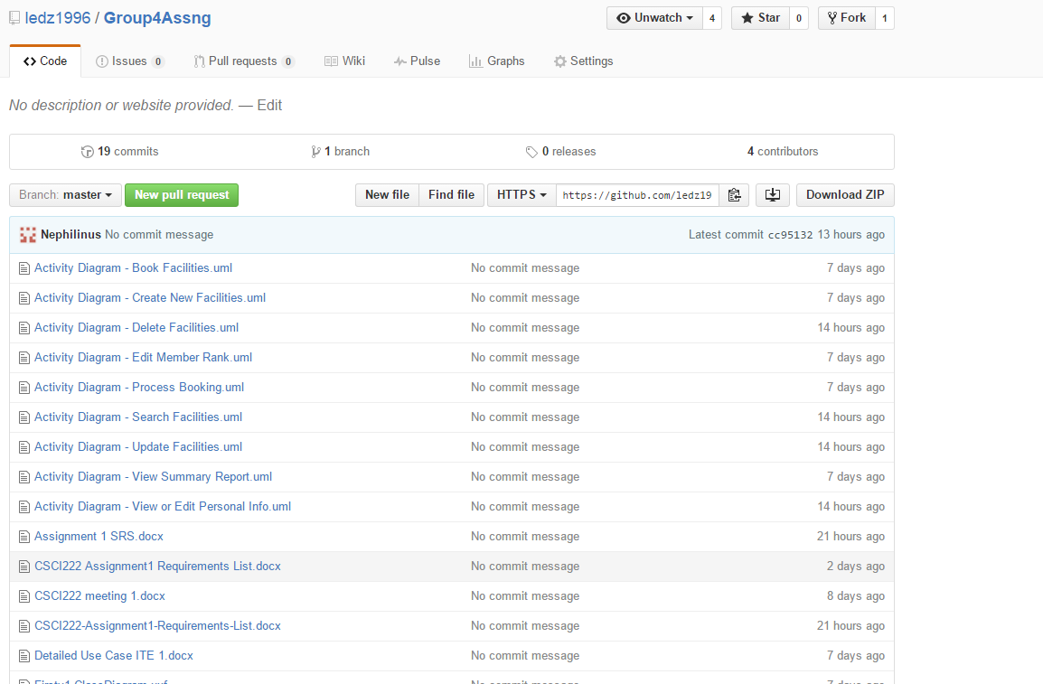

Screenshot #2 - VCS's listing of all the latest source files currently being managed

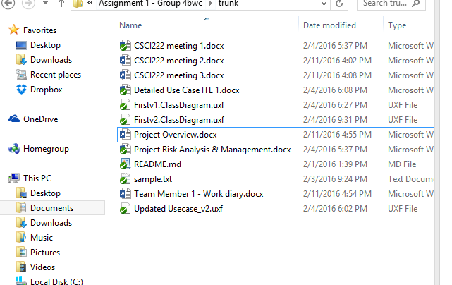

Screenshot #3 - Example using VCS's to check-out source files (it may be necessary to do >1 screen capture, depending on the software used)

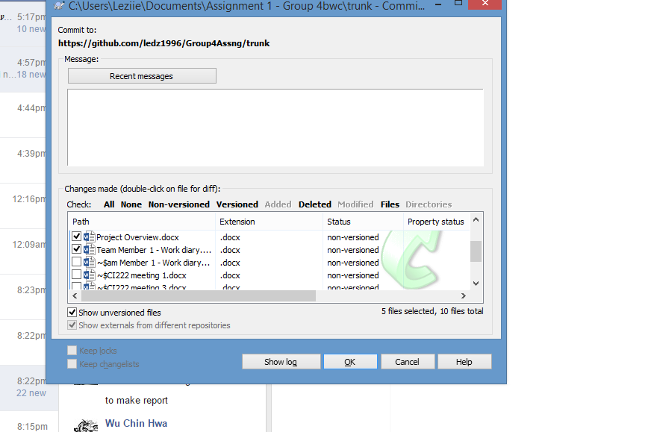
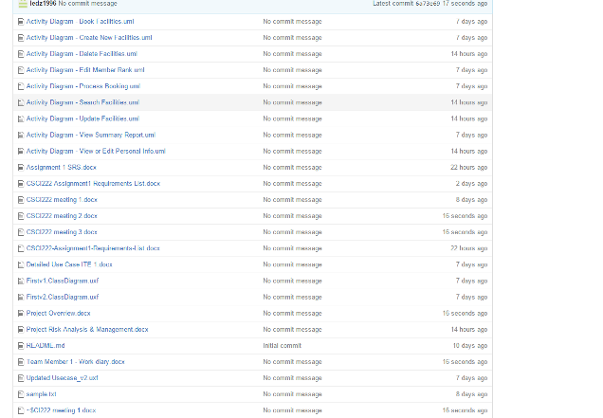

Screenshot #4 - Example using VCS's to check-in source files (it may be necessary to do >1 screen capture, depending on the software used)

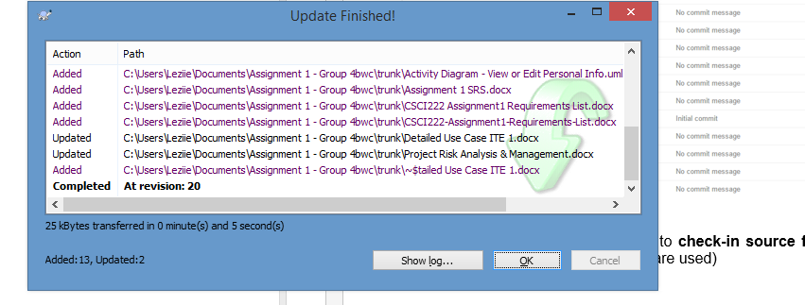
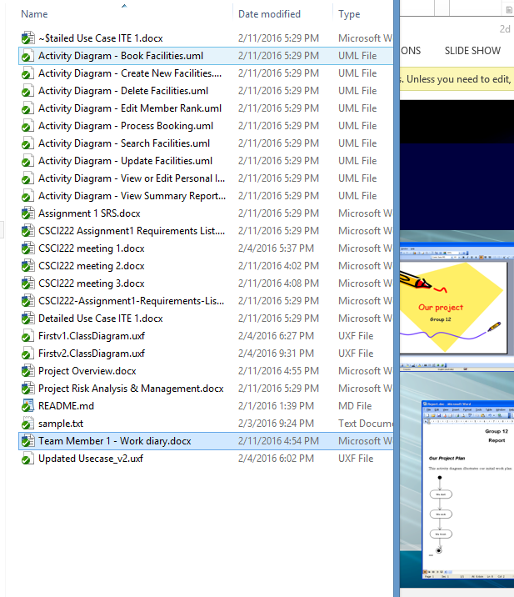

Screenshot #5 - Example using VCS's to display the change history / log (it may be necessary to do >1 screen capture, depending on the software used)

