MLZ Security Lab Starter Kit — Implementation Guide (Azure Commercial)
Repository: github.com/lee-aguilar-msft/Azure-MLZStarterKit-Security

Contents

Step-by-step, from an empty Azure Commercial subscription to a running MLZ Security Lab with Microsoft Sentinel connectors, analytics rules and UEBA enabled — using only the Azure portal, Cloud Shell and the Deploy to Azure button in the repository README.
This is the Commercial counterpart of the Azure Government guide (IMPLEMENTATION-GOV.md). The kit is the same; the portal, the endpoints, the region choice, the VM sizes and several pitfalls are not, so the steps are written out in full here rather than as a list of differences.
Everything in this guide was performed for real in a Commercial test subscription (westus2, tenant contoso.onmicrosoft.com) on 27 October 2026. The screenshots are from those runs. Three deployment runs were needed to shake out the Commercial-specific defects listed in section 8 (#48–#59); every fix is on main, so a fresh run of the kit follows the clean path described here.
Repository: https://github.com/lee-aguilar-msft/Azure-MLZStarterKit-Security
Section | What you do | Time
1. Before you start | Gather the inputs the form asks for | 10 min
2. Subscription prerequisites | Register features and providers, find a region the subscription can deploy VMs in, confirm quota | 20 min
3. Entra ID prerequisites | VM-login security group, break-glass account | 10 min
4. Deploy from the portal | Blue button → 7 form tabs → Review + create | 15 min form, ≈ 55 min deploy
5. Post-deploy | Post-Deploy.ps1 -Cloud Global: Sentinel content, rules, UEBA, connectors; then the identity chain (Prepare-Tenant, Entra Connect, hybrid join, Intune, MDE) | 35 min + ≈ 1 h identity
6. Verify | VMs, Sentinel, Defender plans, Intune / MDE, hydration | 15 min
7. Teardown | destroy.ps1 (includes NetworkWatcherRG flow logs and workspace purge) | 20–40 min
8. Troubleshooting | Every Commercial error hit while writing this guide, with its fix | —

What gets deployed
The kit sits on a standard Mission Landing Zone: the upstream mlz.json module builds the network hub and the T0/T1/T2 spokes, and the kit adds a Tier 3 security-lab spoke plus the subscription- and tenant-level security layer. The Commercial deployment is functionally identical to the Government one; only the endpoints (.com) and the Defender plan list differ.
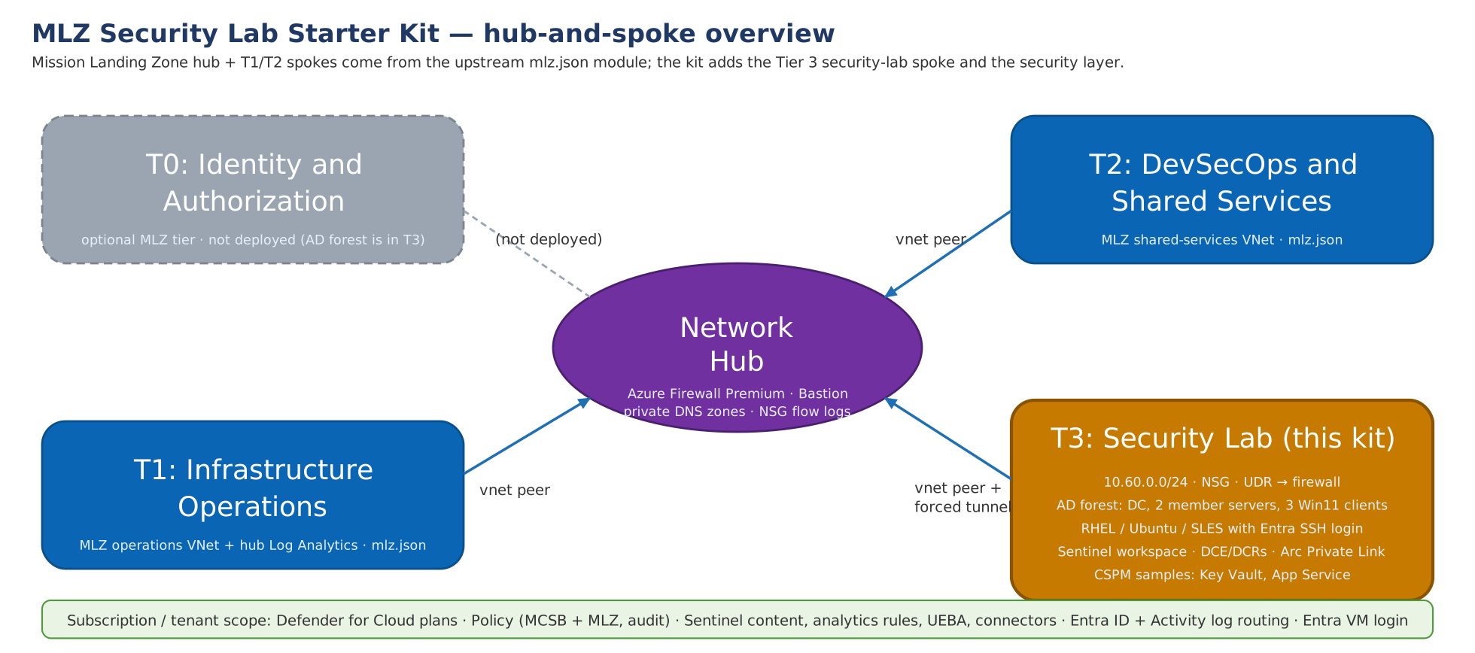
Figure: Hub-and-spoke overview
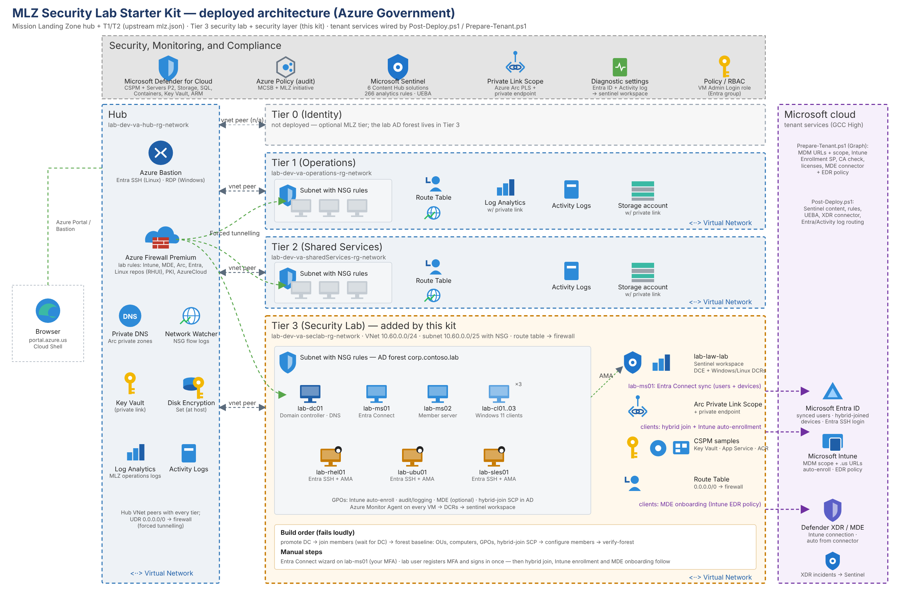
Figure: What the deployment creates
Layer | Resources
MLZ hub | Hub VNet, Azure Firewall (Premium) with the lab rule collection groups, Bastion, hub Log Analytics, NSG flow logs
Tier-3 workload | mca-dev-usw2-seclab-rg-network: VNet 10.60.0.0/24, NSG, route to the firewall
Identity | lab-dc01 (new forest corp.contoso.lab), lab-ms01 / lab-ms02 member servers, lab-cl01–lab-cl03 Windows 11 clients, all domain-joined; Entra VM login role for one security group
Linux | lab-rhel01, lab-ubu01, lab-sles01 (RHEL 9, Ubuntu 22.04, SLES 15 SP6) with Entra SSH login and Azure Monitor Agent
Security | Sentinel workspace law-mca-lab, DCE + Windows/Linux data collection rules, Defender for Cloud plans (all plans, including App Service — APIs optional), MLZ policy set + NIST SP 800-53 R5 + Microsoft cloud security benchmark, Arc Private Link Scope + private DNS zones, CSPM coverage samples (SQL, Key Vault, App Service)
Post-deploy | Sentinel Content Hub solutions, analytics rules, UEBA, Defender XDR connector, Entra ID + Azure Activity log routing
Data hydration | LAB-Hydration scheduled task on every Windows VM and a lab-hydrate systemd timer on every Linux VM: hourly benign user/admin activity so Sentinel and MDE have data to hunt over (section 5.3)

1. Before you start — inputs checklist
Collect these before opening the form; the portal form does not save progress if you navigate away, and changing anything on the Basics tab later resets the Compute tab.
Input | Form tab | Value used in this guide
Subscription | Basics | the Commercial test subscription (<subscription-id>)
Region | Basics | (US) West US 2 — chosen in step 2.4, not by habit
Resource naming identifier / environment | Basics | mca / dev (identifier is 1–3 characters)
Workload name / short name | Basics | seclab / sec
Resource prefix | Basics | lab (VM names lab-dc01, lab-cl01, …)
Security contact e-mail | Security and Compliance | a monitored tenant mailbox
New Sentinel workspace name | Security and Compliance | law-mca-lab
Verified Entra UPN suffix | Lab Options | contoso.onmicrosoft.com
Lab user sAMAccountName | Lab Options | lab.user
AD domain name / NetBIOS | Identity | corp.contoso.lab / CORP (type CORP — the field only shows it as a placeholder)
Admin username + two passwords (admin, DSRM) | Identity | labadmin (passwords are typed by the operator only)
Entra security group object ID for VM login | Identity | <entra-group-object-id>
VM sizes | Compute | Standard_D2as_v7 for servers, clients and Linux (what step 2.4 showed to be deployable)

Password rules: 12+ characters, 3 of 4 character classes, no part of the username. The same rules apply to the DSRM password. Nothing in this kit stores or echoes the passwords.
Roles you need: Owner on the subscription (the template assigns RBAC and Defender plans at subscription scope); in the tenant Global Administrator (or Security Administrator + Intune Administrator + Cloud Application Administrator + License Administrator) for step 5 — UEBA, the Entra ID log routing, the Intune settings and the Conditional Access exclusion are tenant-level — and Hybrid Identity Administrator for the Entra Connect wizard. Activate them through PIM before step 5.
Licensing in the tenant (not deployed by the kit): Entra ID P1/P2 + Intune for the lab user (any Microsoft 365 E3/E5-class SKU — Prepare-Tenant.ps1 -LabUserUpn assigns the first one it finds) and Defender for Endpoint P2 for the clients; the servers are covered by Defender for Servers P2.

2. Subscription prerequisites

2.1 Sign in to the Azure portal and pick the subscription
Open https://portal.azure.com, sign in with the Owner account, open Subscriptions and confirm the subscription you will deploy into. If you have several (a Dev, Prod and Test subscription in the same tenant, say), note the exact name — the form defaults to the first one alphabetically.
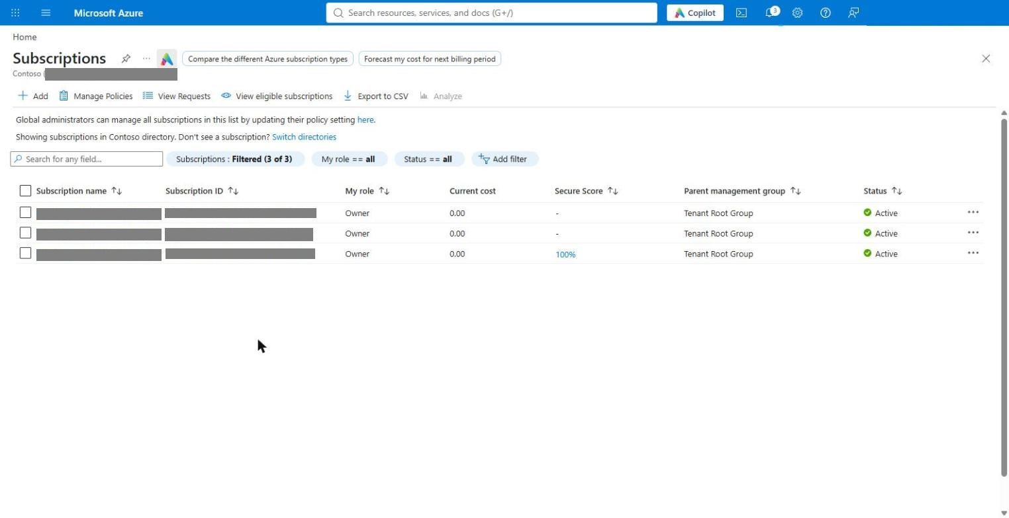
Figure: Subscriptions

2.2 Open Cloud Shell (Bash)
Click the Cloud Shell icon in the top bar. On first use choose Bash, pick the subscription, and select No storage account required — the session is ephemeral, which is fine: everything the guide runs in Cloud Shell is re-downloadable from the repository. Bash is used for the checks in sections 2.3–2.4; step 5 needs the shell switched to PowerShell (toolbar → Switch to PowerShell): the kit's post-deploy scripts use the Az sign-in that only the PowerShell-mode shell carries (#53).
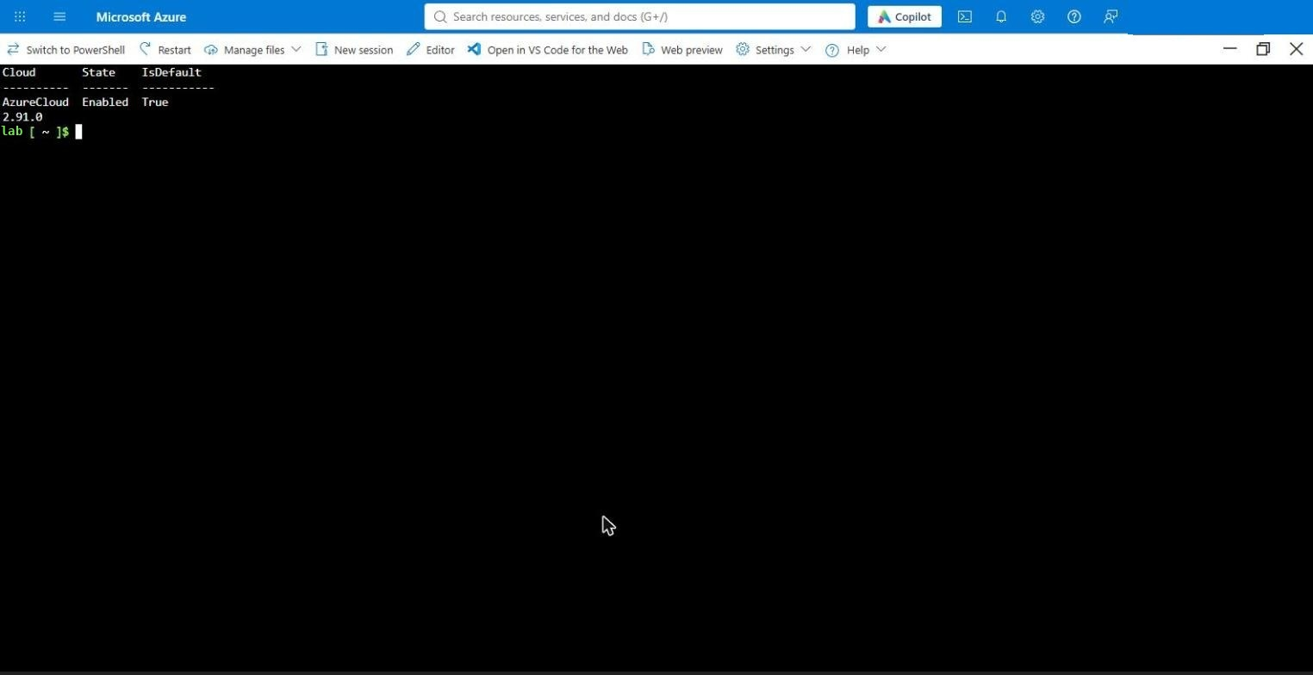
Figure: Cloud Shell ready
Cloud Shell disconnects after about 20 minutes of inactivity. If the pane shows Cloud Shell disconnected, click Restart in its toolbar and re-run the git clone from step 5.1 — the home directory is not kept when you chose No storage account.

2.3 Register the features and resource providers
Paste the block below into Cloud Shell. It is idempotent — re-running it is harmless. The second feature, AllowBringYourOwnPublicIpAddress, is the Commercial-specific one: some subscriptions (Microsoft-internal ones, and any subscription with a policy that adds IP tags to public IPs) refuse the MLZ firewall and Bastion public IPs without it (troubleshooting #48).
az account set --subscription <subscription-id>

# Encryption-at-host for the MLZ VMs and the public-IP feature (both take a few minutes to flip to Registered)
az feature register --namespace Microsoft.Compute --name EncryptionAtHost
az feature register --namespace Microsoft.Network --name AllowBringYourOwnPublicIpAddress

# Auto-shutdown schedules, Arc private link, DNS, Sentinel, Defender, policy, CSPM samples
for p in Microsoft.Compute Microsoft.Network Microsoft.DevTestLab Microsoft.HybridCompute \
Microsoft.ContainerInstance Microsoft.ApiManagement Microsoft.Web Microsoft.KeyVault \
Microsoft.Security Microsoft.OperationalInsights Microsoft.SecurityInsights Microsoft.PolicyInsights \
Microsoft.Insights Microsoft.Storage Microsoft.Sql Microsoft.ContainerRegistry \
Microsoft.OperationsManagement Microsoft.ManagedIdentity; do az provider register --namespace $p; done

# Poll until both print "Registered", then propagate the features into the providers
az feature show --namespace Microsoft.Compute --name EncryptionAtHost --query properties.state -o tsv
az feature show --namespace Microsoft.Network --name AllowBringYourOwnPublicIpAddress --query properties.state -o tsv
az provider register --namespace Microsoft.Compute --wait
az provider register --namespace Microsoft.Network --wait
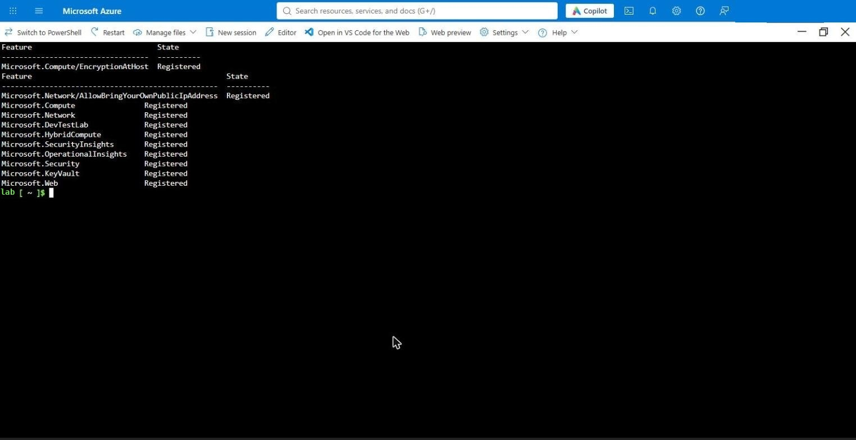
Figure: Features registered
If AllowBringYourOwnPublicIpAddress stays Pending, the subscription needs approval through a support request (days) — use another subscription meanwhile.

2.4 Pick the region: where can this subscription actually create VMs?
This is the step that does not exist in the Government guide and that cost the first Commercial run. Commercial subscriptions (trial, internal, sponsorship, new pay-as-you-go) commonly have entire regions restricted for VM creation, and the picture changes from day to day. On the test subscription, on the day of the first run, East US, Central US, West US and North Central US offered zero deployable VM sizes, East US 2 and South Central US only one, and West US 2 everything; by the evening East US 2 and South Central US had opened up (421 and 538 sizes) while East US and Central US were still at zero. az vm list-skus hides this (it is slow and returns []); ask the SKU API directly and count the unrestricted sizes per region right before you deploy:
SUB=$(az account show --query id -o tsv)
for l in eastus eastus2 westus2 westus3 southcentralus centralus; do
az rest --method get --url "https://management.azure.com/subscriptions/$SUB/providers/Microsoft.Compute/skus?api-version=2021-07-01&\$filter=location%20eq%20%27$l%27" -o json > /tmp/s-$l.json
python3 -c "import json,sys;d=json.load(open('/tmp/s-'+sys.argv[1]+'.json'))['value'];vm=[s for s in d if s['resourceType']=='virtualMachines'];ok=[s['name'] for s in vm if not s.get('restrictions')];print(sys.argv[1],len(ok),'deployable sizes;',' '.join(w for w in ['Standard_D2as_v7','Standard_D2s_v5','Standard_D2ads_v6'] if w in ok))" $l
done
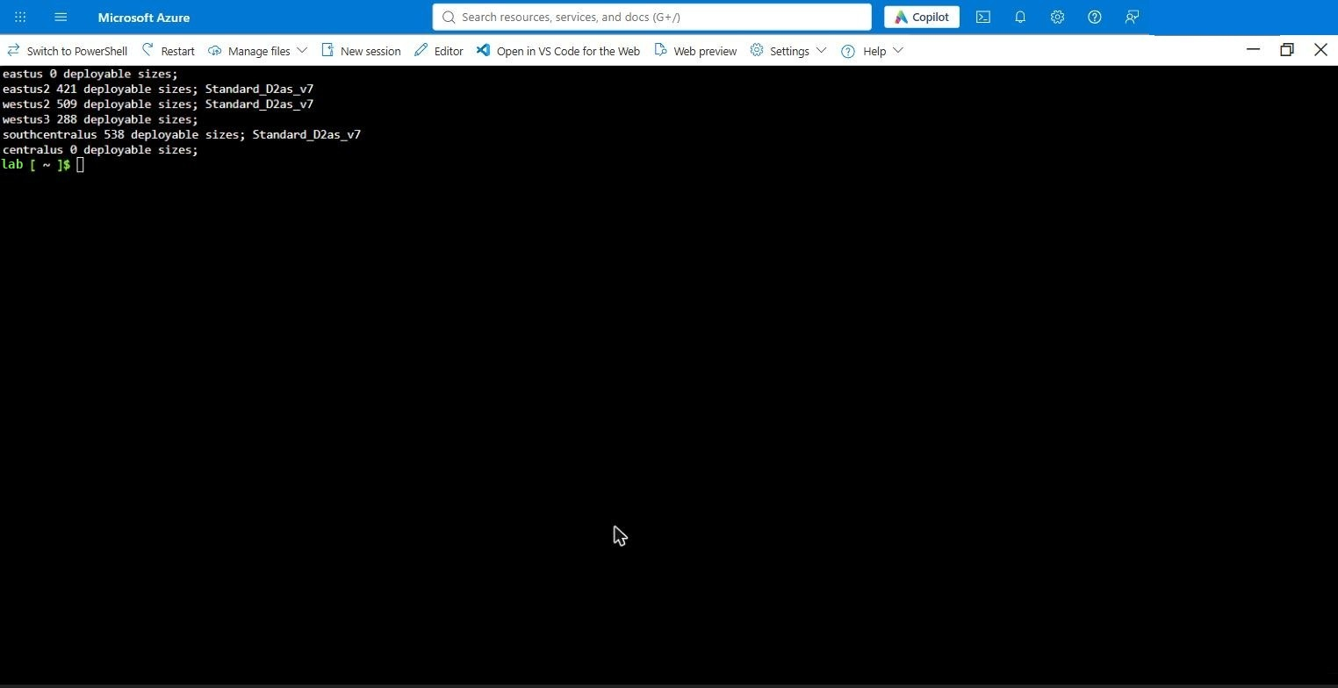
Figure: Deployable VM sizes per region on the test subscription
Pick a region that lists Standard_D2as_v7 (or another of the three lab sizes), then confirm the vCPU family quota there — the lab needs 18 vCPUs for 9 × 2-vCPU VMs, and a family that is deployable can still have no quota (on the test subscription Dadsv6 was deployable in West US 2 but had no quota entry, while Dasv7 and Dsv5 had 100; the screenshot below was taken with the lab running, 18 of 100 Dasv7 vCPUs in use):
az vm list-usage -l westus2 --query "[?contains(name.value,'asv7') || contains(name.value,'DSv5') || contains(name.value,'adsv6') || name.value=='cores'].{family:name.value,used:currentValue,limit:limit}" -o table
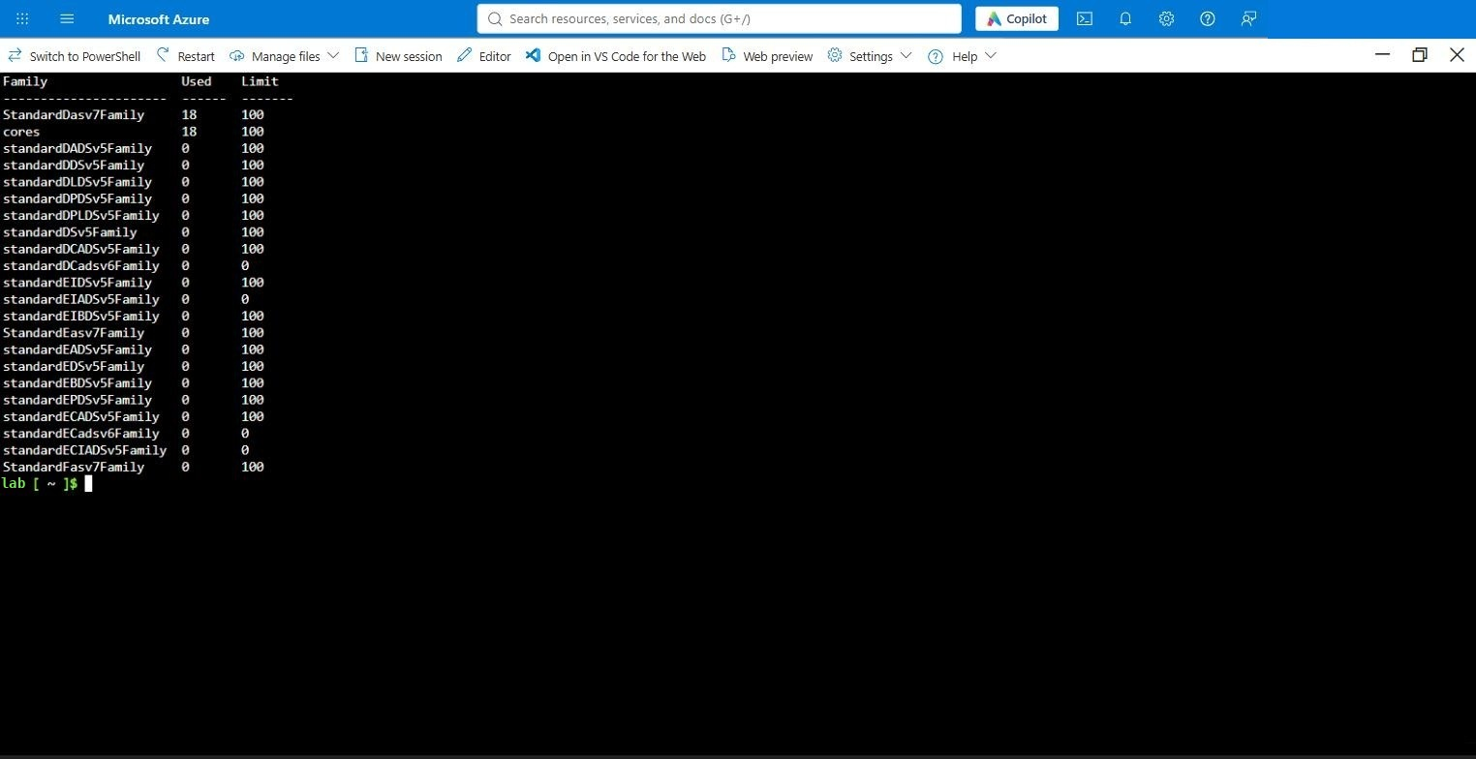
Figure: Quota in West US 2
The Compute tab (step 4.7) only offers sizes the subscription can deploy in the chosen region, so after this step the size question is settled.

3. Entra ID prerequisites

3.1 Security group for Entra VM login
The kit assigns Virtual Machine Administrator Login to one Entra security group on every VM, so members can sign in with Entra credentials through Bastion (RDP and SSH). Create (or reuse) a group, add the operators to it, and copy its Object ID — the Identity tab asks for it.
Microsoft Entra ID → Groups → New group (Security, e.g. Lab VM Login) → add yourself as a member → Overview → copy Object Id.
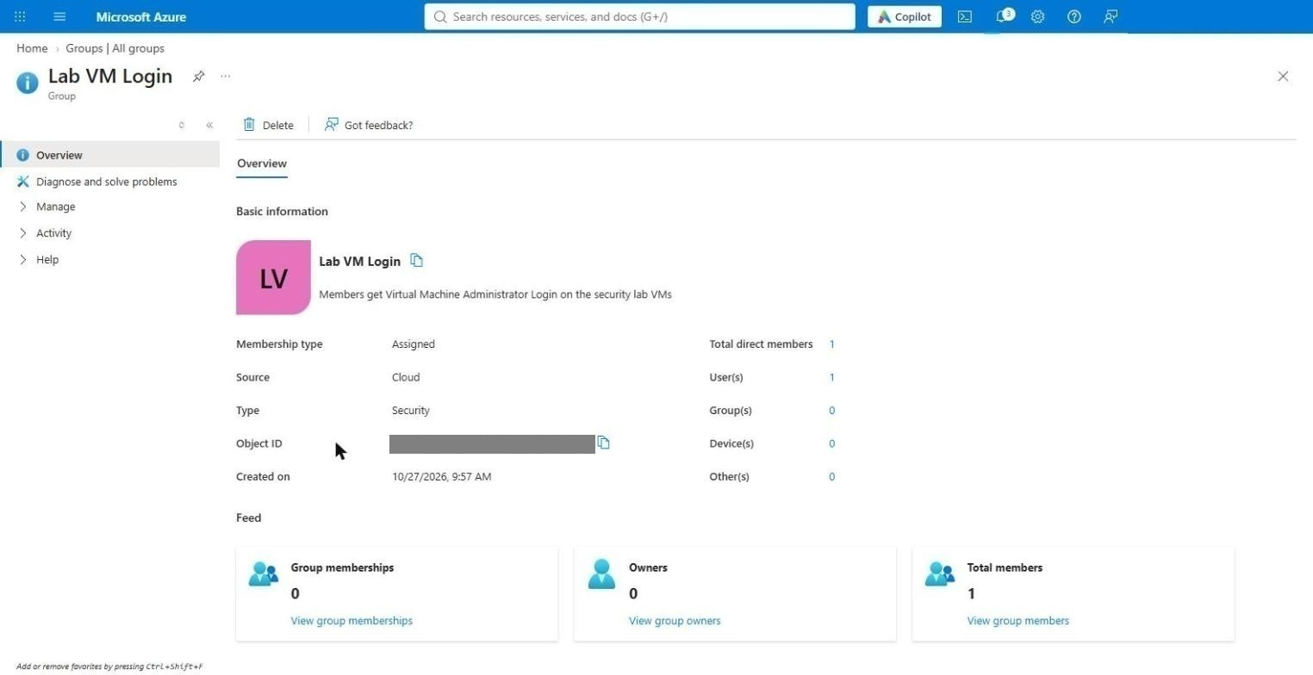
Figure: Entra group with its object ID

3.2 Break-glass (emergency access) account
Create a cloud-only Global Administrator break-glass account in the tenant before you enable any Conditional Access or Entra-login enforcement in the lab, and exclude it from every CA policy. This is a tenant task outside the template; the kit does not create it. Post-Deploy.ps1 prints the same reminder.

3.3 Verified domain for the lab user
The lab user's UPN suffix must be a domain the tenant has verified (otherwise Intune enrollment fails with 0xCAA9001F, troubleshooting #45). On a fresh tenant that is only <tenant>.onmicrosoft.com — Microsoft Entra ID → Custom domain names. Use it on the Lab Options tab.

4. Deploy from the portal (Deploy to Azure button)

4.1 Open the form
In the repository README click Deploy to Azure (the button without Gov). It opens portal.azure.com with the kit's solution.json and uiDefinition.json loaded straight from GitHub (the form title reads MLZ Security Lab Starter Kit).
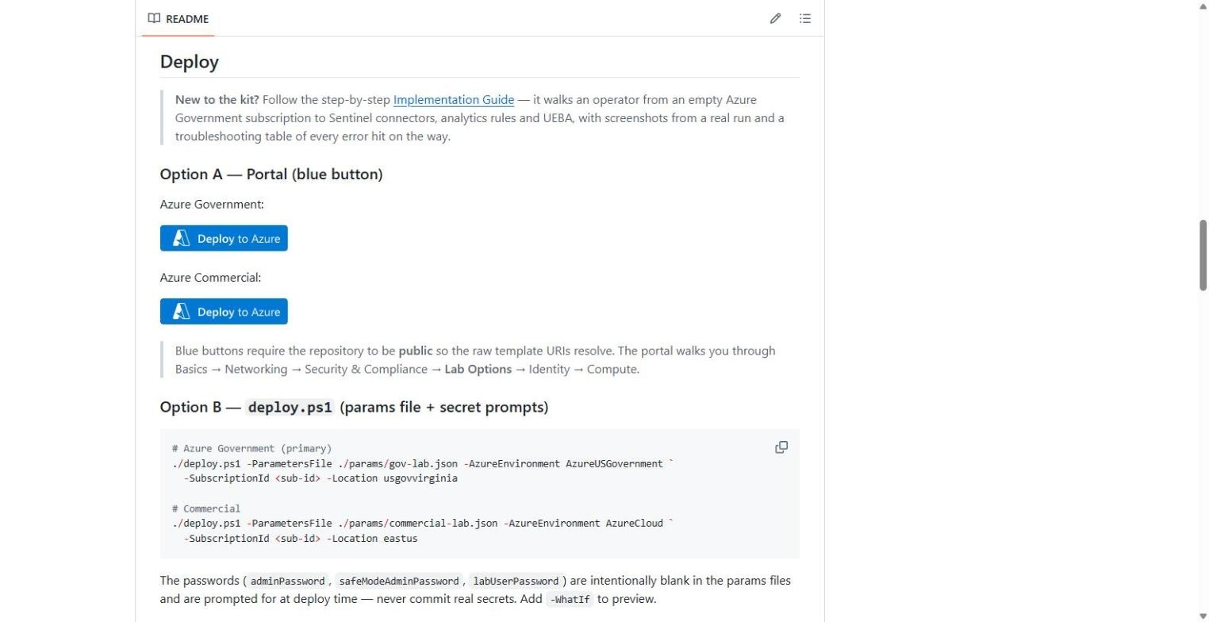
Figure: README deploy buttons
The form is cloud-aware: for any region that is not usgov* / usdod* it shows the full Commercial Defender plan list (App Service and APIs included), uses the portal's live VM size picker, and derives the .com cloud endpoints for the firewall rules, Intune, MDE and Arc.
GitHub's raw-file CDN caches main for up to five minutes. If you have just pushed a change and the form still shows the old one, replace main in both URLs of the button link with the commit hash.

4.2 Basics
Pick the subscription first (the form defaults to the first one in the tenant — check it), then the region from step 2.4, then the naming inputs. The resource prefix is derived from identifier + environment + region + workload: mca / dev / seclab / sec in West US 2 produce resource groups mca-dev-usw2-hub-rg-network, mca-dev-usw2-seclab-rg-network, …; the Resource Prefix lab names the VMs. The identifier accepts 1–3 characters only.
Fill Basics completely before the other tabs and do not come back to it: changing the region or subscription later resets the Compute tab's image and size selections.
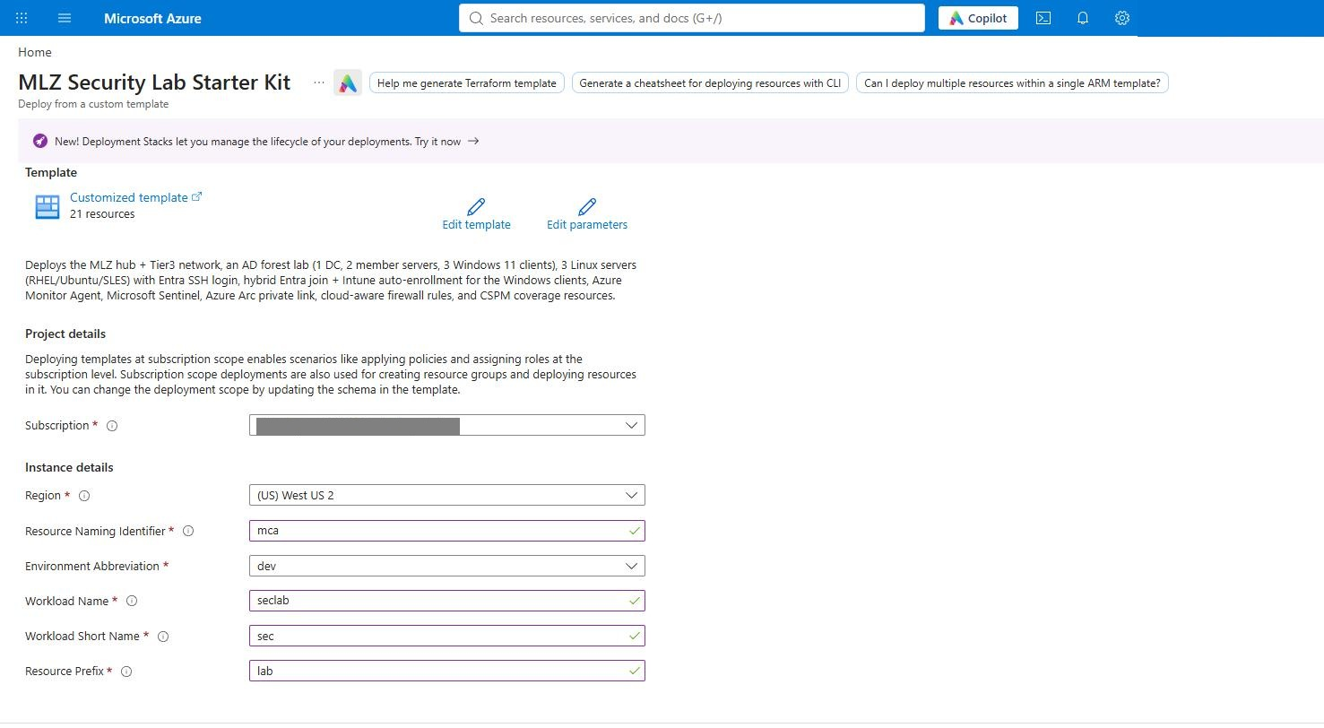
Figure: Basics filled

4.3 Networking
Leave Bastion on. The Tier-3 VNet is 10.60.0.0/24; set the subnet to 10.60.0.0/25 so the 10.60.0.128/28 resolver subnet can be added later without re-addressing. Domain controller IP 10.60.0.10.
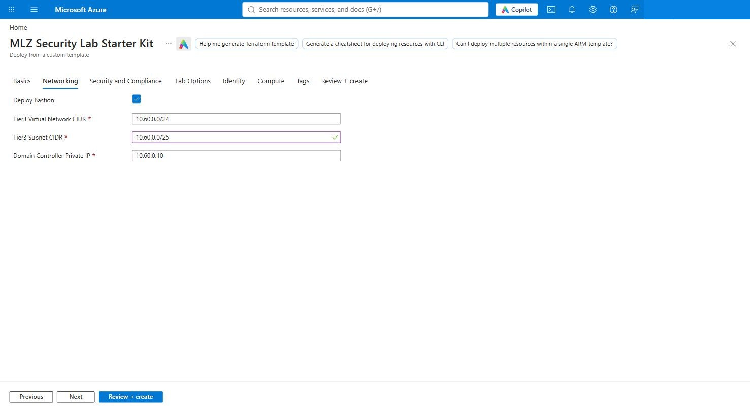
Figure: Networking

4.4 Security and Compliance
Enter the security contact e-mail, then enable the Defender for Cloud base plan and the plans you want. This guide turned on everything the form offers except APIs: CSPM, Servers (P2), Storage, SQL, Containers, App Service (Commercial only), Key Vault, Resource Manager, open-source relational databases, Cosmos DB. Each plan is billed separately. The template creates the plans one at a time — Commercial rejects concurrent plan updates (troubleshooting #49) — so they appear in the deployment list one after another over the first two minutes.
Policy: check Apply MLZ built-in policy set first (the NIST box is greyed out until it is on), then NIST SP 800-53 Rev. 5; keep Microsoft cloud security benchmark (default on). All initiatives are assigned in audit-only mode. Enable Send Activity Log to Log Analytics and Microsoft Sentinel with a new workspace named law-mca-lab.
CSPM coverage samples: SQL, Key Vault and App Service on; API Management off (adds ~45 minutes and ~$50/month).
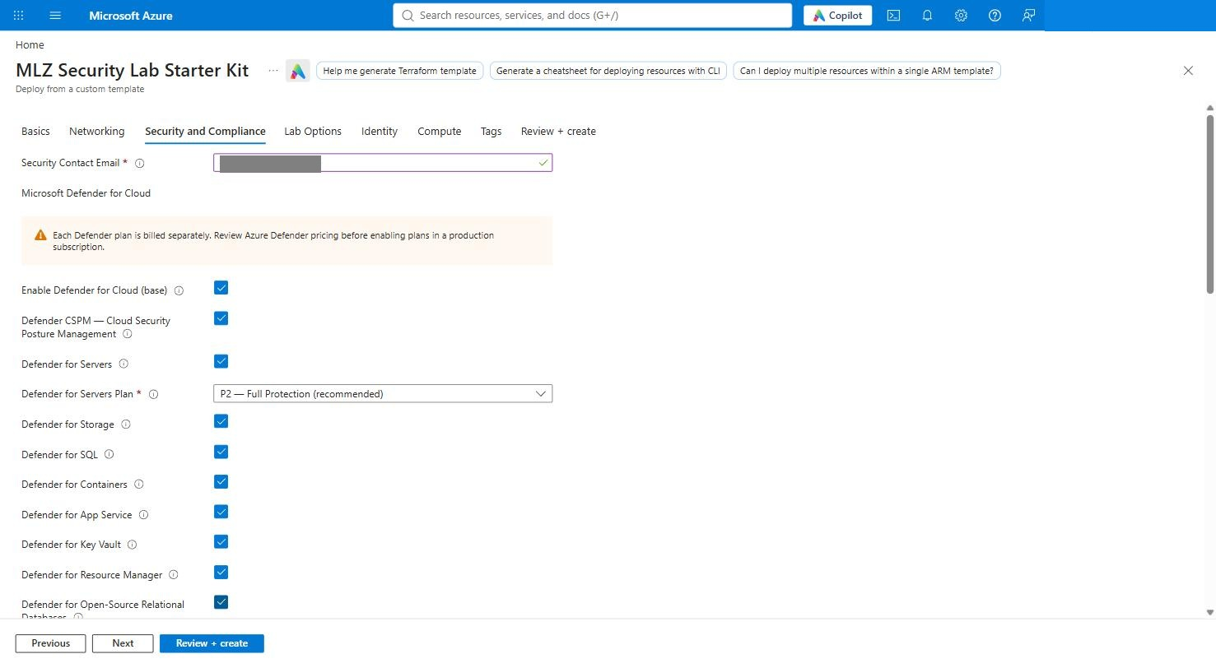
Figure: Defender plans (Commercial list)
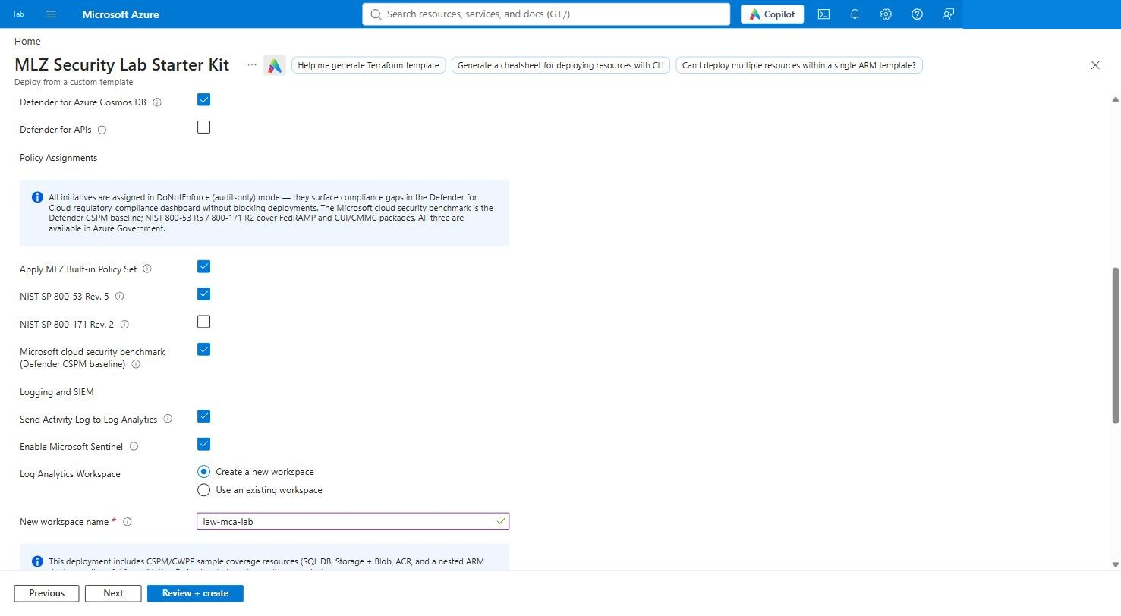
Figure: Policy, Activity Log, Sentinel workspace, samples

4.5 Lab Options
Enter the verified UPN suffix (contoso.onmicrosoft.com) and the lab user name. Keep the three Linux servers, the lab firewall rules, the AzureCloud service-tag allowance and Enable all matching built-in Sentinel analytics rules + UEBA on. Leave Run the Sentinel content enablement inline off — section 5 runs it from Cloud Shell, where you can watch it. Turn on Azure Arc Private Link Scope; leave the DNS resolver off.
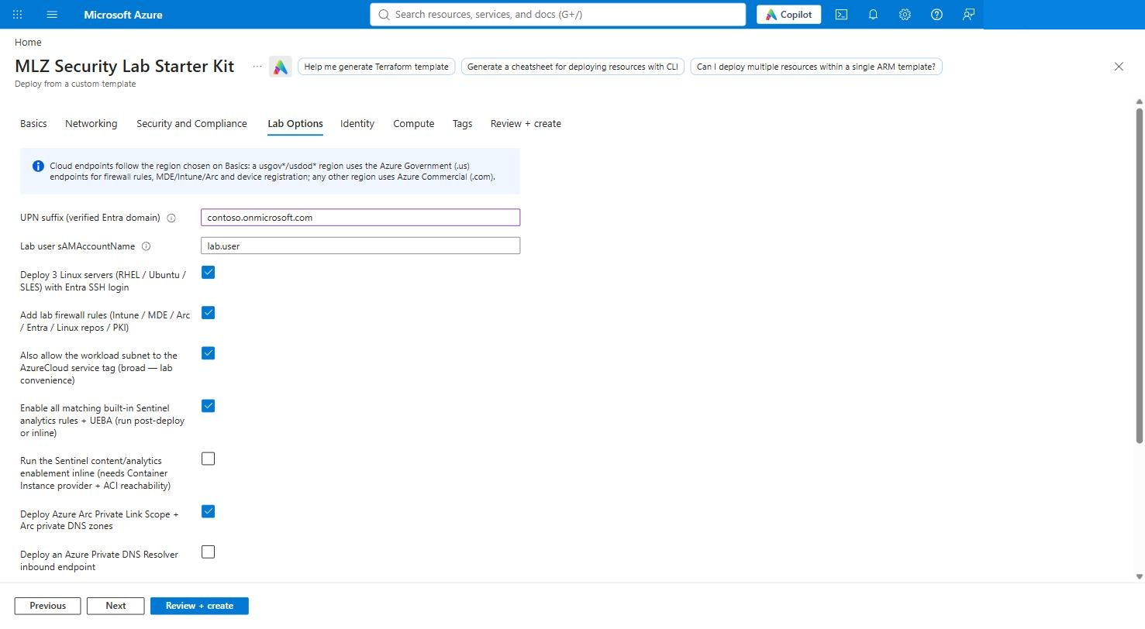
Figure: Lab Options filled

4.6 Identity
Admin username, the admin and DSRM passwords, the optional lab user password, AD domain and NetBIOS name, and the Entra group object ID from step 3.1. Keep Assign Virtual Machine Administrator Login role checked. Type `CORP` into the NetBIOS field — it shows CORP as a placeholder, and Review + create fails with The value must not be empty if you leave it.
Which account signs in where:
VM | Account | Password
lab-dc01 | labadmin@corp.contoso.lab — the DC's local admin becomes the domain admin at promotion | Admin password
lab-ms01, lab-ms02, lab-cl01–03 | labadmin@corp.contoso.lab (Domain Admins); local .\labadmin also exists | Admin password
lab-rhel01, lab-ubu01, lab-sles01 | labadmin (local), or your Entra account through Bastion Microsoft Entra ID | Admin password / Entra sign-in
Clients, as a normal user | lab.user@corp.contoso.lab or lab.user@contoso.onmicrosoft.com | Lab user password
AD recovery mode | — | DSRM password

If you leave the lab user password blank, the user is created with a random password; reset it on the DC with Set-ADAccountPassword lab.user -Reset -NewPassword (Read-Host -AsSecureString).
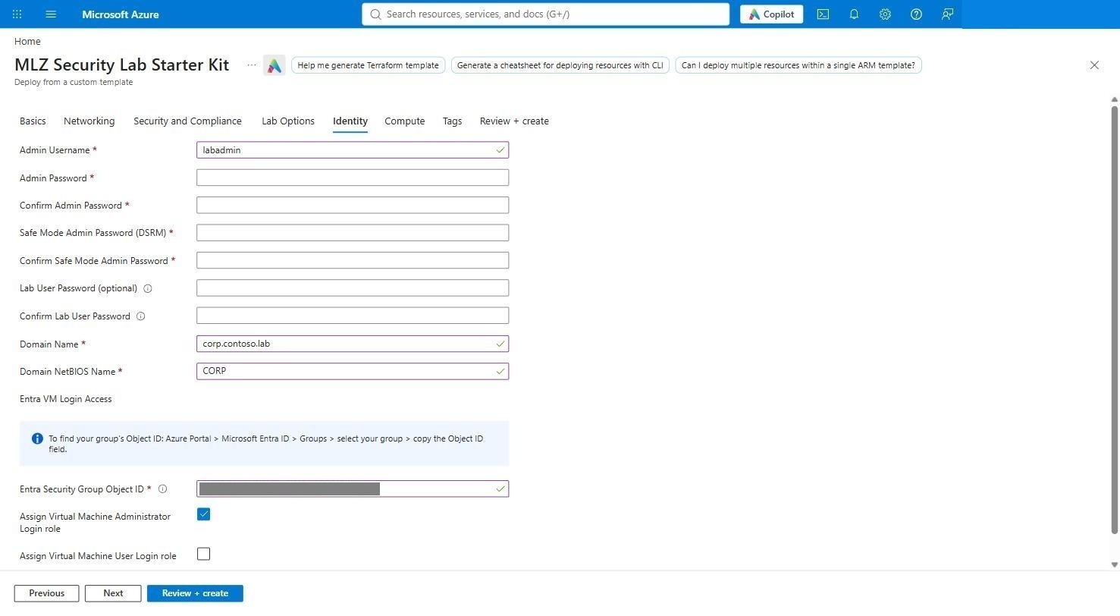
Figure: Identity filled

4.7 Compute
Server image Windows Server 2022 Gen2, client image Windows 11 → Enterprise 24H2 (pick the offer, then the SKU), and the VM sizes. On Commercial the three size fields are the portal's own size picker: it lists only the sizes this subscription can deploy in the region chosen on Basics and pre-selects the first available one (Standard_D2as_v7 where offered — exactly what step 2.4 found). If the pre-selected size is what you want, there is nothing to click. To change it: Change size → search the name → expand the series → select the row → Select.
The Linux picker can stay greyed out (Change size disabled) for a few seconds after the tab opens while the portal resolves the image; wait, or leave the tab and come back.
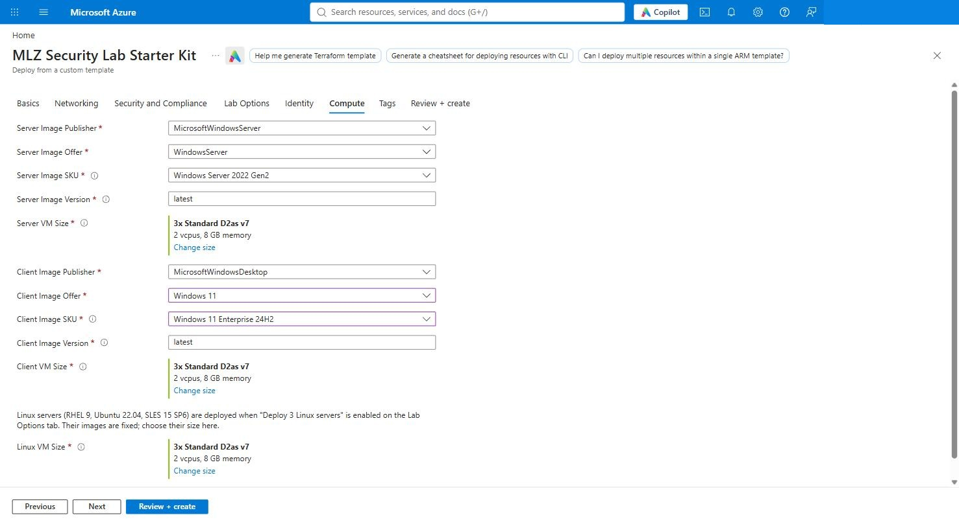
Figure: Compute filled, three pickers on D2as_v7
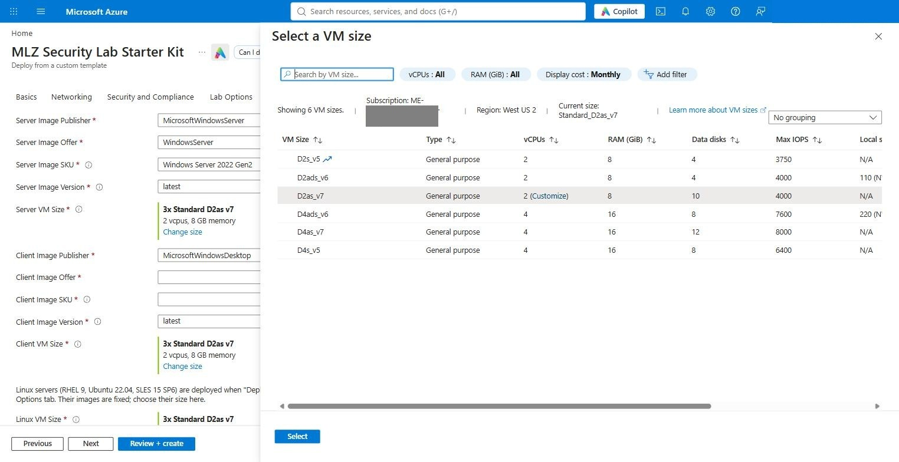
Figure: The size picker: six lab sizes, D2as_v7 pre-selected

4.8 Review + create
Validation runs the whole subscription-scope template. When it passes, check the parameter summary (region, sizes, workspace name, UPN suffix) and click Create. (If it fails with Required information is missing or not valid and the Identity tab carries a red mark, a password field is empty or the two copies differ.)

4.9 Watch the deployment
The top-level deployment is CustomDeployment-<timestamp>. It fans out into nested deployments: the Defender plans and policy assignments at subscription scope, deploy-mlz-core (hub), deploy-tier3, deploy-cspm-coverage, deploy-ad-entra-vms (DC promotion, joins, Linux), deploy-security-lab (workspace, DCRs, Sentinel onboarding) and deploy-arc-pls.
Timing on the successful Commercial run (West US 2):
Phase | Duration | Notes
Defender plans + policy assignments | 3 min | 10 plans, sequential
MLZ core (hub firewall Premium, spokes, Bastion, monitoring, diagnostics) | ≈ 32 min | firewall ≈ 12 min, Bastion ≈ 10 min
Tier-3 spoke + CSPM coverage | ≈ 2 min | after the core
VM module (DC promotion, 5 joins, 3 Linux with Entra SSH + AMA, every extension Succeeded) | 12 min 38 s
security-lab (workspace, DCRs, Sentinel onboarding) | 31 s
Arc private link scope | 1 min 46 s
Total | 52 min 26 s | the two failed attempts before it (section 8) took 40 and 45 min to fail

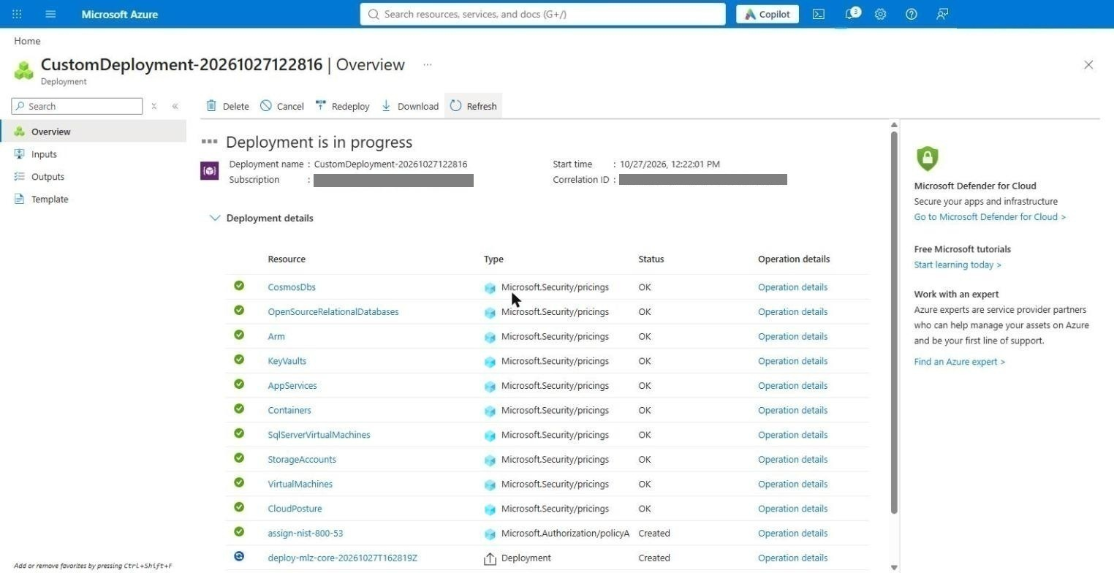
Figure: Deployment in progress
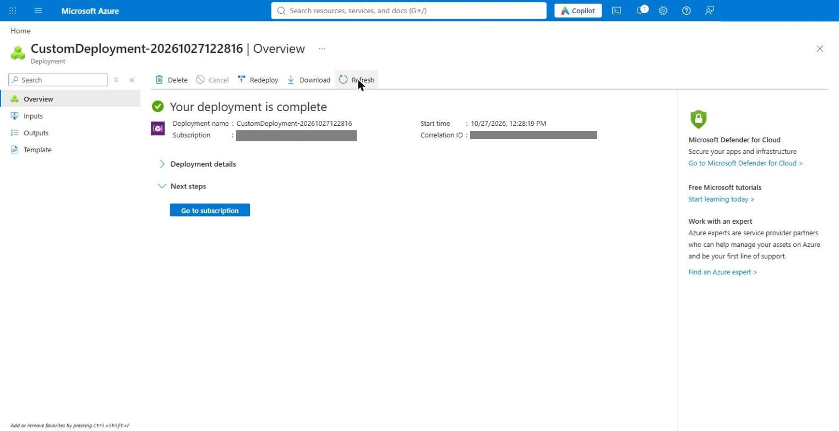
Figure: Deployment succeeded
A quick way to follow it from Cloud Shell:
D=CustomDeployment-<timestamp>
az deployment sub list --query "[?properties.provisioningState=='Running'].name" -o tsv
az deployment group list -g mca-dev-usw2-seclab-rg-network --query "[?properties.provisioningState!='Succeeded'].{n:name,s:properties.provisioningState}" -o table
If a nested deployment fails, open its Error details. For a resource that ended in a failed provisioning state (a firewall with InternalServerError, a VM with OSProvisioningTimedOut) do not use Redeploy — it reuses the faulted instance. Tear down with destroy.ps1 (section 7), fix the cause (section 8) and deploy again; a clean run is about 55 minutes.

5. Post-deploy — Sentinel content, connectors, analytics rules, UEBA
The template onboards the workspace to Sentinel and creates the data collection rules; the Content Hub solutions, the analytics rules, UEBA, the Defender XDR connector and the tenant-level log routing are done by templates/scripts/Post-Deploy.ps1, run from Cloud Shell under your own (Global Administrator) sign-in. On Commercial every script takes `-Cloud Global`.

5.1 Clone the kit in Cloud Shell and run the orchestrator
Cloud Shell toolbar → Switch to PowerShell (a pwsh started from the Bash shell is not signed in to Azure — #53), then:
git clone -q https://github.com/lee-aguilar-msft/Azure-MLZStarterKit-Security.git ~/kit
cd ~/kit/templates/scripts
./Post-Deploy.ps1 -Cloud Global -SubscriptionId <subscription-id> `
-ResourceGroupName mca-dev-usw2-seclab-rg-network -WorkspaceName law-mca-lab -EnableXdrConnector `
*>&1 | Tee-Object -FilePath ~/postdeploy.log
The script needs Global Administrator or Security Administrator on the tenant for the UEBA step (activate it through PIM first — #56); everything else works with Owner on the subscription. It is idempotent: re-run it after fixing anything and it skips what is already in place.
Results of the Commercial run (about 35 minutes, most of it the analytics-rule loop):
Step | Result
Content Hub solutions | 7 installed: Microsoft Entra ID, Azure Activity, Microsoft Defender XDR, Windows Security Events, Syslog, Threat Intelligence (TAXII), UEBA Essentials
Analytics rules from the installed templates | 263 enabled, 35 rejected by the API (templates that need a data type the lab does not have — the script lists them)
Defender XDR connector | created (-EnableXdrConnector), incidents and alerts flow into Sentinel
Entra ID sign-in / audit logs and Azure Activity | routed to the workspace (tenant-level diagnostic setting + subscription Activity log)
UEBA | enabled — entity provider Entra ID; data sources AuditLogs, AzureActivity, SigninLogs, SecurityEvent
Defender for Cloud plans | re-asserted: Servers P2, Storage (DefenderForStorageV2), Key Vault, Resource Manager, App Service, SQL on VMs, open-source DBs, Cosmos DB, Containers, CSPM; the plans the lab does not need stay Free

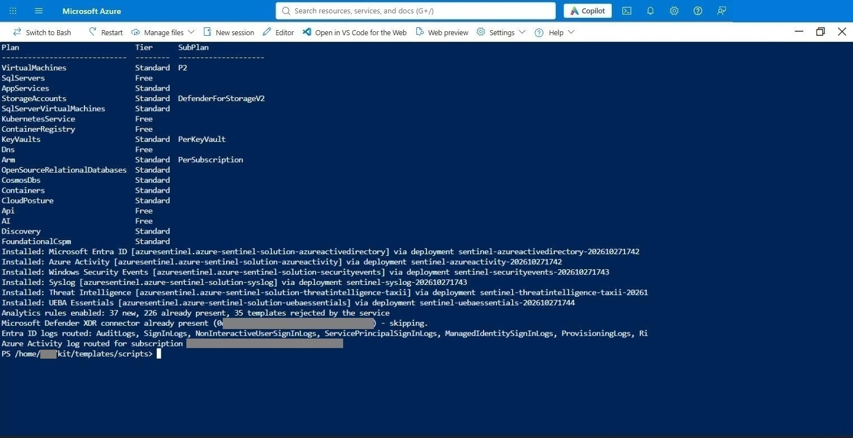
Figure: Post-deploy summary

5.2 Identity, hybrid join, Intune and Defender for Endpoint
Most of the identity chain is automated. The deployment and two scripts do everything except two clicks that have no API (Entra Connect's wizard needs your MFA; the Defender portal's Intune connection toggle has no Graph endpoint).
What | Done by | When
AD forest, OUs (Users, Workstations, MemberServers), lab user, groups | template (configure-forest-baseline) | deployment
Member servers and clients moved into their OUs | template (configure-forest-baseline) | deployment
GPO <OU root> - Intune Auto-Enrollment (MDM auto-enrollment with the signed-in user's Entra credential) linked to Workstations | template | deployment
GPO <OU root> - Security Auditing and Logging | template | deployment
Hybrid-join Service Connection Point (tenant ID + domain) written to AD | template — tenant ID comes from the subscription | deployment
Gate: deployment fails if any of the above is missing (verify-forest) | template | deployment
TLS 1.2 prerequisites and C:\LabTools\README-EntraConnect.txt on lab-ms01 | template (configure-member) | deployment
Clients retry hybrid join every 30 min and Intune enrollment hourly, for 7 days | template (scheduled tasks LAB-HybridJoin-Retry, LAB-IntuneAutoEnroll-Retry) | deployment
Intune MDM user scope (the .com MDM URLs are already the Commercial defaults) | Prepare-Tenant.ps1 -Cloud Global | once per tenant
Microsoft Intune Enrollment service principal; CA exclusion report (or -ExcludeIntuneEnrollmentFromCa) | Prepare-Tenant.ps1 | once per tenant
Intune ↔ MDE connector (Windows), dynamic device group, EDR policy Auto from connector | Prepare-Tenant.ps1 -ConfigureMde | once per tenant
License for the synced lab user | Prepare-Tenant.ps1 -LabUserUpn | after the first sync
Defender portal → Intune connection = On | you (one toggle) | once per tenant
Entra Connect wizard on lab-ms01 | you (needs MFA) | once per deployment

#### 5.2.1 Prerequisites
- A break-glass Global Administrator (cloud-only, excluded from all Conditional Access policies).
- Licences: Entra ID P1/P2 + Intune for the lab user (hybrid join's PRT and MDM auto-enrollment are licensed features), and Defender for Endpoint P2 for the clients (included in Microsoft 365 E5; the servers are covered by Defender for Servers P2).
- Your account: Global Administrator (or Intune Administrator + Cloud Application Administrator + License Administrator + Security Administrator) for Prepare-Tenant.ps1 and the Defender toggle, and Hybrid Identity Administrator (or Global Administrator) for the Entra Connect wizard.
- Optional: the MDE onboarding package — only if you want a GPO-based onboarding path in addition to Intune. Defender portal (security.microsoft.com) → Settings → Endpoints → Onboarding → Windows 10 and 11 → Group Policy → Download; paste the OnboardingInfo JSON into MDE onboarding blob on the Lab Options tab before deploying.
#### 5.2.2 Run Prepare-Tenant.ps1 (MDM scope, enrollment app, MDE connector)
On a Commercial tenant the Intune Automatic Enrollment page already carries the .com MDM URLs, so the script only has to set the MDM user scope and the MDE pieces. From the same Cloud Shell session:
cd ~/kit/templates/scripts
./Prepare-Tenant.ps1 -Cloud Global -ConfigureMde
It signs in to Microsoft Graph with a device code (open https://microsoft.com/devicelogin, enter the code, complete MFA — you have 15 minutes; the kit runs the device-code grant itself because the Graph SDK gives up after 120 seconds, troubleshooting #54), then:
Setting | Value written (Commercial)
MDM user scope | All (or Some with -MdmScopeGroupId <group id>)
MDM URLs | left at the .com defaults (enrollment.manage.microsoft.com, portal.manage.microsoft.com)
Microsoft Intune Enrollment (d4ebce55-015a-49b5-a083-c84d1797ae8c) | service principal created if missing; CA policies that would block it are listed
Intune ↔ MDE connector | Windows devices On
Device group LAB-Intune-Devices | dynamic: device.displayName -startsWith "lab-cl"
EDR policy LAB - Defender for Endpoint onboarding (auto from connector) | Endpoint security → EDR, onboarding package Auto from connector, assigned to the group

A successful run ends with PREPARE-TENANT-STATUS: Success. On the test tenant the run (after the Defender toggle was already on) came back with the MDM scope moved from none to All, the enrollment service principal created, the MDE connector windowsEnabled=True partnerState=enabled, the device group and the EDR policy created, and three warnings for the Microsoft-managed Conditional Access policies … for Microsoft partners and vendors: they target all users and all apps without excluding Intune Enrollment. On this tenant they did block the silent enrollment (#59), so the fix was a second pass with the exclusion switch:
./Prepare-Tenant.ps1 -Cloud Global -SkipMdm -ExcludeIntuneEnrollmentFromCa
Run it as the tenant admin (it changes Conditional Access, so it is a deliberate, separate step).
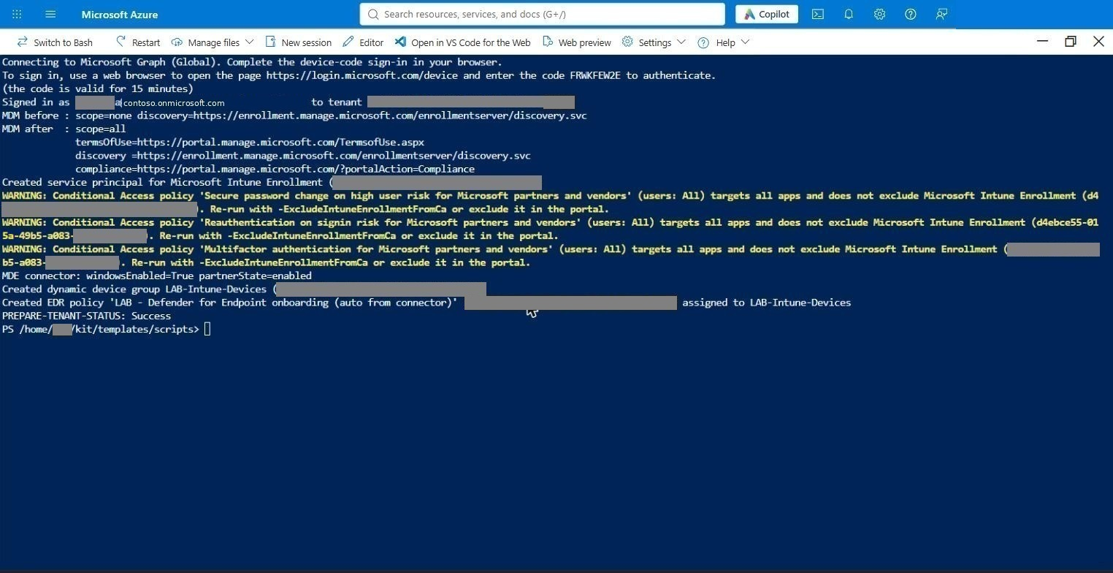
Figure: Prepare-Tenant success
The one Defender toggle. Microsoft Defender portal (security.microsoft.com) → Settings → Endpoints → Advanced features → Microsoft Intune connection = On → Save. Do it before or after the script; the EDR policy starts onboarding as soon as both sides are on.
#### 5.2.3 Entra Connect on lab-ms01 (the one wizard)
- lab-ms01 → Connect → Bastion → authentication type VM password; username labadmin@corp.contoso.lab (UPN form — Bastion rejects CORP\labadmin) and its password.
- In Edge on lab-ms01 open https://entra.microsoft.com → Identity → Hybrid management → Microsoft Entra Connect → Connect Sync → Download Connect Sync Agent, and run it (notes in C:\LabTools\README-EntraConnect.txt). In the wizard choose Customize (not Express).
- Sign-in method Password Hash Synchronization.
- Connect to Entra ID with a Hybrid Identity Administrator / Global Administrator (MFA prompt).
- Add the forest corp.contoso.lab with CORP\labadmin and let the wizard create the AD DS Connector account.
- Domain/OU filtering: the lab root OU only (it contains the lab user and the Workstations OU with lab-cl01–lab-cl03).
- Device options: nothing required — the deployment already wrote the hybrid-join SCP.
- Finish with Start the synchronization process when configuration completes.
After the first sync, license the synced user (PowerShell Cloud Shell, new device code):
./Prepare-Tenant.ps1 -Cloud Global -SkipMdm -LabUserUpn lab.user@contoso.onmicrosoft.com
Check that the sync has landed first — from the same shell, with the Cloud Shell's own Graph token:
$t = (Get-AzAccessToken -ResourceTypeName MSGraph).Token
if ($t -is [securestring]) { $t = [Net.NetworkCredential]::new('', $t).Password }
$h = @{ Authorization = "Bearer $t" }
(Invoke-RestMethod -Headers $h -Uri 'https://graph.microsoft.com/v1.0/organization?$select=onPremisesSyncEnabled,onPremisesLastSyncDateTime').value
(Invoke-RestMethod -Headers $h -Uri 'https://graph.microsoft.com/v1.0/users?$filter=onPremisesSyncEnabled eq true&$select=userPrincipalName,onPremisesLastSyncDateTime').value
onPremisesSyncEnabled = True with a recent onPremisesLastSyncDateTime, and lab.user / lab.churn in the user list, means the wizard's initial sync is done. On the test tenant the licensing pass assigned the first available Intune-capable SKU it found (MICROSOFT_365_E7_NO_TEAMS) and ended with PREPARE-TENANT-STATUS: Success.
#### 5.2.4 Hybrid join, Intune enrollment and MDE onboarding
What happens on its own. Every client has a LAB-HybridJoin-Retry task (runs dsregcmd /join as SYSTEM every 30 minutes for 7 days) and Entra Connect runs a delta sync every 30 minutes, so within about an hour of the first sync each client becomes Microsoft Entra hybrid joined. Once the lab user has signed in to a client, the Intune auto-enrollment task enrolls it, and the EDR policy then onboards it to Defender for Endpoint.
What you must do once:
- The lab user's UPN must use a verified tenant domain — the UPN suffix Lab Option (contoso.onmicrosoft.com).
- The lab user registers MFA once: sign in at https://myaccount.microsoft.com (or aka.ms/mfasetup) and add the Authenticator app.
- Sign in once to each client as the lab user (Bastion → VM password → lab.user@contoso.onmicrosoft.com) so the user gets a Primary Refresh Token — after the licence (5.2.3) and the Conditional Access exclusion (5.2.2) are in place. The kit uses user-credential auto-enrollment, the only kind Microsoft supports for ordinary hybrid-joined PCs (device-credential enrollment is limited to co-management, Autopilot and Azure Virtual Desktop), so every client needs this one sign-in; a password sign-in is enough, no MFA prompt.
To speed up the hybrid join, trigger the join on the clients from the same PowerShell Cloud Shell (Run command executes as SYSTEM on the VM, which is what dsregcmd /join wants):
$rg = 'mca-dev-usw2-seclab-rg-network'
foreach ($vm in 'lab-cl01','lab-cl02','lab-cl03') {
$r = Invoke-AzVMRunCommand -ResourceGroupName $rg -VMName $vm -CommandId RunPowerShellScript `
-ScriptString 'dsregcmd /join | Out-Null; Start-Sleep 20; (dsregcmd /status) -match "AzureAdJoined|DomainJoined|TenantId|AzureAdPrt"'
"== $vm"; $r.Value[0].Message
}
If a client answers AzureAdJoined : NO, its computer object has not reached Entra yet: on lab-ms01 run Start-ADSyncSyncCycle -PolicyType Delta, wait 2–3 minutes and run the block again (C:\LabTools\Invoke-HybridJoinCycle.ps1 on lab-ms01 automates that loop over WinRM).
On the test tenant no second pass was needed — the wizard's initial sync had already carried the Workstations OU up, the first dsregcmd /join completed on all three clients, and the Entra device list showed them (and lab-ms02) as trustType = ServerAd within four minutes. (Entra also reported isManaged = True on them at that point; do not read that as an Intune enrollment — Intune listed no devices until the user-credential enrollment below went through.)
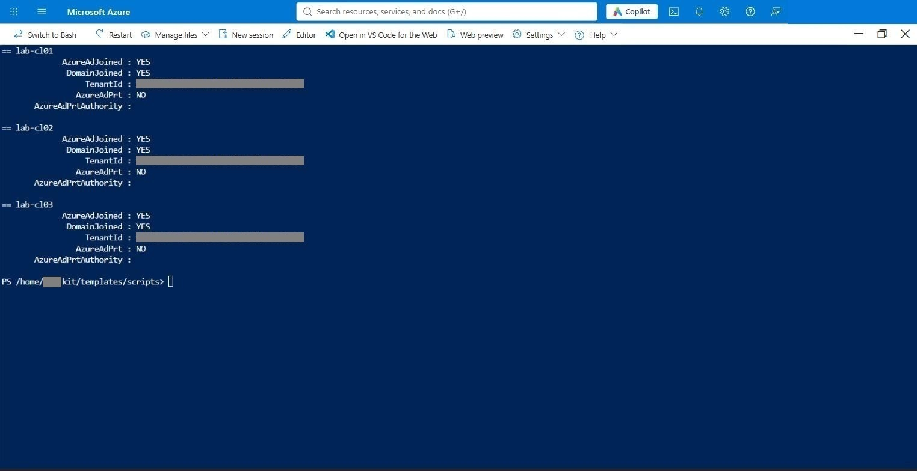
Figure: Hybrid join status from Run command
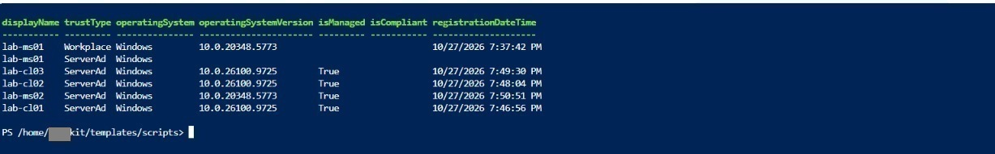
Figure: Entra devices: hybrid joined and Intune-managed
What happened on the test tenant. After the lab user's first sign-in on lab-cl01 the client's own enrollment task kept failing with 0x8018002A until the Conditional Access exclusion (5.2.2, #59) was in place; the next run of the task enrolled the device, Intune listed it as Managed by Intune, Corporate, Compliant and the Defender device inventory showed lab-cl01.corp.contoso.lab Onboarded, managed by Intune, two minutes later. lab-cl02 and lab-cl03 followed with no further action after one lab-user sign-in each (MDM enrollment state 1 on both). The servers were already onboarded through Defender for Servers.
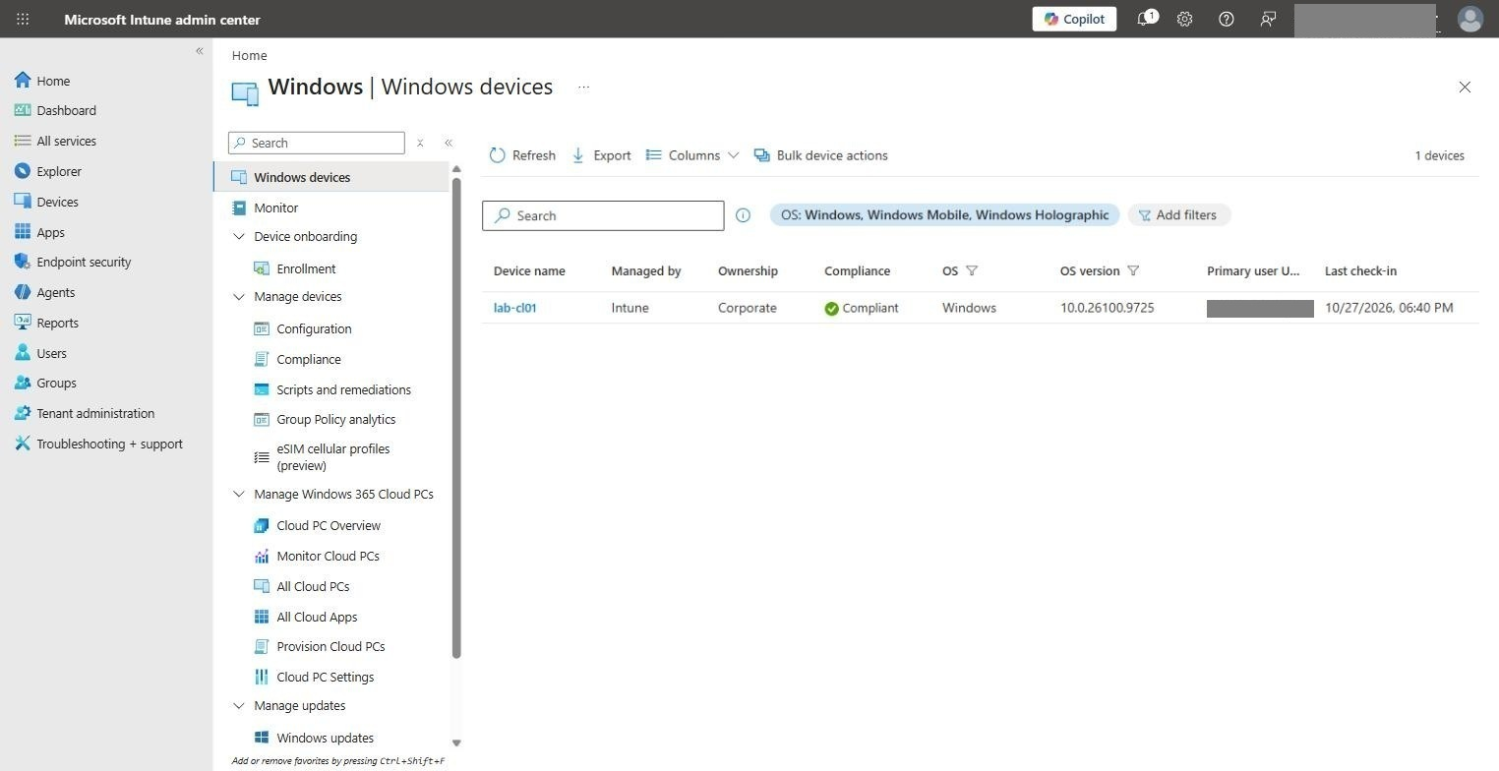
Figure: Intune: lab-cl01 managed and compliant
Check | Where | Expected
Hybrid join | dsregcmd /status on the client | AzureAdJoined : YES, DomainJoined : YES, AzureAdPrt : YES; MdmUrl https://enrollment.manage.microsoft.com/…, AzureAdPrtAuthority https://login.microsoftonline.com/<tenant>
Entra device | Entra admin center → Devices → All devices | lab-cl01–03, join type Microsoft Entra hybrid joined
Intune | Intune admin center (intune.microsoft.com) → Devices → Windows | lab-cl01–03, managed by Intune, compliance evaluated
MDE | Defender portal → Assets → Devices | lab-cl01–03 Onboarded (plus the servers, via Defender for Servers)

If automatic enrollment does not happen, enroll the client by hand — signed in as the lab user, Win+R → ms-device-enrollment:?mode=mdm&username=lab.user@contoso.onmicrosoft.com → sign in (MFA). Settings → Accounts → Access work or school then shows the MDM connection; Info → Sync pushes the first check-in. About 15 minutes later the client is listed in Intune and the EDR policy has onboarded it to Defender for Endpoint.
#### 5.2.5 Signing in through Bastion — which credentials work where
VM | Bastion authentication type | Credentials
Linux (lab-rhel01, lab-ubu01, lab-sles01) | Microsoft Entra ID (SSH) | your Entra account — member of the step 3.1 group
Windows (DC, member servers, clients) | VM password (RDP) | labadmin@corp.contoso.lab, or a domain user such as lab.user@corp.contoso.lab — UPN form; Bastion does not accept CORP\user
Windows client, after hybrid join | VM password (RDP) | lab.user@contoso.onmicrosoft.com — the synced user's UPN and password (same in AD and Entra through password hash sync)

Bastion's Microsoft Entra ID option for Windows RDP only works for Entra-joined VMs, which conflicts with the AD domain join and hybrid join this lab is built on, so the kit does not install it on Windows. Linux Entra SSH is unaffected.

5.3 Data hydration — automatic, nothing to run
Identical to the Government guide: the LAB-Hydration task on every Windows VM and the lab-hydrate timer on every Linux VM start during the deployment and run hourly. Section 6.5 shows how to confirm it is reaching the workspace.

6. Verify

6.1 Virtual machines
Portal → Virtual machines: nine VMs, all Running in West US 2 on Standard_D2as_v7 — lab-dc01, lab-ms01, lab-ms02, lab-cl01–lab-cl03 (Windows) and lab-rhel01, lab-sles01, lab-ubu01 (Linux). None has a public IP: everything is reached through Bastion in the hub.
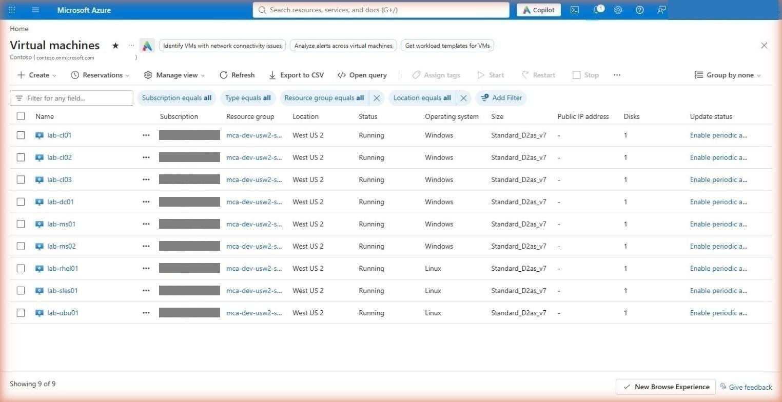
Figure: Virtual machines
The resource group mca-dev-usw2-seclab-rg-network holds the same inventory as on Government (VMs, NICs, disks, workspace, DCE/DCRs, Arc Private Link Scope with its private endpoint and the three privatelink.*.azure.com DNS zones, the CSPM samples and the content-script identity).

6.2 Microsoft Sentinel
On Commercial the workspace is onboarded to the unified Defender portal, so some Sentinel pages in the Azure portal are only a redirect:
Page | Where it lives now
Analytics, Incidents, Hunting, Workbooks, Entity behavior | still in the Azure portal (Microsoft Sentinel → the workspace)
Content hub, Data connectors | security.microsoft.com → Microsoft Sentinel → Content management / Configuration — the Azure page just shows This page has been moved to the Defender portal

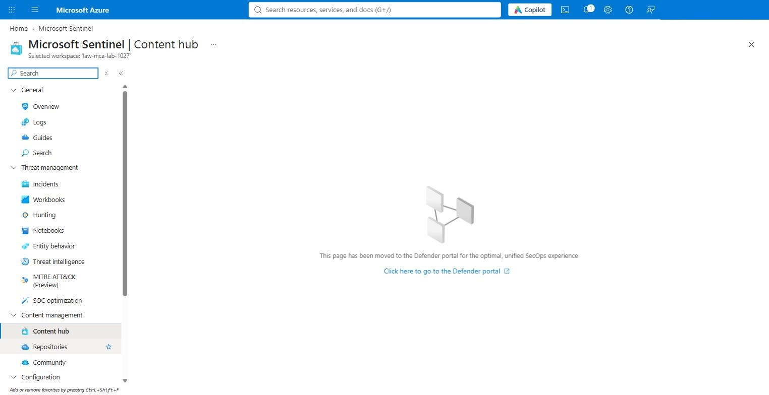
Figure: Content hub moved to the Defender portal
Analytics — 263 active rules (75 High, 158 Medium, 30 Low) created from the installed solutions' templates:
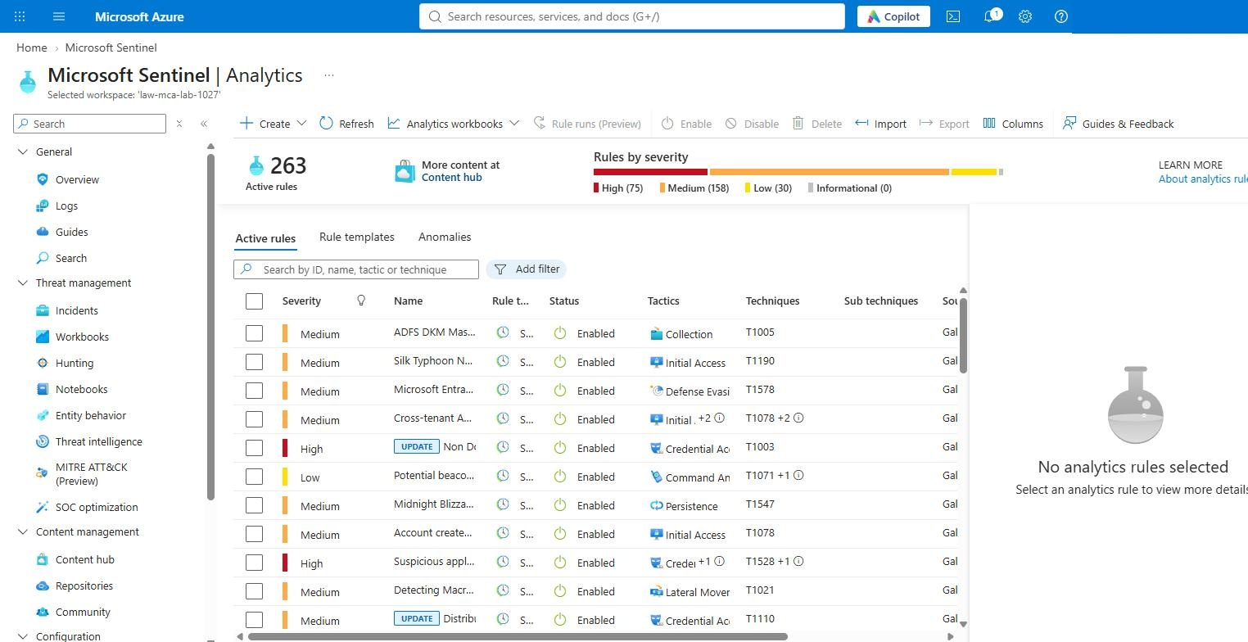
Figure: Analytics rules
Content hub (Defender portal) — 7 solutions Installed: Microsoft Entra ID, Azure Activity, Microsoft Defender XDR, Windows Security Events, Syslog, Threat Intelligence, UEBA Essentials.
Data connectors (Defender portal) — Windows Security Events via AMA and Syslog via AMA connect as soon as the VMs report; Microsoft Defender XDR is connected by the post-deploy script; Microsoft Entra ID and Azure Activity show Connected 10–30 minutes after step 5, when their first logs arrive.
Entity behavior — Settings show UEBA On, Microsoft Entra ID as the entity provider, with Audit Logs, Azure Activity, Signin Logs and Security Events selected.

6.3 Bastion sign-in
Linux: open lab-ubu01 → Connect → Bastion → Microsoft Entra ID → Connect; members of the step 3.1 group get an administrator SSH session with their Entra account. Windows: VM password with labadmin@corp.contoso.lab (see 5.2.5 for why Entra RDP does not apply to domain-joined VMs).

6.4 Defender for Cloud plans
Microsoft Defender for Cloud → Environment settings → the subscription → Defender plans. Expected on Commercial: Defender CSPM, Servers (Plan 2), Databases (SQL on VMs, open-source relational, Cosmos DB), Storage, Containers, Key Vault, Resource Manager and — unlike Government — App Service all On; SQL servers on machines' sibling Azure SQL, Kubernetes/Container registry (legacy), DNS, APIs and AI are left Off. The post-deploy script prints the same table from the API:
az security pricing list --query "value[?pricingTier=='Standard'].{plan:name,subPlan:subPlan}" -o table
Figure: Post-deploy summary: plans, solutions, rules, routing

6.5 Data hydration reaching the workspace
About an hour after the deployment, run this in the Sentinel workspace (Logs):
union
(SecurityEvent | where EventID in (4728, 4729) and MemberName has "churn"
| summarize Events = count(), Last = max(TimeGenerated) by Signal = "AD group churn (4728/4729)", Computer),
(SecurityEvent | where EventID in (4625, 4771) and TargetUserName has "churn"
| summarize Events = count(), Last = max(TimeGenerated) by Signal = "failed sign-in lab.churn", Computer),
(SecurityEvent | where EventID == 4688 and CommandLine has "nltest" and CommandLine has "dsgetdc"
| summarize Events = count(), Last = max(TimeGenerated) by Signal = "Windows user activity (nltest)", Computer),
(Syslog | where ProcessName == "lab-hydrate" or SyslogMessage has "lab-hydrate"
| summarize Events = count(), Last = max(TimeGenerated) by Signal = "Linux lab-hydrate", Computer)
| order by Signal asc, Computer asc
Expect one row per signal and computer with Last within the past hour: group churn and failed sign-ins on the domain controller, user activity on every Windows VM, lab-hydrate on the three Linux servers. The same query runs from a Bash Cloud Shell without opening the Logs blade (save it as hydration.kql first; the CLI asks once to install its log-analytics extension — answer Y):
WS=$(az monitor log-analytics workspace show -g mca-dev-usw2-seclab-rg-network -n law-mca-lab --query customerId -o tsv)
az monitor log-analytics query -w $WS --analytics-query "$(cat hydration.kql)" -t P1D -o table
Ten hours after the Commercial deployment all four signals were present on every machine: 7 group-churn and 14 failed-sign-in events on the DC, 5–7 nltest activity events on each of the six Windows VMs and 18 lab-hydrate entries on each Linux server — hourly, as designed (the Government lab had needed troubleshooting #46/#47 for the last two signals; the fixes carried over).
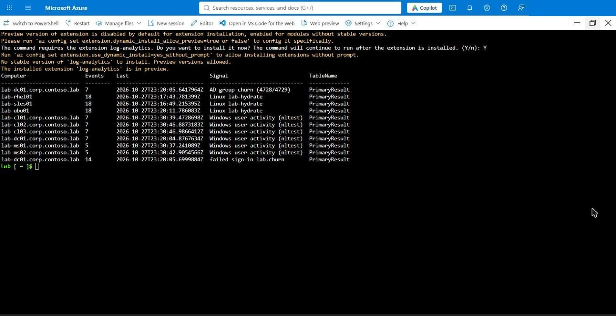
Figure: Hydration check from Cloud Shell

7. Teardown
destroy.ps1 discovers every resource group by the naming prefix and deletes them in parallel. It also force-deletes and purges the Log Analytics workspaces, purges the Key Vaults, removes the policy assignments, resets the Defender plans, and deletes the NSG flow logs the MLZ hub left in NetworkWatcherRG.
curl -sO https://raw.githubusercontent.com/lee-aguilar-msft/Azure-MLZStarterKit-Security/main/destroy.ps1
pwsh -NoProfile -File ./destroy.ps1 -SubscriptionId <subscription-id> -Identifier mca -EnvironmentAbbreviation dev \
-Location westus2 -RemoveDefenderPlans -RemovePolicyAssignments -Force
Expect 20–40 minutes (the Azure Firewall and Bastion are the slow deletes; a firewall in a Failed state takes longest). Check afterwards that Resource groups shows none with the mca-dev-usw2- prefix. Run it from a Cloud Shell session you keep active — or in the background with nohup pwsh … > ~/destroy.log 2>&1 & and tail ~/destroy.log — if the shell drops mid-run, simply run it again; it is safe to repeat.
The tenant-level Entra ID diagnostic setting (sentinel-lab) is not removed by destroy.ps1: delete it under Microsoft Entra ID → Diagnostic settings if you are not redeploying.

8. Troubleshooting — every Commercial error hit while writing this guide
The Government guide's troubleshooting table (#1–#47) applies to the kit as a whole; these are the entries that only showed up on Azure Commercial. All fixes are on main.
# | Where | Error | Cause | Fix (in the kit)
48 | MLZ core | Subscription … is not registered for feature Microsoft.Network/AllowBringYourOwnPublicIpAddress required to carry out the requested operation on a firewall or Bastion public IP | The MLZ public IPs are plain Standard IPs; the requirement comes from the subscription (Microsoft-internal subscriptions, or a policy that adds IP tags to public IPs) | Register the feature (section 2.3), wait for Registered, az provider register -n Microsoft.Network --wait, then tear down and redeploy. If it stays Pending, the subscription needs approval through a support request (days) — use another subscription meanwhile
49 | Deployment | Four of the eleven Microsoft.Security/pricings resources end in Conflict — Another update operation is in progress. Please retry in a few minutes | Commercial's Defender pricing API serialises plan changes per subscription; the template created all plans in parallel (Government tolerated it) | build/gen_solution.py chains the plans with dependsOn so ARM creates them one at a time (a dependency on a toggled-off plan is still satisfied)
50 | MLZ core | Azure Firewall Premium ends in provisioning state Failed with InternalServerError: An error occurred.; the rule collection group then fails with Put on Firewall Policy … Failed with 1 faulted referenced firewalls and the whole core deployment fails | Platform-side fault while the firewall was being built (nothing in the template; East US, Premium tier); the next run built the same firewall in 12 minutes | Tear down (destroy.ps1) and redeploy. Do not try to repair a firewall in Failed state in place — Redeploy on the failed deployment reuses the faulted instance
51 | Compute tab / VM module | Every D-series size shows NotAvailableForSubscription in East US (or the deployment fails with SkuNotAvailable) although the quota is 100 vCPU per family | Region-level VM restrictions on the subscription (common on internal, trial and new subscriptions); the earlier hard-coded Commercial size list offered sizes regardless | Commercial size pickers replaced with the portal's size selector limited to six lab-tested sizes (D2as_v7 / D4as_v7 / D2s_v5 / D4s_v5 / D2ads_v6 / D4ads_v6); it lists only what the subscription can deploy in the region and pre-selects the first one. Check regions with the SKU API (section 2.4) and deploy where the list is not empty — West US 2 on the test subscription
52 | VM module | lab-sles01 ends in OSProvisioningTimedOut (OS provisioning … did not finish in the allotted time), VM running, agent Not Ready, every other VM fine | The SUSE:sles-15-sp5:gen2 latest image (version 2026.10.19, published after SLES 15 SP5 left general support) never completes provisioning — reproduced on D2as_v7, D2s_v5, with and without Trusted Launch; sles-15-sp6 provisions in 2 min on the same size | Kit moved to SUSE:sles-15-sp6:gen2; all lab VMs now have managed boot diagnostics so the serial log is readable next time (a VM in a failed provisioning state cannot have diagnostics enabled afterwards)
53 | Post-Deploy (Cloud Shell) | Post-Deploy.ps1 run as pwsh -File … from a Bash Cloud Shell stops at Run Connect-AzAccount to login | A pwsh child process started from Bash has no Az context; only the PowerShell-mode Cloud Shell signs Az in automatically | Switch the shell to PowerShell (toolbar → Switch to PowerShell) and run ./Post-Deploy.ps1 … directly (section 5.1)
54 | Prepare-Tenant | Authentication timed out after 120 seconds due to inactivity. Please try again. right after the device-code prompt | Connect-MgGraph -UseDeviceCode cancels after a hard-coded 120 s (-ClientTimeout does not change it) — not enough to open the page, enter the code and pass MFA | Kit does the device-code grant itself (RFC 8628) with the SDK's own public client and hands the token to Connect-MgGraph -AccessToken; the code is now valid for the full 15 minutes
55 | Post-Deploy | Sentinel solution install fails with RequestContentTooLarge — The request content size exceeds the maximum size of 4 MB (Defender XDR solution) | New-AzResourceGroupDeployment re-serialises the template pretty-printed; the Commercial XDR package then exceeds ARM's 4 MB inline limit | Enable-SentinelContent.ps1 submits the deployment compact through REST (3.6 MB) and, above the cap, stages the template in the workspace storage account and deploys it from a link
56 | Post-Deploy | UEBA settings PUT returns 401 User does not have required admin roles although the account is Owner of the subscription | Sentinel's UEBA/EntityAnalytics settings require Global Administrator or Security Administrator on the tenant, not an Azure RBAC role | Activate the role (PIM) and re-run Post-Deploy.ps1 (it skips what is already done)
57 | Post-Deploy | Access token expires half-way through the analytics-rule loop (ExpiredAuthenticationToken) | A Cloud Shell token lives ~1 h; the Commercial catalogue has 300 rule templates to install | Enable-SentinelContent.ps1 refreshes its ARM token every 20 min and on any 401
58 | Verify | Defender for Servers reads Free after a deployment that set it to P2 | Commercial Defender plan API occasionally reverts the Servers plan when sub-plans are set in the same pass (also Government #23) | Post-Deploy.ps1 re-asserts every plan and prints the final table; re-run it if the portal shows Off
59 | Client / Intune | Client is hybrid joined, the user has a PRT, but Intune lists no devices; on the client the task Schedule created by enrollment client for automatically enrolling in MDM from AAD ends with 0x8018002A (2149056554) and LAB-IntuneAutoEnroll-Retry fails the same way | Conditional Access requires MFA for the enrollment: the Microsoft-managed … for Microsoft partners and vendors policies in the test tenant apply to all users and all cloud apps and do not exclude Microsoft Intune Enrollment; a background enrollment cannot answer an MFA prompt | ./Prepare-Tenant.ps1 -Cloud Global -SkipMdm -ExcludeIntuneEnrollmentFromCa adds the app exclusion to every enabled all-apps policy (or add it by hand: policy → Target resources → Exclude → Microsoft Intune Enrollment), then re-trigger the client task — Start-ScheduledTask -TaskPath '\Microsoft\Windows\EnterpriseMgmt\<guid>\' -TaskName 'Schedule created by enrollment client for automatically enrolling in MDM from AAD' via Run command
— | Sentinel | Content hub and Data connectors open the Defender portal (security.microsoft.com) instead of a blade in the Azure portal | Commercial Sentinel workspaces onboarded to the unified Defender portal move those pages there | Use the Defender portal links; the kit's post-deploy does not need them
— | Identity tab | Validation failed. Required information is missing or not valid → Domain NetBIOS Name: The value must not be empty | The field shows CORP as a placeholder, not a value | Type CORP (section 4.6)
— | Compute tab | Linux Change size link greyed out, no size shown | Portal race while the size selector resolves the Linux image on first load | Wait a few seconds, or switch tabs and come back; re-selecting the region on Basics also re-triggers it (but resets the other Compute fields)

