MLZ Security Lab Starter Kit — Implementation Guide (Azure Government)
Repository: github.com/lee-aguilar-msft/Azure-MLZStarterKit-Security

Contents

Step-by-step, from an empty Azure Government (GCC High) subscription to a running MLZ Security Lab with Microsoft Sentinel connectors, analytics rules and UEBA enabled — using only the Azure portal, Cloud Shell and the Deploy to Azure Gov button in the repository README.
Everything in this guide was performed for real in the Lab Subscription subscription (usgovvirginia, tenant contoso.onmicrosoft.us) on 14–15 October 2026. The screenshots are from those runs. Three deployment runs were needed to shake out the defects listed in section 8; every fix is on main, so a fresh run of the kit follows the clean path described here.
Repository: https://github.com/lee-aguilar-msft/Azure-MLZStarterKit-Security
Section | What you do | Time
1. Before you start | Gather the inputs the form asks for | 10 min
2. Subscription prerequisites | Register features and providers, confirm SKU and quota | 15 min (+ wait for EncryptionAtHost)
3. Entra ID prerequisites | VM-login security group, break-glass account | 10 min
4. Deploy from the portal | Blue button → 7 form tabs → Review + create | 15 min form, 60–90 min deploy
5. Post-deploy | Post-Deploy.ps1: Sentinel content, rules, UEBA, connectors; identity checklist | 20 min
6. Verify | Resource group, Sentinel, Defender plans | 15 min
7. Teardown | destroy.ps1 (includes NetworkWatcherRG flow logs and workspace purge) | 20–40 min
8. Troubleshooting | Every error hit while writing this guide, with its fix | —

What gets deployed
The kit sits on a standard Mission Landing Zone: the upstream mlz.json module builds the network hub and the T0/T1/T2 spokes, and the kit adds a Tier 3 security-lab spoke plus the subscription- and tenant-level security layer.
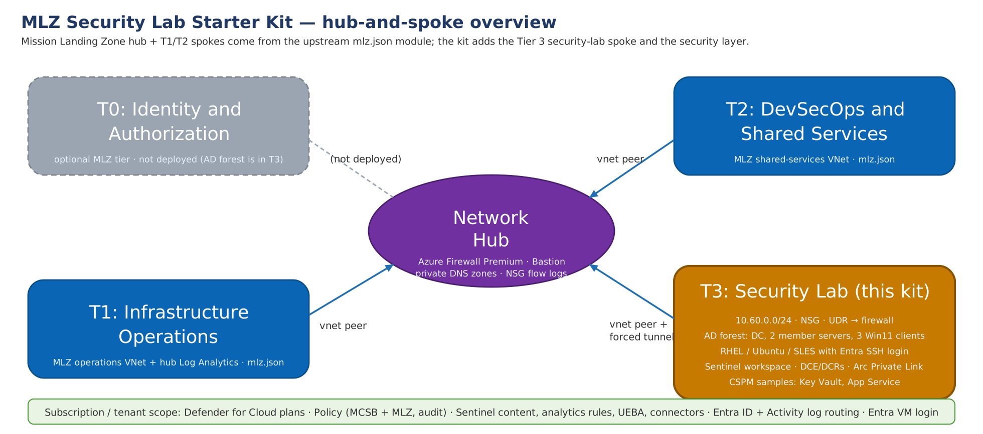
Figure: Hub-and-spoke overview
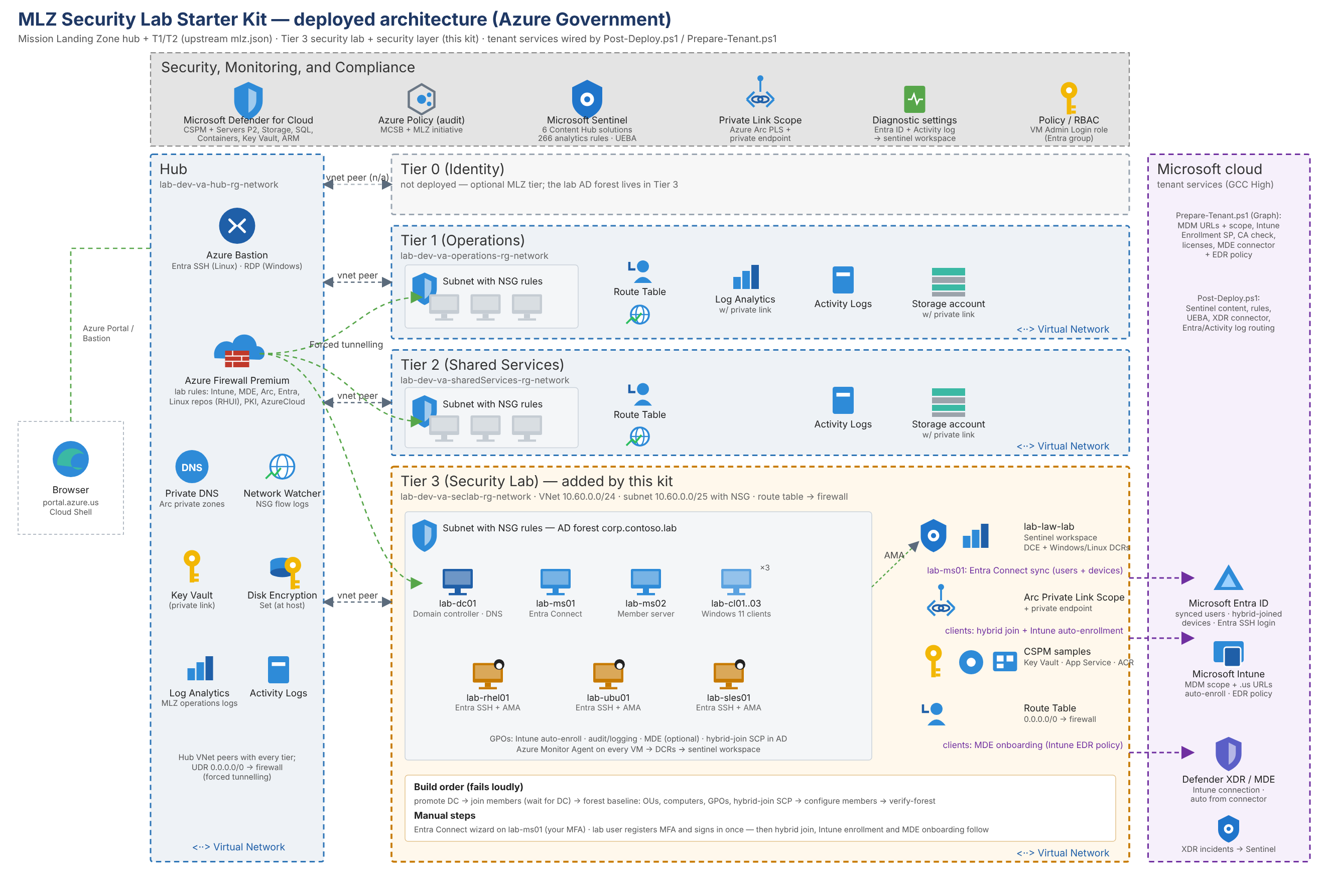
Figure: What the deployment creates
Layer | Resources
MLZ hub | Hub VNet, Azure Firewall (Premium) with the lab rule collection groups, Bastion, hub Log Analytics, NSG flow logs
Tier-3 workload | lab-dev-va-seclab-rg-network: VNet 10.60.0.0/24, NSG, route to the firewall
Identity | lab-dc01 (new forest corp.contoso.lab), lab-ms01 / lab-ms02 member servers, lab-cl01–lab-cl03 Windows 11 clients, all domain-joined; Entra VM login role for one security group
Linux | lab-rhel01, lab-ubu01, lab-sles01 with Entra SSH login and Azure Monitor Agent
Security | Sentinel workspace lab-law-lab, DCE + Windows/Linux data collection rules, Defender for Cloud plans (all plans offered in Azure Government), MLZ policy set + Microsoft cloud security benchmark, Arc Private Link Scope + private DNS zones, CSPM coverage samples (Key Vault, App Service)
Post-deploy | Sentinel Content Hub solutions, ~265 analytics rules, UEBA, Defender XDR connector, Entra ID + Azure Activity log routing
Data hydration | LAB-Hydration scheduled task on every Windows VM and a lab-hydrate systemd timer on every Linux VM: hourly benign user/admin activity so Sentinel and MDE have data to hunt over (section 5.3)

1. Before you start — inputs checklist
Collect these before opening the form; the portal form does not save progress if you navigate away.
Input | Form tab | Value used in this guide
Subscription | Basics | Lab Subscription (<subscription-id>)
Region | Basics | (US) USGov Virginia
Resource naming identifier / environment | Basics | lab / dev
Workload name / short name | Basics | seclab / lab
Security contact e-mail | Security and Compliance | a monitored tenant mailbox
New Sentinel workspace name | Security and Compliance | lab-law-lab
Verified Entra UPN suffix | Lab Options | contoso.onmicrosoft.us
Lab user sAMAccountName | Lab Options | lab.user
AD domain name / NetBIOS | Identity | corp.contoso.lab / CORP
Admin username + two passwords (admin, DSRM) | Identity | labadmin (passwords are typed by the operator only)
Entra security group object ID for VM login | Identity | <entra-group-object-id>
VM sizes | Compute | Standard_D2ads_v6 for servers, clients and Linux

Password rules: 12+ characters, 3 of 4 character classes, no part of the username. The same rules apply to the DSRM password. Nothing in this kit stores or echoes the passwords.
Roles you need: Owner on the subscription (the template assigns RBAC and Defender plans at subscription scope) and Global Administrator or Security Administrator in the tenant (UEBA and the Entra ID log routing in step 5 are tenant-level settings).
Licensing in the tenant (not deployed by the kit): Entra ID P1/P2 and Intune for auto-enrollment; Defender for Endpoint if you want the optional MDE onboarding package.

2. Subscription prerequisites

2.1 Sign in to the Azure Government portal and pick the subscription
Open https://portal.azure.us, sign in with the Owner account, open Subscriptions and confirm the subscription you will deploy into.
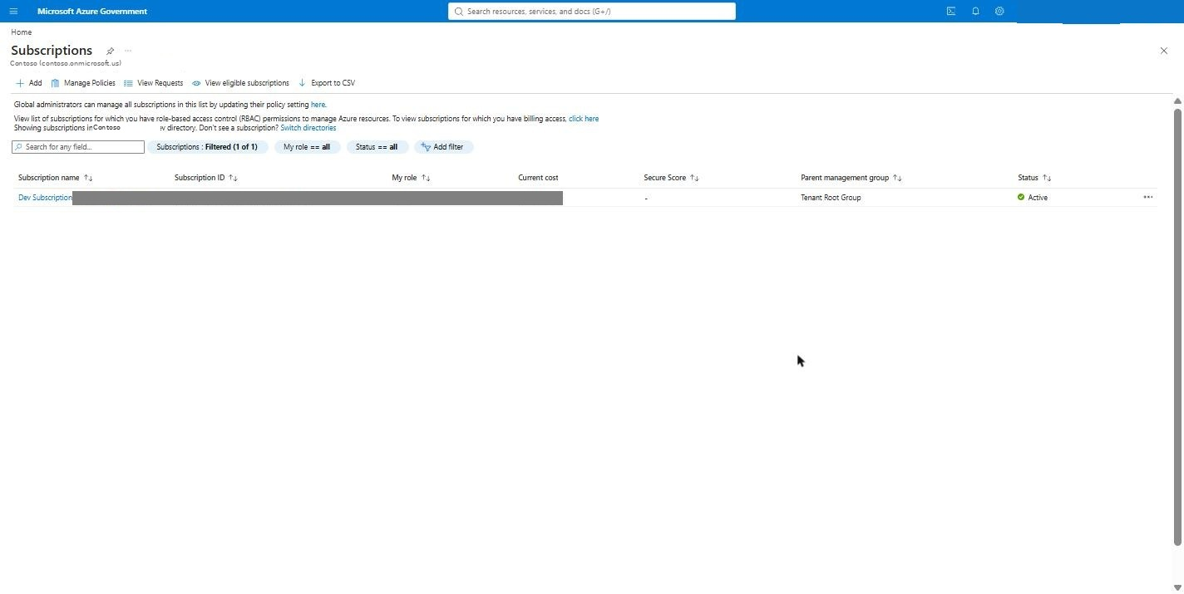
Figure: Subscriptions

2.2 Open Cloud Shell (PowerShell)
Click the Cloud Shell icon in the top bar. On first use choose PowerShell, pick the subscription, and select No storage account required — the session is ephemeral, which is fine: everything the guide runs in Cloud Shell is re-downloadable from the repository.
Figure: Cloud Shell welcome
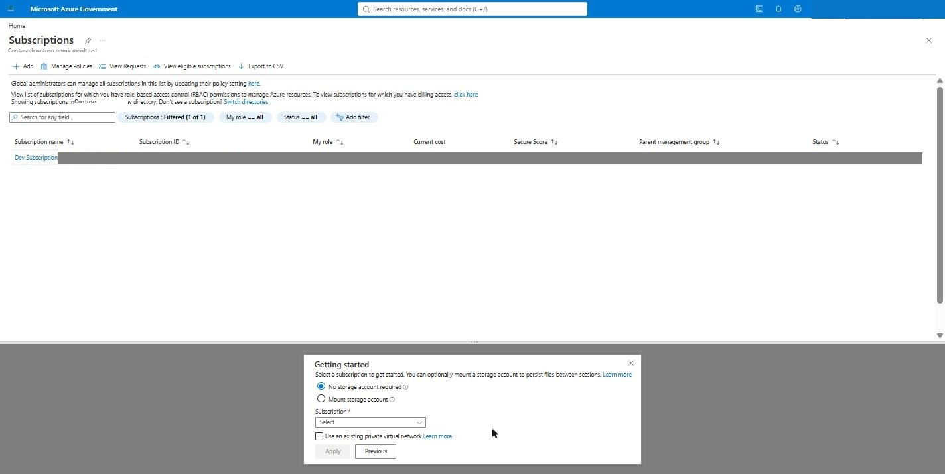
Figure: Cloud Shell getting started
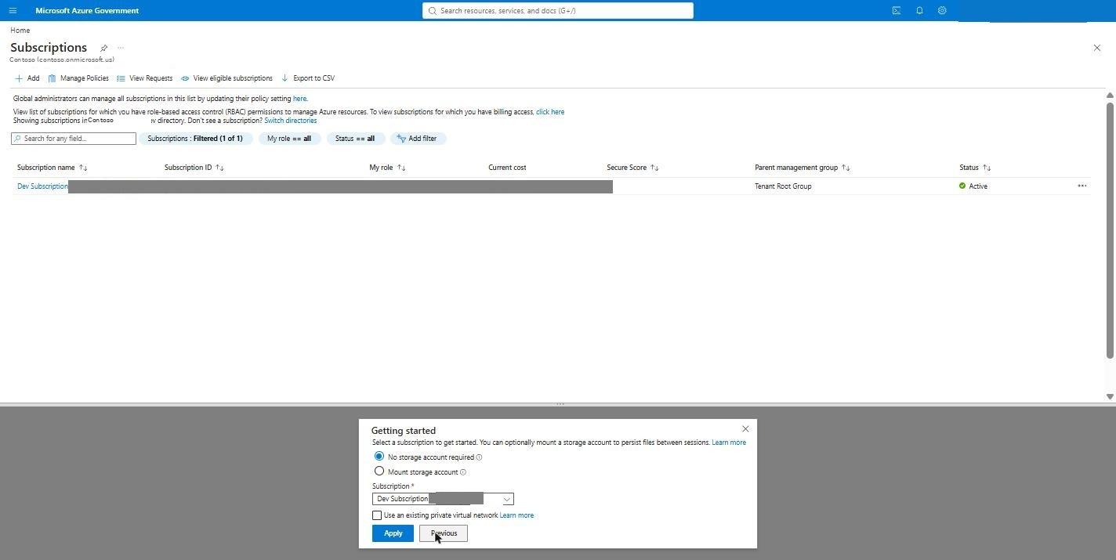
Figure: Cloud Shell subscription selected
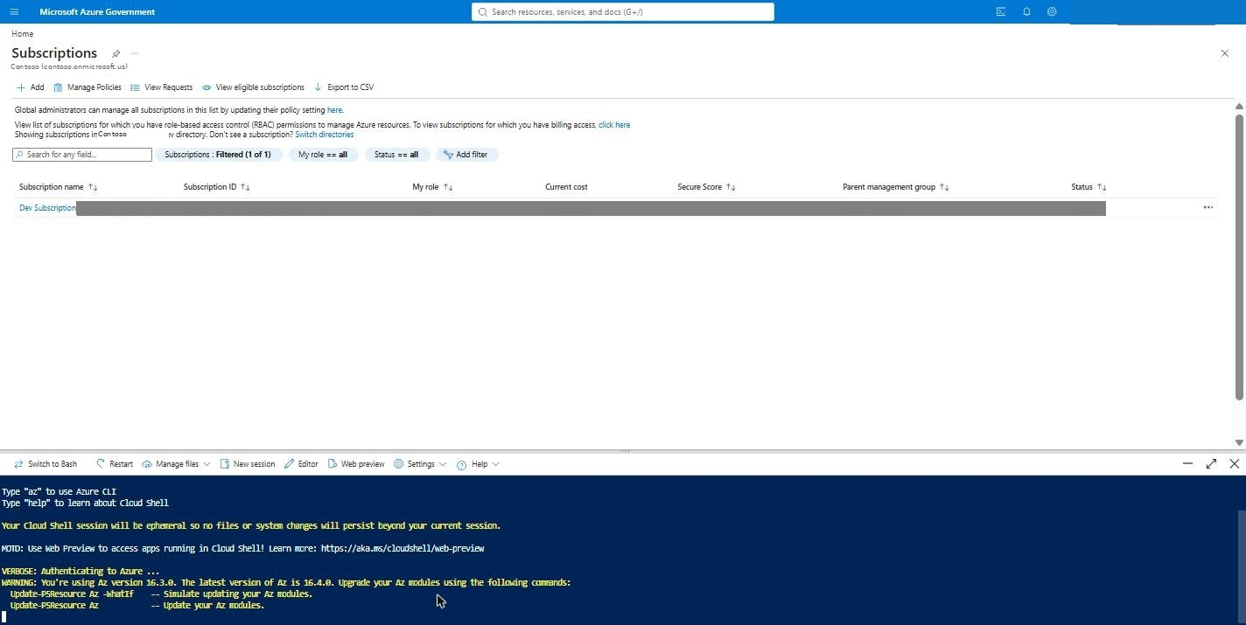
Figure: Cloud Shell ready
Cloud Shell in portal.azure.us disconnects after a few minutes of inactivity. If the pane shows Cloud Shell disconnected or connection could not be established, click Restart in its toolbar and re-run the git clone from step 5.1 — the home directory is not kept.

2.3 Register the features and resource providers
Paste the block below into Cloud Shell. It is idempotent — re-running it is harmless.
az account set --subscription <subscription-id>

# Encryption-at-host for the MLZ VMs (feature flag — takes a few minutes to flip to Registered)
az feature register --name EncryptionAtHost --namespace Microsoft.Compute
az provider register --namespace Microsoft.Compute

# Auto-shutdown schedules, Arc private link, DNS, Sentinel, Defender, policy, CSPM samples
az provider register --namespace Microsoft.DevTestLab
az provider register --namespace Microsoft.HybridCompute
az provider register --namespace Microsoft.Network
az provider register --namespace Microsoft.ContainerInstance
az provider register --namespace Microsoft.ApiManagement
az provider register --namespace Microsoft.Web
az provider register --namespace Microsoft.KeyVault
az provider register --namespace Microsoft.Security
az provider register --namespace Microsoft.OperationalInsights
az provider register --namespace Microsoft.SecurityInsights
az provider register --namespace Microsoft.PolicyInsights

# Poll until this prints "Registered"
az feature show --name EncryptionAtHost --namespace Microsoft.Compute --query "properties.state" -o tsv
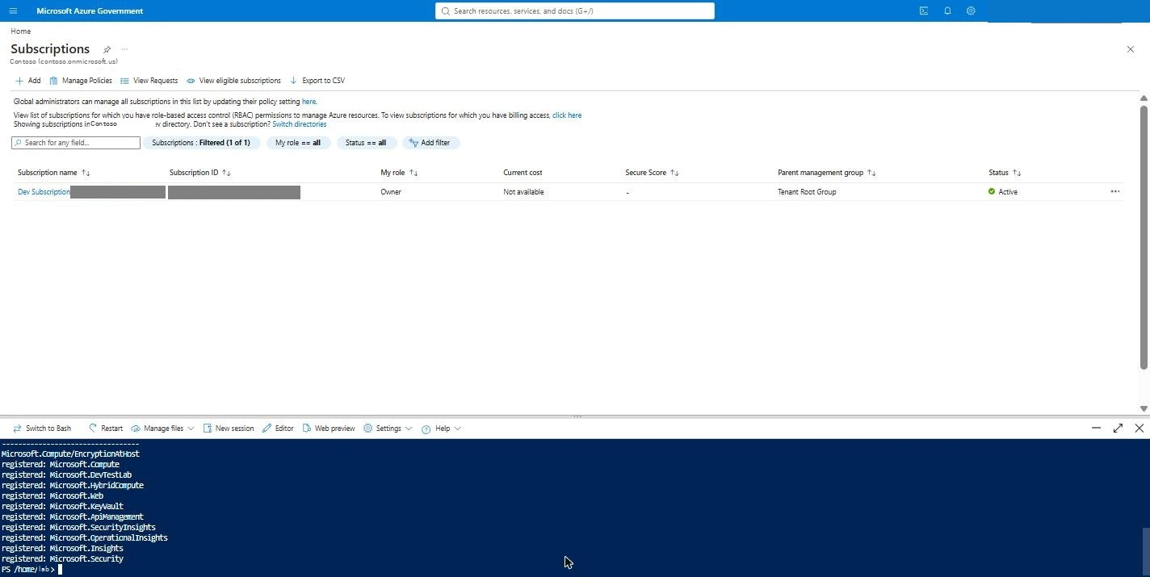
Figure: Register providers
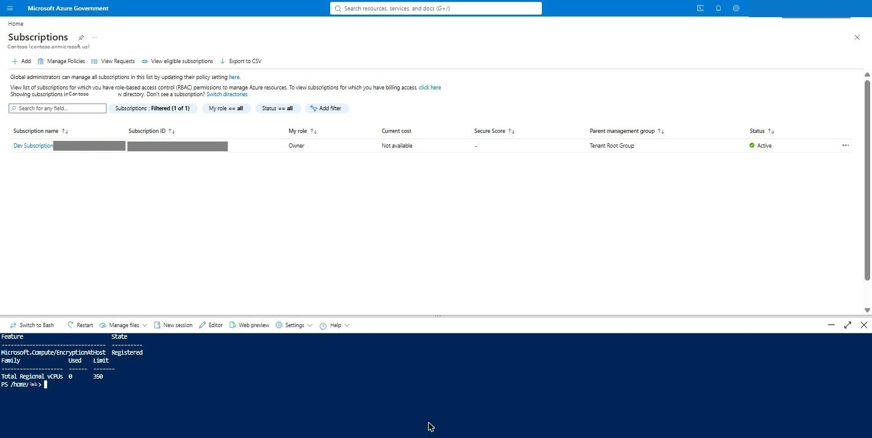
Figure: EncryptionAtHost registered
Azure Commercial only — public IP feature. Some Commercial subscriptions (Microsoft-internal ones, or any subscription with a policy that adds IP tags to public IPs) refuse the MLZ firewall and Bastion public IPs with not registered for feature Microsoft.Network/AllowBringYourOwnPublicIpAddress (troubleshooting #48). Register it up front; on most subscriptions it flips to Registered within minutes:
az feature register --namespace Microsoft.Network --name AllowBringYourOwnPublicIpAddress
az feature show --namespace Microsoft.Network --name AllowBringYourOwnPublicIpAddress --query "properties.state" -o tsv
az provider register --namespace Microsoft.Network

2.4 Confirm VM SKU availability and quota in the region
The lab deploys 6 Windows + 3 Linux VMs. Check the chosen size exists in the region and that the vCPU family quota can hold 18–36 vCPUs:
az vm list-skus -l usgovvirginia --size Standard_D2ads_v6 --output table
az vm list-usage -l usgovvirginia --query "[?contains(name.value,'DADSv6') || name.value=='cores']" -o table
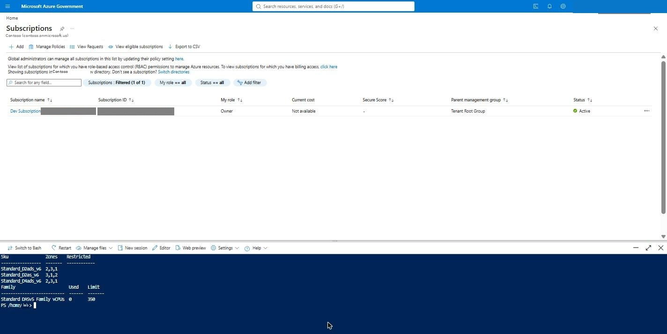
Figure: VM SKU availability
Azure Commercial — pick the region by what the subscription may deploy, not by habit. Commercial subscriptions (trial, internal, sponsorship, new pay-as-you-go) commonly have entire regions restricted for VM creation: on the test subscription used for this guide East US, Central US, West US and North Central US offered zero deployable VM sizes, East US 2 only a handful, and West US 2 everything. az vm list-skus hides this (it is slow and returns []); ask the SKU API directly and count the unrestricted sizes per region before choosing one:
SUB=$(az account show --query id -o tsv)
for l in eastus eastus2 westus2 westus3 southcentralus; do
az rest --method get --url "https://management.azure.com/subscriptions/$SUB/providers/Microsoft.Compute/skus?api-version=2021-07-01&\$filter=location%20eq%20%27$l%27" -o json > /tmp/s-$l.json
python3 -c "import json,sys;d=json.load(open('/tmp/s-'+sys.argv[1]+'.json'))['value'];vm=[s for s in d if s['resourceType']=='virtualMachines'];ok=[s['name'] for s in vm if not s.get('restrictions')];print(sys.argv[1],len(ok),'deployable sizes;','D2ads_v6' if 'Standard_D2ads_v6' in ok else '-')" $l
done
Deploy into a region that lists the size you want. The Compute tab's size pickers on Commercial use the portal's live size selector, so a size the subscription cannot deploy in the chosen region is simply not offered (troubleshooting #51).

3. Entra ID prerequisites

3.1 Security group for Entra VM login
The kit assigns Virtual Machine Administrator Login to one Entra security group on every VM, so members can sign in with Entra credentials through Bastion (RDP and SSH). Create (or reuse) a group, add the operators to it, and copy its Object ID — the Identity tab asks for it.
Microsoft Entra ID → Groups → your group → Overview (copy Object Id) → Members → Add members.
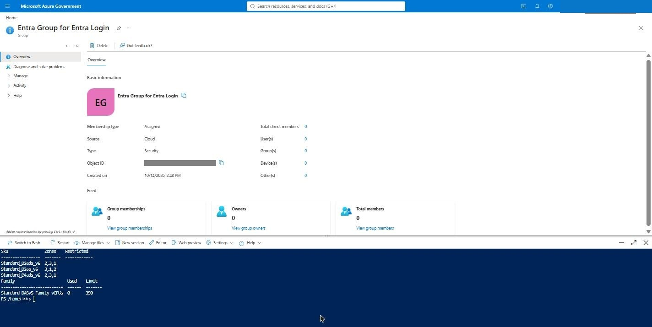
Figure: Entra group overview
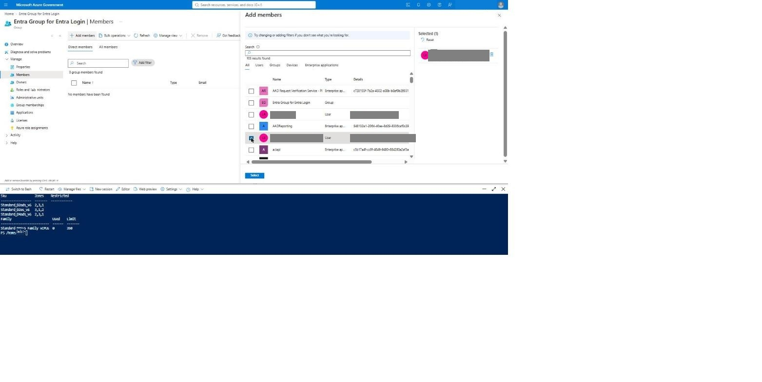
Figure: Add member
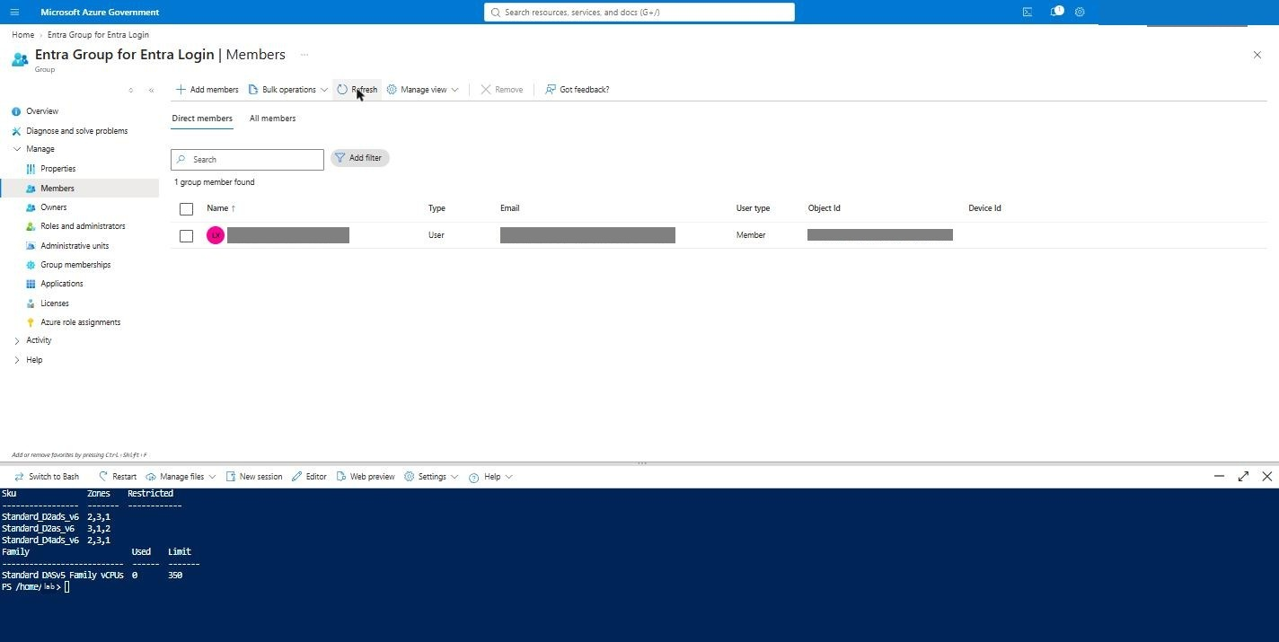
Figure: Member added

3.2 Break-glass (emergency access) account
Create a cloud-only Global Administrator break-glass account in the tenant before you enable any Conditional Access or Entra-login enforcement in the lab, and exclude it from every CA policy. This is a tenant task outside the template; the kit does not create it. Post-Deploy.ps1 prints the same reminder.

4. Deploy from the portal (Deploy to Azure Gov button)

4.1 Open the form
In the repository README click Deploy to Azure Gov. It opens portal.azure.us with the kit's solution.json and uiDefinition.json loaded straight from GitHub (the form title reads MLZ Security Lab Starter Kit). If the portal opens on a different tab or window, you can paste the button's link directly into the address bar.
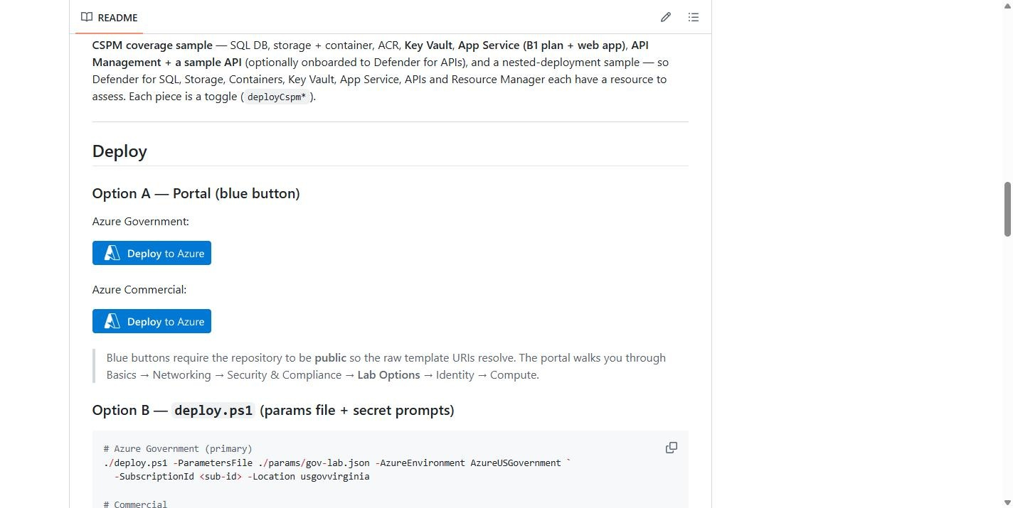
Figure: README deploy button
(A few screenshots from the first run still show the form's previous title, Mission Landing Zone AD + Entra One-Shot; the fields are unchanged.)
The form is cloud-aware: when the region chosen on Basics is usgov* or usdod*, it hides the Defender plans that Azure Government does not offer (App Service, APIs), hides VM sizes that are commercial-only, and derives the .us cloud endpoints automatically.

4.2 Basics
Pick the subscription and region, then the naming inputs. The resource prefix is derived from identifier + environment + region + workload, e.g. lab-dev-va-seclab.
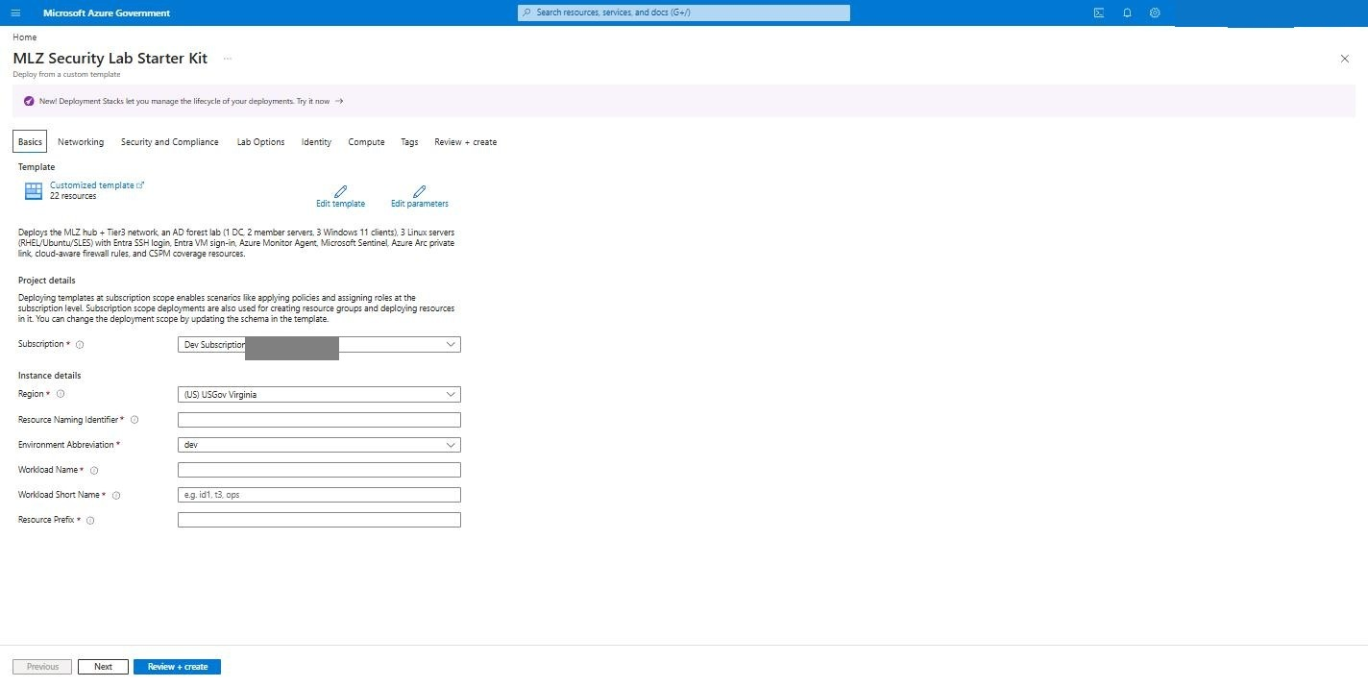
Figure: Basics empty
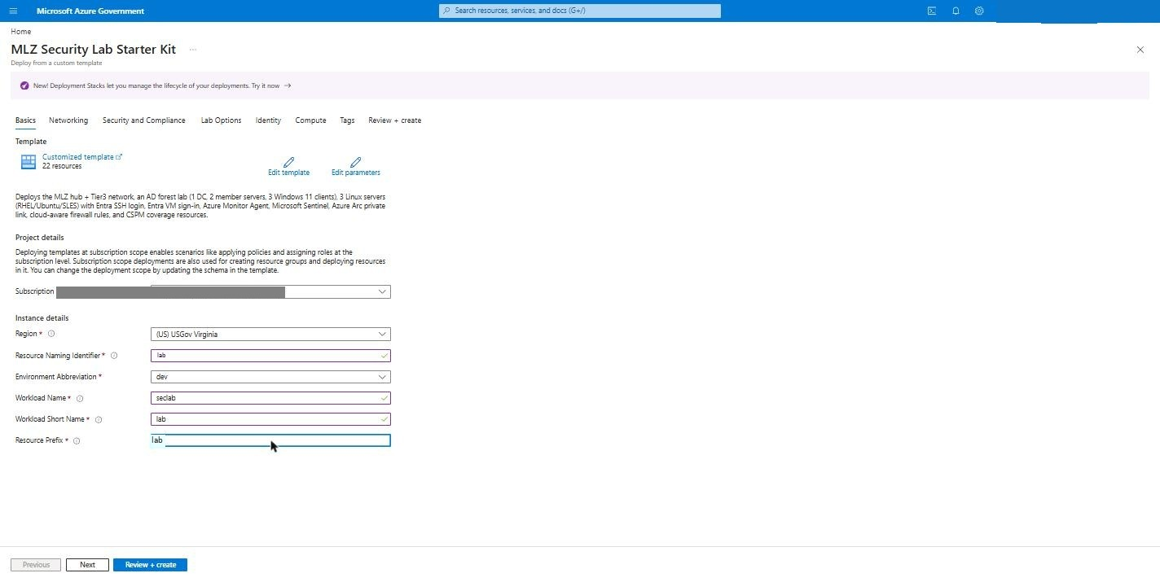
Figure: Basics filled

4.3 Networking
Leave Bastion on. The Tier-3 VNet is 10.60.0.0/24; set the subnet to 10.60.0.0/25 so the 10.60.0.128/28 resolver subnet can be added later without re-addressing. Domain controller IP 10.60.0.10.
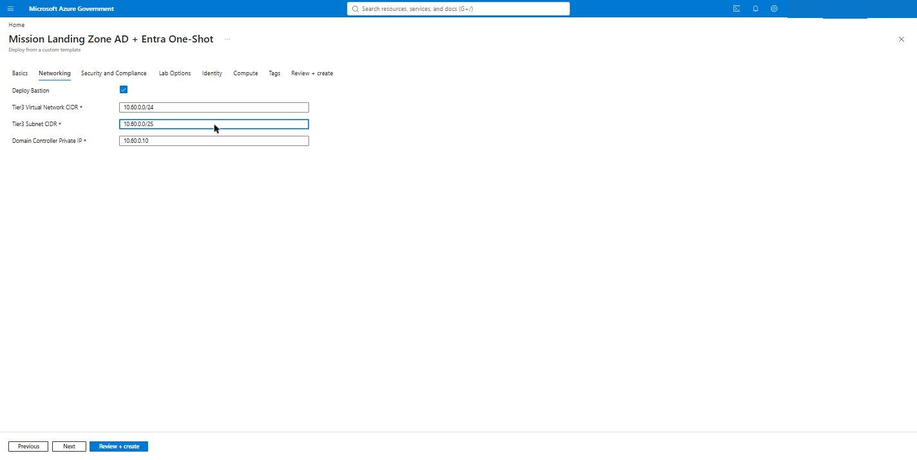
Figure: Networking

4.4 Security and Compliance
Enable the Defender for Cloud base plan and the plans you want (this guide turned on everything the form offers in Azure Government: CSPM, Servers P2, Storage, SQL, Containers, Key Vault, Resource Manager, open-source databases, Cosmos DB). Each plan is billed separately.
Policy: keep Microsoft cloud security benchmark (default on) and add the MLZ built-in policy set; all initiatives are assigned in audit-only mode. Enable Microsoft Sentinel with a new workspace named lab-law-lab.
CSPM coverage samples: Key Vault and App Service on; SQL off in this subscription (see troubleshooting #11); API Management off (adds ~45 minutes).
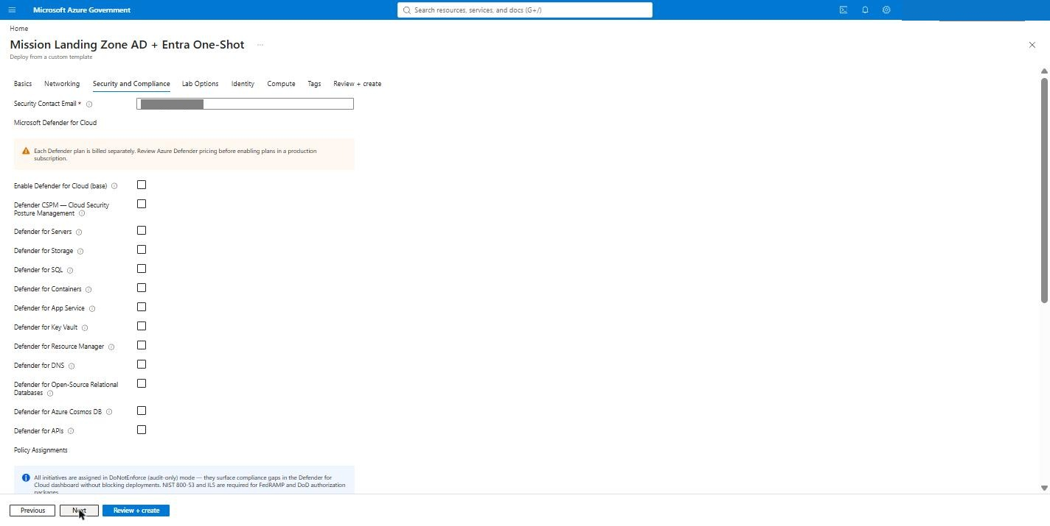
Figure: Security and Compliance empty
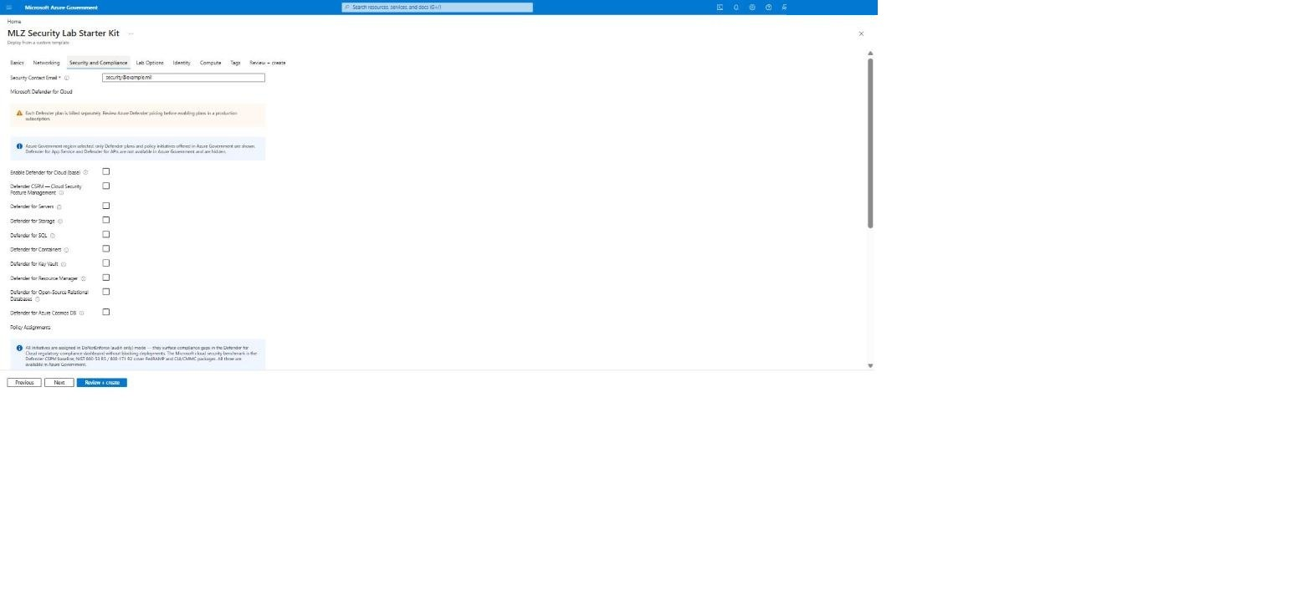
Figure: Defender plans (Gov-aware list)
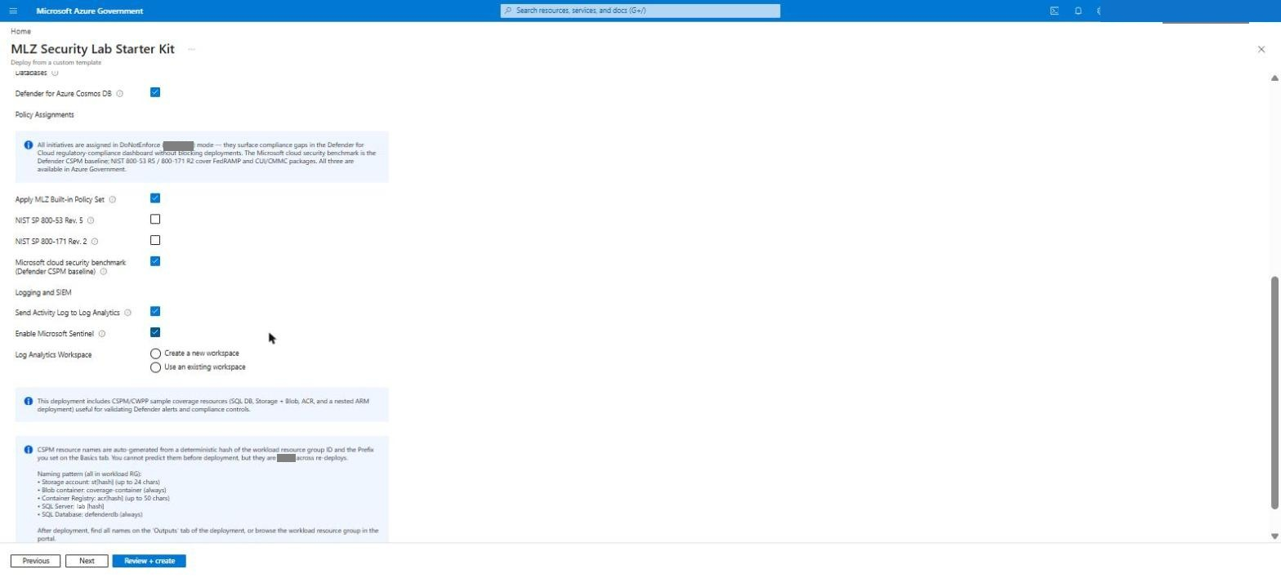
Figure: Policy: MLZ + MCSB
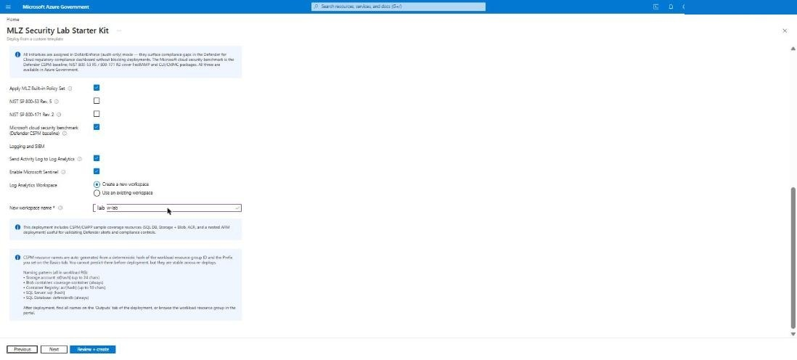
Figure: Sentinel: new workspace

4.5 Lab Options
Enter the verified UPN suffix and the lab user name. Keep the three Linux servers, the lab firewall rules, the AzureCloud service-tag allowance and Enable all matching built-in Sentinel analytics rules + UEBA on. Leave Run the Sentinel content enablement inline off — section 5 runs it from Cloud Shell, where you can watch it. Turn on Azure Arc Private Link Scope.
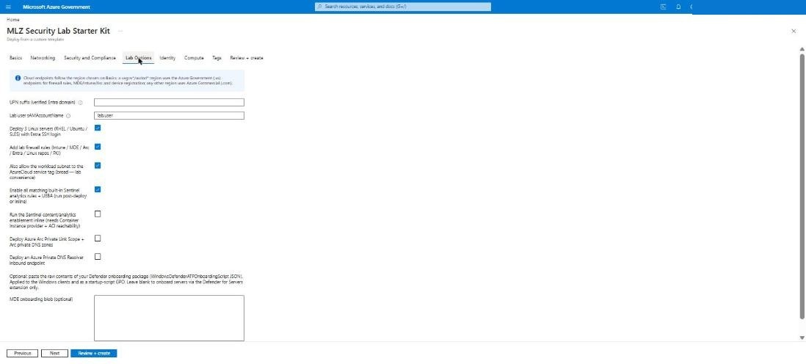
Figure: Lab Options empty
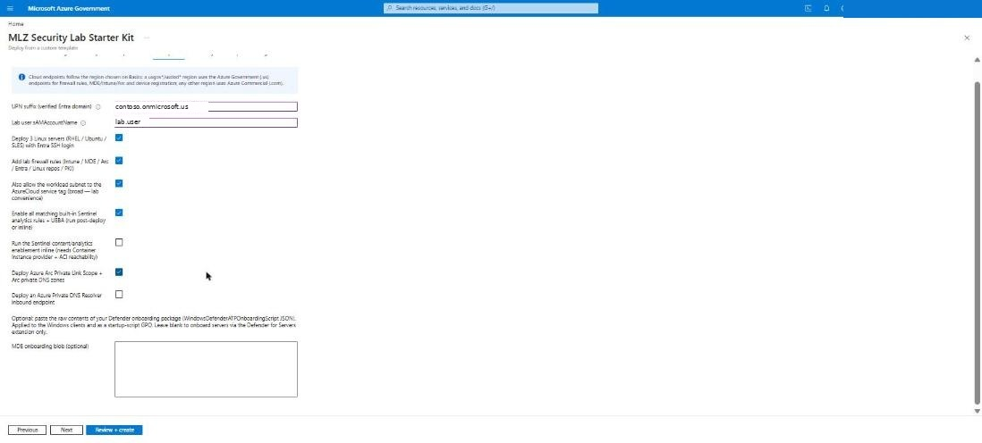
Figure: Lab Options filled

4.6 Identity
Admin username, the admin and DSRM passwords, the optional lab user password, AD domain and NetBIOS name, and the Entra group object ID from step 3.1. Keep Assign Virtual Machine Administrator Login role checked.
Which account signs in where:
VM | Account | Password
lab-dc01 | labadmin@corp.contoso.lab — the DC's local admin becomes the domain admin at promotion | Admin password
lab-ms01, lab-ms02, lab-cl01–03 | labadmin@corp.contoso.lab (Domain Admins); local .\labadmin also exists | Admin password
lab-rhel01, lab-ubu01, lab-sles01 | labadmin (local), or your Entra account through Bastion Microsoft Entra ID | Admin password / Entra sign-in
Clients, as a normal user | lab.user@corp.contoso.lab or lab.user@contoso.onmicrosoft.us | Lab user password
AD recovery mode | — | DSRM password

If you leave the lab user password blank, the user is created with a random password; reset it on the DC with Set-ADAccountPassword lab.user -Reset -NewPassword (Read-Host -AsSecureString).
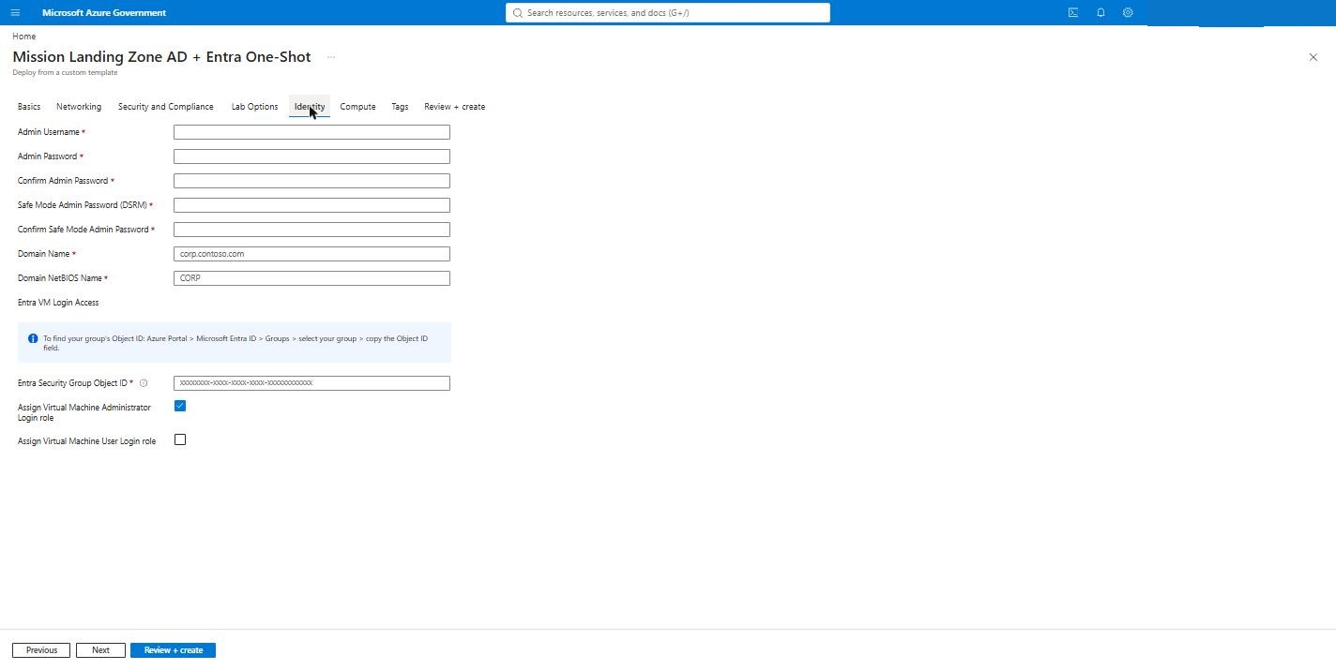
Figure: Identity empty
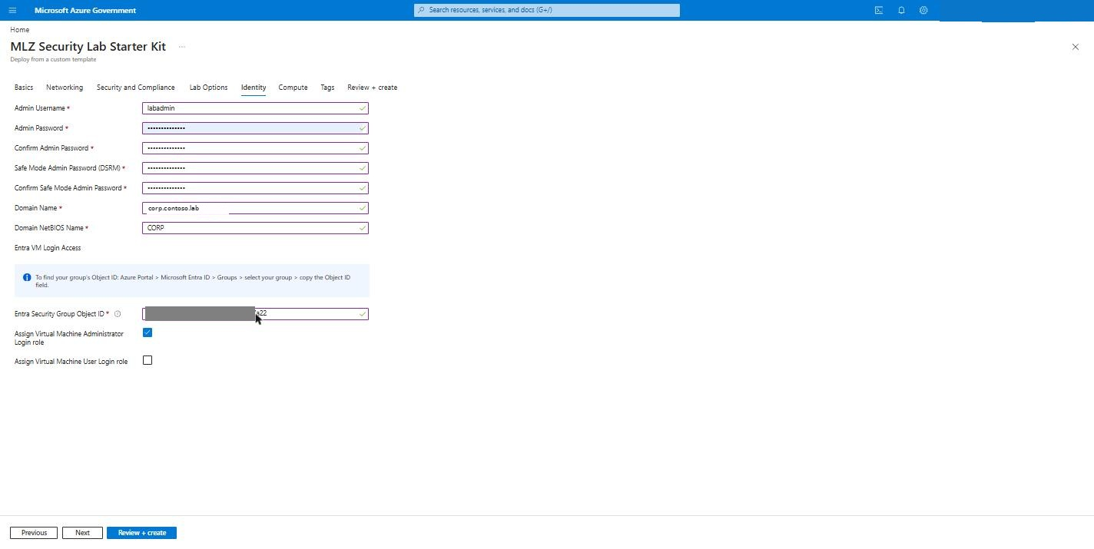
Figure: Identity filled

4.7 Compute
Server image Windows Server 2022 Gen2, client image Windows 11 24H2 (Enterprise or Pro), and the VM sizes. In Azure Government the size lists only show sizes available there.
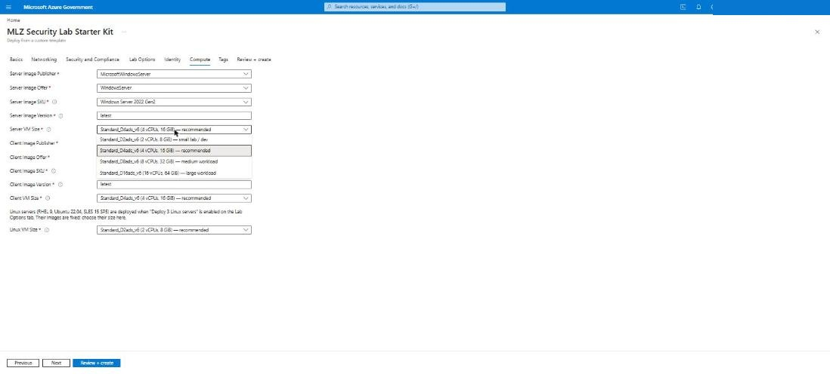
Figure: Compute (Gov size list)
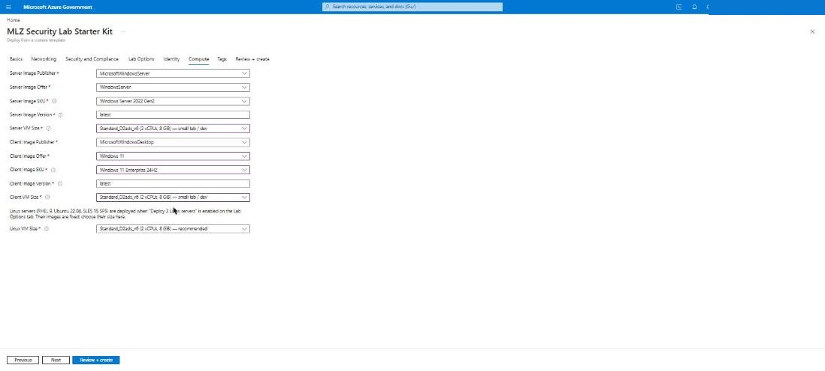
Figure: Compute filled

4.8 Review + create
Validation runs the whole subscription-scope template. When it passes, click Create.
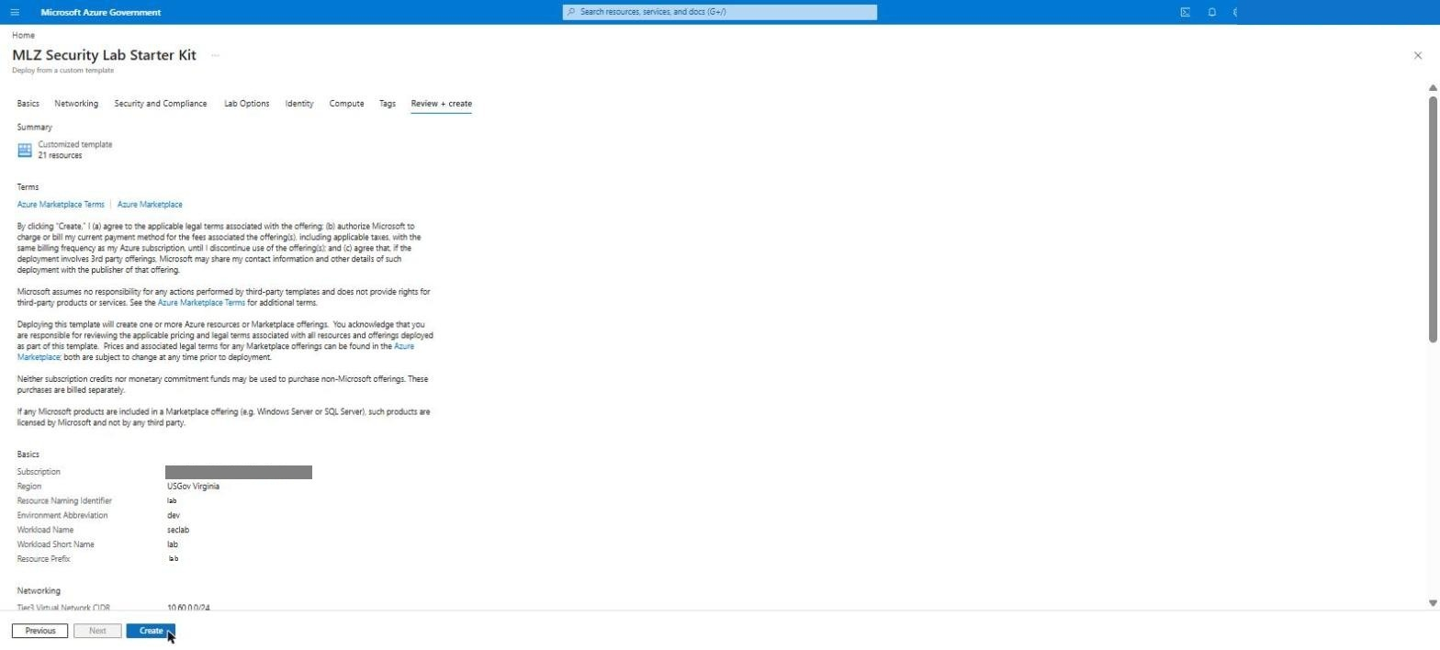
Figure: Validation passed

4.9 Watch the deployment
The top-level deployment is CustomDeployment-<timestamp>. It fans out into nested deployments: deploy-mlz-core (hub), deploy-tier3, deploy-cspm-coverage, deploy-ad-entra-vms (DC promotion, joins, Linux), deploy-security-lab (workspace, DCRs, Sentinel onboarding) and deploy-arc-pls, plus the Defender pricing and policy assignments at subscription scope.
Expected timing on this run: hub + tier-3 ≈ 25 min; VM module ≈ 45 min (DC promotion, 5 domain joins and configure-member, 3 Linux servers with Entra SSH login and the monitor agent); CSPM ≈ 10 min.
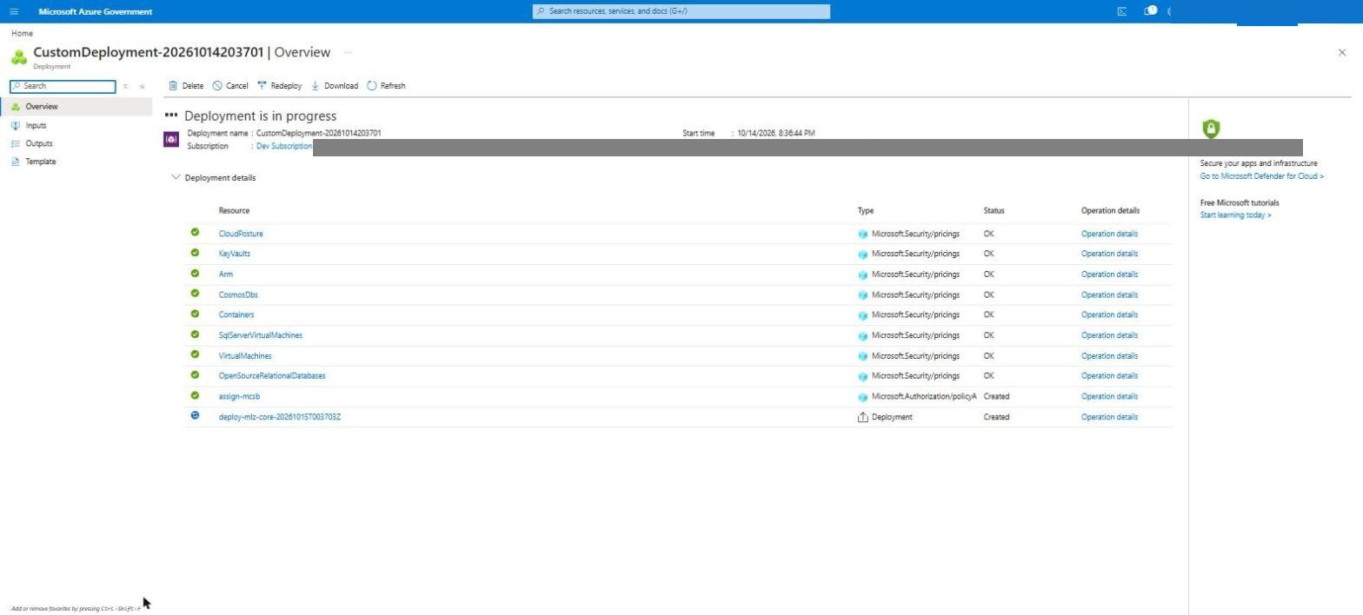
Figure: Deployment started
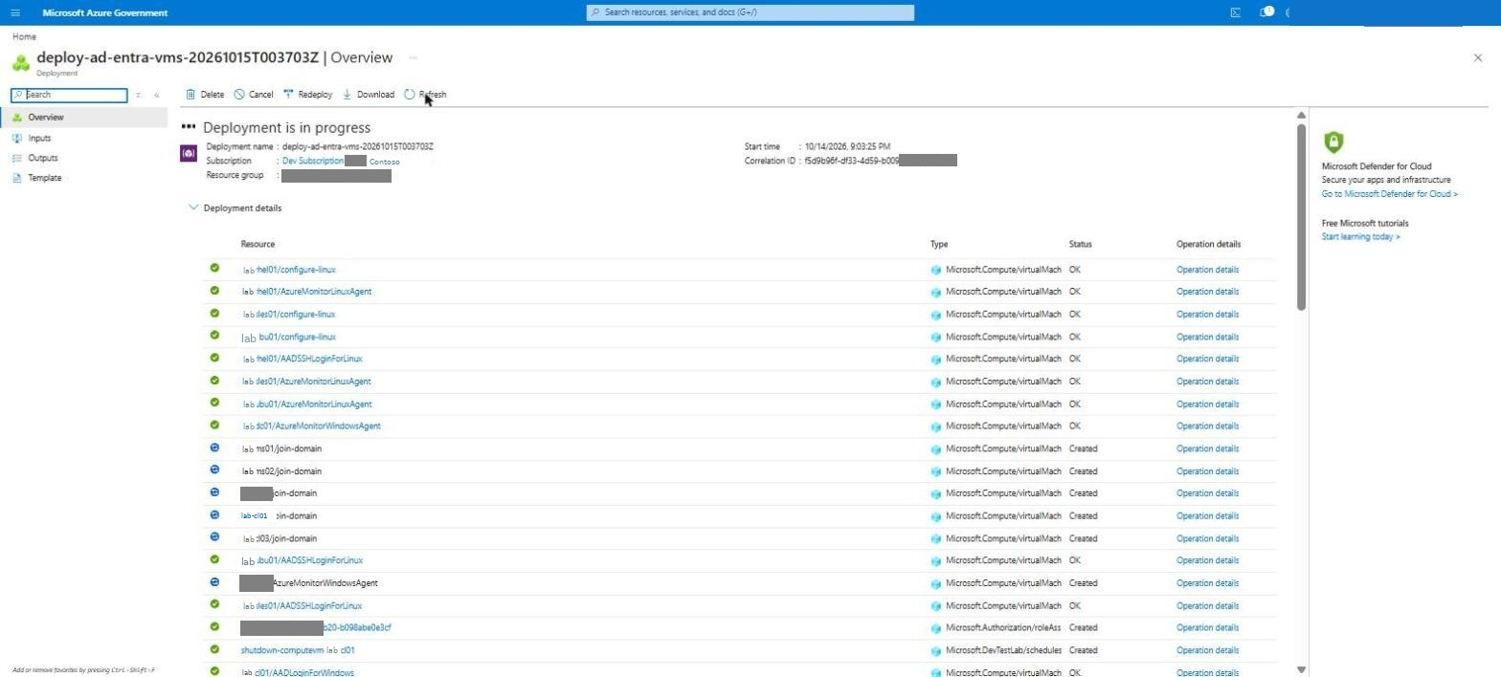
Figure: VM module: Linux OK, joins running
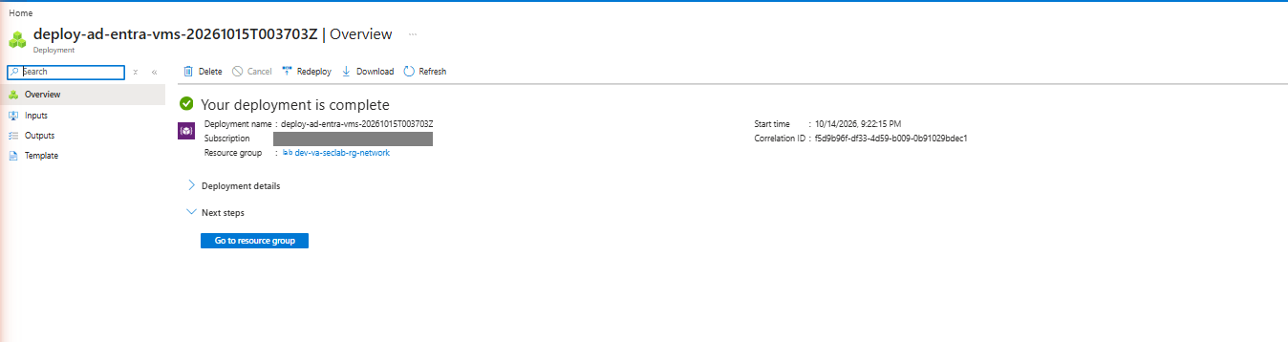
Figure: VM module complete
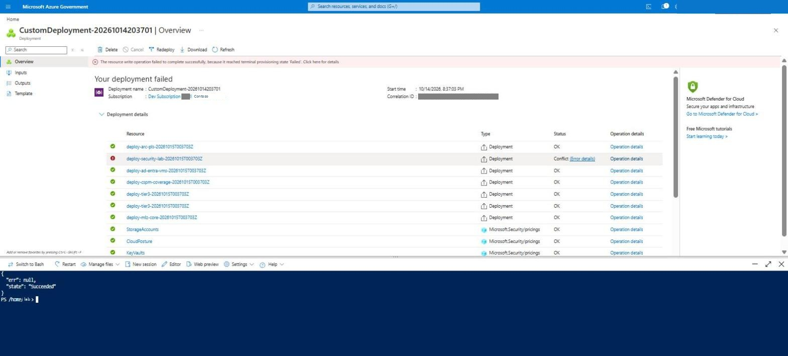
Figure: security-lab module succeeded
On this run the deploy-security-lab module hit the Linux DCR defect (troubleshooting #13) and was re-deployed on its own after the fix. With the fix on main, a fresh deployment completes in one pass. If any nested deployment fails, open its Error details, fix the input (or the template), and use Redeploy on that nested deployment — the modules are idempotent.

5. Post-deploy — Sentinel content, connectors, analytics rules, UEBA
The template onboards the workspace to Sentinel and creates the data collection rules; the Content Hub solutions, the analytics rules, UEBA, the Defender XDR connector and the tenant-level log routing are done by templates/scripts/Post-Deploy.ps1, run from Cloud Shell under your own (Global Administrator) sign-in.

5.1 Clone the kit in Cloud Shell and run the orchestrator
git clone -q https://github.com/lee-aguilar-msft/Azure-MLZStarterKit-Security.git ~/kit
cd ~/kit/templates/scripts
./Post-Deploy.ps1 -SubscriptionId <subscription-id> `
-ResourceGroupName lab-dev-va-seclab-rg-network -WorkspaceName <workspace-name> -EnableXdrConnector `
*>&1 | Tee-Object -FilePath ~/postdeploy.log
The *>&1 | Tee-Object keeps every warning in ~/postdeploy.log so you can review the per-rule messages afterwards. The run takes 8–12 minutes. What it does, in order:
Step | Action | Result on this run
1 | Installs Content Hub solutions by deploying each solution's packaged ARM template (same as the portal's Install) — Microsoft Entra ID, Azure Activity, Microsoft Defender XDR, Windows Security Events, Syslog, UEBA Essentials | 6 installed; Threat Intelligence – TAXII is not in the Azure Government catalog and is skipped
2 | Enables every built-in Scheduled/NRT analytics rule template whose required connector is one of: AzureActiveDirectory, AzureActivity, MicrosoftThreatProtection, MicrosoftDefenderAdvancedThreatProtection, SecurityEvents, WindowsSecurityEvents, Syslog, ThreatIntelligence(Taxii) | 298 matched, 263 enabled (264 active with the built-in Advanced Multistage Attack Detection rule), 35 rejected by the service (they query tables or columns that do not exist yet — expected; re-run the script a day later to pick up the ones whose tables have since filled)
1b | Prints the Defender for Cloud plans and re-asserts Defender for Servers P2 | see 6.4
3 | Turns on Entity Behavior Analytics (UEBA) over AuditLogs, AzureActivity, SigninLogs, SecurityEvent | enabled
4 | Defender XDR data connector (incidents + alerts) | created; skipped as already present on later runs
5 | Routes Entra ID logs (tenant diagnostic setting: AuditLogs, SignInLogs, NonInteractiveUserSignInLogs, ServicePrincipalSignInLogs, ManagedIdentitySignInLogs, ProvisioningLogs, RiskyUsers, UserRiskEvents) and the subscription Activity log to the workspace | both routed
— | Prints the break-glass / Conditional Access checklist and the Entra Connect + hybrid-join runbook | manual follow-up

The script is idempotent: re-running it skips rules that already exist (and removes duplicates left by an interrupted run), re-deploys the solutions harmlessly and leaves existing settings in place.
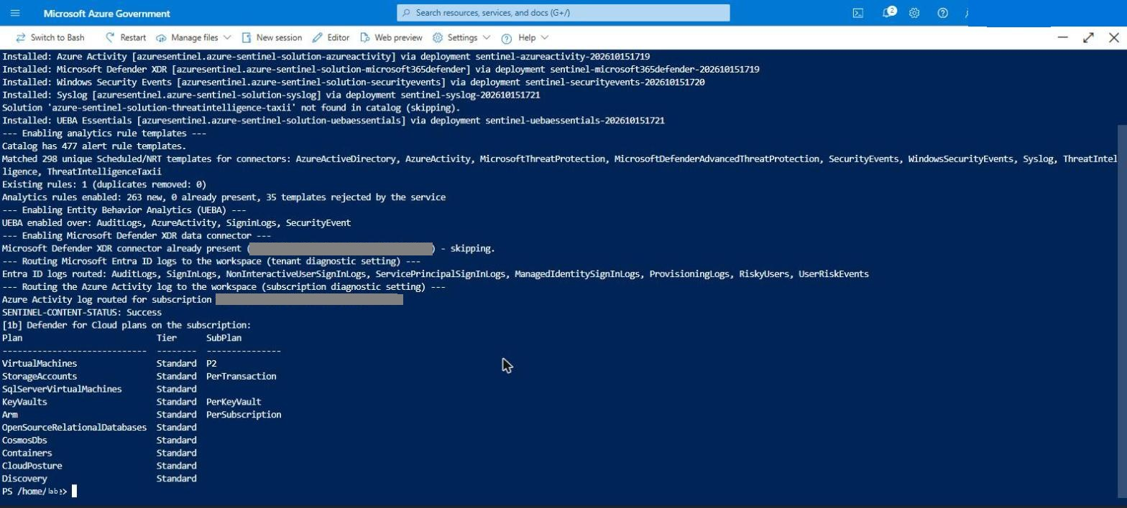
Figure: Post-deploy: solutions, rules, UEBA, XDR, log routing, Defender plans

5.2 Identity, hybrid join, Intune and Defender for Endpoint
Most of the identity chain is automated. The deployment and two scripts do everything except two clicks that have no API (Entra Connect's wizard needs your MFA; the Defender portal's Intune connection toggle has no Graph endpoint).
What | Done by | When
AD forest, OUs (Users, Workstations, MemberServers), lab user, groups | template (configure-forest-baseline) | deployment
Member servers and clients moved into their OUs | template (configure-forest-baseline) | deployment
GPO <OU root> - Intune Auto-Enrollment (MDM auto-enrollment with the signed-in user's Entra credential) linked to Workstations | template | deployment
GPO <OU root> - Security Auditing and Logging | template | deployment
Hybrid-join Service Connection Point (tenant ID + domain) written to AD | template — tenant ID comes from the subscription | deployment
Gate: deployment fails if any of the above is missing (verify-forest) | template | deployment
TLS 1.2 prerequisites and C:\LabTools\README-EntraConnect.txt on lab-ms01 (Entra Connect itself is downloaded from the Entra admin center — see 5.2.3) | template (configure-member) | deployment
Clients retry hybrid join every 30 min and Intune enrollment hourly, for 7 days | template (scheduled tasks LAB-HybridJoin-Retry, LAB-IntuneAutoEnroll-Retry) | deployment
Intune MDM user scope + .us MDM URLs (GCC High) | Prepare-Tenant.ps1 | once per tenant
Microsoft Intune Enrollment service principal; CA exclusion report (or -ExcludeIntuneEnrollmentFromCa) | Prepare-Tenant.ps1 | once per tenant
Intune ↔ MDE connector (Windows), dynamic device group, EDR policy Auto from connector | Prepare-Tenant.ps1 -ConfigureMde | once per tenant
License for the synced lab user | Prepare-Tenant.ps1 -LabUserUpn | after the first sync
Defender portal → Intune connection = On | you (one toggle) | once per tenant
Entra Connect wizard on lab-ms01 | you (needs MFA) | once per deployment

#### 5.2.1 Prerequisites — what you need before you start (no extra GPOs from GitHub)
You do not need to import any GPO backups or third-party automation: the forest baseline creates the GPOs above, and the MDE onboarding is driven by Intune. What you do need:
- A break-glass Global Administrator (cloud-only, excluded from all Conditional Access policies).
- Licences: Entra ID P1/P2 + Intune for the lab user (hybrid join's PRT and MDM auto-enrollment are licensed features), and Defender for Endpoint P2 for the clients (included in Microsoft 365 E5 / G5; the servers are covered by Defender for Servers P2).
- Your account: Global Administrator (or Intune Administrator + Cloud Application Administrator + License Administrator + Security Administrator) for Prepare-Tenant.ps1 and the Defender toggle, and Hybrid Identity Administrator (or Global Administrator) for the Entra Connect wizard.
- Optional: the MDE onboarding package — only if you want a GPO-based onboarding path in addition to Intune. Defender portal (security.microsoft.us) → Settings → Endpoints → Onboarding → Windows 10 and 11 → Group Policy → Download. Inside WindowsDefenderATPOnboardingScript.cmd the OnboardingInfo registry value is a JSON string ({"body":"{\"previousOrgIds\"…); paste that JSON into MDE onboarding blob on the Lab Options tab before deploying. The kit writes it to the clients directly and as a <OU root> - MDE Onboarding startup-script GPO.
#### 5.2.2 Run Prepare-Tenant.ps1 (Intune MDM URLs, enrollment app, MDE connector)
In a GCC High / DoD tenant the Intune Automatic Enrollment page tells you to use the .us endpoints, but the fields still default to the commercial .com URLs, and auto-enrollment of the lab clients fails until they are changed:
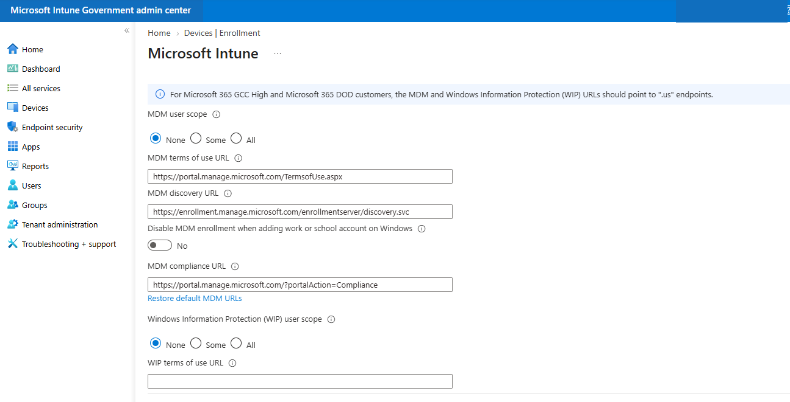
Figure: Intune MDM URLs (defaults still pointing at .com)
Prepare-Tenant.ps1 sets them for you. From the same Cloud Shell session:
cd ~/kit/templates/scripts
./Prepare-Tenant.ps1 -Cloud USGov -ConfigureMde
It signs in to Microsoft Graph with a device code (open https://microsoft.com/deviceloginus, enter the code, complete MFA), then:
Setting | Value written (GCC High / DoD)
MDM user scope | All (or Some with -MdmScopeGroupId <group id>)
MDM terms of use URL | https://portal.manage.microsoft.us/TermsofUse.aspx
MDM discovery URL | https://enrollment.manage.microsoft.us/enrollmentserver/discovery.svc
MDM compliance URL | https://portal.manage.microsoft.us/?portalAction=Compliance
Microsoft Intune Enrollment (d4ebce55-015a-49b5-a083-c84d1797ae8c) | service principal created if missing; CA policies that would block it are listed
Intune ↔ MDE connector | Windows devices On
Device group LAB-Intune-Devices | dynamic: device.displayName -startsWith "lab-cl"
EDR policy LAB - Defender for Endpoint onboarding (auto from connector) | Endpoint security → EDR, onboarding package Auto from connector, assigned to the group

A successful run ends with PREPARE-TENANT-STATUS: Success. Afterwards the Automatic Enrollment page shows the .us URLs and Endpoint security → Endpoint detection and response shows the connector enabled:
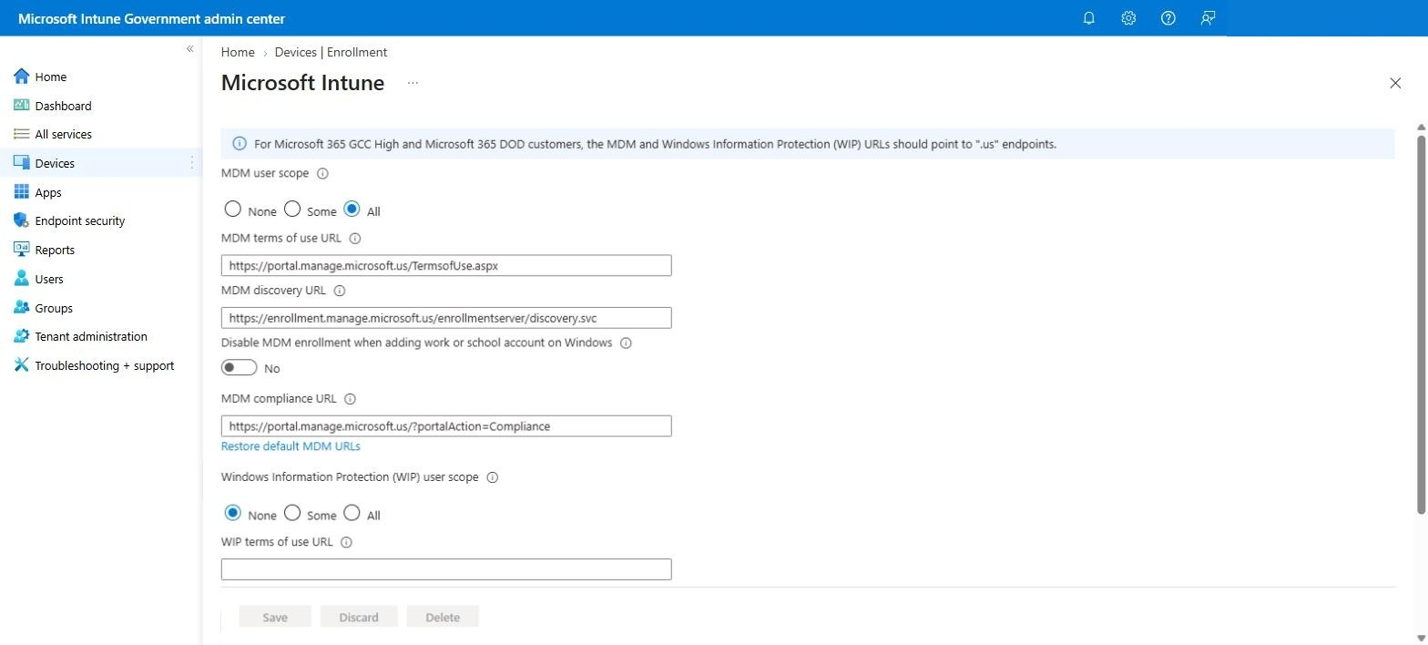
Figure: Intune Automatic Enrollment with the .us URLs
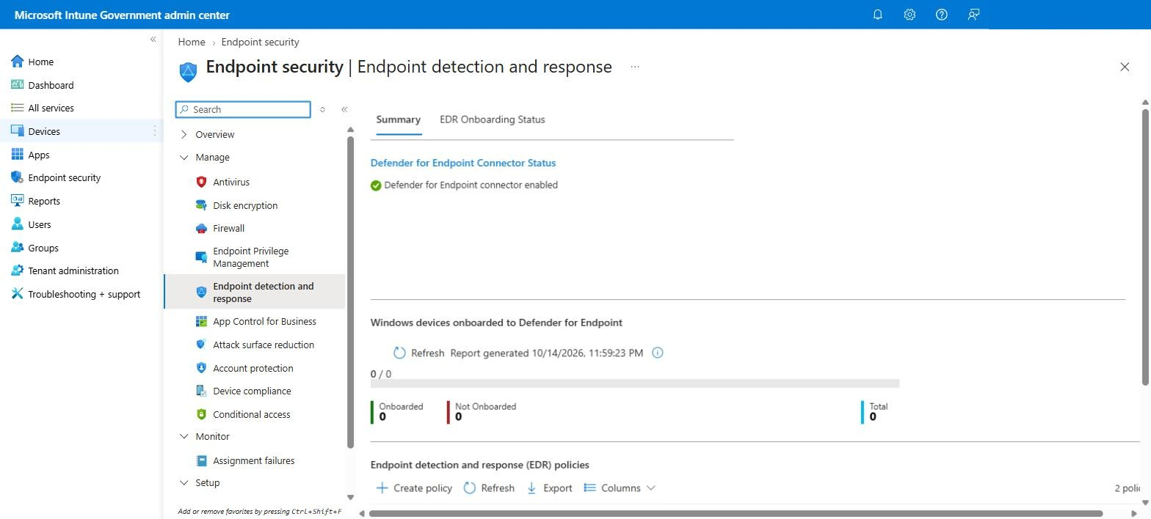
Figure: Intune EDR: Defender for Endpoint connector enabled
Conditional Access: the script lists enabled policies that target all cloud apps without excluding Microsoft Intune Enrollment. Policies that only target guests / external users (such as the Microsoft-managed … for Microsoft partners and vendors policies) are reported as not affecting the lab user and need no change.
Use -Cloud Global for a commercial tenant (it writes the .com URLs instead). To set the URLs by hand: Intune admin center (intune.microsoft.us) → Devices → Enrollment → Windows → Automatic Enrollment.
The one Defender toggle. The connector can only be switched on from the Defender side: Microsoft Defender portal (security.microsoft.us) → Settings → Endpoints → Advanced features → Microsoft Intune connection = On → Save. Do it before or after the script; the EDR policy starts onboarding as soon as both sides are on.
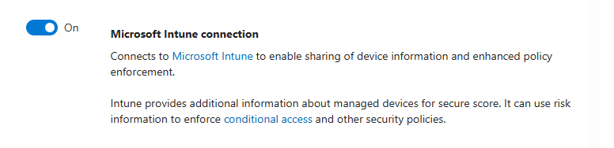
Figure: Defender portal: Microsoft Intune connection On
#### 5.2.3 Entra Connect on lab-ms01 (the one wizard)
- lab-ms01 → Connect → Bastion → authentication type VM password; username labadmin@corp.contoso.lab (the AD admin from the Identity tab, in UPN form — the Bastion portal rejects CORP\labadmin with Username in domain\username format is not supported, and the session then ends with Log in failed) and its password. Plain labadmin (the server's local administrator, same password) also works and is enough to run the wizard — the wizard asks for the domain credentials separately.
- In Edge on lab-ms01 open the Azure portal → Microsoft Entra ID → Microsoft Entra Connect → Get started → Manage → Download Connect Sync Agent, and run it (version 2.5.79.0 or later — older builds were retired on 30 September 2026; notes in C:\LabTools\README-EntraConnect.txt). In the wizard choose Customize (not Express) → install the required components.
- Sign-in method Password Hash Synchronization.
- Connect to Entra ID with a Hybrid Identity Administrator / Global Administrator (MFA prompt).
- Add the forest corp.contoso.lab with CORP\labadmin and let the wizard create the AD DS Connector account.
- Domain/OU filtering: the lab root OU only (it contains the lab user and the Workstations OU with lab-cl01–lab-cl03).
- Device options: nothing required — the deployment already wrote the hybrid-join SCP. (Running Configure Hybrid Microsoft Entra join again is harmless.)
- Finish with Start the synchronization process when configuration completes.
After the first sync, re-run ./Prepare-Tenant.ps1 -Cloud USGov -SkipMdm -LabUserUpn lab.user@contoso.onmicrosoft.us to license the synced user (it ends with License EMSPREMIUM_… assigned and PREPARE-TENANT-STATUS: Success; the Conditional Access warnings for the Microsoft-managed partner/vendor policies can be ignored):
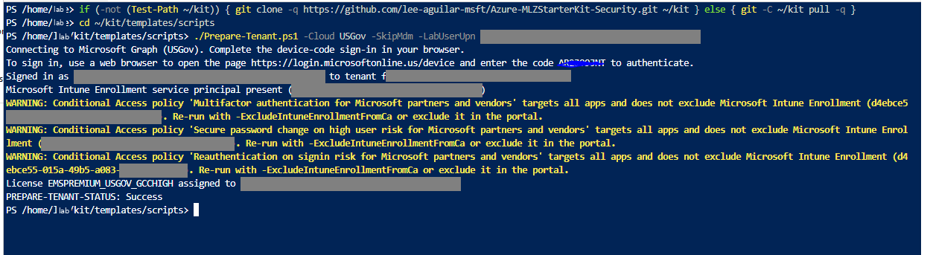
Figure: Prepare-Tenant licensing the synced lab user
#### 5.2.4 Hybrid join, Intune enrollment and MDE onboarding
What happens on its own. Every client has a LAB-HybridJoin-Retry task (runs dsregcmd /join as SYSTEM every 30 minutes for 7 days) and Entra Connect runs a delta sync every 30 minutes, so within about an hour of the first sync each client becomes Microsoft Entra hybrid joined. Once the lab user has signed in to a client, the Intune auto-enrollment task (every 5 minutes, plus the kit's hourly LAB-IntuneAutoEnroll-Retry) enrolls it, and the EDR policy then onboards it to Defender for Endpoint.
What you must do once (otherwise enrollment fails with 0xCAA9001F, troubleshooting #45):
- The lab user's UPN must use a verified tenant domain — set the UPN suffix Lab Option to it (for example contoso.onmicrosoft.us) before deploying, or add the suffix in AD and change the user's UPN afterwards.
- The lab user registers MFA once: sign in at myaccount.microsoft.us (or aka.ms/mfasetup) and add the Authenticator app.
- Sign in once to each client as the lab user (Bastion → VM password → lab.user@contoso.onmicrosoft.us) so the user gets a Primary Refresh Token.
To speed up the hybrid join (instead of waiting for the 30-minute retries), per client:
- lab-ms01 (signed in as the AD admin): Start-ADSyncSyncCycle -PolicyType Delta
- Azure portal → the client VM → Run command → RunPowerShellScript → dsregcmd /join (Run command runs as SYSTEM, which dsregcmd /join needs, and needs no network path to the client).
- Wait 2–3 minutes, run the delta sync again, then run dsregcmd /join once more.
A lab deployed from the current kit also has C:\LabTools\Invoke-HybridJoinCycle.ps1 on lab-ms01, which does the same for several clients over WinRM. It only works when you are signed in to lab-ms01 as the domain admin (labadmin@corp.contoso.lab, not the local labadmin) and the clients were deployed with WinRM enabled (labs built before this fix have neither the script nor WinRM — use Run command):
C:\LabTools\Invoke-HybridJoinCycle.ps1 -ClientNames lab-cl01,lab-cl02,lab-cl03
It reports AzureAdJoined / DomainJoined per client; check AzureAdPrt on the client itself (it is per signed-in user, so a remote session always shows NO). If a client is joined but not enrolled after about 30 minutes, use the manual enrollment below.
Check | Where | Expected
Hybrid join | dsregcmd /status on the client | AzureAdJoined : YES, DomainJoined : YES, AzureAdPrt : YES
Entra device | Entra admin center → Devices → All devices | lab-cl01–03, join type Microsoft Entra hybrid joined
Intune | Intune admin center → Devices → Windows | lab-cl01–03, managed by Intune, compliance evaluated
MDE | Defender portal → Assets → Devices | lab-cl01–03 Onboarded (plus the servers, via Defender for Servers)

Result on lab-cl01 in this run (dsregcmd /status, IDs replaced):
+----------------------------------------------------------------------+
| Device State |
+----------------------------------------------------------------------+
AzureAdJoined : YES
DomainJoined : YES
DomainName : CORP
Device Name : lab-cl01.corp.contoso.lab
TpmProtected : YES
DeviceAuthStatus : SUCCESS
+----------------------------------------------------------------------+
| Tenant Details |
+----------------------------------------------------------------------+
TenantId : 00000000-0000-0000-0000-000000000000
MdmUrl : https://enrollment.manage.microsoft.us/enrollmentserver/discovery.svc
MdmTouUrl : https://portal.manage.microsoft.us/TermsofUse.aspx
MdmComplianceUrl : https://portal.manage.microsoft.us/?portalAction=Compliance
JoinSrvUrl : https://enterpriseregistration.microsoftonline.us/EnrollmentServer/device/
+----------------------------------------------------------------------+
| SSO State |
+----------------------------------------------------------------------+
AzureAdPrt : YES
AzureAdPrtAuthority : https://login.microsoftonline.us/00000000-0000-0000-0000-000000000000
CloudTgt : YES
The MdmUrl / MdmTouUrl / MdmComplianceUrl lines confirm the client picked up the .us MDM URLs that Prepare-Tenant.ps1 wrote; with AzureAdPrt : YES the Intune auto-enrollment can now run.
Enrollment errors 0x8018002b / 0x80180026 in the DeviceManagement-Enterprise-Diagnostics-Provider log almost always mean the MDM URLs are still the .com defaults.
If automatic enrollment does not happen (troubleshooting #44/#45), enroll the client by hand — it takes a minute. Signed in as the lab user: Win+R →
ms-device-enrollment:?mode=mdm&username=lab.user@contoso.onmicrosoft.us
→ sign in (MFA). Settings → Accounts → Access work or school then shows the MDM connection; Info → Sync pushes the first check-in:
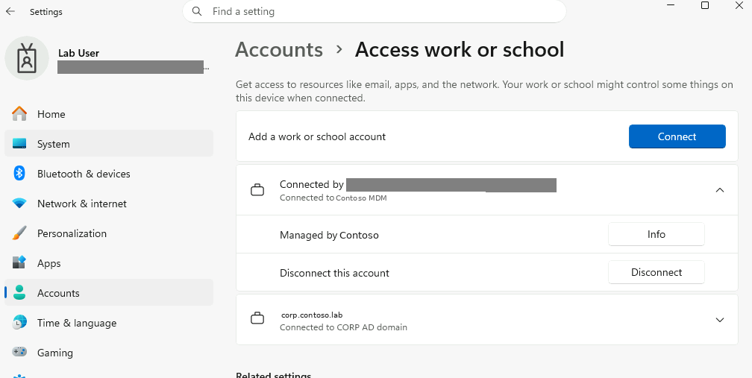
Figure: Access work or school: connected to the tenant's MDM
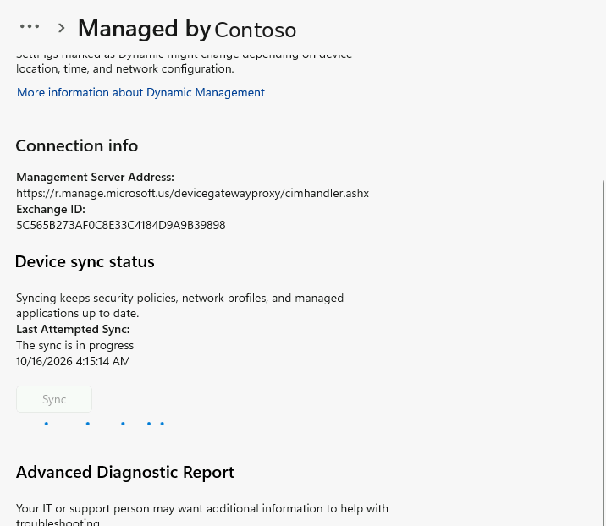
Figure: Info page: management server r.manage.microsoft.us, first sync running
About 15 minutes later the client is listed (and evaluated compliant) in Intune, and the EDR policy has onboarded it to Defender for Endpoint alongside the servers:
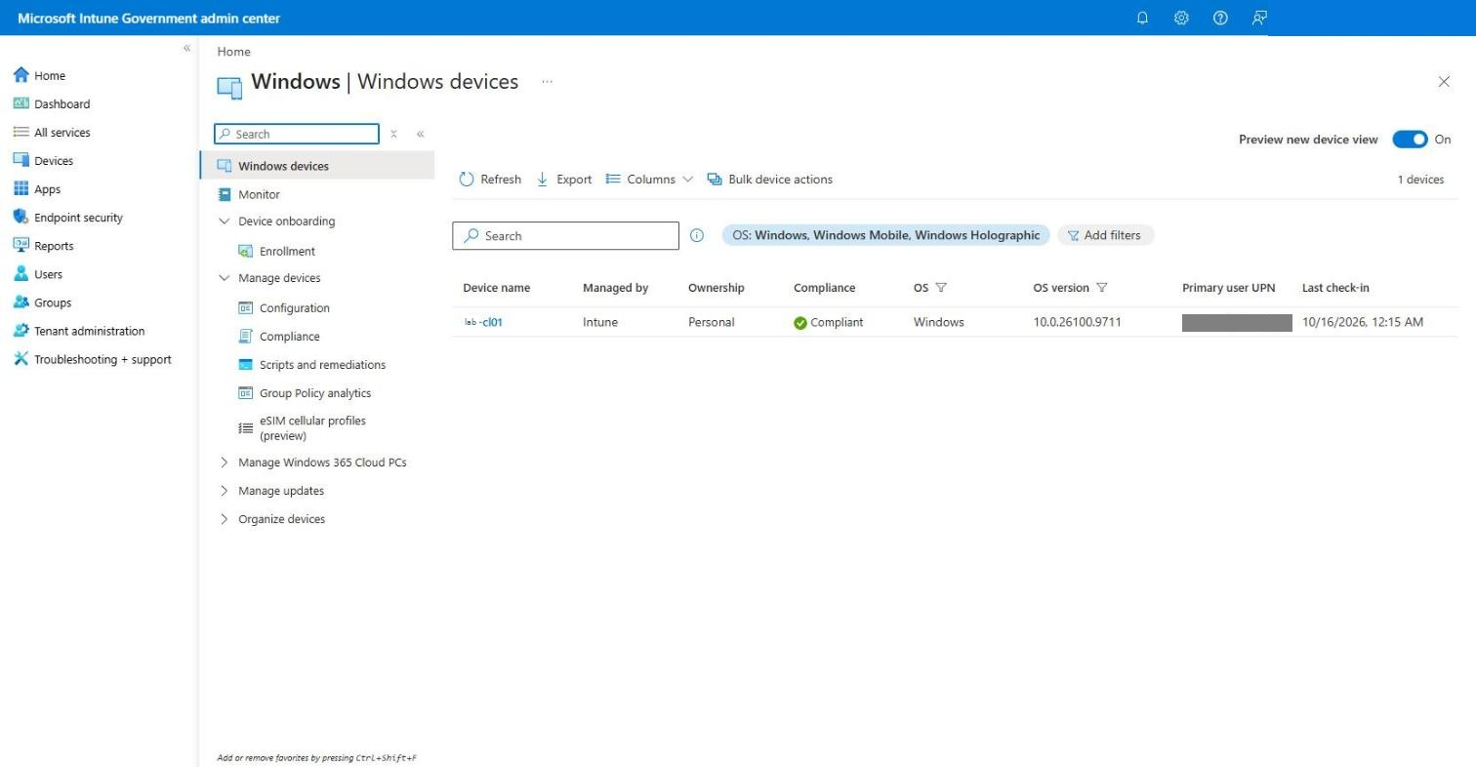
Figure: Intune: lab-cl01 managed by Intune, Compliant
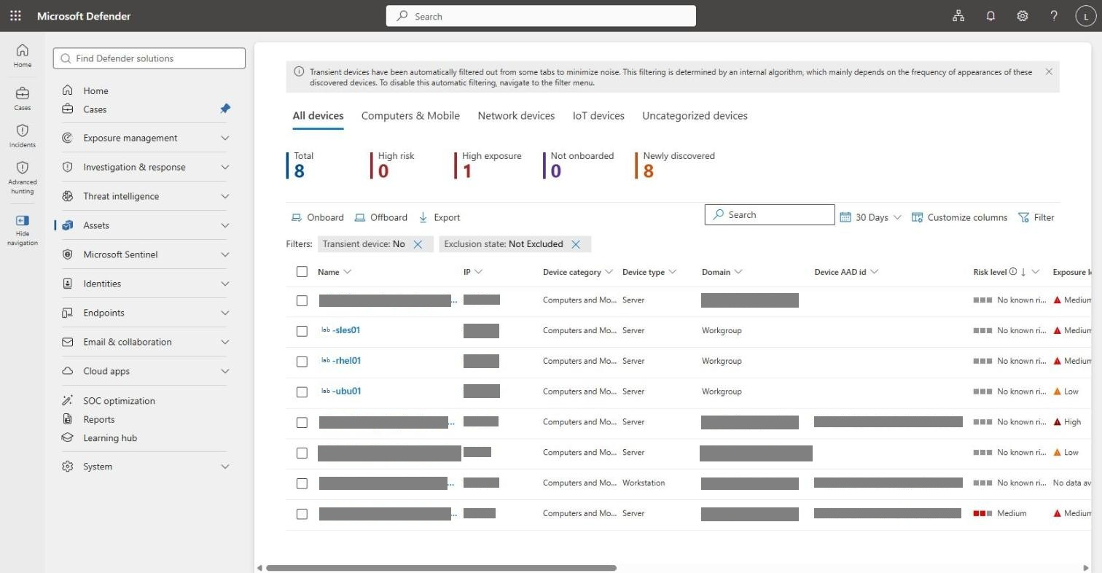
Figure: Defender for Endpoint device inventory: domain controller, member servers, Linux and lab-cl01
A manually enrolled device shows Ownership: Personal; change it to Corporate on the device's Properties page if your compliance policies depend on it.
#### 5.2.5 Signing in through Bastion — which credentials work where
VM | Bastion authentication type | Credentials
Linux (lab-rhel01, lab-ubu01, lab-sles01) | Microsoft Entra ID (SSH) | your Entra account — member of the step 3.1 group (Virtual Machine Administrator Login)
Windows (DC, member servers, clients) | VM password (RDP) | labadmin@corp.contoso.lab, or a domain user such as lab.user@corp.contoso.lab — UPN form; Bastion does not accept CORP\user
Windows client, after hybrid join | VM password (RDP) | lab.user@contoso.onmicrosoft.us — the synced user's UPN and password (same in AD and Entra through password hash sync); Windows then obtains the user's Entra PRT

Bastion's Microsoft Entra ID option for Windows RDP only works for VMs that are Entra-joined through the AADLoginForWindows extension. That extension Entra-joins the VM, which conflicts with the AD domain join and hybrid join this lab is built on, so the kit does not install it on Windows (troubleshooting #27). Linux Entra SSH is unaffected.

5.3 Data hydration — automatic, nothing to run
"Hydration" is the kit's background activity generator: ordinary, benign admin and user behaviour that keeps the Sentinel workspace and Defender for Endpoint supplied with fresh telemetry, so hunting queries, analytics rules and UEBA have something to work on in an otherwise idle lab. It is not an attack simulation.
It is on by default (template parameters deployHydration = true, hydrationIntervalMinutes = 60; the portal form does not show them) and is installed during the deployment itself — there is no step for you:
Where | Installed by | First run | Then | What it does
lab-dc01 | forest baseline (deployment step forest baseline) | ~5 min after the baseline | every 60 min | user activity below + directory activity: reads all users/computers, creates the user lab.churn in LAB → Users, flips its membership in LAB-SOC-Analysts (events 4728/4729), and two failed sign-ins for it (4625/4771)
member servers and clients | member configuration (deployment step configure members) | ~15 min after configuration | every 60 min | creates and deletes temp files, lists processes/services, runs whoami /all, ipconfig /all, nltest /dsgetdc, one HTTPS request to microsoft.com
lab-rhel01, lab-ubu01, lab-sles01 | Linux configuration | right away, and 5 min after every boot | every 60 min | file/process/network listings, sudo -n true, one HTTPS request, a failed su (auth failure in Syslog), tagged lab-hydrate in Syslog

Everything is logged on the VM: C:\LabTools\hydration.log (Windows) and journalctl -t lab-hydrate (Linux). To pause it, disable the LAB-Hydration task (Windows) or systemctl disable --now lab-hydrate.timer (Linux). Section 6.5 shows how to confirm it is reaching the workspace.

6. Verify

6.1 Resource group inventory
lab-dev-va-seclab-rg-network holds 59 resources: the 9 VMs with NICs and disks, the workspace, DCE/DCRs, the Arc Private Link Scope with its private endpoint and three privatelink.*.azure.us DNS zones, the CSPM samples (Key Vault, App Service plan + app, container registry) and the content-script managed identity.
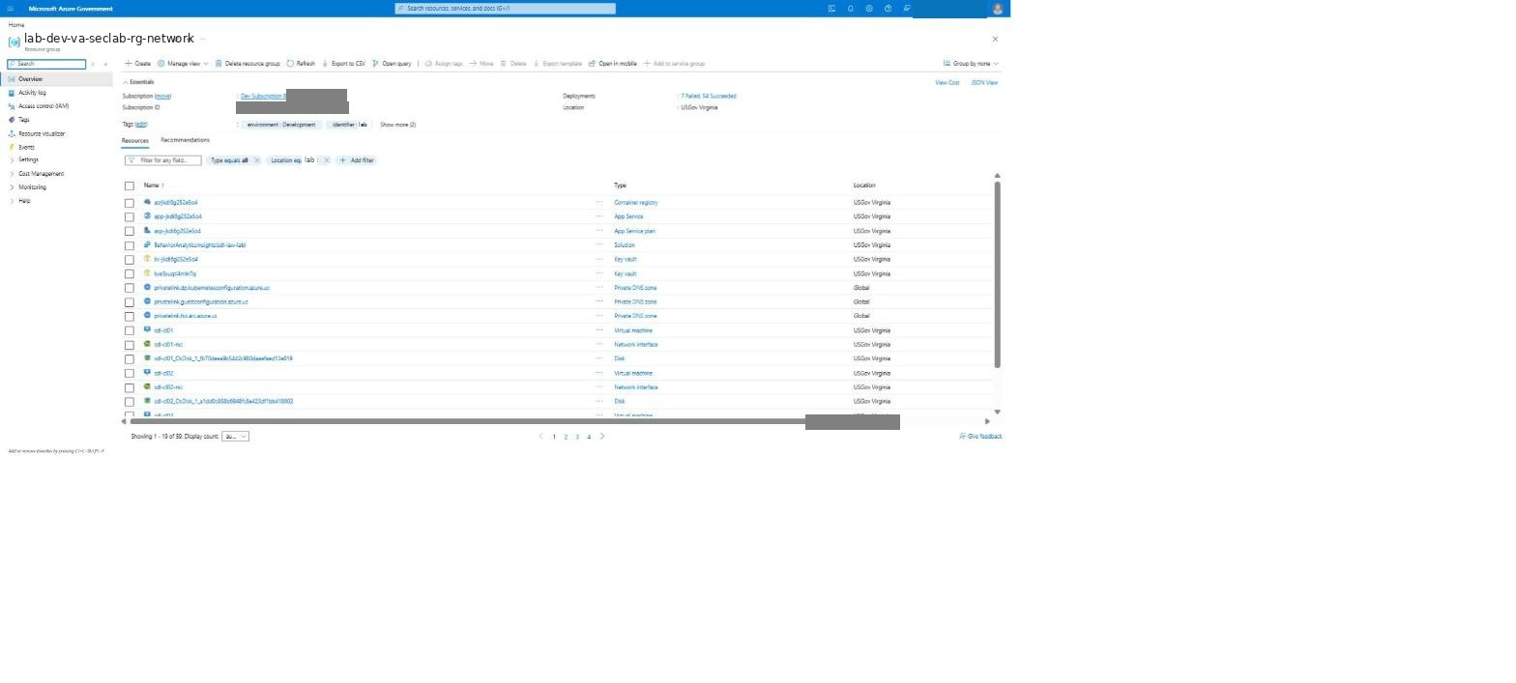
Figure: Resource group

6.2 Microsoft Sentinel
Data connectors — 9 connected immediately (more once the Entra ID / Azure Activity logs arrive): Windows Security Events via AMA, Syslog via AMA, Microsoft Defender XDR (which also lights up Defender for Endpoint / Identity / Cloud Apps / Office 365 / Entra ID Protection / Insider Risk), plus the Entra ID and Azure Activity connectors once their first logs arrive (10–30 minutes after step 5).
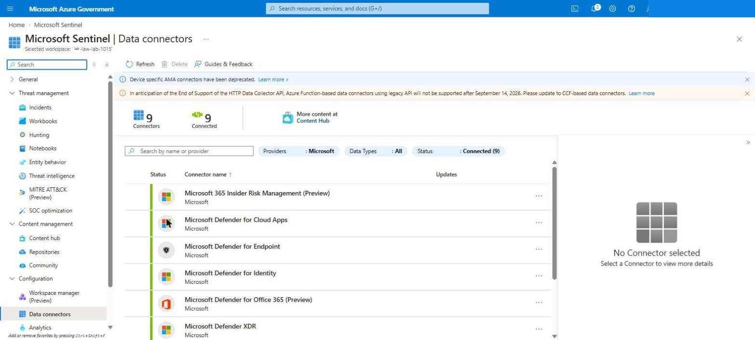
Figure: Data connectors
Analytics — 264 active rules (76 High, 158 Medium, 30 Low) created from the built-in templates.
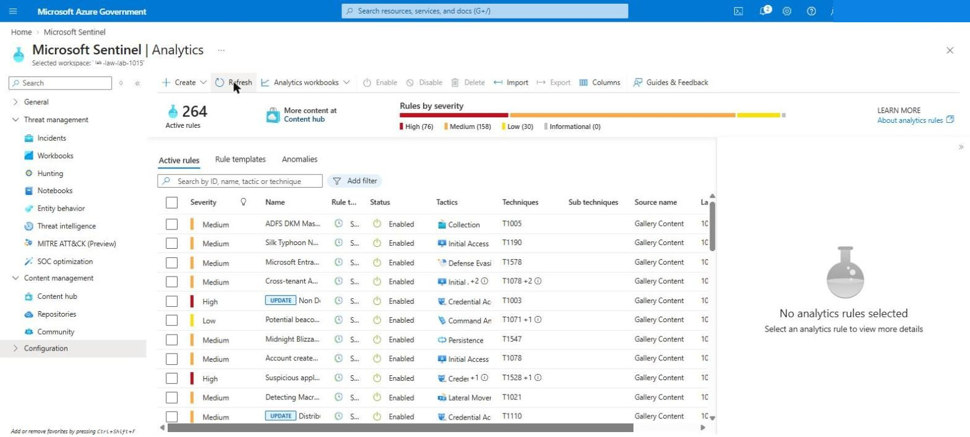
Figure: Analytics rules
Content hub — 6 solutions Installed (Azure Activity, Microsoft Defender XDR, Microsoft Entra ID, Windows Security Events, Syslog, UEBA Essentials).
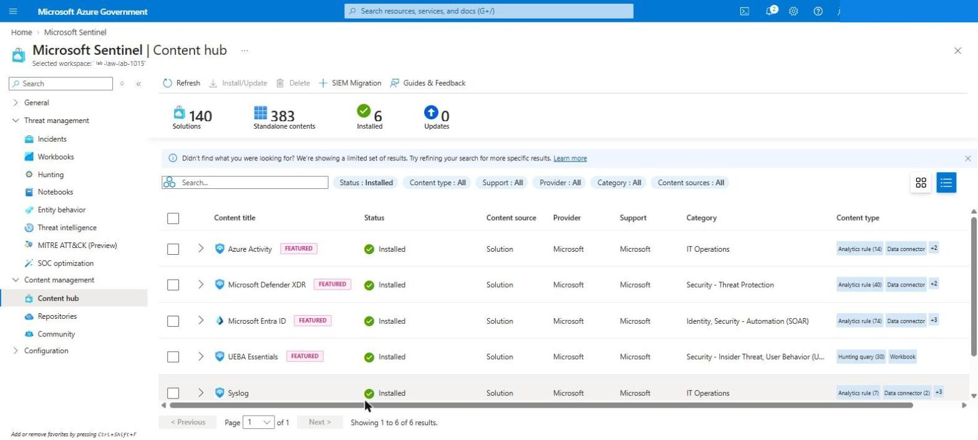
Figure: Content hub
Entity behavior — Entity behavior settings shows UEBA On with Security Events selected; Audit Logs, Azure Activity and Signin Logs become selectable as soon as those tables receive data.
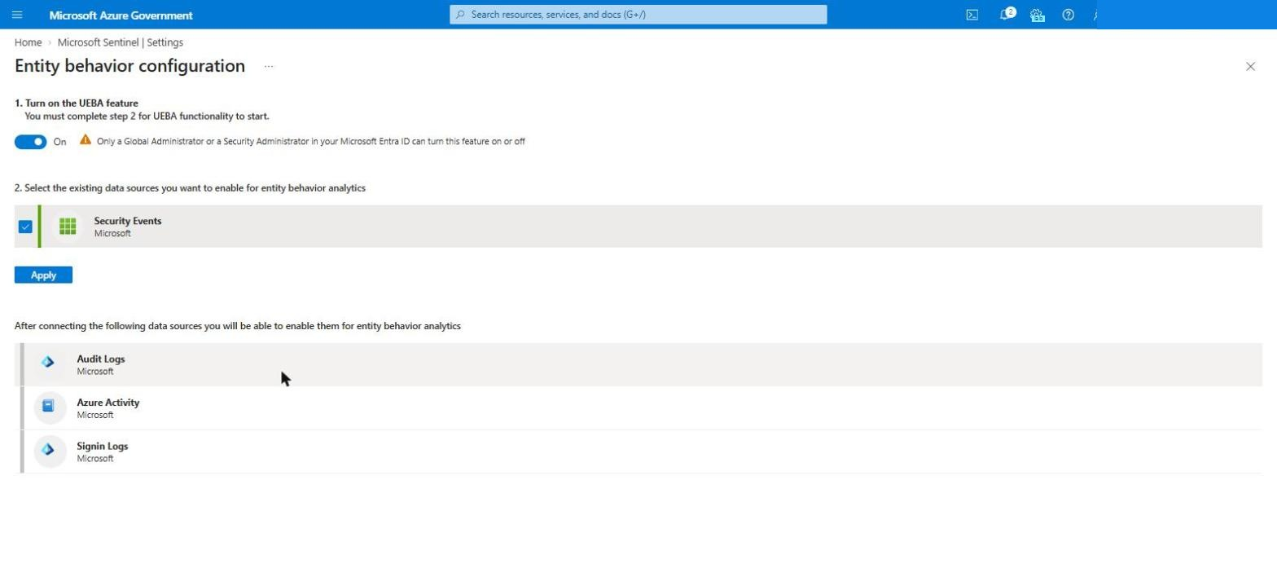
Figure: UEBA settings

6.3 Bastion sign-in
Linux: open lab-ubu01 → Connect → Bastion → Microsoft Entra ID → Connect; members of the step 3.1 group get an administrator SSH session with their Entra account. Windows: VM password with labadmin@corp.contoso.lab (see 5.2.5 for why Entra RDP does not apply to domain-joined VMs).

6.4 Defender for Cloud plans
Microsoft Defender for Cloud → Environment settings → the subscription → Defender plans. Expected: Defender CSPM, Servers (Plan 2), Databases, Storage, Containers, Key Vault and Resource Manager On; App Service and APIs Off (not offered in Azure Government).
On this run Defender for Servers read back as Off even though the deployment operation had succeeded (troubleshooting #23) — Post-Deploy.ps1 now re-asserts it, and you can always set it by hand:
az security pricing create -n VirtualMachines --tier Standard --subplan P2
az security pricing list --query "value[?pricingTier=='Standard'].{plan:name,subPlan:subPlan}" -o table
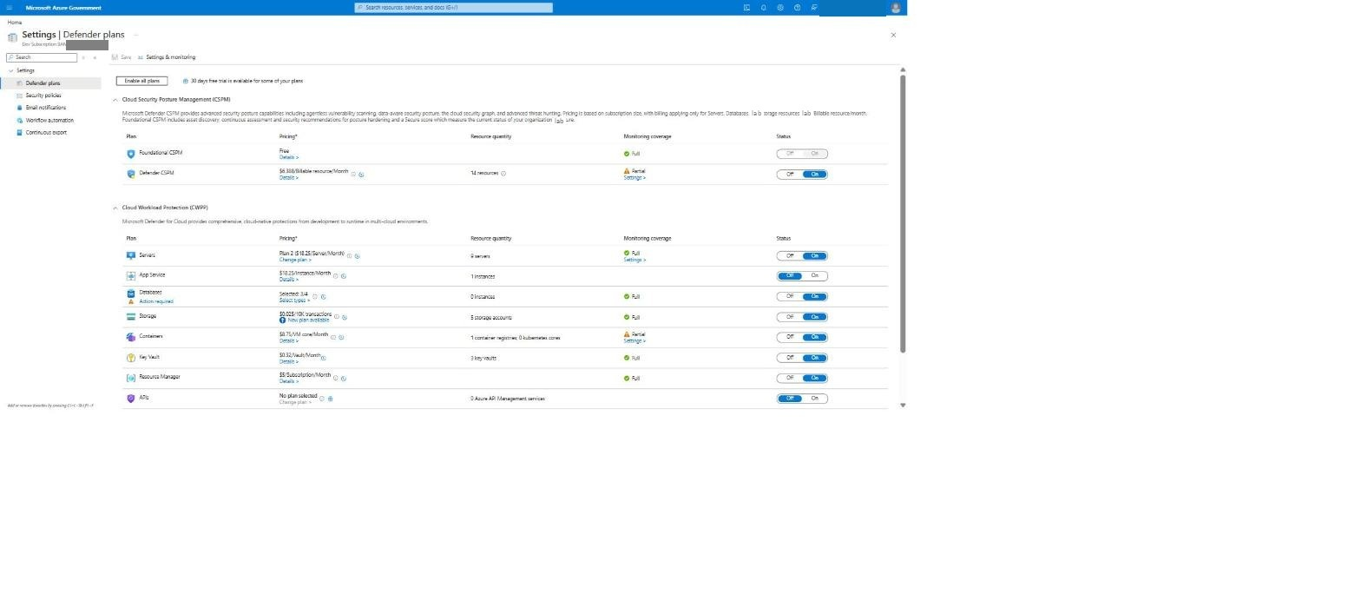
Figure: Defender plans

6.5 Data hydration reaching the workspace
About an hour after the deployment, run this in the Sentinel workspace (Logs):
union
(SecurityEvent | where EventID in (4728, 4729) and MemberName has "churn"
| summarize Events = count(), Last = max(TimeGenerated) by Signal = "AD group churn (4728/4729)", Computer),
(SecurityEvent | where EventID in (4625, 4771) and TargetUserName has "churn"
| summarize Events = count(), Last = max(TimeGenerated) by Signal = "failed sign-in lab.churn", Computer),
(SecurityEvent | where EventID == 4688 and CommandLine has "nltest" and CommandLine has "dsgetdc"
| summarize Events = count(), Last = max(TimeGenerated) by Signal = "Windows user activity (nltest)", Computer),
(Syslog | where ProcessName == "lab-hydrate" or SyslogMessage has "lab-hydrate"
| summarize Events = count(), Last = max(TimeGenerated) by Signal = "Linux lab-hydrate", Computer)
| order by Signal asc, Computer asc
Expect one row per signal and computer, with Last within the past hour: AD group churn and failed sign-in on the domain controller, Windows user activity on every Windows VM, Linux lab-hydrate on the three Linux servers.
In this run (lab built before the fixes in troubleshooting #46 and #47) only the first and third signals appeared — the group churn on the DC (22 events in 24 h, one per hour) and the user activity on all six Windows VMs:
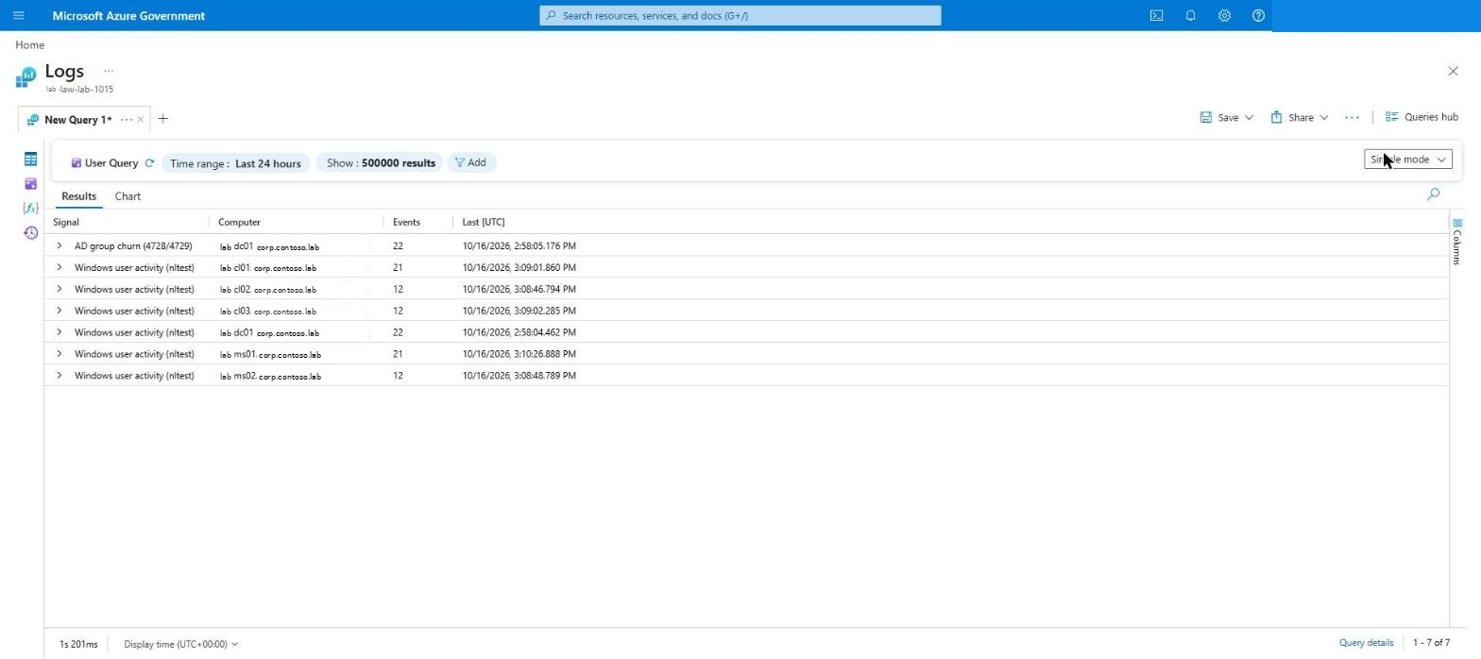
Figure: Hydration check: group churn on the DC, user activity on every Windows VM

7. Teardown
destroy.ps1 discovers every resource group by the naming prefix and deletes them in parallel. It also: force-deletes the Log Analytics workspaces and purges them from soft-delete (otherwise the next deploy recovers the old workspace), purges the Key Vaults, removes the policy assignments, resets the Defender plans, and deletes the NSG flow logs the MLZ hub left in NetworkWatcherRG (they are not in any lab resource group and would otherwise linger).
Invoke-WebRequest -Uri "https://raw.githubusercontent.com/lee-aguilar-msft/Azure-MLZStarterKit-Security/main/destroy.ps1" -OutFile destroy.ps1
./destroy.ps1 -SubscriptionId <subscription-id> -Identifier lab -EnvironmentAbbreviation dev `
-Location usgovvirginia -RemoveDefenderPlans -RemovePolicyAssignments -Force
Expect 20–40 minutes (the Azure Firewall and Bastion are the slow deletes). Check afterwards that Resource groups shows none with the lab-dev-va- prefix and that NetworkWatcherRG holds only the NetworkWatcher_usgovvirginia resource. Run it from a Cloud Shell session you keep active — if the shell drops mid-run, simply run it again; it is safe to repeat.
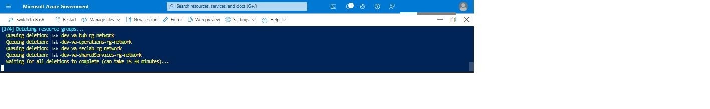
Figure: Teardown running
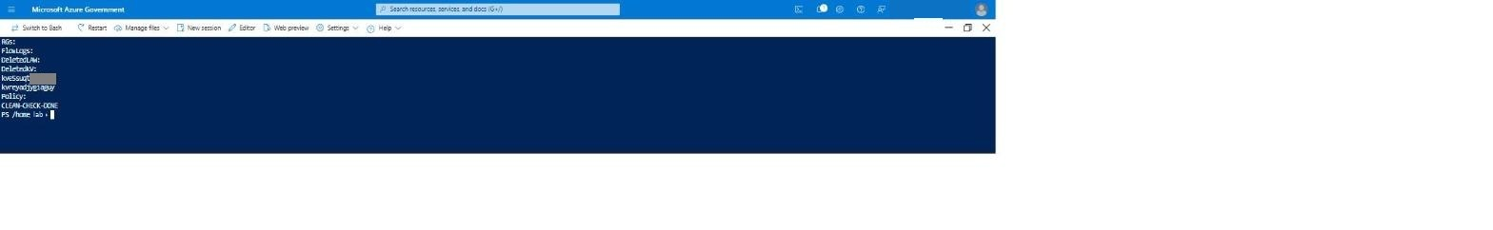
Figure: Clean check
The tenant-level Entra ID diagnostic setting (sentinel-lab) is not removed by destroy.ps1: delete it under Microsoft Entra ID → Diagnostic settings if you are not redeploying.

8. Troubleshooting — every error hit while writing this guide
All fixes below are on main; they are listed so you recognise them if you fork the kit.
# | Where | Error | Cause | Fix (in the kit)
1 | Review + create | 'lab-dev-va-seclab-rg-network' is not valid subscription identifier | resourceId(rg, type, name) in a subscription-scope template is parsed as (subscriptionId, type, name) | Nested RG deployments are referenced by name in dependsOn; no cross-RG resourceId()
2 | Review + create | deploy-ad-entra-vms-… is not defined in the template | reference() to a sibling nested deployment is not resolvable at validation time | security-lab.json derives VM names from the prefix parameter
3 | Deployment | Enabling Defender for APIs requires selection of a pricing plan … SubPlan … P1–P5 | Microsoft.Security/pricings Api needs subPlan | Parameter defenderForApisSubPlan (default P1); plan hidden in Gov
4 | Deployment | The 'Dns' plan is deprecated and can no longer be enabled | Defender for DNS retired | Plan, parameter and checkbox removed
5 | Deployment | policy set definition '…f9a961fa-…' could not be found | Standalone DoD IL5 initiative retired | Replaced by Microsoft cloud security benchmark (deployMcsb)
6 | VM module | MDE.Windows extension: You cannot call a method on a null-valued expression | Template-declared MDE extensions need an onboarding blob Defender for Servers supplies itself | MDE extensions removed; Defender for Servers auto-provisions
7 | VM module | lab-dc01-nic static IP 10.60.0.10 already allocated to lab-pe-arc-nic | Parallel NIC creation: the Arc private-endpoint NIC grabbed the DC's address first | NICs created serially; Arc module runs after the VM module
8 | VM module | AADSSHLoginForLinux failed on RHEL | Azure RHUI (rhui4-1.microsoft.com) blocked by the firewall — package install could not resolve dependencies | RHUI FQDNs added to the Linux-repos rule; prep-linux.sh run-command refreshes repos first
9 | VM module | AADSSHLoginForLinux failed on Ubuntu (apt lock) | cloud-init / unattended-upgrades still held the apt lock | prep-linux.sh waits for cloud-init and package locks
10 | CSPM module | API Management operation: One or more fields contain incorrect values | Sample API id echo-api collided with APIM's built-in Echo API | Renamed lab-echo-api
11 | CSPM module | Location 'USGov Virginia' is not accepting creation of new Windows Azure SQL Database servers | Subscription offer not enabled for Azure SQL in the region | deployCspmSql toggle (off here); open a support request to enable the offer if you want the sample
12 | security-lab validation | DCR association name must be a single segment | Extension resource named with three segments | name: '<dcr>-assoc' with scope
13 | security-lab module | Rule Id …/lab-dcr-linux-syslog does not exist … InvalidAssociation | Linux DCR condition tested a parameter that was empty while the associations used the derived VM names | Condition uses variables('lnxNames'); module redeployed standalone
14 | Post-Deploy.ps1 | A positional parameter cannot be found that accepts argument '-EnableXdrConnector' | Array splat passed the switch positionally | Hashtable splat
15 | Enable-SentinelContent | InvalidAuthenticationToken: The access token is invalid | Az.Accounts 4+ returns Get-AzAccessToken as a SecureString | Token unwrapped via NetworkCredential
16 | Enable-SentinelContent | Solution '…' not found in catalog | Content Hub ids are publisher-prefixed (azuresentinel.azure-sentinel-solution-…) | Suffix match
17 | Enable-SentinelContent | The property 'requiredDataConnectors' cannot be found | StrictMode + templates without that property | Guarded filter
18 | Enable-SentinelContent | PUT contentPackages … 400 (Bad Request), then contentId … is already associated with another package | Registering a package by PUT only flips its status; the real install is the solution's packaged ARM template, which then conflicts with the stale record | Solutions installed by deploying packagedContent; stale records removed first
19 | Enable-SentinelContent | The property 'name' cannot be found on this object | Template id lives on the resource, not under properties | alertRuleTemplateName = $t.name
20 | Enable-SentinelContent | Duplicate analytics rules after re-running | Rule ids were new GUIDs every run | Existing rules indexed by template; duplicates deleted; re-runs skip
21 | Enable-SentinelContent | UEBA: Update request should provide ETag | Settings already existed | Current ETag read and sent
22 | Enable-SentinelContent | Connector kind 'MicrosoftThreatProtection' is not supported in api-version | Defender XDR connector is preview-only in the data connectors API | 2024-01-01-preview for connector calls; existing connector detected and skipped
23 | Verify | Defender for Servers showed Off / Free although the VirtualMachines pricing operation succeeded | Unexplained revert after the subscription-scope deployment | Post-Deploy.ps1 re-asserts Standard/P2 and prints the plans
24 | Cloud Shell | Cloud Shell disconnected / connection could not be established mid-script | Idle timeout; ephemeral session loses the clone | Restart, re-clone, re-run — every script is idempotent
25 | Teardown | NetworkWatcherRG keeps lab-dev-va-*-nw-fl-vnet flow logs; next deploy fails on the soft-deleted workspace | MLZ flow logs live outside the lab RGs; Log Analytics soft-delete | destroy.ps1 deletes flow logs by id and purges the workspaces
26 | Intune | Clients hybrid-joined but never enrolled; deviceenroller errors 0x8018002b / 0x80180026 | GCC High tenant still had the commercial .com MDM URLs | Set the .us MDM terms-of-use / discovery / compliance URLs and the MDM user scope (5.2.2)
27 | Forest build | Deployment Succeeded but the member servers and clients were still in WORKGROUP; join-domain output: The system cannot find the file specified | The forest baseline (OUs) ran while DC promotion was still in progress and was killed by the promotion reboot; the joins then targeted OUs that did not exist. treatFailureAsDeploymentFailure: false hid both failures | Joins wait for LDAP + DNS SRV on the DC (up to 50 min) and join the default container; the baseline runs after all joins and moves computers into their OUs; a final verify-forest run-command fails the deployment if any OU, GPO, computer placement or the SCP is missing
28 | Design review | Bastion Microsoft Entra ID RDP to Windows needs AADLoginForWindows, which Entra-joins the VM | An Entra-joined VM cannot also be AD-joined / hybrid-joined, which this lab depends on | Extension removed from the Windows VMs (kept for Linux SSH); Windows sign-in through Bastion uses AD credentials (5.2.5)
29 | Template validation | Image reference for the default client SKU win11-23h2-pro not found in USGov Virginia | Windows 11 23H2 images are not published in Azure Government | Default client image win11-24h2-pro; 23H2 removed from the form
30 | Teardown | Key Vault purge: MethodNotAllowed | Purge protection is on (MLZ hub vault) — purge is not allowed | Expected; the vault expires after the 7-day retention. Names are unique per deployment, so redeploys are not blocked
31 | Forest build (run 4) | configure-forest-baseline: Get-ADOrganizationalUnit : The object name has bad syntax — the deployment now fails here instead of reporting success | In PowerShell everything a function writes with Write-Output becomes part of its return value: Ensure-OU returned @('Created OU …', 'OU=…'), so the next OU's search base was an array | Helper functions log with Write-Host; the script was re-tested end-to-end against mocked AD cmdlets before redeploying
32 | VM module (run 4) | lab-ubu01/AADSSHLoginForLinux: Could not get lock /var/lib/apt/lists/lock. It is held by process … (apt-get) | On first boot an Ubuntu apt-get update stalled for 30+ minutes; prep-linux waited on it without a limit, hit its 25-minute run-command timeout and left the lock held | prep-linux.sh time-boxes every step, kills stuck apt jobs and never exits with the lock held (log in /var/log/lab-prep-linux.log); Ubuntu apt-hook hosts (*.ubuntu.com, contracts.canonical.com) allowed on the firewall
33 | Post-Deploy (run 4) | Enable-SentinelContent.ps1: The property 'Count' cannot be found on this object right after Matched 298 templates | A brand-new workspace holds exactly one rule (Advanced Multistage Attack Detection); PowerShell returns a one-item list as a scalar and StrictMode rejects .Count on it | List results are wrapped in @(); the script is idempotent, so just re-run Post-Deploy.ps1
34 | Cloud Shell (Azure Government) | Cloud Shell disconnected, then ConnectionFailure / ServiceUnavailable when reconnecting | Service-side Cloud Shell instability; an idle tab also drops after a few minutes | Keep the tab in the foreground and active; if it will not reconnect, wait a few minutes or open Cloud Shell in a new tab. Avoid the toolbar Restart (it raises a browser confirmation)
35 | Post-Deploy (run 4) | Every analytics rule rejected: Log Analytics workspace '<old id>' could not be found (the script now prints Sentinel still maps this workspace name to an earlier, deleted workspace) | An earlier teardown deleted a Sentinel workspace without offboarding Sentinel first. Sentinel keeps the old workspace ID for that name, so a new workspace with the same name inherits the stale mapping | Fixed in destroy.ps1 (offboards Sentinel — DELETE …/onboardingStates/default — before deleting the workspace). The portal form now defaults to a date-stamped workspace name (law-<short>-MMdd); do not re-use a deleted workspace's name. Portal teardown: Sentinel → Settings → Settings → Remove Microsoft Sentinel before deleting the workspace
36 | Security-lab redeploy (run 4) | lab-dcr-windows-security: Table for output stream 'Microsoft-SecurityEvent' is not available for destination 'law' (InvalidOutputTable) | The SecurityEvent table is created by the Sentinel solution a minute or two after the workspace is onboarded; the Windows DCR was written before it existed | Redeploy the same deployment (Deployments → select → Redeploy, same parameters) — the second run finds the table and completes. Moving Sentinel to a new workspace without touching the VMs: redeploy only deploy-security-lab-<suffix> with a new Workspace Name; the DCRs keep their names and are re-pointed, then re-run Post-Deploy against the new name
37 | Prepare-Tenant (run 4) | PATCH …/mobileDeviceManagementPolicies/0000000a-… → 400 Simultaneous patch requests on both URL properties and Policy properties (AppliesTo …) are currently not supported | Graph does not accept the MDM scope (appliesTo) and the MDM URLs in one request | Fixed: the script sends the scope and the URLs as two separate PATCHes, each only when the value differs. Re-run ./Prepare-Tenant.ps1 -Cloud USGov -ConfigureMde (after git pull in ~/kit)
38 | Bastion → Windows (run 4) | Username in domain\username format is not supported under the username, then Connection Error — Log in failed, Please reconnect and try again | The Azure portal's Bastion form only accepts domain accounts in UPN form | Use labadmin@corp.<domain> (or lab.user@corp.<domain>) instead of CORP\labadmin. Inside Windows and in the Entra Connect wizard CORP\labadmin still works
39 | Entra Connect wizard (run 4) | Cannot change configuration — Synchronization is currently in progress; Get-ADSyncScheduler fails with 0x80230613 … management agent could not be found, Azure AD Sync 2.4.129.0, no connectors | The public AzureADConnect.msi link still serves 2.4.x, retired by Microsoft on 30 Sep 2026 (minimum 2.5.79.0); the engine was installed but never configured | Download Connect Sync Agent from the Entra admin center (Entra Connect → Get started → Manage) on lab-ms01 and run it (upgrade in place, or uninstall the 2.4 build first). The kit no longer pre-installs the old build
40 | Entra Connect download on lab-ms01 (run 4) | portal.azure.us never finishes loading inside the lab VM; the firewall log shows aadcdn.msftauth.net / aadcdn.msauth.net denied from the server | The Azure service tags (and the AzureCloud catch-all) cover Azure IP ranges only; the Microsoft sign-in page loads from CDN host names that no service tag contains, so they need FQDN application rules | Fixed: new application rule Allow-Admin-Portal-EntraConnect (Microsoft's Azure Government portal list + sign-in CDN + Entra Connect Sync endpoints). Existing labs: deploy templates/firewall-lab-rules.json to the hub resource group (parameter: the hub firewall policy name, e.g. lab-dev-va-hub-afwp) — it re-applies the whole LAB-SecurityCollectionGroup in about 3 minutes
41 | Entra Connect first sync (run 4) | Only the two Full Import runs appear; Start-ADSyncSyncCycle fails with A sync cycle has already being requested and then …unable to start a new sync cycle because Azure AD Connect wizard is open | The wizard was still open (its Configuration complete page, or a leftover window); the scheduler will not run while any wizard instance is open | Click Exit on every Entra Connect wizard window (or `Get-Process AzureADConnect
42 | Hybrid join (run 4) | C:\LabTools\Invoke-HybridJoinCycle.ps1 not found on lab-ms01 | The script was never staged on the server, and Windows 11 clients have WinRM off, so its remote trigger could not work either | Fixed: the Entra Connect server now gets the script in C:\LabTools, the clients enable WinRM (domain profile), and the script starts the SYSTEM join tasks instead of running dsregcmd /join in the remote admin session. On an existing lab: Start-ADSyncSyncCycle -PolicyType Delta on lab-ms01 → portal Run command on the client: dsregcmd /join → delta sync again → dsregcmd /status shows AzureAdJoined : YES (the clients' LAB-HybridJoin-Retry task also retries every 30 min)
43 | Intune enrollment (run 4) | Client never enrolls; dsregcmd /status changes to AzureAdPrt : NO; Microsoft-Windows-AAD/Operational event 1098 AADSTS50173: The provided grant has expired due to it being revoked … TokensValidFrom … | The lab user signed in before Entra Connect's first password hash sync for that user had landed; the first cloud password write revokes the tokens issued before it, including the PRT that user-credential MDM auto-enrollment needs | Sign the lab user out of the client and back in (same password) to get a fresh PRT, then run deviceenroller.exe /c /AutoEnrollMDM in that user's session (or wait for the enrollment task). Avoid it next time: wait ~5 minutes after the user appears in Entra before the first client sign-in
44 | Intune enrollment (run 4) | Hybrid joined, AzureAdPrt : YES, AutoEnrollMDM = 1 on the client, but no Schedule created by enrollment client… task under \Microsoft\Windows\EnterpriseMgmt and no event 75/76 — enrollment is never attempted | The GPO was written with Set-GPRegistryValue, which registers only the Registry extension. The task is created by the MDM Policy client-side extension ({7909AD9E-09EE-4247-BAB9-7029D5F0A278}, dmenrollengine.dll), which the Group Policy editor registers for this ADMX setting | Fixed in Configure-ForestBaseline.ps1 (adds [{7909AD9E-…}{D02B1F72-…}] to the GPO's gPCMachineExtensionNames and bumps the version). Existing lab: run the same on the DC (or toggle the setting Disabled → Enabled in GPMC), then gpupdate /target:computer /force on the client; the task enrolls within ~5 minutes
45 | Intune enrollment (run 4) | The enrollment task runs every 5 minutes but LastTaskResult stays 3400073247 (0xCAA9001F, Integrated Windows authentication supported only in federation flow); the AAD log shows AADSTS50079 (MFA registration required) | Two causes, in order: (1) the on-prem UPN (lab.user@corp.<domain>) did not match a verified cloud domain, so the synced user got a different cloud UPN than the one Windows presents; (2) user-credential auto-enrollment silently needs a token that satisfies MFA, and a PRT from a password-only sign-in does not carry the MFA claim | Set the UPN suffix Lab Option to the tenant's verified domain (e.g. <tenant>.onmicrosoft.us) so synced users match; have the lab user register MFA once. If auto-enrollment still fails, enroll manually as the lab user: Win+R → ms-device-enrollment:?mode=mdm&username=<lab user UPN> → sign in. Settings → Accounts → Access work or school then shows Connected to &lt;tenant&gt; MDM with an Info button. The device appears in Intune within ~15 minutes (Info → Sync speeds it up)
46 | Data hydration (run 4) | The 6.5 query shows group churn and Windows activity but never failed sign-in lab.churn | Invoke-LabHydration.ps1 tried the bad password through a WMI call with explicit credentials against the local machine; Windows rejects credentials on local WMI connections before any sign-in is attempted, so no 4625/4771 was ever logged | Fixed: the script now calls PrincipalContext.ValidateCredentials twice with a wrong password, which produces real failed sign-ins on the DC. Existing lab: copy the updated script over C:\LabTools\Invoke-LabHydration.ps1 on the DC (the LAB-Hydration task picks it up at the next run)
47 | Data hydration (run 4) | No Linux lab-hydrate rows; on the Linux VMs /usr/local/bin/lab-hydrate.sh and the lab-hydrate timer do not exist although /var/log/lab-configure.log ends with CONFIGURE-STATUS: Success | The template hands the hydration script to configure-linux.sh as a Run Command parameter (arg2); it never arrived as the positional $2 the script read (the Linux Run Command handler passes named parameters as environment variables), so the script saw no hydration payload and skipped that part (the cloud suffix in arg1 fell back to its us default, which hid the problem in Azure Government) | Fixed: configure-linux.sh accepts the parameters either way and logs what it received. Existing lab: re-run the configure-linux run command, or redeploy the VM module
48 | MLZ core, Azure Commercial | Subscription … is not registered for feature Microsoft.Network/AllowBringYourOwnPublicIpAddress required to carry out the requested operation on a firewall or Bastion public IP | The MLZ public IPs are plain Standard IPs; the requirement comes from the subscription (Microsoft-internal subscriptions, or a policy that adds IP tags to public IPs) | Register the feature (section 2.3), wait for Registered, az provider register -n Microsoft.Network, then tear down and redeploy. If it stays Pending, the subscription needs approval through a support request (days) — use another subscription meanwhile
49 | Deployment, Azure Commercial | Four of the eleven Microsoft.Security/pricings resources end in Conflict — Another update operation is in progress. Please retry in a few minutes | Commercial's Defender pricing API serialises plan changes per subscription; the template created all plans in parallel (Gov tolerated it) | build/gen_solution.py chains the plans with dependsOn so ARM creates them one at a time (a dependency on a toggled-off plan is still satisfied)
50 | MLZ core, Azure Commercial | Azure Firewall Premium ends in provisioning state Failed with InternalServerError: An error occurred.; the rule collection group then fails with Put on Firewall Policy … Failed with 1 faulted referenced firewalls and the whole core deployment fails | Platform-side fault while the firewall was being built (nothing in the template; East US, Premium tier) | Tear down (destroy.ps1) and redeploy. Do not try to repair a firewall in Failed state in place — Redeploy on the failed deployment reuses the faulted instance
51 | Compute tab / VM module, Azure Commercial | Every D-series size shows NotAvailableForSubscription in East US (or the deployment fails with SkuNotAvailable) although the quota is 100 vCPU per family | Region-level VM restrictions on the subscription (common on internal, trial and new subscriptions); the earlier hard-coded Commercial size list offered sizes regardless | Commercial size pickers replaced with Microsoft.Compute.SizeSelector, which lists only sizes the subscription can deploy in the selected region (D v5/v6/v7, 2-16 vCPU). Check regions with the SKU API (section 2.4) and deploy where the list is not empty — West US 2 on the test subscription

Finding blocked destinations — query the operations workspace (firewall diagnostics land in AzureDiagnostics):
AzureDiagnostics
| where TimeGenerated > ago(3h) and Category in ("AzureFirewallApplicationRule", "AzureFirewallNetworkRule")
and msg_s has "Deny" and msg_s !has "ICMP" and msg_s !has "SNI TLS"
| parse msg_s with Proto " request from " Src ":" SrcPort " to " Dst ":" DstPort "." *
| summarize Hits=count(), Last=max(TimeGenerated) by Src, Dst
| order by Last desc
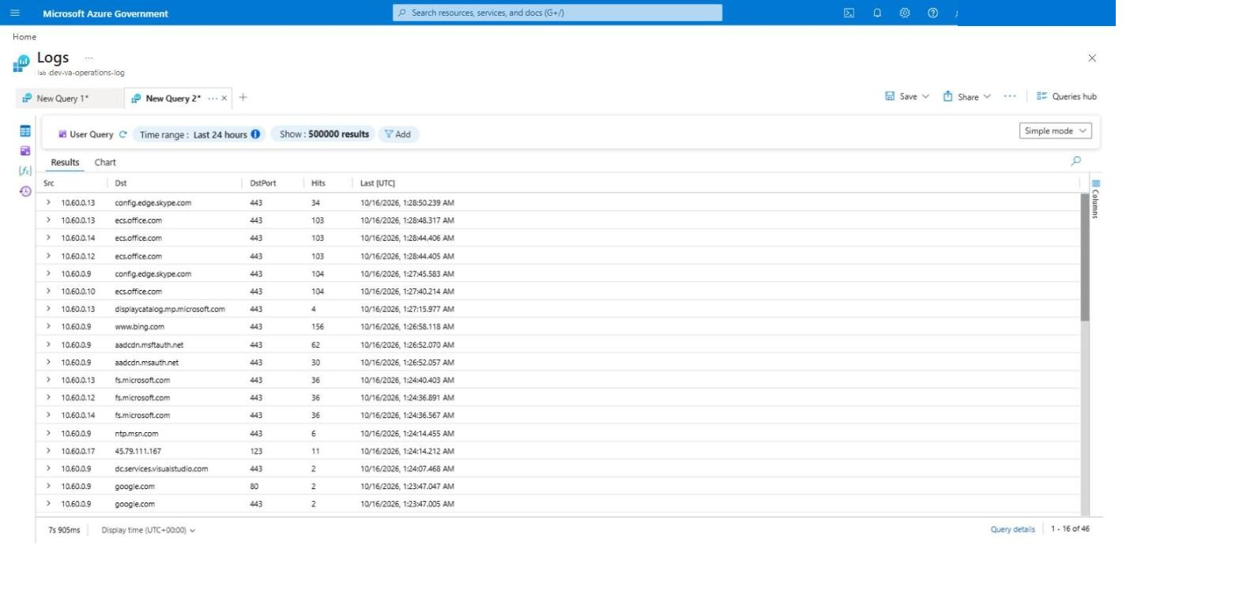
Figure: #40 firewall denies from lab-ms01
Run 4 — #35, the rule save rejected because Sentinel still maps the workspace name to a deleted workspace, and #36, the Windows DCR written before the SecurityEvent table existed:
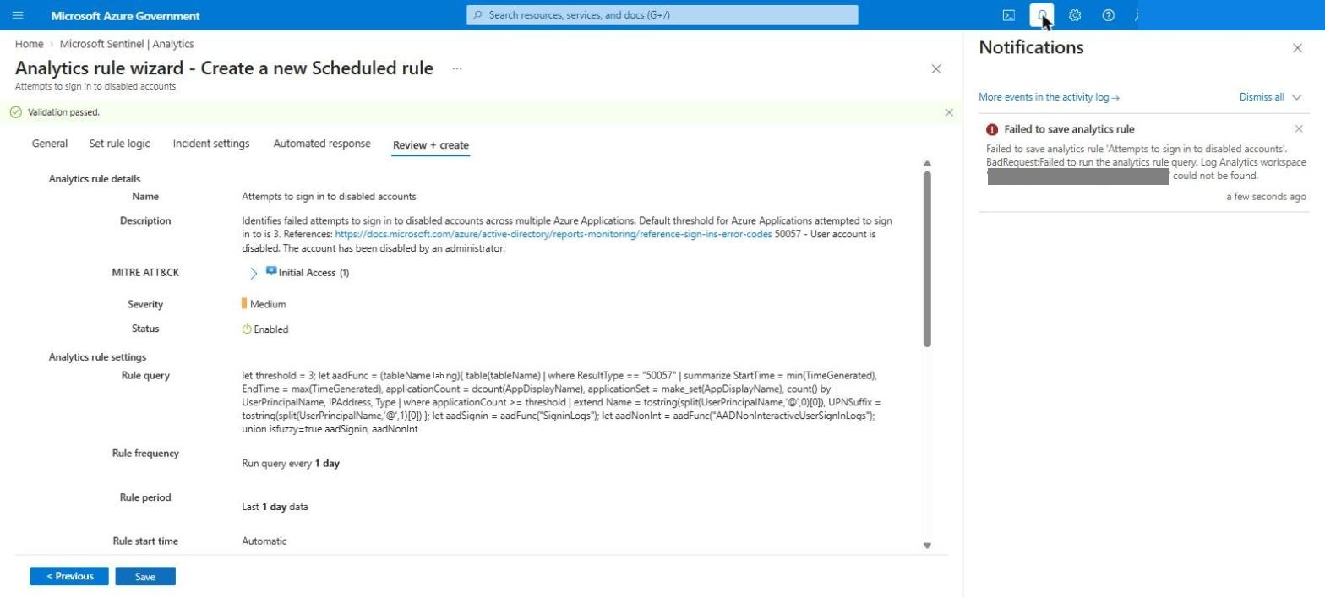
Figure: #35 stale workspace mapping
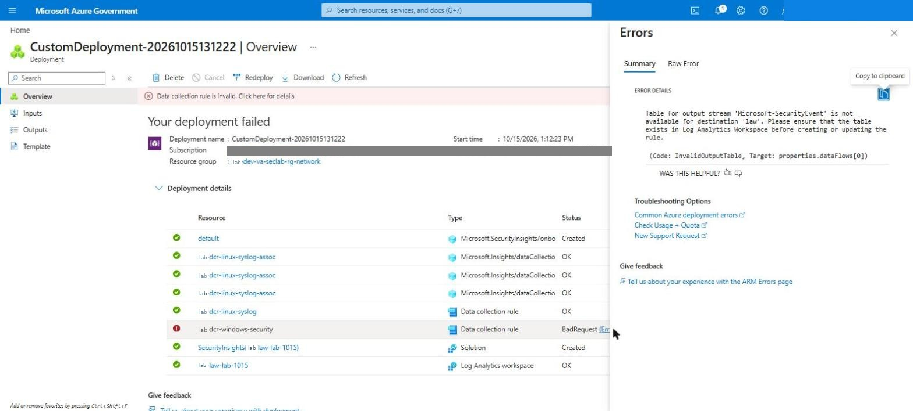
Figure: #36 SecurityEvent table not yet available
Screenshots of the defects as they appeared (runs 1 and 2):
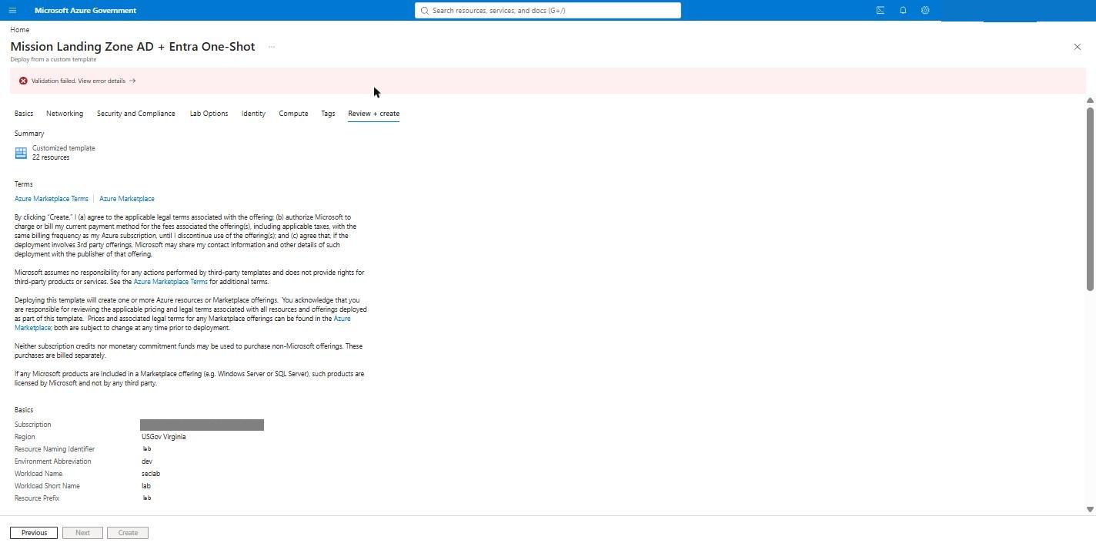
Figure: Validation failed
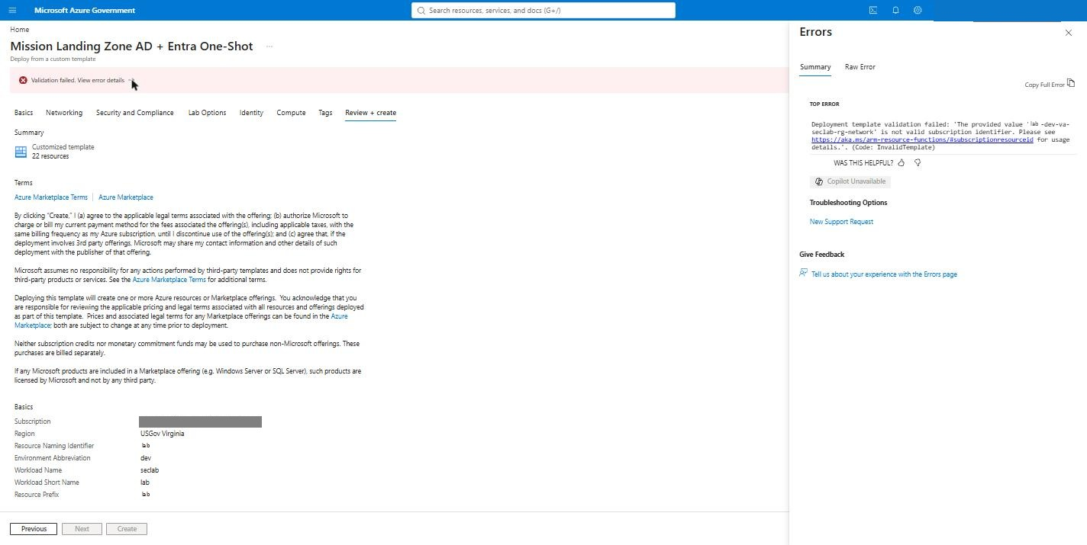
Figure: Validation error details
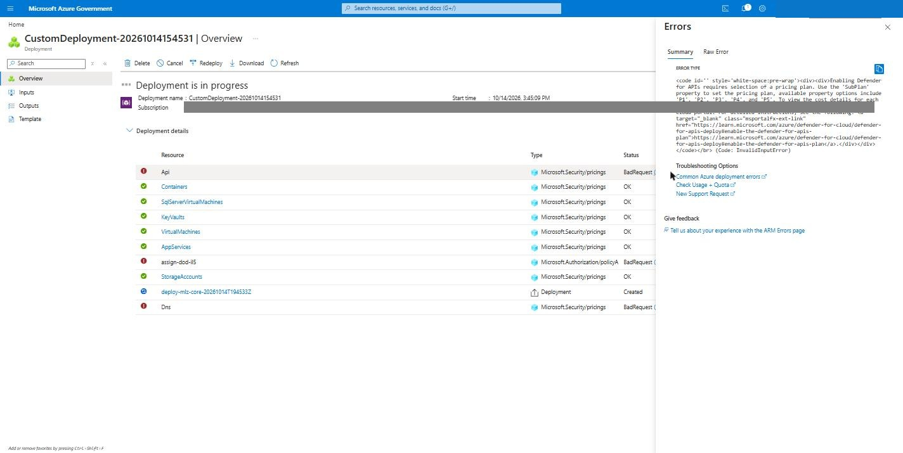
Figure: Run 1: Defender for APIs sub-plan
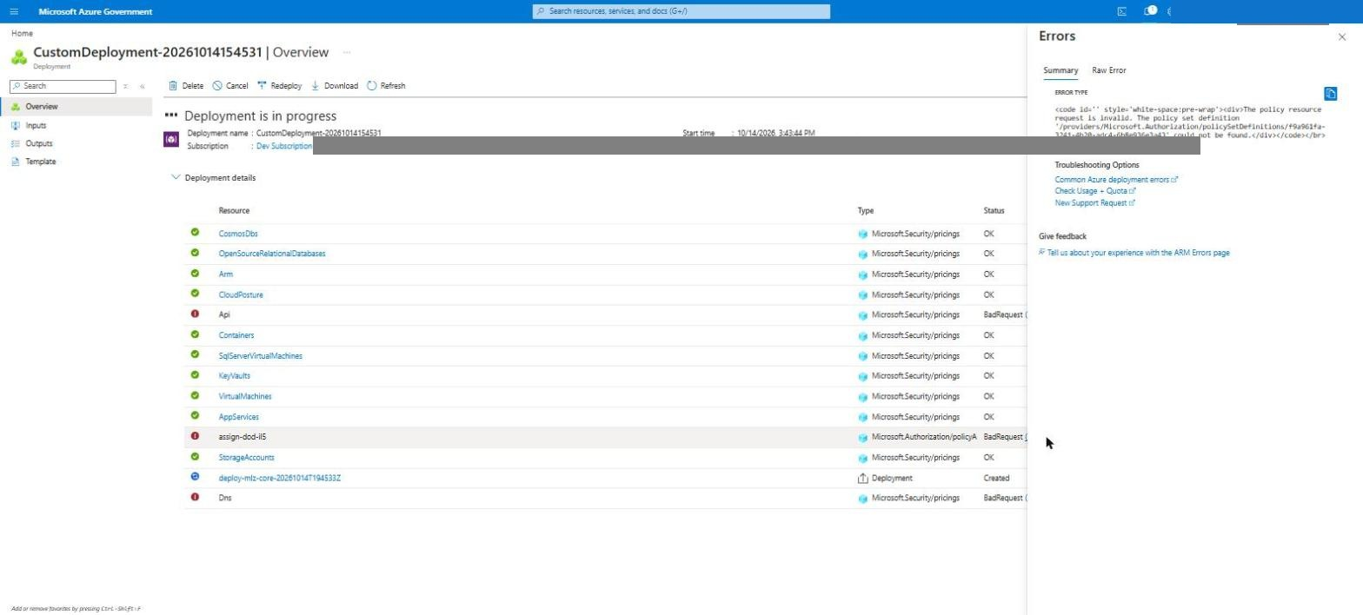
Figure: Run 1: IL5 initiative not found
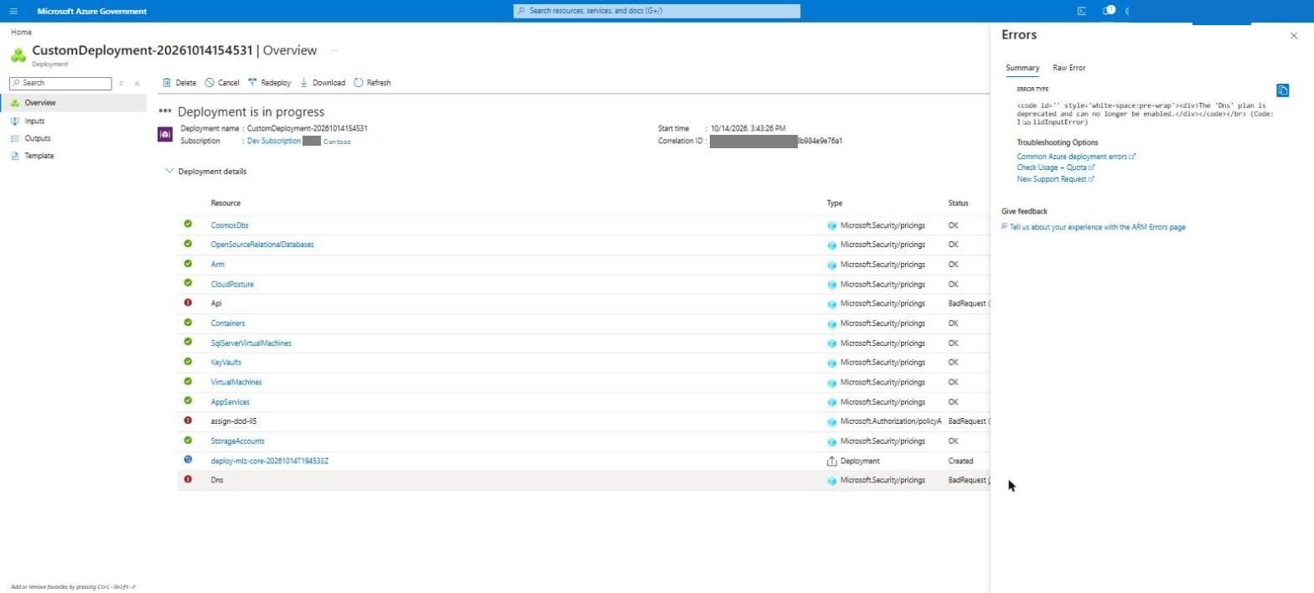
Figure: Run 1: Defender for DNS deprecated
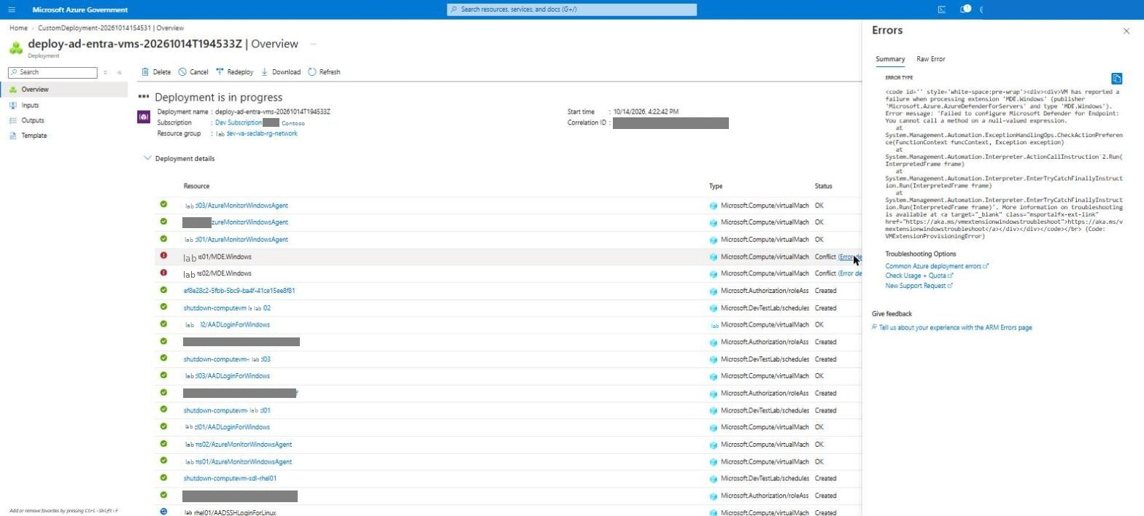
Figure: Run 1: MDE extension
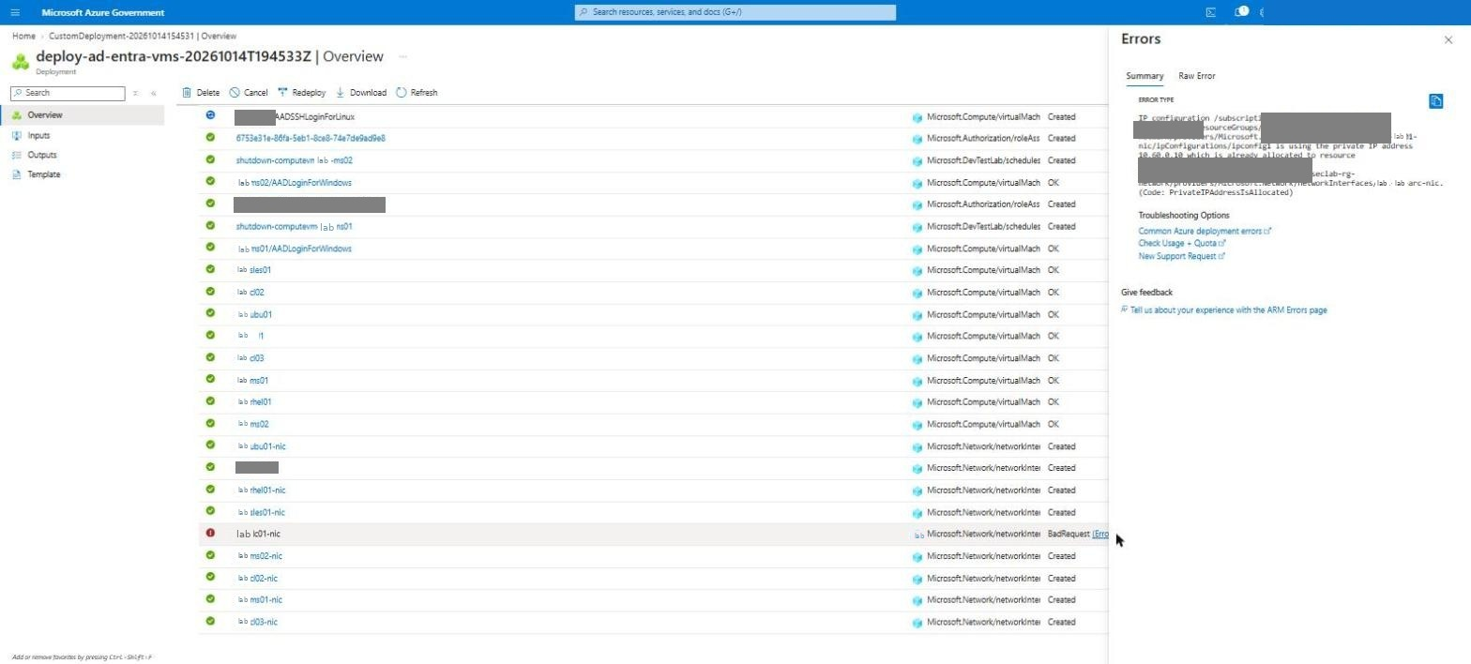
Figure: Run 1: DC IP taken by Arc private endpoint
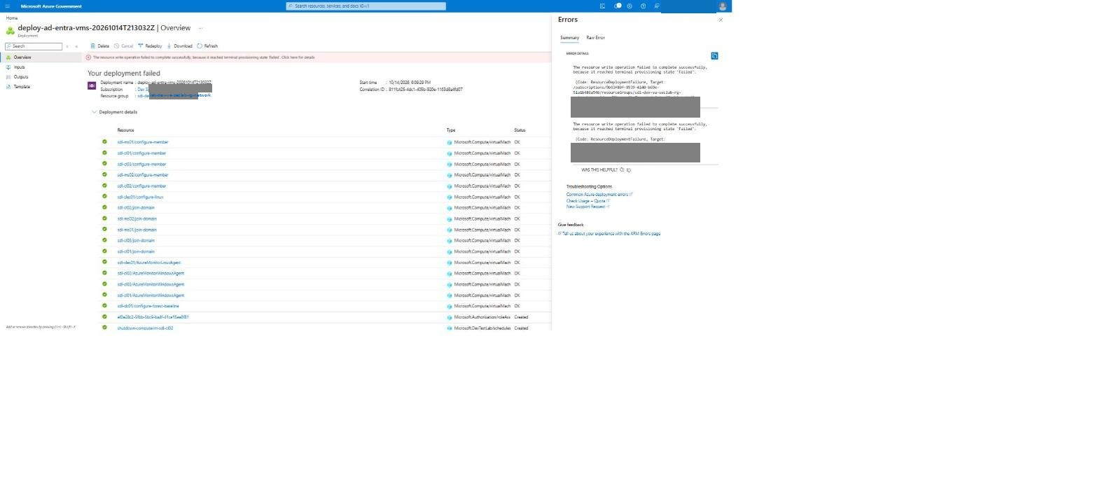
Figure: Run 2: Linux Entra SSH login failed
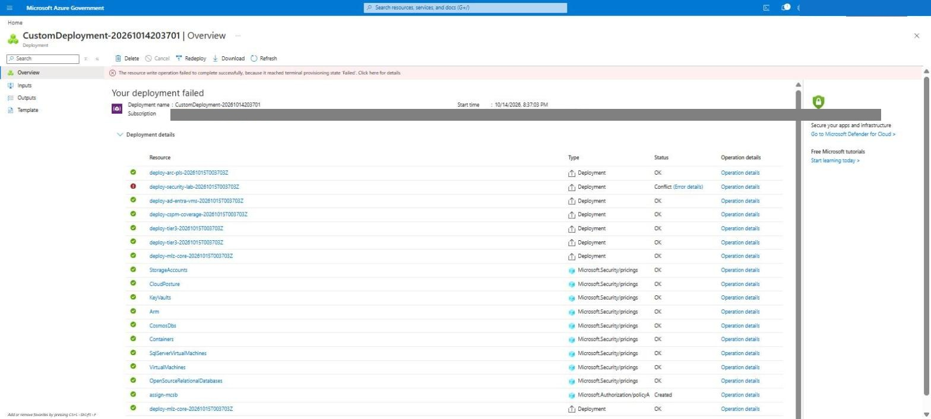
Figure: Run 3: security-lab conflict
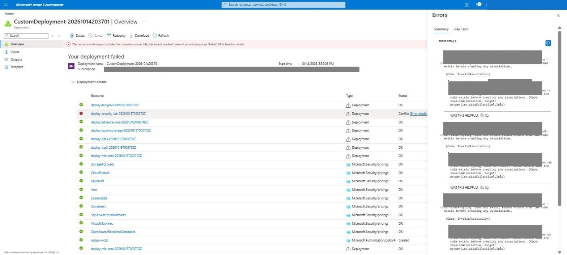
Figure: Run 3: Linux DCR missing
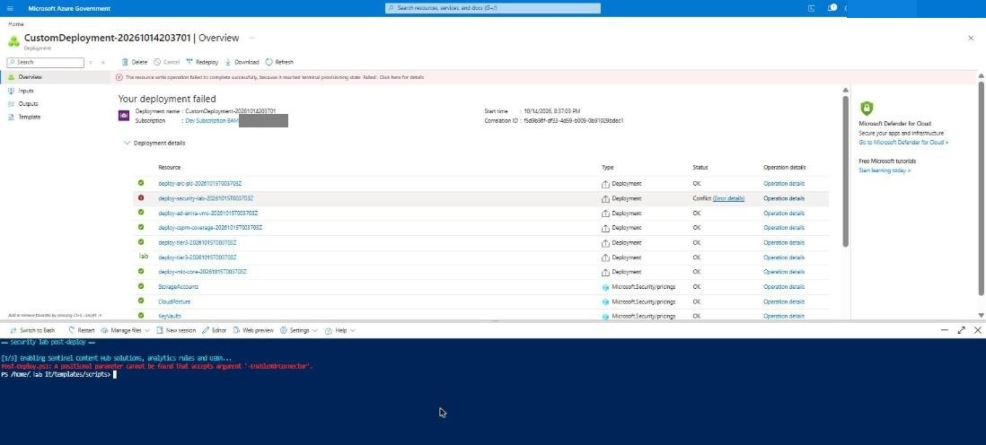
Figure: Post-deploy: splat error
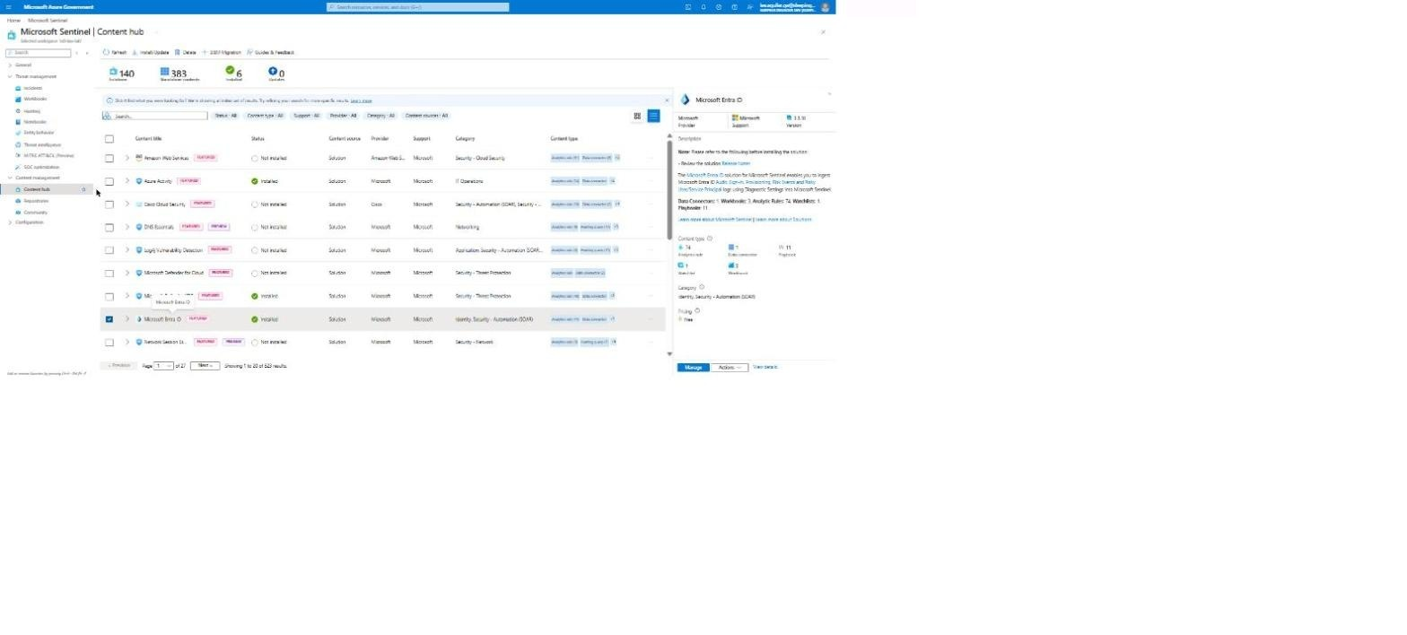
Figure: Content hub before the packaged-content install
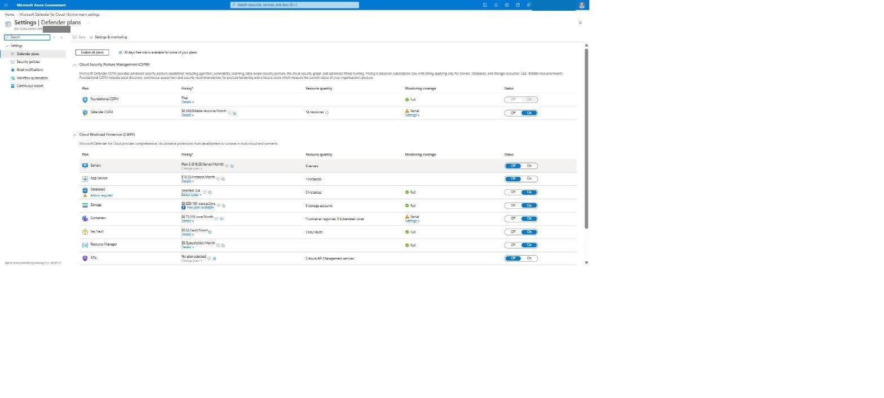
Figure: Defender for Servers before the fix

