Terminal Lesson Plans

Terminus
https://web.mit.edu/mprat/Public/web/Terminus/Web/main.html

Objectives
The goal is for students to be able to:
- use a text-based interface to navigate a computer via basic commands
- understand the syntax of a terminal command
- know how to find documentation about unknown terminal commands
- write the path from one location to another

Task
Try to get to the Portal location, and go through. Answer these questions as you go along.
- Which terminal command(s) allow you to:
  - Figure out your current location?
  - Move to a different location?
  - See the contents of a file?
- What do the following terminal commands do?
  - pwd
  - mv
  - man
- Draw a map of the Western Forest.
- What is the path:
  - from WesternForest to Lessons?
  - from SpellcastingAcademy to StataCenter?
- Define the syntax for a terminal command. Explain.
- What is the difference between a file and a folder/directory?

We will now demonstrate how to navigate your own computer using a terminal.
- What do .. and . represent?
- How do you move a file from one location to another?
- What are paths used for in a terminal command?
- What do these commands do?
  - mv bigFile.dat ../BigStorage/BigDrawer
  - rm /mnt/d/garbage.can
  - echo “Hello” > greeting.txt
  - cat ../../secretFile.key
  - cp ../../glue.glu crafts/paper

Bandit
https://overthewire.org/wargames/bandit/bandit0.html

Objectives
The goal is for students to be able to:
- ssh into a remote server
- use more advanced terminal commands
- get more familiar with reading documentation and researching information

Task
Get to level 5. Answer these questions as you go along.
Hint: You can use an asterisk (*) to indicate a wildcard that matches 0 or more characters.
- What does ssh do?
- What is a port, and how do you specify it when using ssh?
- How do you handle spaces in a filename?
- Write the command to list all files in a directory, even if they are hidden.
- How does using the * wildcard help with getting to level 5?

Commands
Students should understand how to use the following commands:
- man
- pwd
- ls
- cd
- mkdir
- touch
- grep
- cat
- less
- mv
- cp
- rm
- rmdir
- echo

If there are any commands you don’t know how to use, try looking online for references!

Exit Slip
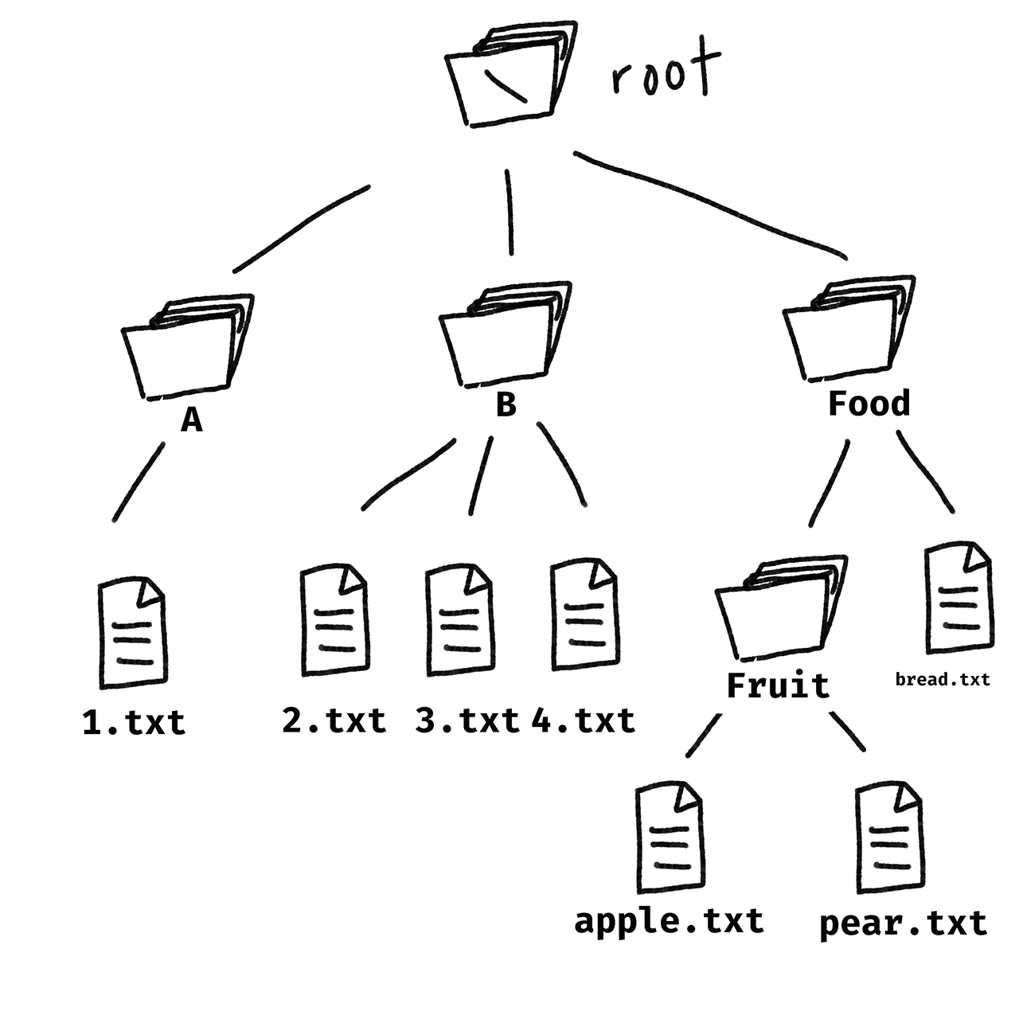
- Suppose you are currently in A. What is the relative path to apple.txt?
- What is the absolute path of pear.txt?
- What is the parent directory of Fruit?
- What terminal command(s) will move 3.txt from B to A?
- Suppose you are currently in Food. What terminal command(s) will let you see the contents of 1.txt?

