## L1: Intro + Homeostasis (1.1-1.4, 2.1-2.2, The Stuff of Life: Up to page 29)

* What is homeostasis?
* What is the efferent?
* What is a receptor?
  + **Hint:** Do two things.
* What are two main integrating centers?
  + **Hint:** One is just a continuation of the other.
* Find the control system's important aspects given some information.
* What is the control-integration center of the brain and in relation to the feedback loop?
* What is the afferent?
* What is the difference between homeostasis and equilibrium?
* What is a effector?
* What is the negative feedback mechanism and use temperature as an example?
* What is the cerebrum?
  + Handles conscious thoughts and actions.
* Which of these statements best describes negative feedback?
  + A change in a regulated variable triggers a response by the effector that opposes the change.
  + The input to a system increases the output, and the output limits its own production by inhibiting the input.
  + It is the main operating principle of most of the body’s homeostatic control mechanisms.
* Where should we add a stimulus from the environment?

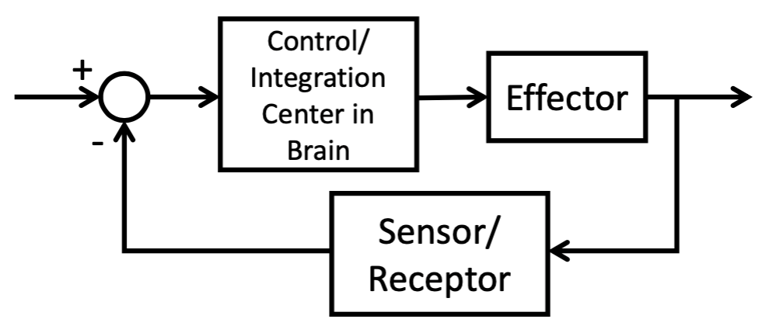

## L2: Intro to Cellular Organelles with a Focus on the Nucleus and DNA Molecules (1.1-1.4, 2.1-2.2, The Stuff of Life: Up to page 29)

1. Identify which are donors and which are acceptors? Draw the arrows and show what way the hydrogen bond is happening within the base pairs

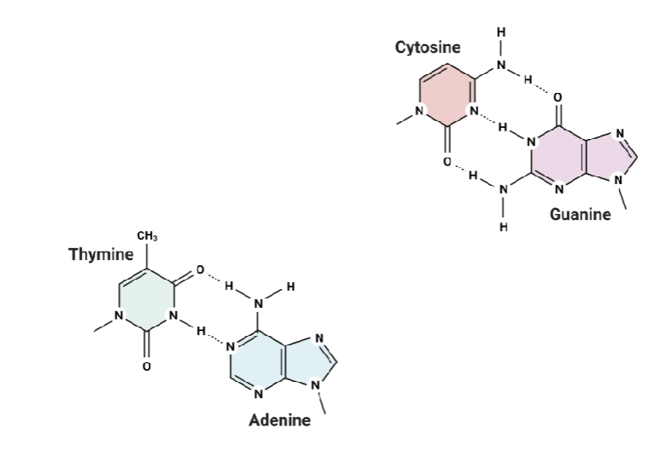

1. What is a nucleotide?
2. What is the shape of DNA?
3. What is a nucleoside?
4. What is the ribosome?
5. Which is higher complexity, chromatin or nucleosome?
6. What is the low-level to high-level process of all these definitions (ie. refer to that one figure)
7. What is DNA supercoiling and the difference between positive supercoiling and negative supercoiling?
8. What are the correct base pairs?
9. What is an organelle?
10. What is a nucleosome?
11. What is the central dogma?
12. What is a chromosome?
13. What is a chromatin?
14. Place the following structures in order from least to most complex organization: chromatin, nucleosome, DNA, chromosome.
    1. DNA, nucleosome, chromatin, chromosome
    2. DNA, nucleobase, chromatin, chromosome
    3. DNA, chromatin, nucleosome, chromosome
15. What is the nucleus?
16. What is the nucleolus?
17. What are amino acids?
18. What is the DNA structure? (Hint: Two things)
19. What is nucleic acid?
20. What are proteins and main functionalities?

## L3: DNA Transcription (The Stuff of Life pg 30-49, 2.3)

* What are the four nitrogen bases for RNA?
* What is mRNA?
* What is the process of translation (high-level)?
* What is the process of transcription (high-level)?
* What is the difference between DNA vs. RNA
* What are genes and gene expression?
* What is the difference between uracil and thymine?
* Which statement correctly describes the organization of DNA in a cell? (Hint: Organization is when there’s lots of them, and what it accumulates too)
  + DNA is made up of nucleotides and is organized in the form of chromosomes.
  + DNA is made up of nucleotides and is organized in the form of nucleosomes.
  + DNA is made up of nucleobases and is organized in the form of nucleosomes.
  + DNA is made up of nucleotides and is organized in the form of a double helix.
* What is the difference between deoxyribose and ribose?
* What is a hydroxyl group?
* What is the difference between primary, secondary, and tertiary structures?
* Why is RNA better suited than DNA for creating proteins?
  + RNA can leave the nucleus, whereas DNA cannot
  + RNA can be easily modified after transcription, whereas DNA cannot
  + RNA is more stable than DNA
* What is the main structural difference between DNA and RNA?
  + DNA is double-stranded while RNA is single-stranded.
  + RNA is more unstable because ribose and uracil molecules are more reactive
  + RNA is shorter than DNA.
* How does gene expression relate to transcription and translation?

## L4: RNA Translation

* What is tRNA vs. mRNA?
* Does the anticodon sequence determine the amino acid that is attached to the tRNA?
* What is the difference between E, P, and A?
* How does the process of translation terminate? And what does this mean? At what site does it end at, E, P, or A?
* Do the anticodon and codon have to have matching nitrogen bases?
* How do tRNA and mRNA contribute to ribosomes?
* What is a codon?
* What does the codon have in relation to the mRNA?
* Where does the amino acid chain grow from in translation?
* How does the amino acid chain stop?
* How to use the codon chart to make different amino acids? Is it directional?
* What is an anticodon in relation to the codon, and where is it located?
* Where is the codon located?
* How does the process of elongation go in relation to EPA? How does it have to be compatible with the mRNA?
* How does initiation begin for translation?
* What is the initiation complex?
* Why is RNA better suited than DNA for creating proteins?
  + RNA can leave the nucleus, whereas DNA cannot
  + RNA can be easily modified after transcription, whereas DNA cannot
  + RNA is more stable than DNA
* Which of the following is not made wholly out of RNA?
  + The ribosome
  + The transfer molecule
  + The messenger molecule that provides the code for protein synthesis
* Which of the following best describes gene expression?
  + The process of copying DNA into RNA
  + The process of creating proteins from RNA
  + The process by which the information in parts of DNA are used to direct the synthesis of proteins and other molecules with specific functions

## L5: Mitochondria and the Membrane

1. What is a high-level description of mitochondria? And what to understand?
2. What is a high-level description of a nucleus? And what to understand?
3. What is a high-level description of a cell membrane? And what to understand?
4. What is the ordering in cellular respiration?
5. What breaks the high energy bonds between the phosphate?
6. What does the breakage of these energy bonds produce?
7. What is the lipid bilayer made of? How are they arranged (hint: polar/non-polar)?
8. What is the permeability coefficient?
9. What is needed for things that have a very lower permeability coefficient?
10. What process in cellular respiration makes the most and least ATP?
11. What is the chemical structure of ATP?
12. What is the general process of cellular respiration?
13. What are the structure components of the mitochondria?
14. What is passive diffusion? And what would this look like in terms of a diagram?
15. What is channel mediated vs carrier mediated? What are the two different channels you can have?
16. Explain the Na+ K+ Pump.
17. What does the cell-membrane consist of?
18. What is secondary active transport?
19. What is a phospholipid molecule?
20. What is the difference between antiporters and symporters?
21. ​​Which of the following are components of the cell membrane
    1. Proteins and phospholipids (i.e. nucleotides, fatty acids)
    2. Proteins and phospholipids (i.e. glycerol, phosphates, fatty acids)
    3. Lipid bilayers, cristae, and a matrix
22. Which best describes primary active transport?
    1. Molecules are transported across the cell membrane by passive diffusion
    2. Carrier proteins pull molecules across the cell membrane with the assistance of ATP to create electrochemical gradients
    3. Protein channels facilitate simultaneous movement of ions down their electrochemical gradient
23. Which of the following is not a function of the cellular membrane?
    1. Creates distinct outer structure of cell
    2. Facilitates crossing of various molecules, ions, etc
    3. Divides the cell into discrete compartments

## L6: Resting Membrane Potential (2.4-2.9, 3.1)

1. What does a patch-clamp recording measure?
2. How does the patch-clamp work using the circuit as an explanation and explaining the different components?
3. What is the purpose of the second op amp in the patch-clamp model?
4. What is the difference between voltage-clamping and current-clamping?
5. What is the purpose of the patch-clamp?

## L6: Resting Membrane Potential (2.4-2.9, 3.1)

1. Where will chloride ions flow to at Vm=-70mV?
   1. Into the neuron
   2. Neither in nor out of the neuron
   3. Out of the neuron
2. Given some membrane potential, determine ion movement:
   1. With your understanding of Nernst Equation
   2. Graphically
3. What does the membrane potential equaling the equilibrium potential of an ion mean?

## L8: Action Potential

1. You just ate poisoned Fugu! Tetrodotoxin (TTX), blocks sodium channels. What happens to your neurons?
   1. They are hyper excited
   2. They are unexcitable
   3. They become demyelinated
2. What are the three types of ion gated channels?
3. What is the resting membrane potential?
4. What is the difference between hyperpolarization, depolarization, and repolarization?
5. What is the structure of the neuron (may have to break this question down) and purpose of key components?
6. What is the overall purpose of the neuron?
7. Can ligand-gated channels not have action potentials?
8. What is a ligand? And examples of a ligand?
9. What is the graded potential? And why does this only have transient changes that return to steady state (ie. why doesn’t it go to the axon?)?
10. What happens at a channel when a ligand attaches and the ions move (ie. where do the ions move?)?
11. What is the difference between Na+ and K+ in terms of their voltage gates?
12. What is the process of the action potential and how do you reach it?
13. Why is there a dip still after the action potential is finished even though the Na+ gate is closed?
14. What is the difference between the K+ and Na+ gates in terms of the action potential and how they move?
15. What is the difference between contiguous and saltatory?
    1. Why is it important for us to have the myelin sheath?
16. What are the factors that affect speed of propagation?
17. How does the myelin sheath improve the speed (ie. what does the signal do now?)?
18. What is the myelin sheath?

## L9: Synapses

1. Fugu is a dish made from pufferfish. Pufferfish have parts of the anatomy that contain tetrodotoxin (TTX) and must be removed carefully. TTX is a toxin that blocks sodium channels. What happens to the neurons if someone consumes fugu that contains TTX?
   1. **Low level:** Wouldn’t be able to create action potential because sodium channels are needed.
      1. Potassium channels can still open to have potassium leave the cell, leading to hyperpolarization.
   2. **High level:** Signals won’t transfer to the neurons, so no neurological control/signal connection.
2. What is the nerve cell connection?
3. What is a synapse?
4. What is the difference between electrical synapse and chemical synapse?
5. What is the presynaptic neuron, and postsynaptic neuron?
6. What is the gap junction? What synapse is it a part of?
7. What are the connexons? What synapse is it a part of?
8. What is the synaptic cleft? What synapse is it a part of?
9. What is the synaptic vesicle? What synapse is it a part of?
10. What is the chemical synapse transmission? (Go through the 8 steps)
11. What is the synaptic vesicle behavior with the neurotransmitters, vesicles, and Ca2+?
12. What is a neurotransmitter? (Just know the one)
13. For a neurotransmitter receptor such as glutamate, which type of transporter or channel do you think would be activated in order to use sodium ions to quickly depolarize the neuron (i.e., make the inside more positive)?
    1. Uniporter
    2. Symporter
    3. Metabotropic receptor
    4. Ligand-gated channel
    5. Voltage-gated channel
    6. Mechanosensitive channel
14. What is the effect of glutamate on the postsynaptic neuron?
15. What would happen to a postsynaptic cell if an ionotropic glutamate channel opened?
    1. What is flowing in and out of the neuron?

## L10: Review

1. Example 1

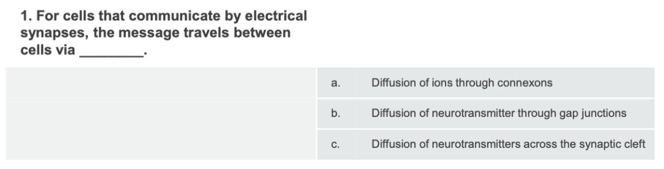

1. Example 3

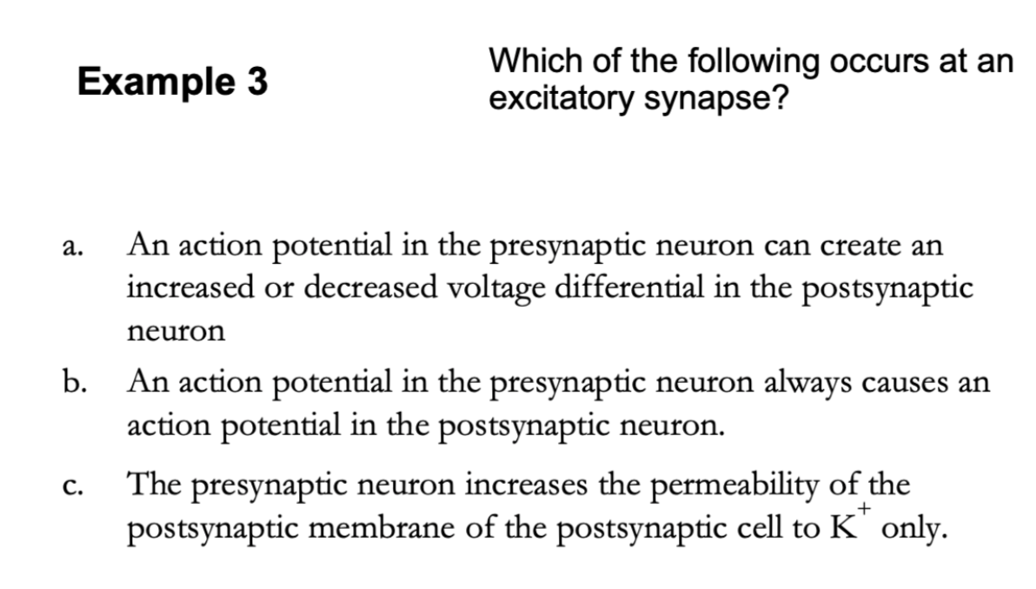

1. Example 4

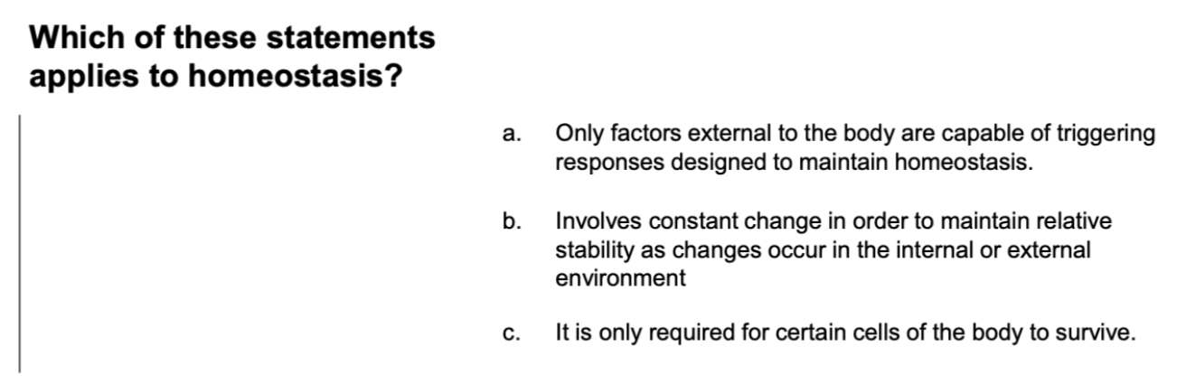

1. Example 5

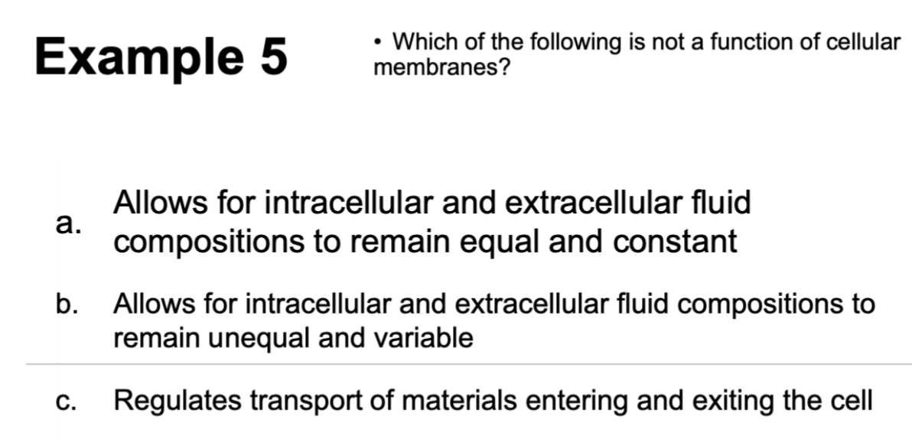

1. Example 6

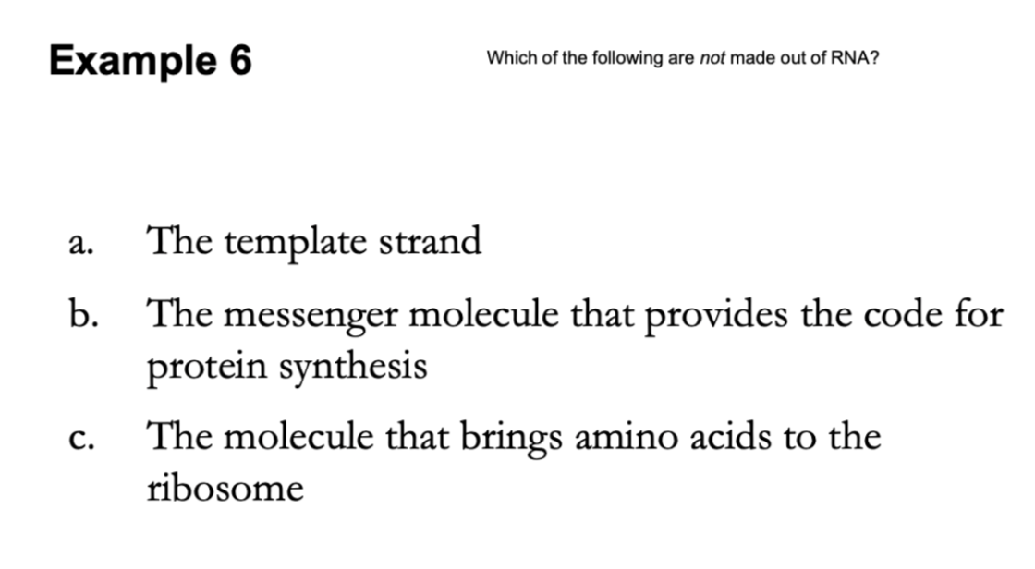

1. Example 7

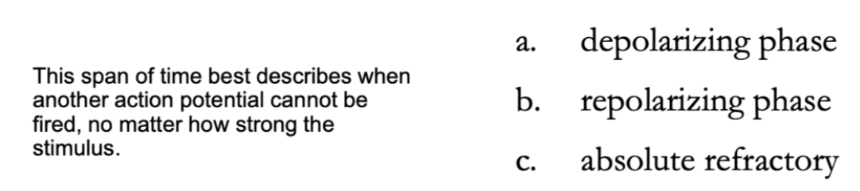

1. Example 8

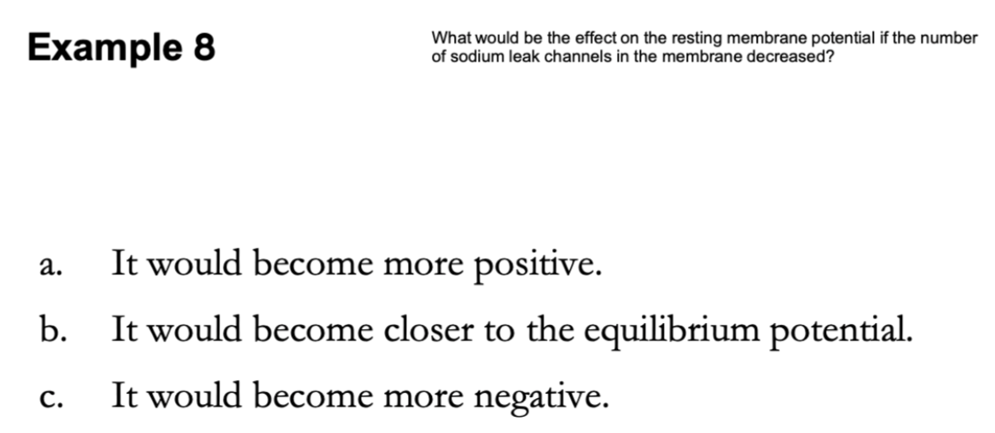

1. Example 9

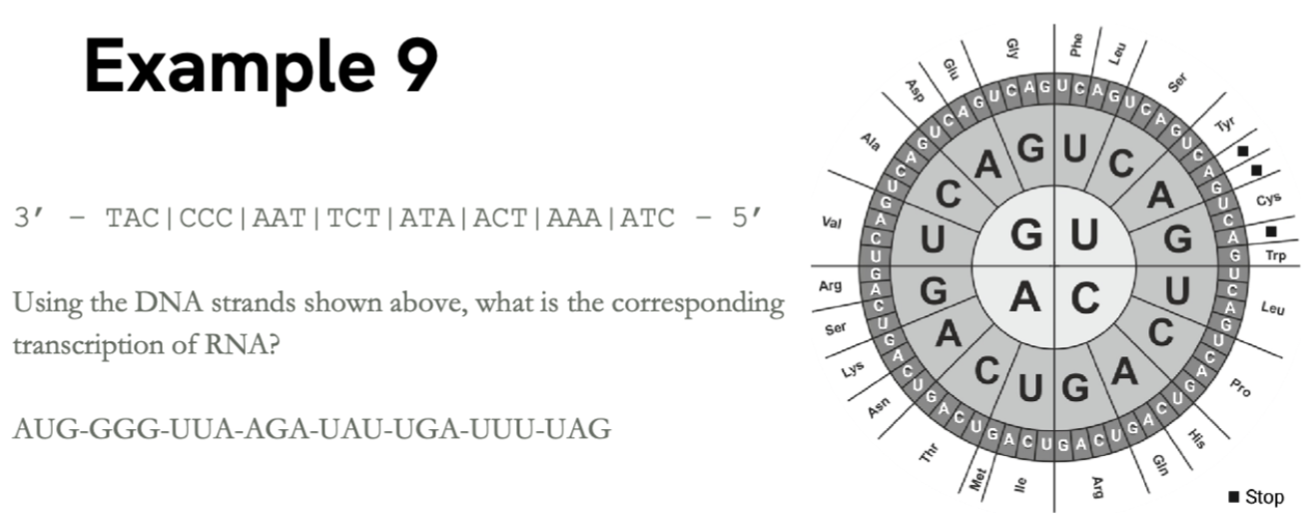

1. Consider a fixed voltage patch clamp circuit

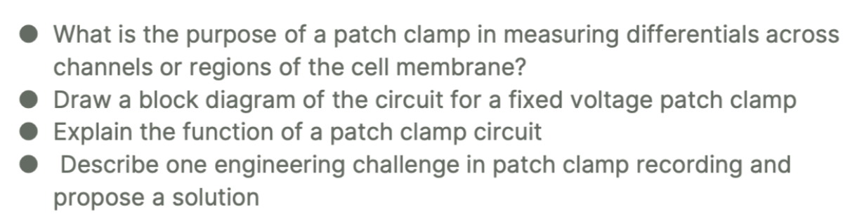

## L11: CNS

1. What is the difference between efferent and afferent nerve fibers (axon)?
2. Which level of the spine would the patellar tendon reflex likely occur?
3. What are the components of the reflex arc?
4. What is the difference between temporal and spatial summations?
5. What do temporal and spatial summations relate to in terms of the type of synapse?
6. What is grand postsynaptic potential?
7. How do neurons enter and exit the spinal column and how do they travel to and from the brain?
8. How would you modify the stretch reflex to incorporate: reciprocal innervation? sensation?
9. What is the structure of synaptic inputs?
10. What is the difference between EPSP and IPSP?
11. What is the purpose of having neurotransmitters that are inhibitory or excitatory?
12. What is postsynaptic inhibition using a diagram?
13. What is presynaptic inhibition using a diagram?
14. What type of synapse is related to post/presynaptic inhibition?
15. What are the different directional terms for nervous system structure?
16. What is the general purpose of cranial nerves?
17. What are the different planes?
18. How do sensory and motor pathways travel?
19. What is the purpose of each sensory tracts and motor tracts?
20. What does the spinal cord cross-section show us?
21. How do nerves get formed (i.e. slide 42)?
22. What is the top-down process of reflex arcs?
23. What is the stretch reflex?
24. What is the withdrawal reflex?
25. What is the difference between white and dark brain matter (maybe useless)
26. Picture below

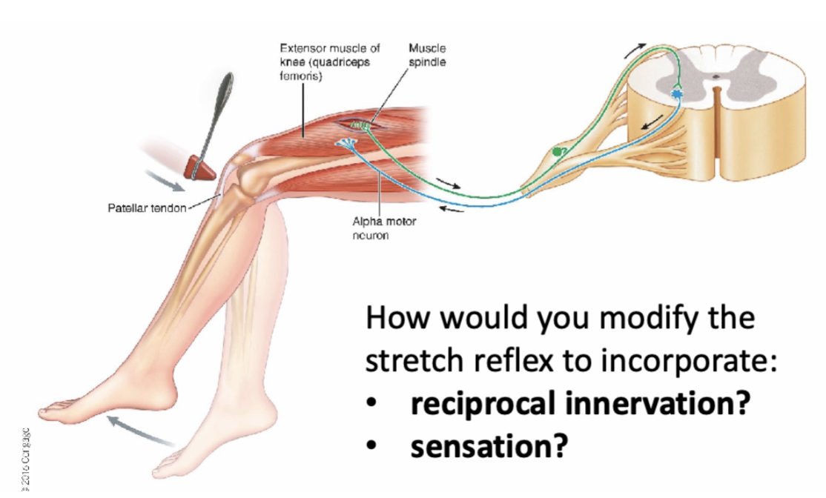

## L12: PNS

1. What type of receptor allows you to become accustomed to wearing clothes?
2. What is the overall process of the nervous system? (i.e. 12.0)
3. What is a mechanically-gated ion channel?
4. What are the two different ways to have receptor potential to action potential? Explain with a pictorial process.
5. Explain the mild process.
   1. What is modality?
   2. What is intensity?
   3. What is location?
   4. What is duration?
6. What is the somatic nervous system and its parts?
7. What is the process for motor neuron to muscle fiber connections (i.e. neuromuscular junction)? Give a pictorial process.
8. What is the afferent division and its components?

## L13: ANS

## 

1. What is the setup of neurons for the ANS?
2. What is a ganglion?
3. What is the sympathetic ganglion chain?
4. What does dual innervation mean?
5. How can central neurons travel (3 different ways)?
6. What is the difference in length for the short/long neurons for the parasympathetic and sympathetic nervous system?
7. What are two therapeutic solutions?
8. What are the 3 major axon groups and their speed?
9. What is the neuroeffector junction and its relation to neuromuscular junction?
10. What are the two different receptors for postganglionic neurotransmitter release, and which neurotransmitters are they associated with and which nervous system?
11. How to classify different neurons (i.e. last slide)?

## L15: Skeletal Muscle Structure

1. What are the functions of the human skeleton?
2. What is a joint?
3. What is cartilage?
4. What is a tendon?
5. What is a ligament?
6. What are the three types of contractions?
7. What are the three types of muscle?
8. What is striated muscle?
9. What is skeletal muscle structure?
10. Give me the hierarchy from the muscle fiber to the sarcolemma, and define each of them.
11. What is inside the sarcomere? And give the definitions of the appropriate terminologies.
12. Give me the process of the neuromuscular junction.
13. What is T-tubule and sarcoplasmic reticulum?
14. What is the process of excitation?
15. What is the process of the cross-bridge cycle?
16. What is the process of relaxation?
17. Question:

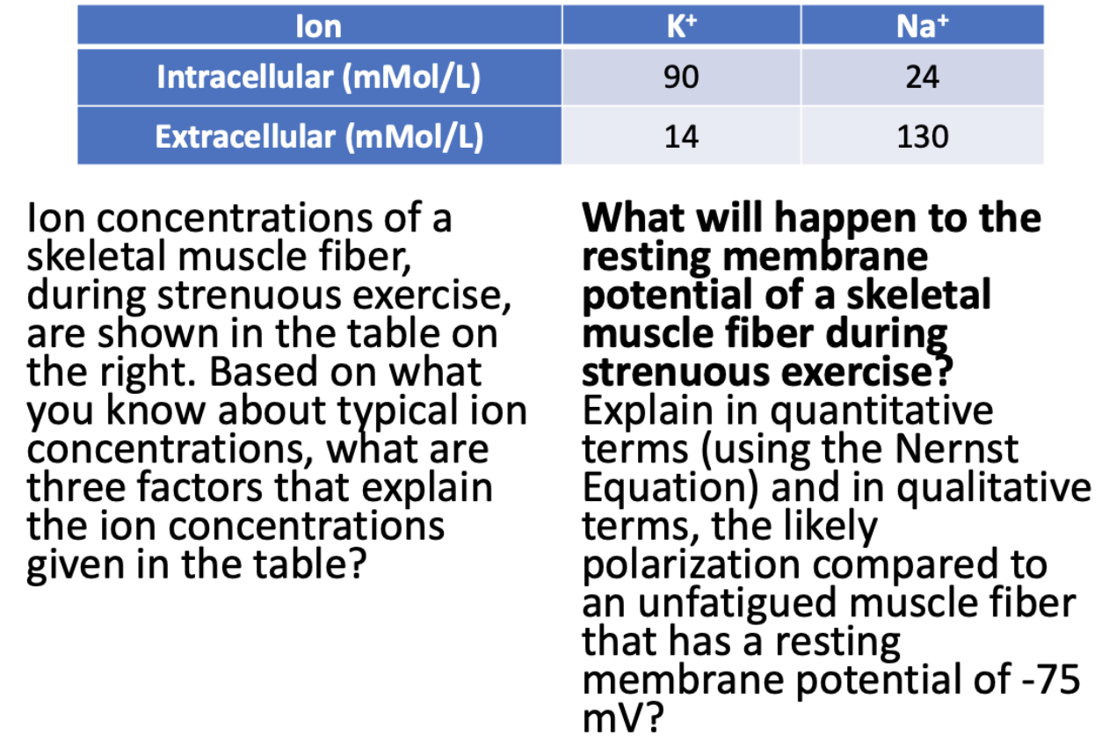

## L16: Skeletal Muscle Function

1. What are the 5 different ways for tension developed by each fiber (high-level?)
2. How does AP frequency affect tension developed by each fiber?
3. What is the relationship of an AP to a muscle twitch?
4. What is the difference between summation and tetanus?
5. How does fiber length affect tension developed by each fiber?
6. What is the active length-tension relationship?
7. What is the passive length-tension relationship?
8. What is the combined length-tension relationship?
9. How does fiber diameter affect tension developed by each fiber?
10. How does fatigue affect tension developed by each fiber?
11. What are the three types?
12. What are the different fiber types, and their respective fiber diameter, rate of fatigue, and size of motor neuron innervating fiber?
13. How does the number of fibers per motor unit affect the tension developed by several active fibers?
14. How does the number of active motor units affect the tension developed by several active fibers?

## L17: Cardiac Anatomy + Action Potential

1. What is the PQRST wave?
2. How does the PQRST wave relate to the heart?
3. What are the three possible states for the two state model?
4. What are the components of the two state model?
5. What does the LS and RS of the heart do?
6. Why do APs differ in the heart?
7. What are the different components of the heart?
8. What is the cycle of the heart?
9. Give me a breakdown through the sequence of depolarization and repolarization.
10. What are the major events of the left ventricular cardiac cycle?
11. What are the major cardiac cycle events relative to the PQRST wave?
12. What is the Stroke Volume equation telling us and how does it relate to the major cardiac cycle events?

## L18: Cardiac Regulation

1. Where does Lub and Dub occur w.r.t major events of left ventricular cardiac cycle and major cardiac cycle events?
2. How does Lub and Dub occur? What happens?
3. Tell me about the pressure changes in the
   1. atria
   2. ventricles
   3. aorta
4. What is the SV equation in relation to left ventricle volume and pressure graphs?
5. What is the cardiac output equation?
6. How is HR modulated? What are the three ways?
7. What are the extrinsic controls of heart rate?
8. What are the extrinsic controls of stroke volume?
9. What is the diagram of the extrinsic control of cardiac output?

## L19: Blood Vessels and Blood Pressure

1. Where is smooth muscle found in the body?
2. What is the difference between smooth muscle and skeletal muscle?
3. How are smooth muscles innervated?
4. What is the general vascular system structure?
5. What is the structure of blood vessels?
6. What is CA2+ permeability for smooth muscle?
7. What are the factors that affect the diameter of arterioles?
   1. Extrinsic
   2. Intrinsic
8. What is the Hagen-Poiseuille Equation
9. What are the factors that affect total peripheral resistance?
10. What has the biggest pressure drop?

## Lab 1

1. What is a PPG?
2. How does the PPG work?
3. How does the heartbeat appear on the PPG?
4. How to measure the heartbeat?
5. What are reasons for signal quality variations?
6. What are the reasons for HR variations?
7. How does PPG signal change when
   1. sensor on vs. off.
   2. increase pressure on the sensor.
8. What is EDA?
9. What does the ANS balance?
10. Where to measure EDA?
11. How does the EDA signal change w/ increasing stress and why?
    1. Sweat

## Lab 2

1. What is EMG?
2. What are two mechanisms to increase whole-muscle tension?
3. How to prevent fatigue during contraction
4. What are major factors that impact signal quality?
5. What to improve signal quality
6. Why does EMG amplitude decrease with time?
7. Why does EMG amplitude different with increasing applied force?
8. Why are there psychological differences in the response of different muscles?

## Lab 3

1. What is ECG?
2. How to measure HR with ECG?
3. What are changes in signal when moving vs. standing still.

## T4: Case Study Inhib Neurotrans

1. “So how can neurons carry electrical signals?” George asks innocently. “I’ve heard of dendrites and axons and stuff, but it never made much sense to me. Aren’t axons and dendrites just like wires that connect to each other using chemical signals?”
   1. They use Morse code--where do you think that came from?
   2. Cells have tiny metal wires going throughout the cell.
   3. They use positive and negative ions moving through protein channels scattered over the whole length of the cell.
   4. They bring positive ions in through dendrites and negative ions in through axons.
   5. They bring negative ions in through dendrites and positive ions in through axons.
2. “OK then, brainiac, why would ions want to move into a neuron if you dump neurotransmitters on it?” George demanded sarcastically.
   1. Because ions bind hormones and hormones like to enter cells.
   2. Because cells can engulf things like ions and bring them in.
   3. Because positive ions always move into a negatively charged cell.
   4. Because negative ions always move into a positively charged cell.
   5. Because ions move through channels according to their electrochemical gradient.
3. George looks interested. “So what kind of protein lets negative ions in when you add a chemical neurotransmitter?”
   1. Ligand gated channels
   2. Voltage gated channels
   3. Mechanosensitive channels
   4. Uniport transporters
   5. Co-transporters
4. George looked skeptical. “OK, I get that a channel works like a gate to let ions into or out of the cell depending upon conditions. Then what? What happens to the ions after they move into the cell?”
   1. Other ions then help move them out and they go on from there.
   2. ATP is used by various pumps to push ions back out of the cell.
   3. ATP binds to the ions and carries them back out of the cell.
   4. A different channel opens and lets the same ions move back out.
   5. So few ions cross the membrane that concentrations do not change enough to matter.
5. For neurons to bring more potassium ions (K+) inside the cell than outside, which type of transport is most likely to be used?
   1. Simple diffusion
   2. Facilitated diffusion
   3. Active transport
   4. None of the above
6. For a steroid hormone such as testosterone, which of the following ways would be used for the hormone to enter a neuron?
   1. Simple diffusion
   2. Facilitated diffusion
   3. Active transport
   4. None of the above
7. For a neurotransmitter receptor such as glutamate, which type of transporter or channel do you think would be activated in order to use sodium ions to quickly depolarize the neuron (i.e., make the inside more positive)?
   1. Uniporter
   2. Symporter
   3. Ligand gated channel
   4. Voltage gated channel
   5. Mechanosensitive channel
8. In order to repolarize the neuron (i.e., take the neuron back more negative as quickly as it went positive), which type of transporter or channel is likely responsible if potassium is the ion out of the cell?
   1. Uniporter
   2. Symporter
   3. Ligand gated channel
   4. Voltage gated channel
   5. Mechanosensitive channel
9. What type of transporters or channels will restore the ion balances and move ions against their gradient?
   1. Uniporter
   2. Symporter
   3. Ligand gated channel
   4. Voltage gated channel
   5. Mechanosensitive channel

## T5: Tired Swimmer

1. Draw a cross section of the mammalian spinal cord, including the dorsal and ventral roots, and draw a muscle to one side on the spinal cord. Draw in a reflex that includes a sensory nerve, an interneuron, and a motor nerve.
2. Fill in the blanks below:

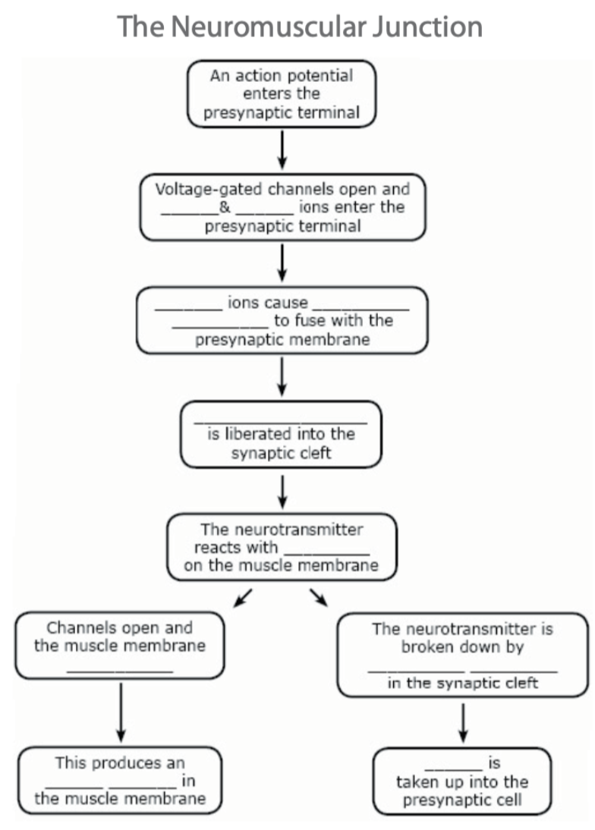

1. Which of these statements applies to acetylcholine?
   1. It is released from an axon terminal.
   2. It destroys acetylcholinesterase.
   3. It is blocked by sodium.
   4. It can be released from a postganglionic sympathetic neuron.
2. Which of the following applies to acetylcholinesterase?
   1. It enhances activity from organophosphates.
   2. It inactivates a neurotransmitter.
   3. It is a neurotransmitter.
   4. It stimulates an excitatory postsynaptic potential.
3. Clostridium botulinum toxin inhibits acetylcholinesterase.
   1. True
   2. False
4. Acetylcholinesterase removes ACh from receptors.
   1. True
   2. False
5. Which of these conditions occurs as the result of a lack of acetylcholinesterase in the synaptic cleft?
   1. Decreased acetylcholine production by the motor neuron.
   2. Relaxation of the muscle fiber.
   3. Excessive, continuous stimulation of the muscle fiber.
   4. Inability of the motor neuron to stimulate the muscle fiber.