

SDV602 assignment 2

Lee Vartha



September 18, 2024

App Design and Documentation

Application Description and Purpose:

This application is designed to provide analysts with an interface to explore statistical data through the visualization of charts. The application contains multiple screens and features:

1. **Authentication**: Register and Login pages are shown for users to setup an account into the system.
2. **Lobby**: This is used as the starting point for the user, allowing them to get a list-view of all available charts.
3. **Chart Screens**: Users are able to navigate through to different types of charts – this includes bar charts, pie charts and line graphs – this gains an insight into the particular data set for the application. Each screen has a chatbox for communication, buttons for navigation and setting images, brief descriptions of the dataset alongside the chart.
4. **Chat Box**: This feature lets users to add comments for the charts, which promotes collaboration.

The datasets used in this application is towards ‘Music Consumption’ and the ‘Impact of Streaming Platforms’. This would be a scientifically-geared application as streaming platforms have made a significant impact on how music could be consumed by the public in a digital sense. Researching on this would make a statement on how there is a change of how music is accessed, how music is made and how the artists now make money.  
I would compare and describe the services such as ‘Apple Music’, ‘Soundcloud’, ‘Spotify’ etc. and explain what the influences are on how listeners engage and access music – since they can explore a diverse range of genres, albums and artists.   
  
The general motivation for the application is described to showcase tools that allow businesses and researchers to visualize their datasets. This application simplifies the process of making their charts and descriptions accessible.

Storyboards

Registration:

In this screen, analysts have the capability to register into the system. They are provided an email and password field to input their details into.  
Once the press the confirm button, they are then navigated to the ‘Lobby’ page.  
  
Lobby:  
In this screen, we are able to see an overview of the data charts in list form. If you click one of the data chart buttons, it will then open the corresponding data chart screens.  
If a user clicks the sign out button, they will have their account logged out and they will be sent back to the ‘registration’ screen.  
When one clicks on the ‘exit application’ button, the entire application will close.

Data Explorer Screens:

DES 1:  
  
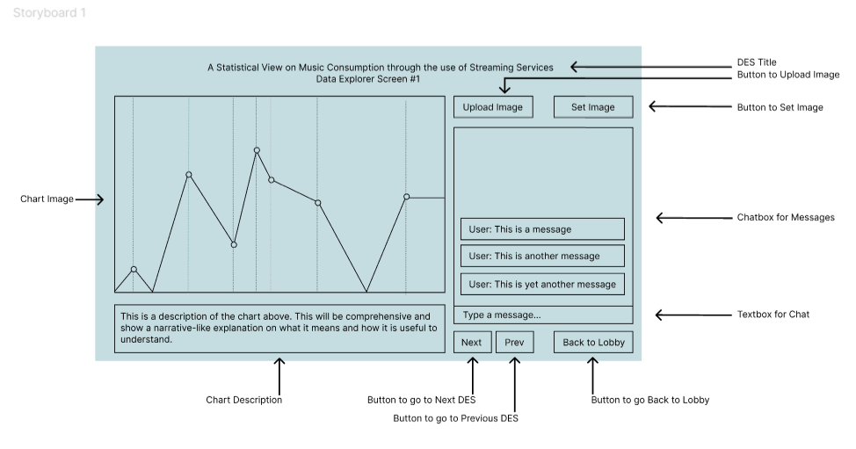  
In this screen, we see a depiction of the first chart and the interface that holds it. This includes a chart, description, chatbox view/input box and an assortment of important buttons.

DES 2:  
  
In this screen, we see a depiction of the second chart and the interface that holds it. As well as the first DES screen, this includes a chart, description, chatbox view/input box and an assortment of buttons.

DES 3:  
  
In this screen, we see a depiction of the third chart and the interface that holds it. As well as the other DES screen, this includes a chart, description, chatbox view/input box and an assortment of buttons.

Navigation for ALL DES:

When the user clicks on the ‘upload image’ button, it reveals a popup to input a URL source which will allow an image to be placed in the placeholder where the chart goes.  
When the user clicks on the ‘set image’ button, it sets the chart to the placeholder.

When the user uses the ‘textbox for chat’, they can create a message which will be shown in the ‘chatbox for messages’

When users click on the ‘next’ button, it will take them to the next DES. Following this, if the user clicks the ‘prev’ button, it will take them to the previous DES.

When the user clicks the ‘Back to Lobby’ button, it will then take them to the lobby screen.

UPLOAD IMAGE:

