
WEB701 assignment
Emily Vartha

-/-/-

Contents
Designing the Website: 1
Website Brief: 1
What are the website requirements? (using information architecture analysis) 1
Site Content: 11
Site Structure: 12
User Stories – Designing to Build: 23
CRUD Analysis – API prototype: 24
Evaluation (Milestone 2): 25
Development (Milestone 3): 25
Summary and Conclusion: 25
References: 25

Designing the Website:

Website Brief:
The Late-Night Nosh charity is a food-rescue service in the Nelson region. Local eateries can donate surplus ‘ready-to-eat’ meals to the local community that would otherwise be scrapped.
We need a website for the Nelson region that allows verified donors list meals and lets beneficiaries (late-night shift workers, students, night-owls) reserve and collect them.
The purpose of the new website is to help reduce food wastage and to feed people that might also be working outside of normal food-bank hours. Like a foodbank, members register and describe the service or products they are providing, the number of the offerings and the pickup window.
The website lets members of the community (beneficiaries) access the service, by providing tokens that can be ‘spent’ in the service. To achieve our goal, we would like to have an online token function on our website that let a beneficiary access a limited number of tokens, for example the system needs a mechanism that verifies that a member of the community is accessing the service and that the token belongs to a particular community member. The website needs some homepage text about general information of our products and services such as types, characteristics, quality factor, usage and benefit.
We require the following features on the website:
- Charity members and beneficiaries can register, login and administer their own accounts
- Members use the website to register their products and services, and beneficiaries use the system to acquire tokens
- Interactive elements that engage the website user
- The system provides an interface that members can use to accept a token in a transaction

What are the website requirements? (using information architecture analysis)

Site goals:
The mission of this website is to rescue surplus food that don’t sell and deliver it to those who need food at a potentially late-night hour, for when other stores aren’t open. The night-shift focus matters as daytime food banks might not typically cover the 9pm-6am window, and cafes still bin unsold meals and snacks after closing. The late-night nosh would bridge this gap as it would rescue perfectly fine and fresh food and handing it to those who are working, awake and hungry when other services aren’t available
The short term goals is to launch the MVP (minimum viable product), let in 5 donor venues and have at least 100 beneficiaries.
For the long term, the goal would be to reduce 2 tonnes of food wastage a year, expand to the entire Tasman district and integrate council composting statistics.
The intended audience includes:
- Donor Members - cafes, bakeries, restaurants, airport-eateries, petrol-station kitchens etc.
- Beneficiaries - hospital staff, night-shift workers, police officers, students, night-owls, homeless people, low-income families
The reason to believe that the audience would want to come is that the donors would list meals quickly and beneficiaries can secure food when most stores are closed.

Define the User Experience
“A one-tap, midnight-friendly marketplace that feels safe, quick and rewarding”
The audience:
Donor Members:
Segment | Why they need it
Cafes/Bistro | Leftover cabinet food and takeaway meals would need to be tossed after a while  Making listings would free cabinet space and a live feed would let them off-load excess pies or cakes before the food-safety cut-off
Bakeries | Daily racks of pastries unsold; waste-disposal fees and the thought of having to bin lots of food.  Making listings would clear stock and builds goodwill
Event caterers | Sport events, weddings, conferences could end up having 10-20 trays of untouched food due to an overestimated guess of how much people would eat; Late-night Nosh’s network can collect and redistribute these snacks after-hours instead of it going back to landfill
Food trucks (event nights) | Over-catered batches after a small event or market site; posting to Nosh avoids having to take food home or trashing them; would additionally help earn a social-media buzz too for popularity.
Supermarket deli counters and bakery section | The end-of-day roast chickens and sausage rolls, including all the deli meats would need to be trashed  This organization would help keep their stock levels down and all of them to design analytics on the kg of food diverted etc.
Campus cafes and student organizations | Term-time peaks and lowers; donating to Late-night Nosh would help strengthen student-wellbeing campaigns, helps with the lessened use of dumpsters
Common reasons for why the donors would need it is the fact that they would all contribute to the reduction of food wastage, which will mean fewer compost fees. As well as this, the real-time impact would provide a counter which would show how many meals were donated, which also helps with reputation to the companies donating. This would also boost staff morale as they’d feel better handing leftovers to those who need it, rather than sending all the food to landfills.
Beneficiaries:
Segment | Why they need it | Hours
Hospital/Hospice Care | Some workers finish late, all the cafeterias would be closed, and they’d want a quick bite after a long shift | 9pm – 7am
Warehouse | Night pack or courier runs – no quick spots to get to and vending machines wouldn’t have enough | 8pm – 6am
Emergency & Security | Police, St John, Security guards on call, no time to cook and they might have to stay up late | Rotating nights
Tertiary students doing all-nighters | Limited budgets, campus cafes shut, small stores closed | 9pm-3am
Late night gym rats | People who go to the gym at very late night/early morning who needs a quick pick-me-up, vending machines in-gym aren’t enough, stores are all shut | Few hours between 9pm-6am
Homeless or couch-surfers | Might feel safer collecting food at night
Low-income families where a parent might work double-shifts or evening shifts | No time to cook and need something quick for their family
Travellers stuck overnight | Flight, bus or ferry got delayed and have to stay an extra night on a tighter budget as they hadn’t anticipated having to stay another night

Based on this audience, I will need to include these sections in my website:
- Donor Dashboard:
A spot where cuisine owners can list their products that need to be gone
- Beneficiary Dashboard:
A spot where purchasing customers can find food quickly and conveniently – ability to see token price and the distance away from them
- Profile Board:
A spot where users (both donors and beneficiaries) can see their details and statistics (how many tokens they have etc.)
- Login/Register page:
A spot where users can login or register into the system, so they have a personalized and saved profile

Scenarios and personas:
Persona | Scenario
Jane (27) | Jane finishes work late at 10pm and doesn’t have a car. She’s getting tired of the fact her cafeteria is closed by the time she can finally eat, and she has had enough of eating instant noodles and nut bars. She checks how many tokens she has: 3 tokens left and then filters whether theres any listings that are ‘<1km’ and spots ‘Thai Pumpkin Soup + Ciabatta – 1 Token ~ Pick up till 10:30pm’  She reserves it, with the balance dropping down to 2 tokens.  The café is a 6 minute walk, so Jane arrives with plenty of time to spare; the barista scans her QR code – she earns a badge for a ‘5 day streak’.
Neil (45) 24-hr petrol station worker | At 11pm, [Name] has to clear the hot cabinet. Since the products have been in-store for a while, he lists ‘6 sausage rolls’, each costing ½ token.  A beneficiary reserves all 6, costing them 3 tokens.  When the beneficiary arrives, he scans the QR; the system removes three tokens and marks the listing as ‘Sold out/Picked-up’
Claudia (21) – Student | At 11pm, Claudia’s coding assignment is due at midnight, and she hasn’t had anything to eat. Since she lives on her own in the halls, she has to either make food herself or buy something instead. She checks her e-wallet balance, and it shows 5 tokens.  She applies the ‘Campus radius < 2km’ filter and adds the filter of ‘Vegetarian dishes’  She finds ‘Vege Pad-Thai Cup – 1 token’  She reserves it and her balance updates, with the bright QR code flashing on-screen.  After taking a 5-minute walk over, Claudia collects her food.  Claudia still holds 4 tokens for the rest of the week and saves her 20 minutes of cooking, which allows her to stay being a night-owl to finish her assignment instead of binging instant noodles
May (25) – Gym Enthusiast | May is a gym-rat who prefers her workouts late at night, to skip the busy queues. She does sometimes make the time to cook her own food-prep meals, yet she was too busy to make something for herself this day.  After finishing her late-night workout at 11:45pm, May opens the ‘Wallet -> Token Balance: 5’  She filters through the listings saying ‘High protein, <5 km”  The feed comes up with ‘New meal nearby - Crispy Chicken Wrap’, so she spends 1 token to reserve and the QR reader brings up a confetti animation, with an updated balance of 4 tokens, which would reset in 4 more days.  She collects her meal, feeling satisfied she would still have enough tokens for the weekend and shares her pickup to her Instagram store via. the in-app share button, which earns her a badge.
John (43) – Baker (Donor) | His job pulls night shift till 2am and his pain point is the fact he hates having to bin unsold focaccia, croissants, danishes and breadsticks. His goal would be to list leftovers in less than a minute to know his food doesn’t have to go to waste.
Sarah (35) – Call-Centre Parent | Sarah ends her double shift, and she’s exhausted at 9:15pm. She checks how many tokens she has, and she realises she has two left.  She finds two kid-friendly ‘mac-n-cheese’ cups at a nearby bistro, which had cost 1 token each  When she arrives, she realises one of the cups were already taken by accident, so the donor cancels the one reservation in the console, which allowed the system to auto-refund 1 token to Sarah’s wallet.
Cal & Janet (31 & 29) – Food truck owners (Donors) | The bad rainy weather meant that sales were low; by 8pm they still have ingredients left for 10 more burgers. In their Donor Console they tap ‘Repeat last listing – qty 10 – pickup until 11:30pm’.  The system pre-fills yesterdays burger photo and tags. Within twenty minutes, 7 are reserved.  Each scan shows the donor running a total: “Burgers saved: 7/10’  Unsold burgers after 11:30pm are auto-flagged “Compost” and is then removed from the feed.  In the donor dashboard, it would then show “Meals donated: 62”

Based on these scenarios, I will ensure the website has the following:
Account/User Management:
Feature | Description
Register/Login | For both donors and beneficiaries, secure login system will be integrated (with JWT tokens)
Role-based dashboard | Show donor features and beneficiary features on different dashboards depending on the logged-in role
Admin interface | To manage users, tokens and approving listings

Tokens/Wallet System:
Feature | Description
Token balance view | Show the current token balance (e.g., ‘Token Balance: 5’)
Token expiry/reset | Token refresh done weekly, shown with a countdown for visualization on reset for users
Spend token | Remove tokens after reservation
Refund mechanism | If the item is not collected/reservation is cancelled, the token is returned
Badge system | Streak badges if ‘5-day pickup’, for example, and whether user had shared on social media for promotion – intrigues the user to use the application more often if ‘profile reward’ was utilized
Listings and Marketplace (Beneficiaries)
Feature | Description
Browse available meals | Grid card view of current listings
Filtering options | Filters such as distance, dietary type (vegetarian, vegan), protein, ‘open till’ etc.
Reserve item | Tap item, confirm token deduction and receive QR code for scan when at pickup site
Expiry/pickup window | Show how long the listing is available for so users know how much time they have
Share listing | Share pickup/badges/listing to socials

Meal Creation/Management (Donors)
Feature | Description
Add new listing | Form to enter meal name, quantity, pickup time, token cost, image and any dietary tags
Quick repost/repeat | Button to repeat previous listing with current quantity (makes it easier if donors make the same meals)
Meal expiry | Meals are auto-removed after pickup window or when marked ‘Compost’
Live tracking | See which meals were reserved or/and picked up in real-time
QR scan tool | Built in QR reader to validate reservations on pickup
QR code system:
Feature | Description
Generate QR code | For beneficiaries after reservation (1 use)
Scan QR code | For donors to mark item as collected (and a way for system to deduct tokens)
Animated/interactive scan feedback | Animation visual (such as confetti) after successful scan or/and badge unlock

Analytics & Impact:
Feature | Description
Donor dashboard | Statistics on amount of meals donated badge tracker
Beneficiary history | “Pickup History” tab showing recent meals, date/time
Community stats | Total meals rescued this week, total active donors

Extras:
Feature | Description
Notifications | ‘New item <1km from you!’ or ‘Meal expires in 10 mins’
In app badges/milestones | For frequent pickups or generous donors
Sharing options | Auto generated social media post with meal pic, pickup time etc.

Summary:
Role type | Features needed
Donor | Login, add listing, quick repost, scan QR code, track donations
Beneficiary | Browse meals, filter, reserve, view token balance, show QR on pickup
Both | Secure login, dashboard, reservation history
Admin | Token management, user approval, analytics

Competitive Analysis:
Website 1 – Olio (Olio - Your Local Sharing App, n.d.)
Table 1 - Olio Website - Images of each page represent a snippet of the website
Screenshot |  | Description
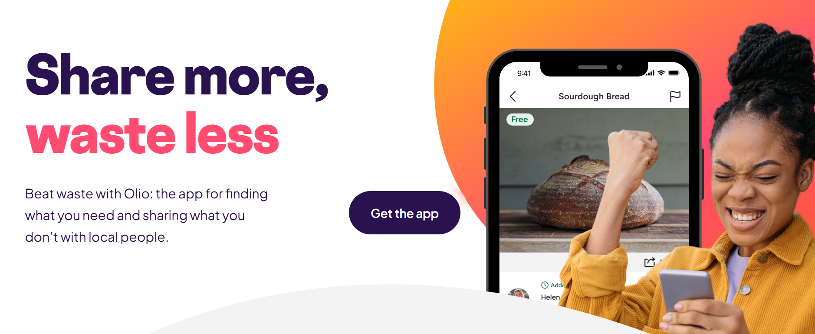 |  | They have a strong motto: “Share more, waste less”. Theres also a clear indication of an available application to download.  This starting landing page is clear and has a slight hero image, which gets the users attention.  The colour scheme is nice and simple too – not too boring as theres pops of colour
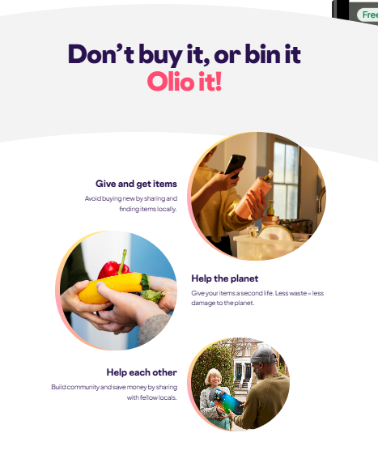 |  | Has very strong UI design, simple and sleek. Has informative sections showing its process and how productivity works for this business.  The fact theres images broken into sections is segmented really nicely and has brief descriptions to match it
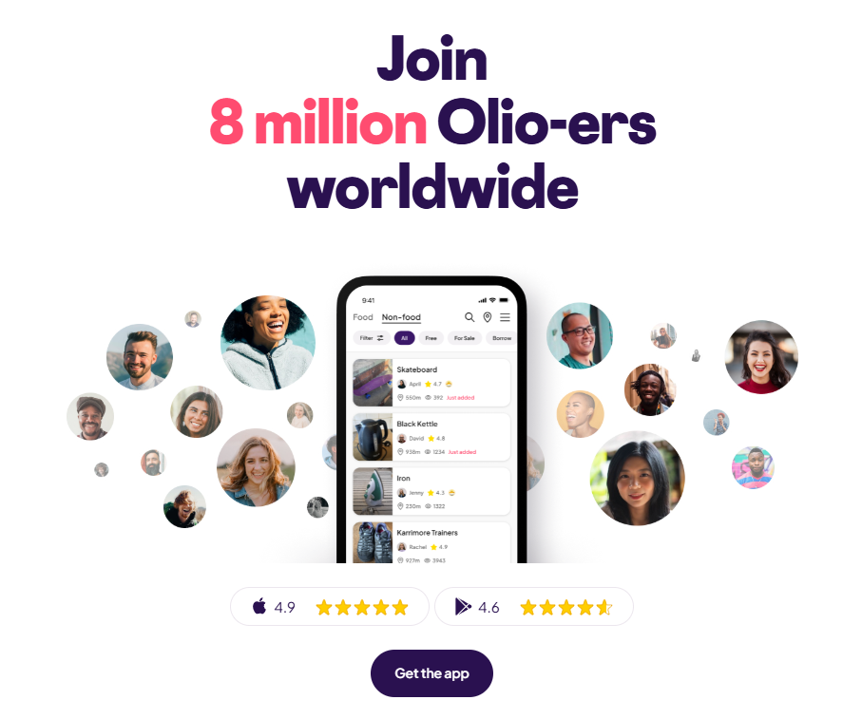 |  | Shows pride in how community-based their business is, involving how many clients are involved and what their star rating is, showing their commitment to high-quality performance and usability.  Still promotes the availability of an application, which makes it phone-friendly, rather than solely having to use the website
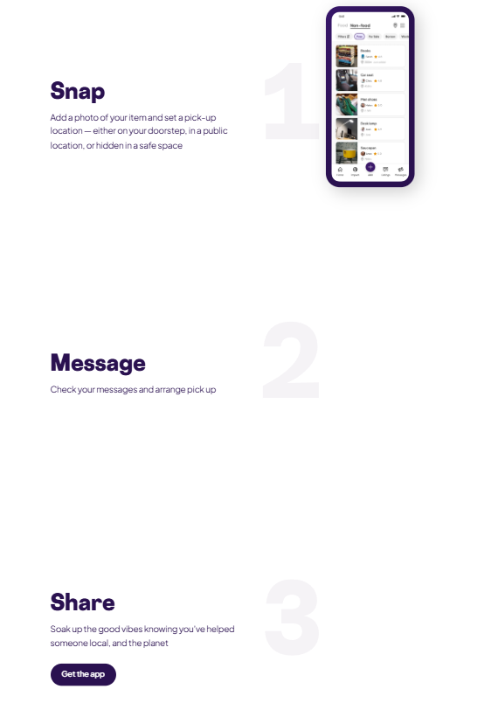 |  | Showcases photographic and worded explanation on how the application works, also proving how simplified the process is in the app, which would help reassure users that it’s not a complicated concept to work with.  I wouldn’t personally include this in my website, as I would only be utilizing a website to provide details on the foodbank. I believe this could be useful to possibly include in the future if its decided to create an application – in that case, it would be efficient since it visually provides a step-by-step explanation of how it works, which could be helpful for those who might not know how usual online food-bank systems might work. This could also be helpful for those in general that aren’t experienced in mobile applications or websites in general.
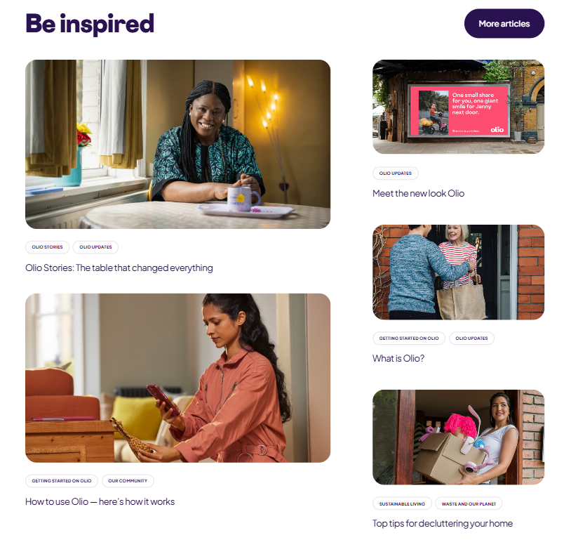 |  | Includes an ‘inspiration’ hub which involves articles and blogs revolving on tutorials, tips and tricks. Shows that this business is not only an item-bank.  While this section is great, I wouldn’t include this in my website till the long-term phase of this charity as its only necessary to showcase listings of available late-night foods. But in the long-run when its more popular and more heavily community-driven as more beneficiaries and donators are involved, this could be interesting for the charity to gain more customer traffic as it involves more than a ‘list of food’.
Qualities I would add in my website | - Strong motto which defines the organization in a nutshell  - Nice colour palette that’s simple with subtle pops of colour  - Clear headings and titles  - Not too much information to confuse new users  - Step-by-step explanation on how the organization works and how to contribute

Website 2 – To Good To Go (Save Good Food From Going To Waste | Too Good To Go, n.d.)
This website isn’t a charity, yet it still supports the idea of reducing food waste.
Screenshot |  | Description
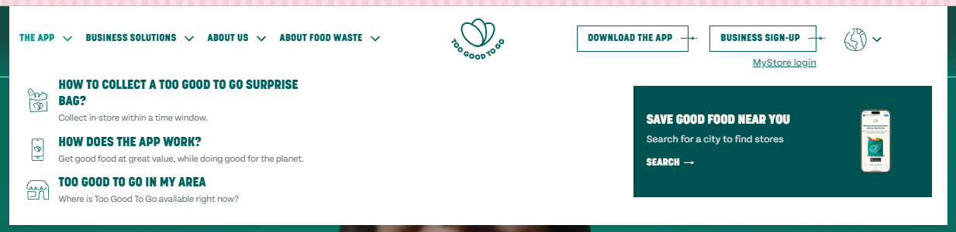 |  | The dropdown menu is intriguing and simplistic, very easy to navigate.  Nav-bars buttons are spaced out evenly too, which is a plus.  It’s also good because they have an educational tab which talks about food waste facts, resources etc.
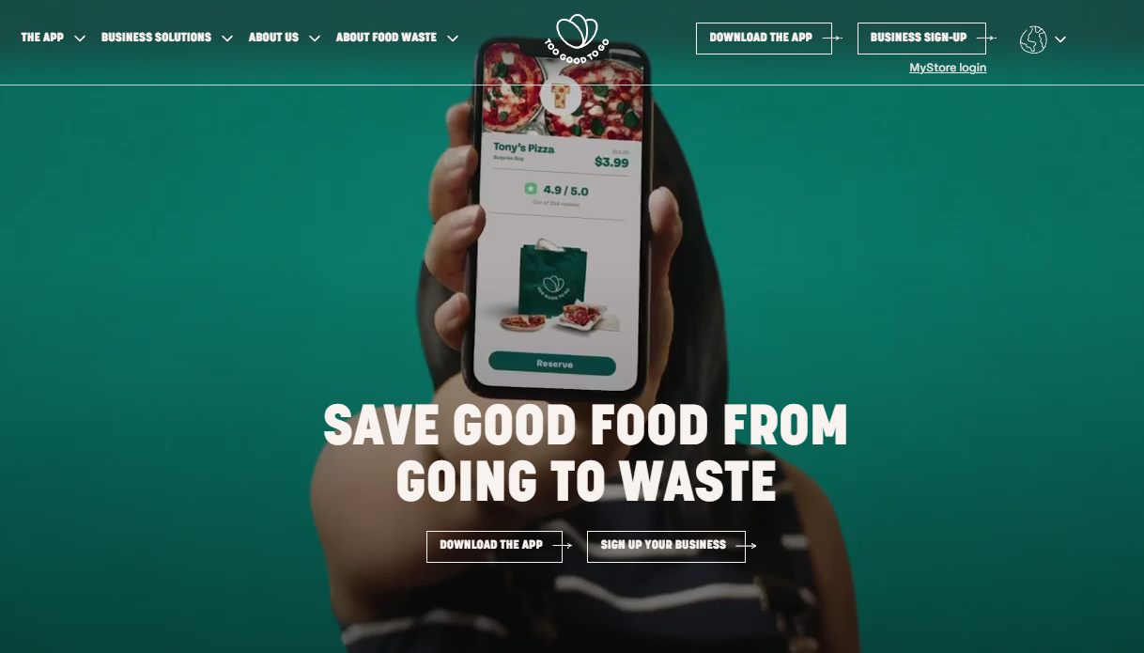 |  | Simple starting design as you enter the website, a video based background which captivates the audience as it’s not always usual to have a moving background for website introductions.  Has a strong slogan, being “Save Good Food From Going To Waste”, with an incentive below the text to ‘download the app’
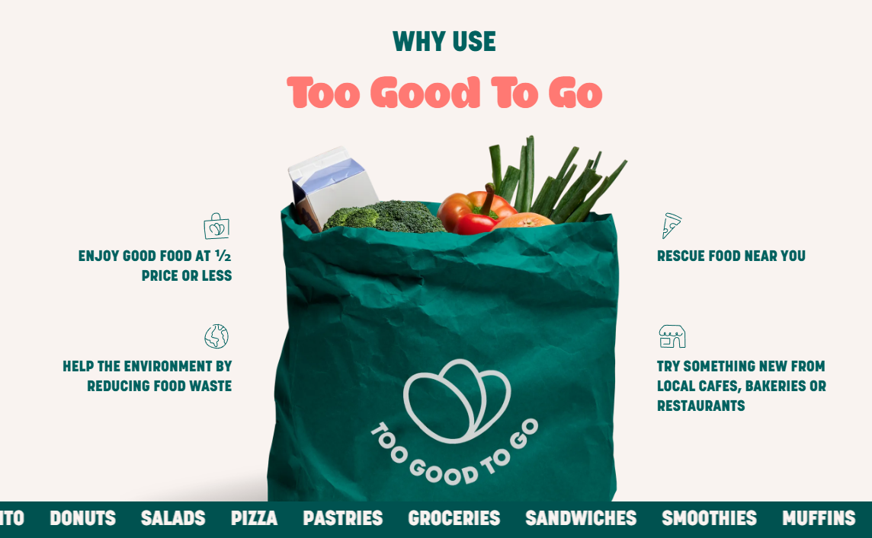 |  | Has a visually convincing explanation of ‘why’ it’s best to use this organization.  I also like that the strip on the bottom actually moves on the website, scrolling through all the foods that they can provide, which gathers details on what exactly you would expect to be able to get.
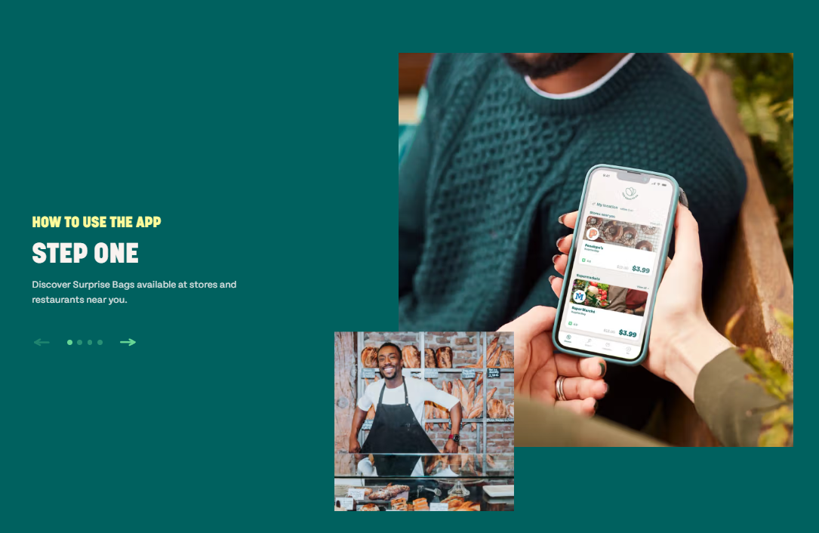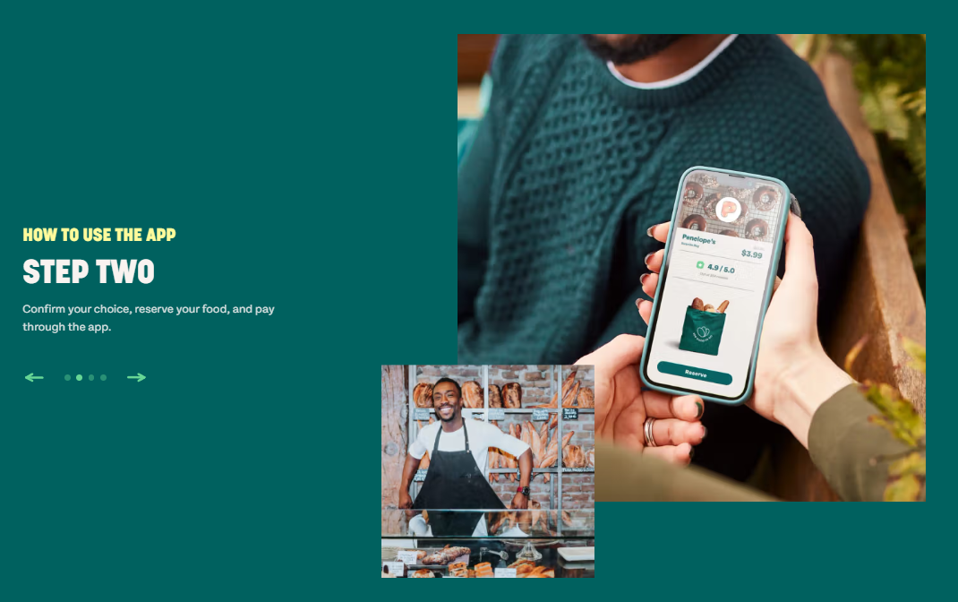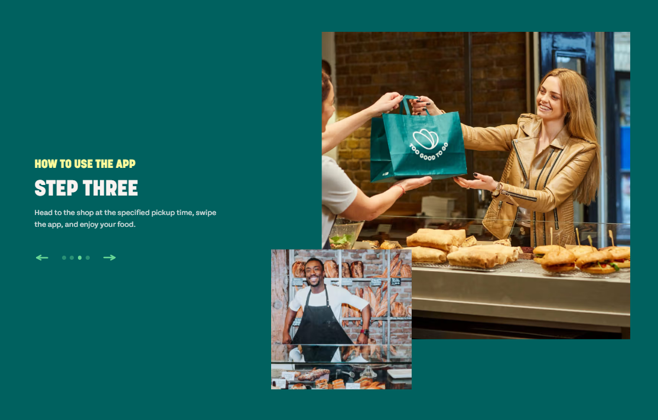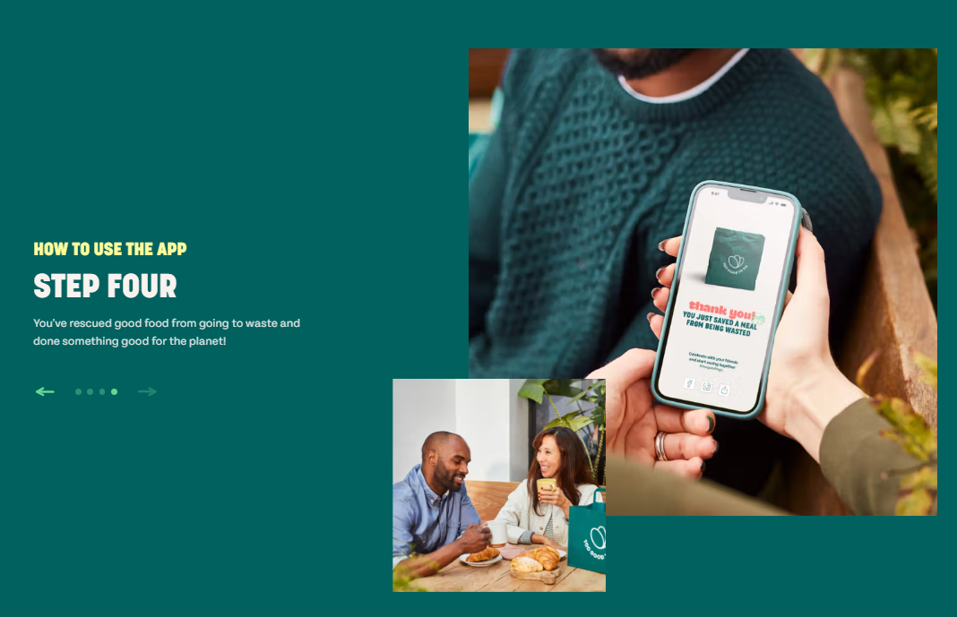 |  | A step-by-step detail on how the app can be used, alongside images to frame the explanation. Its short and simple, that’s beneficial for users to understand exactly how the app will work, not just what it does.
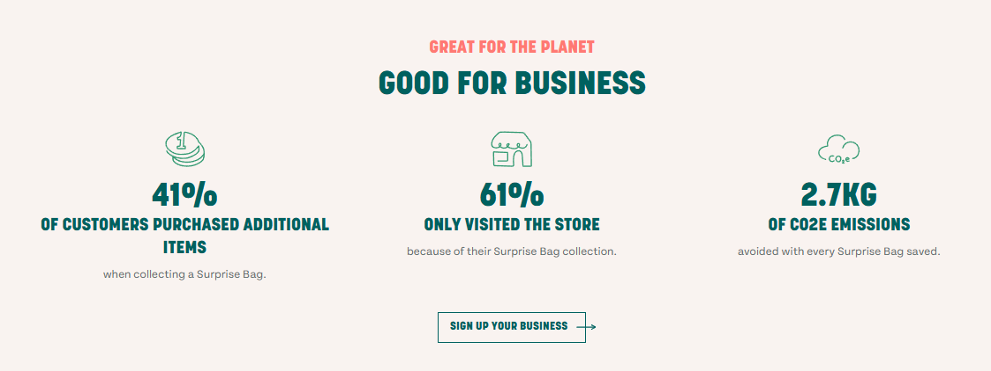 |  | This website includes a section where they provide statistics, which I believe is really beneficial to show as it proves that their cause is making a difference.
Qualities I would add in my website | - Bold colour scheme, sticks to one colour that stands out  - Statistic overview  - Hero-like visuals in main page

Website 3 – Foodprint (Foodprint, n.d.)
Screenshot |  | Description
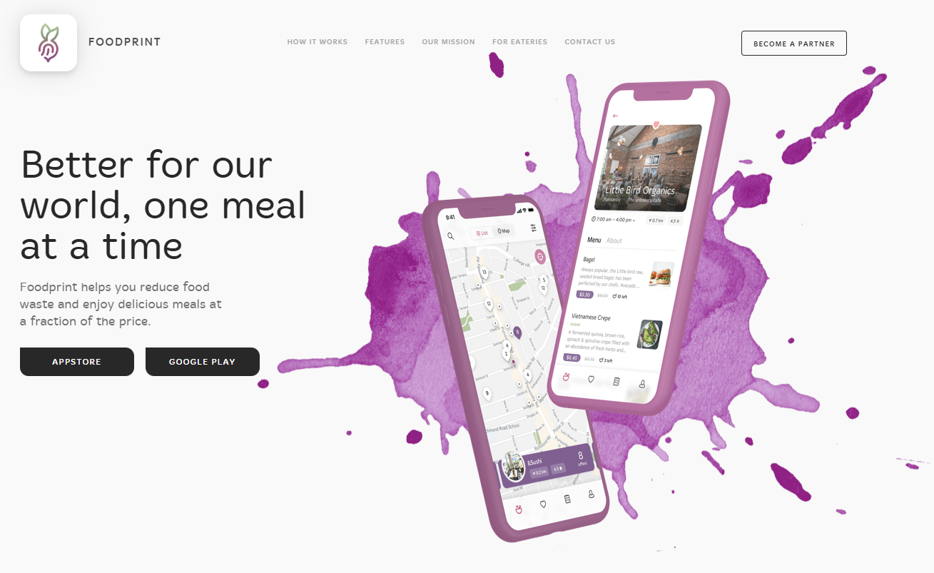 |  | Simple yet brilliant design, I like the single pop of colour they used, similar to a watercolour splash.  Again, this showcases a split hero image – with the image showing bigger than the text.  Theres a bold motto, “Better for our world, one meal at a time”, which captures the mission of the website in a nutshell.
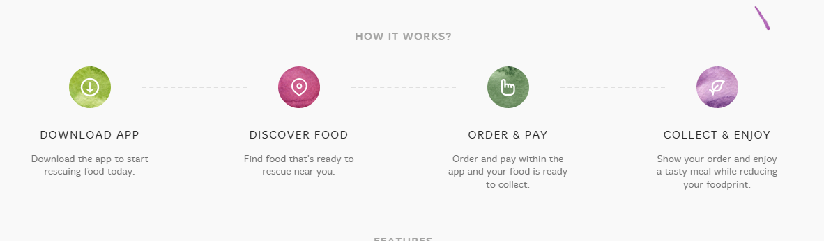 |  | This design to display information is simple to view and aesthetic for visualization. Since the sections are broken into steps with good spacing and order, it makes it easy for users to view
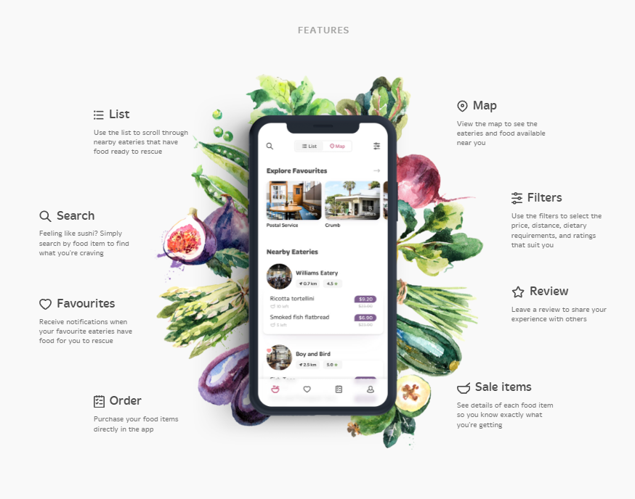 |  | I like the visual design of the phone render displaying the apps different pages. The watercolour designs continue (except with vegetables), which gives the white canvas a burst of natural colours– I like how theres plenty of negative space which makes the fruit artwork more ‘intentional’, than ‘busy’ to look at..  The clean typography makes reading the different points easy  The central focus on the actual UI of the app makes it more captivating to learn more.  The only issue is that the artwork might distract accessibility-minded users if the contrast isn’t carried out properly. The other thing as well as once users read this section on the phone, the amount of elements in this one spot might overwhelm the user, as it could get cluttered.
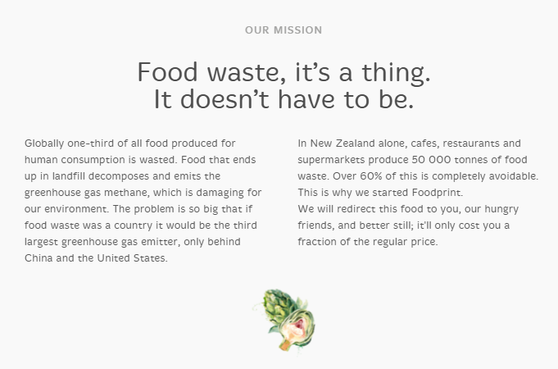 |  | The mention of their mission is clean and easy to look at – theres nothing busy about this.  The only issue might be the fact that users intuitively looking left to right to read, so they would get confused from the fact that it is written in two separate parts, where the user would need to read up to down on both sides.  This layout would NOT be in my website; I would ensure that the written sections can be read with consistent flow and understanding.
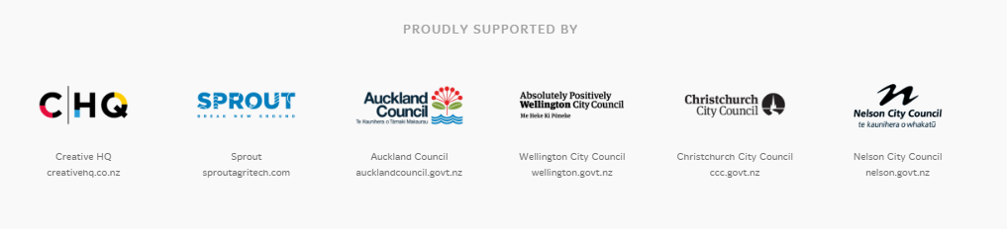 |  | This section is nicely laid out and spaced out decently well as it presents who sponsored them, which includes the local ‘Nelson City Council’, among other councils and other business across the country.
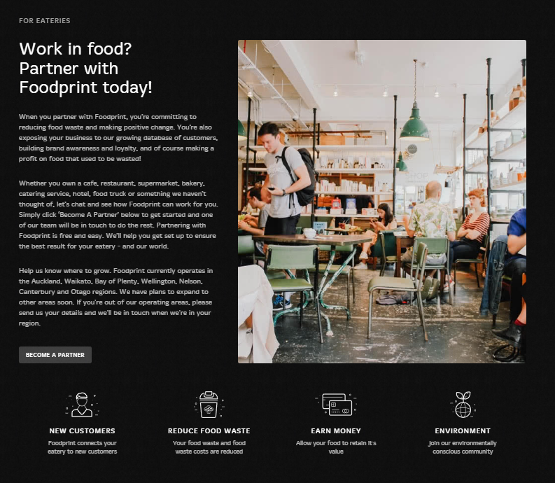 |  | This section is towards the donors and has an in depth description about what it means for companies to contribute to the app and how its beneficial.  They also list perks if they did, including the fact that new customers would come through, the mindfulness of reduced food waste, the chance to earn more money and to be known as environmentally friendly.  The hero image pairs well with the text and is kept simple for the user
Qualities I would add in my website | - Colour scheme, bold colours  - Visually interesting and interactable elements  - Clearly laid/spaced out words

Website 4 – Foodbank NZ (Foodbank New Zealand | Home, n.d.)
Screenshot |  | Description
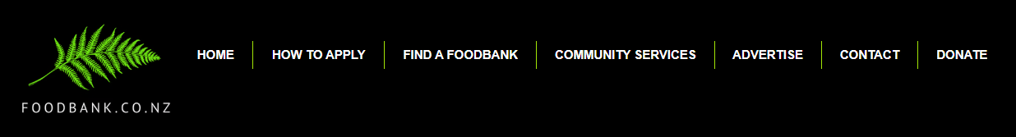 |  | Navbar is simple enough to read and has the line breaks to separate the menu sections  Has a very prominent ‘fern’ logo
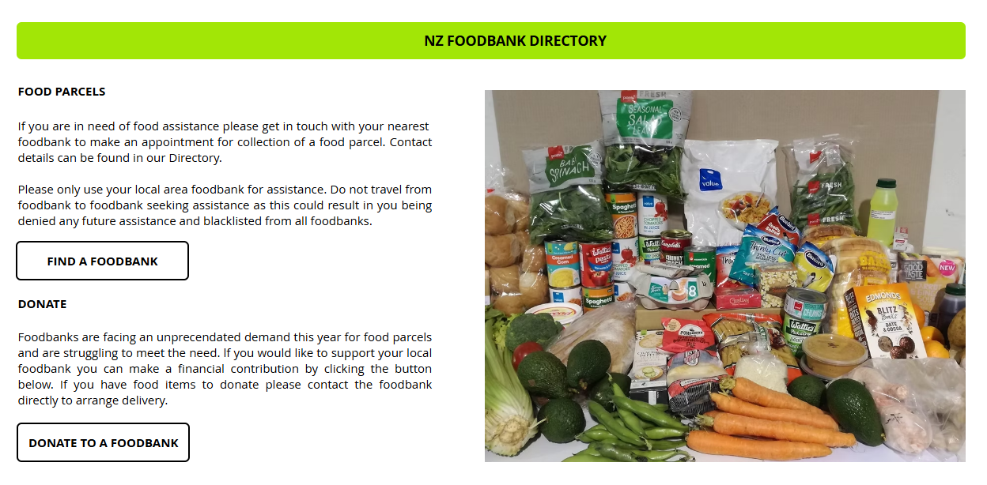 |  | Has a large image which is split with written explanations on finding a foodbank or donating to one.  The image is very ‘busy’, yet promotes exactly what items can be provided and how much can be provided
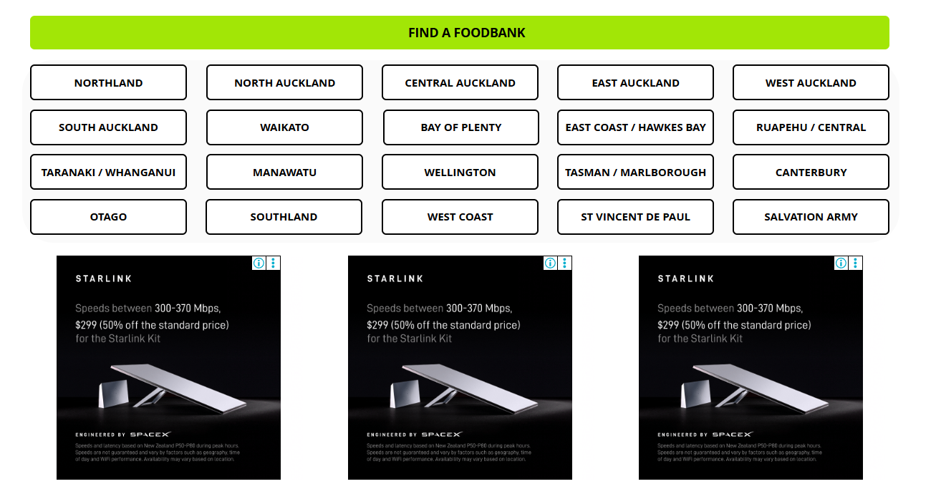  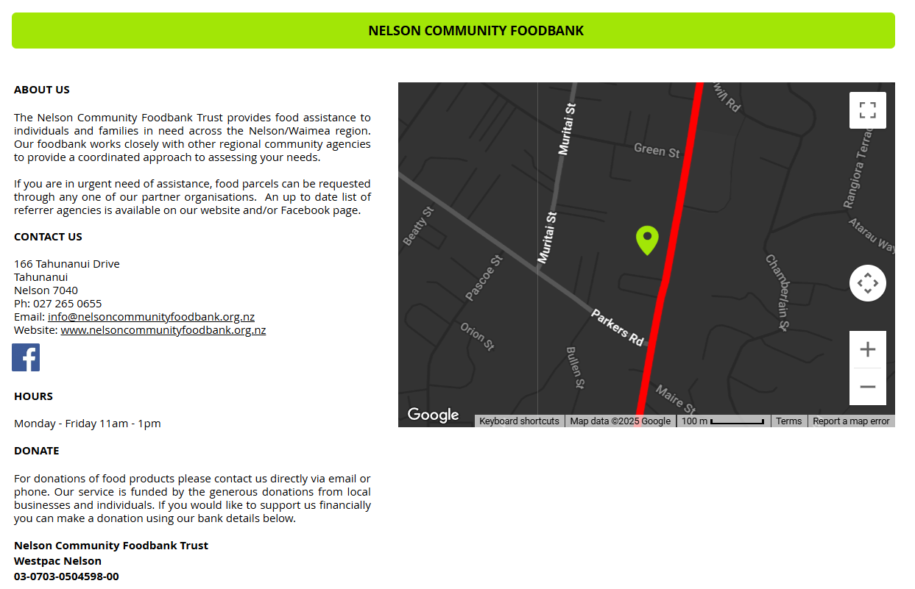 |  | A very big ‘button’ list of all the places where users can find a foodbank.  Unfortunately, most of the website is covered with ads, such as these ones  When I clicked on the ‘Tasman/Marlborough option, I then got introduced yet again more of a ‘button’ list and ads – very repetitive  I do like how they finally add maps to a specific area to pinpoint where the foodbank is, so its easier for the user to visualize where they need to go  The information they have listed for this are very specific and detailed, which is beneficial as it shouldn’t leave any doubt for the user, should they read everything through.
Not much going on in the footer, credits and copyright are on the left and extra menu items are on the right – everything on the right hand side are quite close together, which is strange considering how much space is given in the footer.
This is a very plain design
Qualities I would add in my website | - Specific details to an item (leaves no room for doubt about the area)
Qualities I would not add in my website | - Constant ads of the same product  - Excessive amount of buttons when it could be visualized in a better way

Website 5 – Kiwi Harvest (KiwiHarvest, n.d.)
Screenshot |  |  | Description
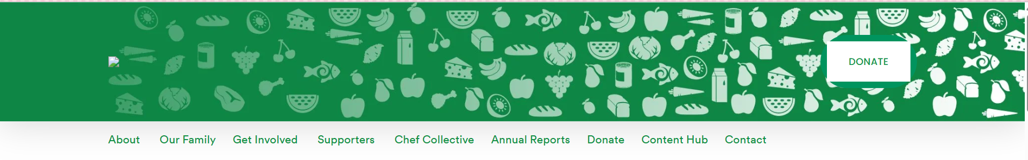
The navigation bar is laid out very strangely… the visuals are nice but might pose as being too busy, if reading is involved to navigate a system.
The logo icon isn’t showing up on the left like its meant to, so users who don’t realise this won’t know how else to get to the ‘home’ page (as they relied on the ‘logo’ for this)
The donate button is white and square, yet has a circular outline of a darker green, which I thought was strange that they included that outline

When users scroll down, the actual navigation buttons disappear and stay at the top of the screen, so users would have to inconveniently scroll up to the top of website again just to find new spots on the website.
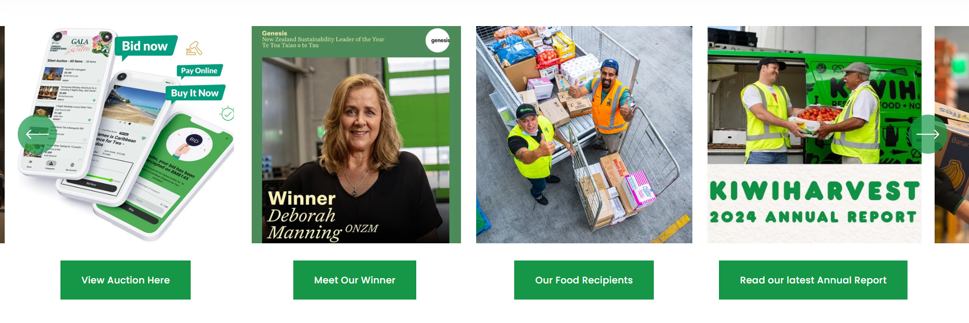 |  | Clear blogs and events listed with visuals to read into what it’s about
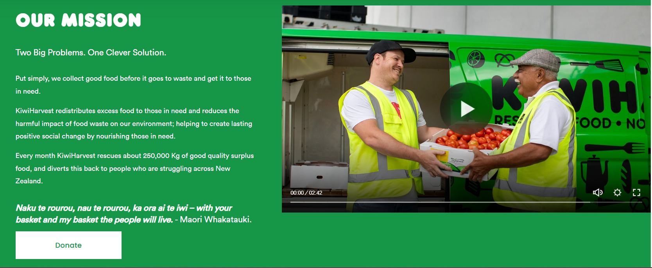 |  | They talk about their mission, which is always important to see how essential their company is to the nation.  They provide a video to explain their situation too, which I find good to capture the audience.
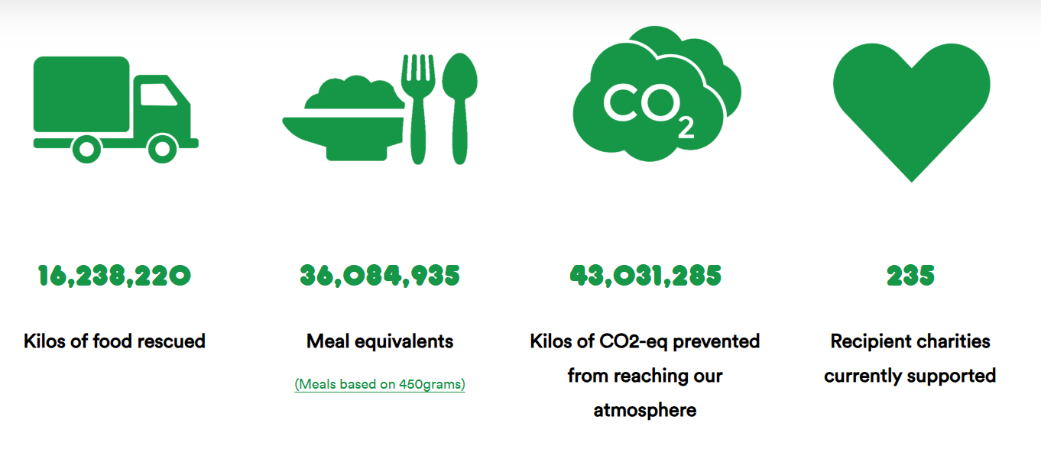 |  | They provide statistics on how beneficial their company has been
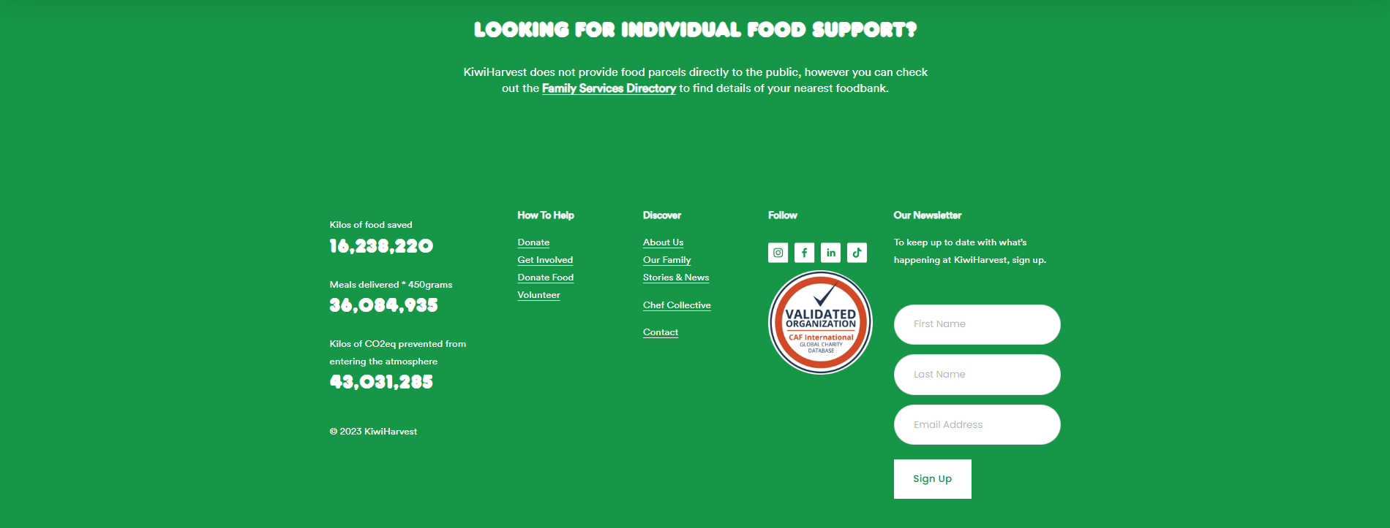 |  | The footer is very large, and everything is spaced out quite weirdly
What qualities I would add in my website: | - Clear statistics
What qualities I would not add in my website: | - Inaccessible navbar  - Overly large footer

Site Content:

Dynamic Content and Functional Requirements:
The Late-Night Nosh website must include two types of information: a marketing copy which explains the mission/cause and screens which deliver the token-driven marketplace
The marketing copy would include:
- a concise hero image and statement such as ‘Good food after a good shift’ or ‘Rescuing late-night meals for Nelson’s night-owls’,
- a three/four step explainer of the workflow (‘list’, ‘reserve’, ‘pickup), rotating donor/beneficiary reviews and counters which tracks meals saved for written statistics.
- Images of food and simple iconography (vegan, gluten-free, vegetarian, spicy etc.)
- A section to reinforce the idea that the rescued meals are fresh, safe and prove variety of the foods available.
- The listings themselves would have a title, a small blurb and the ‘token’ price
The application screens would provide role-specific functions.
Beneficiaries would need:
- a section that shows their weekly token balance
- a real-time list of all available meals
- an intuitive setup where users can press a button once to reserve a meal, which produces a QR code
Donors, on the other hand, would need:
- a separate interface which would have an ‘add meal’ form
- a dashboard listing current meals
- a scanner which removes a token when a QR code is shown during pickup
The administrators would need:
- A panel to approve new users
- Panel to top-up tokens
- Section to audit logs.
For logging in, there will be:
- a button on the nav bar to allow users to log in;
  - The login screen will:
    - let users sign in with a username and password.
  - If a user wants to create an account:
    - They can select a button below, which could say ‘Don’t have an account? Sign up!”
When a user enters the website initially, they can act as a guest to look through the webpages, however if they were to reserve a meal, they would be prompted to login/signup.
Technically speaking, the site would need to support:
- JSON Web-Token (JWT) login/role-based authorization
- CRUD operations for users, meals, reservations and tokens via. REST API
- Notifications applied so a newly listed meal would appear
- Toast popups when confirmation of signup/sign-in/reservation is successful/unsuccessful
- A configuration which resets token balances every Monday at midnight and expires untouched tokens after 2 weeks
In regard to dynamic content, I would make sure that when they look at the account page/dropdown nav, it would say “Welcome, [users name]” for added personalized experience.
I wouldn’t have anything such as advertisements, but I could always add an extension where it suggests certain stores or items based on previous purchases, which yet again repeats the ‘personalized’ concept.

Group and Label your Content:
I used Fig Jam (from Figma):
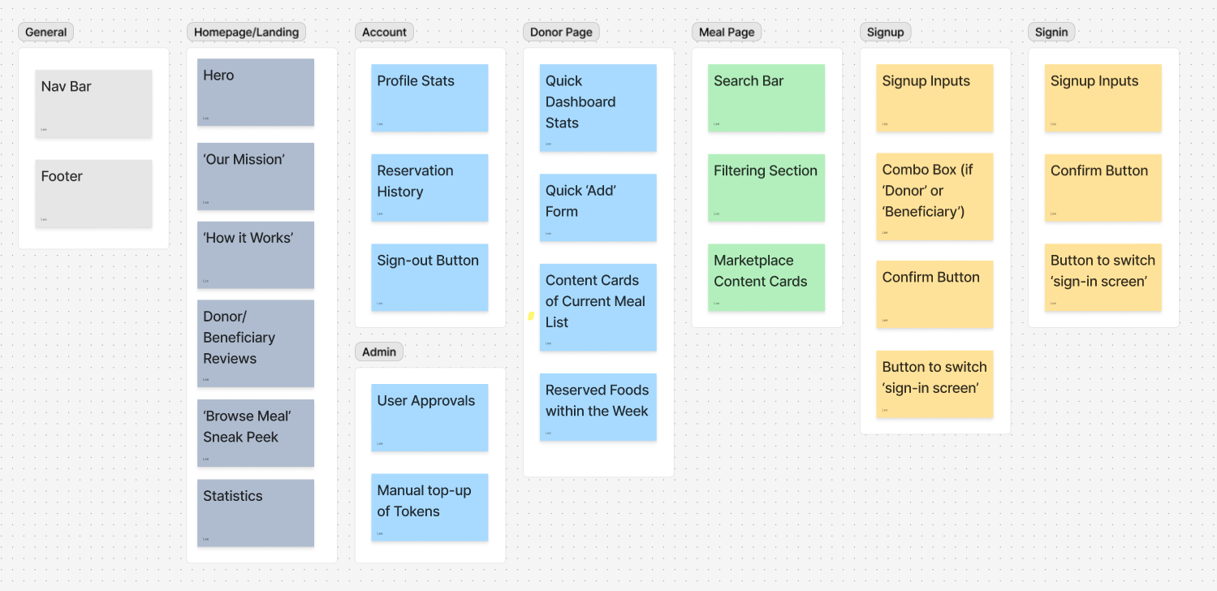
This was used to visualize the setup I had mentioned in the previous task, ‘Dynamic content and Functional requirements’. Each block represents a page and having this meant I could visually see what is required and what might be seen in each page. I kept ‘general’ as its own thing, and each page, such as ‘homepage, account, donor page’ etc. would include this (as it is the navigation bar and footer)
I chose to do each of these pages as based on what I had discovered and looked into based on the scenarios I have made earlier.

Site Structure:

Metaphors:
Metaphor Types | Description
Organizational | - Marketplace Stalls – each meal card is a market stall; users can browse, filter and ‘purchase’ with tokens  - Each meal card sits on its own ‘stall’, with clear separation so users can scan at a glance.
Functional | - Tokens act like coins as you ‘pay’ for a meal  - E-wallet is the coin purse: you spend from it and get it topped-up weekly
Visual | - Night-city Neon – Bright cyan highlights against dark backgrounds to emphasize ‘neon’ signage – immediately signals ‘late-night food’  - Soft rounded cards and subtle glows portray like streetlights  - Deep charcoal/navy backgrounds to mimic the colour of the night sky

Site Structure Listing:
- Home
- Nav bar
  - Home (using logo image)
  - How it works
  - Browse Meals
  - Donate
  - My Account
    - [If User]
      - Token Balance
      - ‘My Profile’
      - Settings
      - Sign Out Button
    - [If Guest]
      - Request asking to login to use features
      - Login/Signup button
- Hero Image
  - Slogan
- How it works
  - Imagery of the process
  - Short descriptions
- Our Mission
  - Description
- Donor/Beneficiary Reviews
- ‘Browse Meal’ Sneak-Peek
  - Meal cards
    - Food title
    - Store
    - Reservation expiry time
    - Token amount
    - Reserve button
  - ‘View All Available Meals’ meals
- Statistics
  - Icon
  - Statistic number or percentage
  - Title of statistics
- Footer
  - Logo
  - Nav Bar Links
  - Copyright
- Meals Page
- Nav bar
  - Home (using logo image)
  - How it works
  - Browse Meals
  - Donate
  - My Account
    - [If User]
      - Token Balance
      - ‘My Profile’
      - Settings
      - Sign Out Button
    - [If Guest]
      - Request asking to login to use features
      - Login/Signup button
- Search Bar
- Filtering
  - Preference (Vegetarian, Pescetarian, Vegan etc.)
  - Distance
  - Cuisine (Italian, Thai, French etc.)
- Marketplace grid containing meal cards
  - Food title
  - Store
  - Reservation expiry time
  - Token amount
  - Reserve button
- Footer
  - Logo
  - Nav Bar Links
  - Copyright

- Donor Dashboard
- Nav bar
  - Home (using logo image)
  - How it works
  - Browse Meals
  - Donate
  - My Account
    - [If User]
      - Token Balance
      - ‘My Profile’
      - Settings
      - Sign Out Button
    - [If Guest]
      - Request asking to login to use features
      - Login/Signup button
- Console landing (donors only)
  - Token Balance
  - ‘Meals Donated’ Stat
  - Add = Quick form
  - Listings = Current meal list
- Scanner = QR reader
- Footer
  - Logo
  - Nav Bar Links
  - Copyright

- Account Page
- Nav bar
  - Home (using logo image)
  - How it works
  - Browse Meals
  - Donate
  - My Account
    - [If User]
      - Token Balance
      - ‘My Profile’
      - Settings
      - Sign Out Button
    - [If Guest]
      - Request asking to login to use features
      - Login/Signup button
- Profile Stats
  - Token Balance
  - Reserve Streak (if applicable)
- Reservation History
  - Title
  - Date (‘1 Hour Ago’, ‘2 Weeks Ago’ etc.)
- Sign out Button
- Footer
  - Logo
  - Nav Bar Links
  - Copyright

- Admin Page
- Nav bar
  - Home (using logo image)
  - How it works
  - Browse Meals
  - Donate
  - My Account
    - [If User]
      - Token Balance
      - ‘My Profile’
      - Settings
      - Sign Out Button
    - [If Guest]
      - Request asking to login to use features
      - Login/Signup button
- Admin Hub
  - Users = Approvals
  - Tokens = Manual top-ups
- Footer
  - Logo
  - Nav Bar Links
  - Copyright

- Login Page
- Nav bar
  - Home (using logo image)
  - How it works
  - Browse Meals
  - Donate
  - My Account
    - [If User]
      - Token Balance
      - ‘My Profile’
      - Settings
      - Sign Out Button
    - [If Guest]
      - Request asking to login to use features
      - Login/Signup button
- Login Inputs
  - Email
  - Password
- Confirm Button
- Button to switch to ‘sign-up’ screen
- Footer
  - Logo
  - Nav Bar Links
  - Copyright

- Signup Page
- Nav bar
  - Home (using logo image)
  - How it works
  - Browse Meals
  - Donate
  - My Account
    - [If User]
      - Token Balance
      - ‘My Profile’
      - Settings
      - Sign Out Button
    - [If Guest]
      - Request asking to login to use features
      - Login/Signup button
- Signup Inputs
  - Name
  - Email
  - Password
- Combo Box (“I am a….” response with ‘Donor’ or ‘Beneficiary’)
- Confirm Button
- Button to switch to ‘sign-in’ screen
- Footer
  - Logo
  - Nav Bar Links
  - Copyright

Architectural ‘Blueprint’:
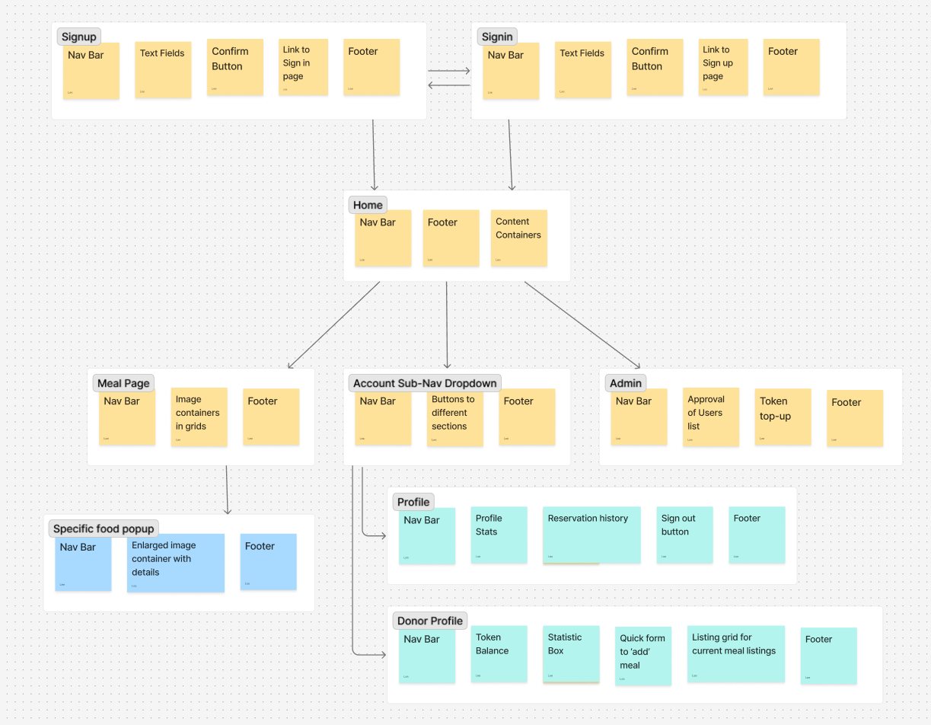

Define Navigation:
Global Navigation:
The user will be able to navigate through the website sections with global navigation, which is portrayed as a ‘navigation bar’ at the top of the screen. The following list is for each button presented on the bar:
- Home (Logo)
- How it Works
- Browse Meals
- Donate
- Account
This is a simplistic design which should be intuitive for the user to utilize – if I added too many buttons, or too many dropdowns, the design is at risk of being confusing and overwhelming. It is very important that the user can have the easiest time going through my website without second thought.
The design of the nav bar will have a solid dark grey colour with white text; something that isn’t busy to look at. I will make it so that when the user hovers over a button, an ‘underline’ will show up, to highlight what ‘button’ they will press (I will NOT have a box around the text for these, for sleek design, so this will be the way to make visualization easier.)
The only sub navbar element I will have been for the account option, which will present a quick view of token balance, among other buttons to view the users’ profile, settings and the option to sign out. I am not going to add sub navbar elements to the others, as it will possibly cause confusion.. The different filtering and options for each screen will be done through local navigation.
Local Navigation:
I haven’t particularly considered if local navigation is placed in this website, though if there were a lot of components-within-components, then I would include a ‘breadcrumb’ element at the top of each page if it were necessary

Visual Design:
Nav Bar


Nav Bar Account Popup (With Logged in User vs Guest):
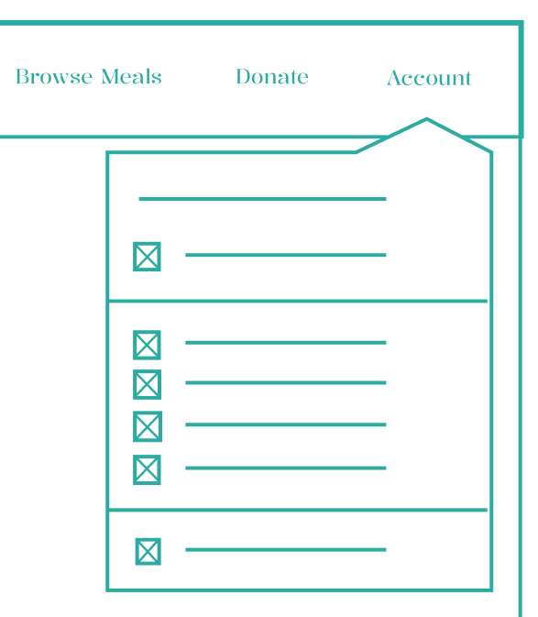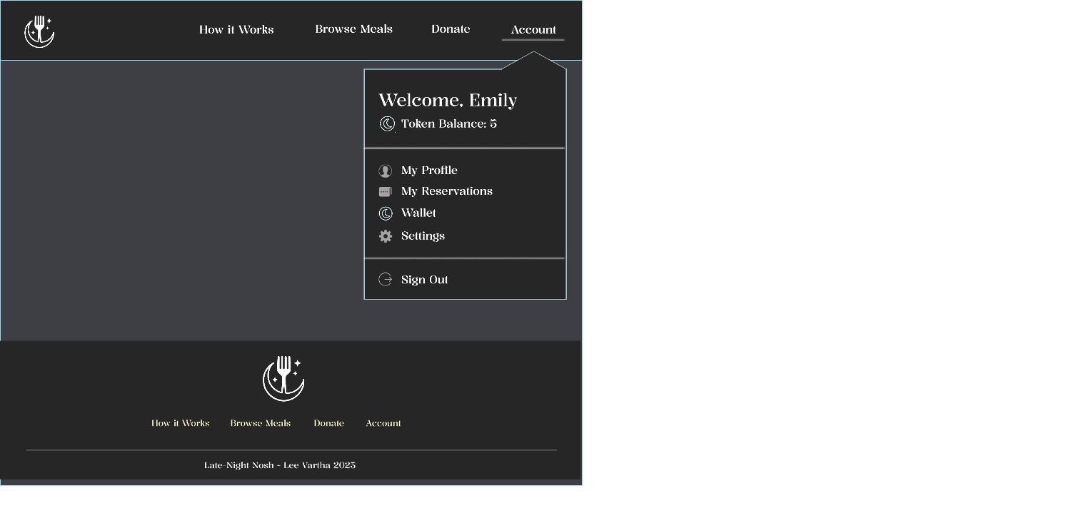
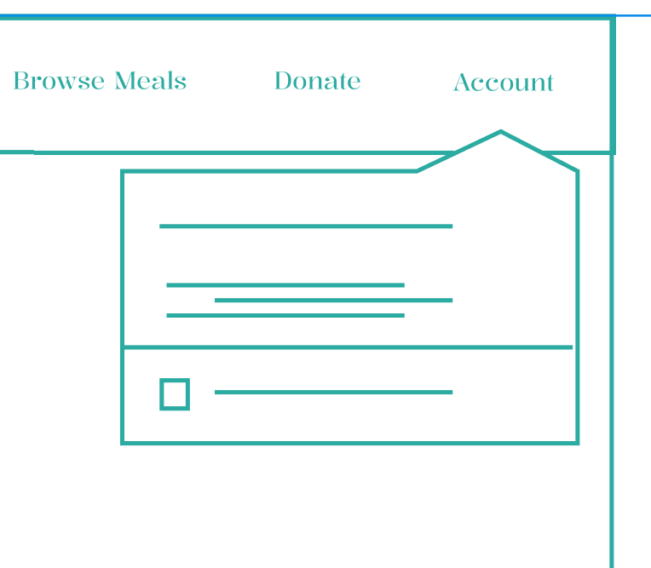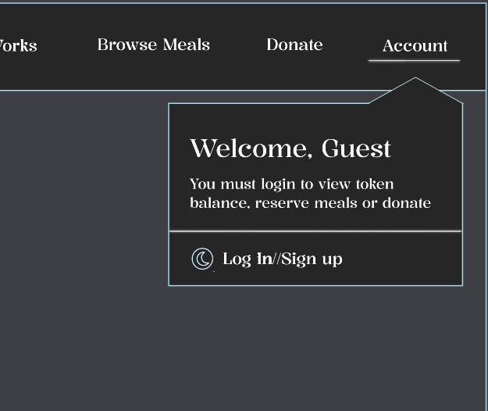

Footer:


Sign up Page:
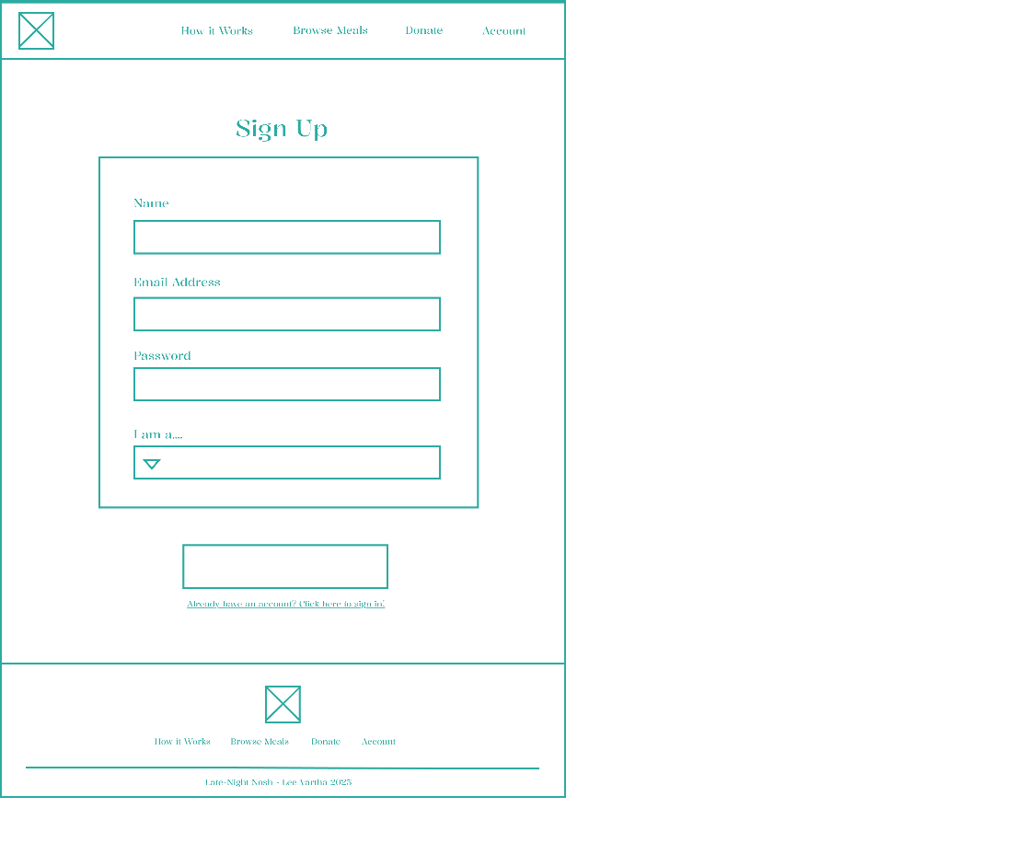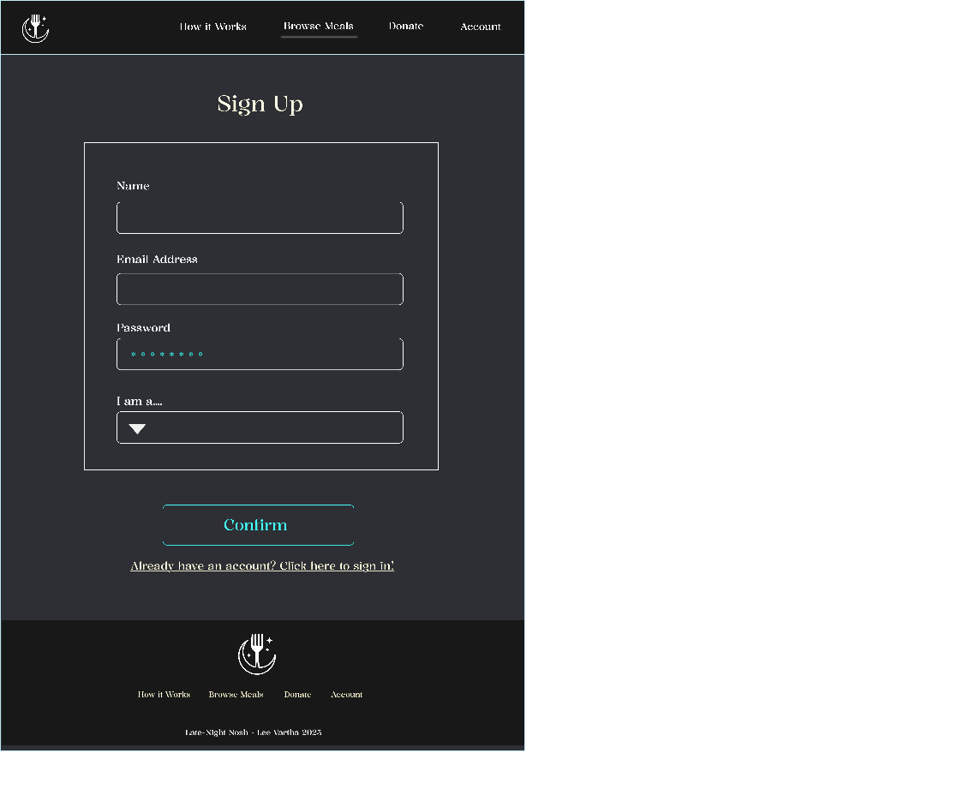

Log in Page:
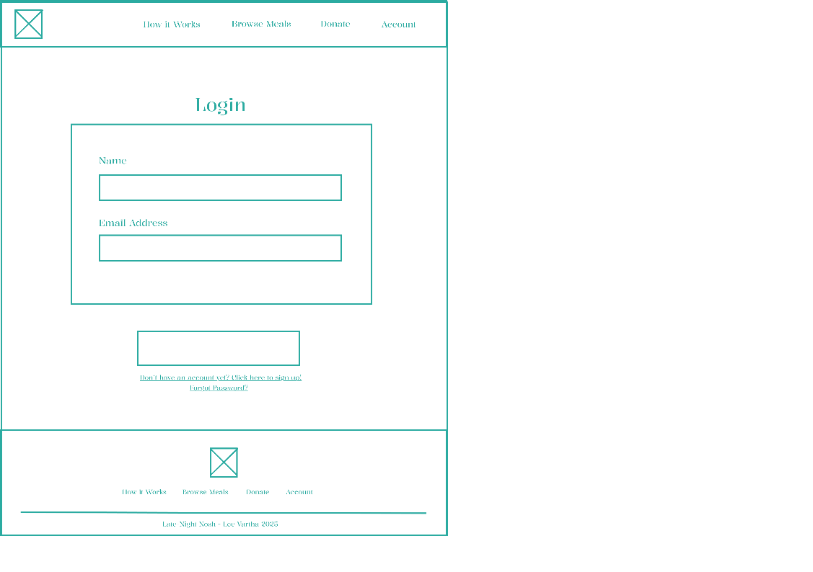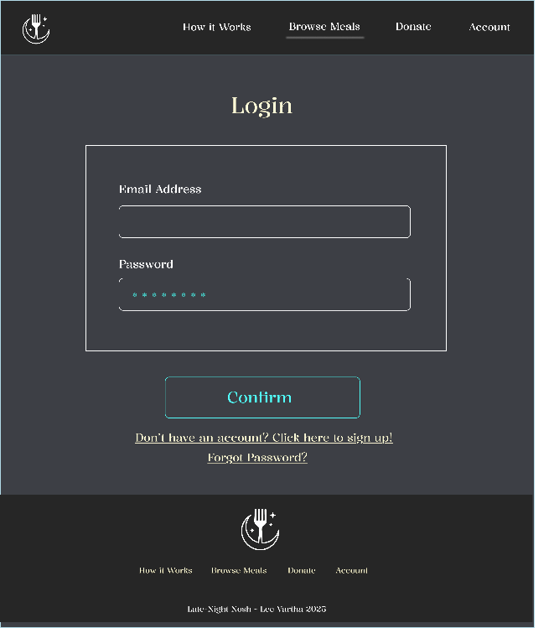

Main Page:
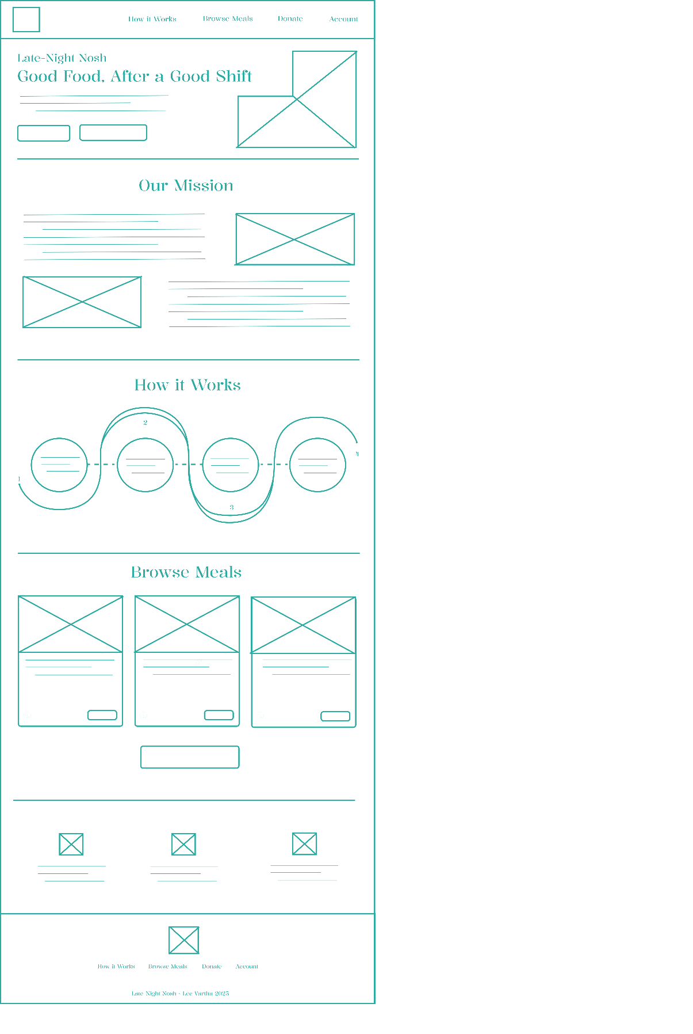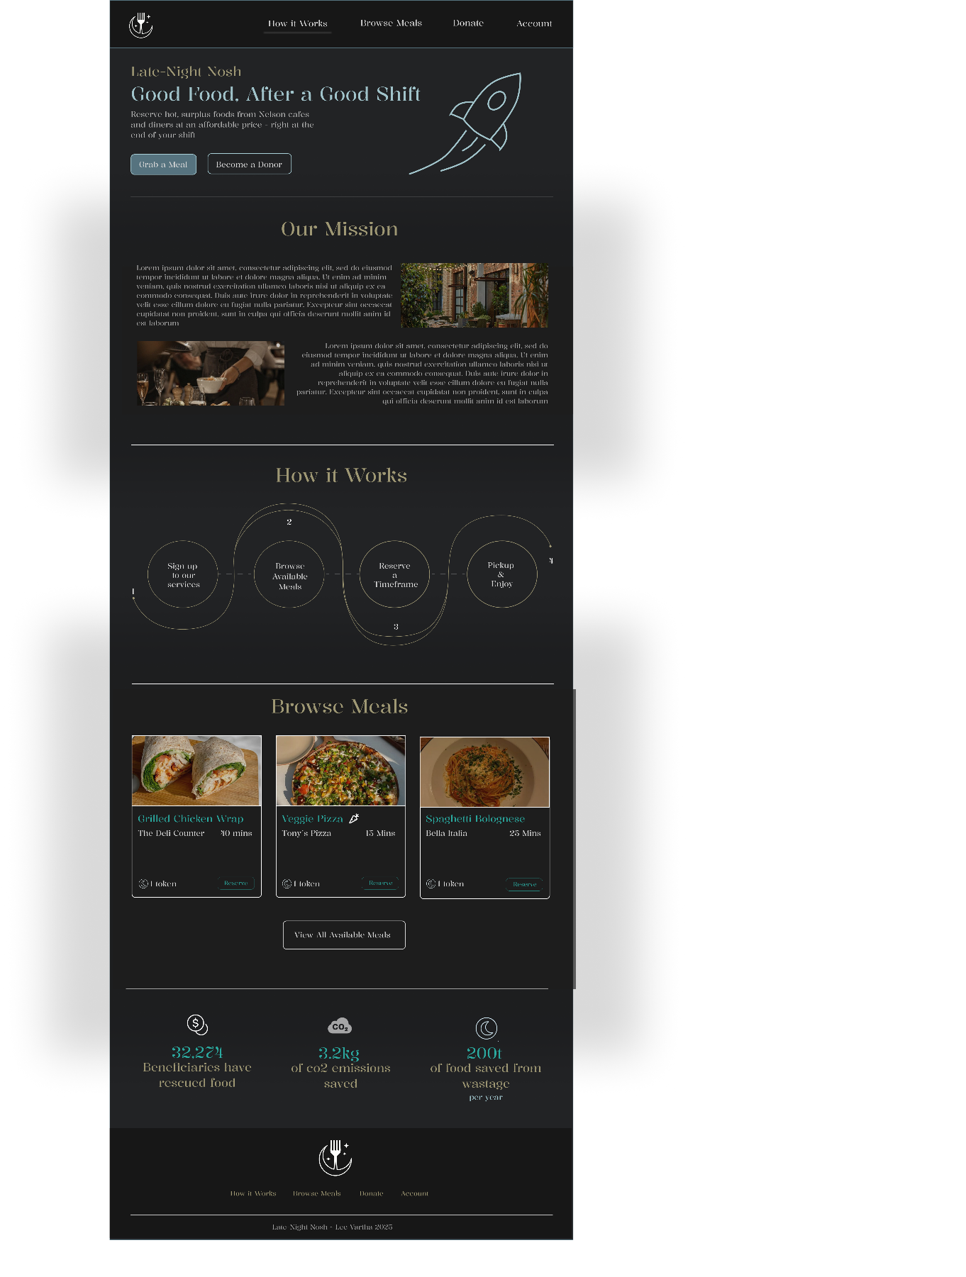

Meals Page:
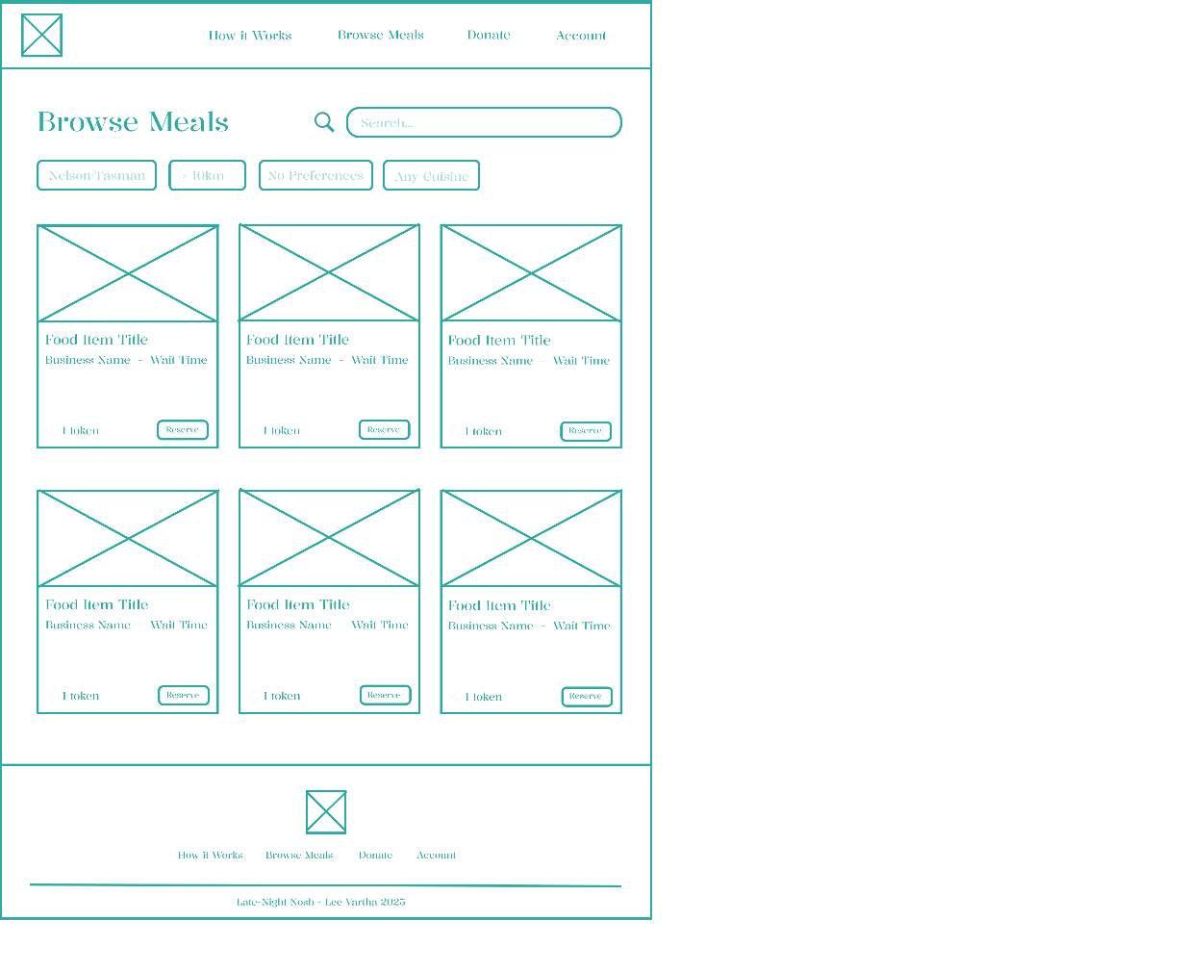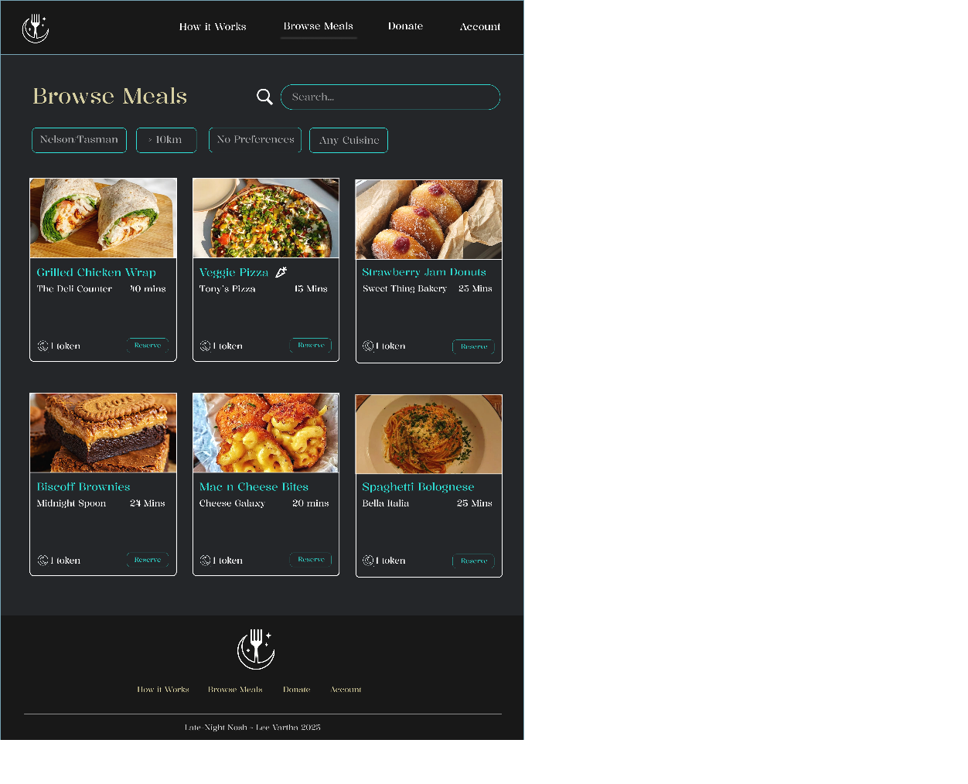

User Profile (Beneficiary):
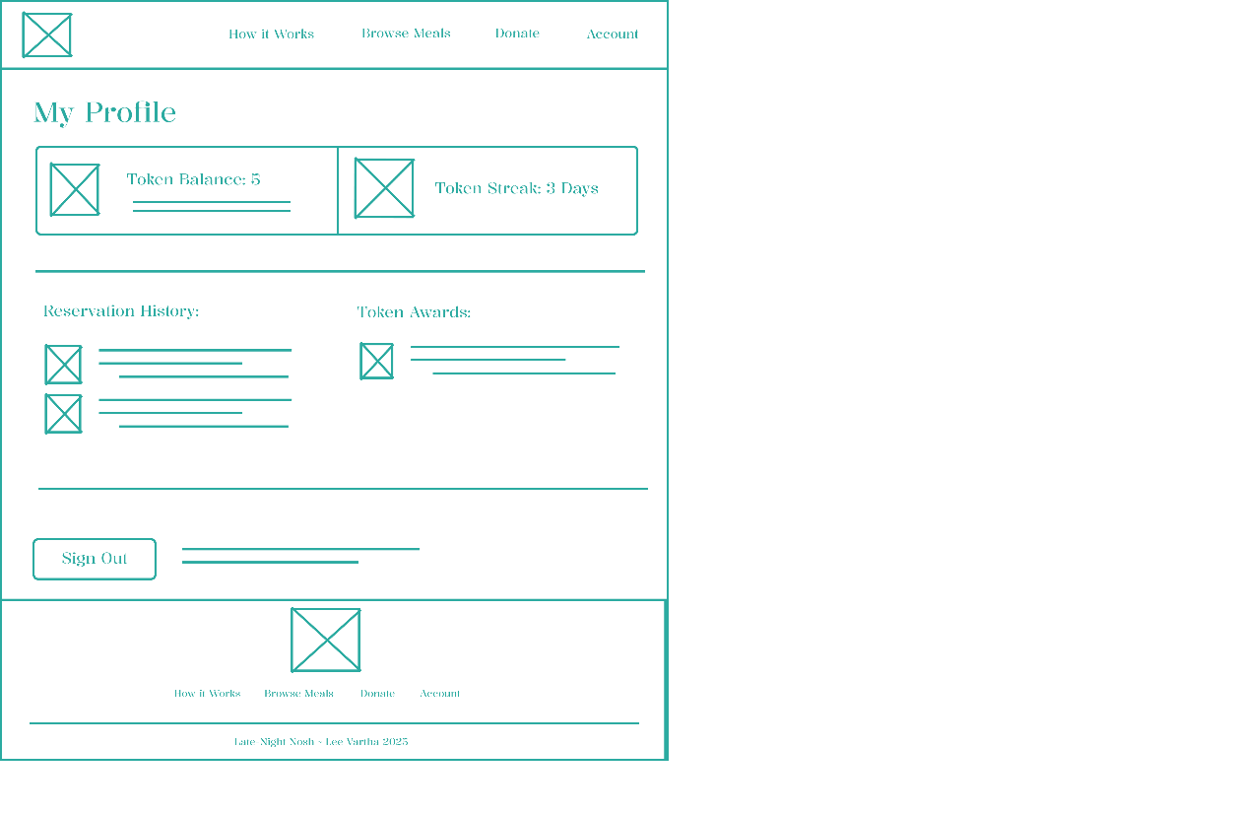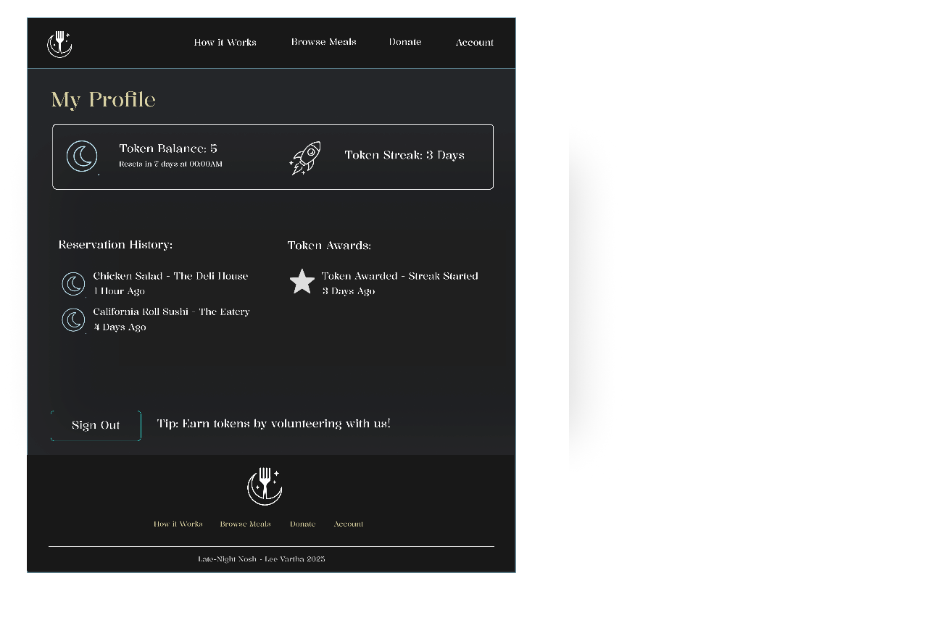

Donor Dashboard
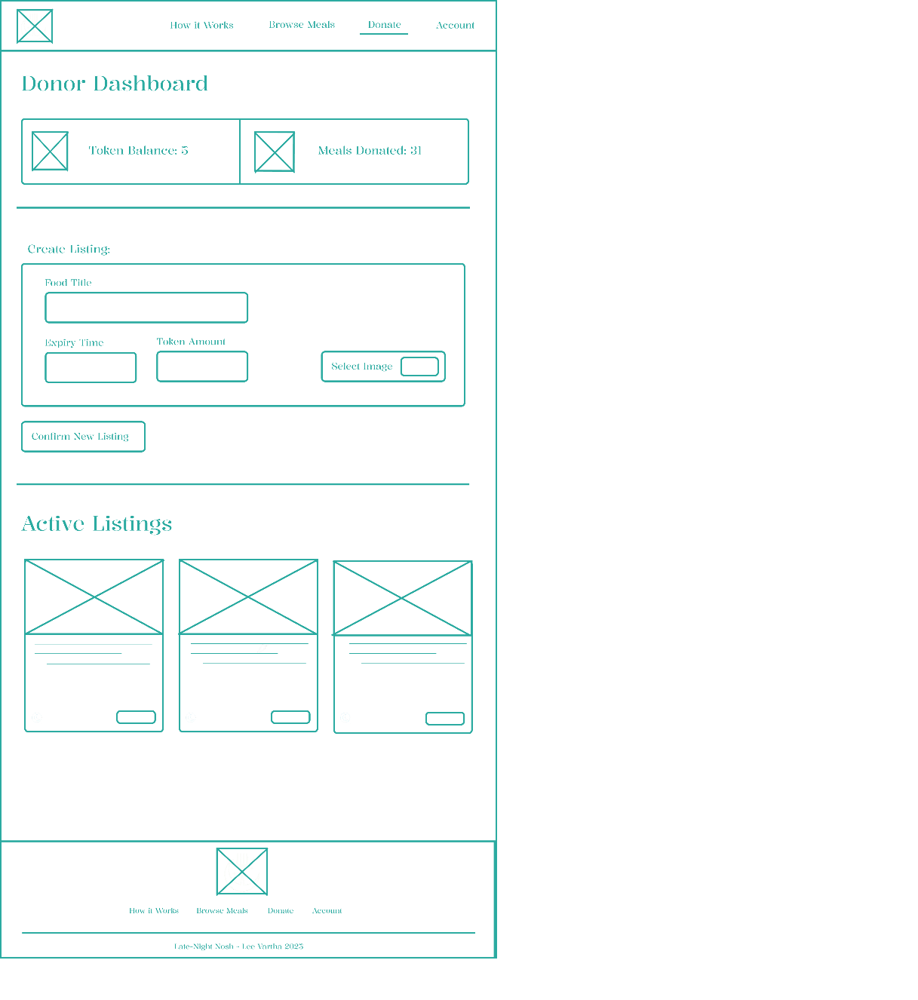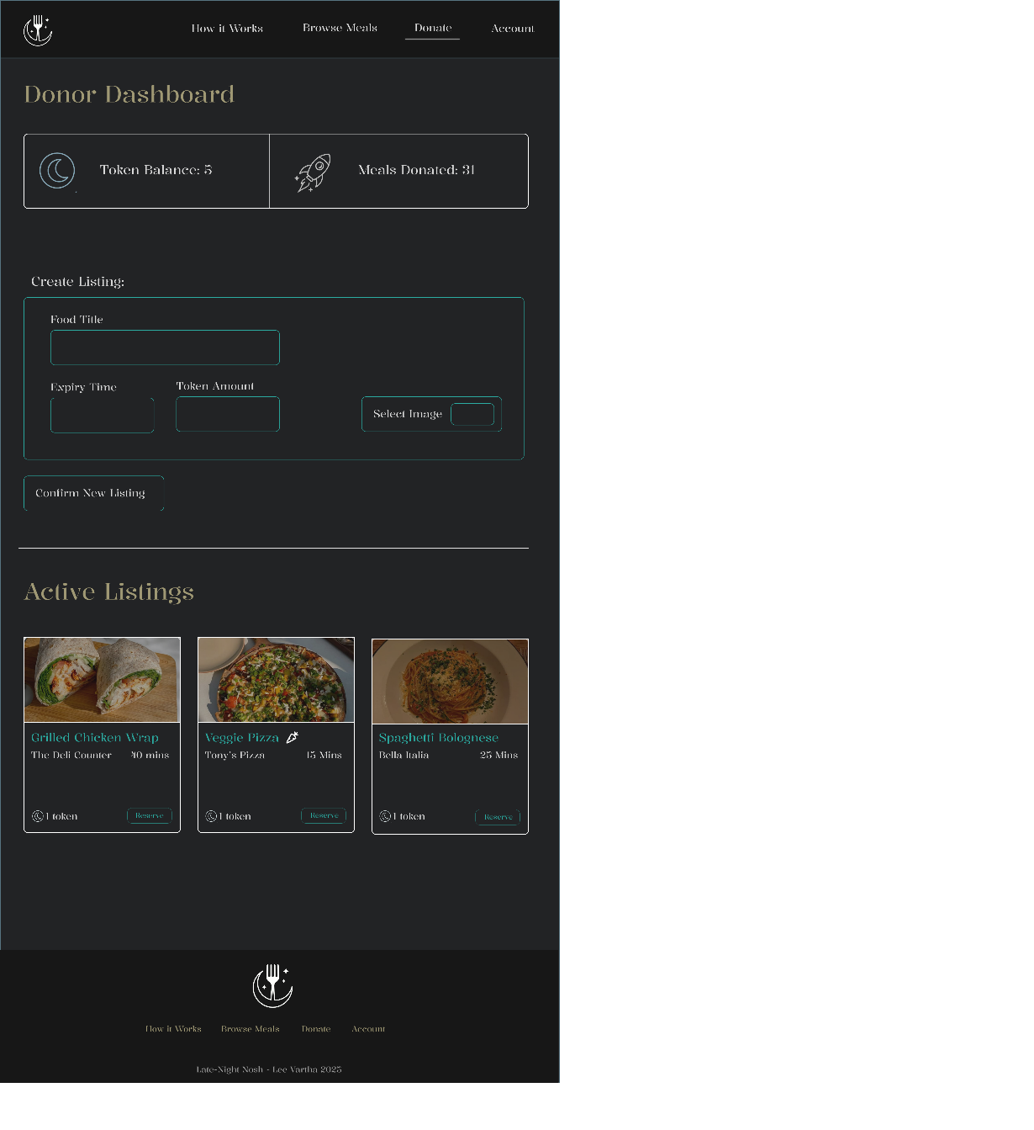

User Stories – Designing to Build:
Account Management:
- As a donor, I want to register with my business details so that I am verified to list surplus meals
- As a donor, I want to log in and out securely, so that I can choose when to manage meal listings
- As a donor, I want to update my profile so that beneficiaries can view accurate information about the business
- As a beneficiary, I want to be able to register with basic information so I can receive a weekly token allowance and browse meals when I need them
- As a beneficiary, I want to log in and out quickly so that I can check tokens and listings when I have finished my late-night shift
Meal Listings/Reservations:
- As a donor, I want to be able to create a new listing (title, quantity, image and pickup window) in under 60 seconds so that I can sell out my surplus food before closing
- As a beneficiary, I want to browse a grid with real-time meals, so I can see available meals as soon as they’re listed
- As a beneficiary, I want to filter by distance, dietary preference, time pickup window etc. so that I can reserve exactly what I need based on where I am
- As a beneficiary, I want to spend a token to reserve a meal ( ½ , 1 or 2, depending on the meal), so that I can pick up hot food when I finish my shift
- As a donor, I want to scan the QR code at hand-over so that I can burn the correct amount of tokens and mark the listing as ‘picked-up’ or ‘sold-out’
Token Wallet:
- As a beneficiary, I want to check my token balance, reset timer and history so I know how many more meals I can reserve this week before waiting for balance reset.
- As a beneficiary, I want to track my ‘streak’ and earn a bonus token after 7 pickups, so I am more motivated to use the service properly
- As a beneficiary, I want to earn +2 tokens by signing up for a volunteer shift, so I can extend my allowance fairly
Interactive:
- As a user, I want a toast notification (‘New Meal Nearby’) when a donor posts a listing within 5km, so that I don’t miss out on any new meal options
- As an Admin, I want to approve new users and top up tokens, so that edge cases can be handled when needed
- As an admin, I want to view statistics (meals saved, top donors, CO2 avoided) and export the reports so I can report to stakeholders

Features:
- Create API

Github Project:
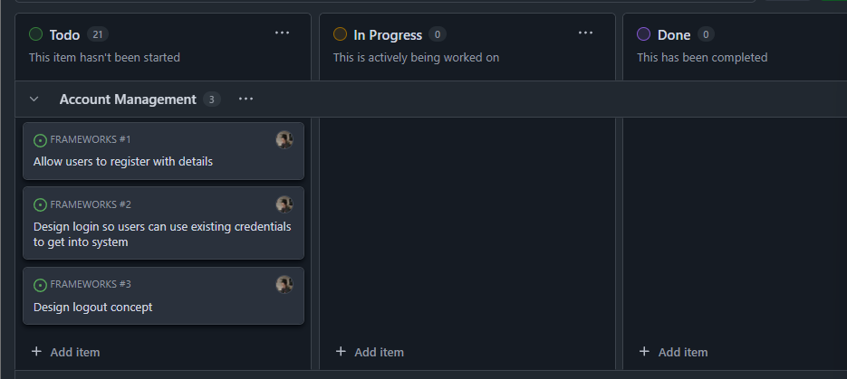
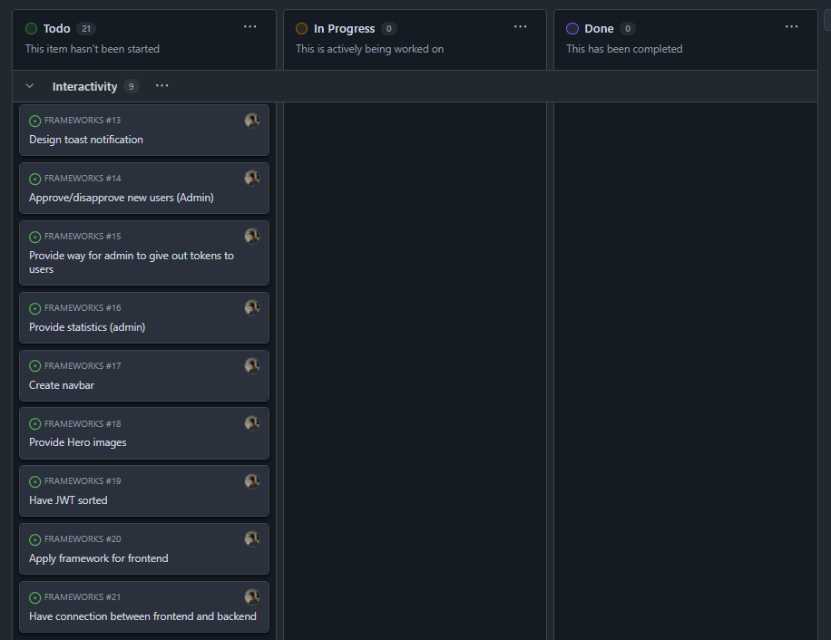
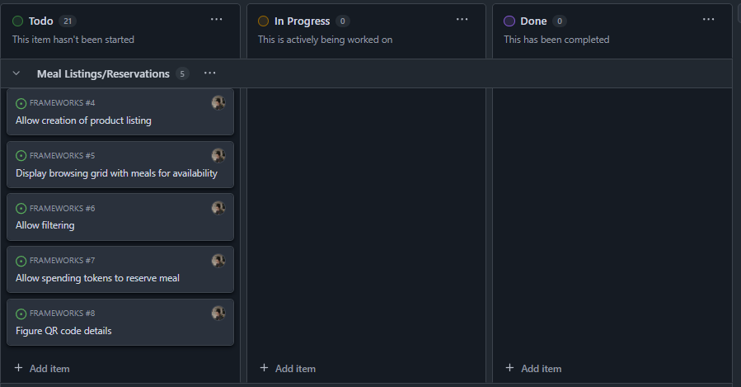
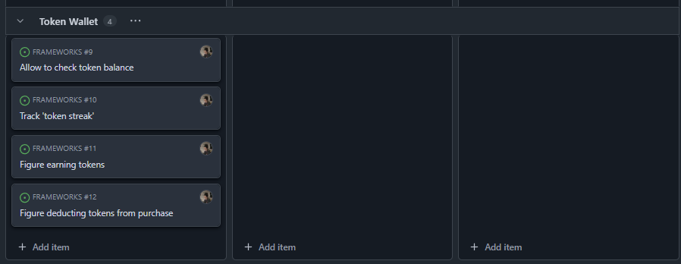

CRUD Analysis – API prototype:
Donor Register
Account
Process | AccountID | FirstName | Email | Password | Token | Member
Signup | Create | Create | Create | Create | Create | Create
Token
Process | TokenID | TokenValue | AccountID
 | Create, Read | Read | C,R,U,D

Donor Login
Account
Process | AccountID | FirstName | Email | Password | Token | Member
Signup | Read | Read | Read | Read | Read | Read

Beneficiary Register
Account
Process | AccountID | FirstName | Email | Password | Token | Member
Signup | Create | Create | Create | Create | Create | Create
Token
Process | TokenID | TokenValue | AccountID
 | Create, Read | Read | C,R,U,D

Beneficiary Login
Account
Process | AccountID | FirstName | Email | Password | Token | Member
Login | Read | Read | Read | Read | Read | Read

Beneficiary Gaining Token
Account
Process | AccountID | FirstName | Email | Password | Token | Member
Get Token | Read | Read | Read | Read | Read | Read
Token
Get Token | TokenID | TokenValue | AccountID
 | Read | Read | Read

Donor Adds Product
Account
Process | AccountID | FirstName | Email | Password | Token | Member
Add Product | Read | Read | Read | Read | Read | Read

Product
Process | ProductID | ProductName | CompanyName | Quantity | TokenCost | WaitTime
Add Product | Create | Create | Create | Create | Create | Create

Beneficiary Spends Token
Account
Process | AccountID | FirstName | Email | Password | Token | Member
Reserve Meal (Spend Token) | Read | Read | Read | Read | Read | Read

Product
Process | ProductID | ProductName | CompanyName | Quantity | TokenCost | WaitTime
Reserve Meal (Spend Token) | Create | Create | Create | Create | Create | Create

API Calls:
[Github link was submitted to dropbox]

Evaluation (Milestone 2):

Describe the purpose of web frameworks:
Web frameworks (stacks) are structured software toolkits that provide a simplified way to build web applications. “These environments provide pre-written code and components that streamline the development process, so developers don’t have to start from scratch everytime they build something” (What Is a Framework?, 2025)
The benefits of frameworks is that it saves time as “developers can use pre-built components and structures” (What Is a Framework?, 2025), which means that users can focus more on the backend or more complex structures of the application.
Utilizing this means that there is less development time, reduced errors etc.
This is useful for the design of my charity website as help is required with secure user management, token-based transactions and storage.
Common features include:
- Routing:
Maps URLs to functions
- Middleware:
Handles auth, requests and error processing
- Templating:
Helps render dynamic UI (React, Vue.js, Angular etc.)
- Database integrating:
Operations in databases can be done quicker using SQL (object-relational mappers) or MongoDB (object-document mappers) and simplifies data retrieval/storage
- Auth:
Helps to support role-based access (JWT/OAuth) and general user authentication
- Testing/Deployment:
Includes helpful tool for virtual containerization (Docker, VENV) and unit testing
Features used for my web development:
- Routing will be used for my website to direct users to different services like register, login, and their corresponding dashboards, whether they’re a donor or a beneficiary.
- Database integrating will be done using MongoDB or SQLite, which will store products, transactions and user profiles
- Authentication will use JWT, which will encode user data for security
- Middleware will be included to manage JWT tokens and role-based accesses to different components
How these are used in specific frameworks:
- MEAN/MERN/MEVN:
These stacks each use the same backend details, yet different frontend frameworks. These three utilize Express.js for routing, Mongoose for MongoDB database storage, and jsonwebtoken library for JWT.
Angular, React or Vue.js manages client-side rendering and for any interactions made, it stores JWTs in the local storage.
- Gradio:
This uses FastAPI for APIs, SQLite for light storage and Gradio’s UI is used for rapid authentication, with PyJWT for handling tokens.
- Python/FastAPI:
This uses FastAPI for performance-built APIs, SQLite for storage and HTML for frontend design.

Introduction to 2 emerging web technologies
The internet is evolving quickly, with new technologies being used to shape how users interact with websites. Emerging web technologies are transforming usual web systems, enabling enhanced performance, accessibility and user engagement for web projects such as my project, the Late-Night Nosh charity website, which utilizes meal donation facilities and token-based transactions for late-night workers and students.
Two emerging web technologies in particular are Progressive Web Apps (PWAs) and Jamstack. Both of these technologies are used to focus on speed, reliability and user engagement. This section will assess the relevance to the internet, detailing the selection and implementation processes etc.
Progressive Web Apps (PWAs) are relevant to the contemporary internet since it is an app that’s built using “web platform technologies, but that provides a user experience like that of a platform-specific app” (Progressive Web Apps | MDN, 2025), which enable websites to function like mobile applications through features like installability, push notifications and offline support.
They are highly relevant to the internet as mobile traffic is bound to evolve and proceed as further years go on. PWAs are used to reduce load time by caching assets, and this would be useful for regions with low-connectivity environments, as users will be able to interact with cached content. Like a website, “a PWA can run on multiple platforms and devices from a single codebase” (Progressive Web Apps | MDN, 2025)
In contrast, Jamstack is an architectural approach where sites are pre-rendered into dynamic features and static assets which are handled through APIs. This is helpful to improve security and scalability by serving content from content delivery networks (CDN), which is a system of server which is used to deliver web content such as HTML pages, images/videos and scripts to users quicker. When a website uses CDN, its static assets are copied and stored on edge servers and when a user accesses that website, the CDN routes the request to the nearest edge server
Its impact on the internet is likely to evolve as companies would prefer to find more cost-efficient deployment models. (“What Is a CDN (Content Delivery Network)?,” 2020)
Both technologies address usual internet trends: PWAs cater to low-connectivity, mobile-first users, while Jamstack is best to support scalable, secure deployments for organizations that prefer to be cost-efficient. PWAs is chosen for the project since it can be implemented without changing the development model, in this case, if I choose MERN. Investigation on this will be reviewing documentation on React’s support on PWA (create-react-app), looking into case studios of existing deployments using PWA and testing how it can be done within a prototype MERN application.
Implementation were identified in three ways:
- Login and Registration pages:
Enabling users to access forms offline and submit data once reconnected – service workers cache form assets and background sync (Workbox ‘BackgroundSyncPlugin’) (MSEdgeTeam, n.d.) will queue submissions when connection is back, which will ensure seamless registration.
- Donor and Beneficiary Dashboards:
Product listings cached locally so beneficiaries can view items and donors can check their past product creations even if connection is low. React’s service worker integration ensures cache updates on reconnection
- Notifications:
Alert beneficiaries when new products are available or to notify donors if their products have been purchased.
Jamstack has been considered but not chosen as it would mean I would need to restructure the MERN architecture and decouple the frontend. While beneficial for scalability and overall speed, it didn’t seem to suit the idea I had in mind.
For my project in particular, it would be best for Late-Night Nosh users who need to access meals after hours. A lot of these users, like late-night workers or students might be on the move, relying on unstable or limited internet connections. With a PWA, the website can cache resources that are necessary (menus, product listings, token balance etc.) so the application can stay usable even if offline or in low-connection spots. It “provide an app-like experience without occupying device storage or requiring high-speed internet” (Are Progressive Web Apps (PWA) the Future of Web Applications?, n.d.) which would be good for those on-the-go
In this example, a beneficiary finishing a late shift could open the app, browse cached listings of available meals and reserve an item. If the device is offline, the background sync feature can make sure the reservation can still process through. The installable capability allows users to experience using the application like a usual food-ordering app without needing to do an app store download.
Additionally, PWA utilizes service workers, which acts like middleware between the PWA and the server it interacts with (Service Workers, n.d.)
Notifications would also be helpful to enhance the experience by alerting users when a donor posts a new ‘last minute’ meal or if a reserved item will expire – this notifications setup is helpful with a late-night setting as food availability can be time sensitive.
For implementation of a prototype, configuring a service worker using Workbox in a MERN prototype could be done to cache login forms, product listings and notification triggers. I can test this offline functionality and background sync using dev tools from Chrome.

Evaluation and Comparison of 5 web frameworks to use for the project
I have made 5 full-stack frameworks:
- MEAN (MongoDB, Express.js, Angular, Node.js)
- MERN (MongoDB, Express.js, React, Node.js)
- MEVN (MongoDB, Express.js, Vue.js, Node.js)
- Gradio (Python-based UI with FastAPI and SQLite)
- Python/FastAPI (FastAPI backend, HTML frontend, PostgreSQL)
Each was installed (pip for Python, npm for JS) and presented locally to meet the three requirements, which are:
- User registration, login and account administration with JWT authentication
- Member interface to accept tokens, secured using JWT
- Database storage and retrieval for products
Stack 1 - MEAN:
Login/Register:
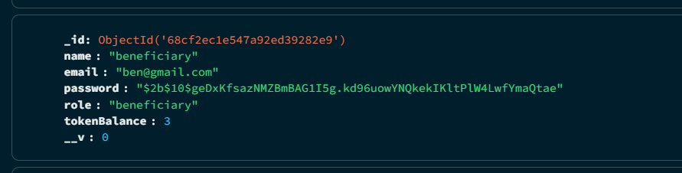
Users can successfully create new accounts and log into existing credentials – MongoDB demonstrates it being saved to the database
Donor:
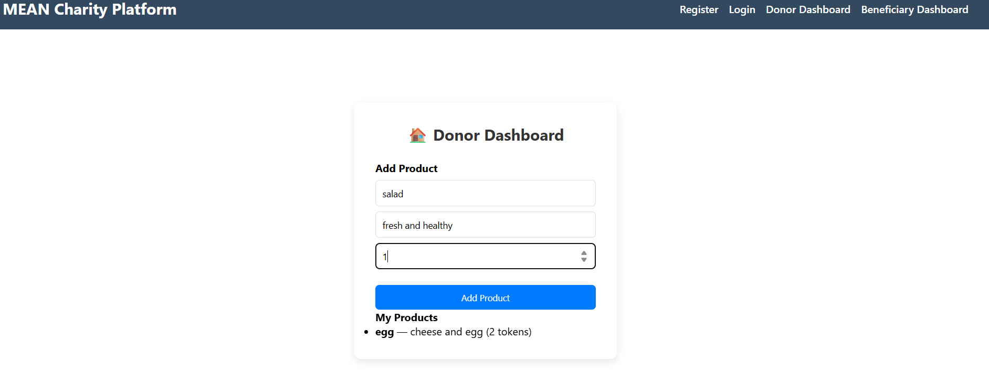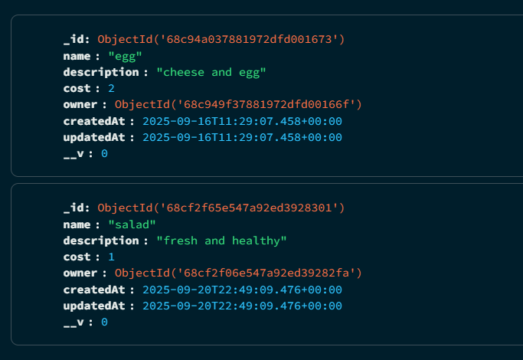
Donors can add their products and view what they have already loaded through. Successfully added products get added to the MongoDB database, as pictured.

Beneficiary:
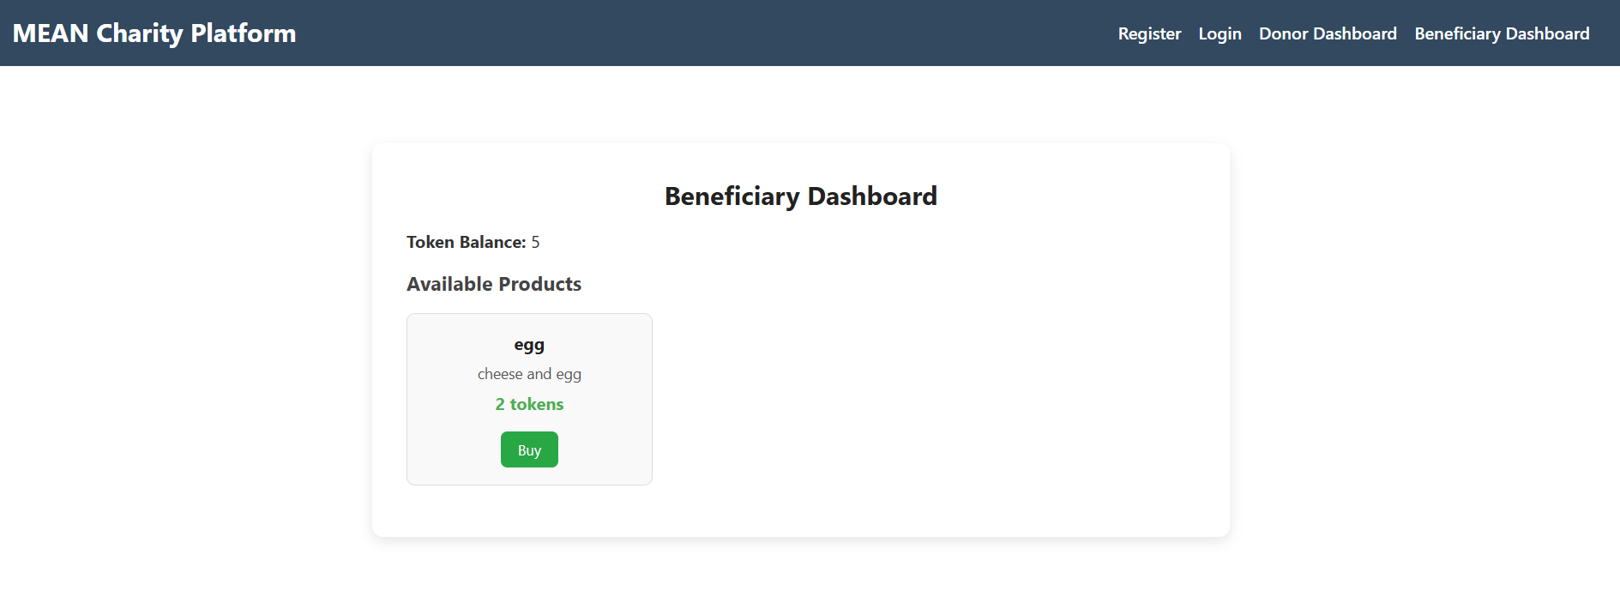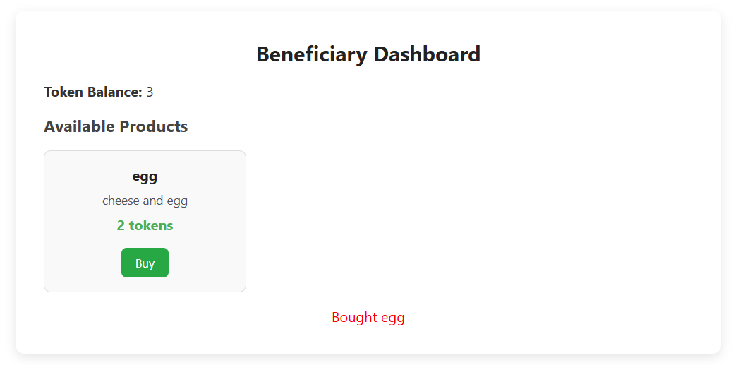
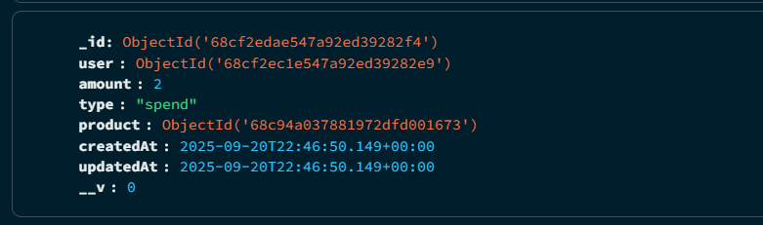
Beneficiaries can view and purchase products if they have enough tokens available. A ‘token’ ticket is added to the database to see whether the tokens used were ‘spent’ or ‘earned’. The database says who used it, the amount, whether its spent or not and for which product.

Code for login/register:
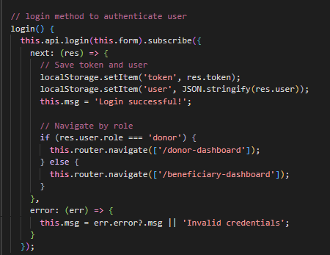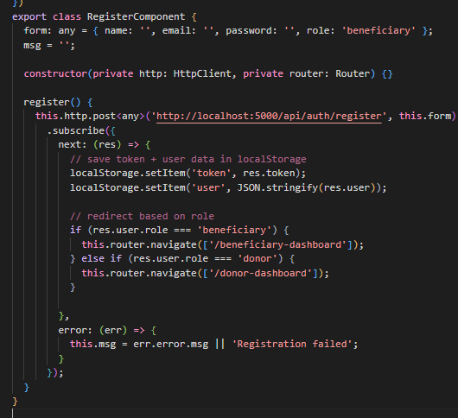

Code for beneficiary dashboard:
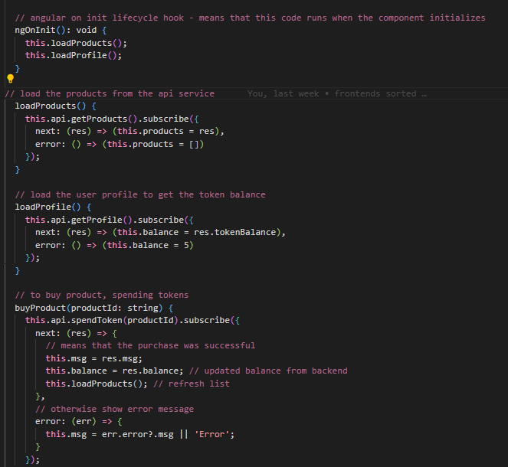
Code for donor dashboard:
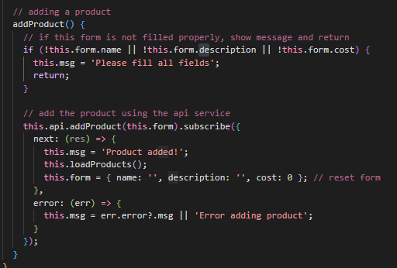
For the login/register solution was built with standalone components, like ‘Login’, ‘Register’, ‘DonorDashboard’ and ‘BeneficiaryDashboard’ in the angular frontend, with FormsModule being used to give components in the project a way to share data (syncs the models data with its view in the UI) and HttpClientModule for API calls
Routes are listed under /api/auth/ are used for Register, Login and Me (profile) in the Express.js backend. For the database, MongoDB/Mongoose is used to store users, hashed passwords (Bcryptjs) and roles, alongside products and token tickets. In relation to JWT, the app gives out tokens when logging in, which is validated by the middleware for protected routes.
For the Donor Dashboard, it uses a form bounded with ‘[(ngModel)]’, which is used for product name, description and cost. Any products created with it is submitted through to HttpClient to /api/products in the express backend (POST /api/products)
In the database, the products created are listed in a mongoose schema, described as: ‘{name, description, cost, donorID}
For the Beneficiary Dashboard, it displays any products that are available using *ngFor, which is used to render a template for each item within a collection. The purchase button triggers ‘HttpClient.post(‘/api/tokens/spend) and the express backend gets ‘POST /api/purchase/:id
In the database, the User schema is updated for token balance if any of them had spent them on products. For what is updated in the databases schema is then reflected in the frontend.

The complexity of this stack would be somewhat hefty;
- Angular needs very specific imports for each directive and missing any of them out brings back errors for the developer, so ensuring all required imports are declared is important to ensure the functionality runs as expected.
- Setting up ngModel for two-way binding needed decent amount of setup and required precision to ensure everything worked properly.
- For product creation, the donor dashboard needed a form with validation, which was standard.
- Developers need to “consider scalability and flexibility when designing RESTful APIs… Ensure that API endpoints can handle versioning and future updates, and logically organize them” (Ginani, 2024)
- For product listing/purchasing, it required some extra steps – this is because it required *ngFor loops and *ngIf for conditions with rendering. All of this relied on CommonModule.
- For the backend, Express routes weren’t too difficult to setup yet ensuring JWT authentication was integrated correctly (with password hashing and token deduction logic) added some extra work.
- Developers need to make sure that development is considered properly as “since the development opportunity is so rapid, business and server logic might suffer from poor isolation, making potential spaghetti code” (What Is The MEAN Stack?, n.d.)
- To create everything required an extensive amount of code, which got complicated to sort through while learning how the system worked.
The benefits of this framework to develop the website are:
- In most cases, MEAN is best for enterprise-scale platforms, rather than quick prototypes.
- Despite Angular being strict with its configuration, it still enforces organizational structure for scalability, which is best for the larger projects.
- MEAN is open source, which “lowers the cost of fielding new applications” (React vs. Angular?, n.d.)
- The forms and validation were quite useful for product creation.
- Express and Node provide a flexible backend which is effective to work with – with Express, creating routes made RESTful APIs (product/token APIs) easy to design.
- In terms of database configuration, Mongoose simplifies MongoDB interactions and provides a space to enforce schema validation.
- Additionally, Angular’s built in features reduces the need to have to look around for external libraries (routine, forms, HttpClient)

Stack 2 - MERN:
Login/Register
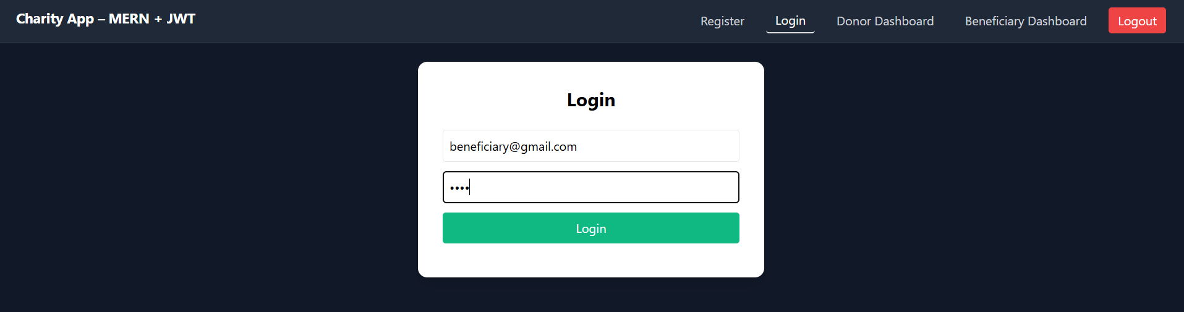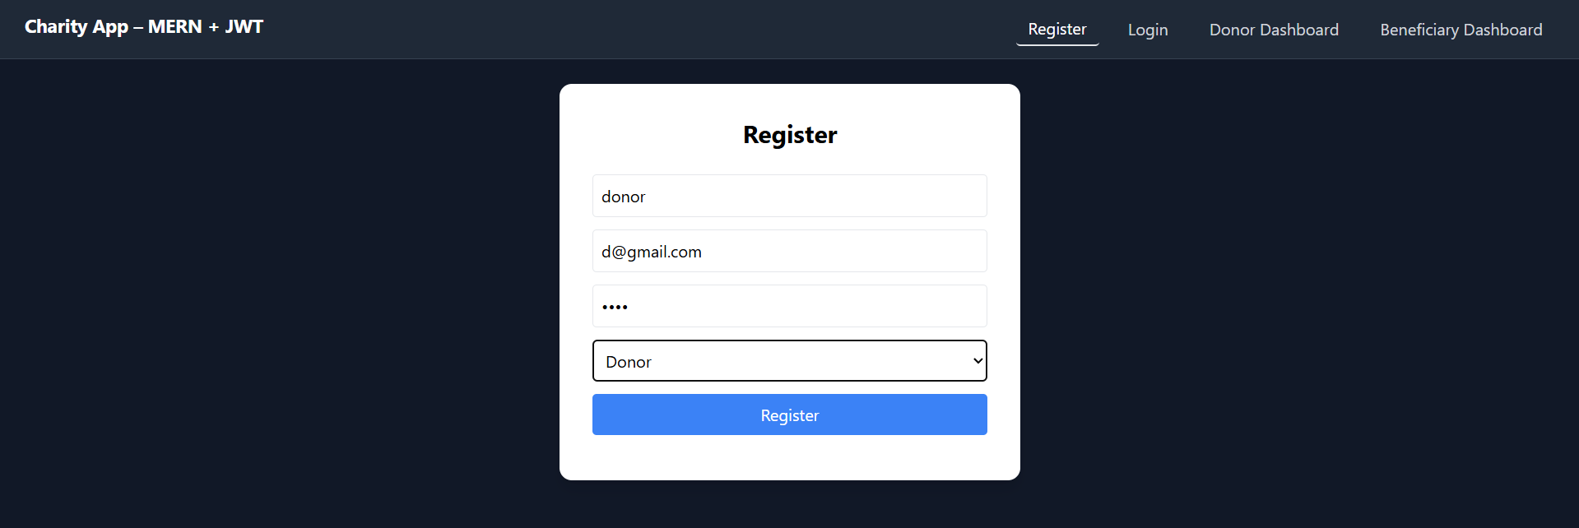
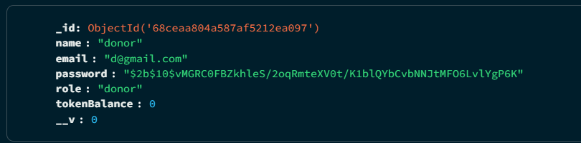
Users can register their account and login using the same details – the MongoDB database picture depicts successful input of user details that are sent to the database.
Donor:
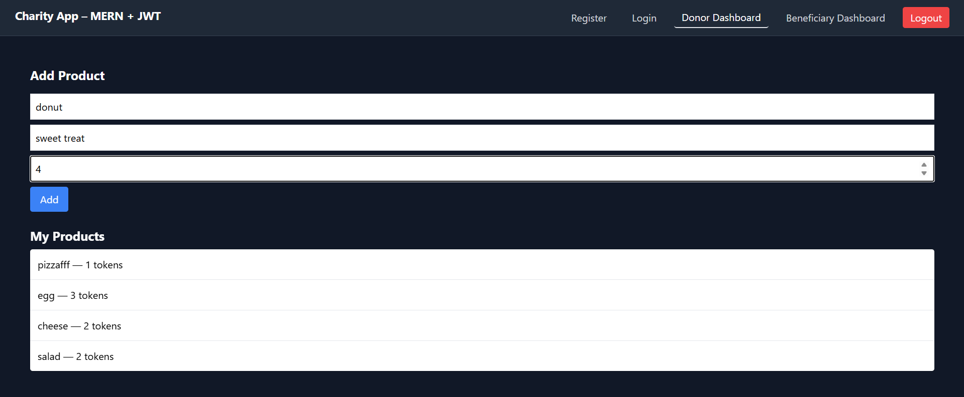
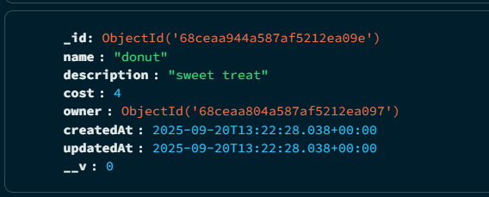
Donors can add their own products and view which ones they have created. MongoDB lists the product name, description, cost and who created it, alongside a timestamp of when it was created/updated
Beneficiary:
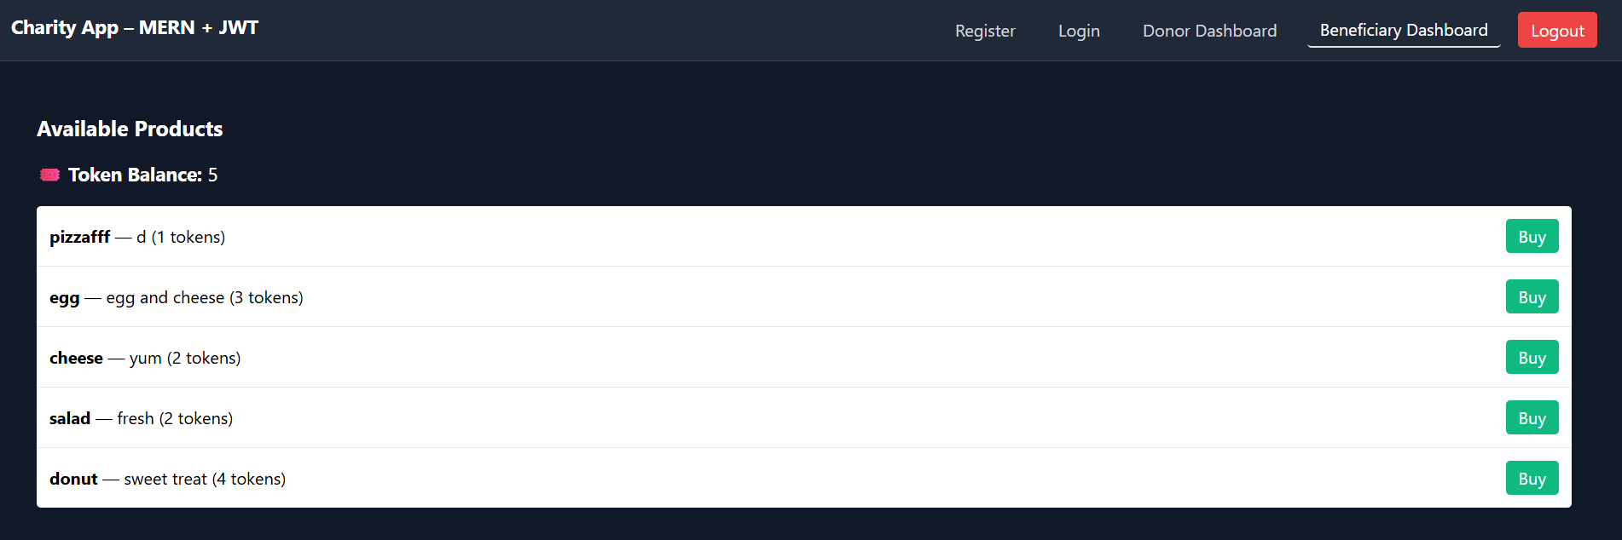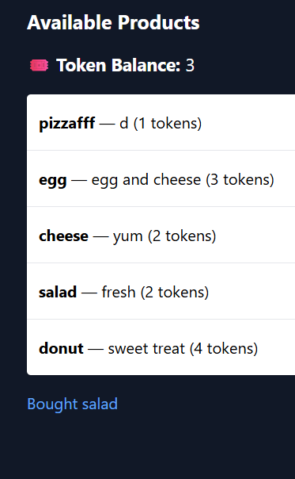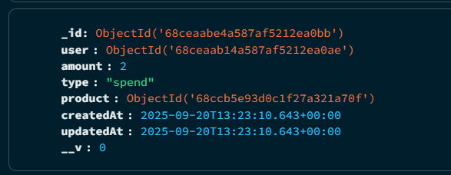
Beneficiaries can purchase any available products with their amount of tokens- the token balance automatically goes down upon purchasing and the database updates with a ticket saying that the type is ‘spent’, with 2 tokens being used

Code for login:
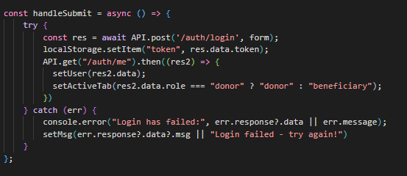
Code for register:
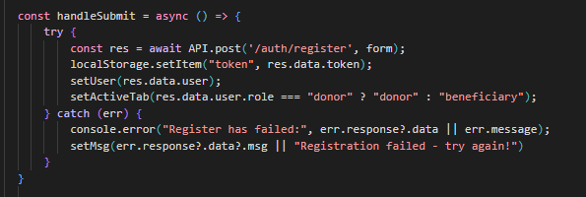
Code for beneficiary dashboard:
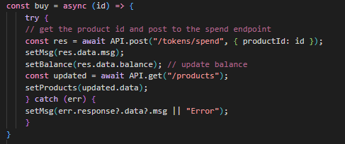
Code for donor dashboard:
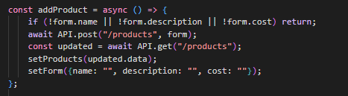

For login/register, this stack used components using hooks (useState, useEffect), which was useful for controlled inputs. For example, the ‘Login’ component maintained state for email and password yet used Axios to post to /api/auth/login. When successful, the user and token is stored in the LocalStorage and react-router-dom then navigated users to their corresponding dashboard (donor-dashboard for donors, beneficiary-dashboard for beneficiaries) In general, Axios was used for HTTP requests (GET, POST etc.). Routes are also listed under /api/auth for Register, Login and Me (profile) in the Express.js backend.
For the database, MongoDB/Mongoose is also used to store user credentials, hashed passwords and roles (beneficiary/donor), as well as products and token spending.
In terms of JWT, the project provides tokens when a user is logged in, which can be earned or deducted - this is also validated by the auth middleware to protect routes.
React has less boilerplate than MEAN, so the separation of concerns are a lot clearer. Less boilerplate means improved readability and maintainability as its defined as less ‘repetitive’ code that ends up being unnecessary for the script to have.
The Donor Dashboard was used through controlled forms (useState) with onChange handlers that controlled product input fields. Axios dealt with sending details through (POST /api/products).
React was able to update the state of the UI so that the donors can easily see their new product in the product list without needing to access the database details or refreshing the page.
The Beneficiary Dashboard fetched products to display what was created by the donors. The dashboard uses Axios in a useEffect hook and mapped them (.map()) through an array. The purchase button then calls ‘POST /api/purchase/:id’ and the backend deducts users tokens and updated the product.
In the database, the User schema is updated like MEAN for token balance if users spent tokens for products. Again, for what is updated in the databases schema is then reflected in the React frontend.
The complexity of the stack was moderate:
- React’s component model and the use of hooks was interesting to work around yet made implementation simpler (for login/registration forms), since controlled inputs didn’t require as much boilerplate as Angular’s forms.
- Application can slow down while dealing with large datasets so “indexing and aggregation pipelines are important to consider as they significantly improve query performance” (My Journey with MERN Stack – Lessons Learned and Challenges Overcome, 2024)
- Product creation in the donors’ dashboard used more simpler state handler and listed products for the donor with ease using JavaScripts .map() function.
- Axios was used for API requests which was simple to keep data flow standard.
- The Express and MongoDB setup is the same as MEAN, with routes for authentication, product creation and token usage.
- There was complexity sorting out JWT tokens and making sure token deductions worked as expected
Overall, MERN was able to feel more approachable to create a quick prototype than MEAN since its somewhat lighter, with less imports and declarations.
The benefits of this framework to develop the website are:
- React works better in terms of speed and flexibility during development
- MERN is open source, which “allows a developer to use open portals to answer questions during development” (Laxaar, 2023)
- React integrates better with libraries like Axios, React Router etc. which made user handling and token components easier to work with.
- React’s JSX makes rendering grids a lot easier
- Prototypes faster than MEAN, yet is still scalable – well suited for developers that want
- Reusable components reduces repetition (e.g., the use of ‘ProductCard’)

Stack 3 - MEVN:
Login
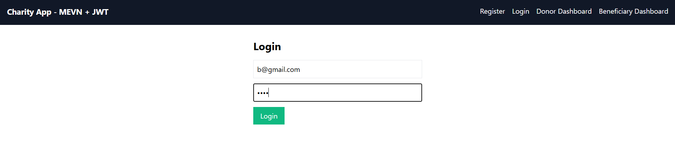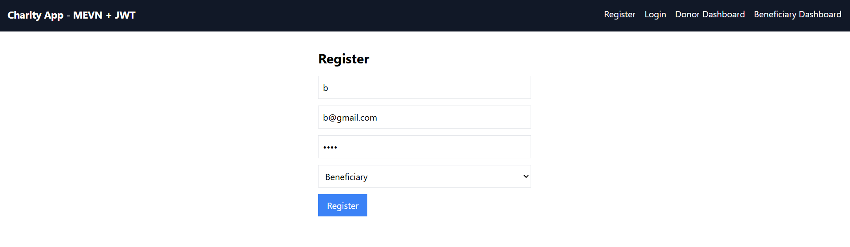
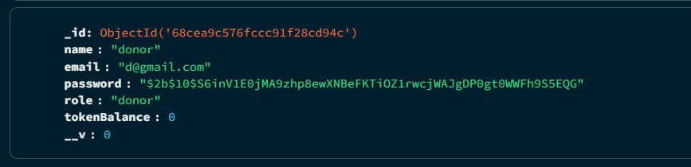
Users can successfully create a personal account and log into the system with those existing credentials – the database reflects any new users being created into the system.
Donor:
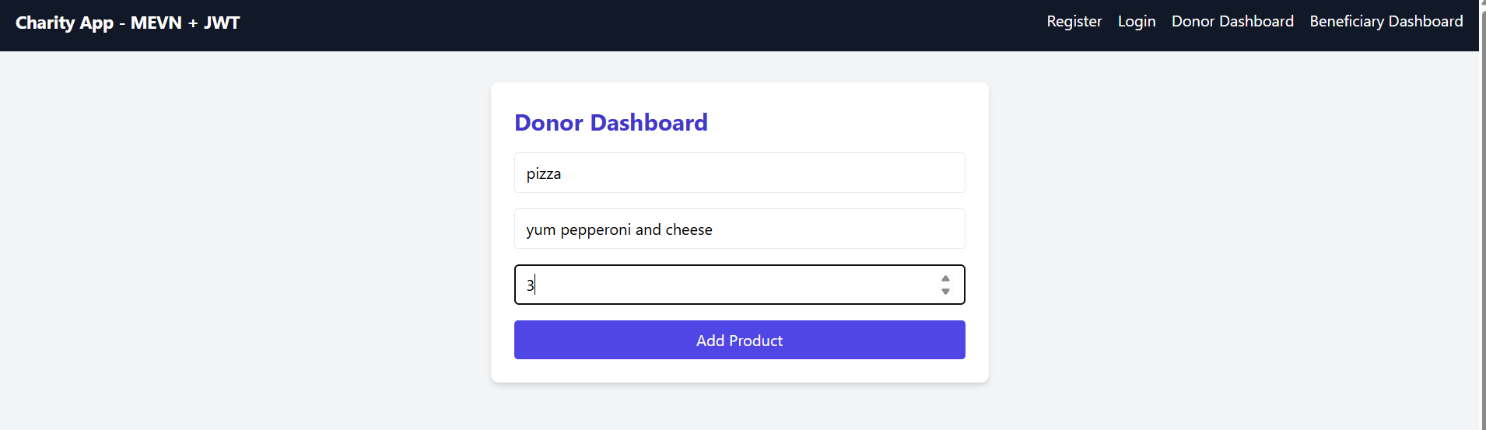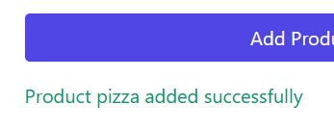
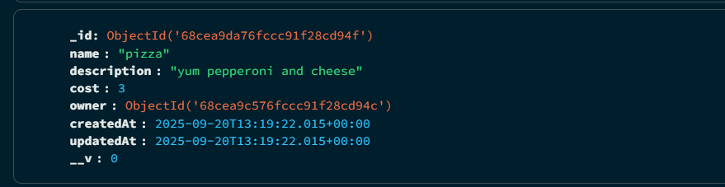
Donors can create their products and is sent straight to the database, with details on what the name of the product is, its description and price, alongside details on who created the product at a certain timestamp.
Beneficiary:
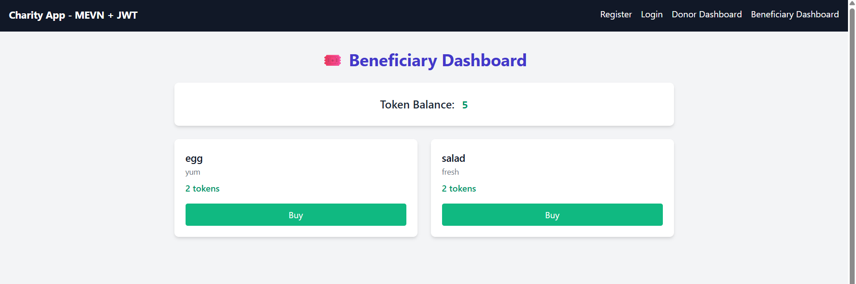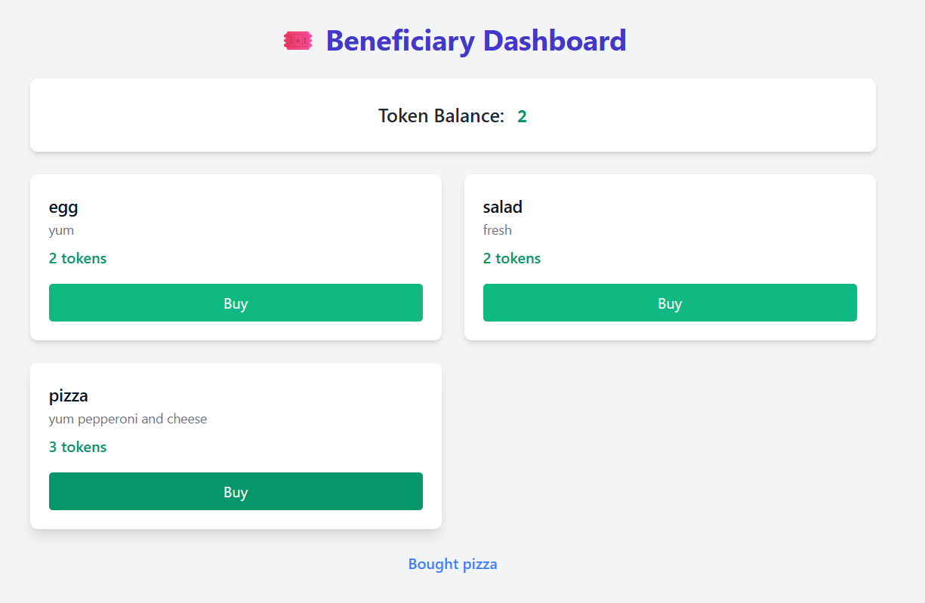
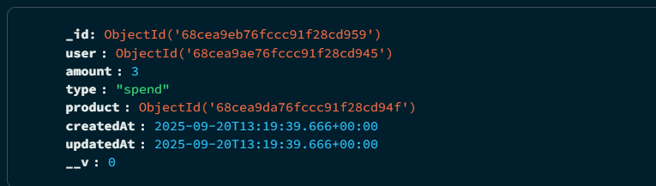
Beneficiaries can view and purchase any products that a donor has created. If they have enough tokens, they can purchase it. Any purchases made are sent as a ticket to the database, describing who spent it, the amount and for what product.
Code for login/register:
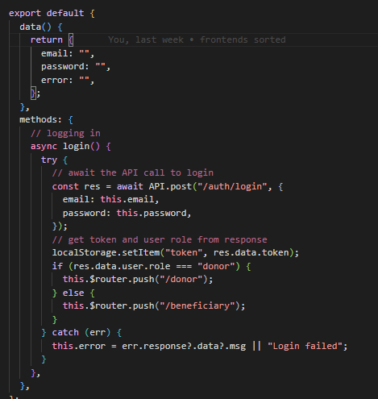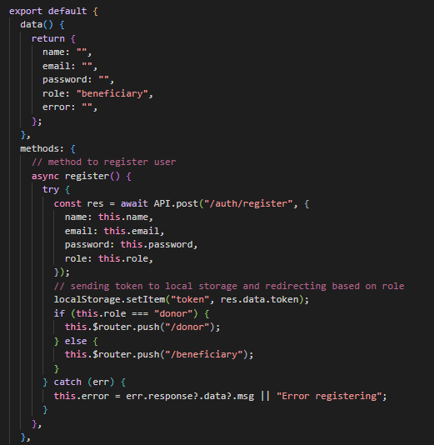
Code for beneficiary dashboard:
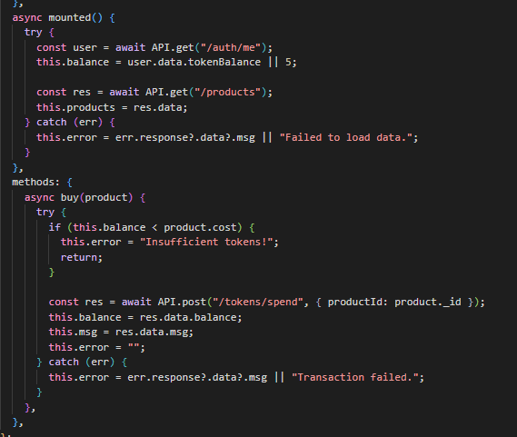
Code for donor dashboard:
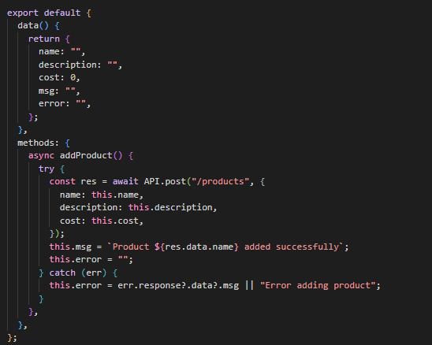
For login/register, Vue simplified authentication using ‘v-model’, which is used to bind values of input fields to data properties. The Login.vue and Register.Vue components were able to bound user inputs into a form object without having to create more imports and files. Submitting details in each form triggers Axios to call ‘/api/auth/login’ or ‘/api/auth/login’, which is similar to MEAN and MERN. When login is successful, Vue stores the token in localStorage and takes the user to their corresponding dashboard using the Vue Router, depending on their role (donor-dashboard for donors, beneficiary-dashboard for beneficiaries)
The backend logic mirrored the same as MEAN/MERN by handling password hashing, JWT and MongoDB users.
For the Donor Dashboard, it also used ‘v-model’ for product inputs and used a @click event to trigger a ‘createProduct()’ method.
Again, Axios sent the product to /api/products and Vue automatically renders the updated product list using the data system. The database then updates itself, displaying the new product with its details (name, description, cost, owner etc.) In comparison to MEAN/MERN, it requires even less boilerplate, which makes processing easier.
For the Beneficiary Dashboard, products are displayed using v-for. Each item showed particular product details, and the purchase button was bound with ‘@click=”purchase(product._id)”. Axios then posts to /api/purchase/:id and Vue updates the token balance and available product list. This reflects in the backend too, as it updates the Users details by changing their deducted token balance and updates the token ticket saying how many tokens had been spent and by who (and for which product).

The complexity of the stack was relatively moderate:
- Vue’s v-model had simplified two-way binding for forms (much like [(ngModel)] in Angular) and didn’t require any further imports like FormsModule used in Angular
- Product listing for v-for was somewhat straightforward and button actions to purchase products were linked using @click handlers.
- Exact same backend setup as MEAN/MERN, which required less time for setting up the prototype and complexity came from server-side token managing than frontend.
This seemed quicker to setup for quick prototyping than the other frameworks and reflects low complexity.

The benefits of this framework to develop the website are:
- Vue’s strength lies between simplicity and structure and doesn’t force heavy boiler unlike Angular
- Utilizes straightforward directives for tasks such as binding, loops and conditions, which allowed product creating and purchasing details quicker to create with fewer lines of code.
- Vue requires less of a learning curve which meant beginners wont come across a lot of errors in comparison to what could be seen for Angular development.
- “Vue.js has a thriving community and ecosystem, which ensures ongoing support and a wide range of libraries and extensions”, (Rubenghosh, 2024)which helps new beginners find resources to build their project.
- Effective to build quick dashboards, user forms and token interactions easier, which is good for quick prototyping.

Stack 4 - Gradio:
Login:
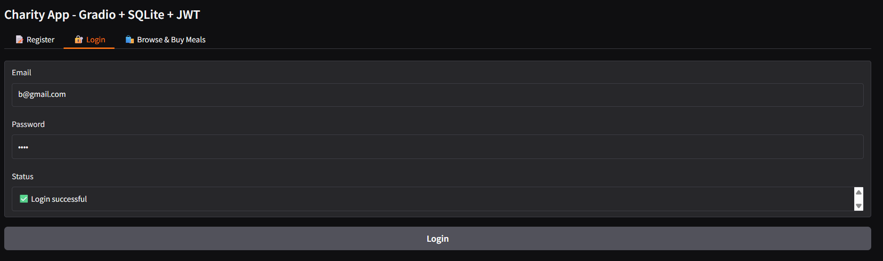
Register:
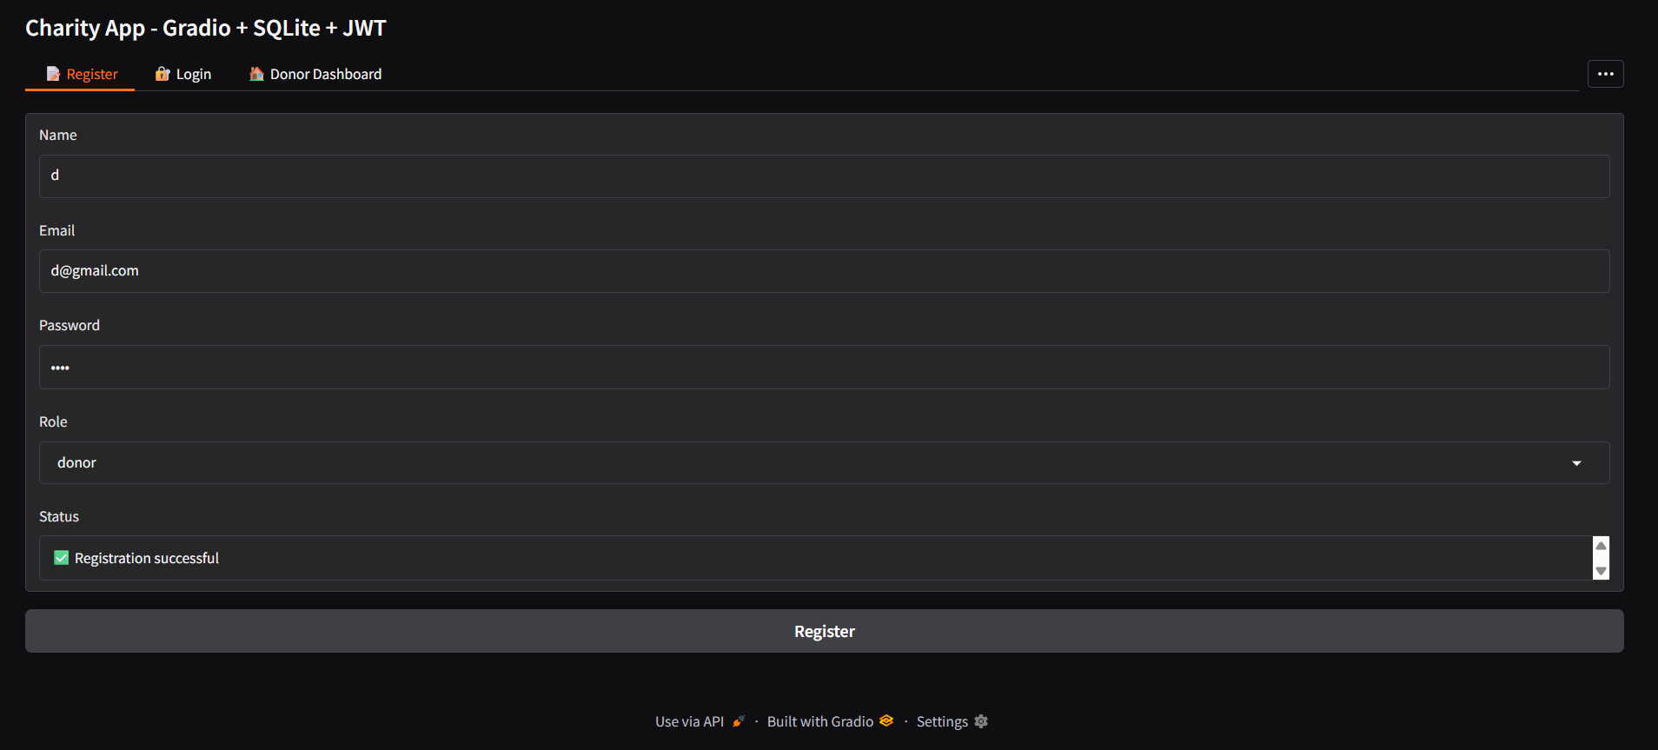
Users can create their own accounts and login successfully. The navbar is designed to display the corresponding page depending on who signed in (whether they are a donor or beneficiary)
A status bar lists whether registration/login was successful or if errors had occurred.
Donor:
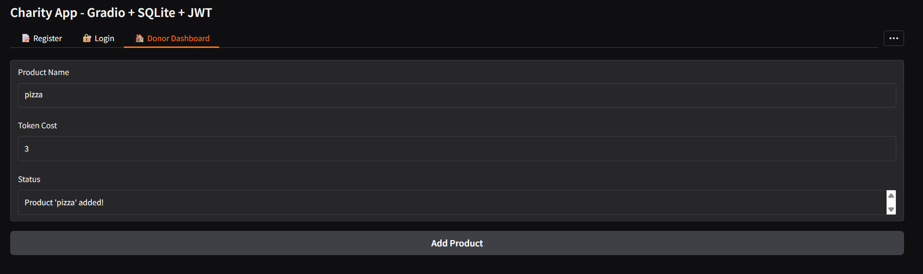
Donors can create products, and it gets sent automatically to the database and the beneficiary dashboard so beneficiaries can view them.
Beneficiary:
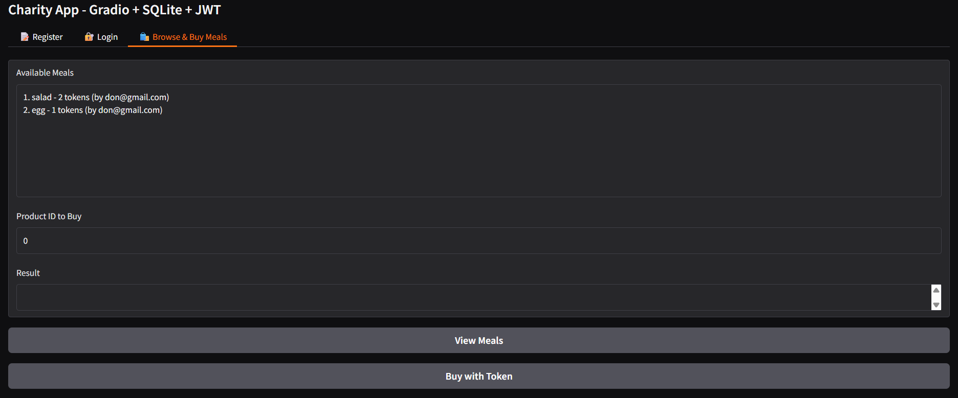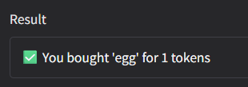
Beneficiaries can click to ‘View Meals’ and select a ProductID to purchase a product with their tokens. If successful and they have enough tokens, then they can purchase it.
Code for login:
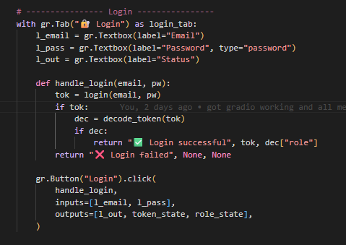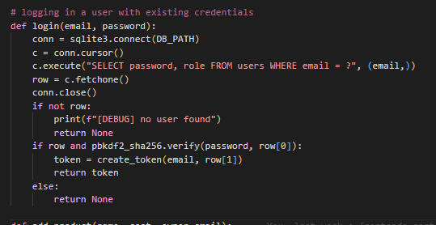
Code for register:
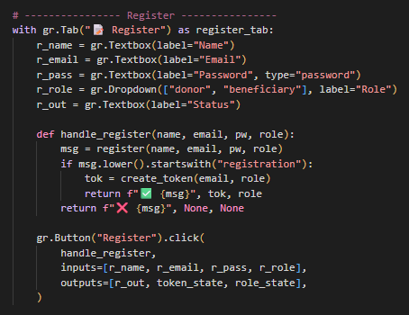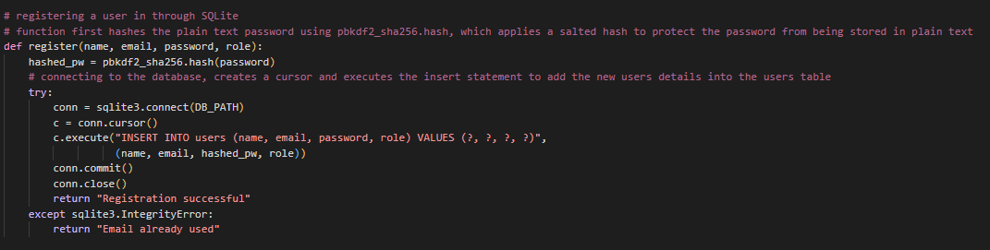
Code for beneficiary dashboard:
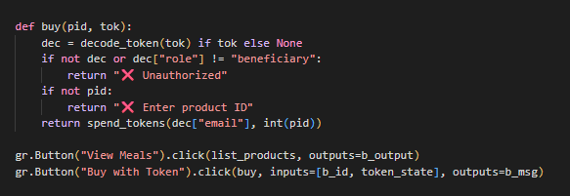
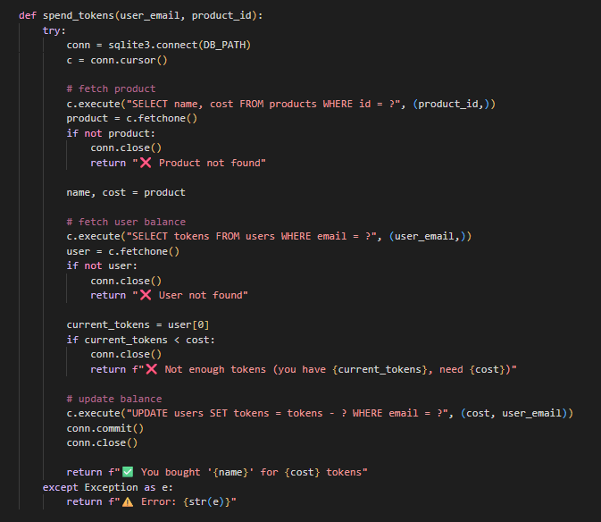
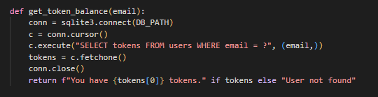

Code for donor dashboard:
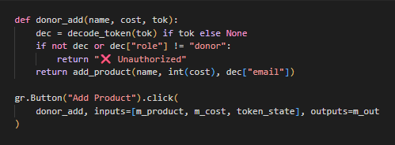
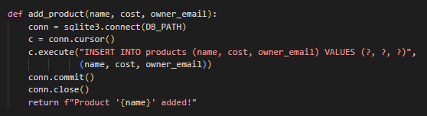
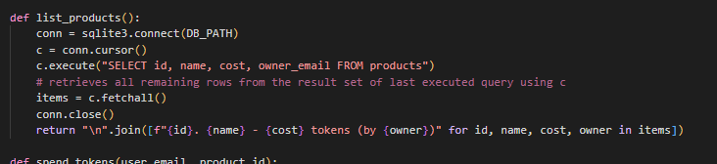

The login/registration workflows were done directly in Python functions. Textboxes were used for email/password, and a dropdown menu was used to choose a role and was linked using .click() in the backend.
These functions made requests to the FastAPI endpoints much quicker (/register, /login).
FastAPI validates the requests to login/signup and hashes the password using bcrypt, generated JWT with PyJWT and stores the user details in SQLite.
Unlike the JS frameworks, UI had been automatically generated by Gradio, which sped up a lot of time having to develop this framework.
For the Donor Dashboard, textboxes were also used for product information (name, description, cost etc.) – the ‘Add Product’ button triggers the ‘add_product()’ function in the backend. FastAPI handles product creation effectively by linking it to the Donor’s ID and the new product displays immediately in a design element to show beneficiaries.
For the Beneficiary Dashboard, the workflow listed all of the available product in a list, reflecting what was created by donors and by who. A beneficiary can click a ‘purchase’ button which triggered the backend function calling FastAPI’s ‘/purchase/{id}’ endpoint. The function validates the beneficiary’s token balance, deducts an amount of tokens and updates the product.
The complexity of Gradio is little to none:
- It had the lowest complexity and was able to be developed in no time at all, especially on the frontend as Gradio auto-generates UI elements like textboxes, buttons and tables straight from Python functions, which meant that it saved time to have to write separate frontend code like Angular, React or Vue.
- Implementing login only required a python function which calls a FastAPI endpoint, and Gradio automatically builds the form.
- Product creation was implemented using textbox inputs with a function to insert details into the database, while product listing was handled using a list, which made it quick to prototype.
- The backend was similar to Express since FastAPI still needed JWT logic, password hashing and token balance status – however, since both frontend and backend could be defined in Python, integration was quicker to sort out than the JavaScript stacks.
- It is suitable to create effortlessly fast prototype designs

The benefits of this framework to develop the website are:
- Gradio is noted to be the fastest at prototyping and allowed the login/registration, product creation/listing/purchasing workflows to be designed with a minimal amount of code.
- “Gradio’s API is designed to be intuitive and easy to learn, even for developers who aren’t familiar with web technologies” (Graph, 2025)
- Unlike JS frameworks, no frontend build system needed to be setup which reduced the amount of development time and allowed time to further develop the backend.
- “Built-in hosting with Hugging Face Spaces – Deploy without any DevOps setup”(Introduction to Gradio, n.d.)
- FastAPI provides strong typing with Pydantic models, automatic validation of data etc.
- While Gradio isn’t better suited to scale for a production-ready platform for enterprises, it certainly shows its strength in providing a quick working prototype

Stack 5 - Python/Fast API:
Login:
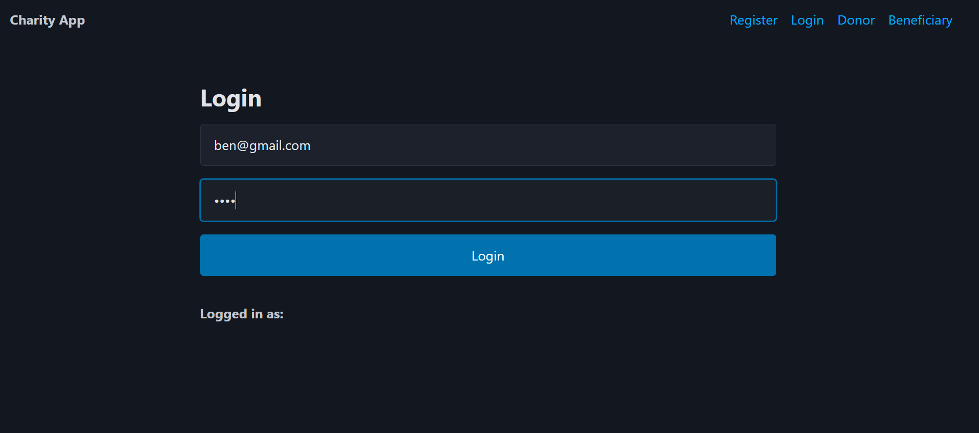
Signup:
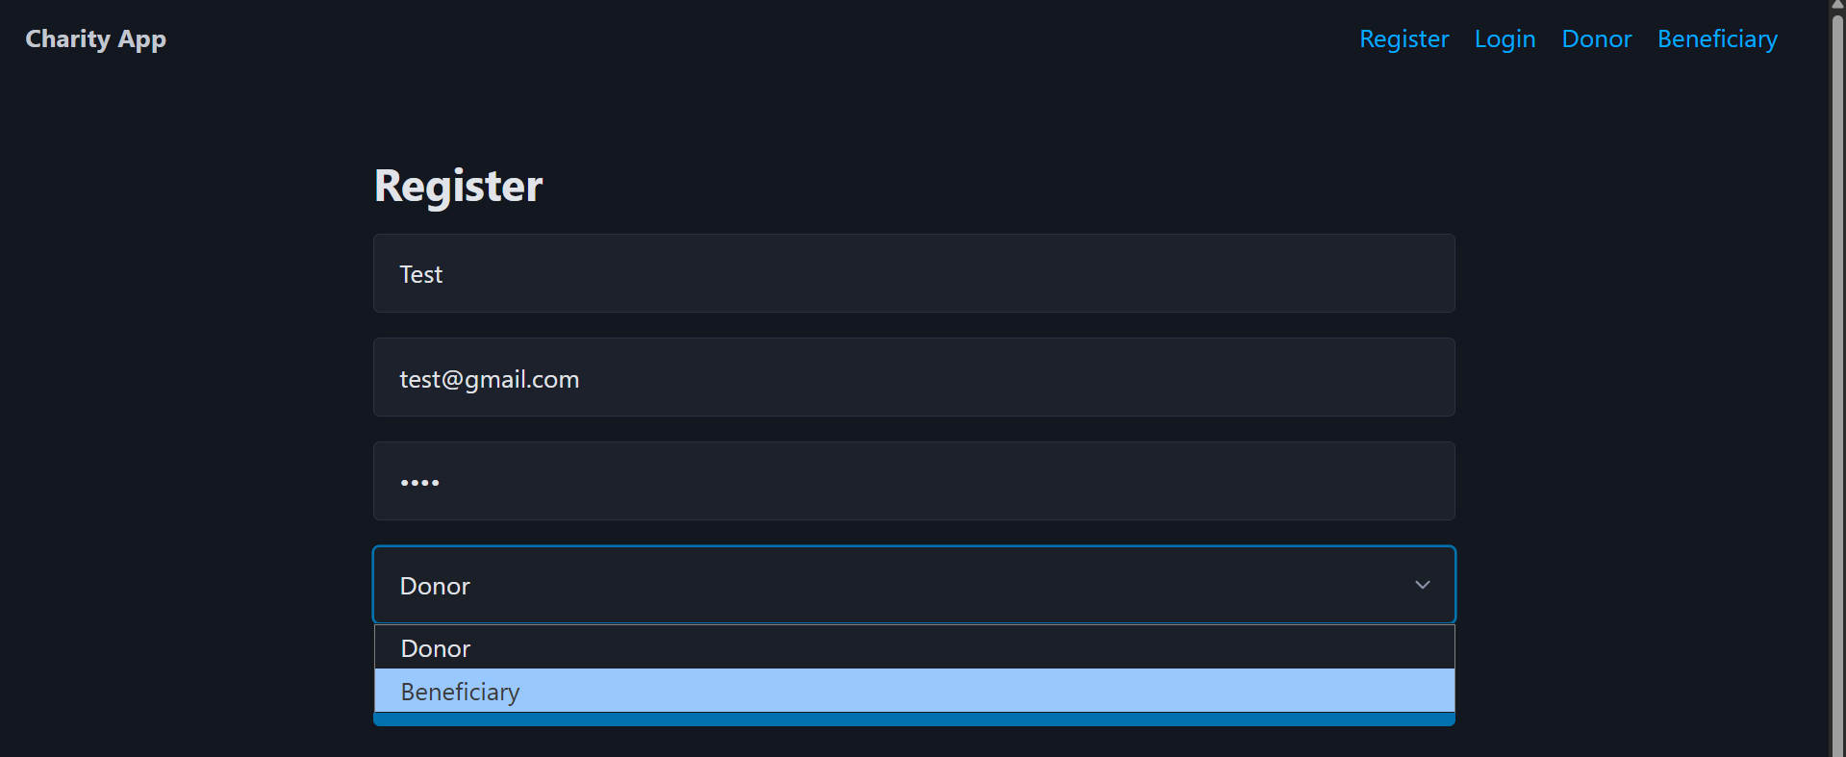
Users can create their own account and log into the system with the existing details successfully.
Donor:
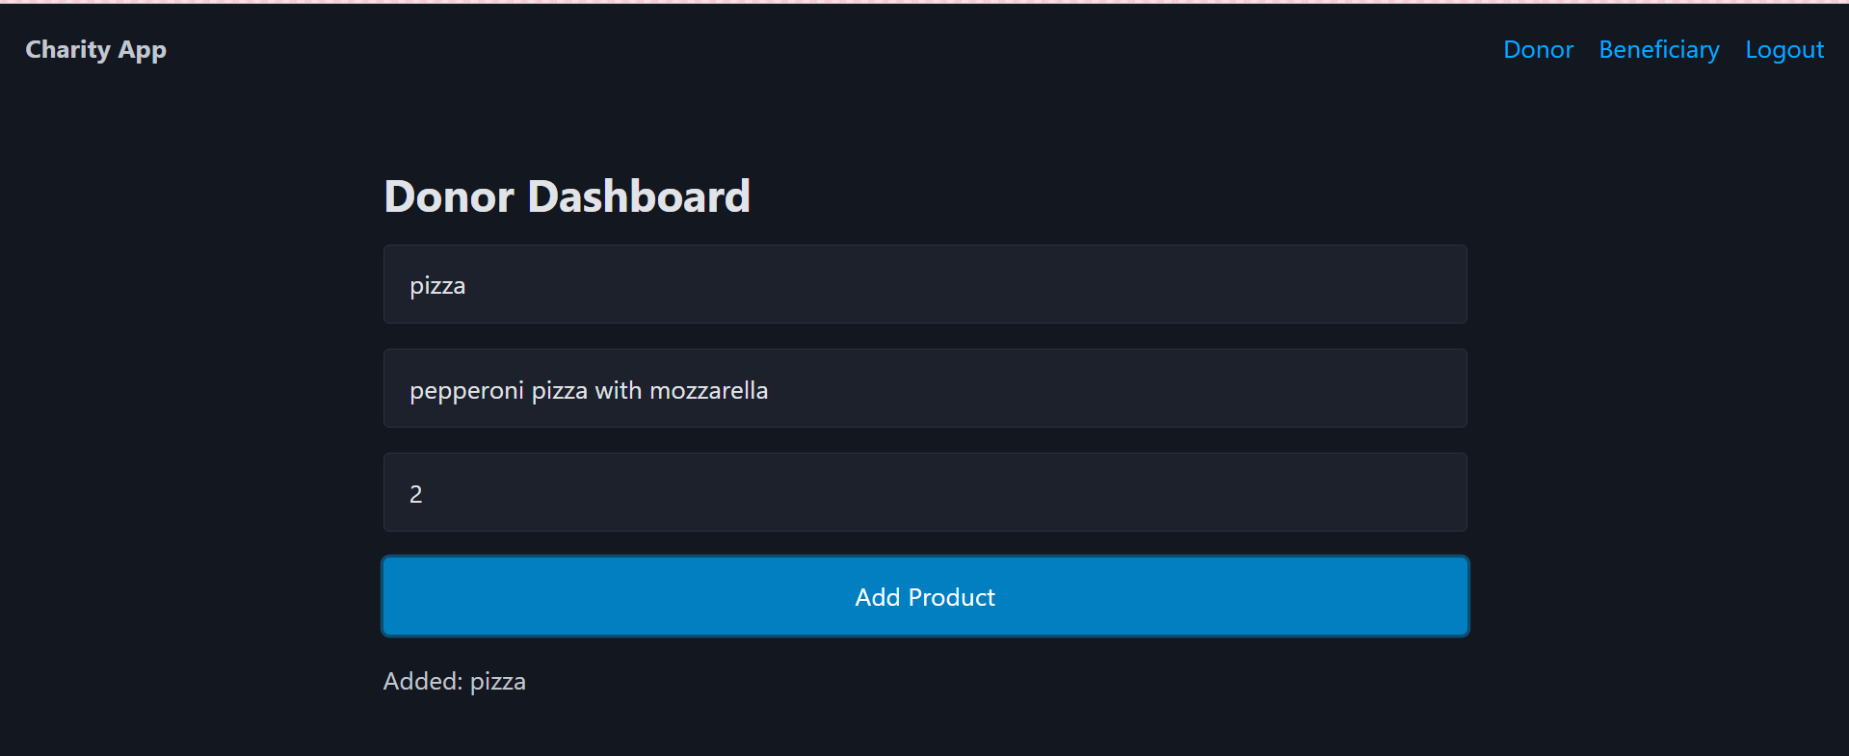
Donors can add in their own products, with details including product name, description and token cost amount.
Beneficiary:
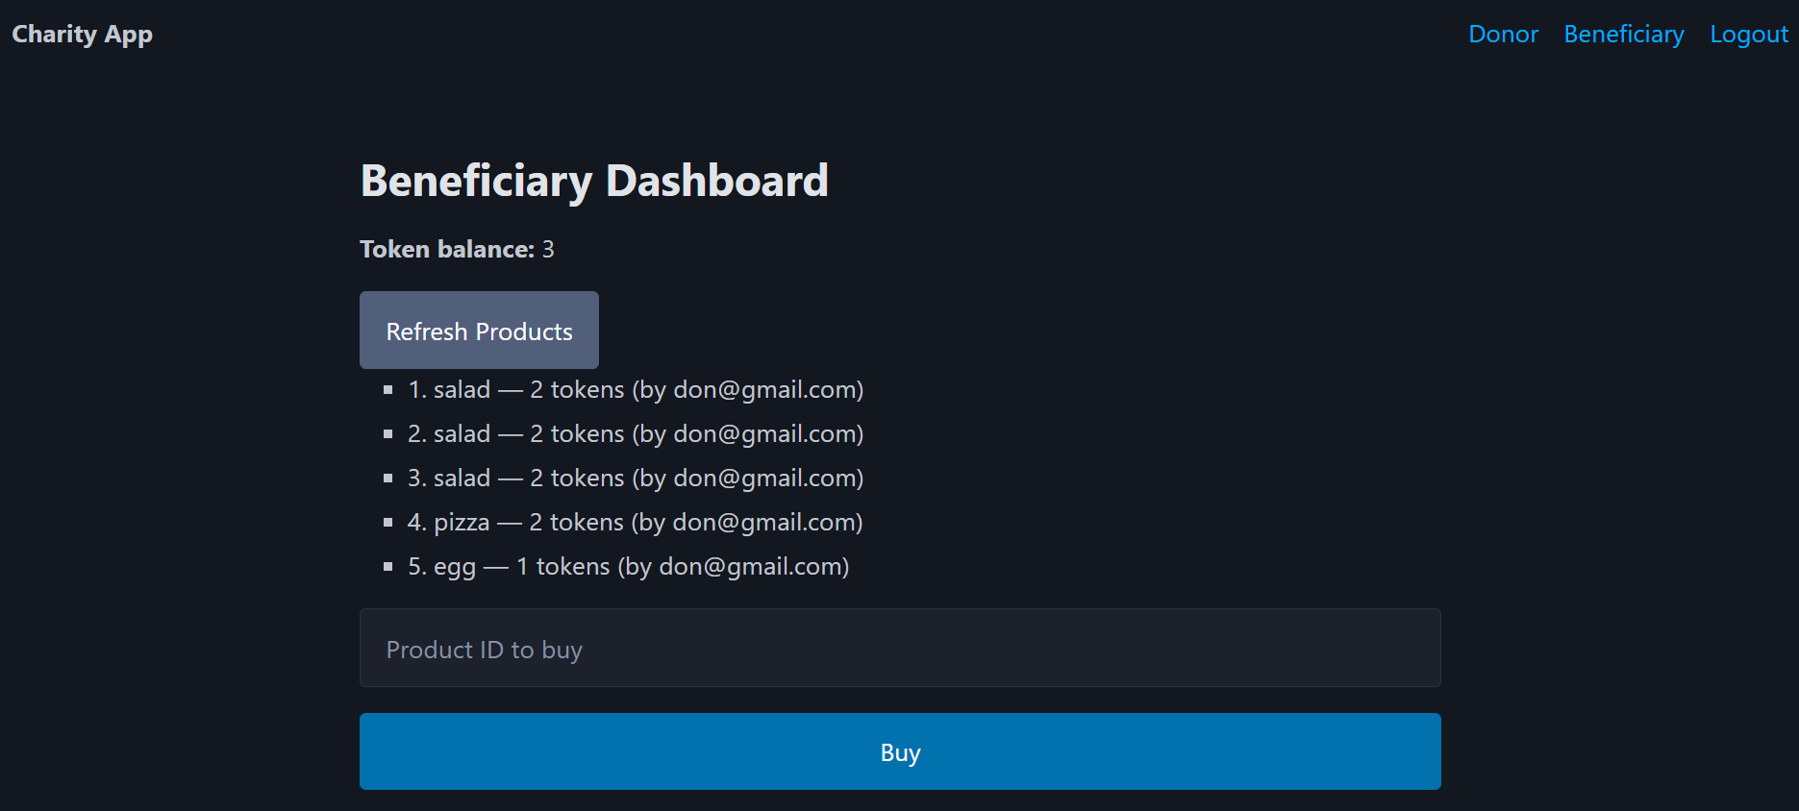
Beneficiaries can view certain products created by a corresponding donor. Beneficiaries can enter a ‘ProductID’ to purchase a product if they have enough tokens.

Code for login:
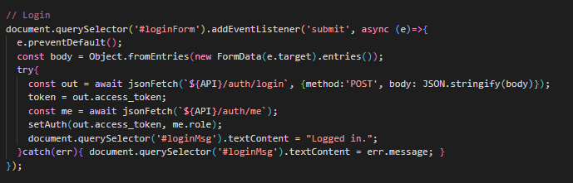
Code for register:
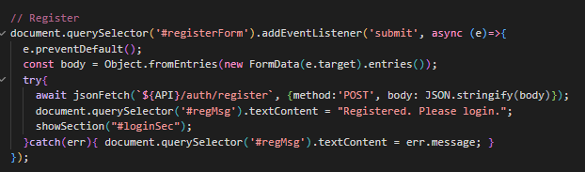
Code for beneficiary dashboard:
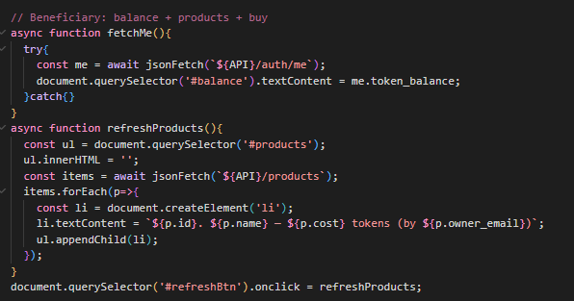
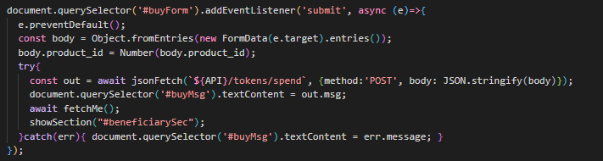
Code for donor dashboard:
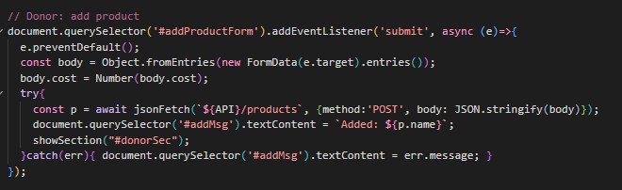
For login/register, the solution was built around FastAPI serving HTML forms for login/registering. The frontend was done using plain HTML and styled with CSS.
The login page submitted data to the FastAPI routes (/register, /login) using HTTP POST requests.
The backend handled validation of form data, password hashing (bcrypt) and token creation with PyJWT. When login is successful, the backend issued a JWT (json web token), which is stored in storage and returned as part of an HTTP response. For registration, the backend made a new user in the database (SQLite) with a starting token balance of 5 (for beneficiaries)
For the Donor Dashboard, donors are able to utilize a form to create products. Once a donor submits the form, FastAPI handles it via a /products POST route. The product is then sent to the database, linked to the donor’s ID.
For the Beneficiary Dashboard, beneficiaries can view a rendered list of available products, which is done through querying the database and passing the result over to where the user can view it. When users click the ‘Purchase’ button, it submits a POST request to /purchase/{id}. FastAPI validates the beneficiary’s token balance, deducts the correct number of tokens and updates both the users token balance and the product’s status in the database. The beneficiary’s page is then refreshed to update the token balance.

The complexity of Python/Fast API was moderately complex:
- Since no modern frontend framework was used, the HTML forms/pages were standard to setup, but it lacks the dynamic state management that Angular, React or Vue could do.
- FastAPI is able to define routes with @app.post and @app.get, which is simple and straightforward to utilize. (Request Body - FastAPI, n.d.) (First Steps - FastAPI, n.d.)
- Data validation with Pydantic reduces boilerplate in comparison to Express used by the other frameworks
- JWT management and password hashing is done using bcrypt and PyJWT, which are effective external libraries
- The virtual environment helps isolate dependencies
Complexity was lower on the frontend, yet similar to Express on the backend.

The benefits of this framework to develop the website are:
- FastAPI offered more automatic request validation with Pydantic models, which made debugging routes simpler.
- There is a very clear separation of concerns since FastAPI can handle auth, routing and database access, with HTML only focuses on UI display for donors and beneficiaries
- VENV isolated the projects dependencies which helps avoid version conflicts and makes the app easier to deploy
- “built-in Python type hints do reliable auto-completion and validation” (Ahmed, 2024)
The only downside was the lack of frontend interactivity, yet HTML’s simplicity meant theres a faster setup for a working prototype.

Stack | Frontend Effort | Backend Effort | Learning Curves | Speed | Used Best For
MEAN | High (Strict compiling) | Medium | Steep | Slower | Large enterprise applications
MERN | Medium (React, JSX and hooks) | Medium | Moderate | Faster than MEAN | Scalable apps that require flexibility
MEVN | Medium (Vue is simple and clean, yet frontend design held me back) | Medium | Low | Fast | Quick prototypes
Gradio | Very low (automatic UI) | Medium | Very low | Most fast | ML prototypes, quick demos
Python/FastAPI | Medium | Medium | Moderate | Decently fast | Standard prototypes
Login:
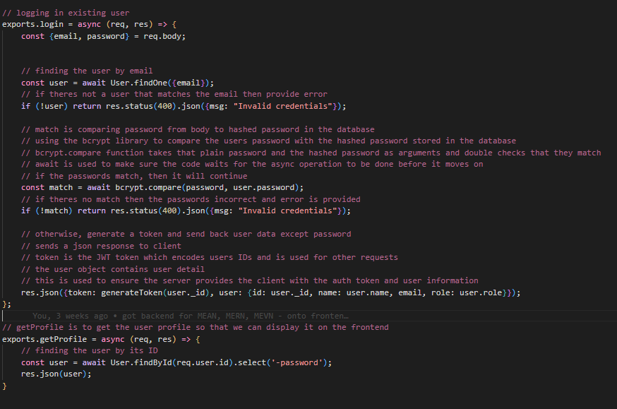
Register:
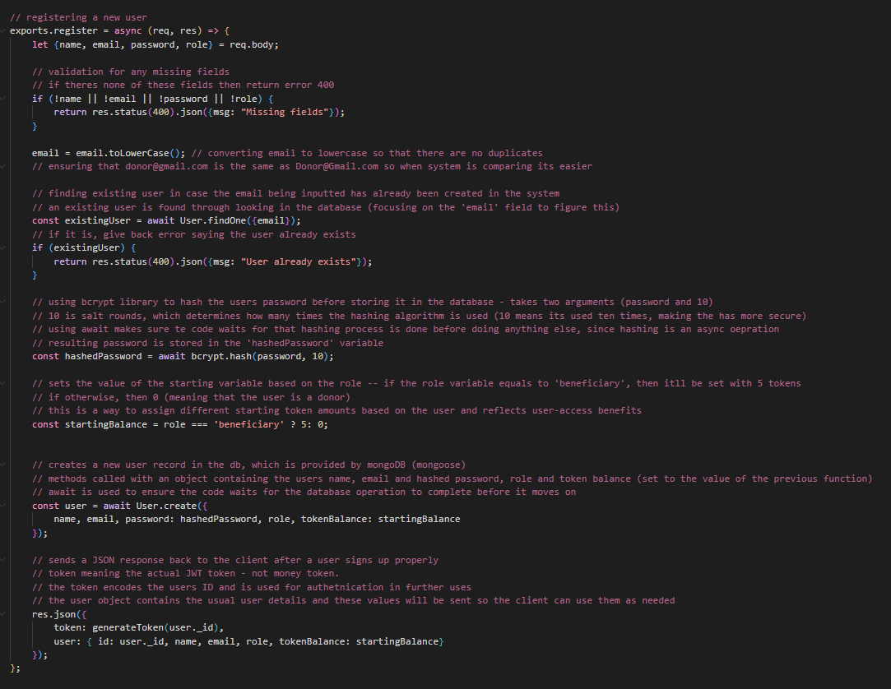

Token Spend/Earn:
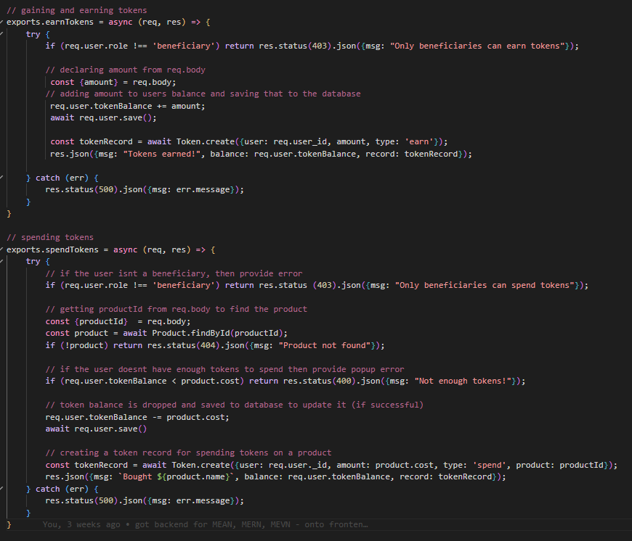
Product Get/Add:
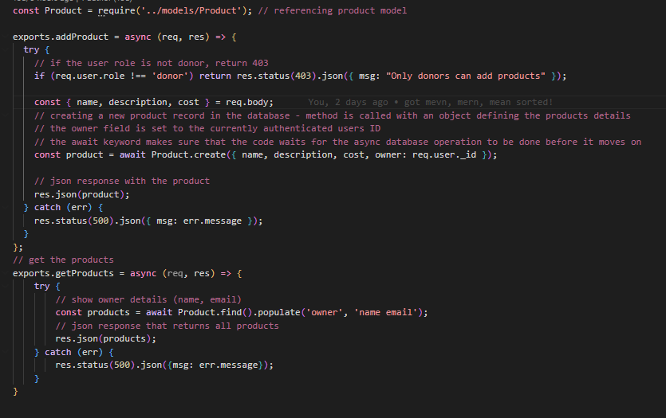

Conclusion:
I will be using MERN (MongoDB, Express.js, React, Node.js) for my late-night nosh charity website since I am able to use a comprehensive backend and utilize a scalable, user-friendly platform to design secure logins, token transactions and data management.

Pros and Cons:
- MEAN (MongoDB, Express.js, Angular, Node.js)
Pros:
It uses JavaScript for both frontend and backend, which makes it more efficient and means there is no need to switch back and forth between languages. Additionally, as it is more community-based than most, it allows developers to refer to plenty of tutorials and documentations. It is a relatively heavy stack, however that can be used to advantage for big projects. In terms of organization can be simple with Angular so that there’s less chance to mix up any large forms. Additionally, the CLI and testing tools (e.g., Karma) were somewhat straightforward. MongoDB is a flexible
Cons:
Despite the fact that there is a lot of resources, there is a lot to integrate with Angular, which means it takes a few longer to learn and understand its structure. Additionally, while organization is well-applied, it can be confusing to find files when needed immediately as there is a lot to work with (unless you know the system very well).
It is a steep learning curve when debugging and some of the routing configs were confusing to configure, which meant that it was certainly a learning-curve designing separate role-based dashboards and ensuring users were sent to the correct one.
Additionally, this had to be created using a significantly more amount of code than in comparison with the other stacks, which dragged out the time it took to create.
Overall, the final app seemed relatively heavy to work with.

- MERN (MongoDB, Express.js, React, Node.js)
Pros:
Like MEAN, this stack also has a huge community and library selection and relatively popular in the IT industry, so looking into details about fixing bugs or creating more features. React is a lot more component-driven and flexible, which makes it easy to build UI dashboards and reuse the code within them.
It is straightforward to integrate with JWT authentication, localStorage and role-based UI rendering.
Additionally, “because the MERN stack only uses one language, it becomes more cost-effective to hire JavaScript experts than different specialist for different technologies” (Laxaar, 2023)
Cons:
There is a lot of manual wiring so bugs can be made quite easy by the developer (a personal slip-up that had to get fixed was resetting token balances on re-login as it didn’t update and reflect the changes in the database). Authentication required extra libraries (react-router, jwt-decode). Integration with Tailwind meant extra configuration and some bugs came in place with it, so it slightly slowed down development.
According to some sources, doing a large project with many developers can be difficult using MERN – “MERN stack best serves Single-page applications” (Laxaar, 2023)

- MEVN (MongoDB, Express.js, Vue, Node.js)
Pros:
MEVN has a strong ecosystem, which allows scalable development. It uses much smaller and cleaner code in comparison to Angular, however also uses JavaScript throughout the entire application, which allowed code reusability.
It has a very flexible component-based architecture, which allows users to “integrate it into existing projects or use it as a progressive framework” (Rubenghosh, 2024)
Cons:
Newly developing a website using this was hard to get the hang of and some confusion happened between Vue CLI and Vite, which caused a few build errors (“Cannot use import outside module). Additionally, tailwind/PostCSS integration provided error (“It looks like you’re trying to use tailwindcss directly as PostCSS plugin”)
It doesn’t allow single-word component names (e.g., “Login.vue”), so a few flags were raised because of it.
The community for Vue is a lot smaller and despite this stack evolving quick, there aren’t a lot of libraries that have been standing for a long time with set knowledge, in comparison to more established tech stacks with more maturely-bound libraries.

- Gradio (Python, FastAPI backend, SQLite, Gradio UI)
Pros:
It is very quick to setup and doesn’t take up a lot of space as only a few files are used for the entire stack, which made designing a breeze. It also has support for machine learning, so scaling the application to include analytics wouldn’t be too hard to integrate. There’s also no need for frontend frameworks like React or Vue for this stack, so it saves a decent amount of time developing. Additionally, it has built-in widgets (buttons, tabs etc.) which means theres a vast reduction in HTML/CSS coding.
It is much quicker to run, in comparison to the other stacks. With the other stacks, two separate terminals needed to be made for each end (frontend and backend). For this, only ‘python app.py’ needs to be run to get everything going.
Cons:
While Gradio is very lightweight and is good for quick prototyping, it might not look suitable for a large, complex application that requires full production. Additionally, despite UI controllers being built-in and are simple, they are relatively limited; while tabs could be created, they couldn’t auto-redirect the user to a page after logging in without having to add some extra code. Role-based dashboards weren’t super simple and had to workaround routing by ‘hiding/showing’ tabs instead.
- (Python + FastAPI + HTML + SQLite)
Pros:
This stack is lightweight and very fast and since HTML is used, it allows developers to skip using heavy JavaScript frameworks, which reduces the time to develop the application. Additionally, it has a clear separation of concerns (backend = FastAPI, frontend = HTML), which means organizations showcase as the design as decoupled yet integrated.
Cons:
This stack has a small community so attempting to look into details about it are difficult, in comparison to React or Angular.
As well as this, pydantic settings had flagged validation errors (“Extra inputs not permitted) when trying to configure JWT expiry.

Consider how the chosen framework will be used to develop the website:
For the development of my website, the MERN stack has been selected as my recommended framework. MERN is a full stack JavaScript environment, so the same language is used across the frontend, backend etc. This structured consistency simplifies the development process and reduces context switching between different technologies.
In the frontend, React is used to build reusable components like login/registration forms, donor dashboard and beneficiary dashboard (as well as an admin dashboard). React hooks used as state management will help enable a user interface which updates responsively and dynamically when users either register themselves, create products, view token balance or purchase products.
The routing will be done using React Router, which ensures navigation is efficient between different sections of the website.
The frontend will be using emerging technologies as well to enhance the functionality and efficiency of the design.
In the backend, Express will be used as the RESTful API layer, handling requests like user authentication, product creation and product purchasing (as well as token deduction logic). Authentication will have developed using JWT (JSON Web Tokens), with hashed passwords being stored using bcrypt.
Middleware will be acquired to encourage validation for protected routes using tokens, making sure that authenticated users can be sent to their corresponding dashboards or to perform certain transactions (donors can only use the donor-dashboard and create products, whereas beneficiaries can only view and purchase products that have been created by the donors)
The database layer will be done using MongoDB, referenced through the Mongoose library. MongoDB is very easy to setup, and its document-oriented model is suited to store user data (name, emails, password, roles, token balances) and product data (name, description, cost, ownership).
Donors will have products linked to their user ID, whereas beneficiaries will have token balances deducted as they purchase items.
Node.js will be used to provide the runtime environment for the backend component, which will offer async event-driven performance which scales under certain requests. Its ecosystem (npm) will also allow the stack to utilize packages such as bcrypt, JWT and CORS.

During this comparative process, I did find Gradio as a rapid prototyping tool and found it enjoyable due to its development speed and simplicity. Gradio let me build functional interfaces in less lines than the rest – the ability to link python functions straight to UI components reduced frontend complexity, which made it great to create a quick prototype concept.
However, despite these advantages I chose not to utilize it for my project as it doesn’t seem suitable for a final implementation of the website. Gradio is designed for machine learning model demos and prototypes rather than fully production ready web apps. The customization seemed less flexible needed. Gradio’s auto-generated UI doesn’t seem to provide the level of scalability I would want for further development in what features I would require.
Unlike MERN, which supports frontend libraries, large-scale database integrations, Gradio is better suited to quick proof-of-concepts rather than a more robust application.
So, while I enjoyed Gradio for this milestone for quick prototyping, I won’t use it for the final website design.

Development (Milestone 3):
[]

Summary and Conclusion:
[]

References:
Ahmed, S. (2024, May 7). FastAPI — Advantages and Disadvantages. Medium. https://medium.com/@shariq.ahmed525/fastapi-advantages-and-disadvantages-fe1e5190317d
Are Progressive Web Apps (PWA) the Future of Web Applications? (n.d.). BrowserStack. Retrieved September 21, 2025, from https://browserstack.wpengine.com/guide/future-of-progressive-web-apps/
First Steps—FastAPI. (n.d.). Retrieved September 21, 2025, from https://fastapi.tiangolo.com/tutorial/first-steps/
Foodbank New Zealand | Home. (n.d.). Foodbank. Retrieved September 1, 2025, from https://www.foodbank.co.nz
Foodprint. (n.d.). Retrieved September 1, 2025, from https://foodprint.app/
Ginani, A. (2024, September 18). 5 Deadly Mistakes in MEAN Stack Development: Don’t try them. Medium. https://medium.com/@elijah_williams_agc/5-deadly-mistakes-in-mean-stack-development-dont-try-them-bb399630d93d
Gooey Biscoff Brownies. (n.d.). Pinterest. Retrieved September 1, 2025, from https://nz.pinterest.com/pin/103512491431847265/
Graph, R. (2025, July 29). Gradio: A Comprehensive Overview. Medium. https://medium.com/@researchgraph/gradio-a-comprehensive-overview-7f9f50e7f977
Introduction to Gradio: How to Build Interactive Apps | UI Bakery Blog. (n.d.). Retrieved September 21, 2025, from https://uibakery.io/blog/introduction-to-gradio
Kiwi Harvest. (n.d.). KiwiHarvest. Retrieved September 1, 2025, from https://www.kiwiharvest.org.nz
Laxaar. (2023, January 16). Pros and Cons of using MERN Stack in your project. Medium. https://medium.com/@laxaar/pros-and-cons-of-using-mern-stack-in-your-project-e9eae7886a1
MSEdgeTeam. (n.d.). Synchronize and update a PWA in the background—Microsoft Edge Developer documentation. Retrieved September 21, 2025, from https://learn.microsoft.com/en-us/microsoft-edge/progressive-web-apps/how-to/background-syncs
My Journey with MERN Stack – Lessons Learned and Challenges Overcome. (2024, December 24). DEV Community. https://dev.to/rayan2228/my-journey-with-mern-stack-lessons-learned-and-challenges-overcome-o6b
Olio—Your Local Sharing App. (n.d.). Olio | At Home. Retrieved September 1, 2025, from https://olioapp.com/en/
Peri chicken Caesar wrap. (n.d.). Pinterest. Retrieved September 1, 2025, from https://nz.pinterest.com/pin/1125968699452208/
Pin on Food. (n.d.). Pinterest. Retrieved September 1, 2025, from https://nz.pinterest.com/pin/56928382798545230/
Progressive web apps | MDN. (2025, August 25). MDN Web Docs. https://developer.mozilla.org/en-US/docs/Web/Progressive_web_apps
React vs. Angular? How to Choose Between MEAN and MERN Stacks. (n.d.). Retrieved September 21, 2025, from https://www.oracle.com/nz/database/mean-mern/
Request Body—FastAPI. (n.d.). Retrieved September 21, 2025, from https://fastapi.tiangolo.com/tutorial/body/
Rubenghosh. (2024, June 22). Exploring the Best Stacks for Web Development. Medium. https://medium.com/@rubenghosh968/exploring-the-best-stacks-for-web-development-b9b837e7962e
Save Good Food From Going To Waste | Too Good To Go. (n.d.). Retrieved September 1, 2025, from https://www.toogoodtogo.com/en-us
Service workers. (n.d.). Web.Dev. Retrieved September 21, 2025, from https://web.dev/learn/pwa/service-workers
Strawberry jam donut. (n.d.). Pinterest. Retrieved September 1, 2025, from https://nz.pinterest.com/pin/127860076916362530/
What is a CDN (Content Delivery Network)? | mlytics. (2020, April 28). Mlytics Learning Center. https://learning.mlytics.com/cdn/what-is-a-cdn-content-delivery-network/
What is a framework? Types and benefits. (2025, January 28). Kontent.Ai. https://kontent.ai/blog/what-is-framework/
What Is The MEAN Stack? Introduction & Examples. (n.d.). MongoDB. Retrieved September 21, 2025, from https://www.mongodb.com/resources/languages/mean-stack

(Gooey Biscoff Brownies, n.d.; Peri Chicken Caesar Wrap, n.d.; Pin on Food, n.d.; Strawberry Jam Donut, n.d.)

