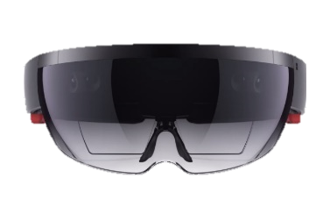

Mixed reality market is just starting to grow, but already getting many developers’ interest

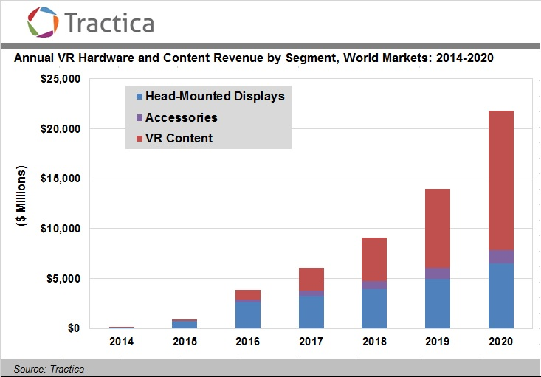

Annual VR Hardware and Content Revenue by Segment, World Markets: 2014-2017

Data from Tractica

Image from Microsoft HoloLens

Statistic

Displays data on calculated position

Sends calculated local, color and sound to the headset continuously

Sends the three-dimensional information about the real world constantly

Image from pixabay (CC0 Public Domain)

Image from Microsoft HoloLens

Image from Microsoft HoloLens

Image from Microsoft HoloLens

How it works

Mixed Reality