SeungJi Lee
sl136
CSCI2951-G
HW1

1.
aprox_boltzmann_1 = 0.0023

2.
aprox_boltzmann_2 = 0.0032

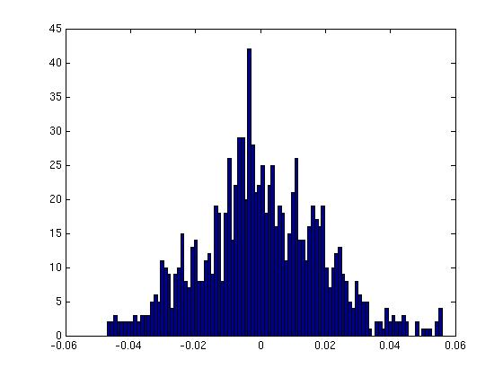
3.
aprox_boltzmann_3 = 0.0049

4.

The measure of energy seems to oscillate frequently inbetween -830 and -820.
Below are the result after interpolation of the kinetic energy

Before the interpolation:
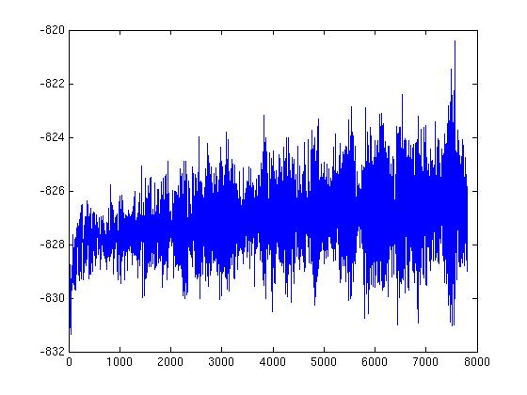

After the interpolation:

