# **TICKET RESERVATION SYSTEM**

# **(finals output)**

**(ctrl+click to skip to specific part)**

**TICKET RESERVATION SYSTEM** 1

**(finals output)** 1

**1.** **Menu** 3

*a.* *Code:* 3

*b.* *Output:* 4

**1.1** **Name with seat number** 5

1.1.a Code: 5

1.1.b Output: 7

**1.2 Search seat if available to reserve** 8

1.2.a. Code: 8

1.2.b. Output: 9

*1.2.b.1 Available:* 9

*1.2.b.2 Reserved:* 10

**1.3 Delete Reservation Record** 11

1.3.a Code: 11

1.3.b Output: 13

*1.3.b.1 If there is no seat to delete:* 13

*1.3.b.2 If seat is deleted successfully:* 14

**1.4** **Reserve seat individual and by group** 15

a. Output: 15

**1.5 View Record** 18

a. Output: 18

**1.6 Exit.** 19

Output: 19

**2.** **Input Data: Name and Seat Number** 20

*Output:* 20

**3.** **Calculated data change status if reserve or not** 21

*Available:* 21

*Reserved:* 22

**4.** **Calculated behavior is checking for continuous seats** 23

*Table presents seats available:* 23

*When seat is not available:* 24

**5.** **Data for system should be saved on a flat file e.g. text file or txt files.** 25

*Output:* 25

**6.** **System can accept multiple reservation.** 26

*System is running a for loop based on number of reservations user inputs:* 26

**7.** **Design your own Menu.** 27

*Start page:* 27

*Menu:* 28

# **Menu**

## *Code:*

1. int messagemenu(void)
2. {
3. while (true)
4. {
5. do
6. {
7. system("cls");
8. cout << space() << "**************************" << endl;
9. cout << space() << "*         Options:       *" << endl;
10. cout << space() << "**************************\n\n" << endl;
11. cout << space() << "**********************************" << endl;
12. cout << space() << "*                                *" << endl;
13. cout << space() << "*     1.Reserve a seat           *" << endl;
14. cout << space() << "*                                *" << endl;
15. cout << space() << "*     2.Search seats             *" << endl;
16. cout << space() << "*                                *" << endl;
17. cout << space() << "*     3.Delete a reservation     *" << endl;
18. cout << space() << "*                                *" << endl;
19. cout << space() << "*     4.View receipt             *" << endl;
20. cout << space() << "*                                *" << endl;
21. cout << space() << "*     5.Exit Program             *" << endl;
22. cout << space() << "*                                *" << endl;
23. cout << space() << "**********************************\n" << endl;
24. cout << space() << "Select a number: ";
25. quitters = getche();
26. cout << space() << endl;
27. } while (!strchr("12345", quitters));
28. return quitters - 49;
29. quitters = 0;
30. }
31. }

## *Output:*

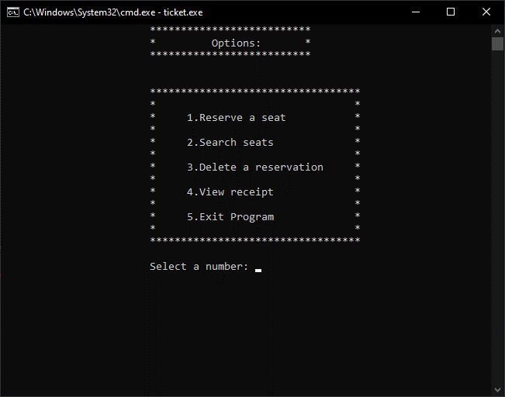

### **Name with seat number**

#### 1.1.a Code:

void reserve(void)

{

    system("cls");

    remove("my_receipt.txt");

    char rowNo;

    int colNo, inputNumSeats;

*//Inputs number of seats to reserve*

    cout << space() << "Enter number of seats to reserve: ";

    cin >> inputNumSeats;

*//Prints out available seats available to reserve.*

    cout << space() << "Here are the available seats you can reserve: \n";

    cinemascreen();

    cout << "\n\n";

    tickets();

    cout << "\n\n" << space() << "Enter your reservation details: \n\n";

    for (int s = 1; s <= inputNumSeats; s++)

    {

        cout << space() << "\tRow Letter: ";

        cin >> rowNo;

        rowNo = toupper(rowNo);

        cout << space() << "\tColumn Number: ";

        cin >> colNo;

        customerNames();

        cout << "\n\n";

        int transRowNo;

        switch (rowNo){

        case 'A':

            transRowNo = 1;

            break;

        case 'B':

            transRowNo = 3;

            break;

        case 'C':

            transRowNo = 5;

            break;

        case 'D':

            transRowNo = 7;

            break;

        case 'E':

            transRowNo = 9;

            break;

        }

        if (ticketTable[transRowNo + 1][colNo] != " X "){

            ticketTable[transRowNo][colNo] = customerName;

            ticketTable[transRowNo + 1][colNo] = " X ";

        }

        else if (ticketTable[transRowNo + 1][colNo] == " X "){

            char answer;

            cout << space() << "Sorry. This seat is already reserved. Reserve again? (Y/N): ";

            cin >> answer;

            answer = toupper(answer);

            if (answer == 'Y')  reserve();

            else  messagemenu();

            return;

        }

*//to get the time they reserved:*

        time_t tt;

        struct tm *ti;

        time(&tt);

        ti = localtime(&tt);

        fstream my_receipt;

        my_receipt.open("my_receipt.txt", ios::out | ios::app);

        my_receipt << "\tCustomer Name: " << customerName << "\n";

        my_receipt << "\tReserved Seat Location: " << rowNo << colNo << "\n";

        my_receipt << "\tTime you reserved: " << asctime(ti);

        my_receipt.close();

    }

*//printout table*

    system("cls"); space(); cinemascreen();  cout << "\n\n"; tickets();

    cout << "\n\n" << space() << space() << "'X' = reserved" << endl;

    cout << space() << space() << "'A1...' = available \n\n" << endl;

    char answer;

    cout << space() << "Would you like to go back to the main menu (Y/N)?: ";

    cin >> answer;

    answer = toupper(answer);

    if (answer == 'Y') messagemenu();

    else reserve();

    return;}

#### 1.1.b Output:

Asks user to input row letter, column number, and customer name.

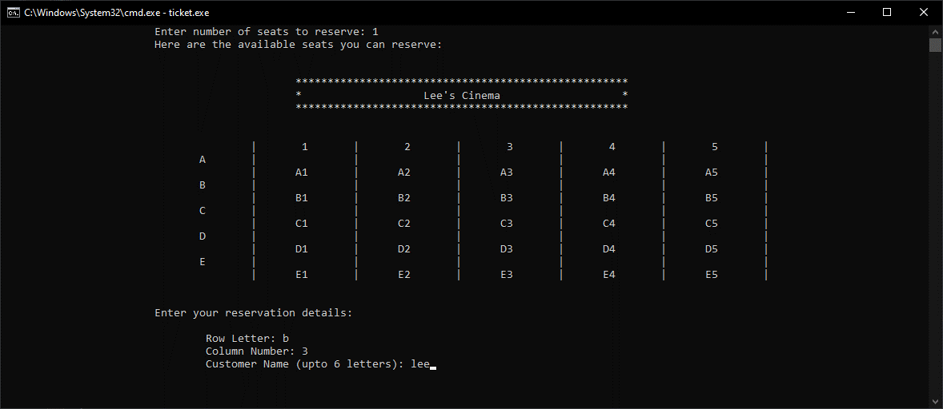

### **1.2 Search seat if available to reserve**

#### 1.2.a. Code:

void search(void)

{

    cout << space() << "Enter row letter that you want to search:";

    cin >> searchRow;

    searchRow = toupper(searchRow);

    cout << space() << "Enter column number that you want to search: ";

    cin >> searchCol;

    cout << "\n\n";

    int transRowNo;

    switch (searchRow) {

    case 'A':

        transRowNo = 1;

        break;

    case 'B':

        transRowNo = 2;

        break;

    case 'C':

        transRowNo = 3;

        break;

    case 'D':

        transRowNo = 4;

        break;

    case 'E':

        transRowNo = 5;

        break;

    }

    if (ticketTable[transRowNo][searchCol] != "  ")

    {*//printout table*

        space();cinemascreen();cout << "\n\n";tickets();

        cout << "\n" << space() << "This seat is reserved. Would you like to search for more (Y/N)? : ";

        cin >> answer;

        answer = toupper(answer);

        if (answer == 'Y') search();

    }

    else

    {

*//printout table*

        space();cinemascreen();cout << "\n\n";tickets();cout << "\n\n";

        cout << space() << "This seat is available. Would you like to reserve a seat (Y/N)? : ";

        cin >> answer;

        answer = toupper(answer);

        if (answer == 'Y') reserve();

    }

}

#### 1.2.b. Output:

Asks user to input row letter and column number they want to search. It continuously checks if seat is reserved or available

*1.2.b.1 Available:* 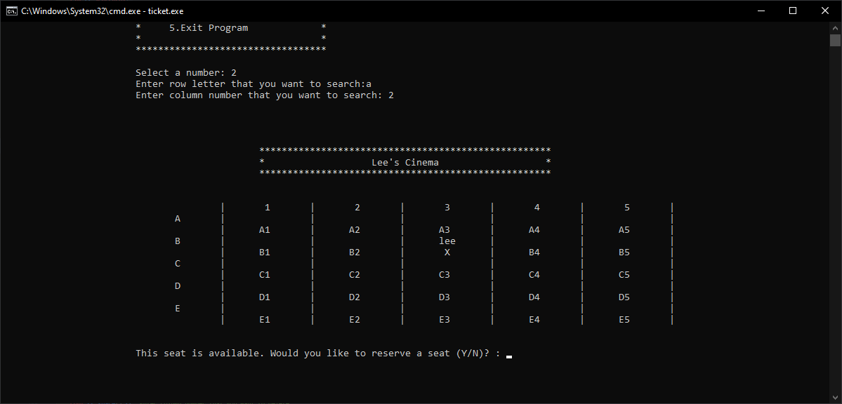

##### *1.2.b.2 Reserved:*

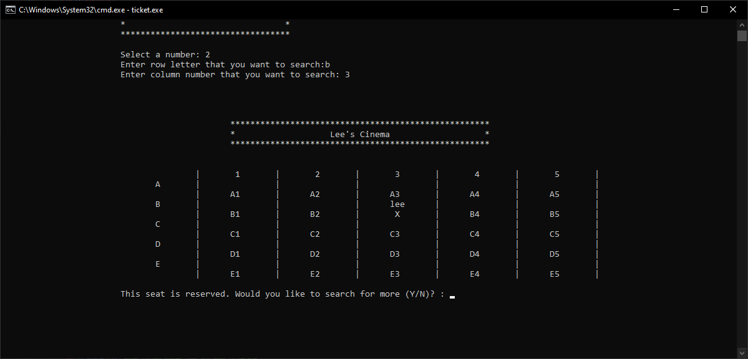

### **1.3 Delete Reservation Record**

#### 1.3.a Code:

void erase(void)

{

    char answer;

    cout << space() << "Enter row letter that you want to delete: ";

    cin >> delRow;

    delRow = toupper(delRow);

    cout << space() << "Enter column number that you want to delete: ";

    cin >> delCol;

    int transRowNo;

    switch (delRow)

    {

    case 'A':

        transRowNo = 1;

        break;

    case 'B':

        transRowNo = 2;

        break;

    case 'C':

        transRowNo = 3;

        break;

    case 'D':

        transRowNo = 4;

        break;

    case 'E':

        transRowNo = 5;

        break;

    }

    string col = to_string(delCol);

    string delInput = delRow + col;

    if (ticketTable[transRowNo + 1][delCol] == " X ")

    {

        ticketTable[transRowNo][delCol] = "   ";

        ticketTable[transRowNo + 1][delCol] = delInput + " ";

        remove("my_receipt.txt");

        cout << "\n\n"  << space() << "Deleted reservation succesfully. Would you like to go back to the main menu (Y/N)? : ";

        char answer;

        cin >> answer;

        answer = toupper(answer);

        if (answer == 'Y')  messagemenu();

        else  erase();

    }

    else

    {

        cout << "No seats reserved. Would you like to reserve first? (Y/N)? : ";

        cin >> answer;

        answer = toupper(answer);

        if (answer == 'Y') reserve();

    }

}

#### 1.3.b Output:

##### *1.3.b.1 If there is no seat to delete:*

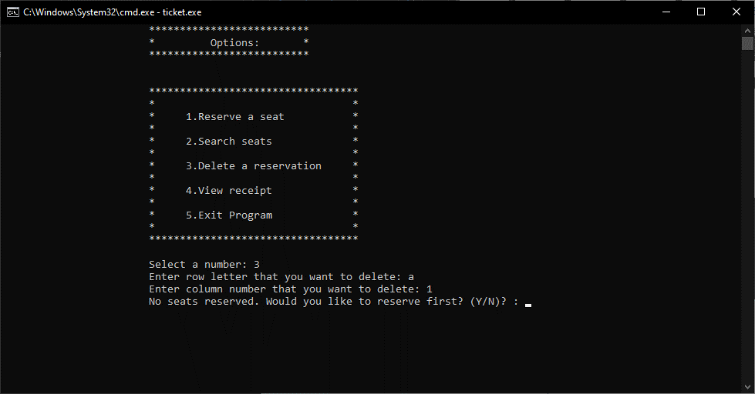

##### *1.3.b.2 If seat is deleted successfully:*

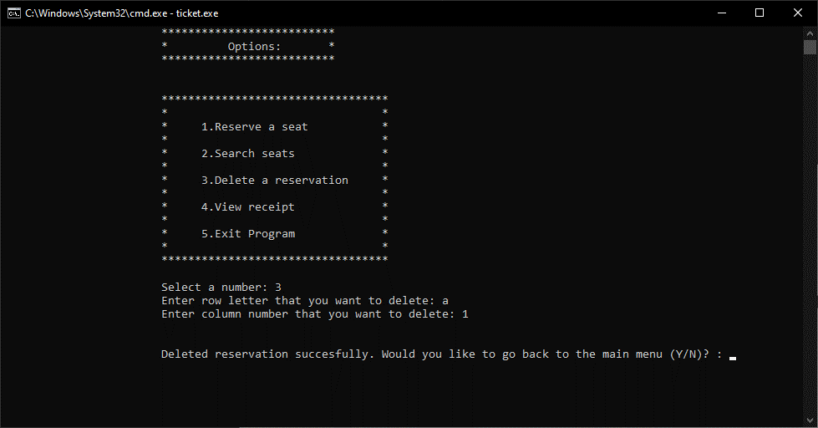

### **Reserve seat individual and by group**

#### Output:

Table:

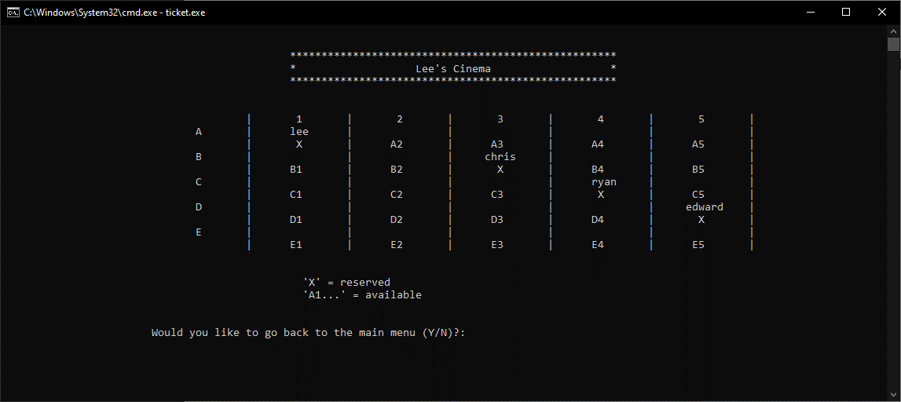

*If seat is already reserved:*

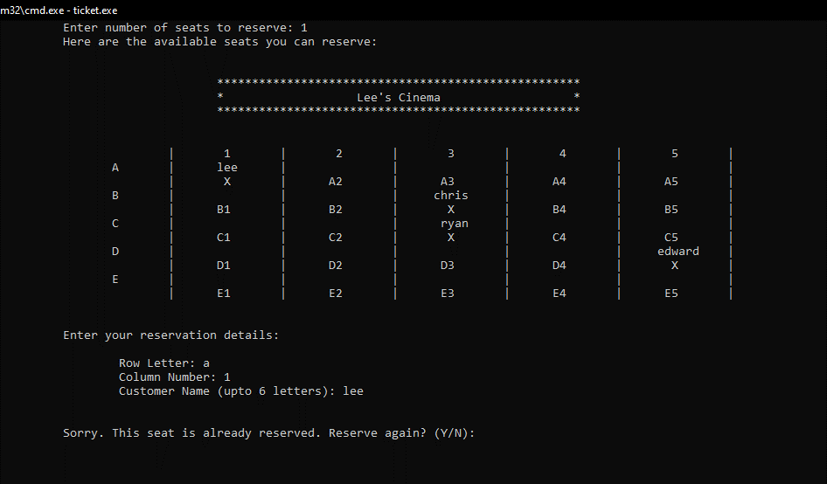

### **1.5 View Record**

#### a. Output:

Details such as table to show your seat and a receipt with the time you reserved your seat.

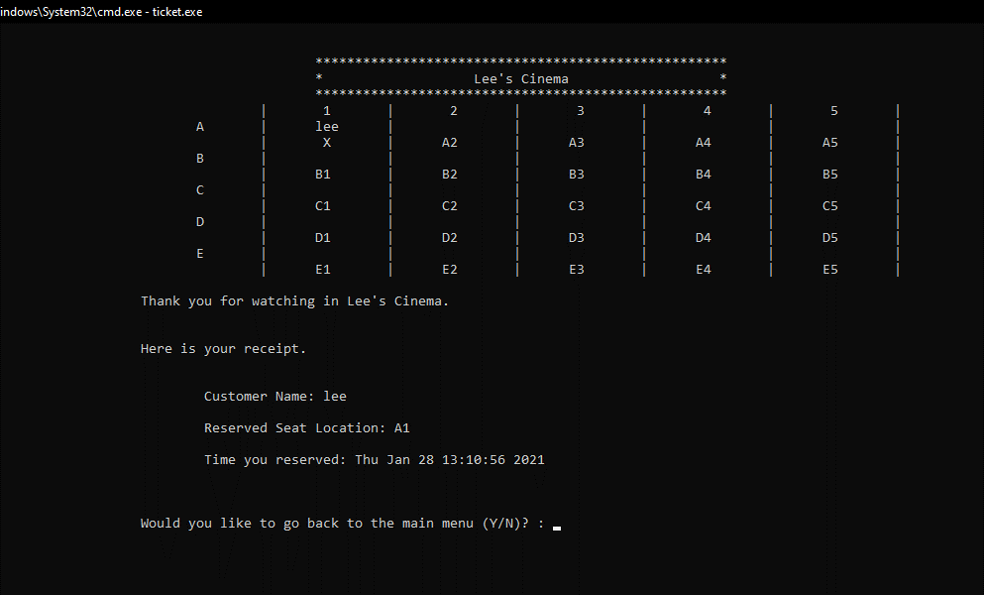

### **1.6 Exit.**

#### Output:

Typing ‘5’ will let you exit the program.

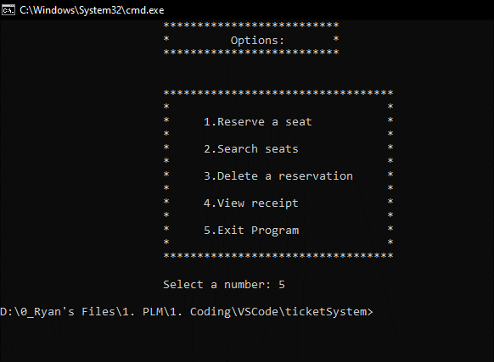

# **Input Data: Name and Seat Number**

## *Output:*



# **Calculated data change status if reserve or not**

## *Available:*



## *Reserved:*



# **Calculated behavior is checking for continuous seats**

## *Table presents seats available:*



## *When seat is not available:*



# **Data for system should be saved on a flat file e.g. text file or txt files.**

## *Output:*

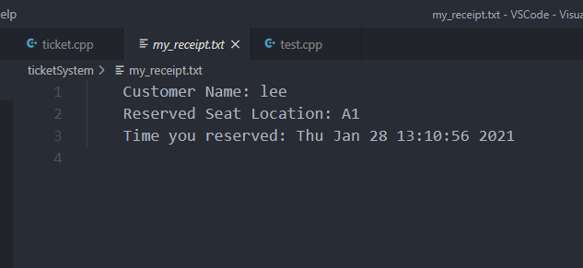

# **System can accept multiple reservation.**

## *System is running a for loop based on number of reservations user inputs:*

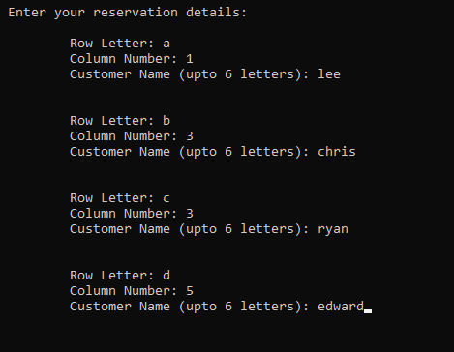

# **Design your own Menu.**

## *Start page:*

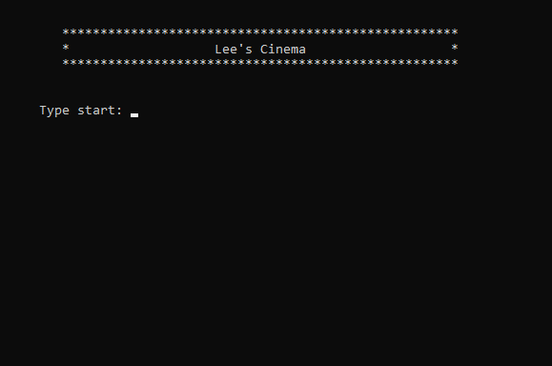

## *Menu:*

