**Project 01 A**

Write a program that creates ASCII art.

Here are some examples:

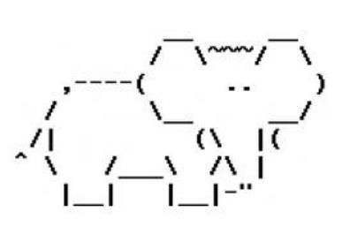

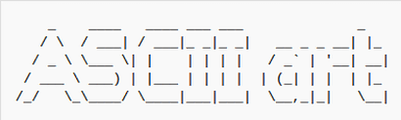

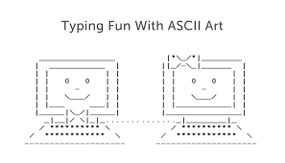

There are some characters that cannot be typed into a print statement because they interfere with the Java language syntax. For example, this statement would cause an error:

(pretend this is on one line)

System.out.println("My favorite movie is "Back to the Future" because it is sci-fi");

This can be solved with an escape character (also called escape sequence).

By using a slash then the quote, you can use quotes within a print statement:

System.out.println("My favorite movie is \"Back to the Future\" because it is sci-fi");

This link has some other useful escape characters that are allowed in the project. <https://www.tutorialspoint.com/escape-sequences-in-java>

**Project Criteria**

* The first line printed out must be your name
* ASCII art created purely by print statements in the Java console
* Minimum of 5 lines printed out

Feel free to be creative and ask questions!