COMPUTER SCIENCE 2

FINAL PAPER
A.Y. 2025-2026

ISKO-ON-THE-GO

11 Danganan, Zyrene Sophia M.
12 De Guzman, Earl Carwyn P.
13 El Hourani, Hadi D.
14 Familiar, MargaretCali G.
15 Garcia, Lee-An Dave A.

8 – ILANG-ILANG

Submitted to:
Ms. Amy U. Aclan
COMPUTER SCIENCE 2 TEACHER
- ISKO-ON-THE-GO: Centralized Communication and Navigation System for Scholars of Philippine Science High School

- Problem Statement / Rationale
In many ways, students at the Philippine Science High School CALABARZON Region Campus in Batangas City (CBZRCIBC) are faced with excessive amounts of information and what may be considered heavy academic demands. Currently, the methods for distributing important information about available resources on campus (e.g., class schedules, batch-specific announcements, and Student Council (SCO) Lost & Found) are disjointed — each of these items exists in separate locations (bulletin boards throughout the school, multiple social media group chats, and through verbal communication) resulting in a significant amount of friction within a student’s daily routine. Because there isn’t a single home for all this information, students spend an excessive amount of time and energy to confirm basic logistics causing additional confusion due to items that have been missed or delay in receiving information, resulting in poor time management.

By developing a single digital-use platform, ISKO-ON-THE-GO was created to help solve the inefficiencies that most Pisay scholars are experiencing. At its core, this system utilizes C++ programming for its user interface and consolidates all of the important resources needed both academically as well as institutionally into one unified interface. The intention behind this is that it eliminates the use of non-integrated communications methods of seeking out information and thereby facilitates autonomous student self-management through the consolidated and reliable means for gaining access to critical or key attributions and financial data.

In addition, with a growing population on campus coming from new and transfer students, it has become increasingly clear that providing a consistent digital onboarding experience is vital.

- Project Overview and Relevance
ISKO-ON-THE-GO, is a mobile app designed for the people of Philippine Science High School CALABARZON Region Campus in Batangas City. It serves as an all-in-one platform where users can easily access important school related information. The app includes features such as announcements, class schedules, cafeteria menus, student information, and lists like borrowed books and lost and found items.

To access the features of our app, the user must log in to the institutional email given by the school. Within the app, the user can select their grade level, section, and ALP/SCALE, and update their personal information for announcement fit for the user. It has optional features like a campus map, event schedules, our student handbook, and additional tools like Wi-Fi access lists to guide users through their needs. The app is designed to help students by organizing their needs into one convenient system.

Through our app, Pisay life will become much easier as not only are you saving time by being informed immediately of anything school related through app announcements but you are also saving phone space by not needing to have multiple apps for school information. By collecting announcements, schedules, and other updates into one app, students can stay informed and organized more efficiently. This is relevant today because students rely on fast and organized access to information. It also helps lessen confusion because information is no longer scattered across different platforms, which also reduces missed announcements. Moreover, the app improves convenience, organization, and preparedness, making it easier for scholars to focus on their studies and school activities.

It also helps students manage their time better by making schedules and responsibilities easy to check. The app makes things more efficient since students no longer need to manually track their tasks and materials. This is helpful during busy academic periods where quick access to information can reduce stress and confusion. The app can also provide real time updates, making it a reliable source of information for the whole student body.

Lastly, ISKO-ON-THE-GO helps our junior batches and lateral transferees adjust faster by providing guidance on campus locations, rules, and services. It also helps academic responsibility by helping them track their schedules, borrowed materials, and important events. The purpose of the application is to act as both an everyday utility for current student scholars as well as a digital bridge between new students by helping them learn about the campus culture through a readily available student handbook along with organized utility modules to help in the process.

- Objectives
The primary goal of implementing this system is to lessen the cognitive load that student scholars experience due to all the information being processed and allow them to redirect this same amount of energy back onto their primary academic and extra-curricular activities. Overall, ISKO-ON-THE-GO will provide a more proactive approach to improving campus life and ensure that all student scholars have immediate access to the support they need from the institution to be successful in their academic career.

Specific: Develop a centralized mobile application, ISKO-ON-THE-GO, designed to streamline the student experience at PSHS-CALABARZON. The application will integrate essential campus resources, including a multi-tiered announcement dashboard, academic and residence hall scheduling, a digital student handbook for policy compliance, and a registry for Student Council (SCO) Lost and Found items, effectively reducing the information fragmentation currently faced by scholars.

Measurable: Successfully implement and demonstrate a functional prototype in C++ that processes institutional email authentication, filters data across the required tiers (campus, batch, class), and enables real-time data retrieval for all implemented modules. The system’s success will be determined by its ability to perform these core functions without system crashes or data validation errors during standard user interaction.

Achievable: Work with a structured, team-based development approach where roles are specialized into documentation, coding, testing, and methodology. By utilizing C++ and maintaining modular code, the team can complete the development of the functional prototype within the given time frame.

Relevant: Align the application’s functionality with the specific needs of the Pisay academic environment. By providing a "one-stop-shop" for rules, regulations, schedules, and campus connectivity, the project directly supports the student body in maintaining academic compliance and operational efficiency, fulfilling the mission of the Department of Science and Technology (DOST) to provide innovative solutions.

Time-bound: Complete the final system prototype and all accompanying technical documentation by the submission deadline of April 23, 2026. Following the submission, the team aims to finalize the project evaluation and presentation to ensure a smooth flow of events.

- Methodology / Technical Approach
A large collection of code was turned into functions to be used for a larger program. The programmers each created their own sets of functions to be added to the final project. All functions were labeled, communicated, and tested continuously to ensure proper working of the program. The codebase was structured using large, modular functions, with shorter segments for managing user interaction, input, and display. In a way, the code followed a ‘function-input-display’ format. Despite this structure, the programmers encountered challenges regarding code consistency with regards to formatting and managing variables. To address these, the programmers maintained open communication and collaborative code reviews to refine logic and implement necessary revisions. Although the team faced initial difficulty in having unique variable naming conventions, they worked together effectively to overcome obstacles to complete the program. Once the researchers began building the main program, what was simply an exploratory phase in coding was slowly transitioning into a series of comprehensive issue discoveries that needed to be looked into.

Functions facilitated the connection of loops that binded the entire code together. Essentially, the initial function opens up a loop, and that loop contains other functions that would bring the user to other functions. This meant that we could keep the code going continuously, and if ever the user wanted to end the program, they could just exit the loop and they'd be brought to an exit screen. Keeping the indentations consistent was one of the biggest challenges the programmers faced in such a large-scale project. Luckily, loops helped ‘categorize’ these indentations. Similar to a map coordinate system, the programmers would count indentations from the closest or last loop. This reduced the number that would be counted, making it easier to track. This also leads to more consistent indentations within the code. Though loops were the keys to creating the desired program, a big part of the errors included loops due to the number of infinite, meaningless, and random loops. Moreover, errors like loops ending in dead ends were found. After continuously testing the code, there were always situations where the loops would be a dead end with nowhere to go. This was usually because of a stray loop from a placeholder function being kept in the line of code.

The programmers began the coding process by following the demands and ideas based on their previous work. This ensured that everyone could split the workload evenly where the list of tasks were easily tracked for everyone to see. Strategy was key and without proper planning within the whole group, communication would be difficult and implementation would take more time than expected due to possible misunderstandings.

Functions were generally a mix of switch structures, if/if-else/else. However, handling more complex requirements needed the programmers to turn to a series of trial-and-errors and various code experimentation in order to discover the best possible way to create or write the function. Additionally, they utilized comments to describe or to comment on the code as it improves readability and makes it easier for the said programmer to return to the code and get back to work conveniently. Comments allowed the programmers to remember what they added to the code, including why they did and how they inserted it. To improve workflow, readability, and efficiency, comments act as indicators, helping to direct the programmers where a specific function is connected to.

Programmers checked every function, statement, and ran the code repeatedly to ensure a smoothly working program that exists without errors or any possible issues that may have been overlooked. Improving the readability and clarity for users were prioritized over revising the program for other coders. Unexpected inputs were handled by switch cases and in some cases, few nested-ifs in others. All in all, each programmer had a different style of coding—some preferred simplicity, some preferred to use more advanced tools—but all of them focused on functionality.

Why C++? In deciding what programming language and/or application to use, the programmers were most comfortable with C++ as they understood its capabilities more over other programming languages, like Python. C++ provides such a wide array of tools and functions to use, which greatly help with efficiency. Some of these tools may even help improve the code independently. Considering that the programmers would be working with large amounts of code all at once, C++ also provided the advantage of being a compiler. Python, for example, is an interpreter—taking and translating code one line at a time—while C++ takes all of the code at once. This means that C++ may have more room for possible optimizations and the program would run faster after the initial wait. Another advantage of a compiler is that they can spot errors before the program starts. A compiler would tell you immediately about an error at line 800 if you tried running the code, even if you had a thousand lines; while an interpreter would run the code line by line until line 800 where only then would it show the error. This means that using a compiler is much more efficient for the programmers. Since there were several instances where the code had an error on a large line number, a compiler definitely helped with code testing, troubleshooting, and time management. Aside from having a wide variety of tools at hand and the incredible advantages of a compiler, the programmers last reason for using C++ was its potential for experimentation. C++ has so many different functions, mixing and matching them can grant great results. Whether it be formatting strings or performing calculations, C++ has a function for everything.

Problems faced during development mainly included planning or communication issues. These two directly cause all other possible issues. However, by using the formats, techniques, functions, and taking advantage of the available tools, the programmers overcame these obstacles in development, and created a working program.

- Flowchart
Access the flowchart of our program by scanning the QR code below.
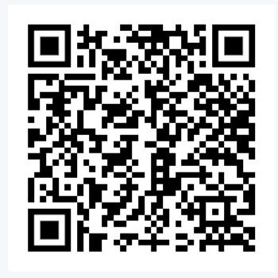

- Program
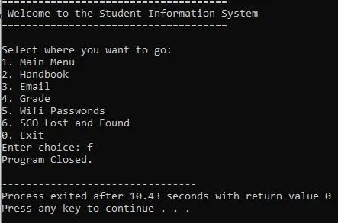
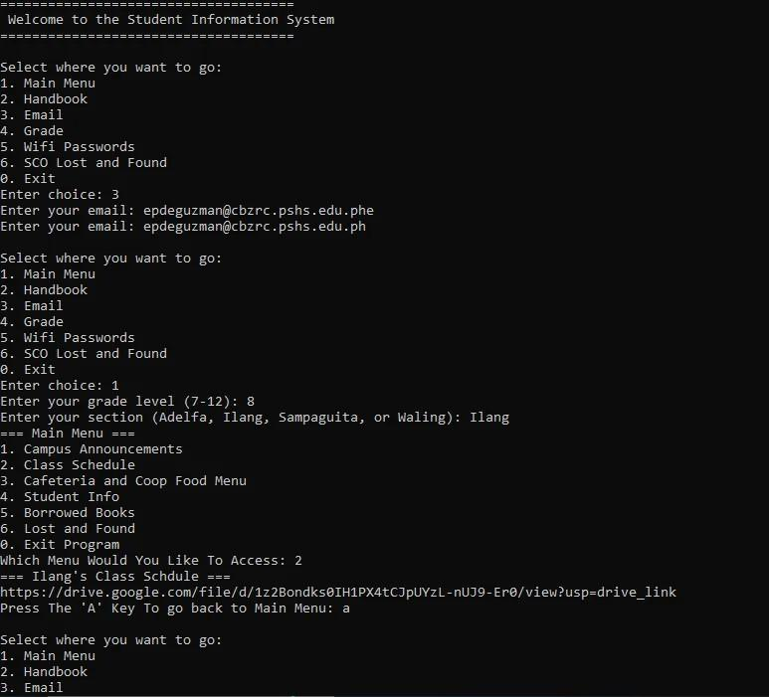
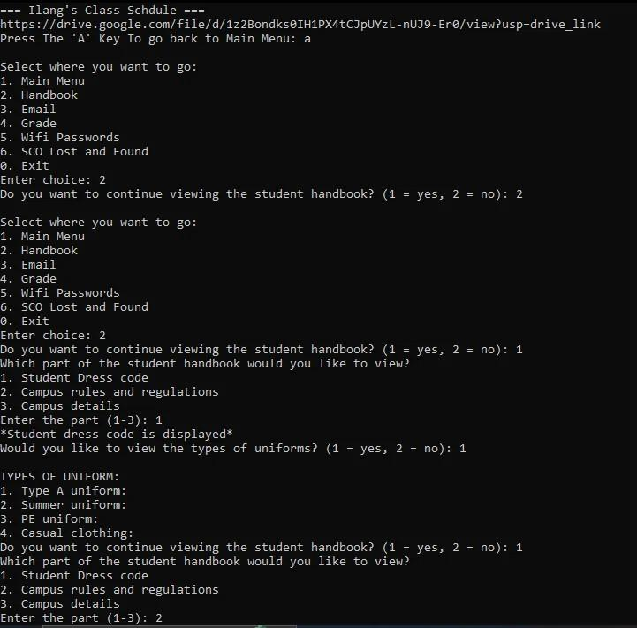
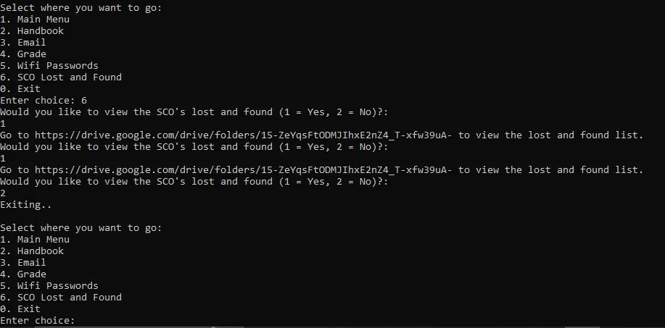
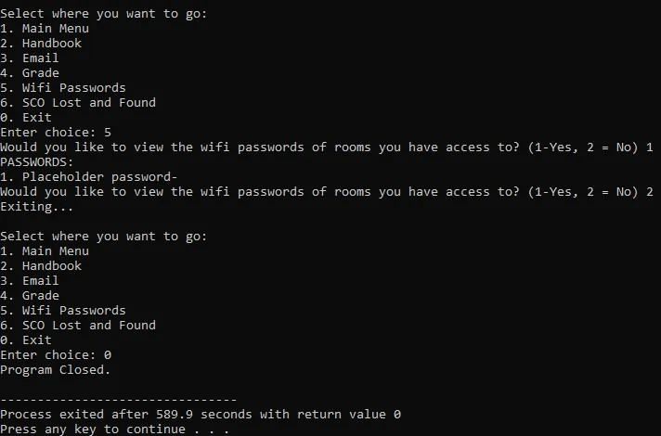

- Team Roles

MEMBER | 1st Quarter | 2nd Quarter | 3rd Quarter | 4th Quarter
Danganan | Feasibility and scope; task management | Project Objectives | Code for main menu; README | Problem Statement/  Rationale; Objectives; Manuscript; Slideshow
De Guzman | Problem Decomposition | Planned Features and Requirements | Troubleshoot handling; Additional Documentation | Project Overview/  Relevance; Objectives; README
El Hourani | Problem Statement | Planned Features and Requirements | Main programmer for functions | Main programmer; Code Revision; Methodology/  Technical Approach
Familiar | Problem Identification | Planned Features and Requirements | README; Additional Documentation | Project Overview/  Relevance; README
Garcia | Proposed solution | Logic Plan | Additional Documentation; Github repository | Flowchart; Github Repository/  Manuscript

Ultimately, all members of the group contributed to the project. All tasks were agreed upon, and everyone provided meaningful input towards research and implementation of this project.

- References
GeeksforGeeks. (2023, October 16). Useful inbuilt functions in C++. GeeksforGeeks. https://www.geeksforgeeks.org/cpp/useful-inbuilt-functions-in-cpp/?fbclid=IwY2xjawRXRNJleHRuA2FlbQIxMQBzcnRjBmFwcF9pZAwzNTA2ODU1MzE3MjgAAR4VY-mKZnF_eIco8-IQw-EdyqnnMq3M8wKsxfTWnf5PzqealS5EJyK9CNHacg_aem_fiPAW1TlJSuTgrZ1kzQAmw

Nyayic, F. (2026, April 16). Coding Style Guide: Developing Consistency in your projects. https://www.linkedin.com/pulse/coding-style-guide-developing-consistency-your-projects-fanny-nyayic-6csxf?fbclid=IwY2xjawRXRNxleHRuA2FlbQIxMQBzcnRjBmFwcF9pZAwzNTA2ODU1MzE3MjgAAR5tPGDAt1j6qNM9hU-tGtwEXvuS9Mo3CYgE0vkrZ6cAcifgpI-NrCNIJp954g_aem_ZnMtJC6bS247xSaCx3-Iqw#:~:text=Readability:%20When%20code%20follows%20a%20consistent%20style,,easier%20to%20collaborate%20on%20the%20same%20codebase

SMART Goals: A How to Guide. (2017). [Slide show]. https://www.ucop.edu/local-human-resources/_files/performance-appraisal/How+to+write+SMART+Goals+v2.pdf
- Final README file

# ISKO-ON-THE-GO: Pisay Iskolars' App
## The All-In-One App for CBRZC Pisay Scholars

## Table of Contents

- [Project Description](#project-description)
- [Objectives](#objectives)
- [Core Features](#core-features>)
- [Additional Features](#additional-features)
- [Program Requirements](#program-requirements)
- [How to Run the Program](#how-to-run-the-program)
- [Authors](#authors)

## Project Description

ISKO-ON-THE-GO is a dedicated mobile application designed to help students of the Philippine Science High School - CALABARZON Region Campus. It is an all-in-one platform where you can access real-time announcements, class schedules, the list for Lost
and Found items, the student handbook details, etc.

With requirements piling up on each other, ISKO-ON-THE-GO addresses this challenge as a unified platform where scholars have complete and quick access to all their school related information. With this in mind, we aim to streamline the student experience for both the upperclassmen and the incoming freshmen.

Our app makes life easier by saving the time you would usually take to look for upcoming assignments and announcements by sending them straight to you through the app's announcements. Moreover, our app also saves a lot on phone storage as you wouldn't need multiple apps for any of your school needs as they are all here. This makes our app a very effective way to save time and space on any of the requirements and important announcements as well as being valuable for academic research, technical documentation, and various assignments that demand a unified framework.

## Objectives

-Implement a secure authentication system that validates users via the institutional email given by the school and restricts access to any invalid inputs.

-Create an announcement dashboard capable of filtering and displaying messages based off the user's grade, class, and batch.

-Integrate a scheduling module that displays the residence hall routines for interns.

-Create a digital Student ID profile that stores personal info, SCALE/ALP details, and allows for user-driven data updates.

-Design a searchable campus database for lists for borrowed library books and the Student Council Organization (SCO) Lost and Found registry.

-Create a digital Student Handbook module that displays the campus dress code, uniform types, and official rules and regulations for quick reference.

-Establish a functional "Log Out" and Exit system so that the user can leave at any time.

## Core Features

• Secure Student Authentication & Validation
- Implements a login system that requires school-provided institutional email addresses to ensure that only verified campus members can access sensitive academic data.

- Features automated validation system that cross-references user-inputted grade levels and sections, preventing data conflicts and ensuring students only see content relevant to their specific academic standing.

●​ Announcement Dashboard
- A provided announcement dashboard which shows only the relevant announcements based off their grade level and section.

●​ ‌Class Schedules
-​ User will be provided a digital interface for students to view their specific class schedules per grade and section. This eliminates the need for physical copies and ensures scholars are always aware of their current period's location and time.

●​ ‌Integrated Student Council Office Lost & Found
-​ A digital version of the SCO’s "Lost and Found" list where students can check for any of their missing belongings in real time, reducing the need to visit the SCO office physically and making the recovery process for lost items much easier.

●​ ‌Session Management
-​ Includes a functional "Log Out" and "Exit" system that shuts off all previous actions to ensure that student information remains private and secure when the device is not in use.

## Additional Features
●​ ‌Digital Student Handbook & Dress Code Guide
-​ Provides a portable, searchable version of the campus rules and regulations.
-​ Includes detailed sections on the campus dress code and specific uniform types required for different school activities or specific days of the week, helping scholars remain compliant with campus standards.

## Program Requirements
●​ ‌Programming language used
-​ C++

●​ ‌Tools or Libraries
-​ String Manipulation
-​ Console-based (Standard Library)

## How to Run the Program
●​ Step-by-step instructions
- 1.​ Make sure to have Dev C++ or a compiler installed on your device.
- 2.​ Download the ISKO_ON_THE_GO.cpp file (should come from a current
student/member of the Pisay CBZRC community).
- 3.​ Open your file manager app.
- 4.​ Search for ISKO_ON_THE_GO.cpp or see it in quick access/recents.
- 5.​ Click the file to launch it (Double-click on desktop/laptop).
- 6.​ Use the program as needed.
- 7.​ Refer to the README file for any concerns.

## Authors
-​ Danganan, Zyrene Sophia M.

-​ De Guzman, Earl Carwyn P.

-​ El Hourani, Hadi D.

-​ Familiar, MargaretCali G.

-​ Garcia, Lee-An Dave A.

