NCI and BUN for predicting SAP patients

Process data
[1] "Đã phát hiện và thay thế 10 giá trị outlier bằng 15"
[1] "Đã phát hiện và thay thế 3 giá trị outlier bằng 13.5"

Descriptive summary

Whole data
Characteristic | Overall N = 260¹ | Test N = 78¹ | Train N = 182¹ | p-value²
sap |  |  |  | 0.638
0 | 198 (76.2%) | 61 (78.2%) | 137 (75.3%)
1 | 62 (23.8%) | 17 (21.8%) | 45 (24.7%)
sex |  |  |  | >0.999
Female | 72 (27.7%) | 22 (28.2%) | 50 (27.5%)
Male | 188 (72.3%) | 56 (71.8%) | 132 (72.5%)
age | 45.0 (36.0-56.0) | 44.0 (36.0-57.0) | 45.0 (35.0-56.0) | 0.937
pe | 110 (42.3%) | 34 (43.6%) | 76 (41.8%) | 0.786
bun | 14.0 (10.0-24.0) | 13.5 (10.0-25.0) | 15.0 (11.0-24.0) | 0.618
bisap |  |  |  | 0.565
0 | 54 (20.8%) | 13 (16.7%) | 41 (22.5%)
1 | 89 (34.2%) | 30 (38.5%) | 59 (32.4%)
2 | 63 (24.2%) | 19 (24.4%) | 44 (24.2%)
3 | 38 (14.6%) | 10 (12.8%) | 28 (15.4%)
4 | 15 (5.8%) | 5 (6.4%) | 10 (5.5%)
5 | 1 (0.4%) | 1 (1.3%) | 0 (0.0%)
lv_bisap |  |  |  | >0.999
<3 | 206 (79.2%) | 62 (79.5%) | 144 (79.1%)
>=3 | 54 (20.8%) | 16 (20.5%) | 38 (20.9%)
etiology |  |  |  | 0.951
Alcohol | 90 (34.6%) | 29 (37.2%) | 61 (33.5%)
Gallstones | 37 (14.2%) | 10 (12.8%) | 27 (14.8%)
Triglycerid | 75 (28.8%) | 22 (28.2%) | 53 (29.1%)
Unknown | 58 (22.3%) | 17 (21.8%) | 41 (22.5%)
hbp | 59 (22.7%) | 17 (21.8%) | 42 (23.1%) | 0.873
diabetes | 49 (18.8%) | 17 (21.8%) | 32 (17.6%) | 0.489
pseudocyst | 10 (4.0%) | 4 (5.3%) | 6 (3.4%) | 0.493
necrosis | 67 (26.5%) | 23 (30.3%) | 44 (24.9%) | 0.437
fluid | 195 (75.0%) | 59 (75.6%) | 136 (74.7%) | >0.999
necrosis_wall | 6 (2.4%) | 0 (0.0%) | 6 (3.4%) | 0.183
mortality | 21 (8.1%) | 6 (7.7%) | 15 (8.2%) | >0.999
lym | 1.2 (1.0-1.7) | 1.5 (1.1-1.9) | 1.2 (0.9-1.6) | 0.003
wbc | 13.3 (10.3-16.6) | 13.4 (10.6-17.2) | 13.3 (10.3-16.0) | 0.414
hct | 41.0 (36.8-44.9) | 40.2 (35.2-44.3) | 41.1 (37.1-45.0) | 0.424
lipase | 448.5 (184.0-1,240.0) | 507.0 (151.4-1,242.0) | 433.0 (205.0-1,158.0) | 0.943
neu | 12.7 (9.6-20.8) | 12.7 (9.1-18.7) | 12.7 (9.9-22.0) | 0.673
cre | 0.8 (0.7-1.1) | 0.8 (0.7-1.1) | 0.8 (0.7-1.2) | 0.513
amylase | 358.0 (145.0-775.0) | 365.0 (88.5-779.5) | 358.0 (166.0-775.0) | 0.446
tri | 460.0 (139.0-1,350.0) | 503.0 (150.0-1,270.0) | 451.0 (127.5-1,391.0) | 0.493
ctsi | 4.0 (3.0-6.0) | 4.0 (4.0-6.0) | 4.0 (3.0-6.0) | 0.266
crp | 181.2 (72.8-256.5) | 189.4 (56.8-255.9) | 177.4 (76.4-257.0) | 0.915
plt | 220.0 (181.0-271.0) | 231.1 (179.0-276.9) | 218.0 (182.0-271.0) | 0.663
nci | 11.4 (7.1-37.2) | 10.5 (6.7-29.4) | 11.9 (7.3-41.8) | 0.390
neu_crp | 2,559.3 (1,023.0-4,933.4) | 2,635.2 (608.9-4,408.5) | 2,501.3 (1,148.8-5,003.9) | 0.627
plr | 177.4 (122.9-246.2) | 162.2 (120.5-218.5) | 191.3 (129.3-257.8) | 0.019
nlr | 11.0 (6.6-22.9) | 8.5 (6.3-16.3) | 11.7 (6.8-27.5) | 0.057
cpr | 0.8 (0.3-1.2) | 0.8 (0.2-1.2) | 0.8 (0.3-1.2) | 0.773
ncrp_plt | 11.1 (4.7-24.4) | 10.8 (3.1-20.3) | 11.1 (5.2-25.6) | 0.483
¹n (%); Median (Q1-Q3)
²Fisher's exact test; Wilcoxon rank sum test

Train by SAP
Characteristic | Overall N = 182¹ | 0 N = 137¹ | 1 N = 45¹ | p-value²
sex |  |  |  | 0.338
Female | 50 (27.5%) | 35 (25.5%) | 15 (33.3%)
Male | 132 (72.5%) | 102 (74.5%) | 30 (66.7%)
age | 45.0 (35.0-56.0) | 44.0 (36.0-56.0) | 48.0 (35.0-54.0) | 0.598
pe | 76 (41.8%) | 41 (29.9%) | 35 (77.8%) | <0.001
bun | 15.0 (11.0-24.0) | 13.0 (9.0-20.0) | 24.0 (15.0-32.0) | <0.001
bisap |  |  |  | <0.001
0 | 41 (22.5%) | 40 (29.2%) | 1 (2.2%)
1 | 59 (32.4%) | 54 (39.4%) | 5 (11.1%)
2 | 44 (24.2%) | 35 (25.5%) | 9 (20.0%)
3 | 28 (15.4%) | 7 (5.1%) | 21 (46.7%)
4 | 10 (5.5%) | 1 (0.7%) | 9 (20.0%)
lv_bisap |  |  |  | <0.001
<3 | 144 (79.1%) | 129 (94.2%) | 15 (33.3%)
>=3 | 38 (20.9%) | 8 (5.8%) | 30 (66.7%)
etiology |  |  |  | 0.344
Alcohol | 61 (33.5%) | 48 (35.0%) | 13 (28.9%)
Gallstones | 27 (14.8%) | 23 (16.8%) | 4 (8.9%)
Triglycerid | 53 (29.1%) | 36 (26.3%) | 17 (37.8%)
Unknown | 41 (22.5%) | 30 (21.9%) | 11 (24.4%)
hbp | 42 (23.1%) | 32 (23.4%) | 10 (22.2%) | >0.999
diabetes | 32 (17.6%) | 18 (13.1%) | 14 (31.1%) | 0.012
pseudocyst | 6 (3.4%) | 4 (3.0%) | 2 (4.4%) | 0.645
necrosis | 44 (24.9%) | 24 (18.2%) | 20 (44.4%) | 0.001
fluid | 136 (74.7%) | 107 (78.1%) | 29 (64.4%) | 0.077
necrosis_wall | 6 (3.4%) | 1 (0.8%) | 5 (11.1%) | 0.004
mortality | 15 (8.2%) | 0 (0.0%) | 15 (33.3%) | <0.001
lym | 1.2 (0.9-1.6) | 1.3 (1.0-1.7) | 1.0 (0.6-1.2) | <0.001
wbc | 13.3 (10.3-16.0) | 12.4 (9.4-14.5) | 16.6 (14.2-18.6) | <0.001
hct | 41.1 (37.1-45.0) | 40.4 (37.1-43.1) | 44.6 (38.9-49.2) | 0.018
lipase | 433.0 (205.0-1,158.0) | 399.0 (173.0-878.0) | 851.3 (327.0-1,745.9) | 0.006
neu | 12.7 (9.9-22.0) | 11.6 (8.9-59.7) | 14.2 (12.8-17.7) | 0.007
cre | 0.8 (0.7-1.2) | 0.8 (0.7-1.1) | 1.1 (0.8-1.8) | 0.002
amylase | 358.0 (166.0-775.0) | 292.7 (142.0-629.0) | 651.0 (447.0-895.0) | <0.001
tri | 451.0 (127.5-1,391.0) | 317.0 (121.0-1,349.0) | 544.5 (209.0-1,731.0) | 0.118
ctsi | 4.0 (3.0-6.0) | 4.0 (3.0-5.0) | 6.0 (4.0-8.0) | <0.001
crp | 177.4 (76.4-257.0) | 155.7 (56.5-246.1) | 233.8 (168.7-310.0) | <0.001
plt | 218.0 (182.0-271.0) | 211.0 (173.0-267.0) | 251.5 (194.0-288.0) | 0.010
nci | 11.9 (7.3-41.8) | 10.0 (6.7-42.7) | 20.0 (11.7-29.4) | 0.005
neu_crp | 2,501.3 (1,148.8-5,003.9) | 2,018.8 (736.2-4,705.7) | 3,483.6 (2,487.4-5,089.3) | 0.001
plr | 191.3 (129.3-257.8) | 165.0 (120.5-233.8) | 253.2 (196.8-403.3) | <0.001
nlr | 11.7 (6.8-27.5) | 10.2 (5.8-28.8) | 16.6 (11.3-22.7) | 0.002
cpr | 0.8 (0.3-1.2) | 0.8 (0.3-1.2) | 0.8 (0.6-1.5) | 0.042
ncrp_plt | 11.1 (5.2-25.6) | 10.6 (3.3-28.0) | 14.1 (9.3-23.2) | 0.054
type
Train | 182 (100.0%) | 137 (100.0%) | 45 (100.0%)
bun_clean | 15.0 (11.0-21.0) | 13.0 (9.0-18.0) | 17.0 (15.0-28.0) | <0.001
¹n (%); Median (Q1-Q3)
²Fisher's exact test; Wilcoxon rank sum test

Distribution plots
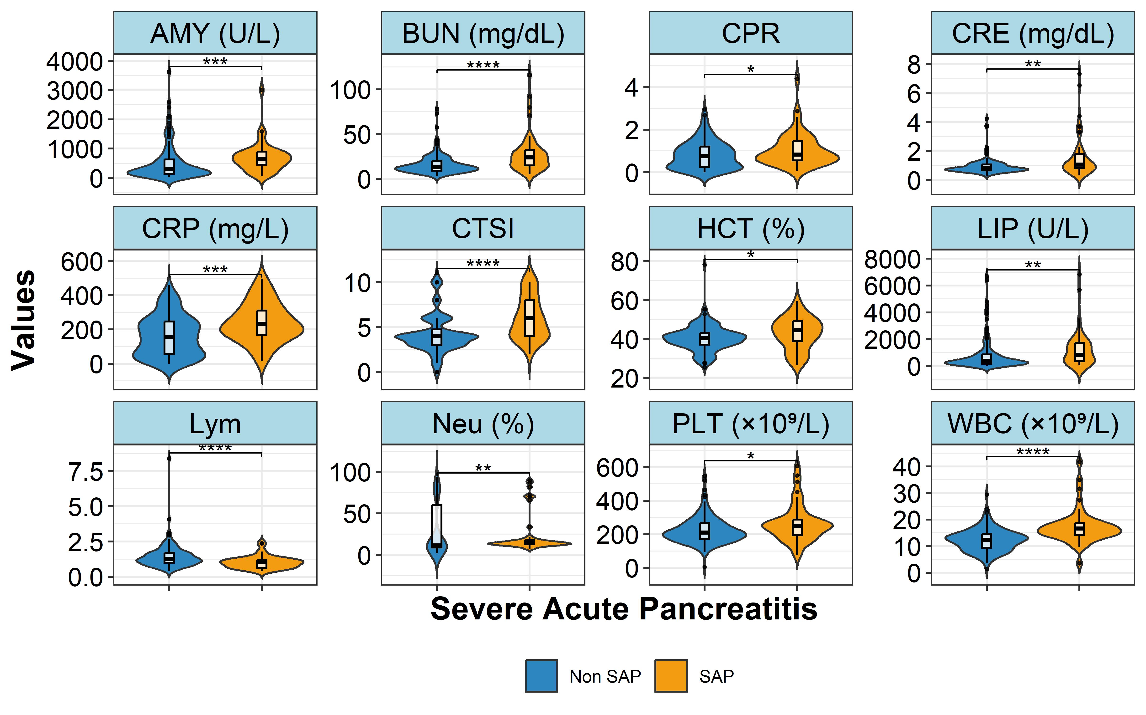

Heatmap
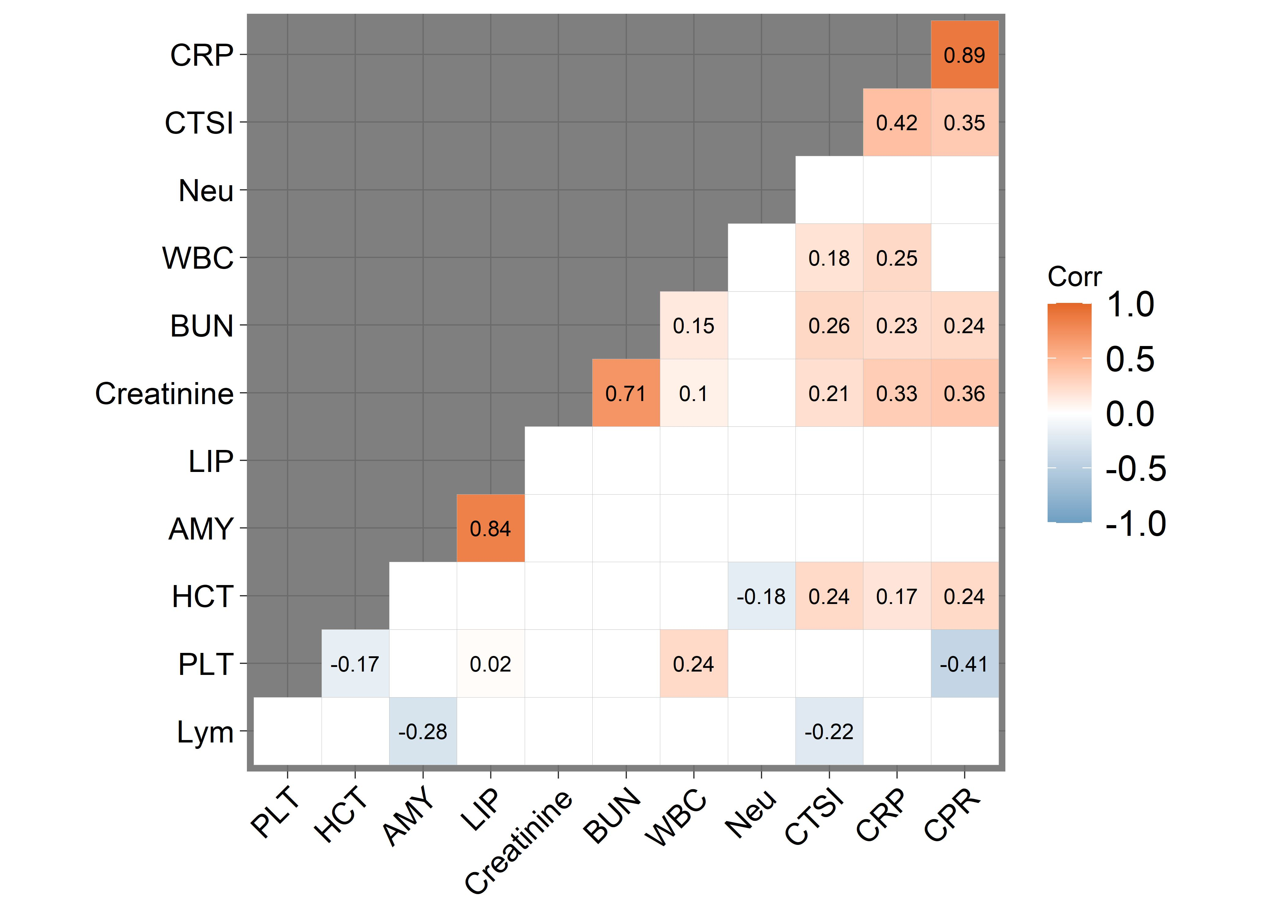

Build models

Train models
### Fit models

ROC Curves
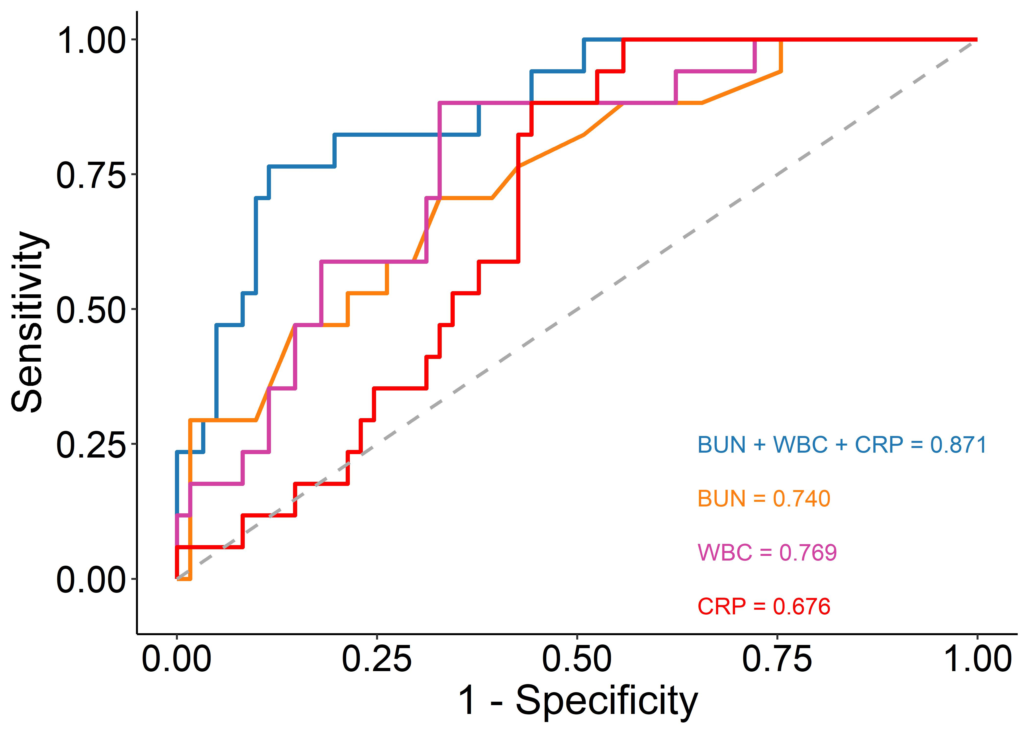

Compare ROC curves
Bootstrap test for two correlated ROC curves
data: roc_m1 and roc_m2
D = 1.9312, boot.n = 1000, boot.stratified = 1, p-value = 0.05345
alternative hypothesis: true difference in AUC is not equal to 0
sample estimates:
AUC of roc1 AUC of roc2
0.8707811 0.7401157
Bootstrap test for two correlated ROC curves
data: roc_m1 and roc_m3
D = 2.5324, boot.n = 1000, boot.stratified = 1, p-value = 0.01133
alternative hypothesis: true difference in AUC is not equal to 0
sample estimates:
AUC of roc1 AUC of roc2
0.8707811 0.7685632
Bootstrap test for two correlated ROC curves
data: roc_m1 and roc_m4
D = 3.0098, boot.n = 1000, boot.stratified = 1, p-value = 0.002614
alternative hypothesis: true difference in AUC is not equal to 0
sample estimates:
AUC of roc1 AUC of roc2
0.8707811 0.6759884

VIF
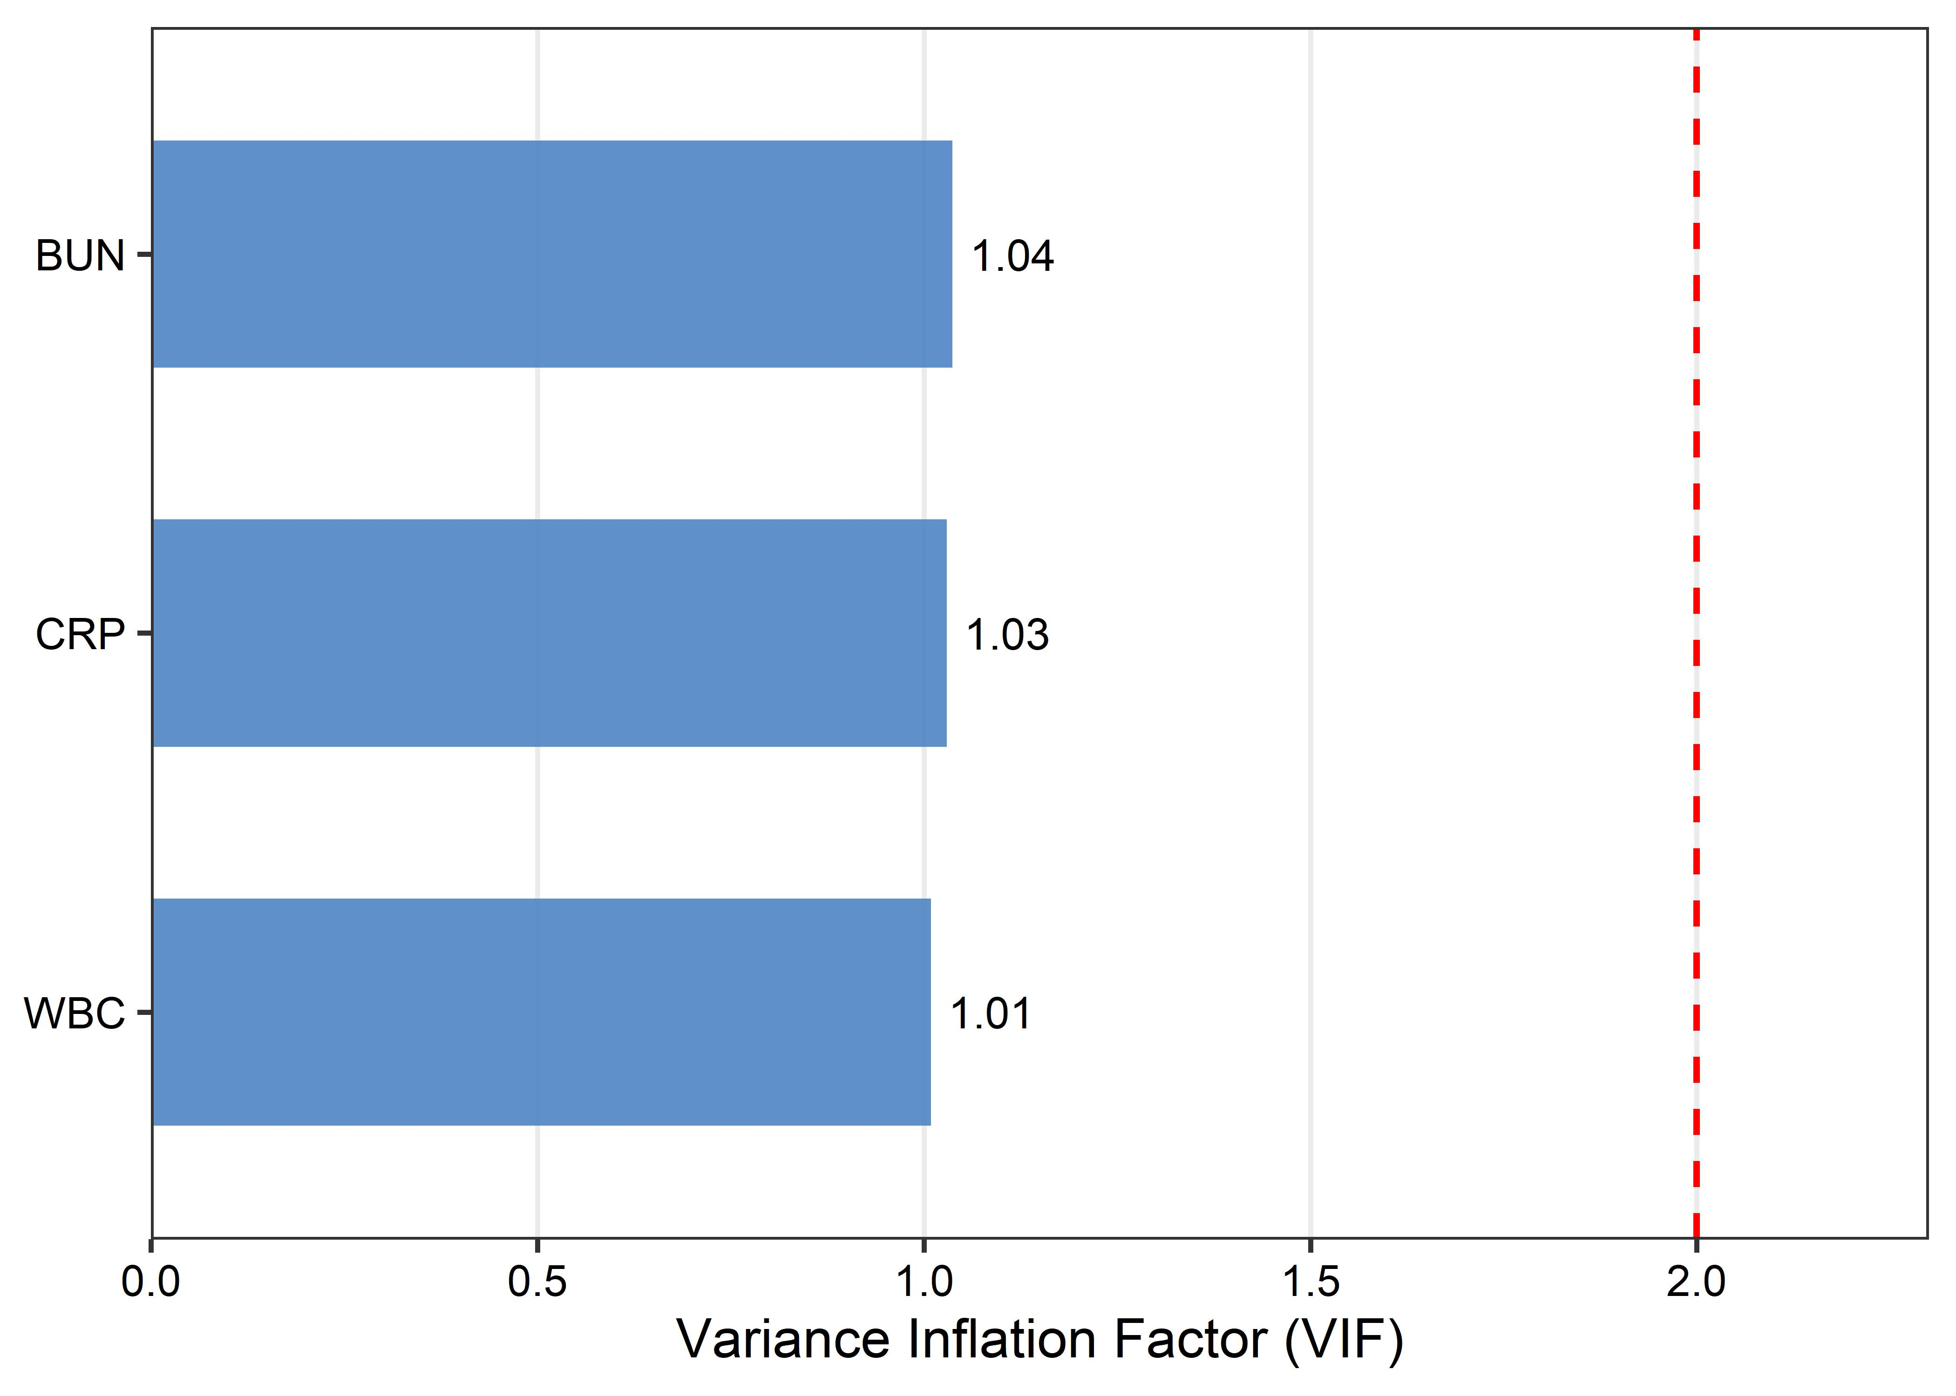

SHAP value
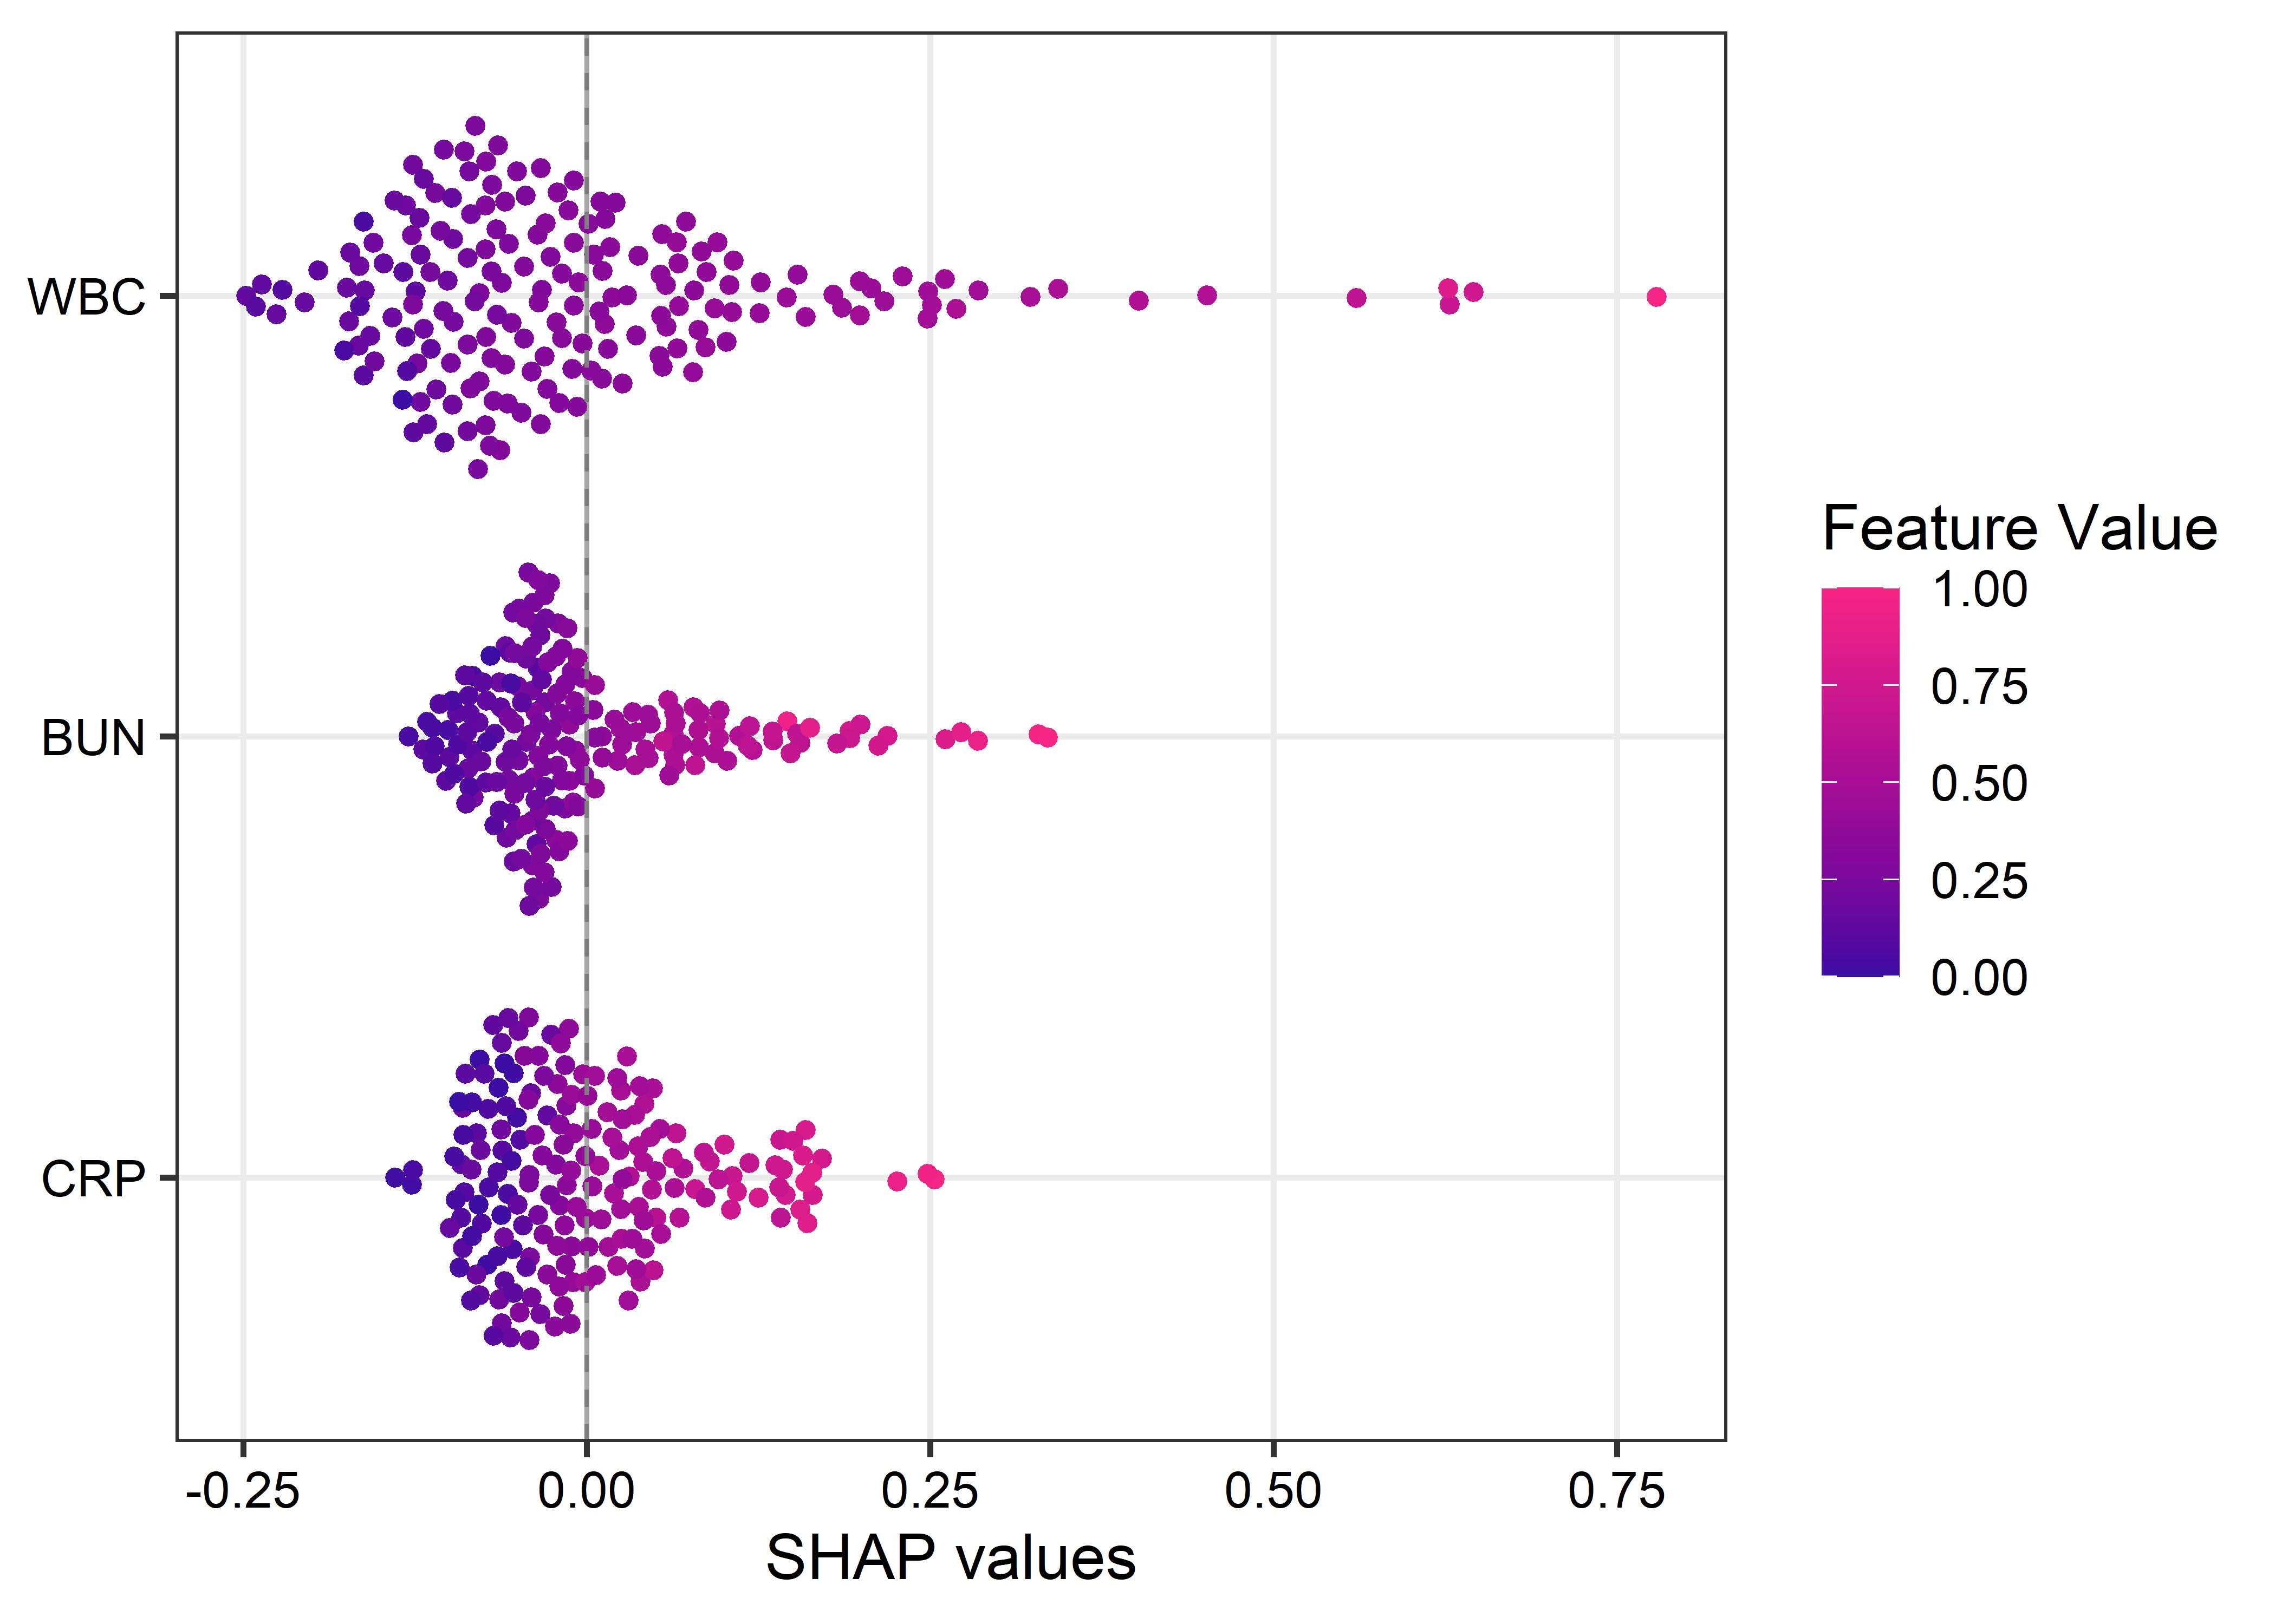

Calculate metrics
95% CI (2000 stratified bootstrap replicates):
threshold threshold.low threshold.median threshold.high specificity.low
best best 0.1395 0.349 0.4199 0.541
specificity.median specificity.high sensitivity.low sensitivity.median
best 0.8689 0.9672 0.6471 0.8235
sensitivity.high accuracy.low accuracy.median accuracy.high npv.low
best 1 0.641 0.859 0.9359 0.9
npv.median npv.high ppv.low ppv.median ppv.high
best 0.9474 1 0.3749 0.6364 0.8667
95% CI (2000 stratified bootstrap replicates):
threshold threshold.low threshold.median threshold.high specificity.low
best best 0.1439 0.2199 0.442 0.2951
specificity.median specificity.high sensitivity.low sensitivity.median
best 0.7049 1 0.3529 0.7647
sensitivity.high accuracy.low accuracy.median accuracy.high npv.low
best 1 0.4487 0.7179 0.8846 0.8451
npv.median npv.high ppv.low ppv.median ppv.high
best 0.9149 1 0.283 0.4194 1
95% CI (2000 stratified bootstrap replicates):
threshold threshold.low threshold.median threshold.high specificity.low
best best 0.2322 0.2453 0.3682 0.557
specificity.median specificity.high sensitivity.low sensitivity.median
best 0.6885 0.8852 0.6471 0.8824
sensitivity.high accuracy.low accuracy.median accuracy.high npv.low
best 1 0.6154 0.7308 0.8462 0.8846
npv.median npv.high ppv.low ppv.median ppv.high
best 0.9545 1 0.3421 0.4412 0.619

Nomogram

Calibration combined model
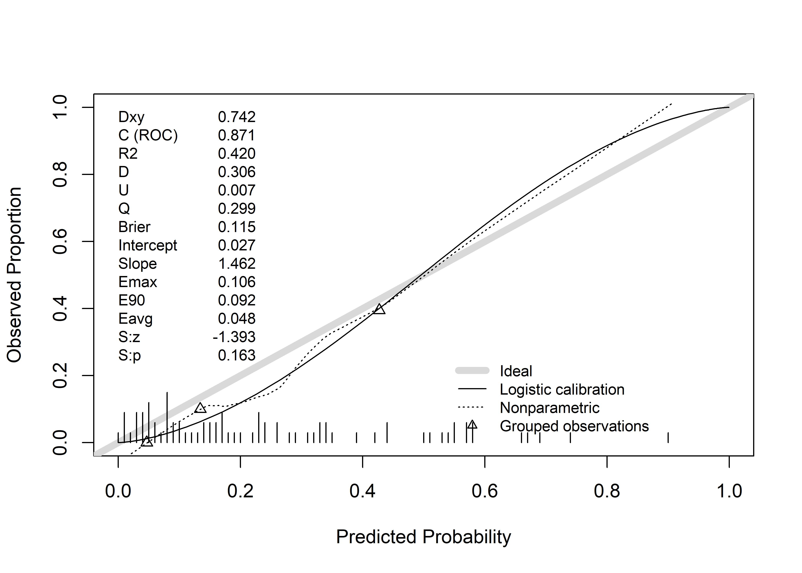

Compare BISAP

ROC Curves
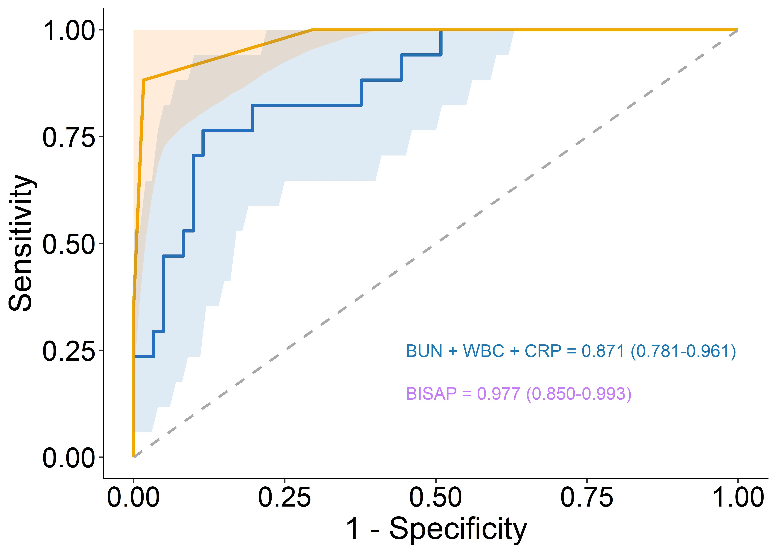

Roc test
Bootstrap test for two correlated ROC curves
data: roc_m1 and roc_m5
D = -2.3338, boot.n = 1000, boot.stratified = 1, p-value = 0.01961
alternative hypothesis: true difference in AUC is not equal to 0
sample estimates:
AUC of roc1 AUC of roc2
0.8707811 0.9773385

Decision curves

Bootstrap to validate final model
AUC crude: 0.8462
AUC adjuted by Bootstrap 1000 steps: 0.8375
Optimism: 0.0087
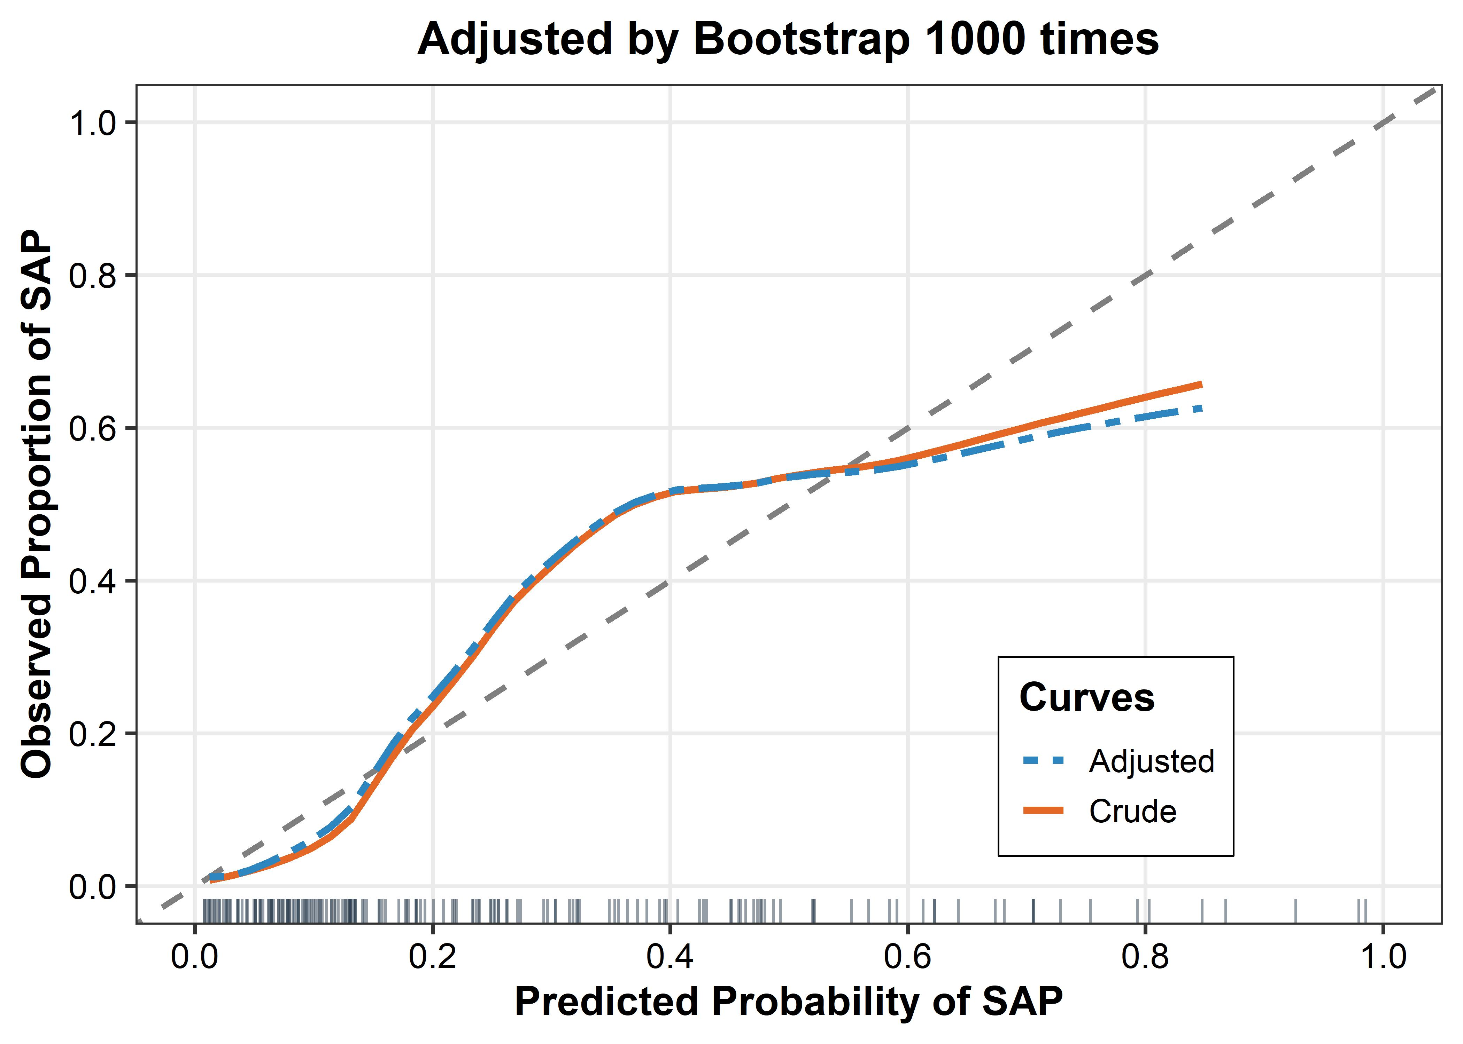

Convert to logistic model language
Logit(P) = -6.1682 + (0.0634 * BUN) + (0.2088 * WBC) + (0.0044 * CRP)

