COMBINE BUN, WBC, CRP FOR PREDICTING
SEVERITY OF ACUTE PANCREATITIS
Table 1. The demographics of patients (N = 260)
 | Overall  N = 260 | Test  N = 78 | Train  N = 182 | p
Severity Acute Pancreatitis |  |  |  | 0.638
0 | 198 (76.2%) | 61 (78.2%) | 137 (75.3%)
1 | 62 (23.8%) | 17 (21.8%) | 45 (24.7%)
Sex |  |  |  | >0.999
Female | 72 (27.7%) | 22 (28.2%) | 50 (27.5%)
Male | 188 (72.3%) | 56 (71.8%) | 132 (72.5%)
Age | 45.0 (36.0-56.0) | 44.0 (36.0-57.0) | 45.0 (35.0-56.0) | 0.937
Pleural Effusion | 110 (42.3%) | 34 (43.6%) | 76 (41.8%) | 0.786
NCI | 11.4 (7.1-37.2) | 10.5 (6.7-29.4) | 11.9 (7.3-41.8) | 0.390
BUN | 14.0 (10.0-24.0) | 13.5 (10.0-25.0) | 15.0 (11.0-24.0) | 0.607
BISAP |  |  |  | 0.565
0 | 54 (20.8%) | 13 (16.7%) | 41 (22.5%)
1 | 89 (34.2%) | 30 (38.5%) | 59 (32.4%)
2 | 63 (24.2%) | 19 (24.4%) | 44 (24.2%)
3 | 38 (14.6%) | 10 (12.8%) | 28 (15.4%)
4 | 15 (5.8%) | 5 (6.4%) | 10 (5.5%)
5 | 1 (0.4%) | 1 (1.3%) | 0 (0.0%)
Level of BISAP |  |  |  | >0.999
<3 | 206 (79.2%) | 62 (79.5%) | 144 (79.1%)
>=3 | 54 (20.8%) | 16 (20.5%) | 38 (20.9%)
Etiology |  |  |  | 0.951
Alcohol | 90 (34.6%) | 29 (37.2%) | 61 (33.5%)
Gallstones | 37 (14.2%) | 10 (12.8%) | 27 (14.8%)
Triglycerid | 75 (28.8%) | 22 (28.2%) | 53 (29.1%)
Unknown | 58 (22.3%) | 17 (21.8%) | 41 (22.5%)
High Blood Pressure | 59 (22.7%) | 17 (21.8%) | 42 (23.1%) | 0.873
Diabetes | 49 (18.8%) | 17 (21.8%) | 32 (17.6%) | 0.489
Pseudocyst | 10 (4.0%) | 4 (5.3%) | 6 (3.4%) | 0.493
Necrosis | 67 (26.5%) | 23 (30.3%) | 44 (24.9%) | 0.437
Fluid | 195 (75.0%) | 59 (75.6%) | 136 (74.7%) | >0.999
Necrosis wall | 6 (2.4%) | 0 (0.0%) | 6 (3.4%) | 0.183
Mortality | 21 (8.1%) | 6 (7.7%) | 15 (8.2%) | >0.999
Lym | 1.2 (1.0-1.7) | 1.5 (1.1-1.9) | 1.2 (0.9-1.6) | 0.003
Wbc | 13.3 (10.3-16.6) | 13.4 (10.6-17.2) | 13.3 (10.3-16.0) | 0.414
Hct | 41.0 (36.8-44.9) | 40.2 (35.2-44.3) | 41.1 (37.1-45.0) | 0.424
Lipase | 448.5 (184.0-1,240.0) | 507.0 (151.4-1,242.0) | 433.0 (205.0-1,158.0) | 0.943
Neu | 12.7 (9.6-20.8) | 12.7 (9.1-18.7) | 12.7 (9.9-22.0) | 0.673
Cre | 0.8 (0.7-1.1) | 0.8 (0.7-1.1) | 0.8 (0.7-1.2) | 0.513
Amylase | 358.0 (145.0-775.0) | 365.0 (88.5-779.5) | 358.0 (166.0-775.0) | 0.446
Triglycerid | 460.0 (139.0-1,350.0) | 503.0 (150.0-1,270.0) | 451.0 (127.5-1,391.0) | 0.493
CTSI | 4.0 (3.0-6.0) | 4.0 (4.0-6.0) | 4.0 (3.0-6.0) | 0.266
Categorical variables show as n(%), continous variables show as median (Q1-Q3)
Using Fisher's exact test for categorical variables; Wilcoxon rank sum test for continous variables
The randomization process between the training (N=182) and testing (N=78) datasets appears highly effective, as there are no statistically significant differences for the majority of variables. Key clinical indicators such as NCI (p=0.390), HCT (p=0.424), and the prevalence of severe acute pancreatitis (p=0.638) are similarly distributed across both groups. The only exception is the Lymphocyte count (Lym), which shows a statistically significant difference (p=0.003), but this does not affect the study objectives.
Table 2. The characteristics of SAP patients in training dataset (N = 182)
 | Overall  N = 182 | No  N = 137 | Yes  N = 45 | p
Sex |  |  |  | 0.338
Female | 50 (27.5%) | 35 (25.5%) | 15 (33.3%)
Male | 132 (72.5%) | 102 (74.5%) | 30 (66.7%)
Age | 45.0 (35.0-56.0) | 44.0 (36.0-56.0) | 48.0 (35.0-54.0) | 0.598
Pleural Effusion | 76 (41.8%) | 41 (29.9%) | 35 (77.8%) | <0.001
NCI | 11.9 (7.3-41.8) | 10.0 (6.7-42.7) | 20.0 (11.7-29.4) | 0.005
BUN | 15.0 (11.0-24.0) | 13.0 (9.0-20.5) | 24.0 (15.0-32.0) | <0.001
BISAP |  |  |  | <0.001
0 | 41 (22.5%) | 40 (29.2%) | 1 (2.2%)
1 | 59 (32.4%) | 54 (39.4%) | 5 (11.1%)
2 | 44 (24.2%) | 35 (25.5%) | 9 (20.0%)
3 | 28 (15.4%) | 7 (5.1%) | 21 (46.7%)
4 | 10 (5.5%) | 1 (0.7%) | 9 (20.0%)
Level of BISAP |  |  |  | <0.001
<3 | 144 (79.1%) | 129 (94.2%) | 15 (33.3%)
≥3 | 38 (20.9%) | 8 (5.8%) | 30 (66.7%)
Etiology |  |  |  | 0.344
Alcohol | 61 (33.5%) | 48 (35.0%) | 13 (28.9%)
Gallstones | 27 (14.8%) | 23 (16.8%) | 4 (8.9%)
Triglycerid | 53 (29.1%) | 36 (26.3%) | 17 (37.8%)
Unknown | 41 (22.5%) | 30 (21.9%) | 11 (24.4%)
High blood pressure | 42 (23.1%) | 32 (23.4%) | 10 (22.2%) | >0.999
Diabetes | 32 (17.6%) | 18 (13.1%) | 14 (31.1%) | 0.012
Pseudocyst | 6 (3.4%) | 4 (3.0%) | 2 (4.4%) | 0.645
Necrosis | 44 (24.9%) | 24 (18.2%) | 20 (44.4%) | 0.001
Fluid | 136 (74.7%) | 107 (78.1%) | 29 (64.4%) | 0.077
Necrosis wall | 6 (3.4%) | 1 (0.8%) | 5 (11.1%) | 0.004
Mortality | 15 (8.2%) | 0 (0.0%) | 15 (33.3%) | <0.001
Lym | 1.2 (0.9-1.6) | 1.3 (1.0-1.7) | 1.0 (0.6-1.2) | <0.001
WBC | 13.3 (10.3-16.0) | 12.4 (9.4-14.5) | 16.6 (14.2-18.6) | <0.001
HCT | 41.1 (37.1-45.0) | 40.4 (37.1-43.1) | 44.6 (38.9-49.2) | 0.018
Lipase | 433.0 (205.0-1,158.0) | 399.0 (173.0-878.0) | 851.3 (327.0-1,745.9) | 0.006
Neu | 12.7 (9.9-22.0) | 11.6 (8.9-59.7) | 14.2 (12.8-17.7) | 0.007
Creatinine | 0.8 (0.7-1.2) | 0.8 (0.7-1.1) | 1.1 (0.8-1.8) | 0.002
Amylase | 358.0 (166.0-775.0) | 292.7 (142.0-629.0) | 651.0 (447.0-895.0) | <0.001
Triglycerid | 451.0 (127.5-1,391.0) | 317.0 (121.0-1,349.0) | 544.5 (209.0-1,731.0) | 0.118
CTSI | 4.0 (3.0-6.0) | 4.0 (3.0-5.0) | 6.0 (4.0-8.0) | <0.001
Categorical variables show as n(%), continous variables show as median (Q1-Q3)
Using Fisher's exact test for categorical variables; Wilcoxon rank sum test for continous variables
There are marked clinical differences between patients with Severe Acute Pancreatitis (SAP) and those without (Non-SAP) in the training dataset. SAP patients exhibit significantly worse laboratory markers, including higher median NCI (20.0 vs 10.0), HCT, and WBC counts, as well as a higher incidence of pleural effusion (77.8% vs 29.9%). These statistically significant disparities (p<0.05) confirm that these variables are strong differentiators of disease severity.
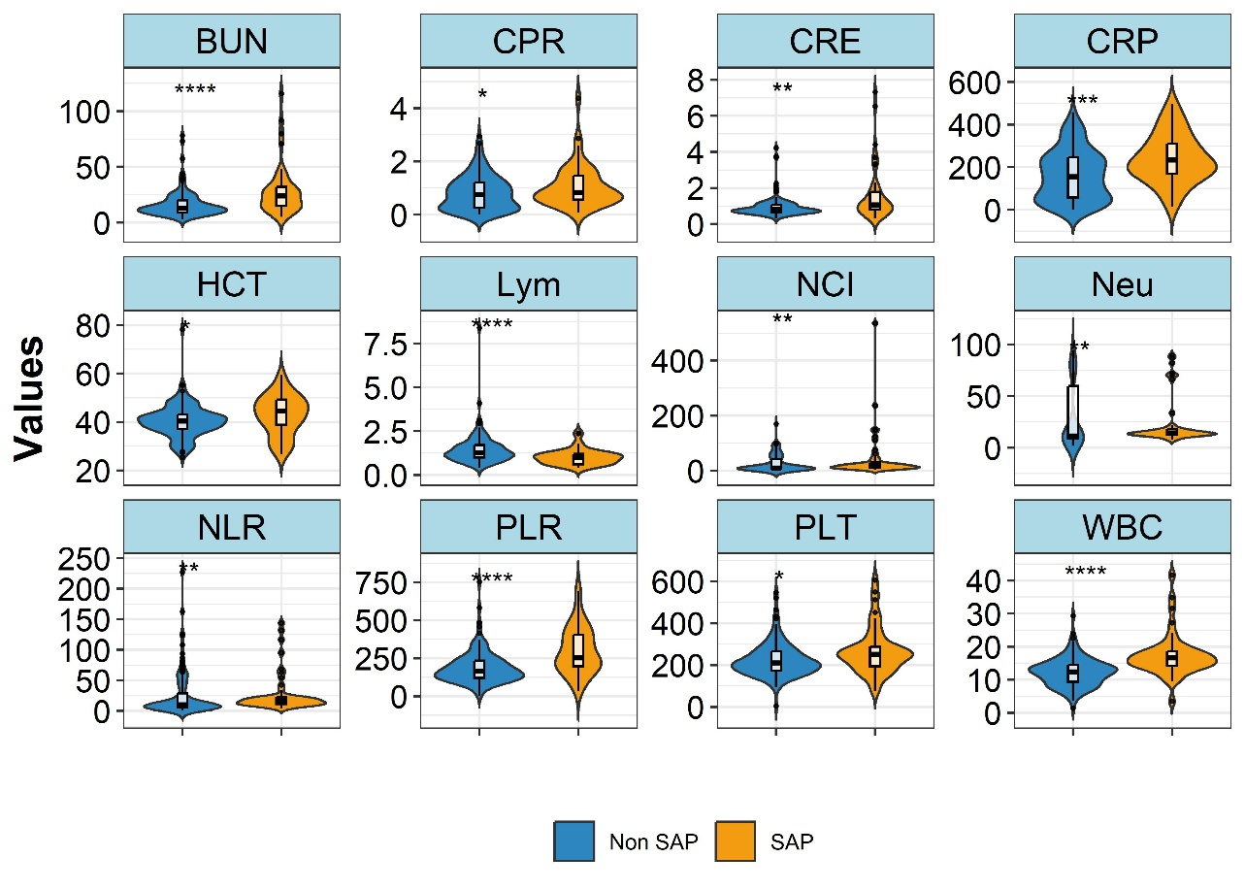
Figure 1. Distribution of clinical features in training dataset (N = 182)
There is a distinct and statistically significant difference between the SAP (Severe Acute Pancreatitis) and Non-SAP groups across several markers. Notably, BUN (Blood Urea Nitrogen), WBC (White Blood Cells), and CRP (C-Reactive Protein) exhibit markedly higher levels in the SAP group compared to the Non-SAP group, with significance levels reaching p < 0.001 for BUN and WBC, and p < 0.01 for CRP. This clear stratification suggests that these three biomarkers are strong individual candidates for distinguishing disease severity.
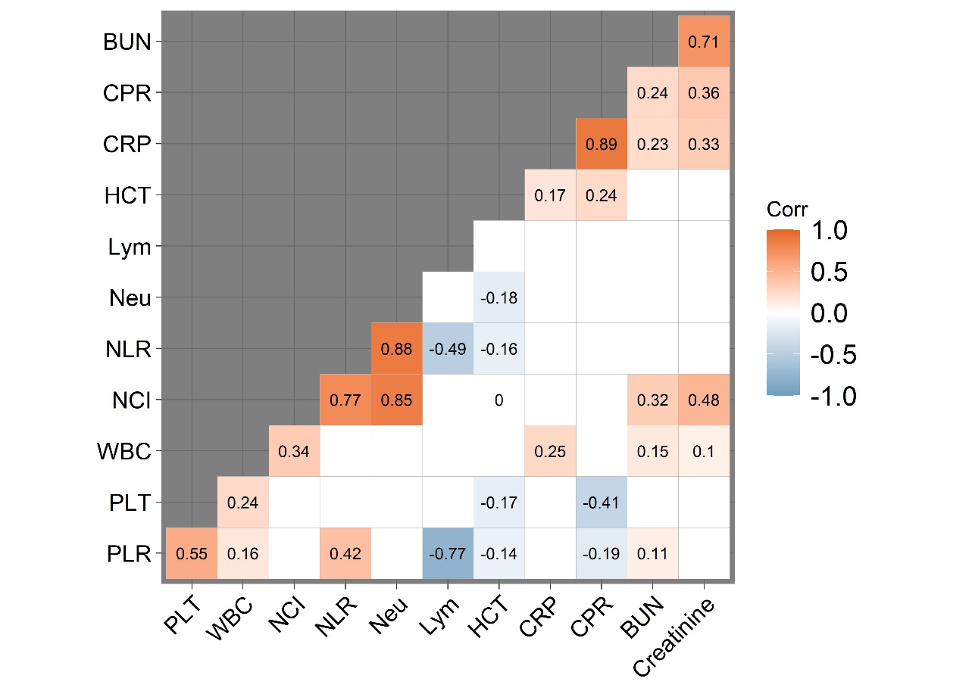
Figure 2. Heatmap for correlation matrix of clinical features in training dataset (N = 182)
The correlation heatmap in Figure 2 provides critical insight into the relationship between these variables. The inter-correlations among the three selected predictors as BUN, WBC, and CRP are relatively low (BUN vs WBC is 0.15; WBC vs CRP is 0.25). This lack of strong multicollinearity is a favorable statistical property, indicating that each variable contributes unique information, thereby justifying their combination into a multivariate predictive model.
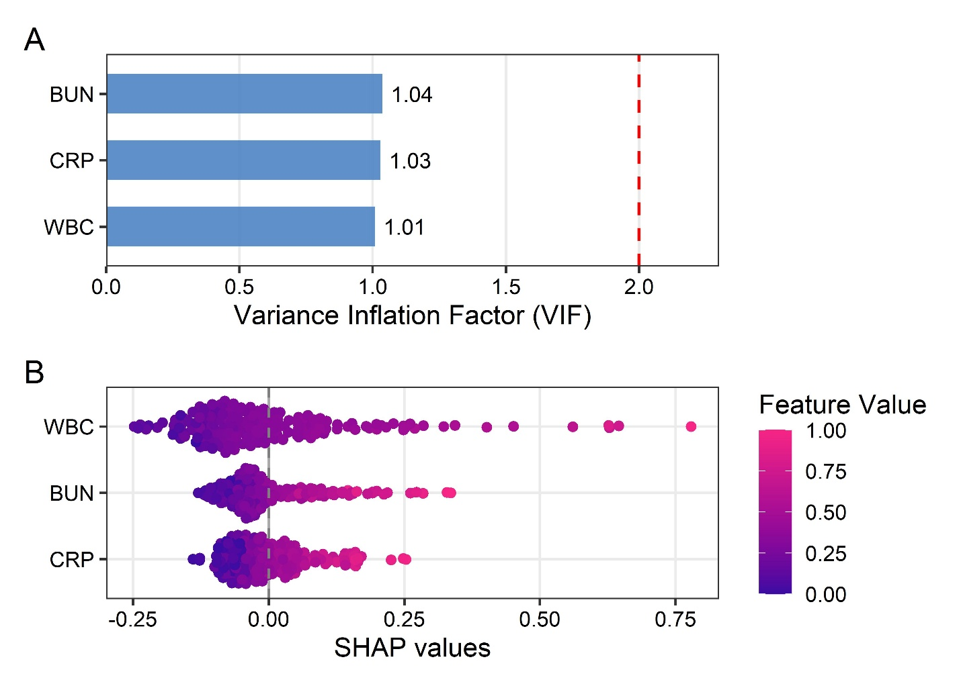
Figure 3. VIF and SHAP value analysis in training dataset
Multicollinearity among the predictors was assessed using the Variance Inflation Factor (VIF). Figue 3A showed that all selected variables (BUN, WBC, CRP) had VIF values less than 2. This is well below the conservative threshold of 2.5 that there is no significant multicollinearity affecting the model's stability. The SHAP summary plot (Figure 3B) reveals a clear directional relationship consistent with clinical pathophysiology. Specifically, high values (pink dots) of BUN, WBC, and CRP are strongly associated with positive SHAP values, indicating an increased probability of SAP. The distinct separation between high and low feature values confirms the model's robustness in distinguishing risk levels.
https://pmc.ncbi.nlm.nih.gov/articles/PMC5993839/
(https://christophm.github.io/interpretable-ml-book/shap.html)

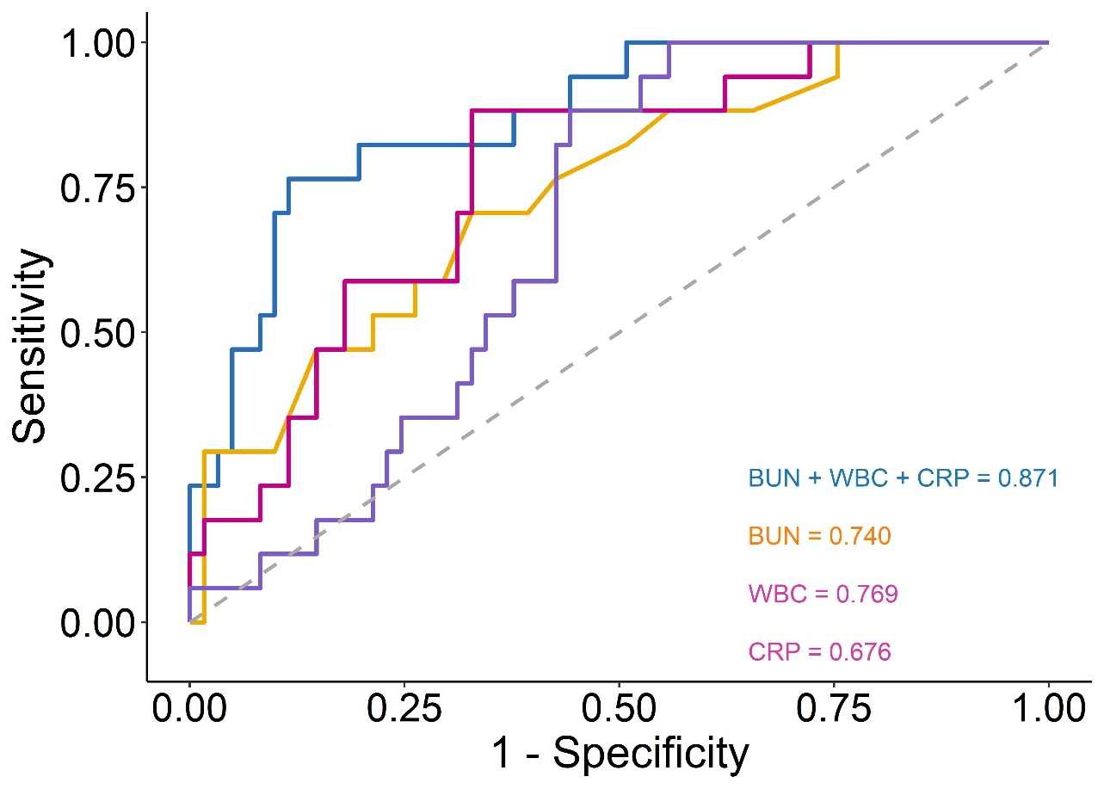
Figure 4. ROC curves between combined model, BUN alone, WBC alone and CRP alone model in testing dataset.
The synergistic value of combining these markers is demonstrated in Figure 4 and quantified in Table 3. The Receiver Operating Characteristic (ROC) analysis reveals that the combined model (BUN + WBC + CRP) significantly outperforms any single biomarker used in isolation. The combined model achieved an Area Under the Curve (AUC) of 0.871 (95% CI: 0.781 – 0.961), which is considerably higher than WBC (0.769), BUN (0.740), or CRP (0.676) alone.
The performance metrics in Table 3 further validate this superiority; the combined model offers the highest overall accuracy (0.859) and a balanced profile of sensitivity (0.823) and specificity (0.868). This indicates that while individual markers like CRP have high sensitivity (0.912) but poor specificity (0.524), integrating them with BUN and WBC creates a robust tool that minimizes false positives while maintaining high detection rates. The combined model gives a higher AUC and statistically significant value than the BUN model (p = 0.048), compared to the WBC model (p = 0.006), and compared to the CRP model (p = 0.002).

Table 3. Metrics of performance of models in testing dataset
 | Combined | BUN | WBC | CRP
AUC | 0.871 (0.781 – 0.961) | 0.74 (0.608 – 0.871) | 0.769 (0.650 – 0.887) | 0.676 (0.557 – 0.794)
Accuracy | 0.859 (0.641 – 0.935) | 0.717 (0.448 – 0.871) | 0.731 (0.628 – 0.859) | 0.615 (0.5 – 0.731)
Sensitivity | 0.823 (0.647 – 1) | 0.764 (0.352 – 1) | 0.882 (0.647 – 1) | 0.912 (0.882 – 1)
Specificity | 0.868 (0.541 – 0.967) | 0.704 (0.295 – 1) | 0.689 (0.557 – 0.868) | 0.524 (0.361 – 0.672)
PPV | 0.636 (0.378 – 0.842) | 0.413 (0.278 – 1) | 0.441 (0.349 – 0.625) | 0.362 (0.303 – 0.444)
NPV | 0.948 (0.896 – 1) | 0.912 (0.845 – 1) | 0.953 (0.885 – 1) | 0.954 (0.933 – 1)
LR⁺ | 6.234 | 2.581 | 2.836 | 1.916
LR⁻ | 0.203 | 0.335 | 0.171 | 0.168
Data show as value (95%CIs – Confidence Intervals),p₁ and p₂ was respectively p -value for NCI + HCT vs NCI and NCI + HCT vs HCT (Using Delong’s test), AUC: Area under the curve, NPV: Negative Predictive Value, PPV: Positive Predictive Value, +LR: Postive likelihood ratio, -LR: Negative likelihood ration
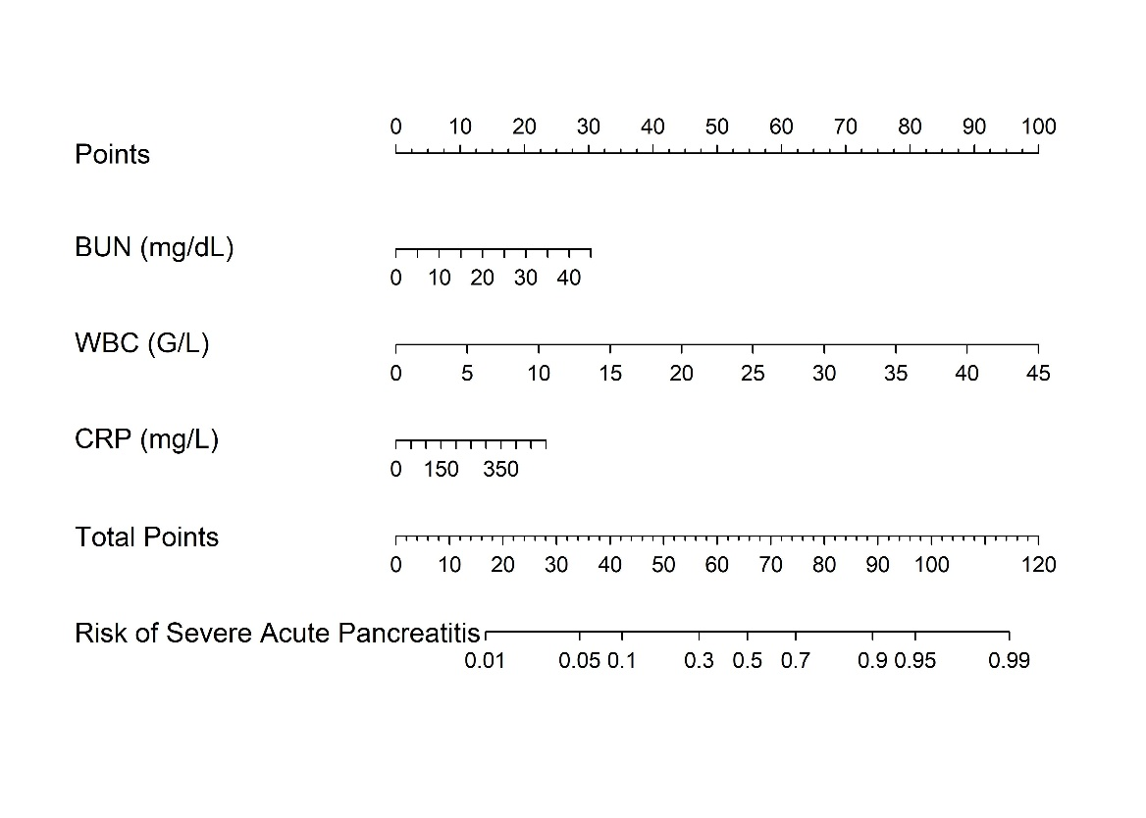
Figure 5. Nomogram of combined model
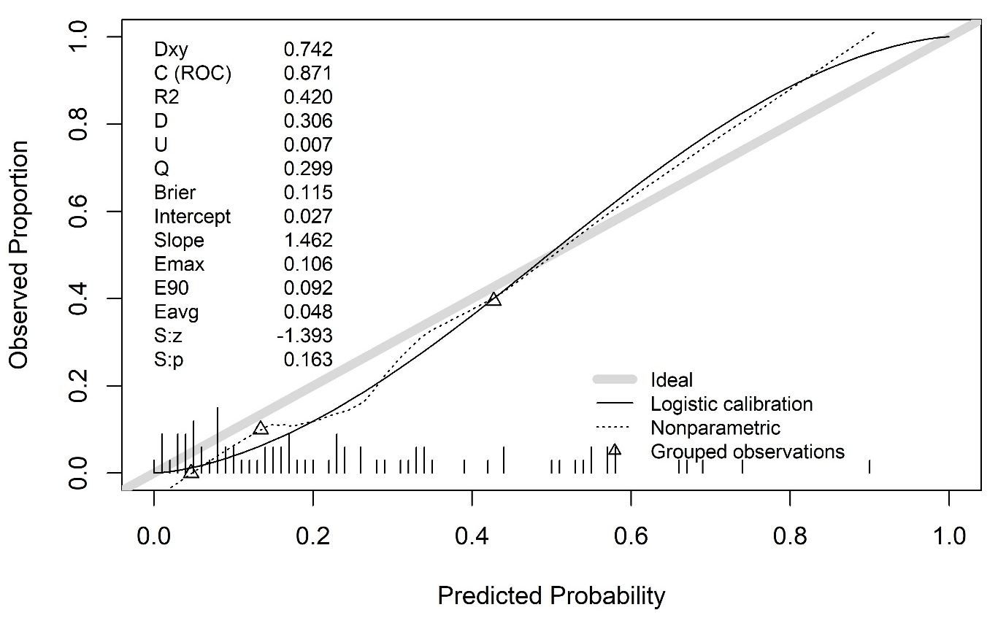
To facilitate clinical application, the multivariate logistic model was translated into a Nomogram (Figure 5), allowing practitioners to calculate the specific probability of SAP progression by assigning points to the values of BUN, WBC, and CRP. In terms of comparative validation.
Figure 6. Calibration of nomogram in testing dataset
The Brier score was 0.115, indicating a low mean squared error between the predicted probabilities and the observed outcomes, which reflects the model's high overall probabilistic accuracy. Furthermore, Spiegelhalter’s test (p = 0.163), this non-significant result confirms that there is no statistically significant deviation between the predicted probabilities and the actual observed frequencies, suggesting that the nomogram is well-calibrated and reliable for clinical application.

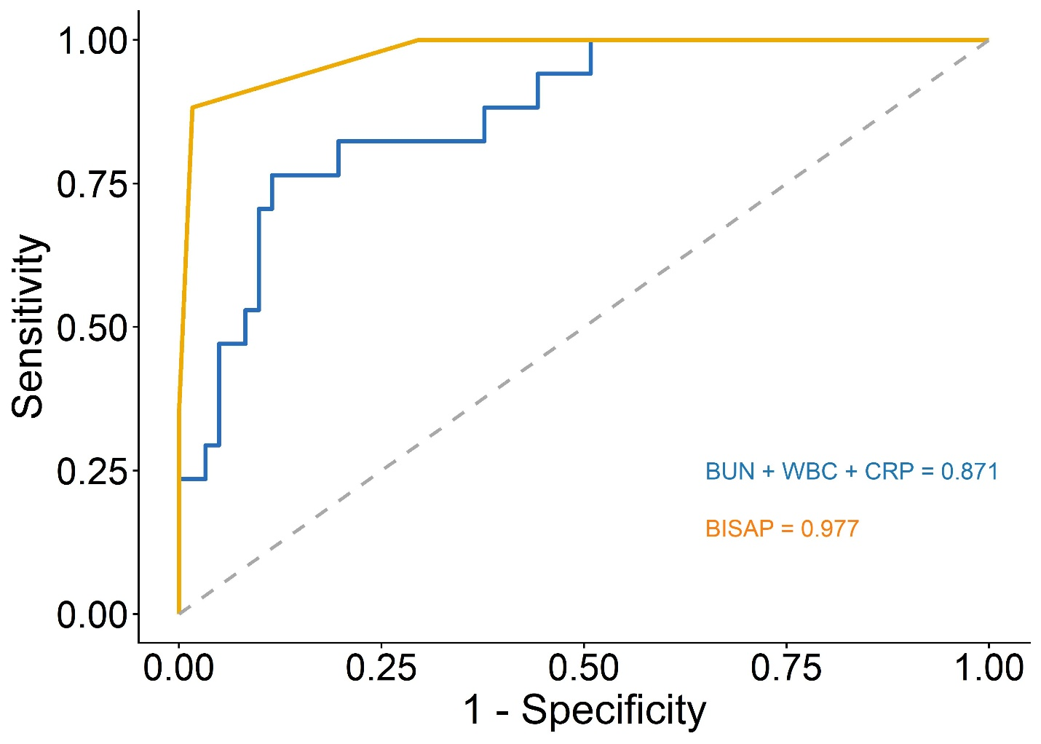
Figure 7. ROC curves between NCI+ HCT model and BISAP model in testing dataset
Figure 7 benchmarks the experimental model against the established BISAP score. While the BISAP score demonstrates exceptional predictive ability (AUC = 0.977), the proposed combined model still maintains strong diagnostic accuracy (AUC = 0.871), serving as a viable alternative or complementary assessment tool. The BISAP model gives a higher AUC and statistically significant value than the combined model (p = 0.017).
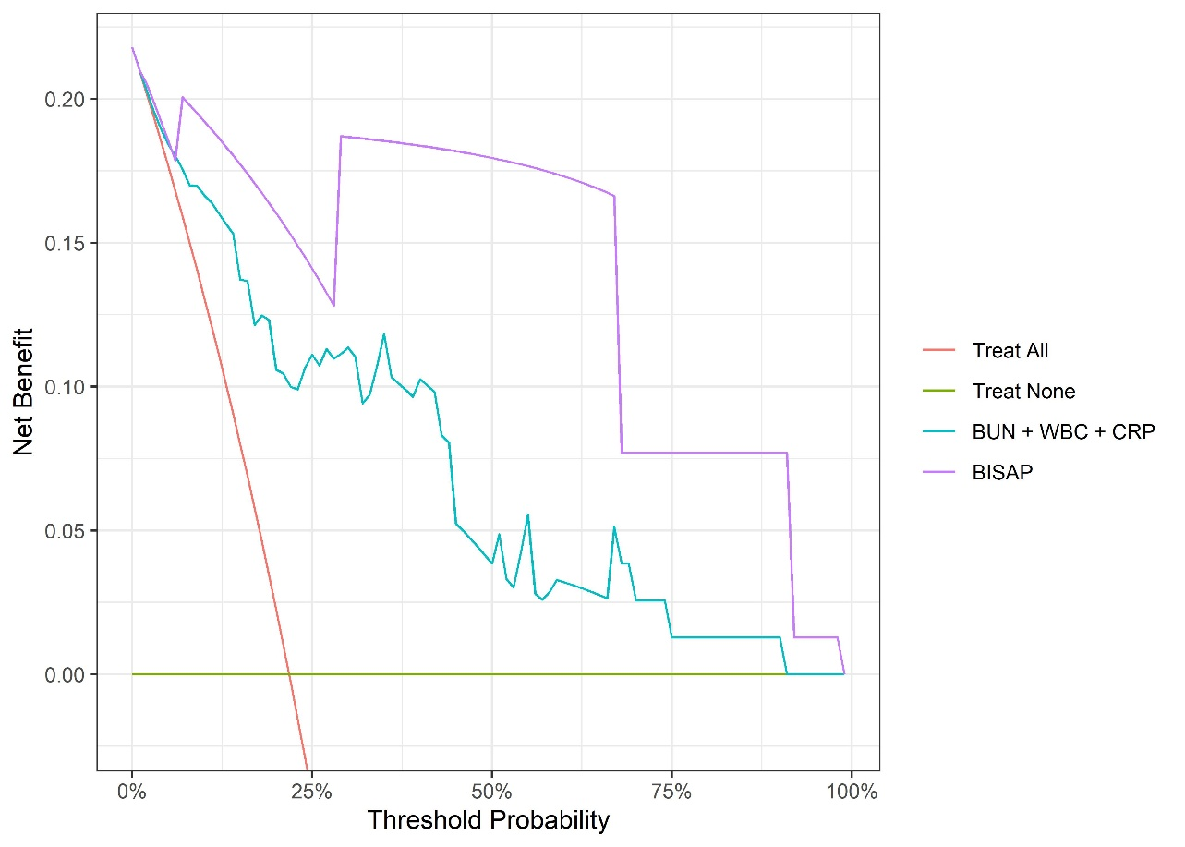
Figure 8. Decision curves between BUN + WBC + CRP model and BISAP model in testing dataset
Figure 8 illustrates the net benefit of the models. The combined model (blue line) demonstrates a positive net benefit across a wide range of threshold probabilities compared to the "treat-none" or "treat-all" strategies, confirming its clinical utility in decision-making processes for managing acute pancreatitis patients.

