MASLD
[1] "ma_ho_so" "ho_ten"
[3] "nam_sinh" "gioi"
[5] "gmn" "can_kg"
[7] "cao_cm" "bmi"
[9] "vong_eo_90_m_80_f" "glucose_100_mg_dl"
[11] "hba1c_5_7_percent" "dtd2"
[13] "ha_130_85" "tha"
[15] "triglyceride_150_5mg_dl" "thuoc_lipid"
[17] "hdl_40_m_50_f" "ggt"
[19] "cap" "fibro"
[21] "mash" "ruou"
[23] "ty_g_wc_index" "fli_index"

Chuẩn bị dữ liệu

Violin plots
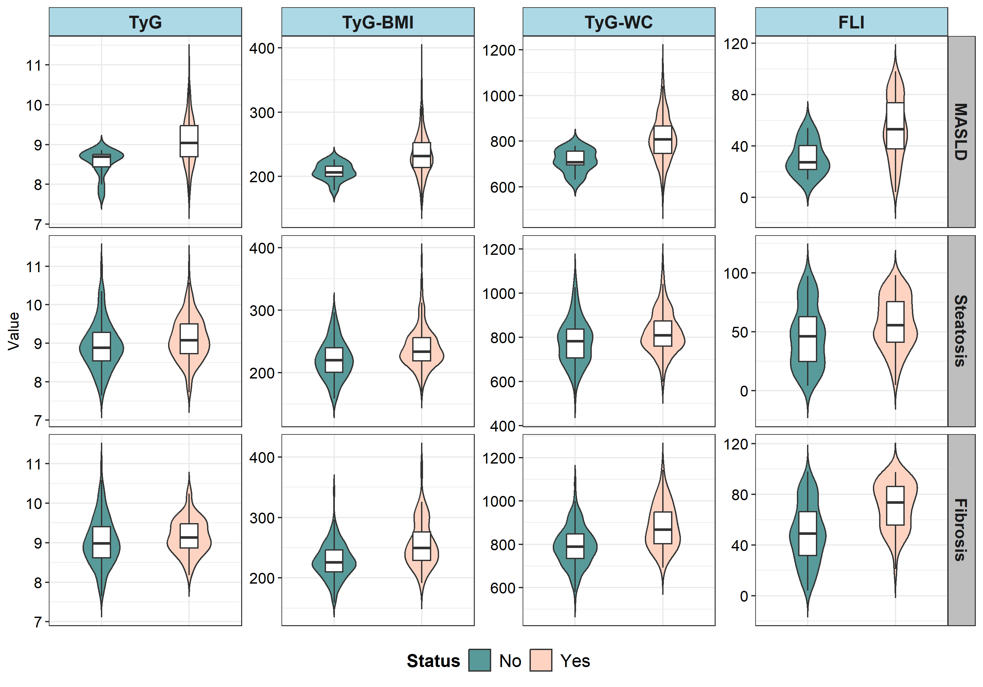

Mục tiêu 1
Characteristic | Overall N = 303¹ | No N = 14¹ | Yes N = 289¹ | p-value²
Age | 42 (34, 49) | 37 (33, 47) | 42 (34, 49) | 0.2
Sex | 208 (69%) | 13 (93%) | 195 (67%) | 0.072
BMI (kg/m2) | 25.46 (23.62, 27.22) | 24.23 (23.46, 25.59) | 25.61 (23.63, 27.34) | 0.030
Waistline | 89 (83, 94) | 83 (80, 87) | 90 (84, 94) | 0.002
Hypertension | 33 (11%) | 0 (0%) | 33 (11%) | 0.4
Diabetes | 24 (7.9%) | 0 (0%) | 24 (8.3%) | 0.6
Blood Pressure (≥130/85 mmHg) | 27 (8.9%) | 0 (0%) | 27 (9.3%) | 0.6
Glucose | 95 (88, 103) | 90 (85, 94) | 96 (88, 104) | 0.019
HbA1c | 5.62 (5.35, 5.90) | 5.39 (5.00, 5.50) | 5.63 (5.38, 5.90) | 0.001
Triglyceride | 168 (122, 242) | 131 (105, 139) | 173 (122, 249) | 0.001
HDL-C | 47 (41, 53) | 52 (45, 54) | 47 (41, 53) | 0.061
Lipid medicine | 27 (8.9%) | 0 (0%) | 27 (9.3%) | 0.6
Alcohol
0 | 303 (100%) | 14 (100%) | 289 (100%)
GGT | 42 (29, 65) | 32 (28, 43) | 43 (29, 67) | 0.11
cap | 282 (262, 316) | 266 (255, 279) | 282 (262, 316) | 0.090
fibro | 6.30 (5.40, 7.30) | 5.45 (5.00, 6.90) | 6.30 (5.40, 7.40) | 0.079
TyG-WC | 799 (742, 865) | 707 (695, 757) | 807 (746, 867) | <0.001
FLI | 51 (36, 73) | 27 (20, 41) | 53 (38, 74) | <0.001
TyG | 9.01 (8.67, 9.45) | 8.69 (8.38, 8.76) | 9.04 (8.69, 9.47) | <0.001
TyG_BMI | 229 (213, 252) | 206 (200, 216) | 232 (214, 253) | <0.001
¹Median (Q1, Q3); n (%)
²Wilcoxon rank sum test; Fisher's exact test; NA
Characteristic | Overall N = 303¹ | S1 N = 107¹ | S2 N = 81¹ | S3 N = 115¹ | p-value²
Age | 42 (34, 49) | 42 (35, 49) | 41 (34, 50) | 41 (33, 48) | 0.7
Sex | 208 (69%) | 76 (71%) | 56 (69%) | 76 (66%) | 0.7
BMI (kg/m2) | 25.46 (23.62, 27.22) | 25.04 (22.89, 26.26) | 25.63 (24.17, 26.93) | 26.37 (23.88, 28.39) | <0.001
Waistline | 89 (83, 94) | 88 (82, 92) | 88 (84, 94) | 91 (85, 96) | 0.002
Hypertension | 33 (11%) | 7 (6.5%) | 8 (9.9%) | 18 (16%) | 0.088
Diabetes | 24 (7.9%) | 4 (3.7%) | 8 (9.9%) | 12 (10%) | 0.14
Blood Pressure (≥130/85 mmHg) | 27 (8.9%) | 5 (4.7%) | 7 (8.6%) | 15 (13%) | 0.091
Glucose | 95 (88, 103) | 94 (88, 101) | 94 (88, 103) | 96 (88, 105) | 0.2
HbA1c | 5.62 (5.35, 5.90) | 5.56 (5.30, 5.82) | 5.61 (5.38, 5.82) | 5.70 (5.41, 6.08) | 0.014
Triglyceride | 168 (122, 242) | 157 (108, 231) | 161 (113, 233) | 190 (135, 270) | 0.004
HDL-C | 47 (41, 53) | 47 (41, 56) | 48 (44, 53) | 45 (40, 51) | 0.005
Lipid medicine | 27 (8.9%) | 3 (2.8%) | 11 (14%) | 13 (11%) | 0.019
Alcohol
0 | 303 (100%) | 107 (100%) | 81 (100%) | 115 (100%)
GGT | 42 (29, 65) | 36 (25, 69) | 43 (27, 62) | 47 (35, 68) | 0.021
cap | 282 (262, 316) | 256 (249, 263) | 279 (274, 287) | 321 (311, 333) | <0.001
fibro | 6.30 (5.40, 7.30) | 5.90 (5.10, 6.70) | 6.20 (5.40, 7.00) | 6.90 (5.80, 8.60) | <0.001
TyG-WC | 799 (742, 865) | 782 (706, 838) | 794 (744, 843) | 822 (769, 917) | <0.001
FLI | 51 (36, 73) | 46 (25, 63) | 50 (41, 66) | 61 (41, 81) | <0.001
TyG | 9.01 (8.67, 9.45) | 8.88 (8.54, 9.28) | 8.87 (8.67, 9.32) | 9.14 (8.84, 9.60) | <0.001
TyG_BMI | 229 (213, 252) | 220 (200, 240) | 231 (217, 245) | 240 (220, 263) | <0.001
¹Median (Q1, Q3); n (%)
²Kruskal-Wallis rank sum test; Pearson's Chi-squared test; NA
Characteristic | Overall N = 303¹ | F0-F1 N = 252¹ | F2 N = 49¹ | F3 N = 2¹ | p-value²
Age | 42 (34, 49) | 42 (35, 49) | 43 (33, 51) | 27 (20, 34) | 0.2
Sex | 208 (69%) | 165 (65%) | 41 (84%) | 2 (100%) | 0.017
BMI (kg/m2) | 25.46 (23.62, 27.22) | 25.21 (23.38, 26.91) | 26.89 (25.39, 30.00) | 31.14 (30.93, 31.35) | <0.001
Waistline | 89 (83, 94) | 87 (83, 93) | 93 (91, 101) | 108 (107, 108) | <0.001
Hypertension | 33 (11%) | 27 (11%) | 5 (10%) | 1 (50%) | 0.3
Diabetes | 24 (7.9%) | 20 (7.9%) | 4 (8.2%) | 0 (0%) | >0.9
Blood Pressure (≥130/85 mmHg) | 27 (8.9%) | 19 (7.5%) | 7 (14%) | 1 (50%) | 0.054
Glucose | 95 (88, 103) | 94 (88, 101) | 99 (88, 110) | 109 (83, 135) | 0.13
HbA1c | 5.62 (5.35, 5.90) | 5.60 (5.30, 5.86) | 5.75 (5.52, 6.13) | 5.81 (5.64, 5.98) | 0.009
Triglyceride | 168 (122, 242) | 165 (114, 244) | 174 (142, 217) | 276 (197, 355) | 0.3
HDL-C | 47 (41, 53) | 47 (41, 53) | 48 (43, 54) | 37 (33, 41) | 0.2
Lipid medicine | 27 (8.9%) | 22 (8.7%) | 5 (10%) | 0 (0%) | 0.8
Alcohol
0 | 303 (100%) | 252 (100%) | 49 (100%) | 2 (100%)
GGT | 42 (29, 65) | 39 (27, 63) | 55 (42, 76) | 84 (27, 141) | 0.002
cap | 282 (262, 316) | 278 (260, 308) | 312 (275, 330) | 327 (316, 337) | <0.001
fibro | 6.30 (5.40, 7.30) | 6.00 (5.20, 6.80) | 9.50 (8.60, 10.30) | 13.95 (13.00, 14.90) | <0.001
TyG-WC | 799 (742, 865) | 789 (734, 848) | 865 (798, 933) | 1,026 (1,025, 1,027) | <0.001
FLI | 51 (36, 73) | 49 (32, 66) | 71 (54, 86) | 91 (85, 97) | <0.001
TyG | 9.01 (8.67, 9.45) | 8.98 (8.62, 9.42) | 9.11 (8.86, 9.46) | 9.55 (9.50, 9.60) | 0.10
TyG_BMI | 229 (213, 252) | 226 (210, 246) | 248 (228, 275) | 297 (297, 298) | <0.001
¹Median (Q1, Q3); n (%)
²Kruskal-Wallis rank sum test; Fisher's exact test; NA

Mục tiêu 2
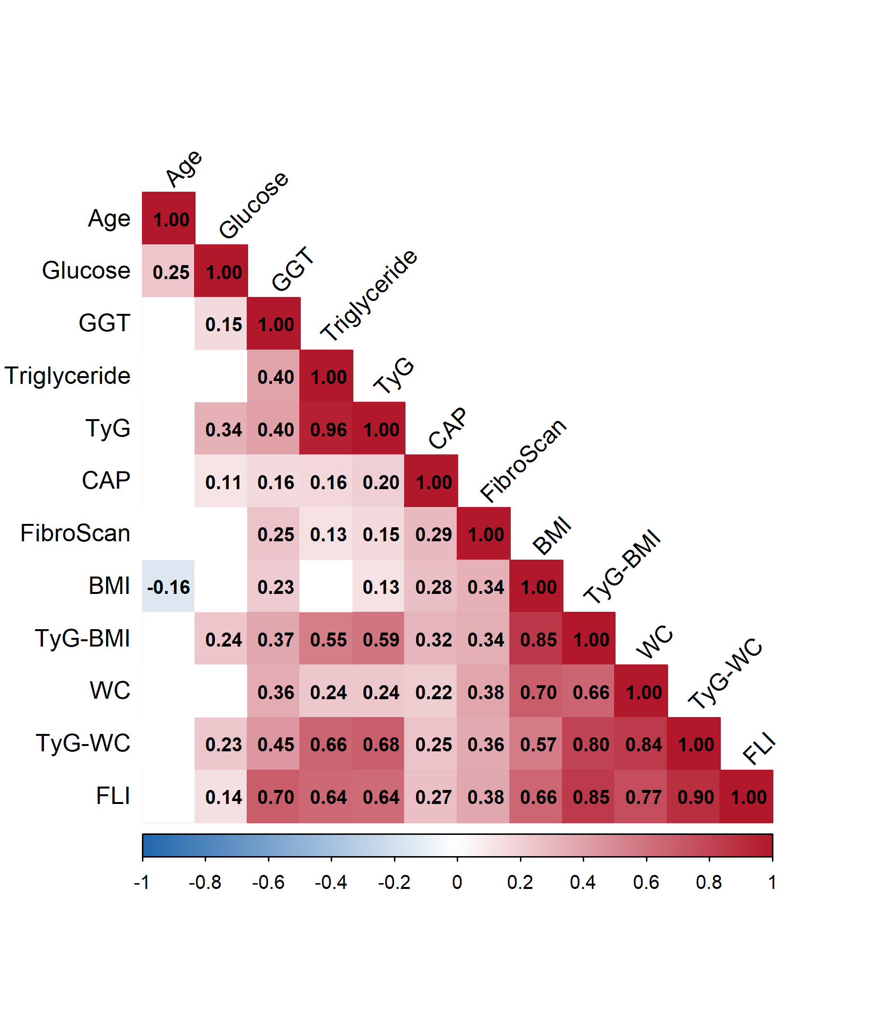

Odd Ratios by multivariate models
 | Model 1 |  |  | Model 2 |  |  | Model 3
Characteristic | exp(Beta) | 95% CI | p-value | exp(Beta) | 95% CI | p-value | exp(Beta) | 95% CI | p-value
ty_g_wc_index | 1.01 | 1.01, 1.02 | <0.001 | 1.02 | 1.01, 1.03 | <0.001 | 1.02 | 1.01, 1.03 | <0.001
TyG_WC_Q
Q1 | — | — |  | — | — |  | — | —
Q2 | 1.83 | 0.62, 5.89 | 0.3 | 3.30 | 1.05, 11.3 | 0.040 | 2.83 | 0.86, 9.97 | 0.086
Q3 | 21.3 | 2.61, 2,759 | 0.001 | 46.3 | 5.44, 6,061 | <0.001 | 43.4 | 4.98, 5,716 | <0.001
Q4 | 21.3 | 2.61, 2,759 | 0.001 | 50.3 | 5.92, 6,589 | <0.001 | 27.5 | 3.03, 3,646 | 0.001
Abbreviation: CI = Confidence Interval
 | Model 1 |  |  | Model 2 |  |  | Model 3
Characteristic | exp(Beta) | 95% CI | p-value | exp(Beta) | 95% CI | p-value | exp(Beta) | 95% CI | p-value
TyG_BMI | 1.03 | 1.01, 1.06 | 0.001 | 1.04 | 1.02, 1.07 | <0.001 | 1.04 | 1.01, 1.07 | 0.001
TyG_BMI_Q
Q1 | — | — |  | — | — |  | — | —
Q2 | 1.35 | 0.46, 4.11 | 0.6 | 1.88 | 0.62, 6.00 | 0.3 | 1.57 | 0.51, 5.11 | 0.4
Q3 | 18.7 | 2.26, 2,439 | 0.003 | 26.7 | 3.12, 3,500 | <0.001 | 22.3 | 2.58, 2,926 | 0.002
Q4 | 18.7 | 2.26, 2,439 | 0.003 | 32.0 | 3.69, 4,207 | <0.001 | 17.8 | 1.95, 2,369 | 0.006
Abbreviation: CI = Confidence Interval
 | Model 1 |  |  | Model 2 |  |  | Model 3
Characteristic | exp(Beta) | 95% CI | p-value | exp(Beta) | 95% CI | p-value | exp(Beta) | 95% CI | p-value
TyG | 5.53 | 1.97, 17.2 | <0.001 | 10.5 | 3.18, 41.9 | <0.001 | 8.89 | 2.41, 38.8 | <0.001
TyG_Q
Q1 | — | — |  | — | — |  | — | —
Q2 | 0.74 | 0.24, 2.17 | 0.6 | 1.07 | 0.33, 3.26 | >0.9 | 1.12 | 0.33, 3.62 | 0.9
Q3 | 13.9 | 1.60, 1,828 | 0.012 | 21.4 | 2.37, 2,827 | 0.003 | 18.3 | 1.94, 2,446 | 0.007
Q4 | 13.9 | 1.60, 1,828 | 0.012 | 21.0 | 2.34, 2,774 | 0.003 | 12.2 | 1.26, 1,634 | 0.027
Abbreviation: CI = Confidence Interval
 | Model 1 |  |  | Model 2 |  |  | Model 3
Characteristic | exp(Beta) | 95% CI | p-value | exp(Beta) | 95% CI | p-value | exp(Beta) | 95% CI | p-value
fli_index | 1.05 | 1.02, 1.08 | <0.001 | 1.07 | 1.04, 1.11 | <0.001 | 1.08 | 1.05, 1.13 | <0.001
FLI_Q
Q1 | — | — |  | — | — |  | — | —
Q2 | 2.96 | 0.89, 12.2 | 0.077 | 5.48 | 1.56, 23.8 | 0.007 | 5.87 | 1.66, 25.6 | 0.005
Q3 | 4.14 | 1.12, 22.2 | 0.032 | 8.35 | 2.13, 46.6 | 0.002 | 9.69 | 2.04, 55.3 | 0.004
Q4 | 21.3 | 2.61, 2,759 | 0.001 | 54.6 | 6.38, 7,169 | <0.001 | 59.1 | 3.92, 21,818 | 0.001
Abbreviation: CI = Confidence Interval
 | Model 1 |  |  | Model 2 |  |  | Model 3
Characteristic | exp(Beta) | 95% CI | p-value | exp(Beta) | 95% CI | p-value | exp(Beta) | 95% CI | p-value
ty_g_wc_index | 1.00 | 1.00, 1.01 | <0.001 | 1.01 | 1.00, 1.01 | <0.001 | 1.01 | 1.00, 1.01 | <0.001
TyG_WC_Q
Q1 | — | — |  | — | — |  | — | —
Q2 | 3.22 | 1.66, 6.42 | <0.001 | 4.08 | 2.02, 8.54 | <0.001 | 4.13 | 2.03, 8.71 | <0.001
Q3 | 2.18 | 1.15, 4.22 | 0.017 | 3.14 | 1.54, 6.63 | 0.002 | 3.28 | 1.59, 6.96 | 0.001
Q4 | 3.39 | 1.73, 6.81 | <0.001 | 4.92 | 2.33, 10.8 | <0.001 | 4.72 | 2.17, 10.7 | <0.001
Abbreviation: CI = Confidence Interval
 | Model 1 |  |  | Model 2 |  |  | Model 3
Characteristic | exp(Beta) | 95% CI | p-value | exp(Beta) | 95% CI | p-value | exp(Beta) | 95% CI | p-value
TyG_BMI | 1.02 | 1.01, 1.03 | <0.001 | 1.02 | 1.01, 1.03 | <0.001 | 1.02 | 1.01, 1.03 | <0.001
TyG_BMI_Q
Q1 | — | — |  | — | — |  | — | —
Q2 | 2.49 | 1.30, 4.83 | 0.006 | 2.66 | 1.38, 5.22 | 0.003 | 2.55 | 1.31, 5.07 | 0.006
Q3 | 2.75 | 1.43, 5.40 | 0.002 | 2.90 | 1.50, 5.74 | 0.001 | 2.88 | 1.48, 5.71 | 0.002
Q4 | 4.44 | 2.23, 9.19 | <0.001 | 4.79 | 2.36, 10.1 | <0.001 | 4.50 | 2.17, 9.66 | <0.001
Abbreviation: CI = Confidence Interval
 | Model 1 |  |  | Model 2 |  |  | Model 3
Characteristic | exp(Beta) | 95% CI | p-value | exp(Beta) | 95% CI | p-value | exp(Beta) | 95% CI | p-value
TyG | 1.67 | 1.11, 2.55 | 0.013 | 1.82 | 1.19, 2.84 | 0.006 | 1.76 | 1.14, 2.80 | 0.011
TyG_Q
Q1 | — | — |  | — | — |  | — | —
Q2 | 1.38 | 0.73, 2.63 | 0.3 | 1.57 | 0.81, 3.06 | 0.2 | 1.68 | 0.86, 3.32 | 0.13
Q3 | 1.80 | 0.94, 3.50 | 0.078 | 2.09 | 1.06, 4.20 | 0.034 | 2.18 | 1.09, 4.45 | 0.027
Q4 | 2.66 | 1.35, 5.38 | 0.005 | 3.00 | 1.49, 6.23 | 0.002 | 2.88 | 1.40, 6.07 | 0.004
Abbreviation: CI = Confidence Interval
 | Model 1 |  |  | Model 2 |  |  | Model 3
Characteristic | exp(Beta) | 95% CI | p-value | exp(Beta) | 95% CI | p-value | exp(Beta) | 95% CI | p-value
fli_index | 1.02 | 1.01, 1.03 | <0.001 | 1.03 | 1.01, 1.04 | <0.001 | 1.03 | 1.02, 1.04 | <0.001
FLI_Q
Q1 | — | — |  | — | — |  | — | —
Q2 | 2.64 | 1.38, 5.15 | 0.003 | 3.47 | 1.73, 7.20 | <0.001 | 3.76 | 1.86, 7.89 | <0.001
Q3 | 3.57 | 1.82, 7.18 | <0.001 | 4.79 | 2.32, 10.3 | <0.001 | 5.17 | 2.47, 11.3 | <0.001
Q4 | 3.12 | 1.61, 6.19 | <0.001 | 4.52 | 2.16, 9.82 | <0.001 | 5.01 | 2.20, 12.0 | <0.001
Abbreviation: CI = Confidence Interval
 | Model 1 |  |  | Model 2 |  |  | Model 3
Characteristic | exp(Beta) | 95% CI | p-value | exp(Beta) | 95% CI | p-value | exp(Beta) | 95% CI | p-value
ty_g_wc_index | 1.01 | 1.01, 1.01 | <0.001 | 1.01 | 1.01, 1.01 | <0.001 | 1.01 | 1.01, 1.01 | <0.001
TyG_WC_Q
Q1 | — | — |  | — | — |  | — | —
Q2 | 3.32 | 1.03, 13.6 | 0.045 | 2.97 | 0.90, 12.4 | 0.075 | 2.88 | 0.87, 12.0 | 0.085
Q3 | 4.13 | 1.32, 16.7 | 0.014 | 3.48 | 1.05, 14.6 | 0.040 | 3.32 | 1.01, 13.9 | 0.049
Q4 | 11.2 | 3.91, 43.6 | <0.001 | 9.20 | 3.02, 37.1 | <0.001 | 8.25 | 2.64, 33.8 | <0.001
Abbreviation: CI = Confidence Interval
 | Model 1 |  |  | Model 2 |  |  | Model 3
Characteristic | exp(Beta) | 95% CI | p-value | exp(Beta) | 95% CI | p-value | exp(Beta) | 95% CI | p-value
TyG_BMI | 1.03 | 1.02, 1.04 | <0.001 | 1.03 | 1.02, 1.04 | <0.001 | 1.02 | 1.01, 1.04 | <0.001
TyG_BMI_Q
Q1 | — | — |  | — | — |  | — | —
Q2 | 3.32 | 1.03, 13.6 | 0.045 | 2.96 | 0.91, 12.2 | 0.073 | 2.72 | 0.82, 11.3 | 0.10
Q3 | 4.95 | 1.62, 19.8 | 0.004 | 4.57 | 1.48, 18.3 | 0.007 | 4.37 | 1.42, 17.5 | 0.009
Q4 | 9.99 | 3.46, 38.8 | <0.001 | 8.92 | 3.04, 35.0 | <0.001 | 8.00 | 2.66, 31.8 | <0.001
Abbreviation: CI = Confidence Interval
 | Model 1 |  |  | Model 2 |  |  | Model 3
Characteristic | exp(Beta) | 95% CI | p-value | exp(Beta) | 95% CI | p-value | exp(Beta) | 95% CI | p-value
TyG | 1.43 | 0.87, 2.35 | 0.2 | 1.27 | 0.75, 2.14 | 0.4 | 1.11 | 0.63, 1.91 | 0.7
TyG_Q
Q1 | — | — |  | — | — |  | — | —
Q2 | 2.73 | 1.07, 7.77 | 0.036 | 2.27 | 0.87, 6.54 | 0.10 | 2.24 | 0.85, 6.48 | 0.10
Q3 | 2.78 | 1.08, 7.90 | 0.033 | 2.22 | 0.84, 6.46 | 0.11 | 1.97 | 0.74, 5.78 | 0.2
Q4 | 2.78 | 1.08, 7.90 | 0.033 | 2.28 | 0.87, 6.58 | 0.095 | 1.87 | 0.69, 5.50 | 0.2
Abbreviation: CI = Confidence Interval
 | Model 1 |  |  | Model 2 |  |  | Model 3
Characteristic | exp(Beta) | 95% CI | p-value | exp(Beta) | 95% CI | p-value | exp(Beta) | 95% CI | p-value
fli_index | 1.04 | 1.03, 1.06 | <0.001 | 1.04 | 1.03, 1.06 | <0.001 | 1.04 | 1.03, 1.06 | <0.001
FLI_Q
Q1 | — | — |  | — | — |  | — | —
Q2 | 6.25 | 1.35, 59.7 | 0.016 | 5.65 | 1.20, 54.6 | 0.027 | 5.58 | 1.18, 53.9 | 0.028
Q3 | 14.0 | 3.34, 129 | <0.001 | 12.4 | 2.90, 116 | <0.001 | 12.1 | 2.82, 114 | <0.001
Q4 | 26.9 | 6.69, 246 | <0.001 | 22.9 | 5.41, 215 | <0.001 | 21.7 | 4.88, 207 | <0.001
Abbreviation: CI = Confidence Interval

Mục tiêu 3
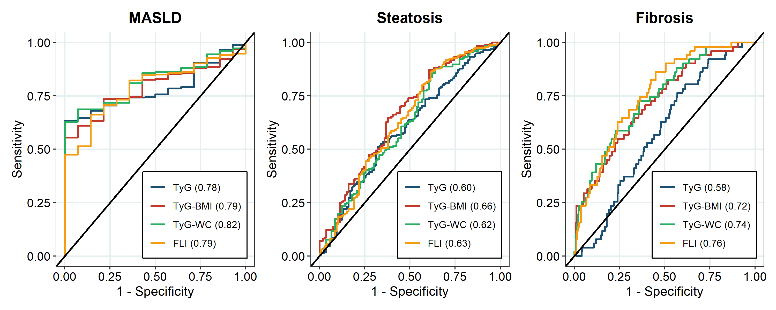
Table 5: Diagnostic performance of non-invasive indices for 3 outcomes
Outcome | Index | AUROC | 95% CI | Cutoff Value | SEN (%) | SPE (%) | PPV (%) | NPV (%) | p Value
MASLD | TyG index | 0.78 | 0.71-0.85 | 8.86 | 63.2 | 100.0 | 100.0 | 11.7 | 0.889
MASLD | TyG-BMI | 0.79 | 0.71-0.86 | 227.01 | 55.6 | 100.0 | 100.0 | 9.9 | 0.984
MASLD | TyG-WC | 0.82 | 0.75-0.89 | 779.43 | 62.8 | 100.0 | 100.0 | 11.6 | 0.134
MASLD | FLI | 0.79 | 0.70-0.88 | 44.46 | 66.3 | 85.7 | 99.0 | 11.0 | -
Steatosis | TyG index | 0.60 | 0.53-0.66 | 9.07 | 51.0 | 67.9 | 74.6 | 42.9 | 0.171
Steatosis | TyG-BMI | 0.66 | 0.59-0.73 | 225.23 | 64.8 | 62.3 | 76.0 | 48.9 | 0.129
Steatosis | TyG-WC | 0.62 | 0.55-0.68 | 728.38 | 87.8 | 35.8 | 71.7 | 61.3 | 0.281
Steatosis | FLI | 0.63 | 0.56-0.70 | 32.82 | 86.2 | 38.7 | 72.2 | 60.3 | -
Fibrosis | TyG index | 0.58 | 0.50-0.66 | 8.86 | 76.5 | 43.0 | 21.4 | 90.0 | <0.001
Fibrosis | TyG-BMI | 0.72 | 0.65-0.80 | 238.82 | 64.7 | 66.9 | 28.4 | 90.3 | 0.138
Fibrosis | TyG-WC | 0.74 | 0.67-0.81 | 819.64 | 72.5 | 64.1 | 29.1 | 92.0 | 0.227
Fibrosis | FLI | 0.76 | 0.69-0.83 | 50.30 | 86.3 | 55.0 | 28.0 | 95.2 | -

Restricted Cubic Splines
