Prognostic Value of Remnant Cholesterol (RC) in Patients with MASLD
An Tran
2026-07-01

1. Baseline characteristics
Table 1: Table 1: Baseline characteristics of the study population according to TyHGB quartiles
Characteristic | Overall N = 713,342,404¹ | Q1 N = 185,662,076¹ | Q2 N = 180,536,822¹ | Q3 N = 178,289,286¹ | Q4 N = 168,854,219¹ | p-value²
RIDAGEYR | 47.87 (15.66) | 44.92 (15.72) | 47.52 (16.00) | 49.86 (15.60) | 49.40 (14.77) | <0.001
RIAGENDR |  |  |  |  |  | <0.001
1 | 3,479 (48.6%) | 595 (34.0%) | 862 (49.6%) | 934 (52.1%) | 1,088 (60.1%)
2 | 4,056 (51.4%) | 1,290 (66.0%) | 1,023 (50.4%) | 950 (47.9%) | 793 (39.9%)
RIDRETH1 |  |  |  |  |  | <0.001
Non-Hispanic Black | 1,600 (12.1%) | 571 (17.5%) | 445 (13.7%) | 332 (9.6%) | 252 (7.3%)
Non-Hispanic White | 2,957 (64.4%) | 664 (61.8%) | 692 (61.8%) | 769 (66.4%) | 832 (68.0%)
Other Races | 2,978 (23.5%) | 650 (20.8%) | 748 (24.5%) | 783 (24.0%) | 797 (24.8%)
DMDEDUC2 |  |  |  |  |  | <0.001
Above University | 3,801 (58.4%) | 1,096 (65.2%) | 958 (59.4%) | 882 (53.9%) | 865 (54.7%)
High School to University | 1,736 (24.0%) | 405 (21.1%) | 439 (23.5%) | 473 (27.9%) | 419 (23.3%)
Under High School | 1,998 (17.6%) | 384 (13.6%) | 488 (17.1%) | 529 (18.2%) | 597 (22.0%)
INDFMPIR | 2.85 (1.63) | 2.94 (1.65) | 2.91 (1.64) | 2.80 (1.63) | 2.71 (1.59) | 0.001
BMXBMI | 33.30 (6.00) | 30.24 (3.39) | 32.85 (4.81) | 34.47 (6.20) | 35.90 (7.45) | <0.001
BMXWAIST | 109.34 (13.91) | 100.60 (9.16) | 108.15 (11.16) | 112.78 (13.83) | 116.59 (15.49) | <0.001
TyHGB | 10.78 (4.46) | 7.78 (0.53) | 9.15 (0.37) | 10.73 (0.58) | 15.89 (6.67) | <0.001
ABSI | 0.82 (0.05) | 0.80 (0.05) | 0.82 (0.04) | 0.82 (0.04) | 0.83 (0.04) | <0.001
WWI | 11.28 (0.75) | 10.99 (0.72) | 11.23 (0.71) | 11.42 (0.71) | 11.49 (0.75) | <0.001
WHtR | 0.65 (0.08) | 0.60 (0.06) | 0.64 (0.07) | 0.67 (0.08) | 0.69 (0.10) | <0.001
LBXTC | 194.04 (41.15) | 189.10 (37.33) | 190.86 (38.55) | 194.55 (40.14) | 202.35 (47.19) | <0.001
LBXTR | 140.72 (111.94) | 72.44 (24.54) | 104.61 (30.38) | 145.06 (42.62) | 249.83 (175.90) | <0.001
LBDHDD | 49.46 (13.47) | 61.32 (14.03) | 50.93 (9.83) | 45.60 (8.94) | 38.95 (8.90) | <0.001
LBDSGLSI | 5.87 (1.90) | 5.03 (0.48) | 5.37 (0.59) | 5.75 (0.90) | 7.44 (3.21) | <0.001
LBXSATSI | 28.76 (20.77) | 25.11 (24.09) | 27.35 (18.68) | 29.71 (18.16) | 33.28 (20.64) | <0.001
LBXSASSI | 25.16 (18.24) | 24.28 (26.67) | 24.04 (12.25) | 25.21 (16.48) | 27.27 (13.06) | <0.001
AST/ALT Ratio | 0.97 (0.28) | 1.05 (0.28) | 0.97 (0.27) | 0.94 (0.27) | 0.91 (0.29) | <0.001
LBXWBCSI | 7.09 (2.08) | 6.42 (1.84) | 7.03 (2.06) | 7.26 (2.05) | 7.70 (2.15) | <0.001
LBXLYPCT | 30.31 (8.00) | 31.16 (8.04) | 30.51 (8.16) | 30.04 (7.95) | 29.43 (7.73) | <0.001
LBXMOPCT | 7.98 (2.47) | 8.16 (2.10) | 8.12 (2.21) | 7.96 (3.24) | 7.65 (2.12) | <0.001
LBXNEPCT | 58.05 (8.90) | 57.09 (8.86) | 57.75 (8.84) | 58.33 (9.23) | 59.15 (8.52) | <0.001
LBXEOPCT | 3.00 (1.98) | 2.92 (2.08) | 2.97 (1.90) | 3.02 (1.95) | 3.10 (1.97) | 0.006
LBXBAPCT | 0.73 (0.44) | 0.74 (0.49) | 0.73 (0.42) | 0.73 (0.42) | 0.74 (0.42) | 0.8
LBDLYMNO | 2.10 (0.90) | 1.95 (0.59) | 2.10 (1.05) | 2.14 (1.00) | 2.22 (0.89) | <0.001
LBDMONO | 0.55 (0.20) | 0.51 (0.17) | 0.56 (0.18) | 0.56 (0.23) | 0.58 (0.23) | <0.001
LBDNENO | 4.18 (1.58) | 3.74 (1.49) | 4.11 (1.52) | 4.30 (1.54) | 4.62 (1.65) | <0.001
LBDEONO | 0.21 (0.15) | 0.19 (0.15) | 0.20 (0.14) | 0.22 (0.15) | 0.24 (0.17) | <0.001
LBDBANO
0 | 4,336 (56.3%) | 1,252 (66.0%) | 1,078 (55.7%) | 1,049 (53.6%) | 957 (49.2%)
0.1 | 3,054 (42.3%) | 606 (32.9%) | 774 (43.3%) | 798 (45.0%) | 876 (48.7%)
0.2 | 86 (1.1%) | 13 (0.6%) | 24 (0.9%) | 19 (1.2%) | 30 (1.7%)
0.3 | 15 (0.2%) | 5 (0.2%) | 2 (0.1%) | 3 (0.2%) | 5 (0.3%)
0.4 | 6 (0.1%) | 2 (0.2%) | 1 (0.0%) | 1 (0.0%) | 2 (0.1%)
0.5 | 2 (0.0%) | 1 (0.1%) | 0 (0.0%) | 0 (0.0%) | 1 (0.0%)
0.7 | 1 (0.0%) | 0 (0.0%) | 0 (0.0%) | 0 (0.0%) | 1 (0.0%)
0.8 | 1 (0.0%) | 0 (0.0%) | 0 (0.0%) | 1 (0.0%) | 0 (0.0%)
LBXRBCSI | 4.79 (0.47) | 4.66 (0.45) | 4.79 (0.46) | 4.84 (0.47) | 4.89 (0.48) | <0.001
LBXHGB | 14.37 (1.50) | 13.97 (1.45) | 14.36 (1.48) | 14.51 (1.52) | 14.67 (1.48) | <0.001
LBXHCT | 42.37 (4.11) | 41.33 (3.98) | 42.35 (4.06) | 42.79 (4.11) | 43.10 (4.06) | <0.001
diabetes | 1,161 (14.9%) | 309 (17.2%) | 262 (13.7%) | 268 (12.7%) | 322 (16.0%) | 0.017
hyperten | 881 (10.5%) | 229 (10.8%) | 221 (10.0%) | 208 (10.7%) | 223 (10.4%) | 0.9
cvd_hx |  |  |  |  |  | <0.001
0 | 6,734 (91.5%) | 1,769 (95.5%) | 1,730 (93.7%) | 1,656 (90.3%) | 1,579 (85.8%)
1 | 801 (8.5%) | 116 (4.5%) | 155 (6.3%) | 228 (9.7%) | 302 (14.2%)
status_acm_factor |  |  |  |  |  | <0.001
0 | 7,009 (94.8%) | 1,798 (96.8%) | 1,774 (95.4%) | 1,744 (94.1%) | 1,693 (92.6%)
1 | 526 (5.2%) | 87 (3.2%) | 111 (4.6%) | 140 (5.9%) | 188 (7.4%)
status_cvm_factor |  |  |  |  |  | 0.002
0 | 7,364 (98.4%) | 1,860 (99.3%) | 1,843 (98.4%) | 1,838 (98.2%) | 1,823 (97.7%)
1 | 171 (1.6%) | 25 (0.7%) | 42 (1.6%) | 46 (1.8%) | 58 (2.3%)
¹Mean (SD); n (unweighted) (%)
²Design-based KruskalWallis test; Pearson's X^2: Rao & Scott adjustment; NA

2. Covariate Selection (Multicollinearity Check & DAG)
Table 2
Table 1: Variance Inflation Factor (VIF) for Final Models
 | All-Cause Mortality (ACM) |  |  | Cardiovascular Mortality (CVM)
Covariate | GVIF | Df | GVIF^(1/2Df) | GVIF | Df | GVIF^(1/2Df)
TyHGB | 1.16 | 1 | 1.08 | 1.12 | 1 | 1.06
RIDAGEYR | 1.27 | 1 | 1.13 | 1.31 | 1 | 1.14
RIAGENDR | 1.39 | 1 | 1.18 | 1.52 | 1 | 1.23
RIDRETH1 | 1.37 | 2 | 1.08 | 1.39 | 2 | 1.08
hyperten | 1.07 | 1 | 1.04 | 1.42 | 1 | 1.19
AST_ALT_ratio | 1.52 | 1 | 1.23 | 1.95 | 1 | 1.40
Figure 1: Directed Acyclic Graph (DAG) and Variance Inflation Factor (VIF) confirming covariate selection
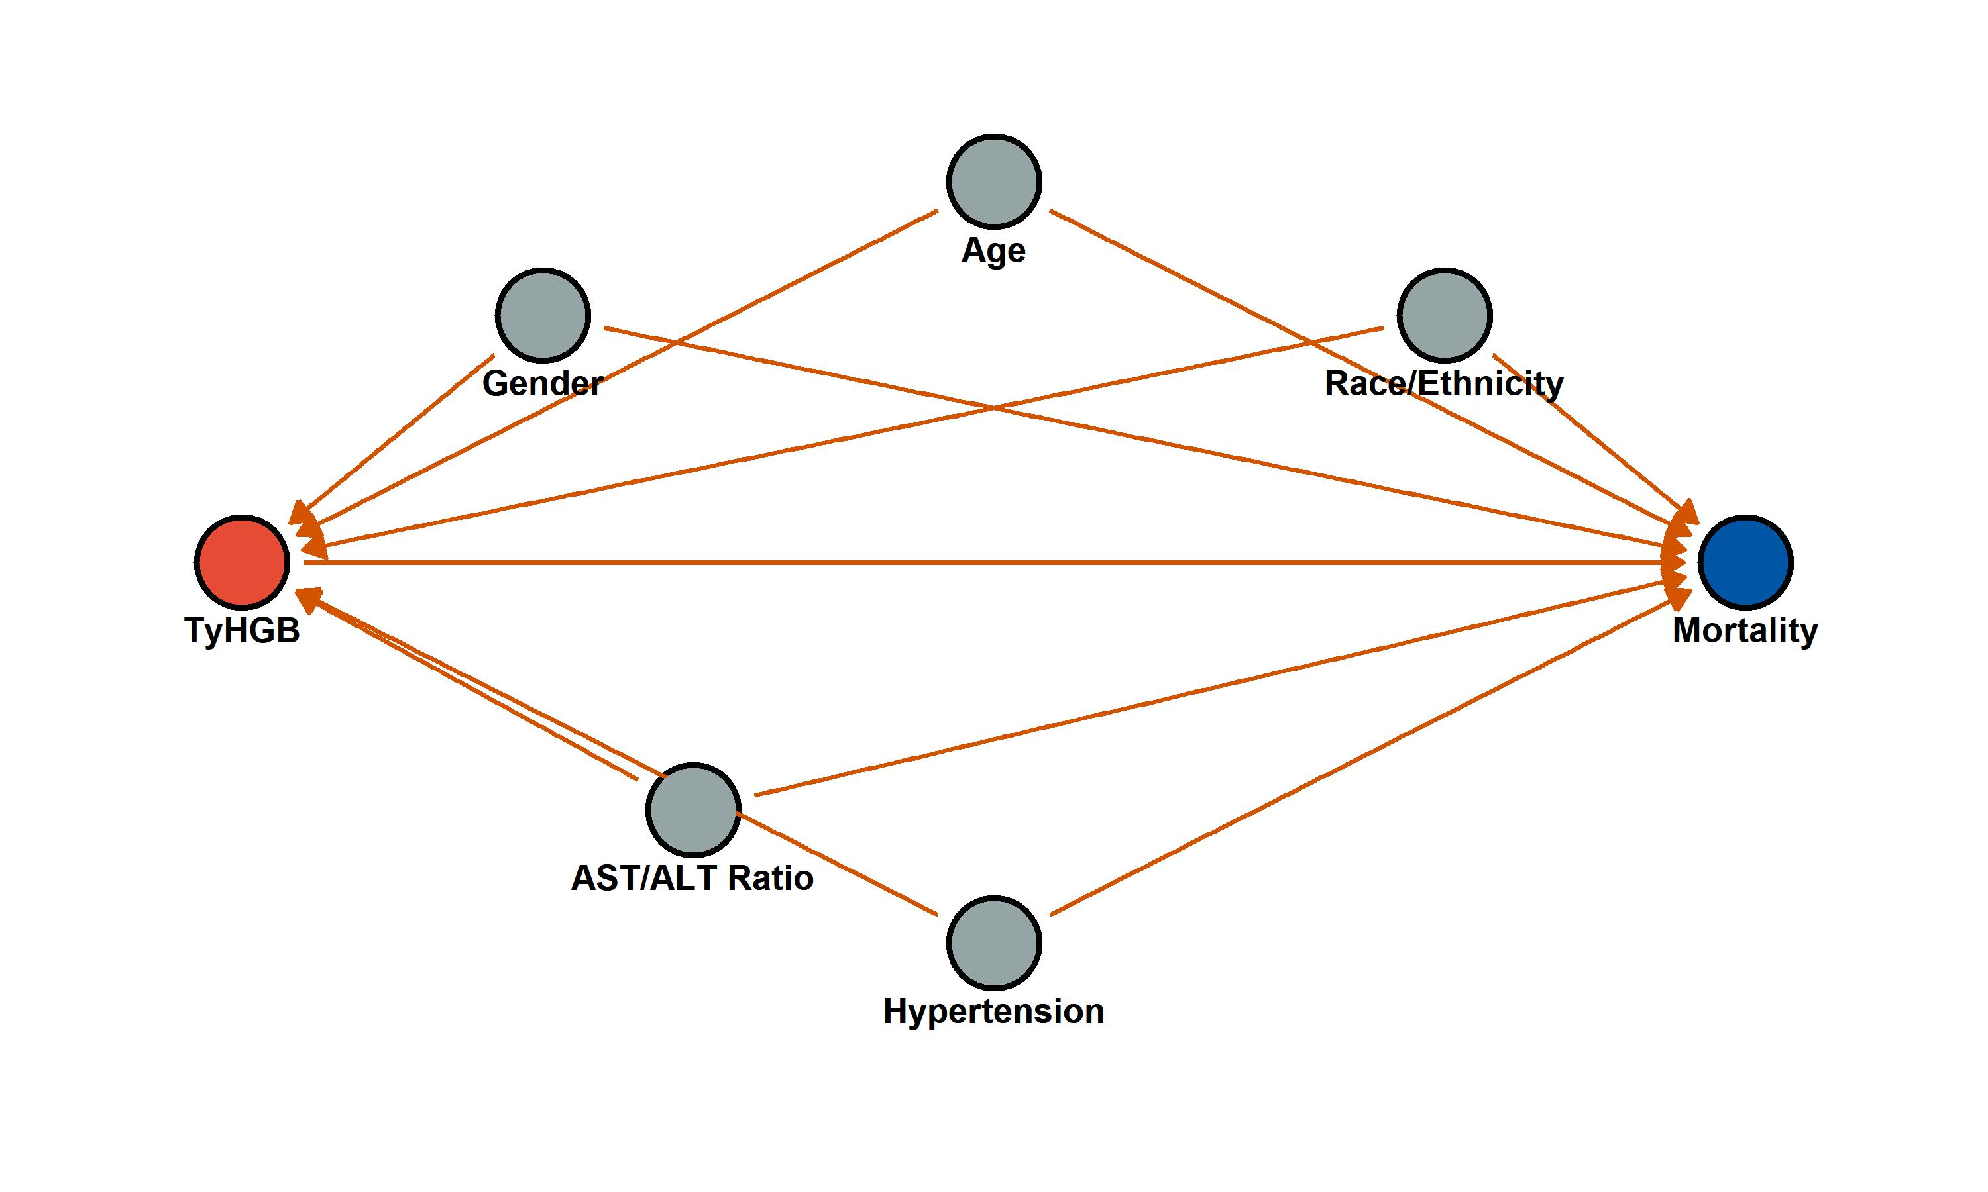
Figure 1: Directed Acyclic Graph (DAG) and Variance Inflation Factor (VIF) confirming covariate selection

3. Univariate and Multivariate Cox regression
Stratified 1 - level Cluster Sampling design (with replacement)
With (184) clusters.
svydesign(id = ~SDMVPSU, strata = ~SDMVSTRA, weights = ~WTSAF2YR,
nest = TRUE, data = df_final)
Stratified 1 - level Cluster Sampling design (with replacement)
With (184) clusters.
svydesign(id = ~SDMVPSU, strata = ~SDMVSTRA, weights = ~WTSAF2YR,
nest = TRUE, data = df_final)
Stratified 1 - level Cluster Sampling design (with replacement)
With (184) clusters.
svydesign(id = ~SDMVPSU, strata = ~SDMVSTRA, weights = ~WTSAF2YR,
nest = TRUE, data = df_final)
Stratified 1 - level Cluster Sampling design (with replacement)
With (184) clusters.
svydesign(id = ~SDMVPSU, strata = ~SDMVSTRA, weights = ~WTSAF2YR,
nest = TRUE, data = df_final)
Stratified 1 - level Cluster Sampling design (with replacement)
With (184) clusters.
svydesign(id = ~SDMVPSU, strata = ~SDMVSTRA, weights = ~WTSAF2YR,
nest = TRUE, data = df_final)
Stratified 1 - level Cluster Sampling design (with replacement)
With (184) clusters.
svydesign(id = ~SDMVPSU, strata = ~SDMVSTRA, weights = ~WTSAF2YR,
nest = TRUE, data = df_final)
Stratified 1 - level Cluster Sampling design (with replacement)
With (184) clusters.
svydesign(id = ~SDMVPSU, strata = ~SDMVSTRA, weights = ~WTSAF2YR,
nest = TRUE, data = df_final)
Stratified 1 - level Cluster Sampling design (with replacement)
With (184) clusters.
svydesign(id = ~SDMVPSU, strata = ~SDMVSTRA, weights = ~WTSAF2YR,
nest = TRUE, data = df_final)
Stratified 1 - level Cluster Sampling design (with replacement)
With (184) clusters.
svydesign(id = ~SDMVPSU, strata = ~SDMVSTRA, weights = ~WTSAF2YR,
nest = TRUE, data = df_final)
Stratified 1 - level Cluster Sampling design (with replacement)
With (184) clusters.
svydesign(id = ~SDMVPSU, strata = ~SDMVSTRA, weights = ~WTSAF2YR,
nest = TRUE, data = df_final)
Stratified 1 - level Cluster Sampling design (with replacement)
With (184) clusters.
svydesign(id = ~SDMVPSU, strata = ~SDMVSTRA, weights = ~WTSAF2YR,
nest = TRUE, data = df_final)
Stratified 1 - level Cluster Sampling design (with replacement)
With (184) clusters.
svydesign(id = ~SDMVPSU, strata = ~SDMVSTRA, weights = ~WTSAF2YR,
nest = TRUE, data = df_final)
Stratified 1 - level Cluster Sampling design (with replacement)
With (184) clusters.
svydesign(id = ~SDMVPSU, strata = ~SDMVSTRA, weights = ~WTSAF2YR,
nest = TRUE, data = df_final)
Stratified 1 - level Cluster Sampling design (with replacement)
With (184) clusters.
svydesign(id = ~SDMVPSU, strata = ~SDMVSTRA, weights = ~WTSAF2YR,
nest = TRUE, data = df_final)
Stratified 1 - level Cluster Sampling design (with replacement)
With (184) clusters.
svydesign(id = ~SDMVPSU, strata = ~SDMVSTRA, weights = ~WTSAF2YR,
nest = TRUE, data = df_final)
Stratified 1 - level Cluster Sampling design (with replacement)
With (184) clusters.
svydesign(id = ~SDMVPSU, strata = ~SDMVSTRA, weights = ~WTSAF2YR,
nest = TRUE, data = df_final)
Stratified 1 - level Cluster Sampling design (with replacement)
With (184) clusters.
svydesign(id = ~SDMVPSU, strata = ~SDMVSTRA, weights = ~WTSAF2YR,
nest = TRUE, data = df_final)
Stratified 1 - level Cluster Sampling design (with replacement)
With (184) clusters.
svydesign(id = ~SDMVPSU, strata = ~SDMVSTRA, weights = ~WTSAF2YR,
nest = TRUE, data = df_final)
Table 3: Table 2: Cox regression analysis demonstrating the independent association of TyHGB (Continuous and Quartiles) with mortality
TyHGB | HR (95% CI)_Model 1 (Unadjusted) | P value_Model 1 (Unadjusted) | HR (95% CI)_Model 2 (Demographics) | P value_Model 2 (Demographics) | HR (95% CI)_Model 3 (Fully Adjusted) | P value_Model 3 (Fully Adjusted)
All-Cause Mortality
Continuous (per 1-SD) | 1.126 (1.078-1.177) | <0.001 | 1.156 (1.082-1.236) | <0.001 | 1.141 (1.059-1.229) | <0.001
Quartile 1 | Ref. | - | Ref. | - | Ref. | -
Quartile 2 | 1.354 (0.945-1.940) | 0.099 | 1.049 (0.757-1.455) | 0.773 | 1.074 (0.774-1.489) | 0.671
Quartile 3 | 1.753 (1.298-2.368) | 0.000 | 1.221 (0.900-1.656) | 0.200 | 1.256 (0.942-1.675) | 0.121
Quartile 4 | 2.199 (1.558-3.105) | 0.000 | 1.619 (1.171-2.239) | 0.004 | 1.682 (1.228-2.305) | 0.001
P for trend |  | <0.001 |  | 0.001 |  | <0.001
Cardiovascular Mortality
Continuous (per 1-SD) | 1.102 (1.035-1.174) | 0.003 | 1.127 (1.012-1.256) | 0.030 | 1.117 (1.000-1.246) | 0.049
Quartile 1 | Ref. | - | Ref. | - | Ref. | -
Quartile 2 | 2.031 (1.067-3.867) | 0.031 | 1.539 (0.810-2.923) | 0.188 | 1.585 (0.829-3.031) | 0.163
Quartile 3 | 2.332 (1.325-4.105) | 0.003 | 1.618 (0.895-2.922) | 0.111 | 1.653 (0.917-2.978) | 0.094
Quartile 4 | 2.966 (1.688-5.213) | 0.000 | 2.163 (1.211-3.862) | 0.009 | 2.246 (1.248-4.042) | 0.007
P for trend |  | <0.001 |  | 0.006 |  | 0.005

4. Kaplan–Meier survival curves
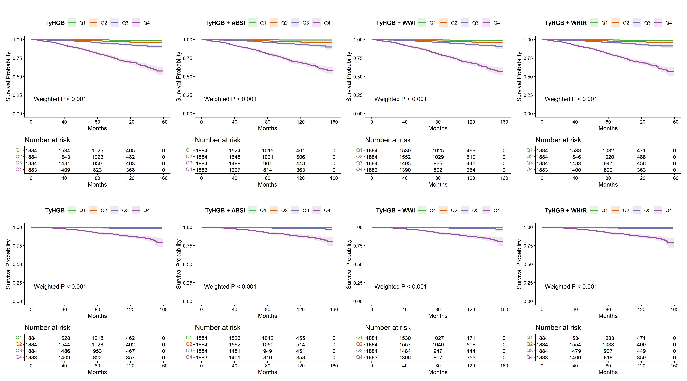
Figure 1: Figure 2: Kaplan-Meier survival curves comparing combining TyHGB with obesity indices

5. ROC curves at times
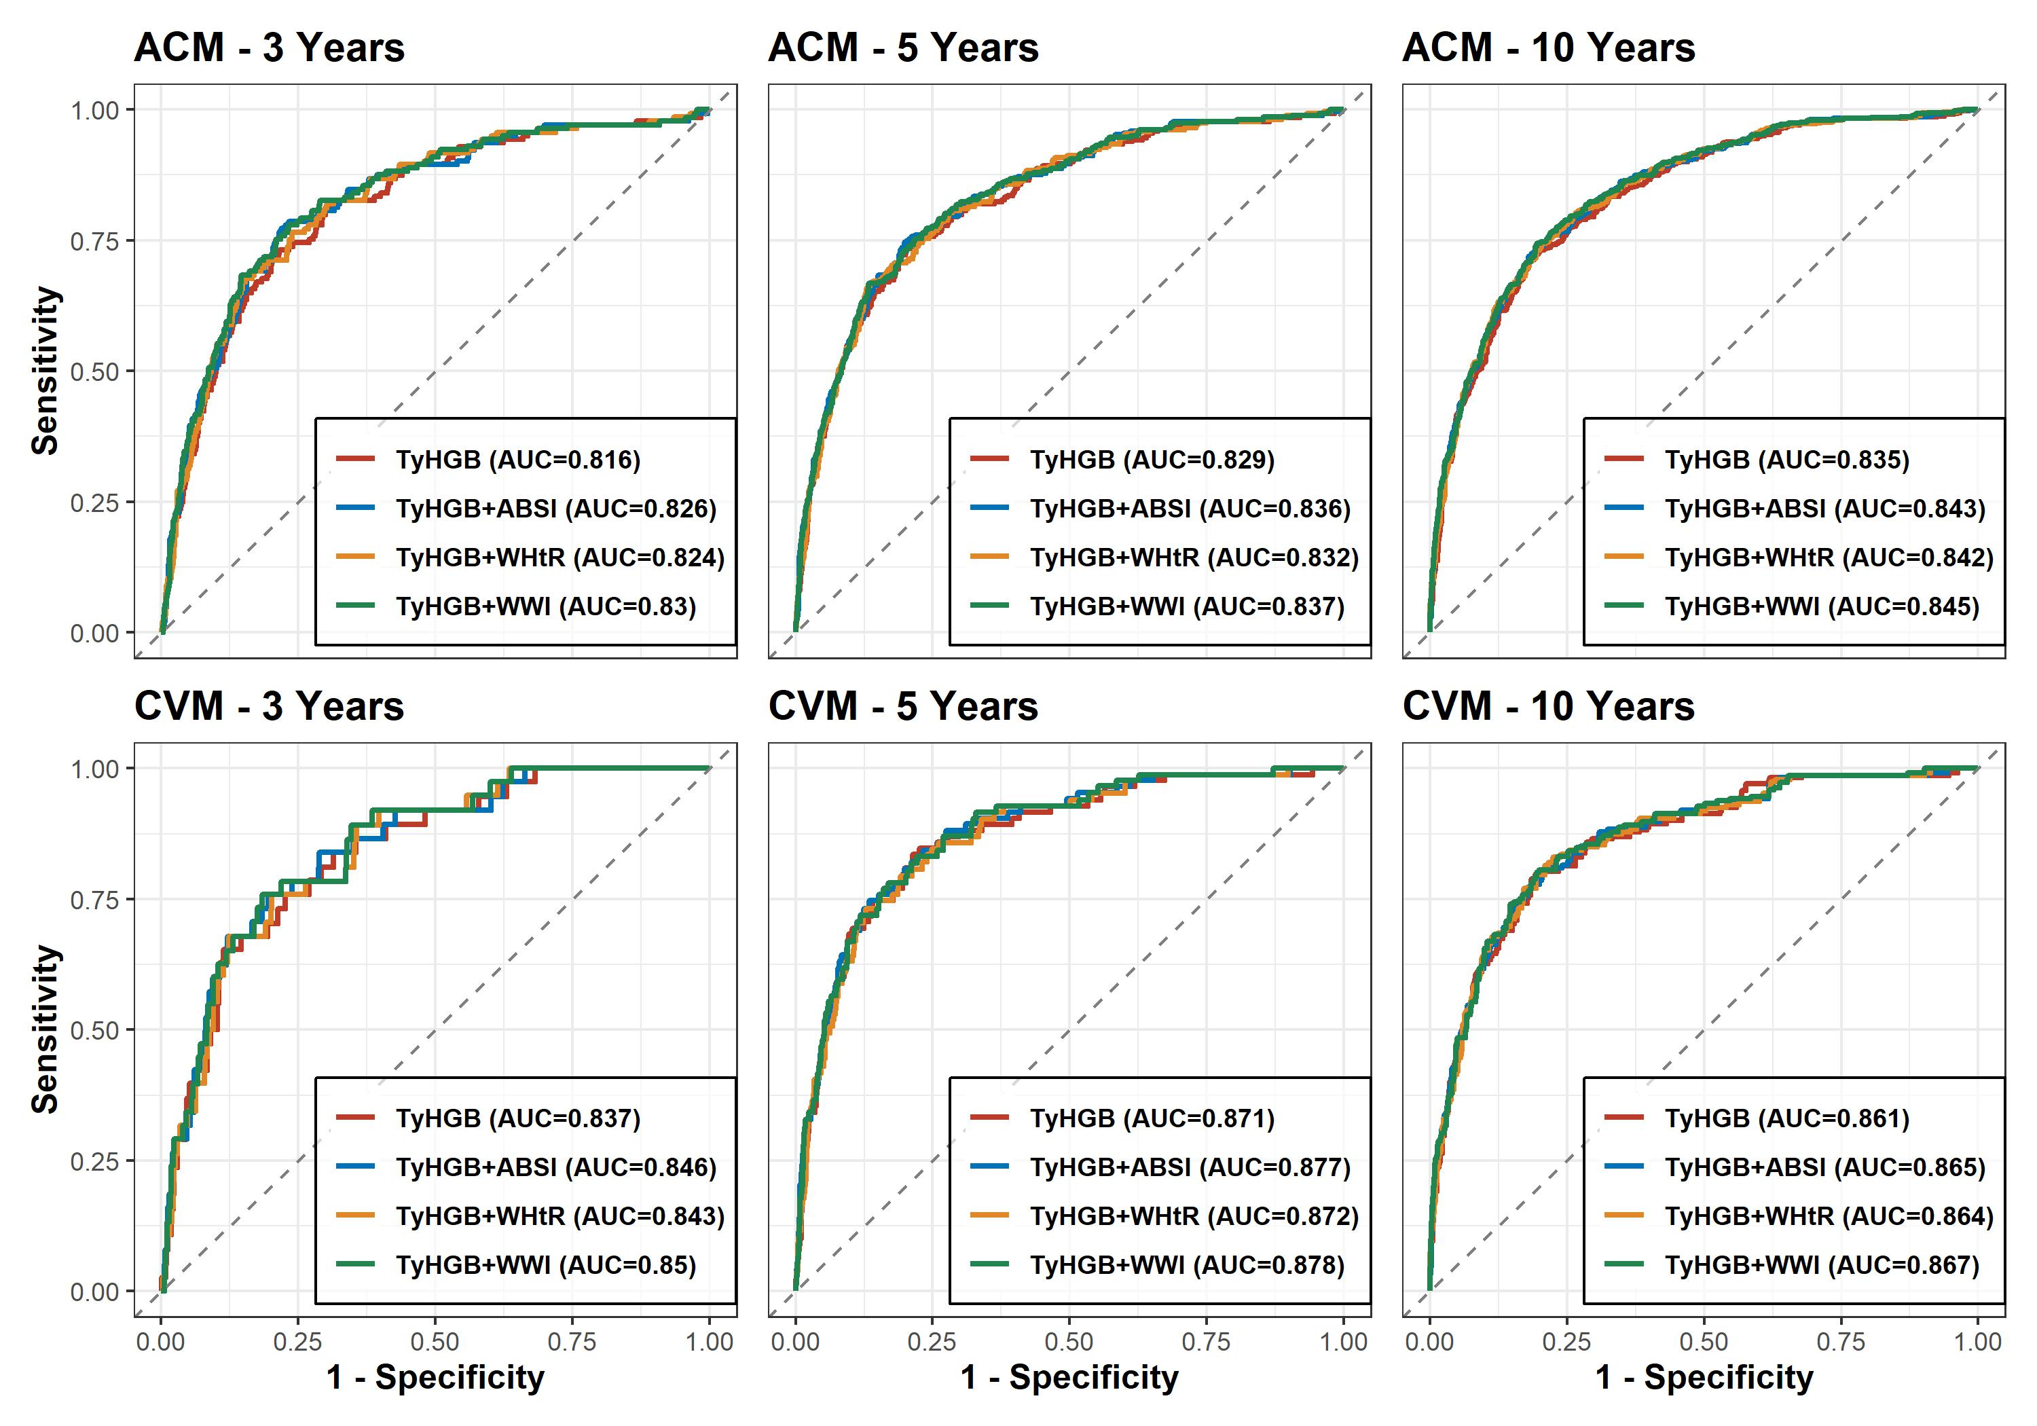
Figure 2: Figure 3: Time-dependent ROC curves comparing combinations of TyHGB and other obesity indices

6. Incremental predictive value
Table 4: Table 3: Incremental predictive value of adding TyHGB and combined indices to the base clinical model
================ KẾT QUẢ CHO: ALL-CAUSE MORTALITY (ACM) TẠI 10 NĂM ================
Base Model (No TyHGB) - C-index: 0.812 (0.781-0.842)
Adding to Base | C-index New (95%CI) | P DeLong | Cont. NRI (95%CI) | P (NRI) | IDI (95%CI) | P (IDI)
------------------------------------------------------------------------------------------------------------
Est. Lower Upper p-value
M1 0.002 -0.002 0.006 0.337
M2 0.194 0.064 0.291 0.000
M3 0.000 -0.003 0.002 0.673
+ TyHGB | 0.814 (0.783-0.845) | 0.9078 | 0.000 (-0.003-0.002) | 0.6730 | 0.002 (-0.002-0.006) | 0.3370
Est. Lower Upper p-value
M1 0.017 0.008 0.025 0
M2 0.205 0.120 0.273 0
M3 0.009 0.005 0.014 0
+ TyHGB + ABSI | 0.820 (0.789-0.851) | 0.7002 | 0.009 (0.005-0.014) | <0.001 | 0.017 (0.008-0.025) | <0.001
Est. Lower Upper p-value
M1 0.020 0.009 0.031 0
M2 0.184 0.084 0.263 0
M3 0.010 0.003 0.017 0
+ TyHGB + WWI | 0.822 (0.791-0.853) | 0.6354 | 0.010 (0.003-0.017) | <0.001 | 0.020 (0.009-0.031) | <0.001
Est. Lower Upper p-value
M1 0.011 0.003 0.019 0.000
M2 0.186 0.084 0.271 0.000
M3 0.003 -0.001 0.010 0.119
+ TyHGB + WHtR | 0.818 (0.787-0.850) | 0.7580 | 0.003 (-0.001-0.010) | 0.1190 | 0.011 (0.003-0.019) | <0.001
================ KẾT QUẢ CHO: CARDIOVASCULAR MORTALITY (CVM) TẠI 10 NĂM ================
Base Model (No TyHGB) - C-index: 0.867 (0.837-0.898)
Adding to Base | C-index New (95%CI) | P DeLong | Cont. NRI (95%CI) | P (NRI) | IDI (95%CI) | P (IDI)
------------------------------------------------------------------------------------------------------------
Est. Lower Upper p-value
M1 0.000 -0.003 0.003 1.050
M2 0.181 -0.004 0.326 0.059
M3 -0.001 -0.001 0.001 0.218
+ TyHGB | 0.869 (0.840-0.899) | 0.9293 | -0.001 (-0.001-0.001) | 0.2180 | 0.000 (-0.003-0.003) | 1.0500
Est. Lower Upper p-value
M1 0.006 -0.005 0.013 0.198
M2 0.167 0.002 0.275 0.040
M3 0.001 -0.001 0.005 0.079
+ TyHGB + ABSI | 0.875 (0.846-0.903) | 0.7394 | 0.001 (-0.001-0.005) | 0.0790 | 0.006 (-0.005-0.013) | 0.1980
Est. Lower Upper p-value
M1 0.009 -0.005 0.019 0.238
M2 0.188 -0.004 0.337 0.059
M3 0.002 -0.001 0.010 0.099
+ TyHGB + WWI | 0.877 (0.849-0.904) | 0.6680 | 0.002 (-0.001-0.010) | 0.0990 | 0.009 (-0.005-0.019) | 0.2380
Est. Lower Upper p-value
M1 0.003 -0.004 0.010 0.356
M2 0.129 -0.018 0.259 0.139
M3 0.000 -0.002 0.003 0.911
+ TyHGB + WHtR | 0.872 (0.844-0.901) | 0.8141 | 0.000 (-0.002-0.003) | 0.9110 | 0.003 (-0.004-0.010) | 0.3560

7. Dose-response relationship
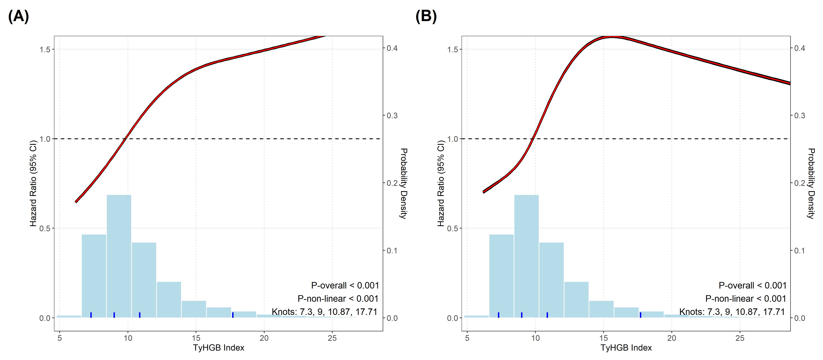
Figure 3: Figure 4: Restricted cubic spline (RCS) curves showing the dose-response relationship between TyHGB index and mortality

8. Subgroup analyses
Stratified 1 - level Cluster Sampling design (with replacement)
With (184) clusters.
subset(sub_design, get(col_name) == lvl)
Stratified 1 - level Cluster Sampling design (with replacement)
With (184) clusters.
subset(sub_design, get(col_name) == lvl)
Stratified 1 - level Cluster Sampling design (with replacement)
With (184) clusters.
subset(sub_design, get(col_name) == lvl)
Stratified 1 - level Cluster Sampling design (with replacement)
With (184) clusters.
subset(sub_design, get(col_name) == lvl)
Stratified 1 - level Cluster Sampling design (with replacement)
With (184) clusters.
subset(sub_design, get(col_name) == lvl)
Stratified 1 - level Cluster Sampling design (with replacement)
With (160) clusters.
subset(sub_design, get(col_name) == lvl)
Stratified 1 - level Cluster Sampling design (with replacement)
With (180) clusters.
subset(sub_design, get(col_name) == lvl)
Stratified 1 - level Cluster Sampling design (with replacement)
With (183) clusters.
subset(sub_design, get(col_name) == lvl)
Stratified 1 - level Cluster Sampling design (with replacement)
With (182) clusters.
subset(sub_design, get(col_name) == lvl)
Stratified 1 - level Cluster Sampling design (with replacement)
With (184) clusters.
subset(sub_design, get(col_name) == lvl)
Stratified 1 - level Cluster Sampling design (with replacement)
With (184) clusters.
subset(sub_design, get(col_name) == lvl)
Stratified 1 - level Cluster Sampling design (with replacement)
With (184) clusters.
subset(sub_design, get(col_name) == lvl)
Stratified 1 - level Cluster Sampling design (with replacement)
With (184) clusters.
subset(sub_design, get(col_name) == lvl)
Stratified 1 - level Cluster Sampling design (with replacement)
With (184) clusters.
subset(sub_design, get(col_name) == lvl)
Stratified 1 - level Cluster Sampling design (with replacement)
With (184) clusters.
subset(sub_design, get(col_name) == lvl)
Stratified 1 - level Cluster Sampling design (with replacement)
With (160) clusters.
subset(sub_design, get(col_name) == lvl)
Stratified 1 - level Cluster Sampling design (with replacement)
With (180) clusters.
subset(sub_design, get(col_name) == lvl)
Stratified 1 - level Cluster Sampling design (with replacement)
With (183) clusters.
subset(sub_design, get(col_name) == lvl)
Stratified 1 - level Cluster Sampling design (with replacement)
With (182) clusters.
subset(sub_design, get(col_name) == lvl)
Stratified 1 - level Cluster Sampling design (with replacement)
With (184) clusters.
subset(sub_design, get(col_name) == lvl)
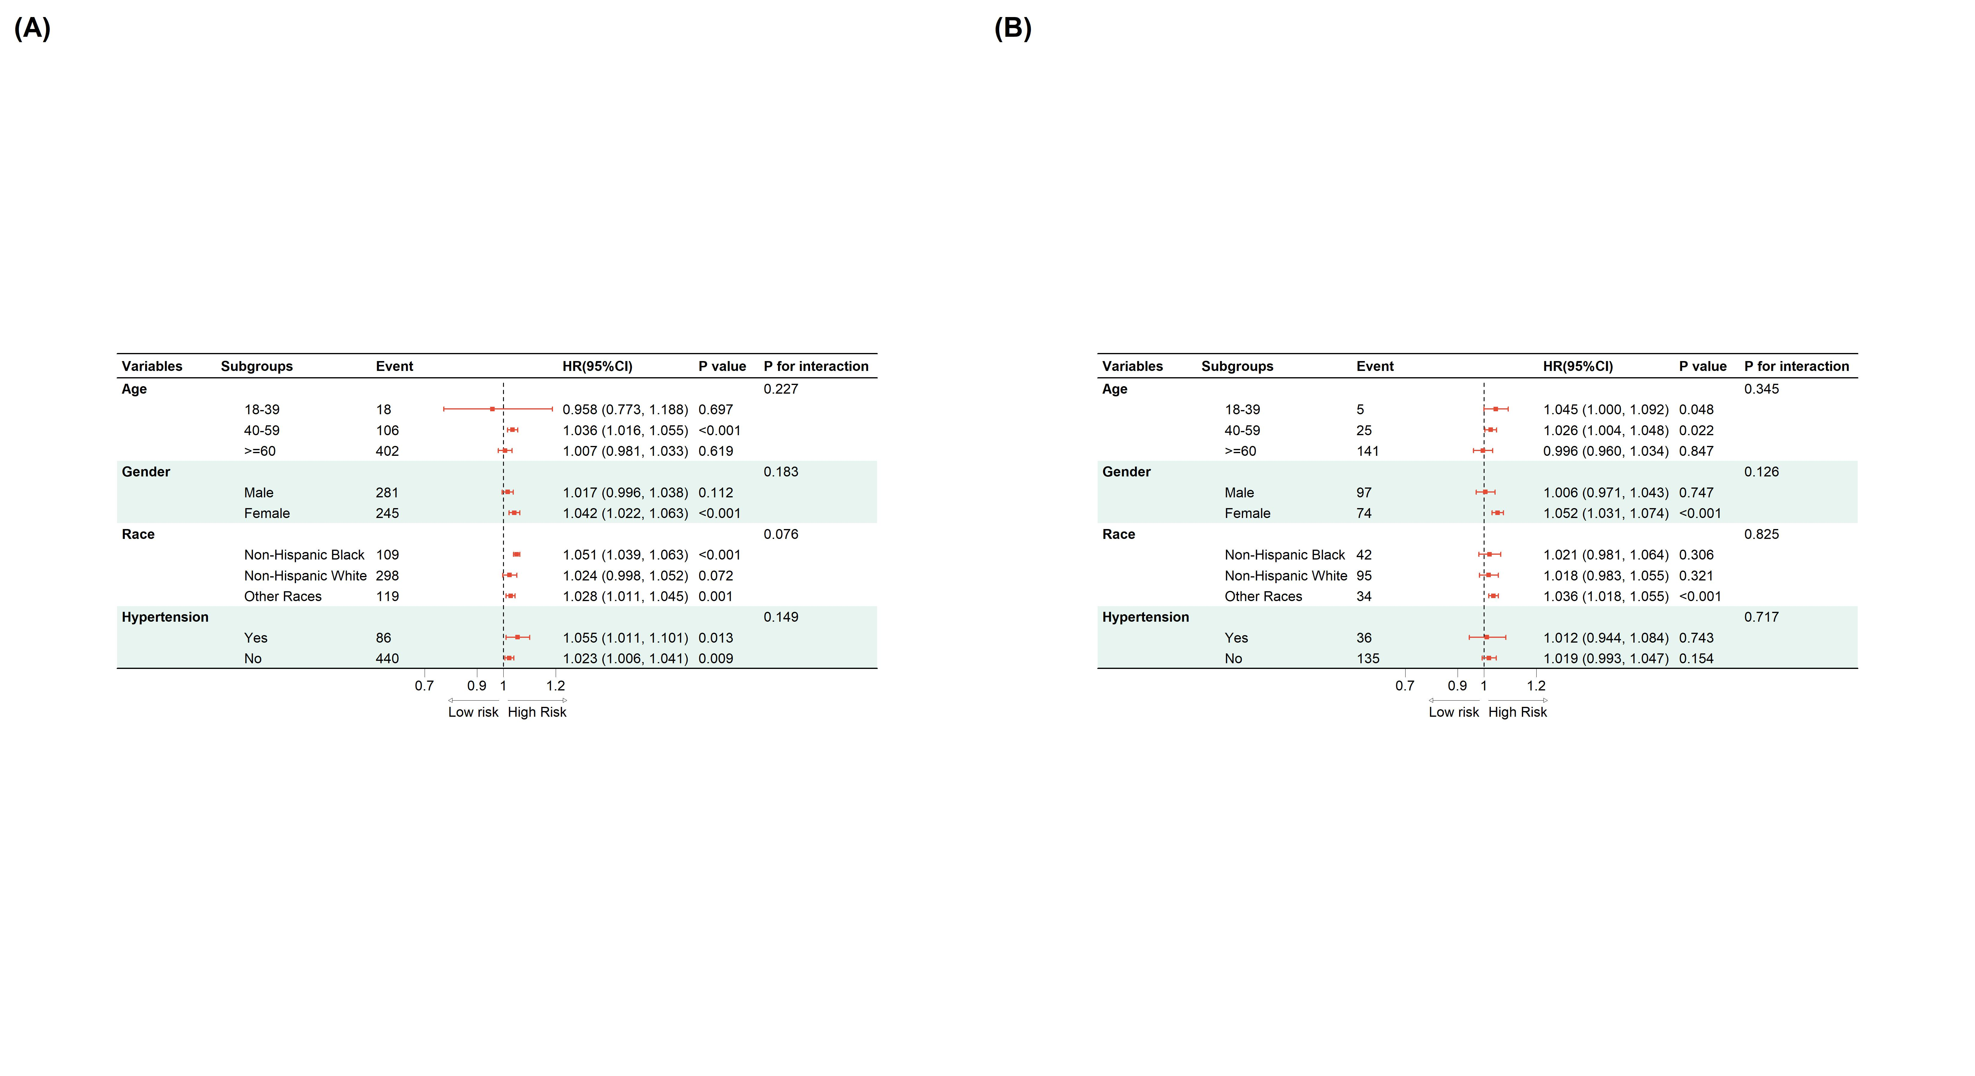
Figure 4: Figure 5: Subgroup analyses for the association between TyHGB index and mortality risk

9. Mediation analysis
Stratified 1 - level Cluster Sampling design (with replacement)
With (184) clusters.
svydesign(id = ~SDMVPSU, strata = ~SDMVSTRA, weights = ~WTSAF2YR,
nest = TRUE, data = df_med)
Stratified 1 - level Cluster Sampling design (with replacement)
With (184) clusters.
svydesign(id = ~SDMVPSU, strata = ~SDMVSTRA, weights = ~WTSAF2YR,
nest = TRUE, data = df_med)
Stratified 1 - level Cluster Sampling design (with replacement)
With (184) clusters.
svydesign(id = ~SDMVPSU, strata = ~SDMVSTRA, weights = ~WTSAF2YR,
nest = TRUE, data = df_med)
Stratified 1 - level Cluster Sampling design (with replacement)
With (184) clusters.
svydesign(id = ~SDMVPSU, strata = ~SDMVSTRA, weights = ~WTSAF2YR,
nest = TRUE, data = df_med)
Stratified 1 - level Cluster Sampling design (with replacement)
With (184) clusters.
svydesign(id = ~SDMVPSU, strata = ~SDMVSTRA, weights = ~WTSAF2YR,
nest = TRUE, data = df_med)
Stratified 1 - level Cluster Sampling design (with replacement)
With (184) clusters.
svydesign(id = ~SDMVPSU, strata = ~SDMVSTRA, weights = ~WTSAF2YR,
nest = TRUE, data = df_med)
Stratified 1 - level Cluster Sampling design (with replacement)
With (184) clusters.
svydesign(id = ~SDMVPSU, strata = ~SDMVSTRA, weights = ~WTSAF2YR,
nest = TRUE, data = df_med)
Stratified 1 - level Cluster Sampling design (with replacement)
With (184) clusters.
svydesign(id = ~SDMVPSU, strata = ~SDMVSTRA, weights = ~WTSAF2YR,
nest = TRUE, data = df_med)
Stratified 1 - level Cluster Sampling design (with replacement)
With (184) clusters.
svydesign(id = ~SDMVPSU, strata = ~SDMVSTRA, weights = ~WTSAF2YR,
nest = TRUE, data = df_med)
Stratified 1 - level Cluster Sampling design (with replacement)
With (184) clusters.
svydesign(id = ~SDMVPSU, strata = ~SDMVSTRA, weights = ~WTSAF2YR,
nest = TRUE, data = df_med)
Stratified 1 - level Cluster Sampling design (with replacement)
With (184) clusters.
svydesign(id = ~SDMVPSU, strata = ~SDMVSTRA, weights = ~WTSAF2YR,
nest = TRUE, data = df_med)
Stratified 1 - level Cluster Sampling design (with replacement)
With (184) clusters.
svydesign(id = ~SDMVPSU, strata = ~SDMVSTRA, weights = ~WTSAF2YR,
nest = TRUE, data = df_med)
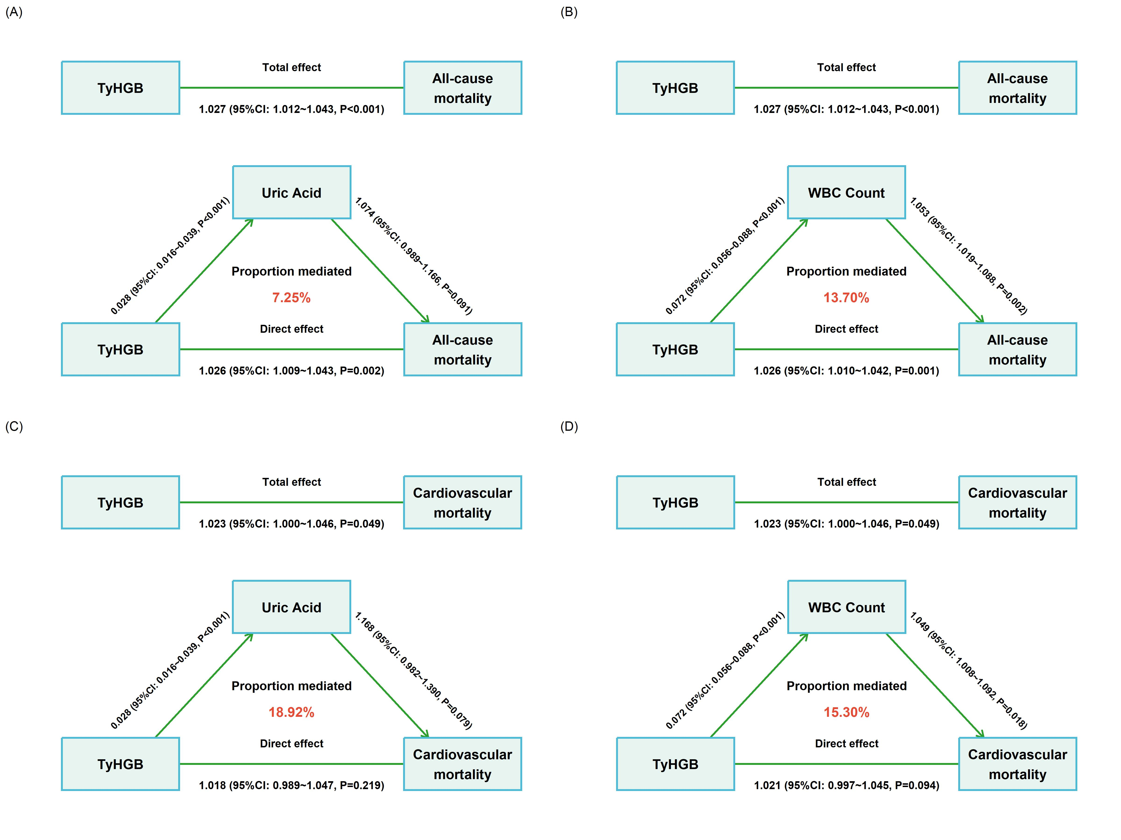
Figure 5: Figure 5: Mediation analysis of the TyHGB index on mortality via Uric Acid and WBC count

10. Competing Risk Analysis (Fine-Gray Model)
Stratified 1 - level Cluster Sampling design (with replacement)
With (184) clusters.
svydesign(id = ~SDMVPSU, strata = ~SDMVSTRA, weights = ~WTSAF2YR *
fgwt, nest = TRUE, data = fg_data)
Stratified 1 - level Cluster Sampling design (with replacement)
With (184) clusters.
svydesign(id = ~SDMVPSU, strata = ~SDMVSTRA, weights = ~WTSAF2YR *
fgwt, nest = TRUE, data = fg_data)
Stratified 1 - level Cluster Sampling design (with replacement)
With (184) clusters.
svydesign(id = ~SDMVPSU, strata = ~SDMVSTRA, weights = ~WTSAF2YR *
fgwt, nest = TRUE, data = fg_data)
Stratified 1 - level Cluster Sampling design (with replacement)
With (184) clusters.
svydesign(id = ~SDMVPSU, strata = ~SDMVSTRA, weights = ~WTSAF2YR *
fgwt, nest = TRUE, data = fg_data)
Stratified 1 - level Cluster Sampling design (with replacement)
With (184) clusters.
svydesign(id = ~SDMVPSU, strata = ~SDMVSTRA, weights = ~WTSAF2YR *
fgwt, nest = TRUE, data = fg_data)
Stratified 1 - level Cluster Sampling design (with replacement)
With (184) clusters.
svydesign(id = ~SDMVPSU, strata = ~SDMVSTRA, weights = ~WTSAF2YR *
fgwt, nest = TRUE, data = fg_data)
Stratified 1 - level Cluster Sampling design (with replacement)
With (184) clusters.
svydesign(id = ~SDMVPSU, strata = ~SDMVSTRA, weights = ~WTSAF2YR *
fgwt, nest = TRUE, data = fg_data)
Stratified 1 - level Cluster Sampling design (with replacement)
With (184) clusters.
svydesign(id = ~SDMVPSU, strata = ~SDMVSTRA, weights = ~WTSAF2YR *
fgwt, nest = TRUE, data = fg_data)
Table 5: Table 4: Competing risk analysis (Fine-Gray model) for cardiovascular mortality comparing multiple indices
 | Univariate analysis (per 1-SD increase) |  | Multivariate Analysis (per 1-SD increase)
 | sHR (95% CIs) | p-value | sHR (95% CIs) | p-value
TyHGB | 1.101 (1.032-1.175) | 0.003 | 1.121 (1.008-1.247) | 0.034
ABSI | 2.341 (1.911-2.869) | <0.001 | 1.252 (0.959-1.636) | 0.098
WWI | 2.122 (1.758-2.561) | <0.001 | 1.386 (1.066-1.801) | 0.015
WHtR | 1.466 (1.298-1.655) | <0.001 | 1.246 (1.026-1.513) | 0.026

11. Construction of Nomograms
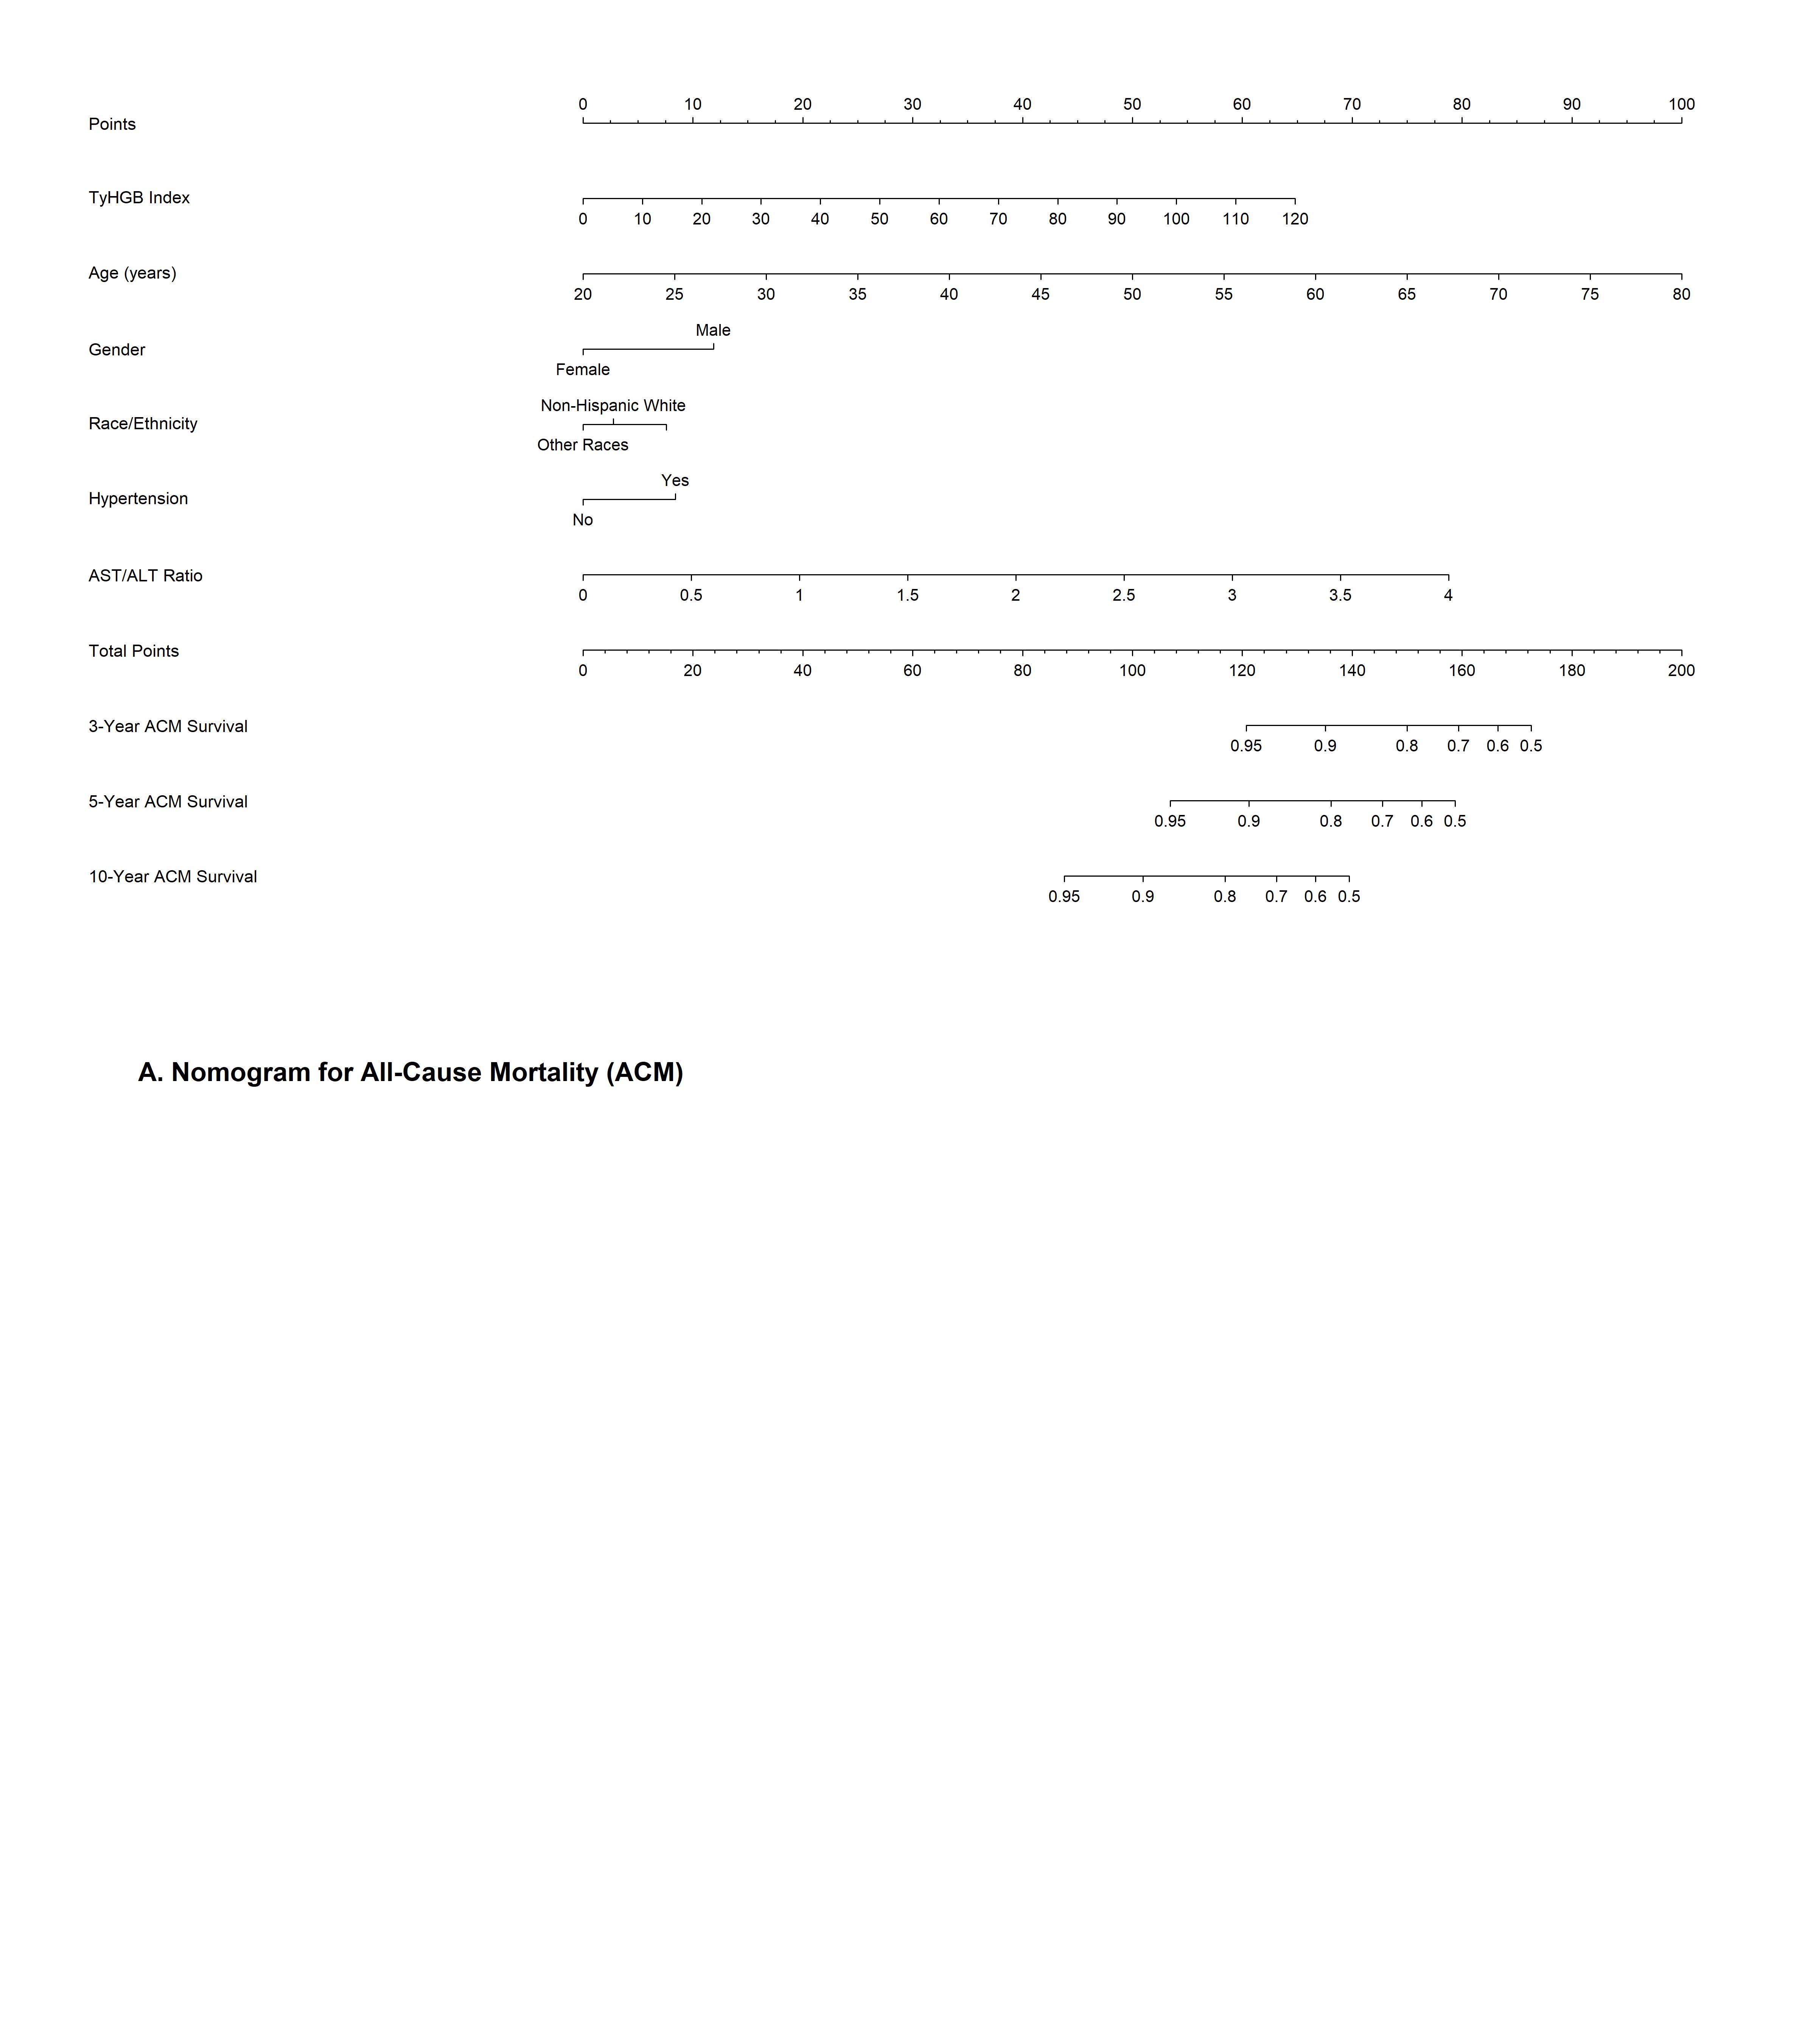
Figure 6: Figure 7: Nomograms predicting 3-, 5-, and 10-year survival probabilities for ACM (A) and CVM (B)
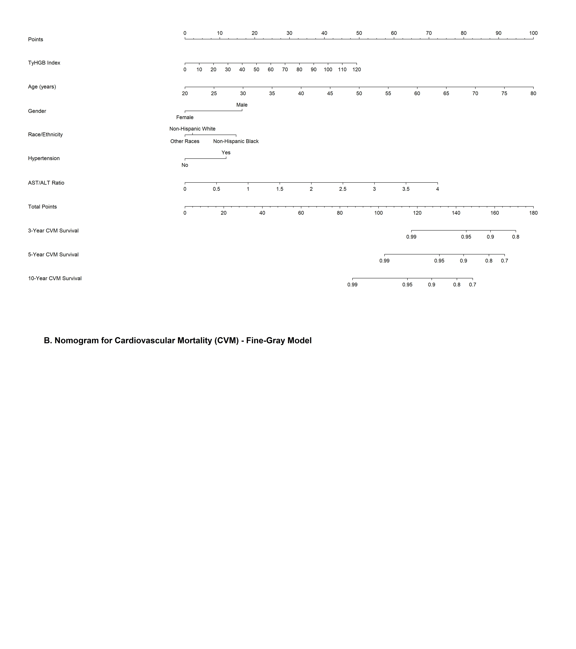
Figure 7: Figure 7: Nomograms predicting 3-, 5-, and 10-year survival probabilities for ACM (A) and CVM (B)

12. Calibration Plots
Using Cox survival estimates at 120 Days
Using Cox survival estimates at 120 Days
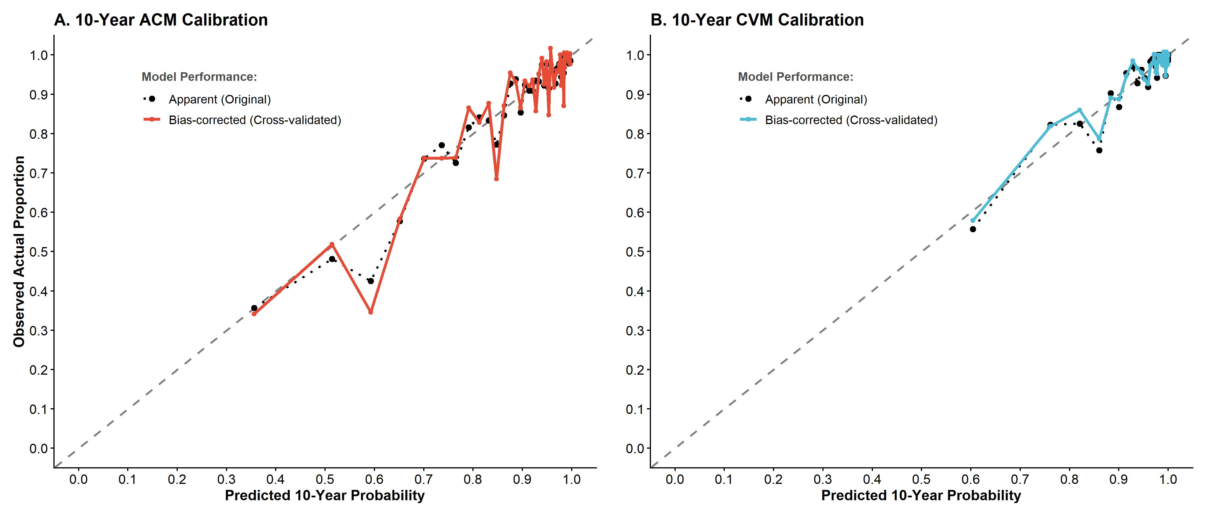
Figure 8: Figure 8: Calibration plots comparing predicted vs observed 10-years

13. Decision Curve Analysis (DCA)
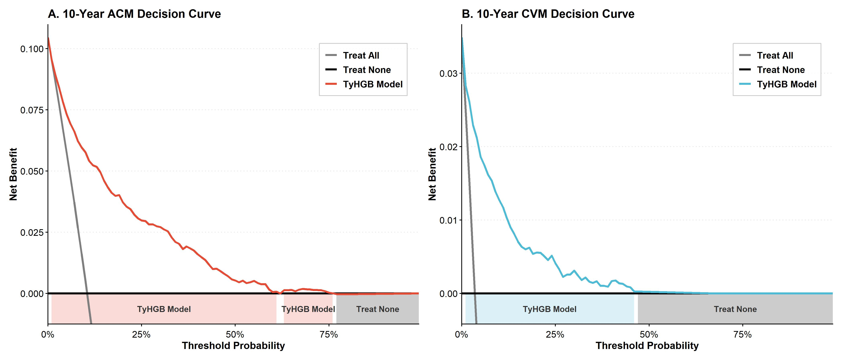
Figure 9: Figure 9: Decision Curve Analysis (DCA) demonstrating the net benefit of the TyHGB clinical model at 10 years

14. Threshold Effect Analysis (Two-piecewise Cox Model)
Stratified 1 - level Cluster Sampling design (with replacement)
With (184) clusters.
svydesign(id = ~SDMVPSU, strata = ~SDMVSTRA, weights = ~WTSAF2YR,
nest = TRUE, data = d_opt)
Stratified 1 - level Cluster Sampling design (with replacement)
With (184) clusters.
svydesign(id = ~SDMVPSU, strata = ~SDMVSTRA, weights = ~WTSAF2YR,
nest = TRUE, data = d_opt)
Stratified 1 - level Cluster Sampling design (with replacement)
With (184) clusters.
svydesign(id = ~SDMVPSU, strata = ~SDMVSTRA, weights = ~WTSAF2YR,
nest = TRUE, data = d_opt)
Stratified 1 - level Cluster Sampling design (with replacement)
With (184) clusters.
svydesign(id = ~SDMVPSU, strata = ~SDMVSTRA, weights = ~WTSAF2YR,
nest = TRUE, data = d_opt)
Table 6: Supplemental Table 4: Threshold effect analysis of TyHGB on ACM and CVM using two-piecewise Cox regression
Model | HR (95% CI) | P value
All-Cause Mortality
Standard linear model | 1.027 (1.012-1.043) | <0.001
Two-piecewise model
TyHGB < 12.1 (Events: 363) | 1.118 (1.050-1.191) | <0.001
TyHGB >= 12.1 (Events: 163) | 1.015 (0.995-1.035) | 0.142
P for LRT |  | 0.010
Cardiovascular Mortality
Standard linear model | 1.023 (1.000-1.046) | 0.049
Two-piecewise model
TyHGB < 11.9 (Events: 116) | 1.188 (1.045-1.349) | 0.008
TyHGB >= 11.9 (Events: 55) | 0.993 (0.946-1.042) | 0.766
P for LRT |  | 0.019

15. Detailed Mediation Analysis
Stratified 1 - level Cluster Sampling design (with replacement)
With (184) clusters.
svydesign(id = ~SDMVPSU, strata = ~SDMVSTRA, weights = ~WTSAF2YR,
nest = TRUE, data = d_clean)
Stratified 1 - level Cluster Sampling design (with replacement)
With (184) clusters.
svydesign(id = ~SDMVPSU, strata = ~SDMVSTRA, weights = ~WTSAF2YR,
nest = TRUE, data = d_clean)
Stratified 1 - level Cluster Sampling design (with replacement)
With (184) clusters.
svydesign(id = ~SDMVPSU, strata = ~SDMVSTRA, weights = ~WTSAF2YR,
nest = TRUE, data = d_clean)
Stratified 1 - level Cluster Sampling design (with replacement)
With (184) clusters.
svydesign(id = ~SDMVPSU, strata = ~SDMVSTRA, weights = ~WTSAF2YR,
nest = TRUE, data = d_clean)
Table 7: Supplemental Table 5: Detailed mediation analysis of TyHGB on ACM and CVM via Uric Acid and WBC count
Mediator | ACME (95% CI) | P (ACME) | ADE (95% CI) | P (ADE) | Prop. Mediated (%)
All-Cause Mortality
Uric Acid | 0.002 (-0.000 to 0.004) | 0.111 | 0.026 (0.009 to 0.042) | 0.002 | 7.25%
WBC Count | 0.004 (0.001 to 0.006) | 0.003 | 0.026 (0.010 to 0.041) | 0.001 | 13.70%
Cardiovascular Mortality
Uric Acid | 0.004 (-0.001 to 0.009) | 0.100 | 0.018 (-0.011 to 0.046) | 0.219 | 18.92%
WBC Count | 0.003 (0.000 to 0.006) | 0.023 | 0.020 (-0.003 to 0.044) | 0.094 | 15.30%

16. Sensitivity Analysis (Excluding deaths within 24 months)
Stratified 1 - level Cluster Sampling design (with replacement)
With (176) clusters.
subset(des_full, time_months > 24)
Stratified 1 - level Cluster Sampling design (with replacement)
With (176) clusters.
subset(des_full, time_months > 24)
Stratified 1 - level Cluster Sampling design (with replacement)
With (176) clusters.
subset(des_full, time_months > 24)
Stratified 1 - level Cluster Sampling design (with replacement)
With (176) clusters.
subset(des_full, time_months > 24)
Stratified 1 - level Cluster Sampling design (with replacement)
With (176) clusters.
subset(des_full, time_months > 24)
Stratified 1 - level Cluster Sampling design (with replacement)
With (176) clusters.
subset(des_full, time_months > 24)
Stratified 1 - level Cluster Sampling design (with replacement)
With (176) clusters.
subset(des_full, time_months > 24)
Stratified 1 - level Cluster Sampling design (with replacement)
With (176) clusters.
subset(des_full, time_months > 24)
Stratified 1 - level Cluster Sampling design (with replacement)
With (176) clusters.
subset(des_full, time_months > 24)
Stratified 1 - level Cluster Sampling design (with replacement)
With (176) clusters.
subset(des_full, time_months > 24)
Stratified 1 - level Cluster Sampling design (with replacement)
With (176) clusters.
subset(des_full, time_months > 24)
Stratified 1 - level Cluster Sampling design (with replacement)
With (176) clusters.
subset(des_full, time_months > 24)
Stratified 1 - level Cluster Sampling design (with replacement)
With (176) clusters.
subset(des_full, time_months > 24)
Stratified 1 - level Cluster Sampling design (with replacement)
With (176) clusters.
subset(des_full, time_months > 24)
Stratified 1 - level Cluster Sampling design (with replacement)
With (176) clusters.
subset(des_full, time_months > 24)
Stratified 1 - level Cluster Sampling design (with replacement)
With (176) clusters.
subset(des_full, time_months > 24)
Stratified 1 - level Cluster Sampling design (with replacement)
With (176) clusters.
subset(des_full, time_months > 24)
Stratified 1 - level Cluster Sampling design (with replacement)
With (176) clusters.
subset(des_full, time_months > 24)
Table 8: Supplemental Table 6: Association between TyHGB and mortality excluding events within the first 24 months (Addressing Reverse Causation)
TyHGB | HR (95% CI)_Model 1 (Unadjusted) | P value_Model 1 (Unadjusted) | HR (95% CI)_Model 2 (Demographics) | P value_Model 2 (Demographics) | HR (95% CI)_Model 3 (Fully Adjusted) | P value_Model 3 (Fully Adjusted)
All-Cause Mortality
Continuous (per 1-SD) | 1.134 (1.083-1.188) | <0.001 | 1.177 (1.097-1.262) | <0.001 | 1.158 (1.066-1.257) | <0.001
Quartile 1 | Ref. | - | Ref. | - | Ref. | -
Quartile 2 | 1.434 (1.032-1.993) | 0.032 | 1.114 (0.806-1.541) | 0.514 | 1.133 (0.825-1.555) | 0.440
Quartile 3 | 1.944 (1.415-2.672) | 0.000 | 1.358 (0.992-1.860) | 0.056 | 1.389 (1.035-1.863) | 0.028
Quartile 4 | 2.454 (1.727-3.486) | 0.000 | 1.813 (1.293-2.543) | 0.001 | 1.863 (1.339-2.592) | 0.000
P for trend |  | <0.001 |  | <0.001 |  | <0.001
Cardiovascular Mortality
Continuous (per 1-SD) | 1.120 (1.053-1.192) | <0.001 | 1.168 (1.054-1.294) | 0.003 | 1.140 (1.015-1.281) | 0.027
Quartile 1 | Ref. | - | Ref. | - | Ref. | -
Quartile 2 | 1.838 (0.928-3.641) | 0.081 | 1.409 (0.702-2.828) | 0.334 | 1.418 (0.703-2.860) | 0.329
Quartile 3 | 1.881 (1.054-3.359) | 0.033 | 1.331 (0.713-2.488) | 0.370 | 1.354 (0.726-2.525) | 0.340
Quartile 4 | 3.136 (1.714-5.738) | 0.000 | 2.327 (1.250-4.332) | 0.008 | 2.343 (1.242-4.422) | 0.009
P for trend |  | <0.001 |  | 0.005 |  | 0.005

17. Multiple Imputation Stability Check (m = 20)
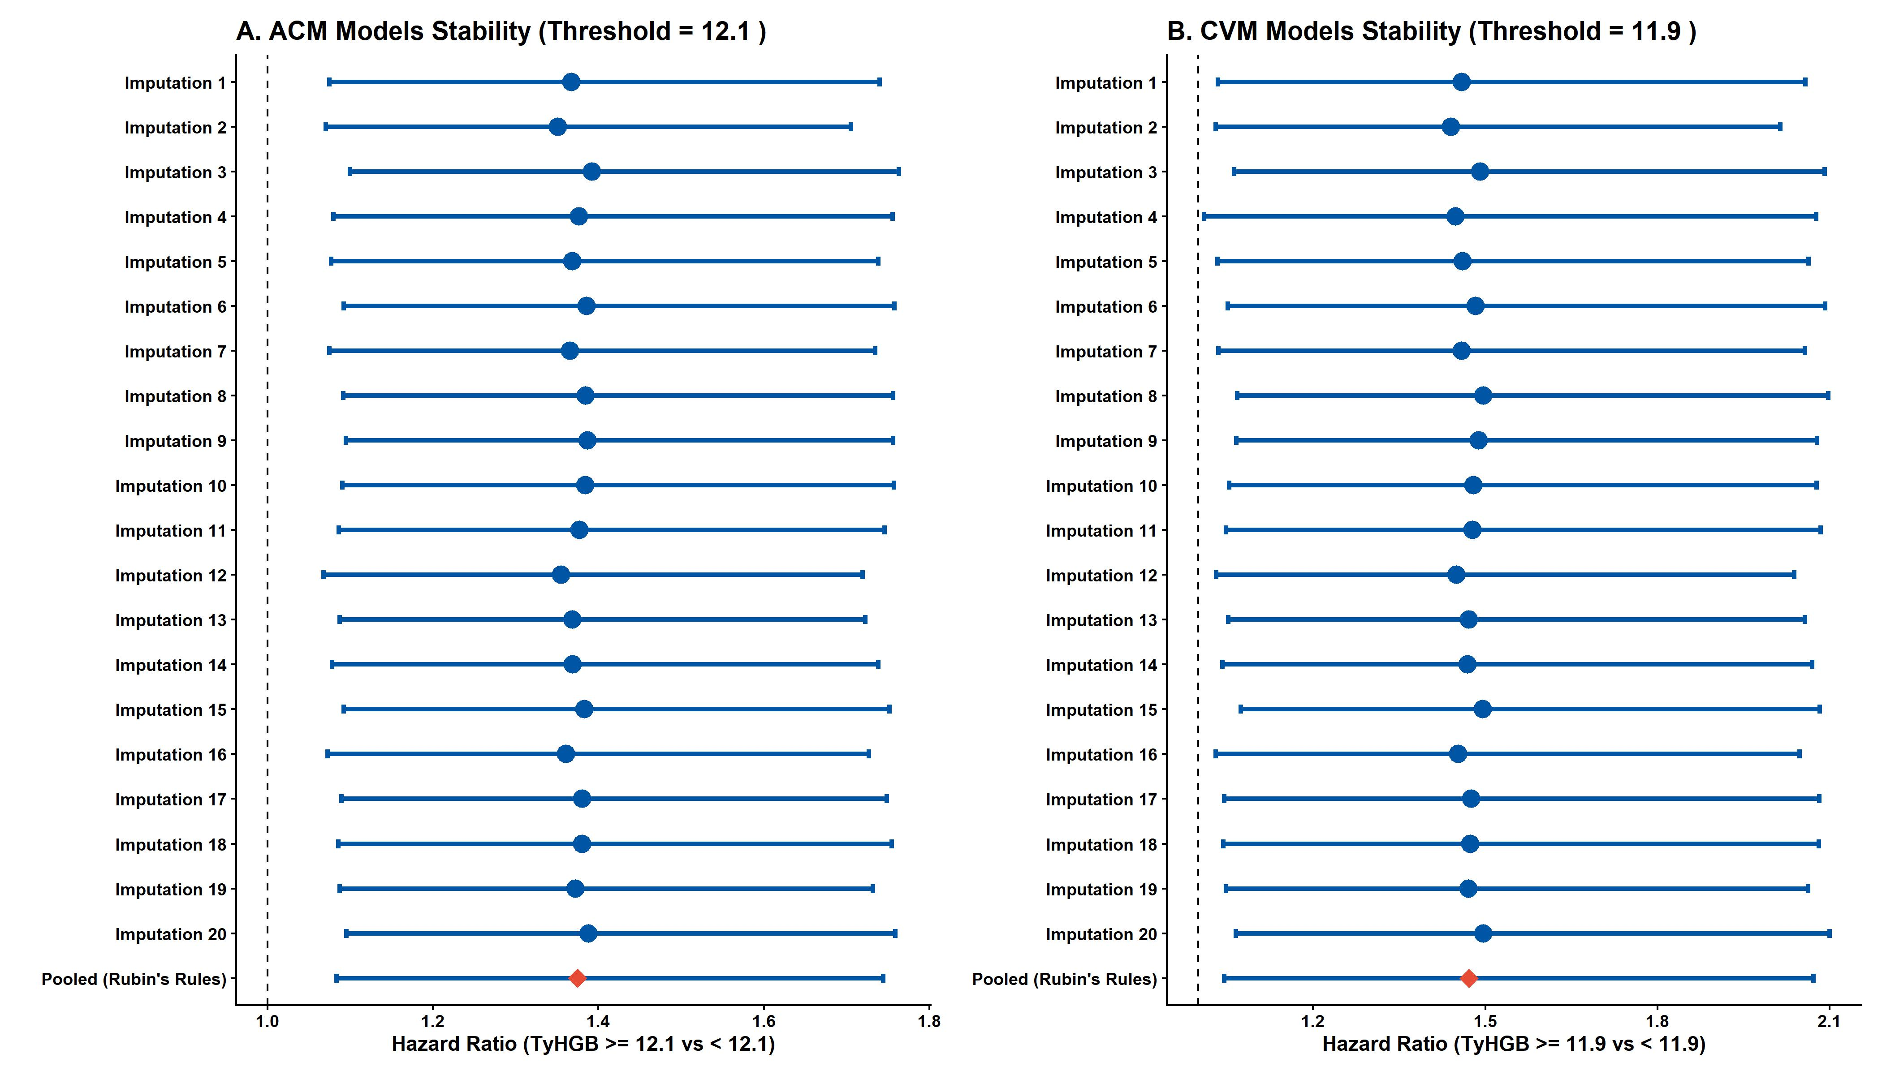
Figure 10: Supplemental Figure: Stability of the TyHGB prognostic value (High vs Low based on threshold) across 20 imputed datasets

18. E-Value Analysis
Stratified 1 - level Cluster Sampling design (with replacement)
With (184) clusters.
svydesign(id = ~SDMVPSU, strata = ~SDMVSTRA, weights = ~WTSAF2YR,
nest = TRUE, data = df_eva)
Stratified 1 - level Cluster Sampling design (with replacement)
With (184) clusters.
svydesign(id = ~SDMVPSU, strata = ~SDMVSTRA, weights = ~WTSAF2YR,
nest = TRUE, data = df_eva)
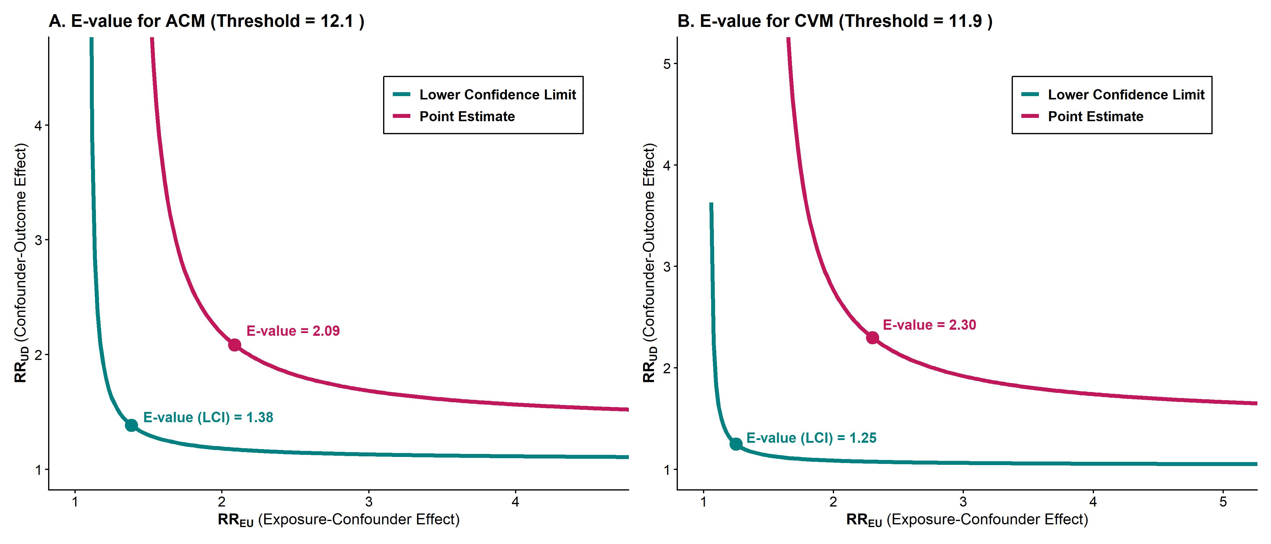
Figure 11: Supplemental Figure: E-value curves for the High vs Low TyHGB index on mortality

