ASG3-DOCUMENTATION(A24CS5031



SECV2223-02

WEB PROGRAMMING

SEMESTER 2

2024/2025

ASSIGNMENTS - 3

TITLE: **DEPLOYING THE PERSONAL WEBSITE WITH DYNAMIC PHP+MYSQL FEATURES**

**LECTURER:** Ts**.** Dr. Sarina Sulaiman

| **NAME** | **MATRIC NO.** |
| --- | --- |
| MUHAMMAD FIRDAUS BIN MD SHAHRUNNAHAR | A24CS5031 |

# 

# **1.0 Steps for hosting:**

To use InfinityFree to host a website, you need to sign up for a free account and then go to the user dashboard. After that, go to the control panel (cPanel) to manage your domains, files, and databases. Use the File Manager tool to put all the files you need for your website in the "htdocs" folder. Set up a domain with free subdomains or custom domains, and then change the name servers so that they refer to InfinityFree's servers. You may test the website by going to the domain or subdomain in a web browser after it is set up. This free hosting option is great for personal projects, portfolios, or learning.

# **2.0 Dynamic Features:**

Form Submission is one of the dynamic features I implement. This feature allows people to send messages to the author for any reason. The form requested three pieces of information like your name, your email address, and your message. After filling out all of the relevant fields, the user will select Send message, and the message will be saved in the author database. This dynamic feature is useful for anybody who wants to post their work online for employment enquiries.

# **3.0 Deployment challenges and solutions:**

I had a few challenges during the deployment process. My first task is to locate a free web hosting platform for my project. There are several web hosting platforms available, however virtually all of them need payment to utilize. Finally, I found a free web hosting platform, Infinityfree, to utilize for my project deployment.

The last difficulty is to create a live broadcast database for my deployment phase. In this section, I encountered an issue in which I needed to alter my localhost database details in order to deploy the live database. In order to do so, I must first import my local database onto the infinityfree platform. Also, in order to deploy my database, I need to alter the database details in my code to match the information provided by infinityfree.

# **4.0 Lighthouse score summary:**

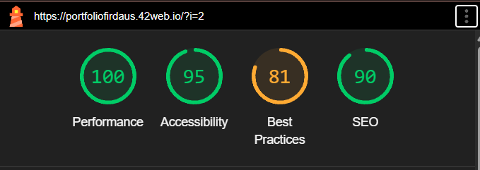

## **Figure 4.1:** My portfolio website auditing results using Google Lighthouse Tools.

A perfect 100 in Performance implies the website loads rapidly and properly. Image, script, and other components are optimised, so site viewers should not encounter delays or latency. This is critical for user retention and enjoyment.

The site got 95 for accessibility. This signifies that most accessibility standards have been achieved, making the site accessible to a wide range of users, including those with disabilities. A great score demonstrates semantic HTML, colour contrast, image alt text, and keyboard navigation.

The site's SEO score was 90, signifying strong search engine optimization. This means Google will likely index and rank it correctly, making it more visible to visitors and employers. Proper metadata, page titles, and mobile-friendly design increase SEO.

Our Best Practices score was 82, slightly lower. This suggests that while the site follows many technical best practices, it may be improved in specific areas. The audit detected that the tested page was redirected from?i=1 to?i=2. The redirection may impact how tools and search engines assess the page, producing performance or SEO difficulties. To achieve the most accurate results and ensure redirects are necessary and efficient, test and optimize the end URL directly.

Final audit results reveal that my portfolio website is well-designed for performance, accessibility, and SEO. Resolving best practices problems, especially URL redirection, may enhance site dependability and technological quality. These results demonstrate that the site is appropriate for public use and recommend a few modifications.